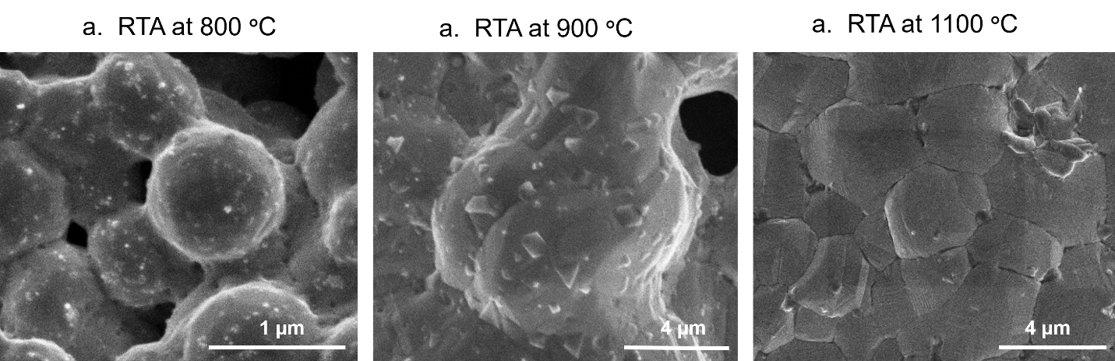
Supplementary Figure 1 | SEM images of the GLNs/Ni powder. a RTA at 800°C. b RTA at 900°C. c RTA at 1100°C. With increasing temperature, the Ni powders exhibited a clear tendency to sinter together gradually losing their individual powder morphology, particularly at temperatures above 800 °C.

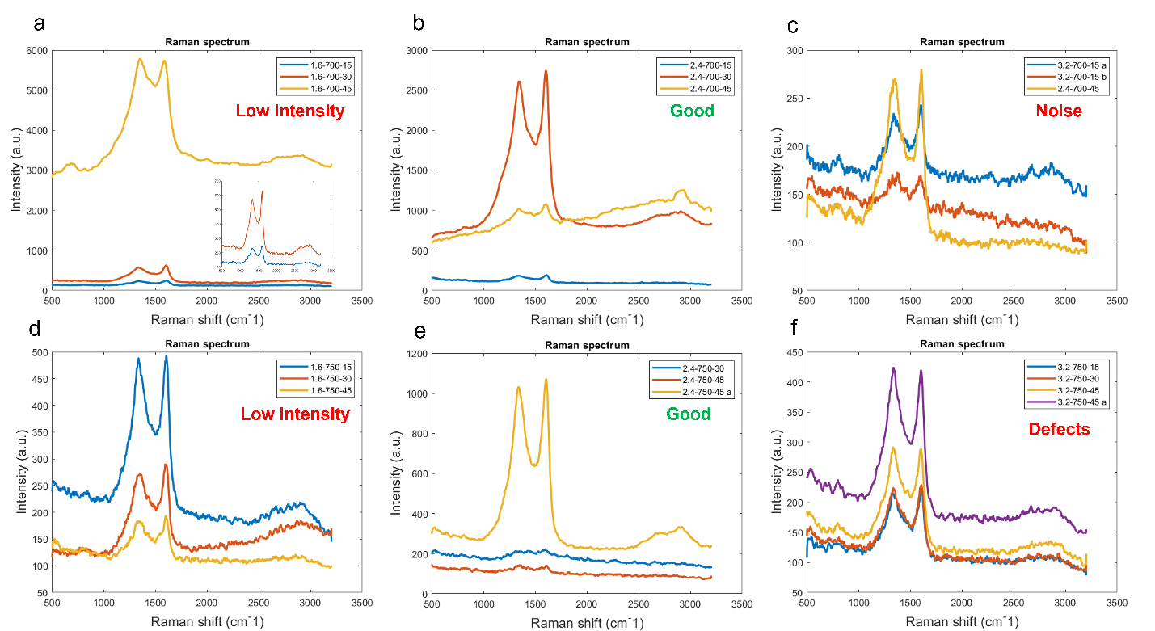Supplementary Figure 2 | Raman shift results for three sucrose concentrations at two temperatures (700 °C and 750 °C). a–c Correspond to sucrose contents of 1.6, 2.4, and 3.2 wt.% at 700 °C, respectively. d–f Correspond to sucrose contents of 1.6, 2.4, and 3.2 wt.% at 750 °C, respectively.

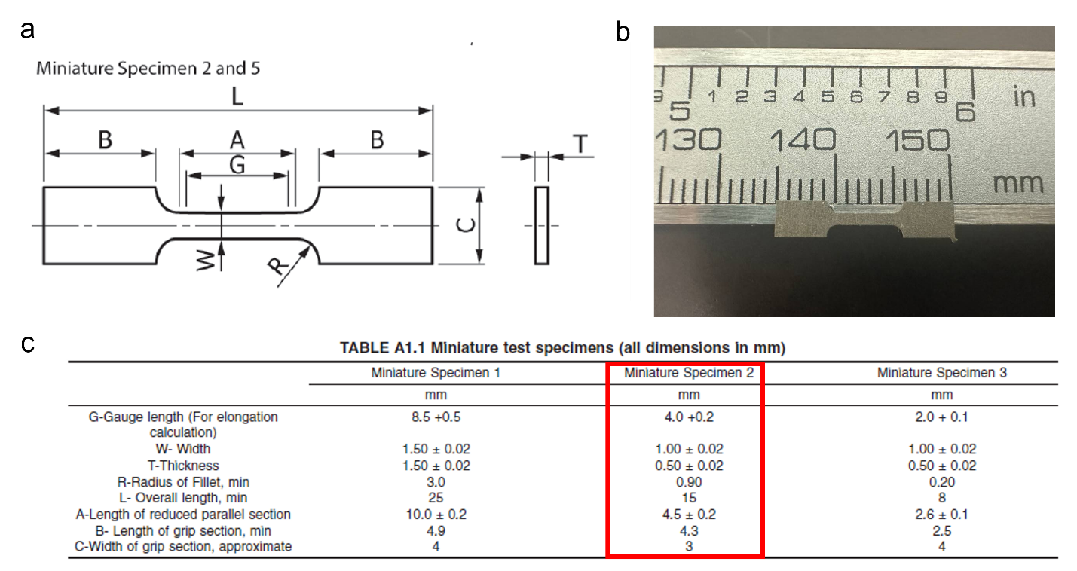
Supplementary Figure 3 | a Schematic view of the miniature tensile test sample, according to ASTM E8-E*M-24. b real test tensile sample. c miniature test specimen (2) dimensions
Mechanical performance
The stress-strain curve can be divided into four regimes: (I) elastic behavior which loads up to the yield point, (II) Lüders drop or yield point phenomenon caused by sudden dislocation release, (III) strain hardening with dislocation pile-up inside Ni grains and balanced annihilation at the GLNs/Ni interface, and (IV) post-UTS elongation until fracture, dominated by interactions between 3D-GLNs and microcracks. The absence of regime (II) in 700-30-1000 suggests that elevated SPS temperatures may promote grain coarsening and induce defects in the in-situ grown 3D-GLNs, thus altering the deformation mechanism¹. The peak UTS points for all samples are marked by orange triangles in the curves. The 700-30-1000 specimen showed a continuous, nearly linear strain-hardening behavior after yielding, without the characteristic Lüders drop, indicating a smooth elastic–plastic transition typical of recrystallized Ni with coarser grains. In contrast, 700-30-850, 750-45-850, and 750-45-1000 displayed a clear Lüders drop following the yield point, attributed to GLNs acting as interstitial obstacles that pin dislocations within the Ni lattice. Once the applied stress surpassed the critical level, dislocations broke free, producing a temporary stress drop before entering the strain-hardening regime.

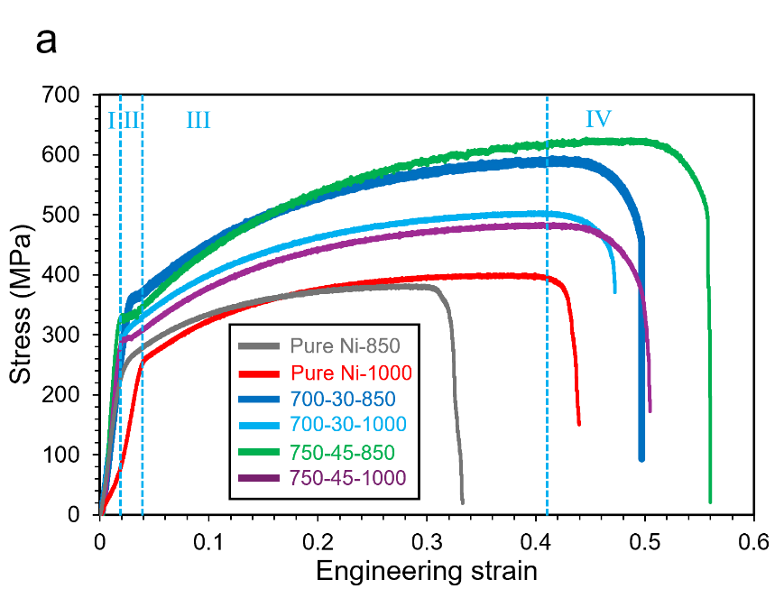
Supplementary Figure 4 | Tensile stress-strain curves of pure Ni, 700-30 and 750-45 at 850 and 1000 SPS

References
1. Zhang, X. et al. A powder-metallurgy-based strategy toward three-dimensional graphene-like network for reinforcing copper matrix composites. Nature communications 11, 2775 (2020).

