Supplementary Information

Title: Stacked electrohydrodynamic pumps with densely perforated electrodes

Authors:
Aimi Fukasawa¹, Shingo Fukushima¹, Yuto Konno¹, Ahmed Miguel Román Abolhosen¹, Yuya Shibahara¹, Naoki Ogawa², Hideko Akai², Jun Shintake¹*

Affiliations:
¹Department of Mechanical and Intelligent Systems Engineering, The University of Electro-Communications, 182-8585 Tokyo, Japan
²Functional Design Laboratory, Science & Innovation Center, Mitsubishi Chemical Co., Ltd., 1000 Kamoshidacho, Aoba Ward, Yokohama, Kanagawa 227-8502, Japan
*Email: shintake@uec.ac.jp

Supplementary Movie Legends:
Movie 1. Operation of the stacked EHD pump with densely perforated electrodes
Movie 2. Actuation of an EHD-McKibben artificial muscle
Movie 3. Actuation of an EHD-fluidic elastomer actuator
Movie 4. Grasping of a spherical object
Movie 5. Grasping of a cubic object

This PDF file includes:
Supplementary Note 1. Calculation of porosity
Supplementary Table 1. Pump design parameters
Supplementary Table 2. Performance comparison of the proposed pump and pumps for soft robotics reported in the literature
Supplementary Figure 1. Three-hour continuous operation at 4.0 kV (13.3 kV/mm) of the single-layer pump with 0.6 mm holes and 50.0% porosity
Supplementary Figure 2. Output performance of a differently designed multi-hole EHD pump at different numbers of stacked layers

Supplementary Note 1. Calculation of porosity
The electrode porosity ($ϕ$) in Supplementary Table 1 is defined as the percentage of the total active electrode area ($S$) occupied by the total hole area ($s_{r}$). The total active electrode area $S$ is defined as a circle with a diameter of 10 mm, corresponding to a radius of $R$ = 5 mm. For a given design with $n$ holes, each having a diameter $D_{h}$, the porosity is calculated using the following equations:
The total active electrode area $S$ is:

$$\begin{aligned}S=πR^{2} \#\left(1\right)\end{aligned}$$

The total hole area $s_{r}$ is calculated from the hole diameter $D_{h}$ and the number of holes $n$:

$\begin{aligned}s_{r}=nπ{\left(\frac{D_{h}}{2}\right)}^{2} \#\left(2\right)\end{aligned}$

The porosity ($ϕ$) is then given by:
$$\begin{aligned}ϕ=\left(\frac{s_{r}}{S}\right)×100 \left[\%\right]\#\left(3\right)\end{aligned}$$

Supplementary Table 1. Pump design parameters.
Design | IA | IB | IC | IIA | IIB | IIIA | IIIB | IIIC
Hole diameter [mm] | 0.6 | 0.3 | 0.15 | 0.6 | 0.3 | 0.6 | 0.3 | 0.15
Number of holes | 139 | 139 | 139 | 100 | 402 | 74 | 296 | 1195
Porosity [%] | 50.0 | 12.5 | 3.1 | 36.0 | 36.2 | 26.6 | 26.6 | 26.7
Total hole perimeter [mm] | 262.0 | 131.0 | 65.5 | 188.5 | 378.9 | 139.5 | 279.0 | 558.4
Total hole area [mm²] | 39.3 | 9.8 | 2.5 | 28.3 | 28.4 | 20.9 | 20.9 | 20.9
Pump mass per layer, including case components [g] | 0.13 | 0.16 | 0.16 | 0.14 | 0.14 | 0.15 | 0.15 | 0.15
Mass of 5-layer pump, including case components [g] | 0.64 | 0.78 | 0.81 | 0.70 | 0.70 | 0.73 | 0.73 | 0.73
Number of layers | 1-5 | 1, 2, 5 | 1, 2, 5 | 1, 2, 5 | 1, 2, 5 | 1, 2, 5 | 1, 2, 5 | 1, 2, 5

Supplementary Table 2. Performance comparison of the proposed pump and pumps for soft robotics reported in the literature.
 | Mass [g] | Flow rate [mL/min] | Pressure [kPa] | Power density [W/kg]
This study | 0.643 | 2041.0 | 4.2 | 55.0
Ref. ¹ | 0.3 | 128 | 161 | 347
Ref. ² | 0.4 | 52.0 | 20.0 | 15.2
Ref. ³ | 1.0 | 6.0 | 14.0 | 0.4
Ref. ^{4*} | 17.1 | 88.0 | 107.0 | 2.3
Ref. ⁵ | 8.2 | 18.8–80.4 | 4.9–12.7 | 8.2
Ref. ^{6*} | 3.0 | 423.0 | 9.2 | 5.4
Ref. ^{7*} | 71.2 | 800.0 | 90.2 | 4.2
Ref. ⁸ | 9.0 | 1327.1 | 3.63 | 2.2
Ref. ⁹ | 5.3 | 167.4 | 4.1 | 0.5
Ref. ^{10*} | 4.0 | 5.1 | 71.0 | 0.4
*The power density value was estimated from the information available in the paper.

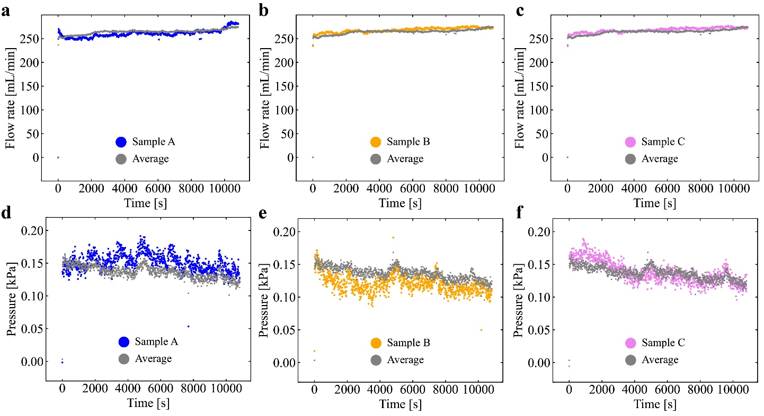
Supplementary Figure 1. Three-hour continuous operation at 4.0 kV (13.3 kV/mm) of the single-layer pump with 0.6 mm holes and 50.0% porosity. a–c Flow rate measured for three independent samples. d–f Pressure measured for three independent samples. Gray markers represent the average across the three samples.

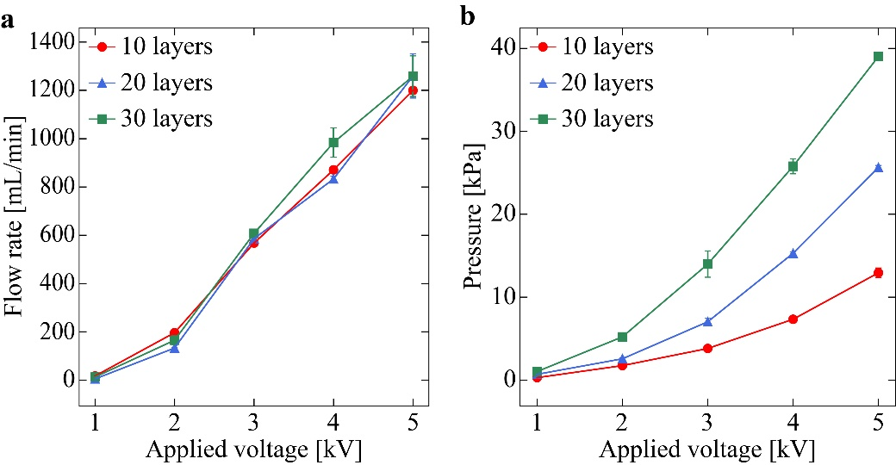
Supplementary Figure 2. Output performance of a differently designed multi-hole EHD pump at different numbers of stacked layers. The pump consisted of square EHD layers with 10 mm × 10 mm electrodes and 0.3 mm holes (porosity 38%), with the same electrode gap (0.3 mm) and interlayer gap (1 mm) as the pumps investigated in the main text. a Flow rate as a function of applied voltage for pumps with 10, 20, and 30 stacked layers. b Pressure as a function of applied voltage for pumps with 10, 20, and 30 stacked layers. Data points represent the averages of three samples, and error bars represent the standard deviations.

Supplementary References
1. Luo, Y., Schouten, M. & Shea, H. Increasing the power density of electrohydrodynamic pumps by mapping the fluid landscape. Sci. Adv. 12, eaeb2623 (2026).
2. Smith, M., Cacucciolo, V. & Shea, H. Fiber pumps for wearable fluidic systems. Science 379, 1327–1332 (2023).
3. Cacucciolo, V. et al. Stretchable pumps for soft machines. Nature 572, 516–519 (2019).
4. Marzuq, A. et al. A Compact, Self-Recovering Wire Electrode Electrohydrodynamic Pump for High-Speed McKibben Artificial Muscle Actuation. Adv. Intell. Syst. 8, e202501035 (2025).
5. Wang, C. et al. Pump in a tube: a facilely-manufactured electrohydrodynamic tube pump for driving soft grippers. SSRN (2025). https://doi.org/10.2139/ssrn.5761254
6. Tang, W. et al. Customizing a self-healing soft pump for robot. Nat. Commun. 12, 2247 (2021).
7. Xin, Y. et al. 3D-Printed Electrohydrodynamic Pump and Development of Anti-Swelling Organohydrogel for Soft Robotics. Adv. Mater. 37, 2415210 (2025).
8. Shibahara, Y. et al. Electrohydrodynamic fiber pump with dual-flow channels. Adv. Intell. Syst. 8, e202501473 (2026).
9. Kanno, R. et al. Silicone-based highly stretchable multifunctional fiber pumps. Sci. Rep. 14, 4618 (2024).
10. Wang, J. et al. Stretchable, transparent, high-pressure electrohydrodynamic pumps with ionic conductors for soft fluidic systems. Res. Square (2025).

