Three-Dimensional Walnut-Like, Hierarchically Zn-MOF Microsphere: One-Pot Synthesis, Characterization and its application as a Green Catalyst for the Asymmetric Hantzsch Synthesis of Polyhydroquinolines
Sayed Mohammad Ramish ª, Arash Ghorbani-Choghamarani ^{b,*}, Masoud Mohammadi ª

ª Department of Chemistry, Faculty of Science, Ilam University, Ilam, Iran.
^{b} Department of Organic Chemistry, Bu-Ali Sina University, 6517838683, Hamedan, Iran.

*Corresponding Author: E-mail addresses: a.ghorbani@basu.ac.ir & arashghch58@yahoo.com (A. Ghorbani-Choghamarani)

Selected spectral data
Ethyl-4-(4-hydroxyphenyl)-2,7,7-trimethyl-5-oxo-1,4,5,6,7,8-hexahydroquinoline-3-carboxylate: 1H NMR (500 MHz, DMSO-d6): δ (ppm) 0.85 (s, 3H), 1.00 (s, 3H), 1.12 (t, J = 7.2 Hz, 3H), 1.95 (d, J = 16.0 Hz, 1H), 2.14 (d, J = 16.0 Hz, 1H), 2.22 - 2.30 (m, 4H), 2.40 (d, J = 16.8 Hz, 1H), 3.97 (q, J = 7.2 Hz, 2H), 4.74 (s, 1H), 6.54 (d, J = 8.4 Hz, 2H), 6.93 (d, J = 8.0 Hz, 2H), 8.94 (s, 1H), 9.01 (s, 1H); ¹³C NMR (126 MHz, DMSO) δ 194.33, 167.05, 155.28, 149.16, 144.43, 138.45, 128.38, 114.56, 114.36, 110.36, 104.13, 58.99, 34.81, 32.17, 29.20, 26.50, 18.33, 14.22.

Ethyl-4-(2-nitrophenyl)-2,7,7-trimethyl-5-oxo-1,4,5,6,7,8-hexahydroquinoline-3-carboxylate (4i): ¹H NMR (500 MHz, DMSO): δ (ppm) 0.76 (s, 3H), 0.93-1.11 (m, 6H), , 1.89 (d, J = 16.0 Hz, 1H), 2.15 (d, J = 16.0 Hz, 1H), 2.21 - 2.29 (m, 4H), 2.39 (d, J = 17.2 Hz, 1H), 3.82-3.96 (m, 2H), 5.65 (s, 1H), 7.29 (t, J = 8.0 Hz, 1H), 7.42 (d, J = 8.0 Hz, 1H), 7.55 (m, 1H), 7.72 (m, 1H), 9.12 (s, 1H); ¹³C NMR (126 MHz, DMSO) δ 194.02, 166.61, 149.79, 147.67, 145.95, 141.97, 130.66, 126.86, 123.72, 123.51, 109.85, 103.06, 59.07, 32.06, 28.91, 26.33, 18.30, 13.89.

Ethyl-4-(3-nitrophenyl)-2,7,7-trimethyl-5-oxo-1,4,5,6,7,8-hexahydroquinoline-3-carboxylate (4e): 1H NMR (500 MHz, DMSOd6): δ (ppm) 0.84 (s, 3H), 1.02 (s, 3H), 1.12 (t, J = 6.8 Hz, 3H), 1.97 (d, J = 16.0 Hz, 1H), 2.16 (d, J = 16.4 Hz, 1H), 2.27 - 2.35 (m, 4H), 2.46 (t, J = 16.8 Hz, 1H), 3.97 (q, J = 7.2 Hz, 2H), 4.97 (s, 1H), 7.50 (m, 1H), 7.61 (m, 1H), 7.97-7.99 (m, 2H), 9.24 (s, 1H),; ¹³C NMR (126 MHz, DMSO) δ 194.35, 166.51, 166.41, 150.16, 149.80, 147.39, 146.40, 146.19, 134.47, 121.99, 120.87, 109.26, 102.67, 101.09, 59.27, 36.48, 32.21, 29.07, 26.33, 18.35, 14.04.

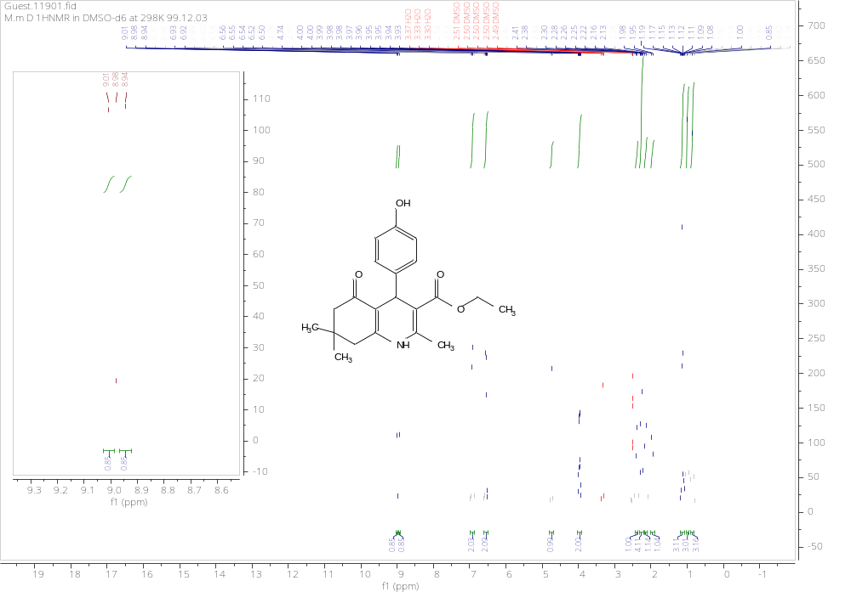
¹H NMR (500 MHz, DMSO-d6) of: Ethyl-4-(4-hydroxyphenyl)-2,7,7-trimethyl-5-oxo-1,4,5,6,7,8-hexahydroquinoline-3-carboxylate:

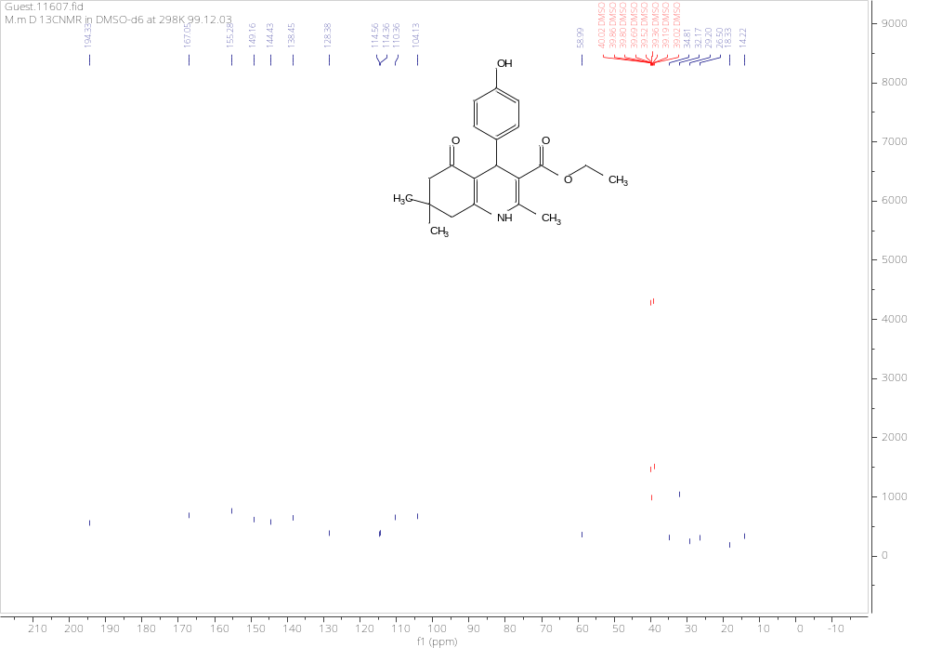
¹³ C NMR (126 MHz, DMSO-d6) of: Ethyl-4-(4-hydroxyphenyl)-2,7,7-trimethyl-5-oxo-1,4,5,6,7,8-hexahydroquinoline-3-carboxylate:

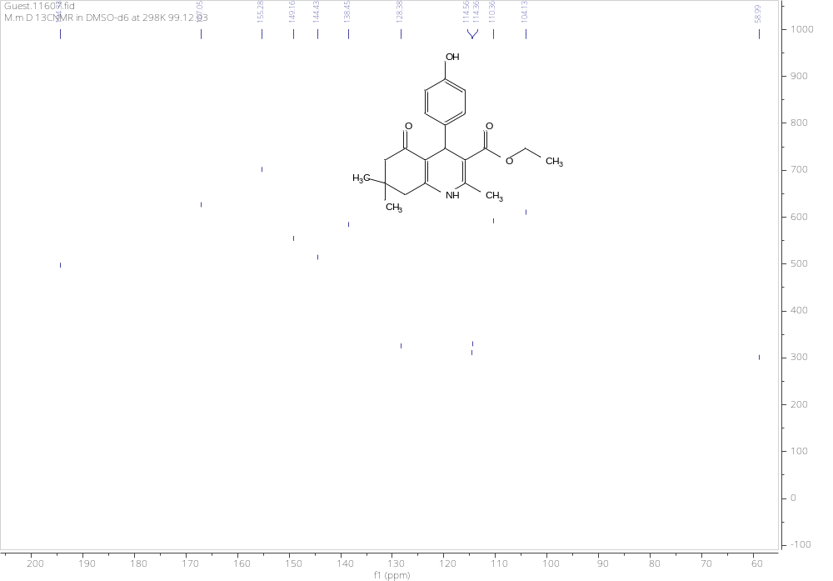
¹³ C NMR (126 MHz, DMSO-d6) of: Ethyl-4-(4-hydroxyphenyl)-2,7,7-trimethyl-5-oxo-1,4,5,6,7,8-hexahydroquinoline-3-carboxylate:

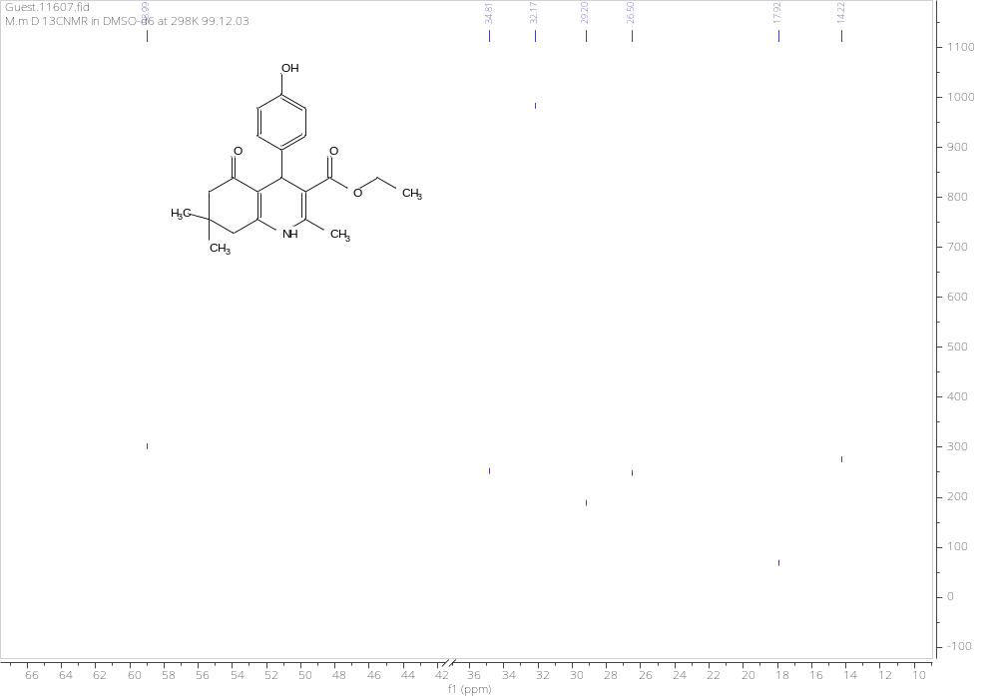

¹³ C NMR (126 MHz, DMSO-d6) of: Ethyl-4-(4-hydroxyphenyl)-2,7,7-trimethyl-5-oxo-1,4,5,6,7,8-hexahydroquinoline-3-carboxylate:

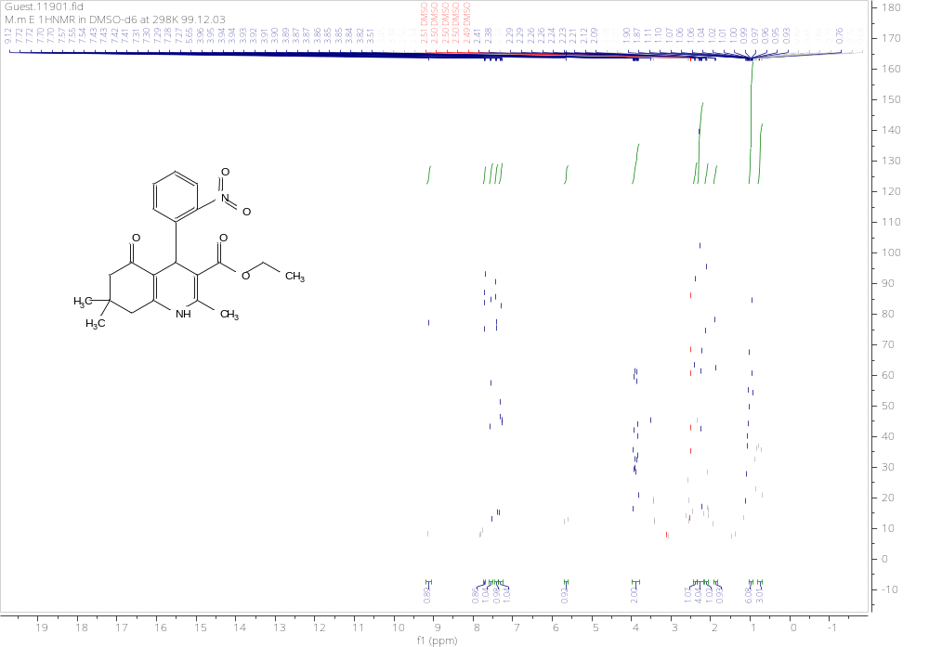

¹H NMR (500 MHz, DMSO) of Ethyl-4-(3-nitrophenyl)-2,7,7-trimethyl-5-oxo-1,4,5,6,7,8-hexahydroquinoline-3-carboxylate.

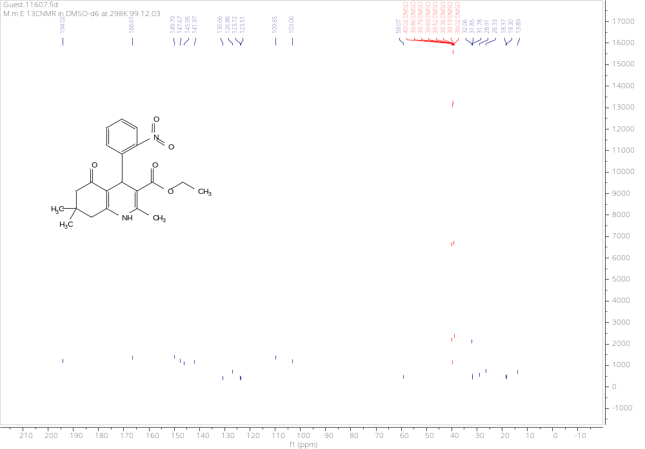

¹³C NMR (126 MHz, DMSO) of Ethyl-4-(3-nitrophenyl)-2,7,7-trimethyl-5-oxo-1,4,5,6,7,8-hexahydroquinoline-3-carboxylate.

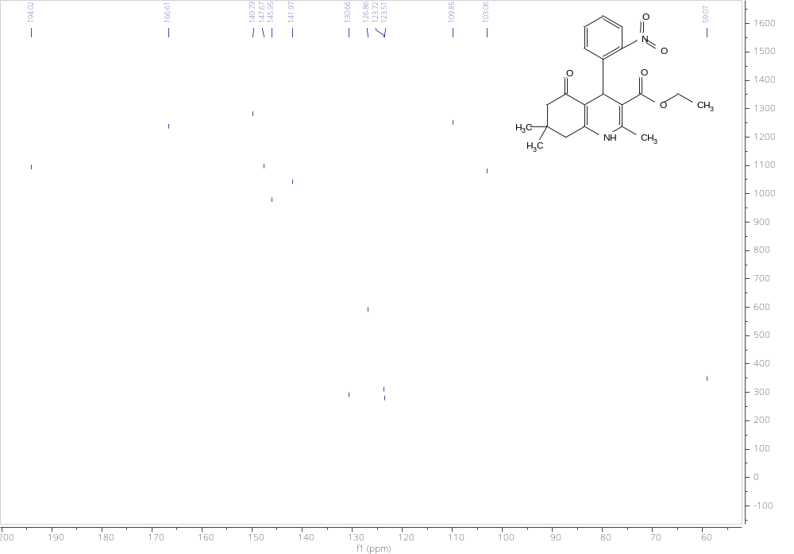
¹³C NMR (126 MHz, DMSO) of Ethyl-4-(3-nitrophenyl)-2,7,7-trimethyl-5-oxo-1,4,5,6,7,8-hexahydroquinoline-3-carboxylate.

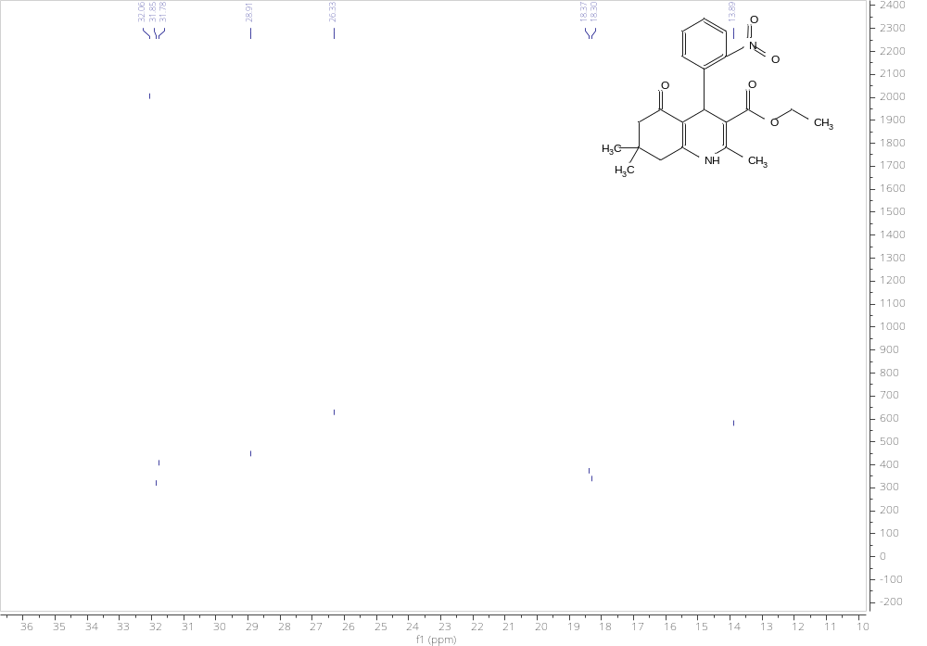

¹³C NMR (126 MHz, DMSO) of Ethyl-4-(3-nitrophenyl)-2,7,7-trimethyl-5-oxo-1,4,5,6,7,8-hexahydroquinoline-3-carboxylate.

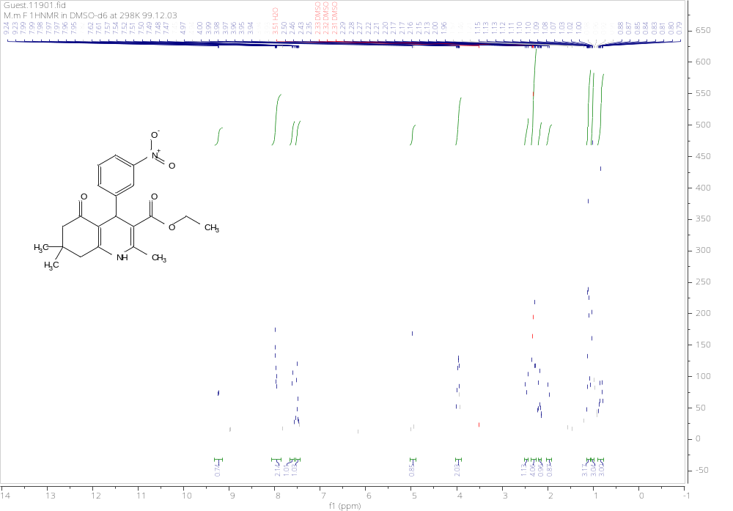

1H NMR (500 MHz, DMSOd₆) of Ethyl-4-(3-nitrophenyl)-2,7,7-trimethyl-5-oxo-1,4,5,6,7,8-hexahydroquinoline-3-carboxylate.

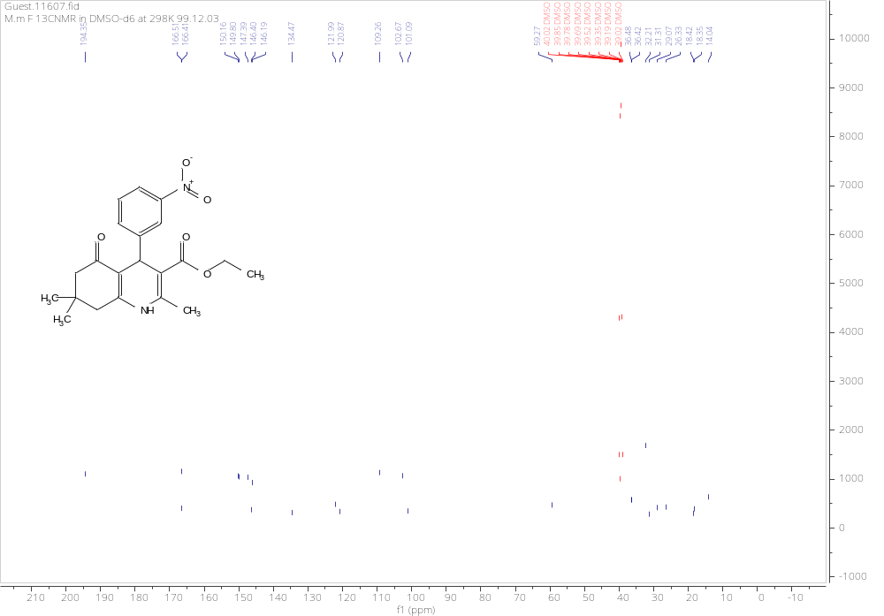

¹³C NMR (126 MHz, DMSO) of Ethyl-4-(3-nitrophenyl)-2,7,7-trimethyl-5-oxo-1,4,5,6,7,8-hexahydroquinoline-3-carboxylate .
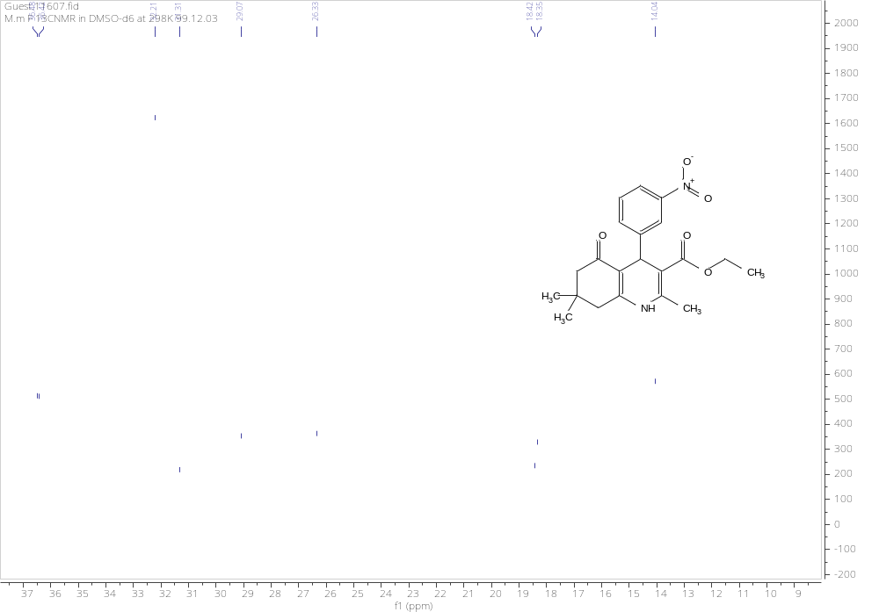

¹³C NMR (126 MHz, DMSO) of Ethyl-4-(3-nitrophenyl)-2,7,7-trimethyl-5-oxo-1,4,5,6,7,8-hexahydroquinoline-3-carboxylate .

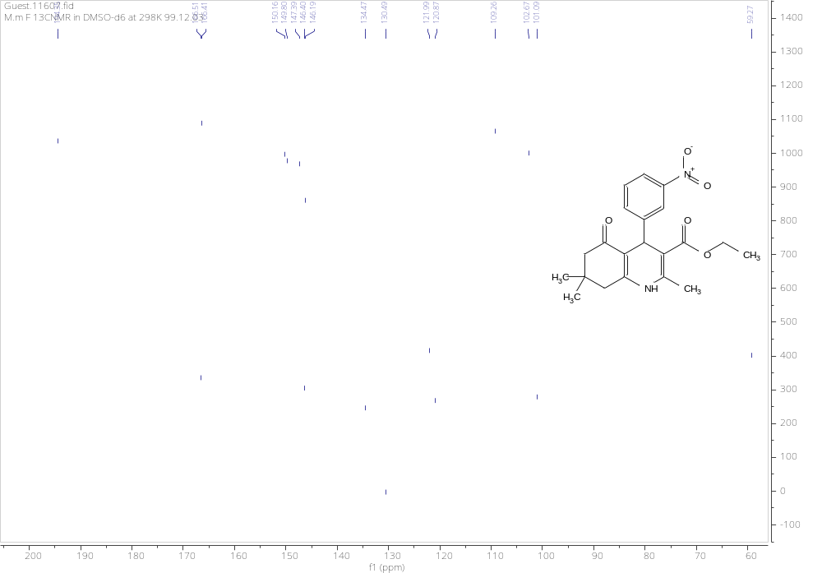
¹³C NMR (126 MHz, DMSO) of Ethyl-4-(3-nitrophenyl)-2,7,7-trimethyl-5-oxo-1,4,5,6,7,8-hexahydroquinoline-3-carboxylate .

