Appendix
Optimization of LIPSS preparation parameters

Optimization of laser energy flux density for LIPSS formation
To identify suitable processing parameters of LIPSS, the cemented carbide surface was processed by varying the laser energy flux density and overlap ratio. Under a fixed overlap condition （$f$=100 KHz，$O_{x}$=66.7%，$O_{y}$=50% ,$N_{s}$=5）, the 3D morphologies of the LIPSS surfaces obtained under different laser energy flux densities were characterized by AFM, as shown in Fig. S1. At a low energy flux density (Fig. S1(a)), close to the material removal threshold of cemented carbide, the absorbed surface energy was limited and the plasma-induced shock effect was relatively weak, resulting in reduced surface deformation and the formation of a texture with a width period of 105 nm. When the energy flux density increased to 4.39 J/cm², textures with width periods of 920-960 nm were consistently induced on the cemented carbide surface, as shown in Fig. S1(b-d). This indicates that once the laser energy flux density exceeds the material removal threshold of cemented carbide, further increases in energy flux density have no significant effect on the width period of the LIPSS. Statistical results further show that with increasing energy flux density, both the LIPSS height and nanoscale roughness increase accordingly (Fig. S2(a,b)).
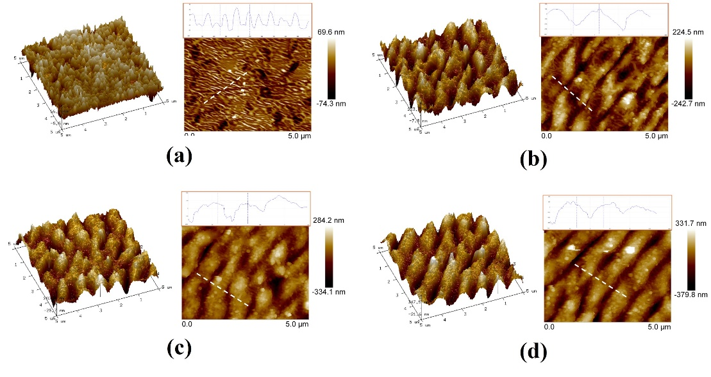
Fig. S1 Effect of laser energy flux density on the 3D morphology of LIPSS of cemented carbide
(a) $I$= 2.41 J/cm², (b) $I$= 4.39 J/cm², (c) 6.37 J/cm², (d) 8.35 J/cm².
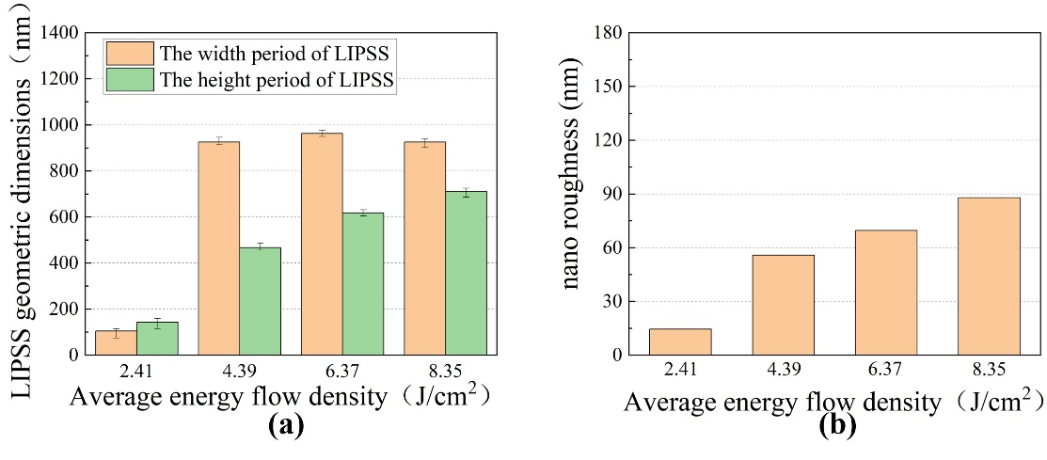
Fig. S2 Effect of laser energy flux density on (a) LIPSS geometric dimensions and (b) nano roughness of LIPSS of cemented carbide
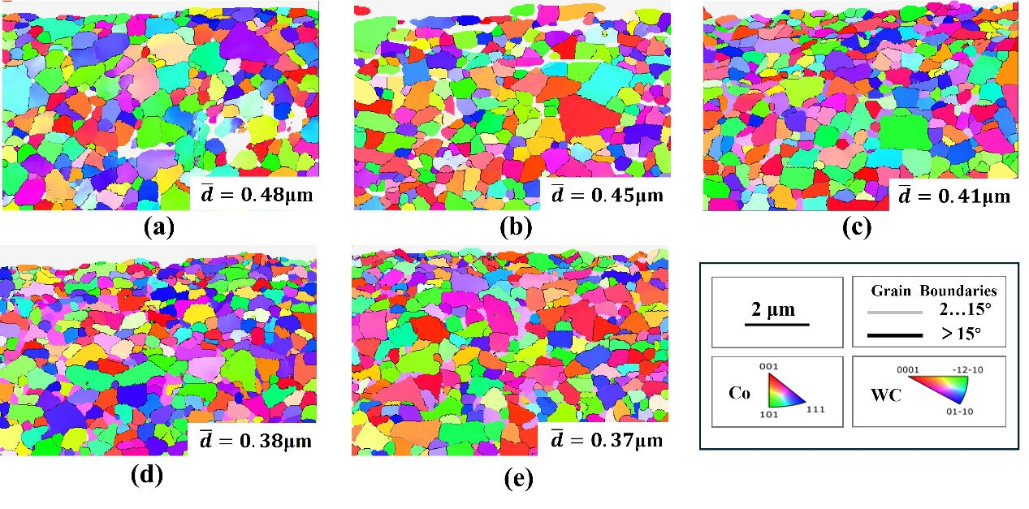
Fig. S3 EBSD grain orientation distribution map under various energy flux density
(a) Untreated group，(b) $I$= 2.41 J/cm²，(c) $I$= 4.39 J/cm², (d) 6.37 J/cm² ，(e) 8.35 J/cm²
In addition, EBSD characterization was performed on the cross sections of the cemented carbide, and the grain-size evolution under different laser energy flux densities was statistically analyzed. The results show that the surface grains gradually refine with increasing energy flux density, indicating that laser irradiation enhances the microstructural refinement effect in the near-surface region. However, when the energy flux density was further increased, the extent of grain refinement became less pronounced, and no significant additional refinement was achieved with further energy input. Overall, a clear grain-refinement effect was obtained within the energy flux density range of 4.39–8.35 J/cm². Among these conditions, 6.37 J/cm² already produced evident grain refinement, while further increasing the energy flux density resulted in no substantial improvement. Therefore, this value was selected for the subsequent optimization of the overlap ratio.

Optimization of overlapping rate for LIPSS formation
As shown in Fig. S4(a–d), the three-dimensional morphologies of the textured cemented carbide surfaces obtained under different ultrafast laser overlap ratios are presented. At a fixed energy flux density of 6.37 J/cm², the width period of the resulting textures remained nearly constant at approximately 960 nm for all overlap ratios, indicating that once the energy flux density exceeds the material removal threshold of cemented carbide, further changes in either energy flux density or overlap ratio have no significant effect on the texture width period. In contrast, the texture height is much more sensitive to both energy flux density and overlap ratio, with the latter showing a particularly pronounced influence. When the energy flux densities were 4.39, 6.37, and 8.35 J/cm², the corresponding texture heights were 467, 618, and 711 nm, respectively (Fig. S2(a)). By comparison, when the overlap ratio Ox was set to 33.3%, 66.7%, 83.3%, and 96.6%, the corresponding texture heights increased to 458, 618, 938, and 1264 nm, respectively (Fig. S5(a)). These results indicate that, under a suitable energy flux density, optimizing the overlap ratio is more effective for achieving precise control over the three-dimensional texture morphology.
In addition, the surface roughness increased with increasing overlap ratio (Fig. S5(b)). Under high-overlap conditions, the local thermal accumulation effect became more pronounced, leading to more irregular morphological variations on the microstructured surface. Specifically, a greater number of “tendril-like” nanostructures and spherical nanoparticles were generated, which together contributed to the increase in surface roughness. Meanwhile, a higher overlap ratio also enlarged the overlap region between adjacent laser focal spots, promoting the redistribution of molten material and further intensifying the surface undulation, thereby increasing the roughness.
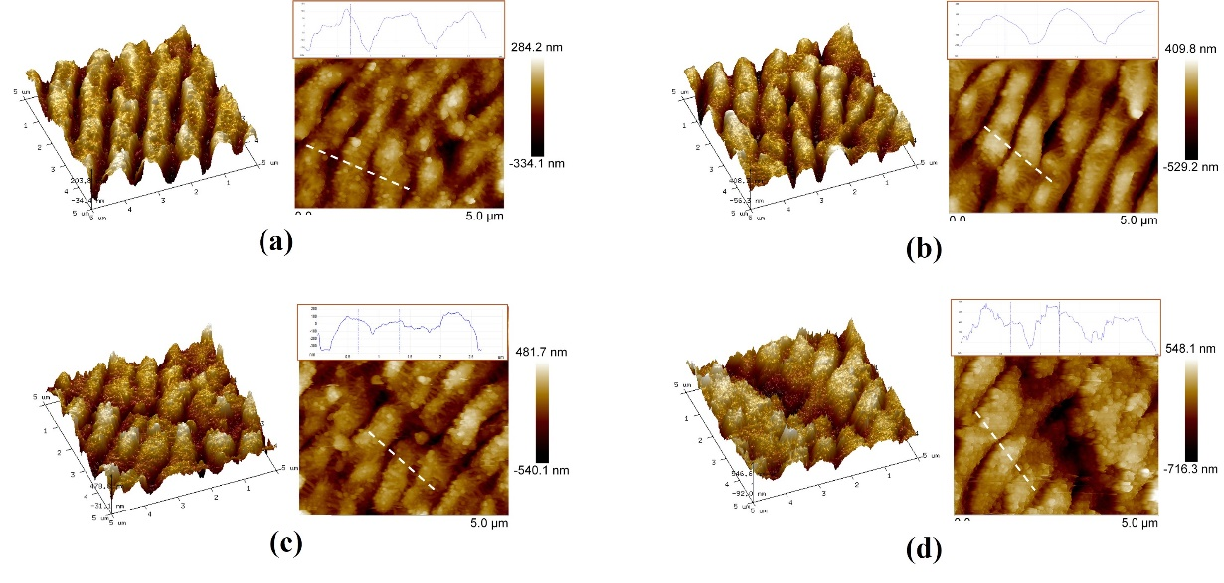
Fig. S4 Effect of overlapping rate on the 3D morphology of texture of cemented carbide
(a) $O_{x}$=33.3%, (b) $O_{x}$=66.7%, (c) $O_{x}$=83.3%, (d) $O_{x}$=96.6%.
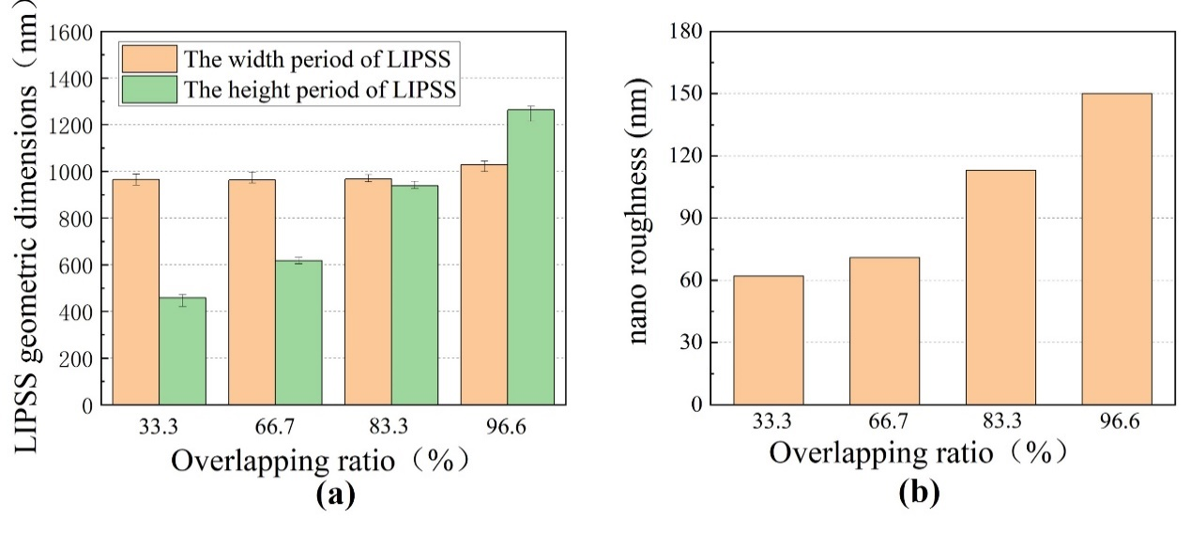
Fig. S5 Effect of overlapping rate on (a) LIPSS geometric dimensions and (b) nano roughness of LIPSS of cemented carbide
As shown in Fig. S6, with the introduction of ultrafast laser strengthening, the surface grain size of cemented carbide decreases with increasing laser overlap ratio to 0.44 μm, 0.37 μm, 0.37 μm, and 0.39 μm, respectively. These results indicate that the surface grains of cemented carbide are significantly refined under laser irradiation.
Furthermore, XPS analysis was conducted to examine the composition and valence states of surface oxides formed on cemented carbide under different laser overlap ratios. To ensure analytical accuracy, the binding energy scale was calibrated using the amorphous C1s peak at 284.6 eV. As shown in Fig. S7, the gray curves represent the experimental spectra, while the pink curves correspond to the fitted results. Two tungsten (W) components with different valence states can be identified in the XPS spectra. The orange peak at 35.88 eV corresponds to W6+, which, based on comparison with characteristic oxide spectra, can be assigned to CoWO₄ and WO₃. The green peak at 32.48 eV corresponds to W2+, which mainly originates from WC in the cemented carbide substrate.
With increasing laser overlap ratio, the intensity of the W6+ peak gradually increases, whereas that of the W2+ peak correspondingly decreases. The largest difference between the two peaks is observed at Ox = 96.6%. This trend indicates that ultrafast laser treatment significantly promotes the oxidation of WC in the near-surface region of cemented carbide. In contrast, at Ox = 33.3% and Ox = 66.7%, the degree of surface oxidation remains relatively low. Combined with the cross-sectional grain-refinement results shown in Fig. S6, these findings indicate that Ox = 66.7% provides evident microstructural refinement while effectively avoiding excessive oxidation, and was therefore selected as the optimal overlap ratio for the subsequent experiments.
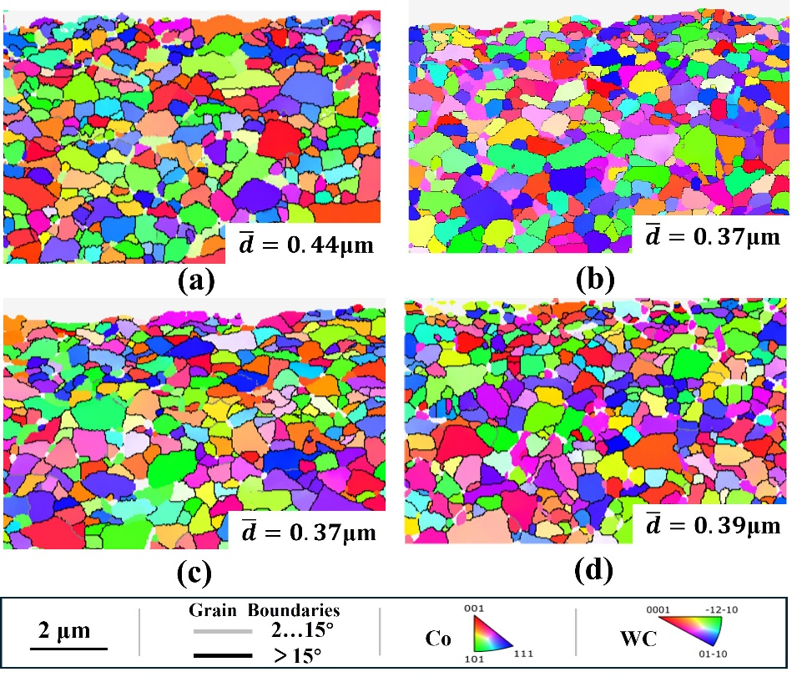
Fig. S6 EBSD grain orientation distribution map under various overlapping rate
(a) $O_{x}$=33.3%, (b) $O_{x}$=66.7%, (c) $O_{x}$=83.3%, (d) $O_{x}$=96.6%.
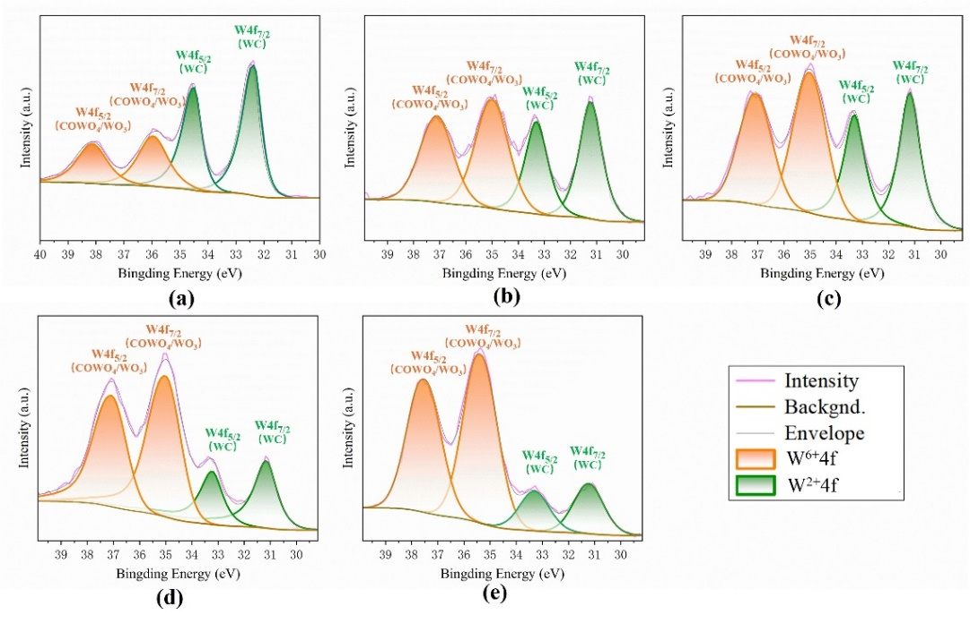
Fig. S7 XPS W4f spectra of cemented carbide surfaces under various overlapping ratio
- Untreated group, (b) $O_{x}$=33.3%, (c) $O_{x}$=66.7%, (d) $O_{x}$=83.3%, (e) $O_{x}$=96.6%.

Tables
Table S1 Surface energy parameters of deionized water and glycol.
Liquid | $γ_{L}^{D}$ (mN/m) | $γ_{L}^{P}$ (mN/m) | $γ_{L}$ (mN/m) | Polarity
Deionized water | 21.8 | 51 | 72.8 | polar
Glycol | 29 | 19 | 48 | non-polar

Table S2 Grain boundary length of the untreated coated group and the LIPSS-coated group.
Misorientation angle (°) | Untreated coating group |  | LIPSS-coated group
Misorientation angle (°) | HfB₂ | AlTiCrN | HfB₂ | AlTiCrN
LAGBs: 2°–15° | 21.1 | 159.2 | 51.6 | 137.8
HAGBs: >15° | 28.7 | 278.5 | 53.6 | 463
Total | 49.8 | 437.7 | 105.2 | 600.8

Table S3 Deposition parameters for HfB₂ using HiPIMS.
No. | Procedure | Deposition parameters
1 | Vacuum | Pressure: 4.0×10⁻⁵mbar
2 | Heating | Temperature: 500 °C; 3000 s)
3 | Etching | Ar: 50 sccm; Table speed: 10 rpm; 1200 s
4 | Coating | Cathode: HfB₂; Ar: 420 sccm; Bias: 60 V; Power: 4000 W; 3600 s
5 | Cooling | Temperature: 120 °C

Table S4 Deposition parameters for AlTiCrN using ARC.
No. | Procedure | Deposition parameters
1 | Vacuum | Pressure: 2.0×10⁻⁴ mbar
2 | Heating | Temperature: 550 °C; 3000 s
3 | Etching | Ar: 50 sccm; Table speed: 3 rpm; 1200 s
4 | Interfacial layer | Cathode: AlTi; N₂: 400 sccm; Current: 100 A; Bias: 60 V; 400 s
5 | Alternating layer1 | Cathode: AlCr; N₂: 400 sccm; Current: 100 A; Bias: 60 V; 200 s
6 | Alternating layer2 | Cathode: AlTi; N₂: 400 sccm; Current: 100 A; Bias: 60 V; 200 s
 |  | Steps nos. 5 and 6 were repeated six times
7 | Top layers | Cathode: AlCr; N₂: 400 sccm; Current: 100 A; Bias: 60 V; 1200s
8 | Cooling | Temperature: 120 °C

