Supplementary Materials
Contents
Supplementary Notes 2
Supplementary Note 1: Monomer data processing pipeline 2
Supplementary Note 2: Complex data processing pipeline 2
Supplementary Note 3: Antibody-antigen dataset processing pipeline 3
Supplementary Note 4: Task 3
Supplementary Tables 7
Supplementary Figures 25

Supplementary Notes

Supplementary Note 1: Monomer data processing pipeline
To construct a protein monomer dataset for model pre-training, we downloaded all available structures (mmCIF format) as of February 1st, 2025, from the RCSB Protein Data Bank (PDB). For NMR ensembles, only the first model for structures containing multiple models was retained. For protein complex assemblies, each single-chain protein was extracted from the structure files. Subsequently, the resulting single chains were processed through the following filtering pipeline:
- Structures with a resolution > 5 Å were removed, while NMR structures were retained.
- Remove data rows containing annotations such as HETATM, ANISOU, and altLoc.
- All non-protein molecules, including crystallization additives, ions, small molecules, glycans, DNA, and RNA, were removed.
- All hydrogen atoms were removed.
- All non-standard amino acids were labeled as UNK from the structures. Chains containing > 50% unknown residues and non-standard amino acids (UNK) were discarded.
- If less than 50% of the chain contains complete residues (defined as containing the main chain heavy atoms N, CA, and C), or if the total number of complete residues is less than 50, the chain is discarded.
- Atoms with an occupancy rate less than 0.5 are removed. Any chain with more than 50% missing atoms is discarded.
- Protein chains with residue length between 50 and 900 AA were retained.
- Residue indexes were renumbered (1-indexed) based on the reference sequence, and residues with insertion codes were numbered sequentially.
- The filtered single-chain sequences were clustered at 70% sequence identity using MMseqs2 (v17-b804f).

Supplementary Note 2: Complex data processing pipeline
To construct the protein dimer dataset for model pre-training, we specifically filtered PDB entries containing exactly two chains within a single structure model. To ensure data quality, these dimer complexes were processed with the following pipeline:
1-8. Consistent with the description in Supplementary Note 1 (step 1 - step 8)
- Each protein chain with a residue length between 20 and 650 AA was retained.
- Structures recorded in the SAbDab database were removed.
- We applied an interface-based clustering approach similar to AlphaFold3. First, MMseqs2 (v17-b804f) was used to perform 100% sequence identity clustering on each chain in the dimer. Then, the cluster IDs of the two chains were paired to form the interface IDs of the complex, and clustered according to 70% similarity to form the final clusters of the complexes.

Supplementary Note 3: Antibody-antigen dataset processing pipeline
To construct the antibody-antigen dataset for model pre-training, we retrieved entry identifiers from the SAbDab database ( as of May 16, 2025) and downloaded the corresponding structures from the RCSB PDB. These data were processed through the following pipeline:
- Entries lacking a heavy chain or missing any SAbDab-specified chain in the corresponding PDB structure were removed.
- Structures with a resolution > 3.5 Å were removed. All NMR structures were retained.
3-8. Each chain went through in Supplementary Note 1 (steps 3-7, step 9)
- For a multi-chain structure, if any chain was discarded in the above steps, the whole structure was removed.
- Antibody-antigen structures with a total sequence length > 1250 AA were discarded.
- For the structure containing more than two antigen chains or exhibiting chain identifier conflicts between the antibody and antigen, only the antibody structure was retained.
- For structures containing only a single antibody chain (e.g., scFv or VHH), sequences were clustered at 70% identity using MMseqs2 (v17-b804f). For antibody-antigen and monoclonal antibody structures, we applied the interface-based clustering approach described in Supplementary Note 2 (step 11).

Supplementary Note 4: Task
Comparison the sequence and structural diversity of monomers and complexes. To verify whether complexes contain richer sequence and structural information than monomers, we conducted two evaluations. First, to compare the sequence diversity of monomers and complexes, we used MMseqs2 (v17-b804f) to cluster the data (including 613,872 monomers and 62,044 complexes) with a 70% sequence identity threshold, and then calculated the reduction in dataset size after clustering. Second, to assess the structural diversity between monomers and complexes, we adopted the theoretical framework to calculate the normalized R_{g} of the data before clustering. Specifically, for each representative structure, all protein atoms from all constituent chains were extracted and their center of mass were determined. R_{g} was then calculated as the mass-weighted root mean square distance from these selected atoms to their center of mass. To ensure comparability across proteins of different sizes, the R_{g} values were normalized by $N^{1/3}$, where $N$ represents the total number of selected atoms. Finally, to compare the structural diversity of monomers and complexes, we generated histogram of the probability density distributions of normalized R_{g} values and their corresponding boxplot to analyze the result.
Impact of complexes on monomer generative model. To evaluate the contributions of monomers and complexes to the prediction of monomer ensembles, we pre-trained Model C, Model M, and Model A as mentioned in Methods. To evaluate these models, we selected 30 general targets from the independent monomer test data as a test set (Supplementary Table 1). For each test protein, 1,000 frames were sampled using Model C, Model M, and Model A, respectively. Additionally, we extracted 10,001 frames from the corresponding 100 ns MD trajectories of each test protein as reference ensembles for subsequent evaluation. Before computing the metrics, we performed global sequence alignment using the BLASTp to extract the shared residues between the predicted and the reference MD. We excluded non-standard residues and redundant atoms. The obtained trajectories were then filtered to retain only $C_{α}$ atoms. Finally, to eliminate global translational and rotational motions, we aligned the predicted ensembles to the reference MD based on the $C_{α}$ coordinates. To compare the global conformational features of the predicted ensembles with those generated from MD simulations. Following these preprocessing steps, we calculated the PwD-JSD, R_{g}-JSD, and rRMSF metrics to evaluate the consistency of global features between the predicted and reference MD ensembles. Furthermore, to assess the conformational coverage of the predicted ensemble to the reference MD ensemble, we extracted and applied periodic boundary corrections to the backbone dihedral angles from the aligned trajectories. After standardizing the data, we solely fitted a time-lagged independent component analysis (TICA) model on the reference MD data. Following the ConfDiff approach, we mapped the data to slow processes across multiple lag times to find the coordinates of maximal autocorrelation. Finally, we projected the predicted conformations onto the TICA space defined by the MD data and quantified the distributions by calculating the RMWD and TIC-JSD.
MD fine-tuning data volume analysis. To evaluate the impact of MD fine-tuning data volume on model performance, we first partitioned the MD trajectories into a training and a validation set based on PDB release dates. In the In-house database, the training set included antigen-antibody complexes and dimers released before January 23, 2021, with a resolution < 3.5 Å; the validation set included structures released between January 24, 2024, and May 7, 2025, with a resolution < 3.0 Å (Supplementary Table 2). Using the MD fine-tuning strategy mentioned in Methods, we randomly selected subsets of 1,000, 2,000, and 3,000 trajectories from the training set. We then fine-tuned model C on these subsets and the full dataset (5,502 trajectories) to obtain the corresponding models: Model 1k, Model 2k, Model 3k, and DynoM. Subsequently, we used the same 30 protein test set and pipeline mentioned above to calculate PwD-JSD, R_{g}-JSD, rRMSF, TIC-JSD and TIC-RMWD metrics to evaluate these models. Finally, to specifically show the performance variations of different models on identical proteins, the two-dimensional TICA projections of five proteins (PDB ID: 9FJ1, 9DZS,9JVM, 9JDS and 9GV5) were selected and plotted as scatter plots for visualization.
Comparison with other methods. To comprehensively evaluate the capabilities of DynoM, we compared it with three state-of-the-art models for protein conformational sampling: AlphaFlow (-MD-base), BioEmu (v1.1), and ConfDiff (-OF-r3-MD). Because existing methods primarily focus on shorter monomeric protein domains, we added 33 proteins, including 21 with sequence lengths exceeding 500 residues, to our previously established 30-protein test set. By incorporating these larger proteins, we evaluated the models' generalization capabilities on long sequences, as well as their ability to capture long-range interactions in large-scale proteins. All baseline models are run on their default settings. we sampled 1,000 frames from each model for evaluation. We also extracted 10,001 frames from the 100 ns all-atom MD simulation trajectories of these 63 proteins as reference structures. Subsequently, we calculated evaluated the R_{g}-JSD, PwD-JSD, rRMSF, TIC-JSD and TIC-RMWD metrics. Furthermore, to investigate the models' capacity to capture long-range interactions, we calculated the average spatial distance deviations across all Cα atom pairs between the predicted ensembles and the reference MD. These pairwise distance deviations were then arranged into a symmetric $N×N$ matrix and mapped onto a two-dimensional heatmap, visualizing the inter-domain distance deviations of the predicted conformations relative to the MD references. Additionally, we selected specific key sites within the spanning structural domains and plotted histograms of the PwD distributions for both the predicted and reference MD to display the structural deviations in these specific inter-domain regions.
Sampling conformational changes. To evaluate the model's capacity to capture multi-conformational proteins, we selected eleven representative multi-state proteins from the BioEMU and PathPre datasets. For two of the proteins from the BioEMU dataset, we randomly selected 10 frames each from both the 1,000-frame generated ensemble and the reference MD trajectory. These structures were visualized using PyMOL to demonstrate the structural similarity between the predicted and the reference MD ensembles. Subsequently, we employed PCA to map the distinct conformational states onto a two-dimensional space. By calculating the Gaussian kernel density of this 2D projection and applying the inverse Boltzmann relation, we converted the normalized densities into pseudo-energy values and constructed an energy landscape to determine whether the predicted conformations adequately covered the multi-state distribution obtained from the MD simulations. Finally, we utilized the Define Secondary Structure of Proteins (DSSP) algorithm to calculate the distribution of secondary structure content. This step verified the model's ability to accurately capture secondary structural transitions within specific dynamic regions while maintaining the stability of relatively rigid regions. For the nine multi-conformational proteins sourced from the PathPre dataset, we used their two dominant RCSB experimental structures as references. We computed the RMSD between the predicted and reference MD structures, and plotted RMSD-based free energy landscapes to display whether the model successfully captured the correct multi-conformations(Figure 4, Supplementary Fig. 7-10).
Performance of DynoM in Capturing Dynamic Conformations. To evaluate DynoM's ability to capture the dynamic conformations of protein complexes, we compared it against AlphaFold3 (AF3). To prevent data leakage, we constructed an independent test set by randomly selecting 20 antigen-antibody complexes from the PDB (as of July 21, 2024). For each complex, 100 structures were generated using both methods. AF3 predictions were obtained via the DeepMind AlphaFold Server with default settings. First, we renumbered the antibodies according to the Chothia loop definitions using ANARCI. We then calculated the RMSD of the complementarity-determining regions (CDRs H1–H3, L1–L3) and the framework regions using PyRosetta4. Furthermore, the antibody heavy and light chains were treated as a single unit for docking against the antigen. The DockQ program (https://github.com/wallnerlab/DockQ) was employed to compare predicted structures with the reference structures, and calculate interface RMSD (iRMSD) and DockQ scores. Predicted structures with a DockQ score > 0.23 were classified as acceptable models. Finally, we analyzed the distributions of TM-scores and iRMSD to assess whether the conformational space sampled by the models successfully covered the MD ensembles.

Supplementary Tables
Supplementary Table 1: Thirty independent test proteins used in Figure 2
See the Supplementary_table_1.csv

Supplementary Table 2: In-house protein complex dataset used for MD simulations.
See the Supplementary_table_2.csv

Supplementary Table 3: The PwD-JSD metrics between the generated conformational distribution and the reference MD distribution for seven methods on each of the 30 independent test proteins. The best result for each protein was highlighted in bold.
PDB ID | Model_M | Model_C | Model_A | Model_1K | Model_2K | Model_3k | DynoM
8XCL | 0.3689 | 0.4125 | 0.3185 | 0.2729 | 0.2704 | 0.2667 | 0.2843
8XHY | 0.395 | 0.4377 | 0.3559 | 0.3078 | 0.3073 | 0.306 | 0.3027
8Y4Y | 0.439 | 0.4808 | 0.3849 | 0.306 | 0.3026 | 0.3043 | 0.2901
8YT7 | 0.3976 | 0.4414 | 0.3671 | 0.3354 | 0.3328 | 0.3299 | 0.3191
8Z13 | 0.3894 | 0.3945 | 0.3361 | 0.3112 | 0.3132 | 0.3112 | 0.3168
8Z3H | 0.4212 | 0.4552 | 0.3636 | 0.2819 | 0.2776 | 0.2789 | 0.2817
8Z3I | 0.3267 | 0.3658 | 0.3252 | 0.3114 | 0.3176 | 0.314 | 0.3115
8ZGZ | 0.4694 | 0.4768 | 0.4468 | 0.419 | 0.4068 | 0.4126 | 0.42
8ZIC | 0.3971 | 0.4106 | 0.3458 | 0.3124 | 0.3108 | 0.3138 | 0.3148
8ZKE | 0.4616 | 0.4842 | 0.4508 | 0.4072 | 0.3956 | 0.3978 | 0.3968
8ZVA | 0.4727 | 0.527 | 0.4273 | 0.37 | 0.3678 | 0.3634 | 0.356
9B86 | 0.3938 | 0.4223 | 0.3432 | 0.2879 | 0.2797 | 0.277 | 0.2786
9BOJ | 0.4045 | 0.3951 | 0.4008 | 0.3741 | 0.3746 | 0.3747 | 0.3828
9C0A | 0.4784 | 0.5172 | 0.4319 | 0.3789 | 0.3738 | 0.3743 | 0.3591
9CG2 | 0.369 | 0.4036 | 0.3627 | 0.3204 | 0.3206 | 0.3164 | 0.3275
9DDL | 0.6547 | 0.6612 | 0.6237 | 0.5928 | 0.5862 | 0.5918 | 0.5723
9DZS | 0.346 | 0.3906 | 0.3427 | 0.3242 | 0.3304 | 0.3296 | 0.3485
9EMO | 0.4143 | 0.4409 | 0.3882 | 0.3402 | 0.3296 | 0.3294 | 0.3208
9FJ1 | 0.4149 | 0.4631 | 0.3774 | 0.3454 | 0.3383 | 0.3407 | 0.3321
9GRZ | 0.5473 | 0.5493 | 0.5385 | 0.4979 | 0.5023 | 0.5023 | 0.5025
9GV5 | 0.4397 | 0.436 | 0.4169 | 0.4048 | 0.4064 | 0.4088 | 0.4203
9H92 | 0.4383 | 0.4979 | 0.3819 | 0.294 | 0.2856 | 0.2864 | 0.2955
9HHQ | 0.4584 | 0.4637 | 0.4487 | 0.4401 | 0.4421 | 0.4443 | 0.4468
9HTU | 0.4864 | 0.5318 | 0.4176 | 0.3363 | 0.3276 | 0.334 | 0.3324
9J7V | 0.4385 | 0.4804 | 0.3993 | 0.3417 | 0.3306 | 0.3335 | 0.3165
9JDS | 0.4494 | 0.4778 | 0.4348 | 0.3845 | 0.3782 | 0.3831 | 0.3865
9JJU | 0.428 | 0.4191 | 0.4159 | 0.3985 | 0.3932 | 0.3901 | 0.3902
9JVM | 0.5614 | 0.5718 | 0.5241 | 0.5023 | 0.4968 | 0.5009 | 0.4998
9MRB | 0.3491 | 0.4045 | 0.3781 | 0.3185 | 0.3133 | 0.315 | 0.3158
9NOY | 0.3947 | 0.4173 | 0.3938 | 0.3666 | 0.3618 | 0.3642 | 0.3639
Median | 0.4246 | 0.4483 | 0.391 | 0.34095 | 0.3317 | 0.33375 | 0.33225

Supplementary Table 4: The R_{g}-JSD metrics between the generated conformational distribution and the reference MD distribution for seven methods on each of the 30 independent test proteins. The best result for each protein was highlighted in bold.
PDB ID | Model_M | Model_C | Model_A | Model_1K | Model_2K | Model_3k | DynoM
8XCL | 0.3042 | 0.3794 | 0.1276 | 0.2176 | 0.1919 | 0.1367 | 0.159
8XHY | 0.5518 | 0.7422 | 0.3394 | 0.3594 | 0.3043 | 0.3559 | 0.1982
8Y4Y | 0.6875 | 0.7498 | 0.4079 | 0.3814 | 0.3811 | 0.4062 | 0.3038
8YT7 | 0.5994 | 0.704 | 0.432 | 0.3629 | 0.2985 | 0.3325 | 0.2697
8Z13 | 0.2263 | 0.3158 | 0.2188 | 0.2292 | 0.2727 | 0.2327 | 0.3147
8Z3H | 0.6855 | 0.7536 | 0.1412 | 0.3056 | 0.297 | 0.3462 | 0.1454
8Z3I | 0.4604 | 0.5816 | 0.332 | 0.3649 | 0.4631 | 0.3968 | 0.3217
8ZGZ | 0.4028 | 0.4422 | 0.3892 | 0.3884 | 0.3586 | 0.3345 | 0.376
8ZIC | 0.3646 | 0.5384 | 0.2408 | 0.2542 | 0.2907 | 0.2588 | 0.3518
8ZKE | 0.6919 | 0.7071 | 0.6484 | 0.675 | 0.5606 | 0.6237 | 0.6489
8ZVA | 0.6953 | 0.3062 | 0.7759 | 0.7506 | 0.7655 | 0.7567 | 0.7411
9B86 | 0.4889 | 0.6603 | 0.3333 | 0.2453 | 0.2042 | 0.2665 | 0.2466
9BOJ | 0.6704 | 0.5152 | 0.4957 | 0.4986 | 0.4443 | 0.468 | 0.5164
9C0A | 0.5326 | 0.6594 | 0.3339 | 0.4273 | 0.4089 | 0.4356 | 0.2827
9CG2 | 0.4799 | 0.4661 | 0.3496 | 0.3205 | 0.3173 | 0.3099 | 0.3689
9DDL | 0.832 | 0.3424 | 0.8195 | 0.832 | 0.8148 | 0.8199 | 0.8085
9DZS | 0.3178 | 0.2566 | 0.4022 | 0.4184 | 0.5001 | 0.5177 | 0.5968
9EMO | 0.5989 | 0.7039 | 0.4482 | 0.5796 | 0.4946 | 0.5276 | 0.2601
9FJ1 | 0.786 | 0.8272 | 0.619 | 0.5371 | 0.552 | 0.5904 | 0.4634
9GRZ | 0.2873 | 0.2578 | 0.3758 | 0.2624 | 0.3563 | 0.3165 | 0.3615
9GV5 | 0.5921 | 0.3978 | 0.4159 | 0.4718 | 0.5354 | 0.5433 | 0.5887
9H92 | 0.795 | 0.8303 | 0.7215 | 0.5623 | 0.4647 | 0.4904 | 0.3142
9HHQ | 0.4461 | 0.3964 | 0.4293 | 0.4322 | 0.4301 | 0.4262 | 0.4391
9HTU | 0.2655 | 0.4404 | 0.4025 | 0.3233 | 0.3419 | 0.3079 | 0.3339
9J7V | 0.7609 | 0.8141 | 0.5947 | 0.6493 | 0.5795 | 0.6241 | 0.4579
9JDS | 0.6905 | 0.8212 | 0.6047 | 0.5668 | 0.4601 | 0.5067 | 0.5455
9JJU | 0.5987 | 0.5177 | 0.2879 | 0.4858 | 0.4301 | 0.4187 | 0.3634
9JVM | 0.4947 | 0.6599 | 0.4563 | 0.4617 | 0.3632 | 0.4293 | 0.2526
9MRB | 0.5844 | 0.7516 | 0.1598 | 0.46 | 0.4405 | 0.5252 | 0.4294
9NOY | 0.4831 | 0.1422 | 0.3272 | 0.2994 | 0.3188 | 0.2957 | 0.2756
Median | 0.5681 | 0.56 | 0.40235 | 0.42285 | 0.4195 | 0.42245 | 0.35665

Supplementary Table 5:The rRMSF metrics between the generated conformational distribution and the reference MD distribution for seven methods on each of the 30 independent test proteins. The best result for each protein was highlighted in bold.
PDB ID | Model_M | Model_C | Model_A | Model_1K | Model_2K | Model_3k | DynoM
8XCL | 0.8843 | 0.894 | 0.8887 | 0.926 | 0.9127 | 0.9226 | 0.9126
8XHY | 0.8267 | 0.8393 | 0.8173 | 0.8515 | 0.8646 | 0.8619 | 0.8659
8Y4Y | 0.7079 | 0.6659 | 0.6463 | 0.6173 | 0.6167 | 0.6214 | 0.6106
8YT7 | 0.8122 | 0.8136 | 0.7968 | 0.8207 | 0.8065 | 0.7907 | 0.7961
8Z13 | 0.8236 | 0.8365 | 0.8196 | 0.798 | 0.8148 | 0.8085 | 0.7967
8Z3H | 0.8573 | 0.8647 | 0.8814 | 0.8496 | 0.8912 | 0.8717 | 0.8887
8Z3I | 0.9475 | 0.9519 | 0.9373 | 0.9395 | 0.933 | 0.9584 | 0.9163
8ZGZ | 0.9584 | 0.9347 | 0.9445 | 0.9415 | 0.9575 | 0.9386 | 0.9507
8ZIC | 0.7613 | 0.777 | 0.6994 | 0.8025 | 0.8194 | 0.8235 | 0.765
8ZKE | 0.7243 | 0.7705 | 0.7798 | 0.7738 | 0.7616 | 0.7408 | 0.8425
8ZVA | 0.9172 | 0.6313 | 0.7551 | 0.8083 | 0.809 | 0.7797 | 0.7318
9B86 | 0.9042 | 0.9312 | 0.8808 | 0.8567 | 0.8586 | 0.8575 | 0.8424
9BOJ | 0.8932 | 0.864 | 0.8862 | 0.87 | 0.8361 | 0.8201 | 0.8049
9C0A | 0.696 | 0.6996 | 0.669 | 0.7224 | 0.7317 | 0.7284 | 0.7379
9CG2 | 0.9359 | 0.9342 | 0.9222 | 0.909 | 0.9043 | 0.9136 | 0.9325
9DDL | 0.4659 | 0.4708 | 0.4374 | 0.5885 | 0.5875 | 0.5862 | 0.6068
9DZS | 0.9554 | 0.9321 | 0.9573 | 0.9318 | 0.922 | 0.9253 | 0.91
9EMO | 0.9039 | 0.895 | 0.8895 | 0.9008 | 0.9002 | 0.9026 | 0.8924
9FJ1 | 0.9654 | 0.9682 | 0.9718 | 0.9742 | 0.9701 | 0.9706 | 0.974
9GRZ | 0.9337 | 0.9271 | 0.9456 | 0.9168 | 0.9397 | 0.9438 | 0.9234
9GV5 | 0.9662 | 0.9513 | 0.9403 | 0.9419 | 0.9326 | 0.934 | 0.9474
9H92 | 0.9745 | 0.9744 | 0.9786 | 0.9813 | 0.9772 | 0.9756 | 0.9799
9HHQ | 0.8735 | 0.8693 | 0.8473 | 0.897 | 0.8386 | 0.9204 | 0.8429
9HTU | 0.8907 | 0.8791 | 0.8653 | 0.8824 | 0.9344 | 0.8936 | 0.9097
9J7V | 0.9249 | 0.9293 | 0.9473 | 0.9196 | 0.9402 | 0.9559 | 0.9482
9JDS | 0.925 | 0.936 | 0.9409 | 0.9608 | 0.9336 | 0.9431 | 0.919
9JJU | 0.8602 | 0.8397 | 0.7922 | 0.7979 | 0.8127 | 0.8113 | 0.7979
9JVM | 0.9401 | 0.941 | 0.9237 | 0.9292 | 0.9281 | 0.9425 | 0.9461
9MRB | 0.547 | 0.6317 | 0.5033 | 0.5869 | 0.5863 | 0.6036 | 0.6685
9NOY | 0.8606 | 0.8507 | 0.8807 | 0.8889 | 0.8658 | 0.8601 | 0.843
Median | 0.89195 | 0.8742 | 0.8811 | 0.88565 | 0.8785 | 0.88265 | 0.8773

Supplementary Table 6: The TIC-RMWD metrics between the generated conformational distribution and the reference MD distribution for seven methods on each of the 30 independent test proteins. The best result for each protein was highlighted in bold.
PDB ID | Model_M | Model_C | Model_A | Model_1K | Model_2K | Model_3k | DynoM
8XCL | 1.7969 | 1.0593 | 0.9556 | 1.4523 | 1.5662 | 1.2171 | 1.6226
8XHY | 0.6238 | 0.5384 | 0.5746 | 0.5738 | 0.5472 | 0.5292 | 0.5645
8Y4Y | 0.7147 | 0.7138 | 0.6754 | 0.6688 | 0.7178 | 0.7409 | 0.6143
8YT7 | 0.7738 | 0.7411 | 0.6817 | 0.7772 | 0.8144 | 0.7949 | 0.9077
8Z13 | 0.6755 | 0.7131 | 0.6581 | 0.6559 | 0.6569 | 0.6728 | 0.607
8Z3H | 0.5566 | 0.5505 | 0.549 | 0.512 | 0.5468 | 0.5922 | 0.5345
8Z3I | 0.6435 | 0.6564 | 0.6967 | 0.5841 | 0.5987 | 0.592 | 0.5878
8ZGZ | 0.8943 | 0.8238 | 0.8078 | 0.8923 | 0.9069 | 0.9042 | 0.9114
8ZIC | 0.7643 | 0.6919 | 0.7589 | 1.0193 | 1.1194 | 1.0893 | 1.1593
8ZKE | 0.6009 | 0.7135 | 0.6415 | 0.5869 | 0.5835 | 0.5758 | 0.6155
8ZVA | 0.4436 | 0.5892 | 0.5921 | 0.6382 | 0.6016 | 0.7022 | 0.8765
9B86 | 0.7031 | 0.6359 | 0.527 | 0.5312 | 0.5103 | 0.5492 | 0.705
9BOJ | 0.8857 | 0.6401 | 0.6481 | 0.6961 | 0.6716 | 0.6667 | 0.8806
9C0A | 0.5764 | 0.6118 | 0.6324 | 0.5835 | 0.6109 | 0.57 | 0.5993
9CG2 | 0.7171 | 0.724 | 0.6887 | 0.6801 | 0.6322 | 0.61 | 0.8632
9DDL | 0.8746 | 0.8194 | 0.8559 | 0.9434 | 0.9072 | 0.91 | 0.9941
9DZS | 0.6133 | 0.6106 | 0.6267 | 0.6243 | 0.6365 | 0.628 | 0.6345
9EMO | 0.5873 | 0.8278 | 0.6125 | 0.5851 | 0.5808 | 0.5902 | 0.5664
9FJ1 | 0.6683 | 0.6784 | 0.6206 | 0.6402 | 0.6421 | 0.6348 | 0.5695
9GRZ | 0.8257 | 0.6741 | 0.6631 | 0.6645 | 0.7405 | 0.7276 | 0.7759
9GV5 | 0.679 | 0.6775 | 0.6636 | 0.7219 | 0.7199 | 0.7286 | 0.6711
9H92 | 0.6305 | 0.7921 | 0.6559 | 0.6303 | 0.5852 | 0.6551 | 0.6774
9HHQ | 0.687 | 0.6666 | 0.6713 | 0.6821 | 0.6971 | 0.736 | 0.7295
9HTU | 0.5268 | 0.5653 | 0.5417 | 0.5264 | 0.5292 | 0.5291 | 0.5815
9J7V | 0.829 | 0.8022 | 0.7753 | 0.7323 | 0.7158 | 0.6854 | 0.926
9JDS | 0.7099 | 0.7741 | 0.781 | 0.7706 | 0.8359 | 0.8206 | 0.8252
9JJU | 0.5223 | 0.5832 | 0.6563 | 0.5844 | 0.5717 | 0.5693 | 0.5682
9JVM | 0.9188 | 0.6755 | 0.6796 | 0.6585 | 0.6666 | 0.6646 | 0.7143
9MRB | 0.5296 | 0.5819 | 0.5509 | 0.5377 | 0.552 | 0.5427 | 0.5765
9NOY | 0.7534 | 0.8415 | 0.7056 | 0.8588 | 0.9217 | 0.9377 | 0.8649
Median | 0.683 | 0.67795 | 0.6606 | 0.6572 | 0.6495 | 0.66565 | 0.6912

Supplementary Table 7: The TIC-JSD metrics between the generated conformational distribution and the reference MD distribution for seven methods on each of the 30 independent test proteins. The best result for each protein was highlighted in bold.
PDB ID | Model_M | Model_C | Model_A | Model_1K | Model_2K | Model_3k | DynoM
8XCL | 0.361 | 0.3769 | 0.3551 | 0.3098 | 0.3109 | 0.3021 | 0.3045
8XHY | 0.407 | 0.4003 | 0.411 | 0.3785 | 0.3689 | 0.3689 | 0.3076
8Y4Y | 0.3894 | 0.4461 | 0.3984 | 0.3541 | 0.3523 | 0.356 | 0.3367
8YT7 | 0.3211 | 0.3554 | 0.3446 | 0.3043 | 0.3058 | 0.2984 | 0.2813
8Z13 | 0.3537 | 0.4197 | 0.3959 | 0.3981 | 0.3917 | 0.4009 | 0.3652
8Z3H | 0.3095 | 0.3138 | 0.3029 | 0.2972 | 0.2997 | 0.2949 | 0.2913
8Z3I | 0.3606 | 0.4052 | 0.3851 | 0.3477 | 0.3583 | 0.3518 | 0.3419
8ZGZ | 0.4523 | 0.4914 | 0.4816 | 0.4781 | 0.4686 | 0.4616 | 0.4242
8ZIC | 0.3835 | 0.4109 | 0.3947 | 0.3868 | 0.3754 | 0.3751 | 0.3846
8ZKE | 0.4092 | 0.5051 | 0.4426 | 0.4076 | 0.3957 | 0.4019 | 0.3927
8ZVA | 0.2721 | 0.3789 | 0.351 | 0.3023 | 0.2997 | 0.3022 | 0.2939
9B86 | 0.3637 | 0.3802 | 0.3379 | 0.324 | 0.3227 | 0.319 | 0.3108
9BOJ | 0.3889 | 0.4586 | 0.4718 | 0.4264 | 0.4075 | 0.4157 | 0.39
9C0A | 0.4229 | 0.4531 | 0.4398 | 0.4149 | 0.4236 | 0.3991 | 0.4136
9CG2 | 0.3209 | 0.3728 | 0.3453 | 0.3216 | 0.3048 | 0.3149 | 0.2807
9DDL | 0.4433 | 0.4733 | 0.4443 | 0.4044 | 0.4038 | 0.4093 | 0.3889
9DZS | 0.3675 | 0.409 | 0.4046 | 0.3621 | 0.3486 | 0.365 | 0.3324
9EMO | 0.3794 | 0.432 | 0.4002 | 0.3874 | 0.381 | 0.381 | 0.3674
9FJ1 | 0.4126 | 0.4506 | 0.4223 | 0.3648 | 0.3713 | 0.3564 | 0.324
9GRZ | 0.3057 | 0.357 | 0.3417 | 0.3238 | 0.3309 | 0.3366 | 0.3033
9GV5 | 0.4232 | 0.4742 | 0.417 | 0.4153 | 0.4153 | 0.4055 | 0.3839
9H92 | 0.4649 | 0.5205 | 0.4825 | 0.4076 | 0.3947 | 0.4386 | 0.4164
9HHQ | 0.4164 | 0.4536 | 0.4399 | 0.3945 | 0.4023 | 0.4028 | 0.3704
9HTU | 0.3925 | 0.451 | 0.443 | 0.3827 | 0.378 | 0.3618 | 0.3652
9J7V | 0.4058 | 0.4413 | 0.4315 | 0.3804 | 0.3795 | 0.3752 | 0.3398
9JDS | 0.4323 | 0.4901 | 0.4654 | 0.4282 | 0.4164 | 0.4216 | 0.4103
9JJU | 0.3966 | 0.4364 | 0.4453 | 0.3927 | 0.3804 | 0.3849 | 0.3619
9JVM | 0.3686 | 0.3879 | 0.3967 | 0.4049 | 0.4073 | 0.4104 | 0.3996
9MRB | 0.3263 | 0.3811 | 0.3535 | 0.3219 | 0.3233 | 0.3124 | 0.3331
9NOY | 0.378 | 0.4418 | 0.3729 | 0.3267 | 0.3253 | 0.3203 | 0.3257
Median | 0.3862 | 0.4342 | 0.4024 | 0.38155 | 0.3767 | 0.372 | 0.3519

Supplementary Table 8: Thirty-three additional independent test proteins used in Figure 3
See the Supplementary_table_8.csv

Supplementary Table 9: The PwD-JSD metrics between the generated conformational distribution and the reference MD distribution for four competing methods on each of the 63 independent test proteins. The best result for each protein was highlighted in bold.
PDB ID | AlphaFlow | BioEmu | ConfDiff | DynoM
8QB6 | 0.4108 | 0.4223 | 0.4189 | 0.4159
8RIE | 0.3256 | 0.3508 | 0.327 | 0.342
8XCL | 0.2621 | 0.3176 | 0.3053 | 0.2843
8XHY | 0.3034 | 0.3064 | 0.2916 | 0.3027
8Y4Y | 0.3127 | 0.3345 | 0.3015 | 0.2901
8YT7 | 0.3291 | 0.3324 | 0.331 | 0.3191
8YZG | 0.3199 | 0.2884 | 0.3327 | 0.339
8Z13 | 0.3193 | 0.4313 | 0.3274 | 0.3168
8Z3H | 0.2913 | 0.2696 | 0.281 | 0.2817
8Z3I | 0.4467 | 0.536 | 0.4141 | 0.3115
8ZFE | 0.3602 | 0.528 | 0.3729 | 0.3606
8ZGZ | 0.4742 | 0.5203 | 0.4775 | 0.42
8ZIC | 0.3167 | 0.4152 | 0.3408 | 0.3148
8ZKE | 0.4583 | 0.5375 | 0.4849 | 0.3968
8ZNA | 0.404 | 0.3813 | 0.3884 | 0.3979
8ZVA | 0.3731 | 0.4354 | 0.3374 | 0.356
9B86 | 0.2925 | 0.4177 | 0.2937 | 0.2786
9BOJ | 0.407 | 0.5485 | 0.406 | 0.3828
9C0A | 0.4083 | 0.387 | 0.373 | 0.3591
9CG2 | 0.3331 | 0.3283 | 0.3619 | 0.3275
9DDL | 0.6139 | 0.596 | 0.5717 | 0.5723
9DEA | 0.4575 | 0.4398 | 0.4515 | 0.4465
9DEV | 0.4916 | 0.3952 | 0.4654 | 0.4702
9DFP | 0.4364 | 0.3782 | 0.4089 | 0.4115
9DLH | 0.4672 | 0.5866 | 0.4379 | 0.4229
9DMR | 0.3648 | 0.3634 | 0.3895 | 0.3644
9DZS | 0.3841 | 0.3857 | 0.3554 | 0.3485
9EMO | 0.3473 | 0.4706 | 0.3545 | 0.3208
9FJ1 | 0.3977 | 0.3849 | 0.3654 | 0.3321
9FPO | 0.3726 | 0.429 | 0.368 | 0.3526
9GN5 | 0.3702 | 0.448 | 0.3684 | 0.369
9GRZ | 0.5544 | 0.5746 | 0.4921 | 0.5025
9GV5 | 0.4562 | 0.4847 | 0.3716 | 0.4203
9GYE | 0.3311 | 0.4159 | 0.3463 | 0.3203
9H92 | 0.3247 | 0.4025 | 0.3188 | 0.2955
9HHQ | 0.4965 | 0.4876 | 0.3913 | 0.4468
9HTF | 0.4219 | 0.3914 | 0.4025 | 0.3957
9HTU | 0.3584 | 0.3412 | 0.3366 | 0.3324
9J08 | 0.3548 | 0.5122 | 0.3423 | 0.3387
9J7V | 0.3314 | 0.5659 | 0.3482 | 0.3165
9JDS | 0.4328 | 0.5344 | 0.4087 | 0.3865
9JJU | 0.4512 | 0.4117 | 0.4196 | 0.3902
9JV1 | 0.4125 | 0.445 | 0.3371 | 0.3293
9JVM | 0.4866 | 0.6071 | 0.4971 | 0.4998
9KN2 | 0.3898 | 0.3479 | 0.3105 | 0.3346
9L1Y | 0.4148 | 0.497 | 0.4009 | 0.3773
9LB7 | 0.3516 | 0.3602 | 0.3282 | 0.3191
9LPT | 0.4101 | 0.3905 | 0.3523 | 0.3354
9M38 | 0.4211 | 0.4237 | 0.4151 | 0.4095
9MRB | 0.3406 | 0.4206 | 0.4361 | 0.3158
9NOY | 0.4417 | 0.5185 | 0.3715 | 0.3639
9NT5 | 0.4902 | 0.4789 | 0.4601 | 0.4365
9O3Q | 0.4605 | 0.4295 | 0.4529 | 0.455
9OQY | 0.4591 | 0.4928 | 0.4503 | 0.4262
9OVQ | 0.3358 | 0.378 | 0.3466 | 0.3406
9QF3 | 0.4072 | 0.4128 | 0.4018 | 0.4002
9QF8 | 0.4174 | 0.4781 | 0.3877 | 0.3962
9QFA | 0.4229 | 0.4047 | 0.3804 | 0.3816
9QG9 | 0.2539 | 0.4423 | 0.2187 | 0.3997
9S2T | 0.3255 | 0.4186 | 0.3575 | 0.3365
9S8V | 0.4485 | 0.3658 | 0.3758 | 0.3078
9S9C | 0.4089 | 0.388 | 0.3915 | 0.371
9UL7 | 0.3457 | 0.425 | 0.3066 | 0.3028
Median | 0.404 | 0.4206 | 0.3716 | 0.3591

Supplementary Table 10: The R_{g}-JSD metrics between the generated conformational distribution and the reference MD distribution for four competing methods on each of the 63 independent test proteins. The best result for each protein was highlighted in bold.
PDB ID | AlphaFlow | BioEmu | ConfDiff | DynoM
8QB6 | 0.7315 | 0.7994 | 0.812 | 0.8101
8RIE | 0.4342 | 0.4068 | 0.548 | 0.6551
8XCL | 0.1247 | 0.253 | 0.2911 | 0.159
8XHY | 0.3095 | 0.346 | 0.2027 | 0.1982
8Y4Y | 0.3601 | 0.554 | 0.4529 | 0.3038
8YT7 | 0.4161 | 0.2707 | 0.4343 | 0.2697
8YZG | 0.3079 | 0.2341 | 0.319 | 0.3069
8Z13 | 0.3654 | 0.2245 | 0.4594 | 0.3147
8Z3H | 0.4308 | 0.27 | 0.3732 | 0.1454
8Z3I | 0.4151 | 0.6419 | 0.4517 | 0.3217
8ZFE | 0.2831 | 0.6758 | 0.5465 | 0.2008
8ZGZ | 0.5658 | 0.5677 | 0.3934 | 0.376
8ZIC | 0.3357 | 0.4446 | 0.3543 | 0.3518
8ZKE | 0.8059 | 0.5737 | 0.5287 | 0.6489
8ZNA | 0.2504 | 0.4077 | 0.254 | 0.2773
8ZVA | 0.7851 | 0.7204 | 0.6187 | 0.7411
9B86 | 0.1415 | 0.6645 | 0.2608 | 0.2466
9BOJ | 0.8186 | 0.4362 | 0.5334 | 0.5164
9C0A | 0.331 | 0.3736 | 0.2326 | 0.2827
9CG2 | 0.3491 | 0.29 | 0.4149 | 0.3689
9DDL | 0.8248 | 0.7962 | 0.8112 | 0.8085
9DEA | 0.8001 | 0.6724 | 0.5031 | 0.5058
9DEV | 0.7162 | 0.7106 | 0.7163 | 0.7655
9DFP | 0.8086 | 0.6622 | 0.7422 | 0.7433
9DLH | 0.4392 | 0.7481 | 0.6257 | 0.5035
9DMR | 0.2147 | 0.2832 | 0.3279 | 0.1914
9DZS | 0.7179 | 0.4854 | 0.4044 | 0.5968
9EMO | 0.4463 | 0.6915 | 0.32 | 0.2601
9FJ1 | 0.1662 | 0.5008 | 0.3797 | 0.4634
9FPO | 0.6479 | 0.5665 | 0.6284 | 0.5401
9GN5 | 0.2809 | 0.4456 | 0.3769 | 0.3503
9GRZ | 0.7091 | 0.4255 | 0.2958 | 0.3615
9GV5 | 0.5492 | 0.5364 | 0.5433 | 0.5887
9GYE | 0.3212 | 0.6 | 0.5975 | 0.4961
9H92 | 0.6631 | 0.7116 | 0.3184 | 0.3142
9HHQ | 0.5934 | 0.4544 | 0.4156 | 0.4391
9HTF | 0.247 | 0.4984 | 0.3347 | 0.3982
9HTU | 0.2472 | 0.5059 | 0.3231 | 0.3339
9J08 | 0.7589 | 0.7853 | 0.6856 | 0.6468
9J7V | 0.4492 | 0.3805 | 0.6463 | 0.4579
9JDS | 0.5459 | 0.7669 | 0.71 | 0.5455
9JJU | 0.667 | 0.4692 | 0.4041 | 0.3634
9JV1 | 0.2889 | 0.3518 | 0.3771 | 0.3199
9JVM | 0.3788 | 0.7908 | 0.5426 | 0.2526
9KN2 | 0.4811 | 0.4998 | 0.3048 | 0.3574
9L1Y | 0.7554 | 0.6799 | 0.6053 | 0.5947
9LB7 | 0.5068 | 0.3652 | 0.4783 | 0.1589
9LPT | 0.575 | 0.3955 | 0.4411 | 0.4633
9M38 | 0.6317 | 0.5334 | 0.6536 | 0.6365
9MRB | 0.451 | 0.3782 | 0.4245 | 0.4294
9NOY | 0.154 | 0.1933 | 0.2639 | 0.2756
9NT5 | 0.7653 | 0.5028 | 0.7415 | 0.703
9O3Q | 0.8321 | 0.5656 | 0.8323 | 0.8302
9OQY | 0.6675 | 0.3807 | 0.4306 | 0.5127
9OVQ | 0.5406 | 0.3706 | 0.294 | 0.4057
9QF3 | 0.2184 | 0.5887 | 0.6265 | 0.6114
9QF8 | 0.2863 | 0.6823 | 0.7034 | 0.657
9QFA | 0.4718 | 0.4092 | 0.5116 | 0.3197
9QG9 | 0.3172 | 0.3886 | 0.209 | 0.4453
9S2T | 0.1654 | 0.5407 | 0.6524 | 0.6208
9S8V | 0.6308 | 0.2802 | 0.4293 | 0.2644
9S9C | 0.4337 | 0.3692 | 0.4509 | 0.4843
9UL7 | 0.7924 | 0.4845 | 0.361 | 0.4623
Median | 0.4492 | 0.4984 | 0.4411 | 0.4294

Supplementary Table 11: The rRMSF metrics between the generated conformational distribution and the reference MD distribution for four competing methods on each of the 63 independent test proteins. The best result for each protein was highlighted in bold.
PDB ID | AlphaFlow | BioEmu | ConfDiff | DynoM
8QB6 | 0.8045 | 0.8395 | 0.8029 | 0.8247
8RIE | 0.5216 | 0.4969 | 0.5542 | 0.5362
8XCL | 0.9002 | 0.8069 | 0.8967 | 0.9247
8XHY | 0.8891 | 0.8708 | 0.8441 | 0.8768
8Y4Y | 0.621 | 0.5815 | 0.6784 | 0.6011
8YT7 | 0.8703 | 0.7446 | 0.8055 | 0.7936
8YZG | 0.914 | 0.8296 | 0.9145 | 0.9009
8Z13 | 0.7402 | 0.7762 | 0.822 | 0.7992
8Z3H | 0.8883 | 0.8733 | 0.9326 | 0.9114
8Z3I | 0.7288 | 0.5361 | 0.4353 | 0.9255
8ZFE | 0.9548 | 0.9668 | 0.9618 | 0.9655
8ZGZ | 0.8283 | 0.8871 | 0.9245 | 0.9634
8ZIC | 0.8187 | 0.8844 | 0.8734 | 0.8068
8ZKE | 0.7839 | 0.7245 | 0.7338 | 0.7354
8ZNA | 0.6044 | 0.64 | 0.6971 | 0.6427
8ZVA | 0.7543 | 0.8666 | 0.9389 | 0.7169
9B86 | 0.9127 | 0.924 | 0.8388 | 0.8327
9BOJ | 0.9413 | 0.3069 | 0.8496 | 0.8526
9C0A | 0.7412 | 0.7662 | 0.7744 | 0.7642
9CG2 | 0.8704 | 0.7441 | 0.8174 | 0.9411
9DDL | 0.5594 | 0.53 | 0.6154 | 0.5982
9DEA | 0.742 | 0.6955 | 0.879 | 0.8511
9DEV | 0.6915 | 0.6806 | 0.6729 | 0.7385
9DFP | 0.7943 | 0.831 | 0.8126 | 0.8033
9DLH | 0.943 | 0.9452 | 0.9536 | 0.941
9DMR | 0.9742 | 0.6045 | 0.9552 | 0.9469
9DZS | 0.8884 | 0.6796 | 0.8774 | 0.8982
9EMO | 0.8252 | 0.837 | 0.8208 | 0.893
9FJ1 | 0.9649 | 0.9639 | 0.9691 | 0.9622
9FPO | 0.8373 | 0.3836 | 0.8818 | 0.882
9GN5 | 0.9505 | 0.5865 | 0.9265 | 0.7942
9GRZ | 0.9366 | 0.931 | 0.9298 | 0.9421
9GV5 | 0.9323 | 0.6068 | 0.9455 | 0.9181
9GYE | 0.6286 | 0.5747 | 0.742 | 0.7731
9H92 | 0.9718 | 0.9701 | 0.9535 | 0.9808
9HHQ | 0.8798 | 0.8184 | 0.8942 | 0.8832
9HTF | 0.8877 | 0.7872 | 0.7904 | 0.8999
9HTU | 0.9136 | 0.8643 | 0.8575 | 0.8985
9J08 | 0.7148 | 0.6373 | 0.6976 | 0.7222
9J7V | 0.9311 | 0.9506 | 0.9229 | 0.95
9JDS | 0.9259 | 0.9423 | 0.9345 | 0.9335
9JJU | 0.8833 | 0.6978 | 0.5642 | 0.783
9JV1 | 0.7558 | 0.309 | 0.7997 | 0.7966
9JVM | 0.9473 | 0.9464 | 0.9453 | 0.9419
9KN2 | 0.8393 | 0.6311 | 0.9034 | 0.8404
9L1Y | 0.8055 | 0.6684 | 0.8571 | 0.8518
9LB7 | 0.9109 | 0.8815 | 0.8514 | 0.8741
9LPT | 0.4836 | 0.588 | 0.8916 | 0.9353
9M38 | 0.5888 | 0.344 | 0.7666 | 0.8608
9MRB | 0.3288 | 0.252 | 0.4393 | 0.6424
9NOY | 0.869 | 0.8462 | 0.8908 | 0.8396
9NT5 | 0.794 | 0.5652 | 0.7831 | 0.7942
9O3Q | 0.7629 | 0.8084 | 0.7939 | 0.792
9OQY | 0.8929 | 0.742 | 0.9031 | 0.9057
9OVQ | 0.8904 | 0.6381 | 0.6195 | 0.6505
9QF3 | 0.8246 | 0.8745 | 0.8323 | 0.8693
9QF8 | 0.7371 | 0.5228 | 0.8536 | 0.9109
9QFA | 0.9429 | 0.9448 | 0.9628 | 0.9798
9QG9 | 0.9251 | 0.979 | 0.9916 | 0.9566
9S2T | 0.9615 | 0.7569 | 0.9481 | 0.9609
9S8V | 0.9618 | 0.9572 | 0.9371 | 0.9765
9S9C | 0.762 | 0.5962 | 0.8494 | 0.86
9UL7 | 0.8769 | 0.8172 | 0.8765 | 0.865
Median | 0.8703 | 0.7662 | 0.8571 | 0.8693

Supplementary Table 12: The TIC-RMWD metrics between the generated conformational distribution and the reference MD distribution for four competing methods on each of the 63 independent test proteins. The best result for each protein was highlighted in bold.
PDB ID | AlphaFlow | BioEmu | ConfDiff | DynoM
8QB6 | 0.8257 | 0.8433 | 0.9329 | 0.8035
8RIE | 1.1243 | 0.9855 | 1.2953 | 0.7554
8XCL | 1.2649 | 1.0512 | 1.9542 | 1.6226
8XHY | 0.9729 | 0.7353 | 0.575 | 0.5645
8Y4Y | 0.82 | 0.6852 | 0.6412 | 0.6143
8YT7 | 1.4027 | 0.5607 | 1.0157 | 0.9077
8YZG | 2.9957 | 0.8046 | 1.6759 | 1.5927
8Z13 | 1.9731 | 1.1747 | 0.5761 | 0.607
8Z3H | 0.6366 | 0.5892 | 0.78 | 0.5345
8Z3I | 0.9027 | 0.7826 | 0.6138 | 0.5878
8ZFE | 1.3145 | 0.5847 | 0.4856 | 0.5073
8ZGZ | 0.9238 | 0.8107 | 0.965 | 0.9114
8ZIC | 1.082 | 0.7331 | 1.2141 | 1.1593
8ZKE | 0.5799 | 0.7256 | 0.5811 | 0.6155
8ZNA | 0.708 | 0.5835 | 0.763 | 0.6803
8ZVA | 2.1408 | 0.7062 | 1.2063 | 0.8765
9B86 | 0.7525 | 0.74 | 0.6066 | 0.705
9BOJ | 0.6649 | 0.6663 | 0.6244 | 0.8806
9C0A | 0.6316 | 0.6413 | 0.7303 | 0.5993
9CG2 | 0.5129 | 1.0938 | 0.8903 | 0.8632
9DDL | 1.0376 | 0.8315 | 0.9677 | 0.9941
9DEA | 0.9318 | 0.7643 | 0.8332 | 0.6255
9DEV | 0.6644 | 0.6442 | 0.824 | 0.685
9DFP | 0.628 | 0.5383 | 0.5654 | 0.4783
9DLH | 0.777 | 0.7966 | 1.0816 | 0.9065
9DMR | 1.2475 | 0.6161 | 1.1488 | 0.9491
9DZS | 0.7716 | 0.5856 | 0.5749 | 0.6345
9EMO | 0.6338 | 0.5536 | 0.6656 | 0.5664
9FJ1 | 0.6135 | 0.7679 | 0.7536 | 0.5695
9FPO | 0.8741 | 0.6291 | 0.9 | 0.8583
9GN5 | 1.1913 | 0.8156 | 0.9644 | 0.9748
9GRZ | 2.0445 | 1.8625 | 0.7318 | 0.7759
9GV5 | 0.6894 | 0.7183 | 0.7202 | 0.6711
9GYE | 0.7678 | 0.779 | 0.6518 | 0.6721
9H92 | 1.016 | 1.0052 | 0.5897 | 0.6774
9HHQ | 0.5289 | 0.6302 | 0.6731 | 0.7295
9HTF | 0.7116 | 0.6234 | 0.6097 | 0.6162
9HTU | 0.7962 | 0.5418 | 0.6667 | 0.5815
9J08 | 0.5513 | 0.6406 | 0.9796 | 0.857
9J7V | 0.5251 | 0.619 | 0.8191 | 0.926
9JDS | 1.021 | 0.7478 | 0.7448 | 0.8252
9JJU | 0.5741 | 0.6595 | 0.5638 | 0.5682
9JV1 | 0.9388 | 0.7635 | 1.0982 | 1.2616
9JVM | 0.8815 | 0.7384 | 0.7095 | 0.7143
9KN2 | 0.7021 | 0.6712 | 0.549 | 0.5523
9L1Y | 0.926 | 0.8126 | 0.8919 | 0.9303
9LB7 | 0.6276 | 0.7384 | 0.7027 | 0.6415
9LPT | 0.4994 | 0.5348 | 0.8074 | 0.4936
9M38 | 0.5646 | 0.7617 | 0.7105 | 0.8151
9MRB | 0.5612 | 0.5223 | 0.573 | 0.5765
9NOY | 1.3858 | 0.8696 | 0.81 | 0.8649
9NT5 | 1.1975 | 0.8389 | 1.0543 | 0.791
9O3Q | 1.1134 | 0.7764 | 0.6248 | 0.6854
9OQY | 0.7601 | 0.7307 | 0.6787 | 0.6142
9OVQ | 0.7533 | 0.5804 | 0.5763 | 0.8768
9QF3 | 0.7226 | 0.7603 | 0.7633 | 0.7613
9QF8 | 0.6863 | 0.6824 | 0.7145 | 0.681
9QFA | 0.6662 | 0.6597 | 0.692 | 0.6708
9QG9 | 1.0893 | 0.8643 | 0.9987 | 0.6598
9S2T | 0.7323 | 0.7324 | 0.6252 | 0.6225
9S8V | 0.8935 | 0.7235 | 0.7607 | 0.7291
9S9C | 0.5473 | 0.7067 | 0.6302 | 0.6214
9UL7 | 0.8513 | 0.6403 | 0.5958 | 0.703
Median | 0.777 | 0.7307 | 0.7303 | 0.6854

Supplementary Table 13: The TIC-JSD metrics between the generated conformational distribution and the reference MD distribution for four competing methods on each of the 63 independent test proteins. The best result for each protein was highlighted in bold.
PDB ID | AlphaFlow | BioEmu | ConfDiff | DynoM
8QB6 | 0.3498 | 0.3724 | 0.3187 | 0.3678
8RIE | 0.4039 | 0.3841 | 0.352 | 0.403
8XCL | 0.3028 | 0.346 | 0.2887 | 0.3045
8XHY | 0.3339 | 0.3793 | 0.3386 | 0.3076
8Y4Y | 0.3218 | 0.4125 | 0.3414 | 0.3367
8YT7 | 0.2951 | 0.3437 | 0.2902 | 0.2813
8YZG | 0.3262 | 0.324 | 0.3466 | 0.3301
8Z13 | 0.3454 | 0.4101 | 0.3556 | 0.3652
8Z3H | 0.2721 | 0.304 | 0.2872 | 0.2913
8Z3I | 0.3309 | 0.3834 | 0.3316 | 0.3419
8ZFE | 0.3201 | 0.3969 | 0.3065 | 0.3251
8ZGZ | 0.3919 | 0.5366 | 0.4273 | 0.4242
8ZIC | 0.3602 | 0.3946 | 0.3766 | 0.3846
8ZKE | 0.3724 | 0.5211 | 0.3991 | 0.3927
8ZNA | 0.3934 | 0.4038 | 0.3949 | 0.4041
8ZVA | 0.2625 | 0.29 | 0.2683 | 0.2939
9B86 | 0.3039 | 0.3831 | 0.3218 | 0.3108
9BOJ | 0.3433 | 0.5469 | 0.3889 | 0.39
9C0A | 0.3596 | 0.4429 | 0.3987 | 0.4136
9CG2 | 0.2491 | 0.3163 | 0.2974 | 0.2807
9DDL | 0.4411 | 0.4233 | 0.4137 | 0.3889
9DEA | 0.2775 | 0.2949 | 0.2634 | 0.2629
9DEV | 0.346 | 0.3495 | 0.351 | 0.3571
9DFP | 0.2992 | 0.3002 | 0.2772 | 0.3014
9DLH | 0.3549 | 0.4201 | 0.3479 | 0.3404
9DMR | 0.3231 | 0.3547 | 0.2982 | 0.3059
9DZS | 0.2885 | 0.3328 | 0.3076 | 0.3324
9EMO | 0.3774 | 0.3907 | 0.4355 | 0.3674
9FJ1 | 0.3043 | 0.4259 | 0.3674 | 0.324
9FPO | 0.3539 | 0.3895 | 0.3824 | 0.4051
9GN5 | 0.3027 | 0.3802 | 0.3245 | 0.316
9GRZ | 0.3427 | 0.3974 | 0.3035 | 0.3033
9GV5 | 0.3833 | 0.5048 | 0.385 | 0.3839
9GYE | 0.355 | 0.4369 | 0.4253 | 0.4417
9H92 | 0.3252 | 0.4455 | 0.3797 | 0.4164
9HHQ | 0.3187 | 0.4722 | 0.4143 | 0.3704
9HTF | 0.3245 | 0.423 | 0.3977 | 0.3916
9HTU | 0.3592 | 0.4234 | 0.3517 | 0.3652
9J08 | 0.317 | 0.3813 | 0.3324 | 0.3553
9J7V | 0.3117 | 0.4103 | 0.3929 | 0.3398
9JDS | 0.4278 | 0.5044 | 0.4092 | 0.4103
9JJU | 0.39 | 0.3933 | 0.3732 | 0.3619
9JV1 | 0.3199 | 0.3803 | 0.3136 | 0.3112
9JVM | 0.3777 | 0.3665 | 0.3636 | 0.3996
9KN2 | 0.382 | 0.4338 | 0.3529 | 0.3655
9L1Y | 0.38 | 0.4773 | 0.3967 | 0.3675
9LB7 | 0.3923 | 0.4642 | 0.4093 | 0.419
9LPT | 0.2714 | 0.3171 | 0.2913 | 0.2851
9M38 | 0.3414 | 0.4365 | 0.4178 | 0.4312
9MRB | 0.2982 | 0.3109 | 0.3019 | 0.3331
9NOY | 0.3646 | 0.4392 | 0.3338 | 0.3257
9NT5 | 0.3471 | 0.348 | 0.3694 | 0.3314
9O3Q | 0.3939 | 0.4317 | 0.3839 | 0.443
9OQY | 0.409 | 0.5077 | 0.4177 | 0.4084
9OVQ | 0.4182 | 0.3454 | 0.3907 | 0.4092
9QF3 | 0.4261 | 0.4691 | 0.4545 | 0.4721
9QF8 | 0.3618 | 0.4297 | 0.4306 | 0.417
9QFA | 0.4114 | 0.4226 | 0.4102 | 0.4526
9QG9 | 0.3675 | 0.409 | 0.3543 | 0.3451
9S2T | 0.3821 | 0.4398 | 0.3471 | 0.3715
9S8V | 0.3957 | 0.4716 | 0.4034 | 0.4471
9S9C | 0.4319 | 0.495 | 0.4452 | 0.4655
9UL7 | 0.3617 | 0.484 | 0.362 | 0.4475
Median | 0.3498 | 0.409 | 0.362 | 0.3655

Supplementary Table 14: PDB ID where DynoM surpassed other baseline models in predicting pairwise Cα-Cα deviation.
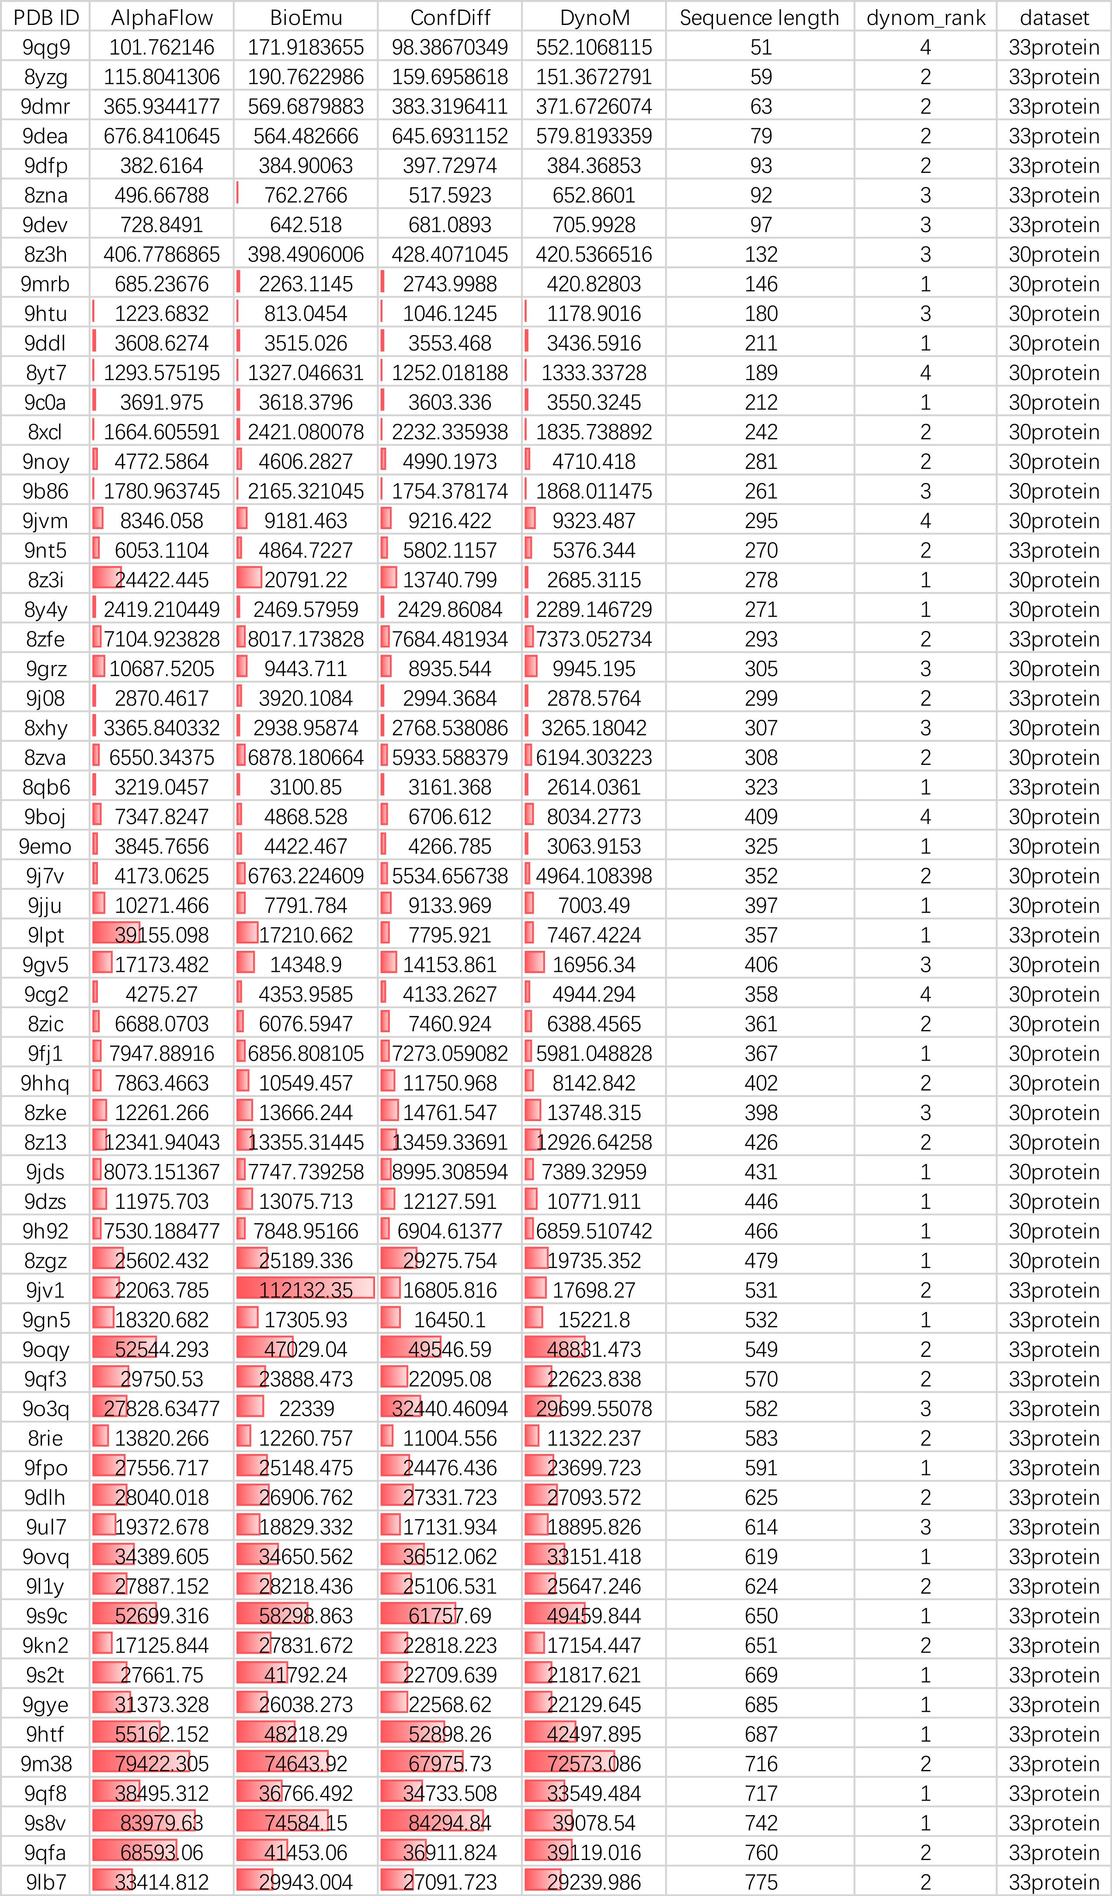

Supplementary Table 15: PDB ID of multi-state proteins collected from BioEmu and PathPre datasets
PDB ID (State 1) | PDB ID (State 2) | Classification | Data From
2WG5F | / | Local structural changes | BioEmu
3UDCA | / | Local structural changes | BioEmu
2ALJ | 1YR1 | Local structural changes | PathPre
3DRF | 3DRJ | Apo-holo transitions | PathPre
6MF4 | 6MF5 | Apo-holo transitions | PathPre
4P6V | 7XK6 | Apo-holo transitions | PathPre
2K9N | 2KDZ | Apo-holo transitions | PathPre
4N3Y | 4N3Z | Rigid-body domain movements | PathPre
6YAE | 2XA7 | Rigid-body domain movements | PathPre
7STE | 8DQX | Rigid-body domain movements | PathPre
1Y5O | 2N23 | Fold-unfold transitions | PathPre

Supplementary Table 16: The RMSD and DockQ metrics between the DynoM and AlphaFold3 on 20 antigen-antibody complexes( each complex contains 100 ensembles).
See the Supplementary_table_16.csv

Supplementary Table 17: Model hyperparameter settings during training
Training stage | Pretrain | Finetune
Batch size | 8 | 8
Gradient Accumulation Steps | 4 | 4
Optimizer | Adam(weight decay = 0.0) | Adam(weight decay = 0.0)
Learning Rate | 3e-4 | 3e-4
Learning Rate Scheduler | ReduceLROnPlateau  (factor = 0.5 ) | ReduceLROnPlateau  (factor = 0.5 )
Warm up steps | 5000 | 5000
GPU type | A100 | A100
Number of GPUs | 8 | 8

Supplementary Figures

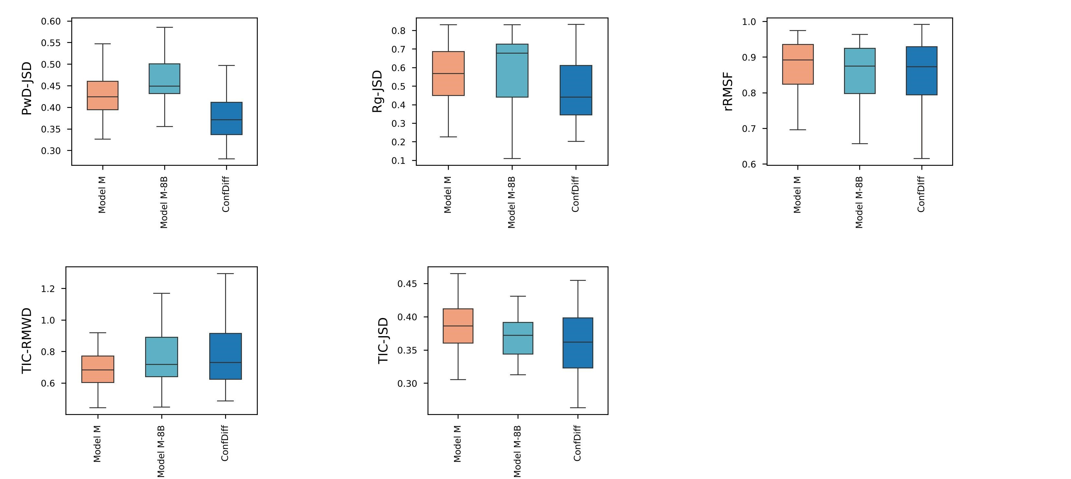
Supplementary Figure 1. The boxplots of PwD-JSD, R_{g}-JSD, rRMSF, TIC-RMWD, and TIC-JSD between the generated and the reference MD ensembles for three models: model M, model M-8B, and ConfDiff.The model M-8B is configured with 8 diffusion blocks and was trained on the monomers, while all other training hyperparameters remained identical to those of model M.

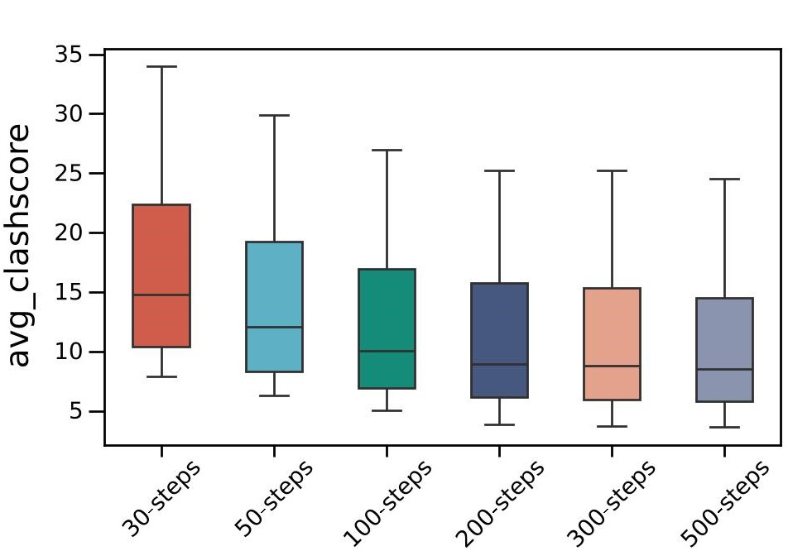
Supplementary Figure 2. Boxplots of mean clash scores for protein conformations sampled by the DynoM model across varying diffusion steps (30, 50, 100, 200, 300, and 500).

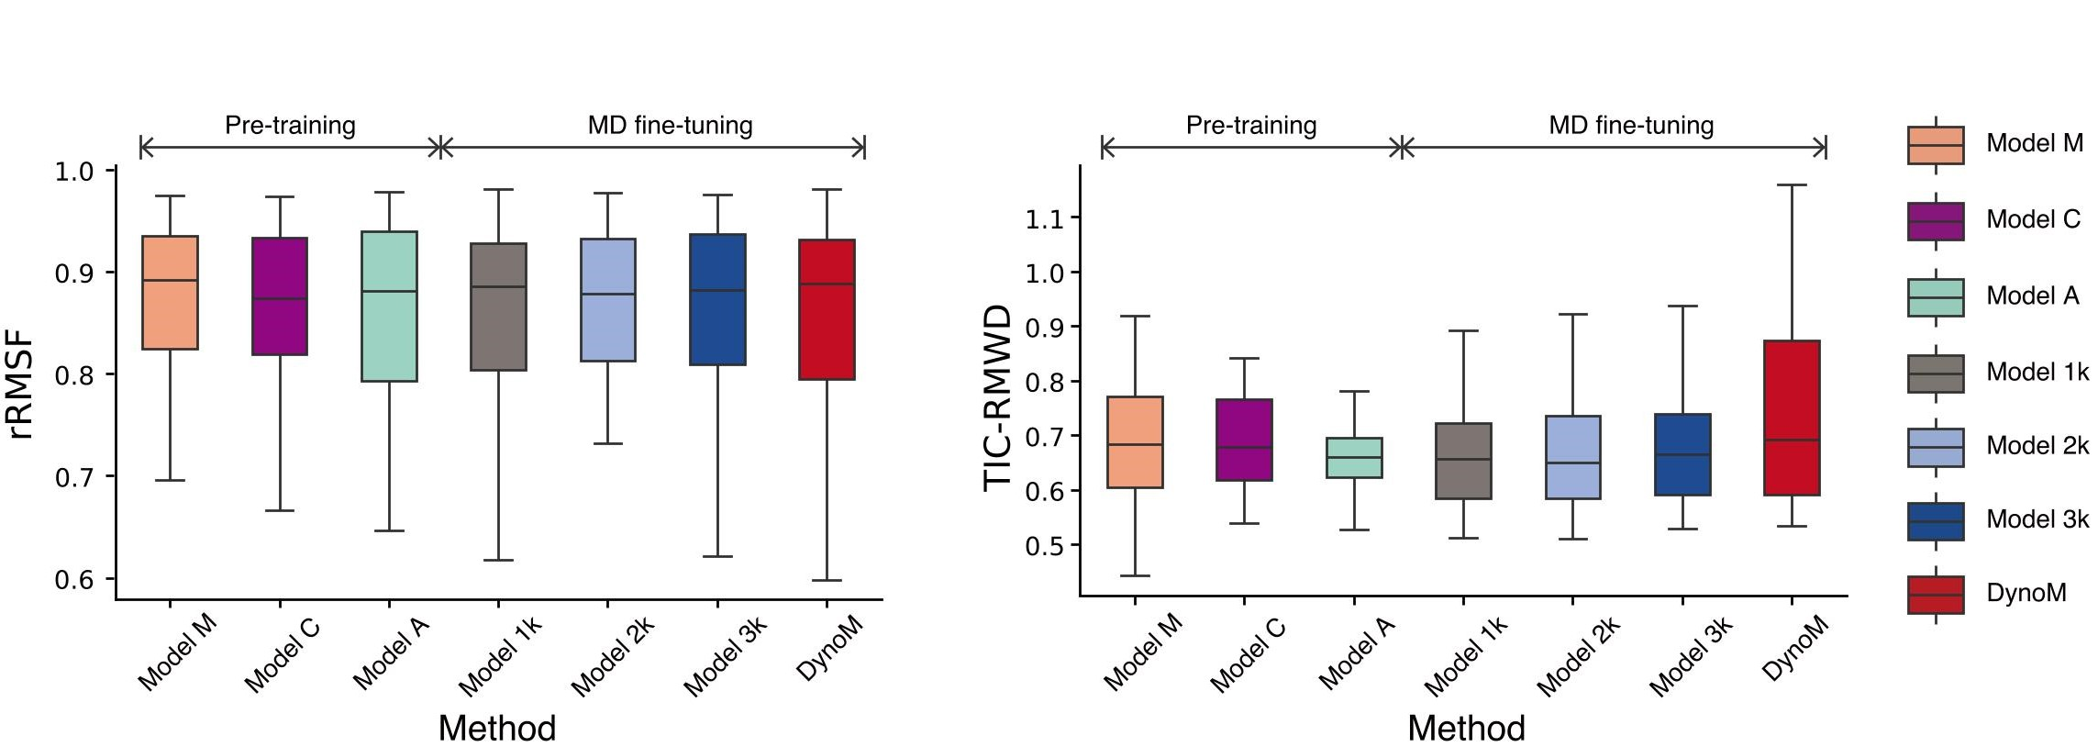
Supplementary Figure 3. Boxplots show the distributions of five evaluation metrics (rRMSF and TIC-RMWD) across the 30 protein test set for the seven evaluated models (Model C, Model M, Model A, Model 1K, Model 2K, Model 3K, and DynoM)

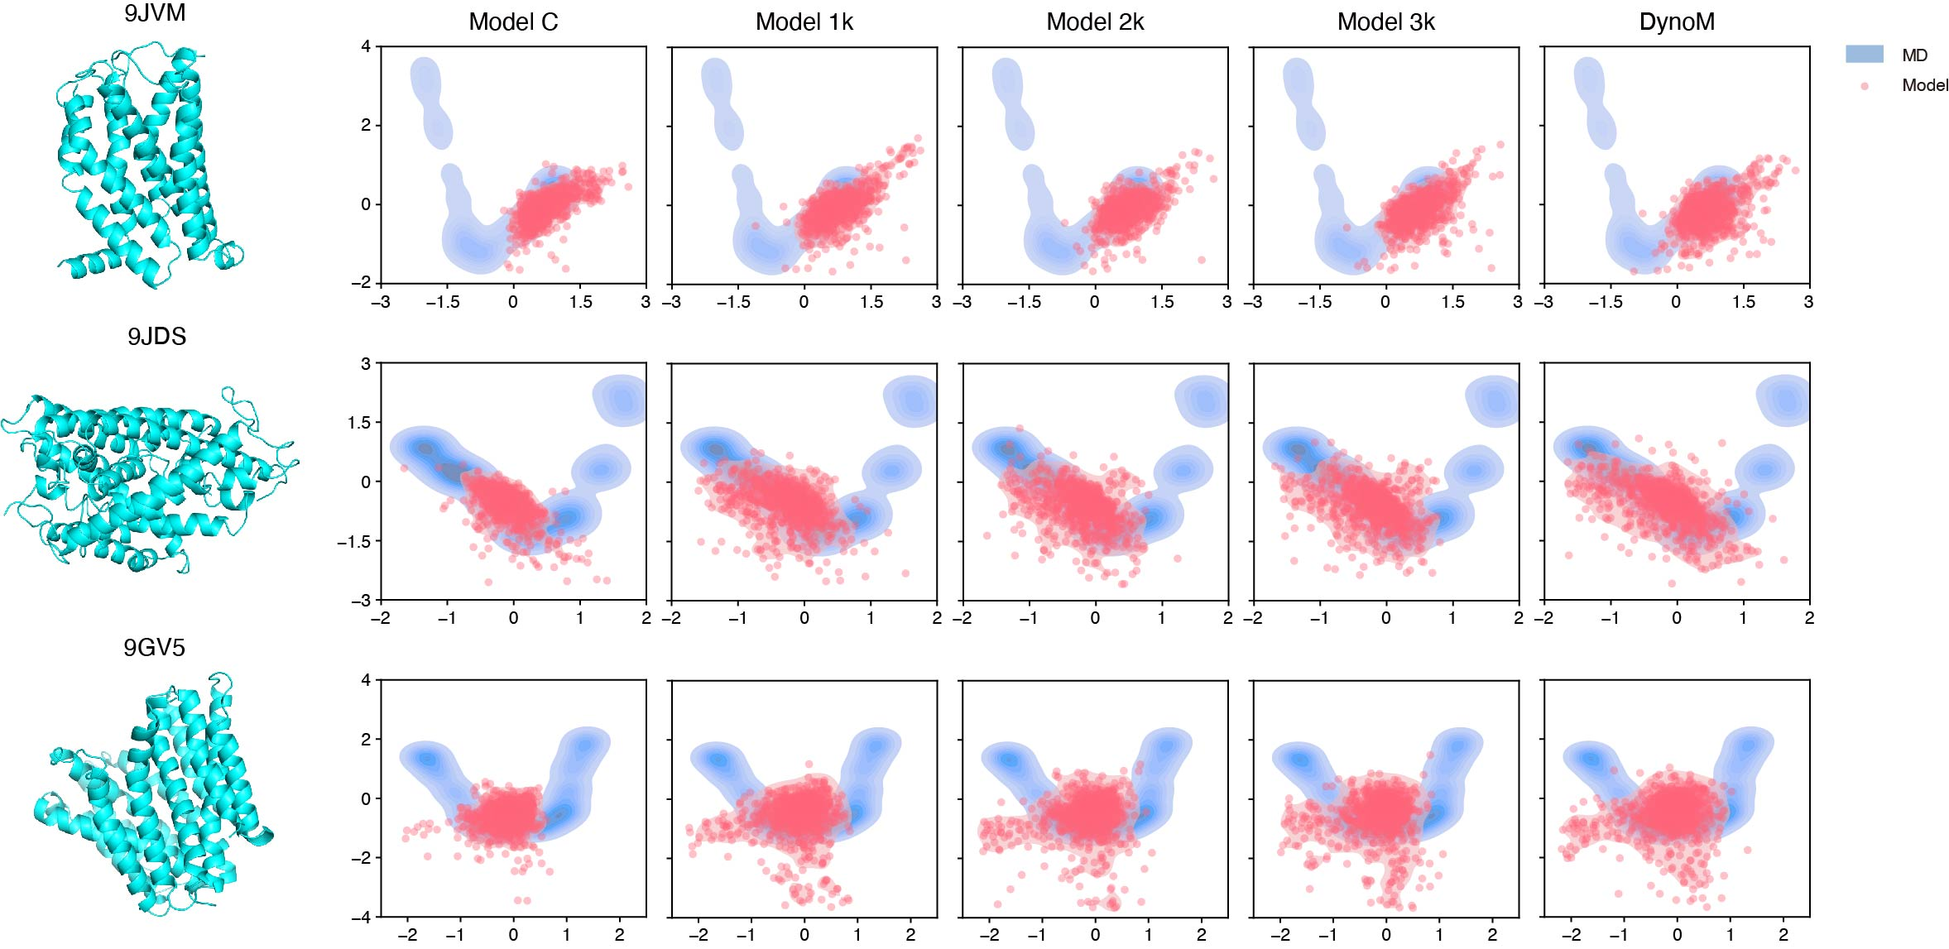
Supplementary Figure 4. The conformations generated by MD and models with various amounts of fine-tuning data were projected onto the first two time-lagged independent components for three protein cases (PDB ID: 9JVM, 9JDS and 9GV5). The blue contours represent the reference MD, and the red scatter points and contours represent the predicted conformations.

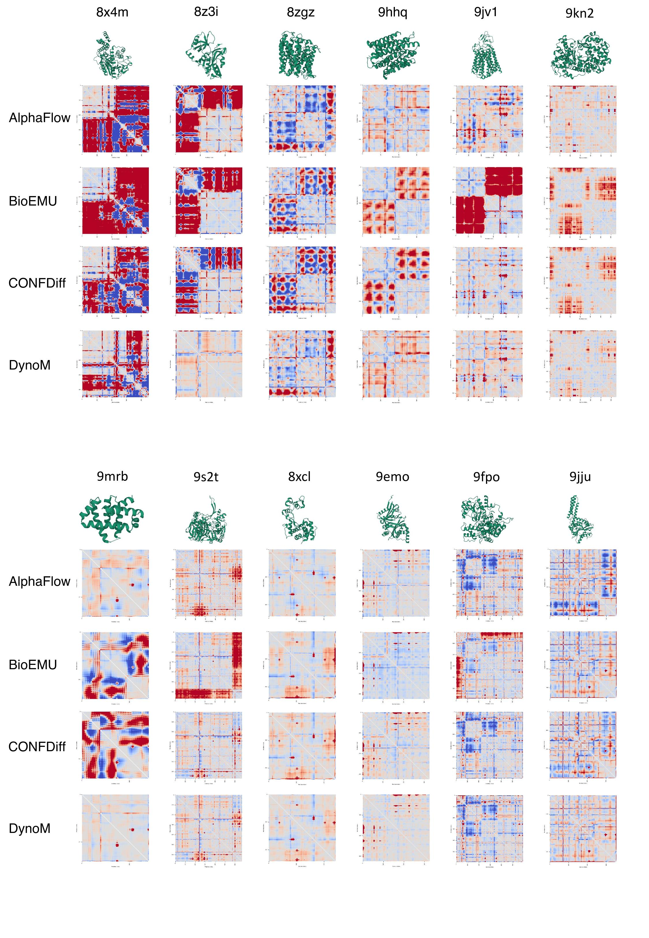
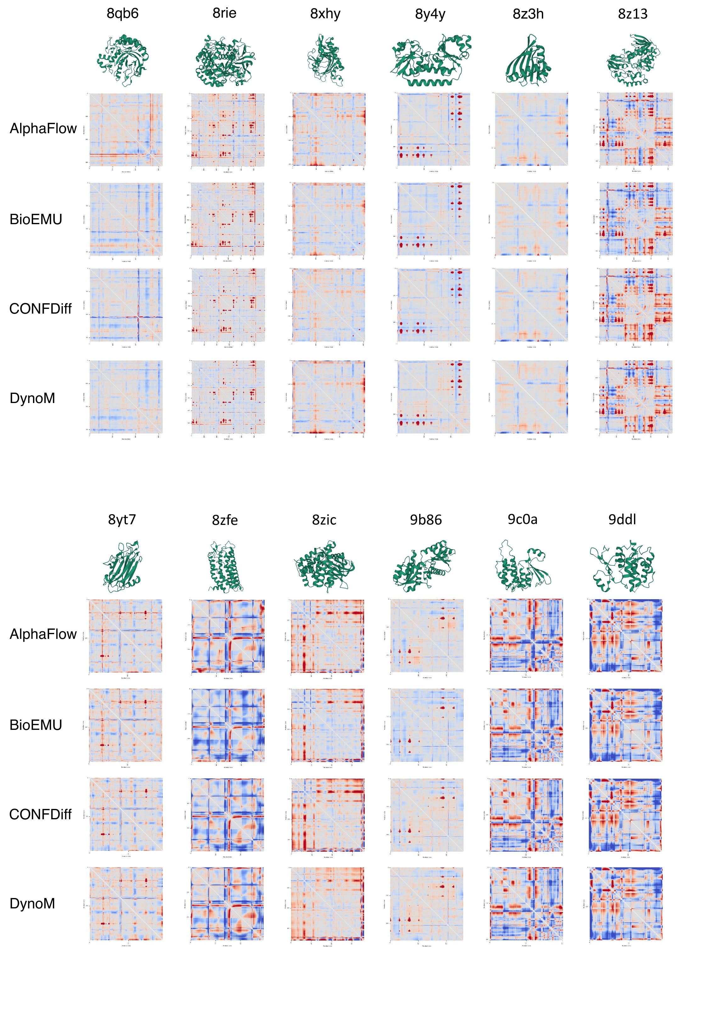
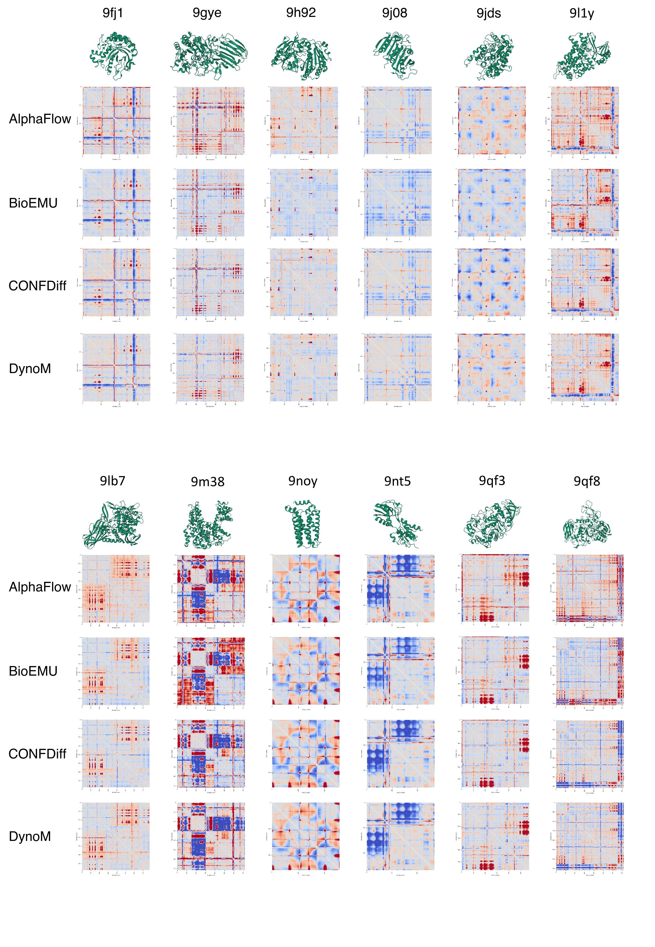
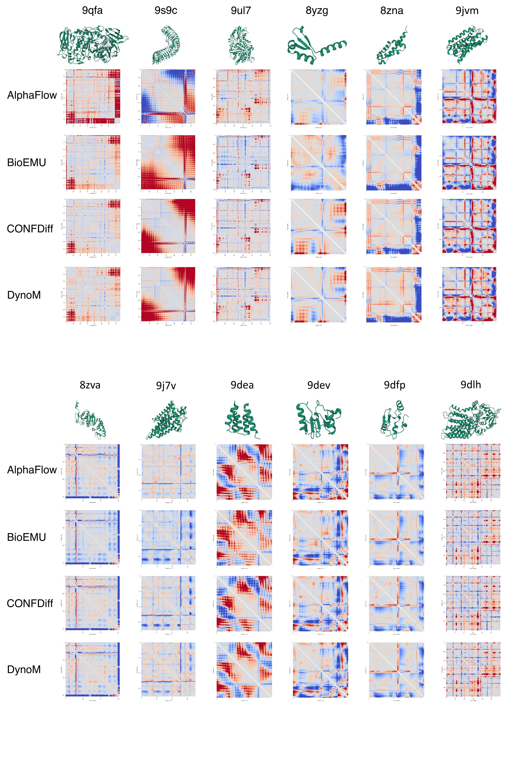
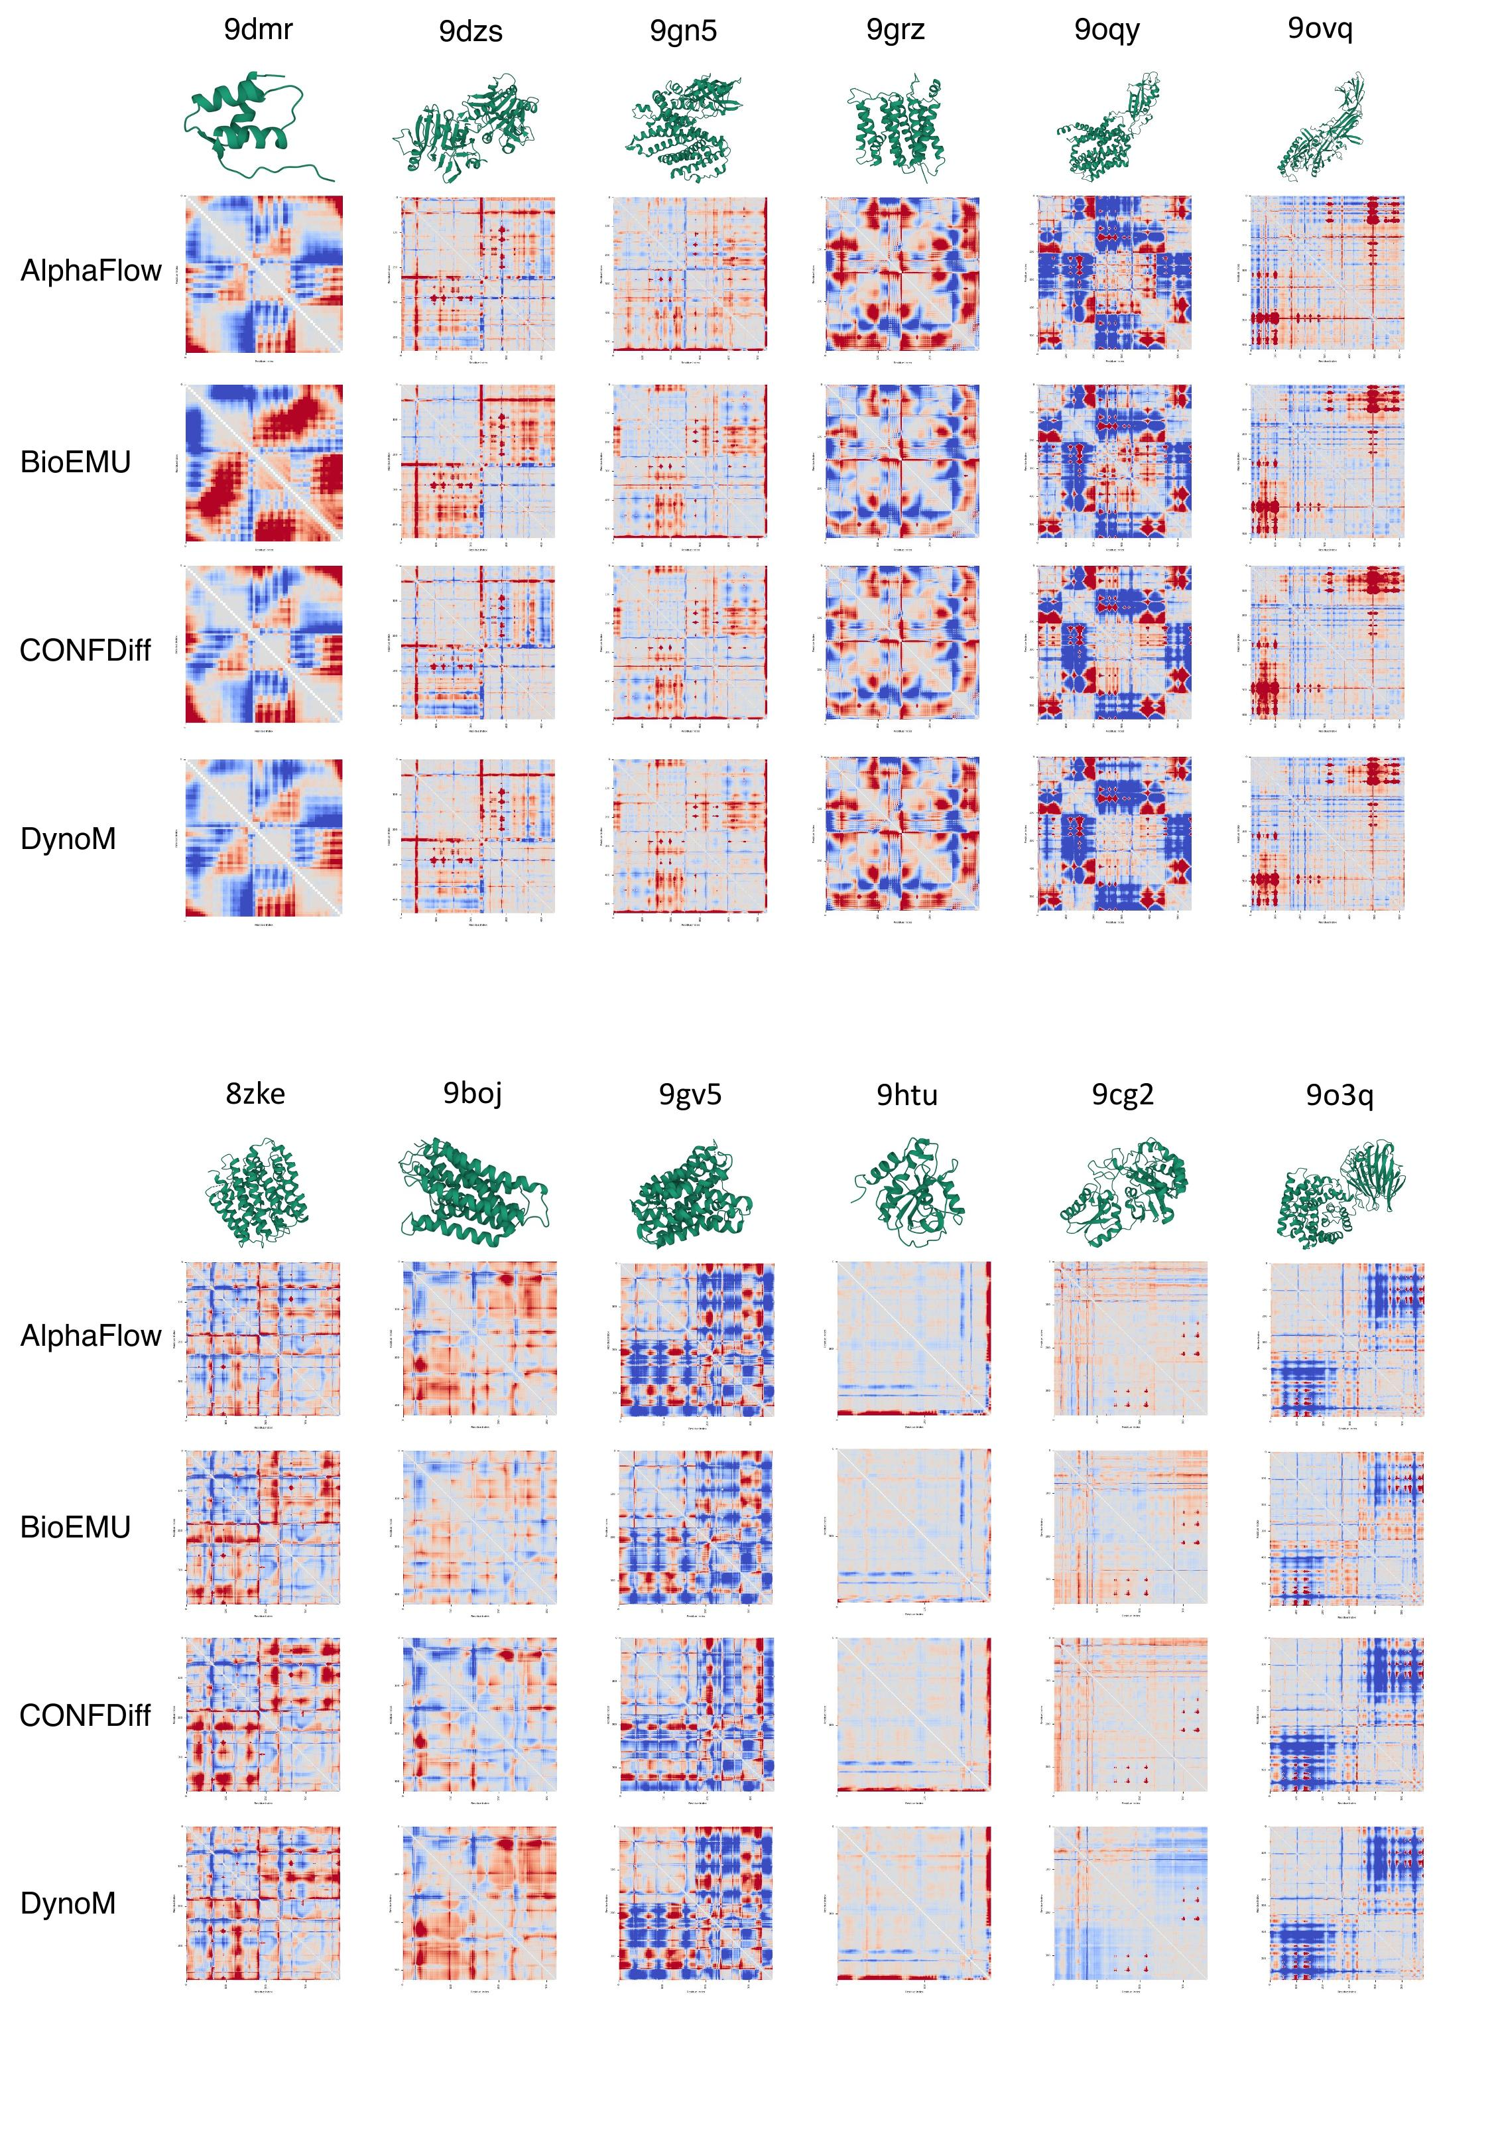
Supplementary Figure 5. The results for the remaining 60 proteins in the test set are shown. The 2D heatmap illustrated the residue-to-residue deviation of average pairwise Cα-Cα distances between the predicted and ground-truth MD ensembles. Red indicates that the distance is overestimated, and blue indicates that the distance is underestimated.
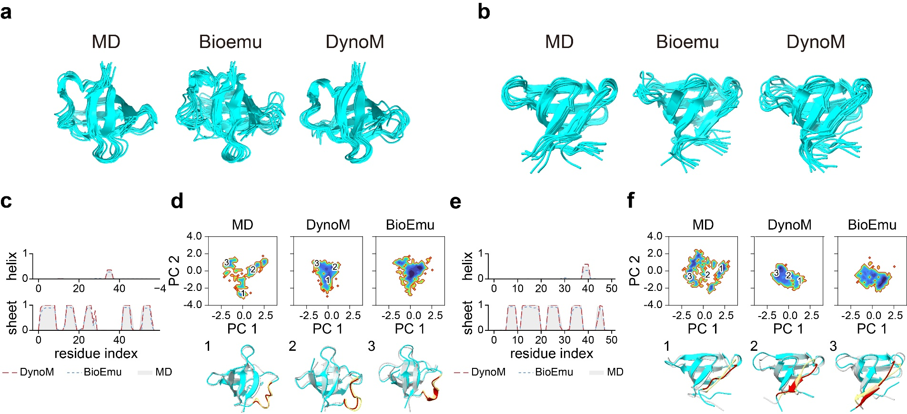
Supplementary Figure 6. a-b, Conformation ensembles generated by MD, BioEmu, and DynoM on the two protein cases (PDB ID: 2WG5F and 3UDCA) with local structural changes. c&e, Frequency distribution of secondary structures ($α$-helix and $β$-sheet) for each residue in a set of 1000 conformations generated by the reference MD (gray), BioEmu(blue curve), and DynoM (red curve), separately. d&f, Free energy surfaces (in kcal/mol) of ground truth MD, DynoM, and BioEmu in the space of the first two principal components. Three representative conformations were selected and labeled as 1-3. Gray and yellow represent the conformations of MD; light blue and red represent the conformations generated by DynoM.

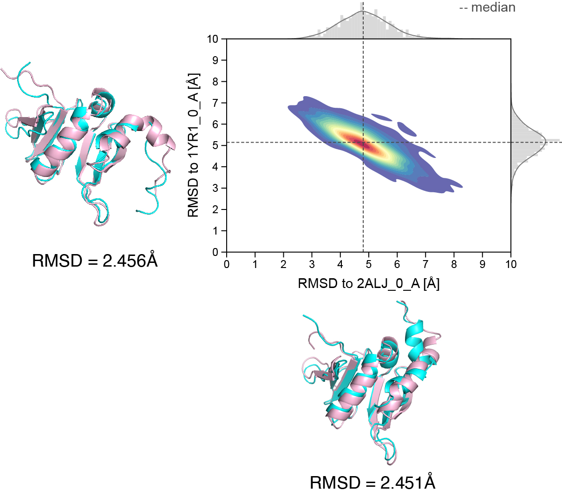
Supplementary Figure 7. Performance of DynoM in sampling local structural conformational changes (PDB ID: 2ALJ and 1YR1). The density 2D plots illustrate the distribution of the generated ensemble relative to two distinct reference structures (RMSD on x- and y-axes).

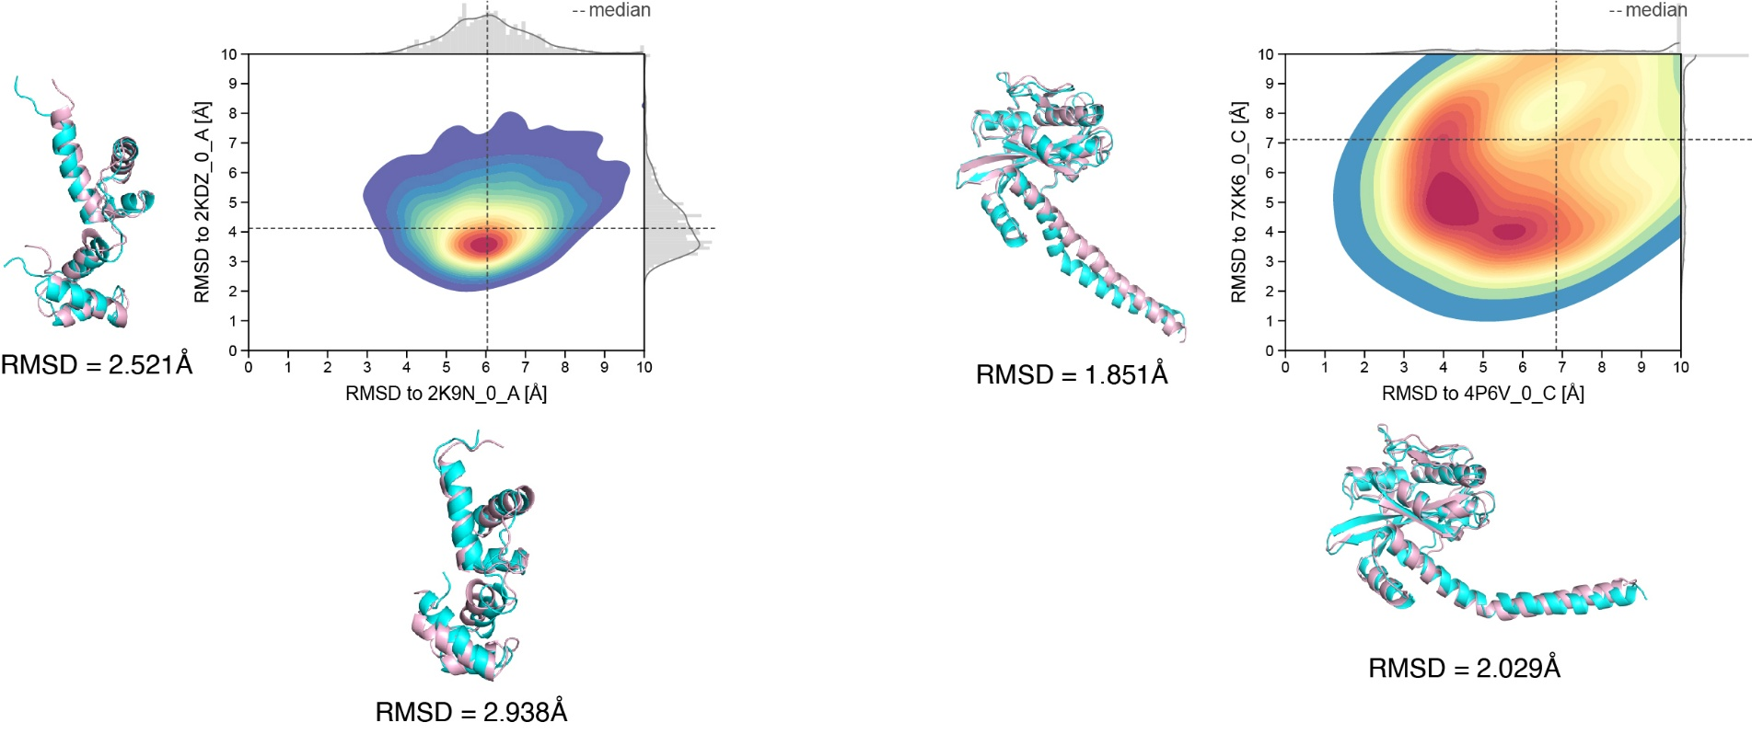
Supplementary Figure 8. Performance of DynoM in sampling apo-holo conformational transitions(PDB ID: 2K9N and 2KDZ, 4P6V and 7XK6). The density 2D plots illustrate the distribution of the generated ensemble relative to two distinct reference structures (RMSD on x- and y-axes).

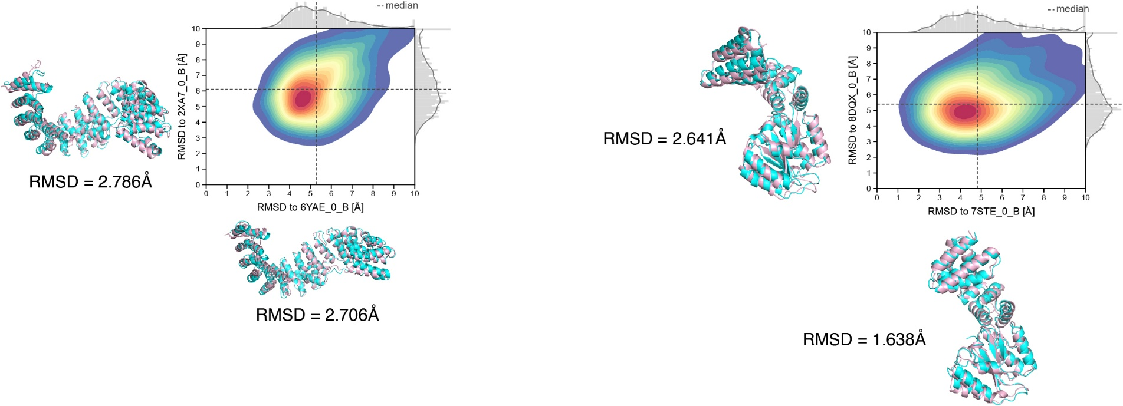
Supplementary Figure 9. Performance of DynoM in sampling rigid-body domain conformational motions (PDB ID: 6YAE and 2XA7, 7STE and 8DQX). The density 2D plots illustrate the distribution of the generated ensemble relative to two distinct reference structures (RMSD on x- and y-axes).

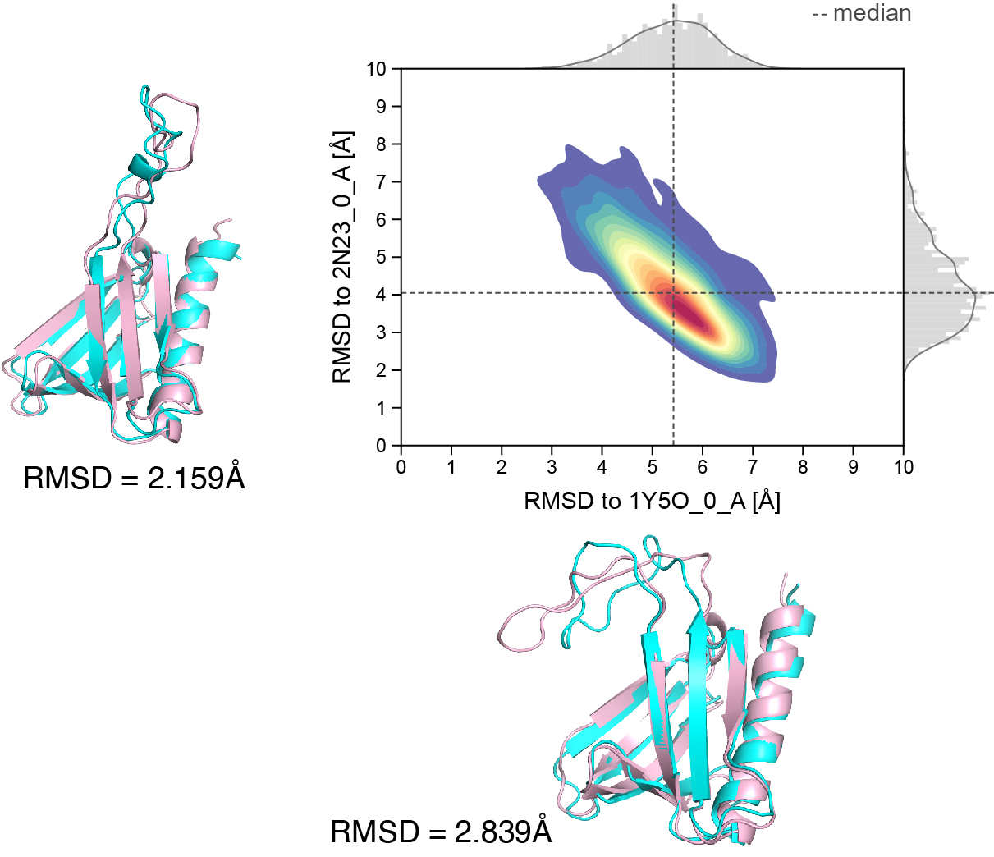
Supplementary Figure 10. Performance of DynoM in sampling folding-unfolding conformational transitions(PDB ID: 1Y5O and 2N23). The density 2D plots illustrate the distribution of the generated ensemble relative to two distinct reference structures (RMSD on x- and y-axes).

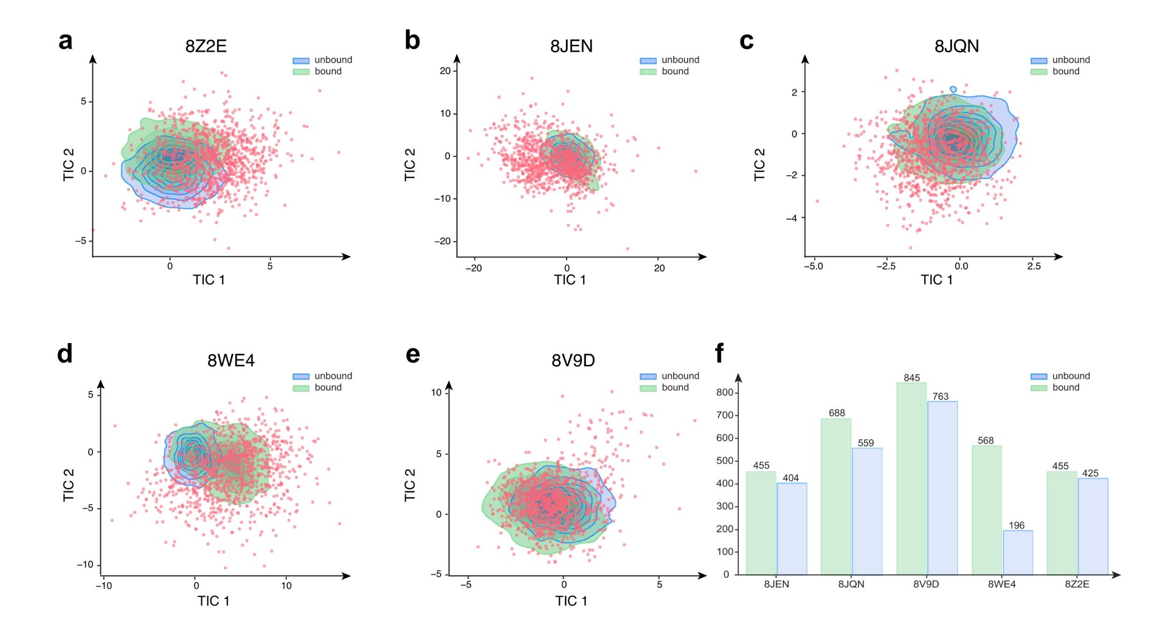
Supplementary Figure 11. a-e. The conformational landscape of five antibody-antigen complexes in TICA space. Each subplot shows the dimensionality reduction result of a specific complex (PDB ID: 8Z2E, 8JEN, 8JQN, 8WE4, 8V9D) based on the backbone dihedral angles (lag time = 900). The blue and green regions represent the conformational distribution density of the antigen in unbound and bound states, respectively, simulated by MD over 100 ns; the red scatter plots represent 1,000 conformations of the antigen predicted by DynoM. f. Number of the generated conformations falling within the bound and unbound MD regions in the TICA conformational space.

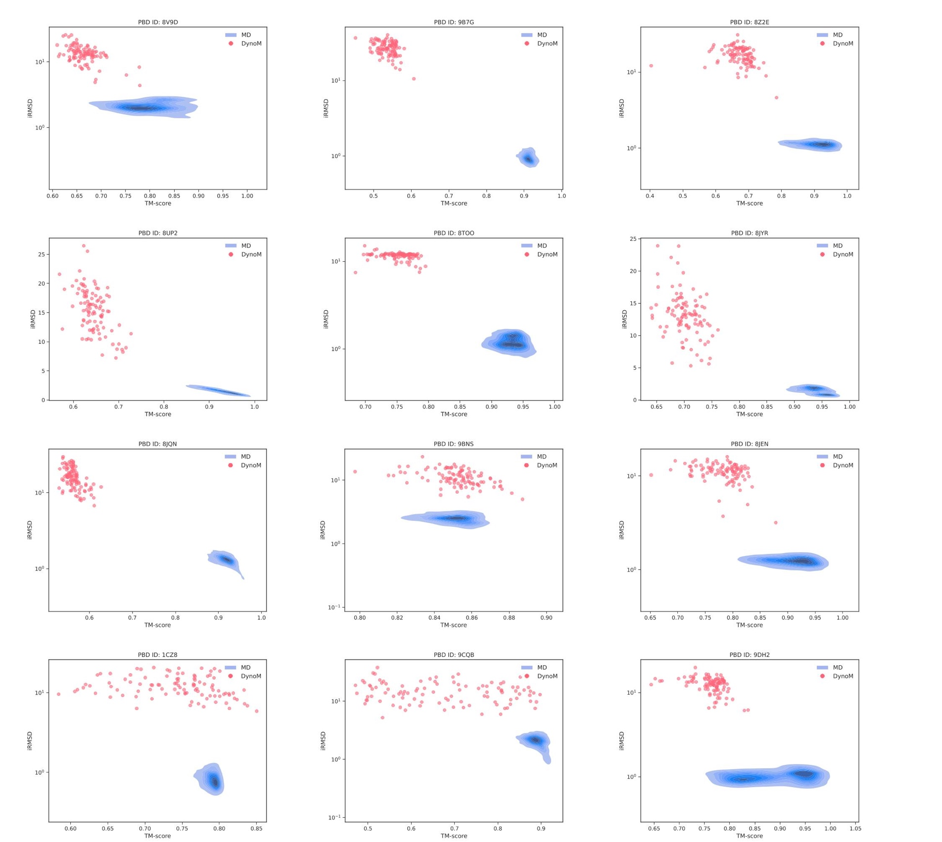
Supplementary Figure 12. Comparing the predicted ensembles of DynoM and the reference MD and their TM score-iRMSD distributions (PDB ID: 8V9D, 9B7G, 8Z2E, 8UP2, 8TOO, 8JYR, 8JQN, 9BNS, 8JEN, 1CZ8, 9CQB, 9DH2).

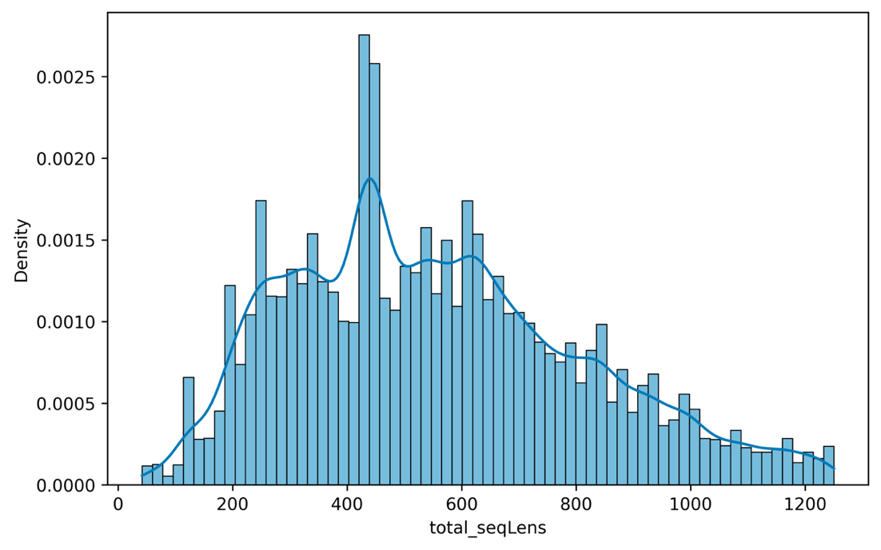
Supplementary Figure 13. Histogram of protein length distribution in the complex training set.

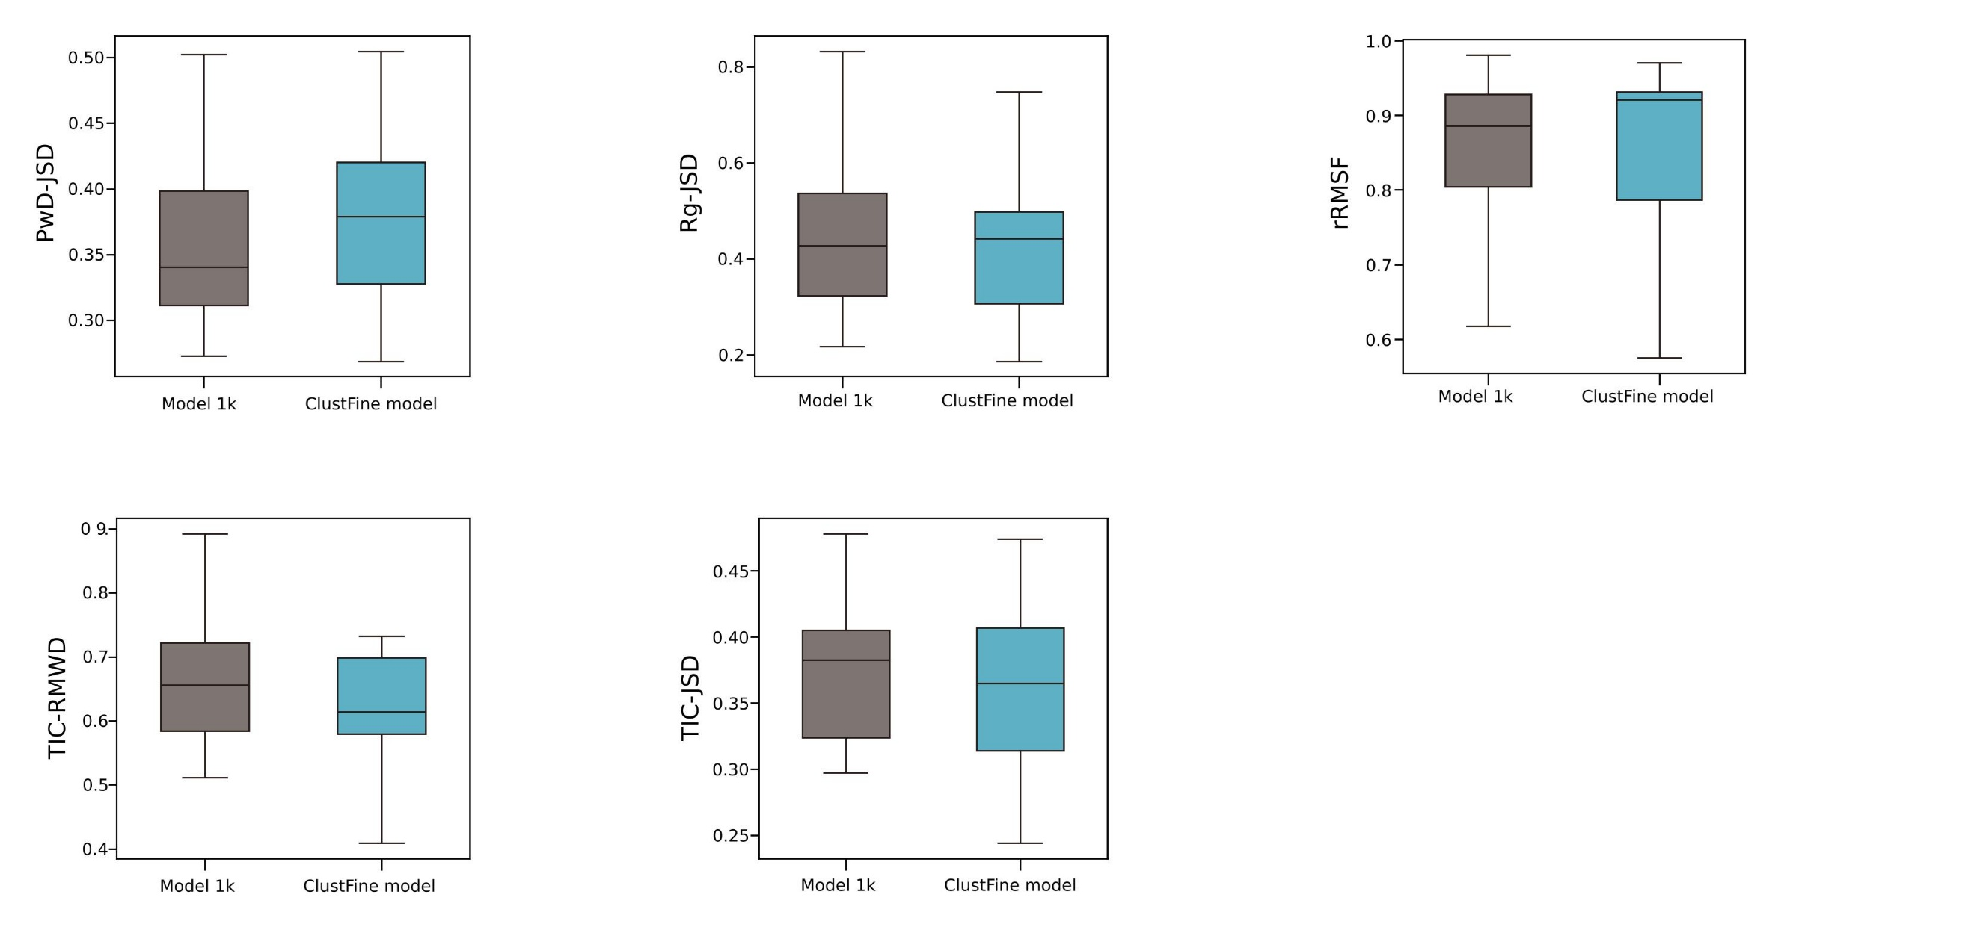
Supplementary Figure 14. Comparative analysis of ensemble accuracy and the ClustFine training strategy. Boxplots of TIC-JSD, PwD-JSD, R_{g}-JSD, TIC-RMWD, and rRMSF, comparing generated samples against reference MD trajectories for the 1k and the ClustFine models. To finetune the ClustFine model, we employ an RMSD-based clustering strategy. Specifically, MD trajectories are clustered into discrete bins at 0.1Å intervals based on their RMSD relative to the reference structure. During each training epoch, a batch of n clusters is randomly selected (n = batch size), and a single frame is sampled from each bin to supervise the training process. All other training hyperparameters remained identical to those used for the model 1k.

