Appendix 1. Unfiltered process map at 100% activity and path threshold, displaying all observed transitions between care events (spaghetti map)
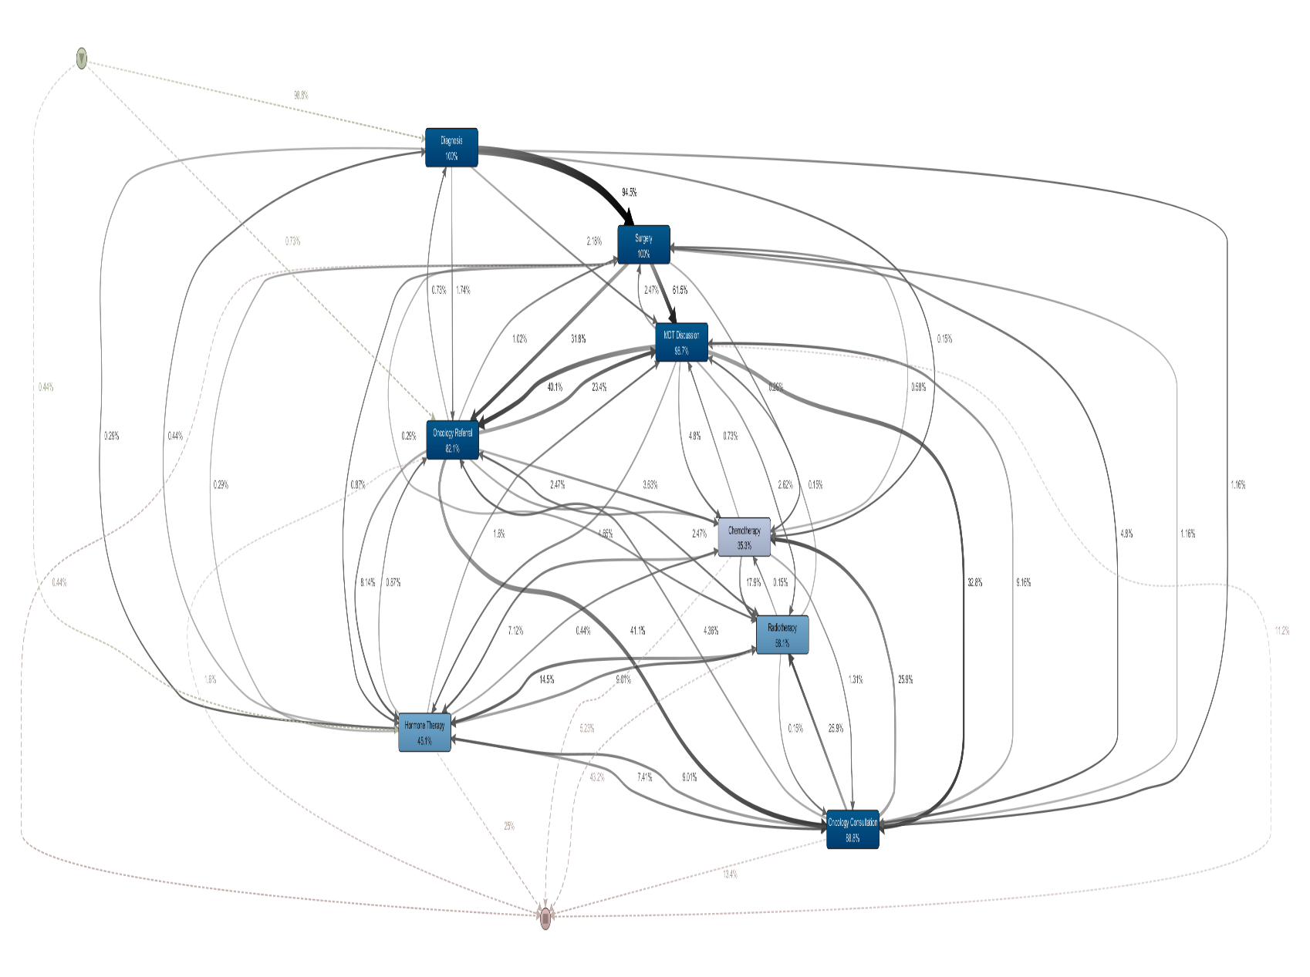

Appendix 2. Distribution of coordination patterns by hospital
Coordination pattern | Wollongong Hospital (n=535) | Shoalhaven Hospital (n=153) | Total (n=688)
MDT before referral | 185 (34.6%) | 75 (49.0%) | 260 (37.8%)
Referral-led | 197 (36.8%) | 27 (17.6%) | 224 (32.6%)
MDT-only | 83 (15.5%) | 39 (25.5%) | 122 (17.7%)
Same-day MDT and referral | 63 (11.8%) | 10 (6.5%) | 73 (10.6%)
Referral-only | 6 (1.1%) | 2 (1.3%) | 8 (1.2%)
No recorded coordination | 1 (0.2%) | 0 (0.0%) | 1 (0.1%)
Total | 535 (100.0%) | 153 (100.0%) | 688 (100.0%)
χ² = 30.1, df = 5, p < 0.001
Note: Percentages are column percentages within hospital. Cases with same-day MDT discussion and oncology referral are displayed separately to indicate the extent of timestamp-ordering ambiguity, but were classified as MDT-led in the primary regression model.
Appendix 3. Sensitivity analyses for coordination pattern classification
Sensitivity model | N | Shoalhaven OR | 95% CI | p
Primary Model B (same-day → MDT-led) | 547 | 2.54 | 1.56–4.05 | <0.001
Sensitivity 1: same-day → Referral-led | 547 | 2.91 | 1.86–4.55 | <0.001
Sensitivity 2: same-day excluded entirely | 474 | 3.00 | 1.83–4.94 | <0.001
Sensitivity 3: MDT-dominated (incl. MDT-only) vs Referral-dominated | 668 | 2.63 | 1.68–4.14 | <0.001
Sensitivity 4: hormone therapy events removed from event log* | 547 | 2.54 | 1.56–4.05 | <0.001
Note: All models were adjusted for molecular subtype, TNM stage, histological grade, age group, and treating hospital, with Wollongong Hospital as the reference category. Models used complete-case data, so patients with missing or non-applicable histological grade or unknown molecular subtype were excluded. The primary Model B sample was n=547, compared with n=557 in the descriptive MDT-led/Referral-led cohort. Removal of hormone therapy events assessed whether incomplete hormone therapy dates affected reconstructed pathway classification and did not materially change the MDT-led vs Referral-led model.

Appendix 4. Outcome distribution by covariate for Models A and B
Appendix 4A. Covariate distribution by pre-treatment oncology consultation
Covariate stratum | N | Pre-treatment oncology consultation: YES | Pre-treatment oncology consultation: NO
Molecular subtype
Luminal | 407 | 322 (79.1%) | 85 (20.9%)
HER2-positive | 69 | 60 (87.0%) | 9 (13.0%)
Triple negative | 53 | 50 (94.3%) | 3 (5.7%)
TNM stage
I | 225 | 186 (82.7%) | 39 (17.3%)
II | 234 | 189 (80.8%) | 45 (19.2%)
III–IV | 78 | 63 (80.8%) | 15 (19.2%)
Histological grade
1 | 87 | 65 (74.7%) | 22 (25.3%)
2 | 244 | 188 (77.0%) | 56 (23.0%)
3 | 200 | 179 (89.5%) | 21 (10.5%)
Age group
<65 | 288 | 241 (83.7%) | 47 (16.3%)
≥65 | 249 | 197 (79.1%) | 52 (20.9%)
Hospital
Wollongong | 421 | 337 (80.0%) | 84 (20.0%)
Shoalhaven | 116 | 101 (87.1%) | 15 (12.9%)
Note: This table describes the descriptive sample for Model A, defined as patients with a recorded first treatment initiation date and sufficient information to determine whether oncology consultation occurred before or on that date (N=537). The complete-case regression sample used in Figure 3 Model A was n=529 after excluding patients with incomplete covariate information. Patients with unknown molecular subtype (n=8) and missing or non-applicable histological grade (n=6) were included in the overall cohort total but omitted from the corresponding stratified rows because of small cell counts. Percentages are calculated within each covariate stratum.
Appendix 4B. Covariate distribution by coordination pattern
Covariate stratum | N | MDT-led | Referral-led
Molecular subtype
Luminal | 441 | 263 (59.6%) | 178 (40.4%)
HER2-positive | 53 | 34 (64.2%) | 19 (35.8%)
Triple negative | 56 | 31 (55.4%) | 25 (44.6%)
TNM stage
I | 246 | 138 (56.1%) | 108 (43.9%)
II | 232 | 147 (63.4%) | 85 (36.6%)
III–IV | 79 | 48 (60.8%) | 31 (39.2%)
Histological grade
1 | 105 | 62 (59.0%) | 43 (41.0%)
2 | 256 | 151 (59.0%) | 105 (41.0%)
3 | 190 | 115 (60.5%) | 75 (39.5%)
Age group
<65 | 283 | 173 (61.1%) | 110 (38.9%)
≥65 | 274 | 160 (58.4%) | 114 (41.6%)
Hospital
Wollongong | 445 | 248 (55.7%) | 197 (44.3%)
Shoalhaven | 112 | 85 (75.9%) | 27 (24.1%)
Note: This table describes the MDT-led and Referral-led cohort (N=557). The complete-case sample used in the multivariable Model B was n=547. Patients with unknown molecular subtype (n=7) and missing or non-applicable histological grade (n=6) were included in the overall cohort total but omitted from the corresponding stratified rows because of small cell counts. Percentages are calculated within each covariate stratum.

