Identification of Benzothiazole‒Rhodanine Derivatives as α-Amylase and α-Glucosidase Inhibitors: Design, Synthesis, In-silico and In-Vitro Analysis
Mahendra Gowdru Srinivasa¹, Natasha Naval Aggarwal¹, Banylla Felicity Dkhar Gatphoh¹, Madan Kumar S², Kannika B. R.², Pujar G.V.³, Sheshagiri Dixit³, Subhankar P. Mandal³, Prashantha Kumar B.R.³, Pukar Khanal⁴, Revanasiddappa B.C.¹*

*Department of Pharmaceutical Chemistry, NGSM Institute of Pharmaceutical Sciences (NGSMIPS), Nitte (Deemed to be University), Mangalore-575018, (Karnataka) India
Email: revan@nitte.edu.in
² IOE, Vijnana Bhavan, University of Mysore, Mysuru, 570006, Karnataka, India
³Department of Pharmaceutical Chemistry, JSS College of Pharmacy, JSS Academy of Higher Education and Research, Mysuru-570015, Karnataka, India.
⁴Department of Pharmacology and Toxicology, KLE College of Pharmacy Belagavi, KLE
Academy of Higher Education and Research (KAHER), Belagavi-590010, India

Analytical Supplymentry Data:
(Z)-3-(benzo[d]thiazol-2-yl)-5-(4-nitrobenzylidene)-2 thioxothiazolidin-4-ones (A1): Yellow solid. Yield: 67%, melting point (MP). 233-35°C, FT-IR (cm-¹): 3065 (Ar,C-H), 1700 (C=O), 1611 (C=N), 1531(C=C). ¹H-NMR (400 MHz, DMSO-d₆, δ, ppm): 7.228-7.963 (m, Ar, 8H), 8.03(s, =CH, 1H). ¹³CNMR (400MHz, DMSOd₆, δ, ppm): 113.42, 115.97, 118.13, 118.23, 122.05, 125.23, 126.23, 127.34, 140.01, 143.82, 145.78, 154.01, 155.89, 157.78, 162.71, 176.10 and 202.24. HR-MS (m/z): calculated for C₁₇H₉N₃O₃S₃ is 398.98; found: 398.9896 (M+).

(Z)-3-(benzo[d]thiazol-2-yl)-5-(4-bromobenzylidene)-2-thioxothiazolidin-4-one (A2): Yellow solid. Yield 72%, MP. 245-47°C, FT-IR (cm-¹): 3048 (Ar, C-H), 1725 (C=O), 1655 (C=N), 1593 (C=C). ¹H-NMR (400 MHz, DMSO-d₆, δ, ppm): 6.98-7.51 (m, Ar, 8H), 7.61 (s, =CH, 1H). ¹³C-NMR (400MHz, DMSO-d₆, δ, ppm): 111.16, 115.84, 116.53, 120.50, 121.56, 121.85, 123.00, 125.39, 126.47, 129.10, 131.24, 131.60, 131.79, 148.47, 154.10, 164.00 and 192.02. HR-MS (m/z): calculated for C₁₇H₉BrN₂OS₃ is 433.91; found: 433.9170(M+).

(Z)-3-(benzo[d]thiazol-2-yl)-5-(4-chlorobenzylidene)-2-thioxothiazolidin-4-one (A3): Yellow solid. Yield 69%, MP. 273-75°C, FT-IR (cm-¹): 3048 (Ar, C-H), 1655 (C=O), 1593 (C=N), 1516 (C=C). ¹H-NMR (400 MHz, DMSO-d₆, δ, ppm): 6.97 - 7.62 (m, Ar, 8H), 7.6 (s, =CH, 1H). ¹³C-NMR (400MHz, DMSO-d₆, δ, ppm): 115.11, 117.68, 118.11, 119.91, 121.29, 122.38, 122.71, 123.42, 125.87, 126.05, 132.32, 132.41, 142.13, 146.47, 153.52, 179.51 and 196.23. HR-MS (m/z): calculated for C₁₇H₉ClN₂OS₃ is 354.47; found: 354.4713 (M+).

Z)-3-(benzo[d]thiazol-2-yl)-5-benzylidene-2-thioxothiazolidin-4-one (A4): Yellow solid. Yield 65%, MP. 259-61°C; FT-IR (cm-¹): 3010 (Ar, C-H), 1723 (C=O), 1631(C=N), 1531 (C=C). ¹H-NMR (400 MHz, DMSO-d₆, δ, ppm): 6.97 - 7.47 (m, Ar, 8H), 7.63 (s, =CH, 1H). ¹³C-NMR(400MHz,DMSO-d₆,δ,ppm): 116.32, 117.68, 118.11, 119.91, 121.29, 122.38, 122.71, 123.42, 125.87, 126.05, 132.32, 132.41, 142.13, 146.47, 153.52, 169.43 and 196.23. HR-MS (m/z): calculated for C₁₇H₁₀N₂OS₃ is 354.47; found: 354.47 (M+).

(Z)-3-(benzo[d]thiazol-2-yl)-5-(4-hydroxy-3-methoxybenzylidene)-2-thioxothiazolidin-4-one (A5): Yellow solid. Yield 87%, MP. 214-16°C, FT-IR (cm-¹): 3176 (OH), 3064 (Ar, C-H), 1722 (C=O), 1639 (C=N), 1530 (C=C). ¹H-NMR (400 MHz, DMSO-d₆, δ, ppm): 4.20 (s, OCH_{3,} 3H), 6.99 - 7.53 (m, Ar-H, 7H), 7.63 (s, =CH, 1H), 9.98-9.82 (s, OH, 1H). ¹³C-NMR (400MHz, DMSO₆, δ, ppm): 40.09, 114.47, 115.84, 117.96, 121.42, 121.47, 125.98, 130.95, 143.39, 143.84, 148.10, 150.10, 150.24, 150.24, 150.30, 150.79, 151.03 168.54 and 191.54. HR-MS (m/z): calculated: for C₁₉H₁₄N₂O₃S₃ is 400.50; found: 400.5043 (M+).

(Z)-3-(benzo[d]thiazol-2-yl)-5-(3,4-dimethoxybenzylidene)-2-thioxothiazolidin-4-one (A6): Yellow solid. Yield 74%, MP. 227-29°C, FT-IR (cm-¹): 3274 (OH), 3007 (Ar, C-H), 1726 (C=O), 1641 (C=N), 1460 (C=C). ¹H-NMR (400 MHz, DMSO-d₆, δ, ppm): 3.82 (s, OCH_{3,} 3H), 4.26 (s, OCH_{3,} 3H), 6.97-7.49 (m, Ar-H, 7H), 7.53 (s, =CH, 1H). ¹³C-NMR (400MHz, DMSOd₆, δ, ppm): 55.96, 56.32, 109.92, 111.72, 118.10, 121.30, 121.59, 125.87, 126.54, 130.09, 131.26, 144.92, 149.62, 152.98, 154.64, 166.96, 168.54, 177.92 and 191.80.HR-MS (m/z): calculated for C₁₉H₁₄N₂O₃S₃ is 414.52; found: 414.5277 (M+).
(Z)-3-(benzo[d]thiazol-2-yl)-5-(4-methoxybenzylidene)-2-thioxothiazolidin-4-one (A7):
Yellow solid. Yield 67%, MP. 266-68°C; FT-IR (cm-¹): 3211 (OH), 3014 (Ar, C-H), 1725 (C=O), 1632 (C=N), 1531 (C=C). ¹H-NMR (400 MHz, DMSO-d₆, δ, ppm): 3.85 (s, OCH_{3,} 3H), 6.99 - 7.21 (m, Ar-H, 8H), 7.31 (s, =CH, 1H). ¹³C-NMR (400MHz, DMSO-d₆, δ, ppm): 56.12, 113.82, 114.94, 115.02, 118.14, 121.25, 121.28, 125.86, 130.10, 131.32, 132.24, 148.21, 153.16, 164.66, 166.89, 168.55, 179.92 and 191.71. HR-MS (m/z): calculated for C₁₈H₁₂N₂O₂S₃ is 384.50; found: 384.5043 (M+).

(Z)-3-(benzo[d]thiazol-2-yl)-5-(4-(dimethylamino)benzylidene)-2-thioxothiazolidin-4-one (A8): Yellow solid. Yield 56%, MP. 235-37°C; FT-IR (cm-¹): 2912 (Ar, C-H), 1725 (C=O), 1649 (C=N), 1529 (C=C). ¹H-NMR (400 MHz, DMSO-d₆, δ, ppm): 3.01 (s, 2 x CH₃, 6H), 6.77 - 7.64 (m, Ar-H, 8H), 7.66 (s, =CH, 1H). ¹³C-NMR (400MHz, DMSO-d₆, δ, ppm): 40.33, 40.53, 111.49, 118.11, 121.30, 124.95, 125.87, 131.26, 131.98, 132.24, 139.12, 140.21, 141.12, 152.99, 154.64, 154.86, 166.95, 168.53 and 190.30. HR-MS (m/z): calculated for C₁₉H₁₅N₂OS₃ is 397.54; found: 397.5439 (M+).
(Z)-3-(benzo[d]thiazol-2-yl)-5-(3,4-dichlorobenzylidene)-2-thioxothiazolidin-4-one (A9): Yellow solid. Yield 79%, MP. 217-19°C, FT-IR (cm-¹): 3194 (-OH), 2996 (Ar, C-H), 1725 (C=O), 1640 (C=N), 1532 (C=C). ¹H-NMR (400 MHz, DMSO-d₆, δ, ppm): 6.99 - 7.64 (m, Ar-H, 8H), 7.66 (s, =CH, 1H), 9.78 (s, OH, 1H). ¹³C-NMR (400MHz, DMSO-d₆, δ, ppm): 114.52, 116.29, 117.86, 121.47, 121.53, 126.01, 130.77, 122.51, 130.77, 132.51, 150.14, 151.21, 154.38, 155.78, 156.15, 167.10, 168.52, 169.93 and 191.36. HR-MS (m/z): 369.96 (M+1 found) and calculated: 369.9819 (M+).
(Z)-3-(benzo[d]thiazol-2-yl)-5-(2-hydroxybenzylidene)-2-thioxothiazolidin-4-one (A10):
Yellow solid, Yield 52%, MP. 192-94°C; FT-IR (cm-¹): 3293 (OH), 3064 (Ar, C-H), 1725 (C=O), 1639 (C=N), 1529 (C=C). ¹H-NMR (400 MHz, DMSO-d₆, δ, ppm): 6.94 - 7.49 (m, Ar-H, 8H), 7.62 (s, =CH, 1H), 10.26 (s, OH, 1H). ¹³C-NMR (400MHz, DMSO-d₆, δ, ppm): 117.88, 118.11, 119.91, 121.29, 122.30, 122.71, 123.42, 125.87, 126.79, 129.70, 131.27, 136.82, 153.02, 161.17, 166.93, 168.53 and 192.31. HR-MS (m/z): 369.96 (M+1 found) and calculated: 369.9178 (M+).

Compound A1 :( Z)-3-(benzo[d]thiazol-2-yl)-5-(4-nitrobenzylidene)-2 thioxothiazolidin-4-one

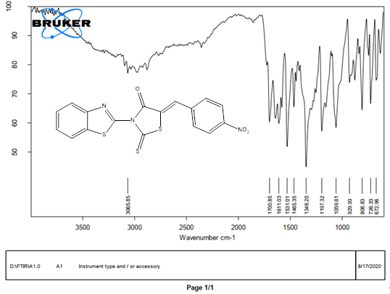
Compound A1 :( Z)-3-(benzo[d]thiazol-2-yl)-5-(4-nitrobenzylidene)-2 thioxothiazolidin-4-one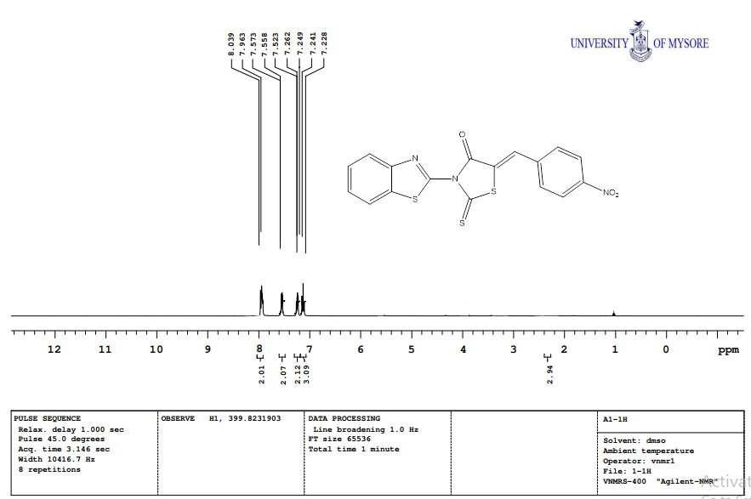

Compound A1 :( Z)-3-(benzo[d]thiazol-2-yl)-5-(4-nitrobenzylidene)-2 thioxothiazolidin-4-one
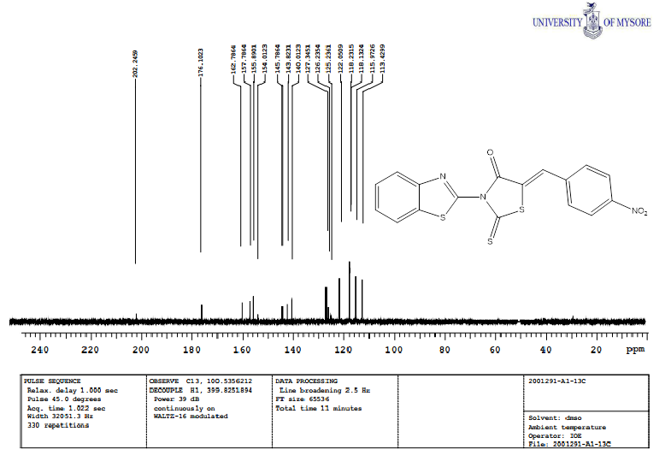
Compound A1 :( Z)-3-(benzo[d]thiazol-2-yl)-5-(4-nitrobenzylidene)-2 thioxothiazolidin-4-one

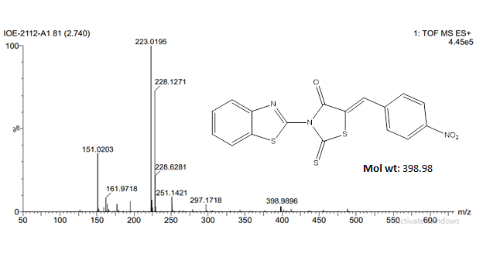

- Compound A2: (Z)-3-(benzo[d]thiazol-2-yl)-5-(4-bromobenzylidene)-2-thioxothiazolidin-4-one

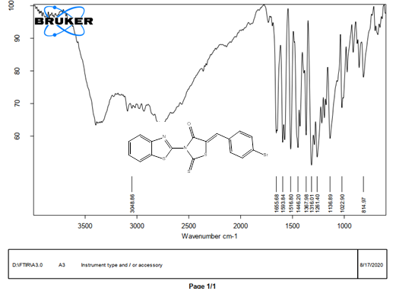

Compound A2: (Z)-3-(benzo[d]thiazol-2-yl)-5-(4-bromobenzylidene)-2-thioxothiazolidin-4-one

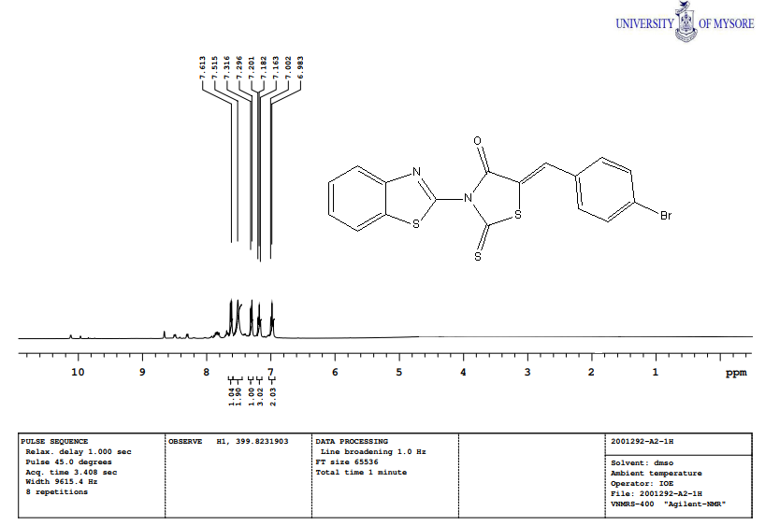
Compound A2: (Z)-3-(benzo[d]thiazol-2-yl)-5-(4-bromobenzylidene)-2-thioxothiazolidin-4-one

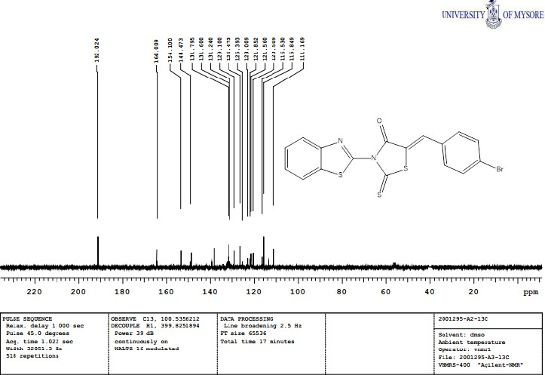
Compound A2: (Z)-3-(benzo[d]thiazol-2-yl)-5-(4-bromobenzylidene)-2-thioxothiazolidin-4-one

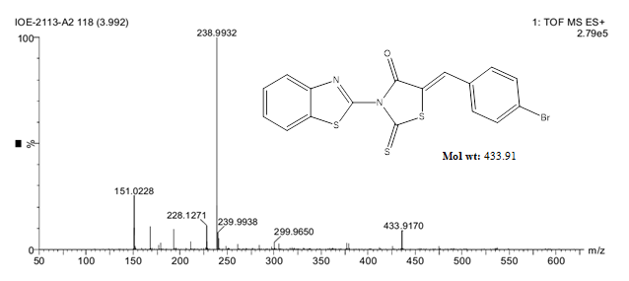

- Compound A3: (Z)-3-(benzo[d]thiazol-2-yl)-5-(4-chlorobenzylidene)-2-thioxothiazolidin-4-one:

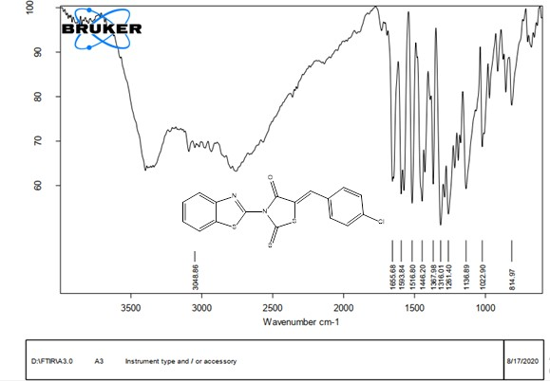
Compound A3: (Z)-3-(benzo[d]thiazol-2-yl)-5-(4-chlorobenzylidene)-2-thioxothiazolidin-4-one:

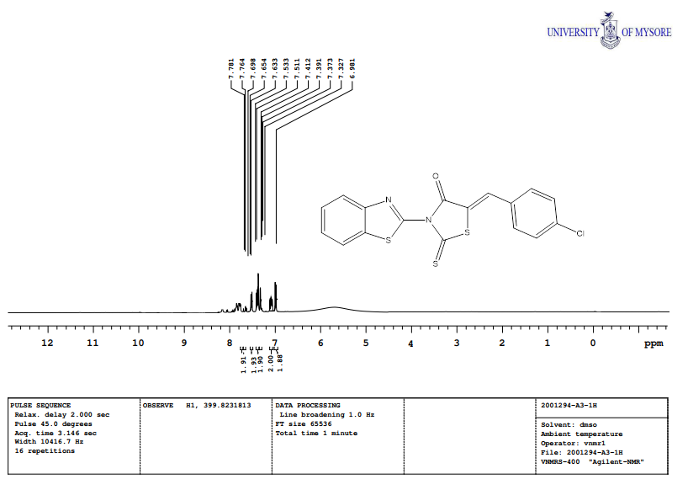
Compound A3: (Z)-3-(benzo[d]thiazol-2-yl)-5-(4-chlorobenzylidene)-2-thioxothiazolidin-4-one:
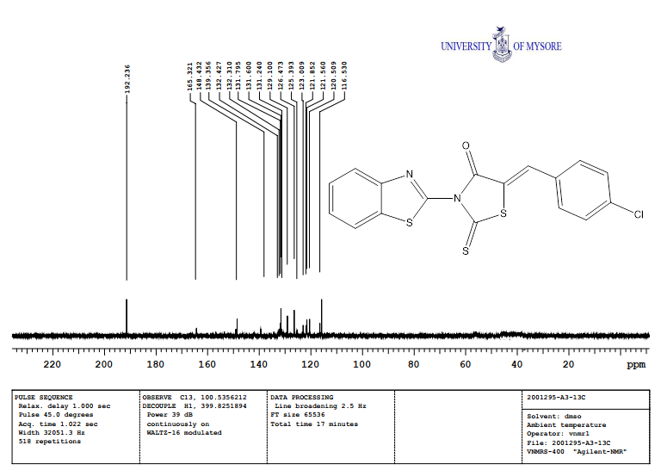
Compound A3: (Z)-3-(benzo[d]thiazol-2-yl)-5-(4-chlorobenzylidene)-2-thioxothiazolidin-4-one:

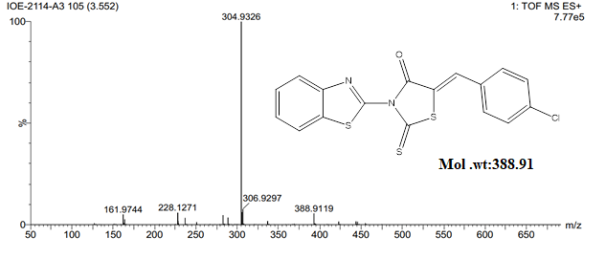

- Compound A4: (Z)-3-(benzo[d]thiazol-2-yl)-5-benzylidene-2-thioxothiazolidin-4-one:
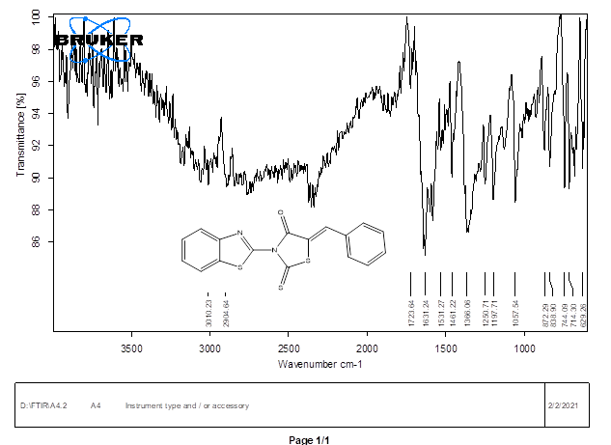
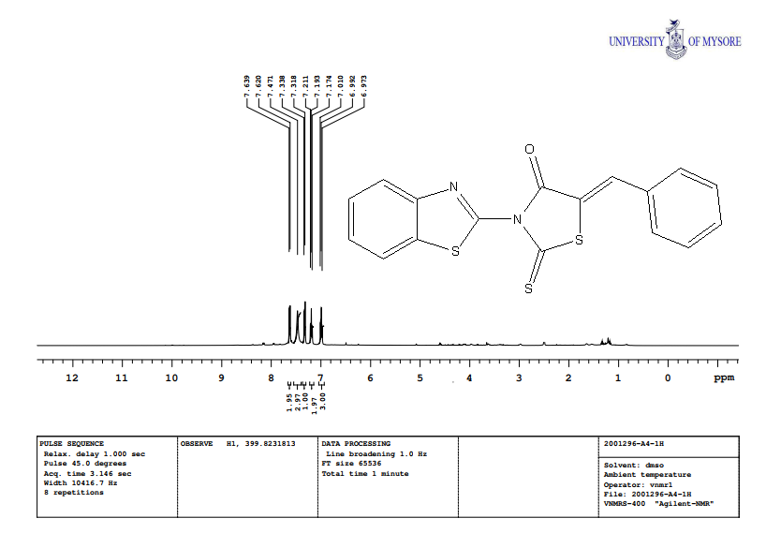
Compound A4: (Z)-3-(benzo[d]thiazol-2-yl)-5-benzylidene-2-thioxothiazolidin-4-one:
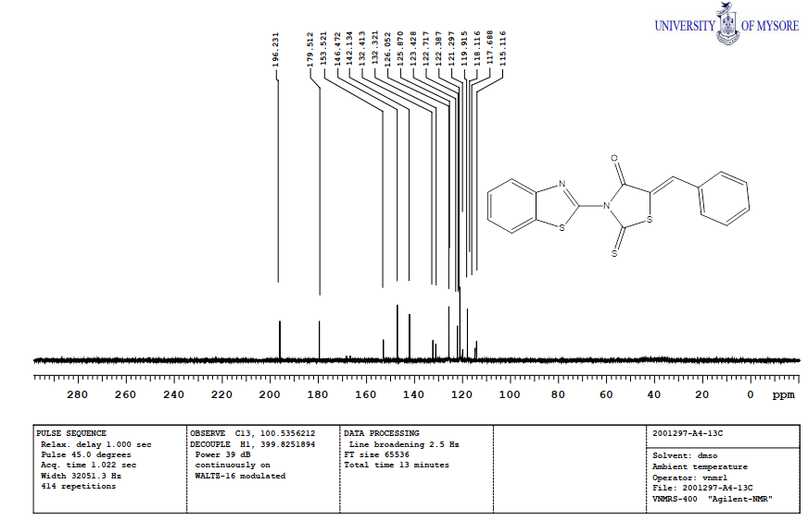
Compound A4: (Z)-3-(benzo[d]thiazol-2-yl)-5-benzylidene-2-thioxothiazolidin-4-one:
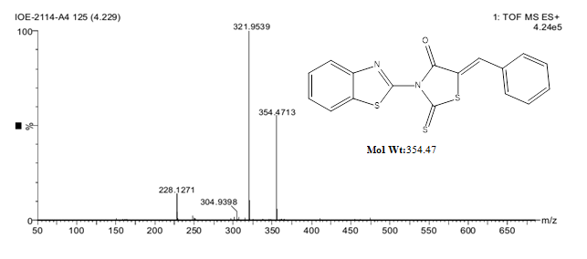

Compound A5: (Z)-3-(benzo[d]thiazol-2-yl)-5-(4-hydroxy-3-methoxybenzylidene)-2-thioxothiazolidin-4-one:

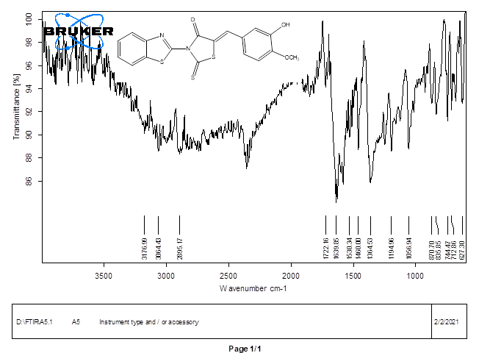

(Z)-3-(benzo[d]thiazol-2-yl)-5-(4-hydroxy-3-methoxybenzylidene)-2-thioxothiazolidin-4-one

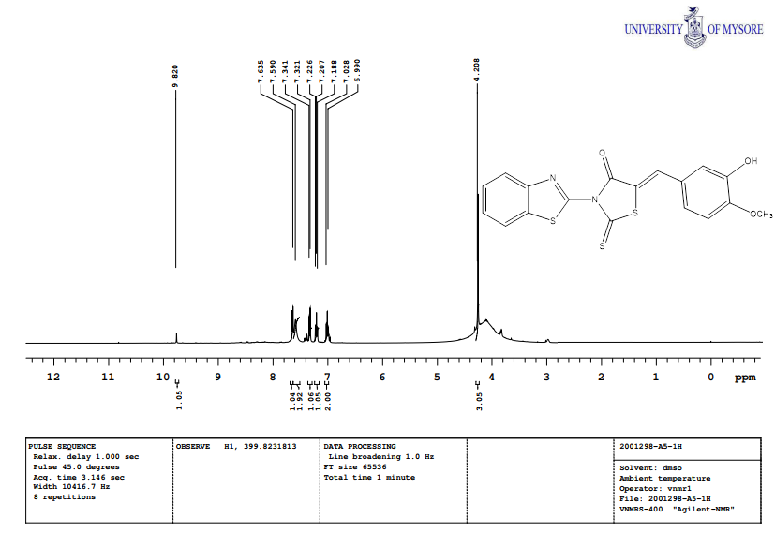
(Z)-3-(benzo[d]thiazol-2-yl)-5-(4-hydroxy-3-methoxybenzylidene)-2-thioxothiazolidin-4-one
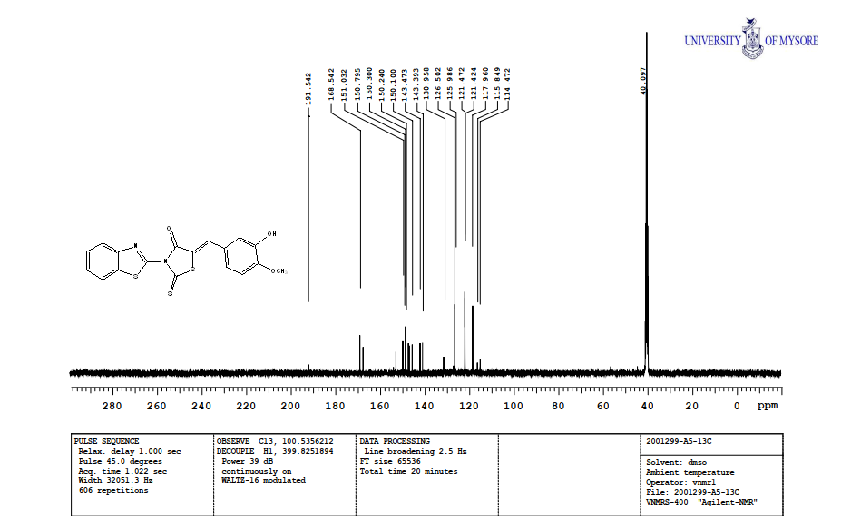
(Z)-3-(benzo[d]thiazol-2-yl)-5-(4-hydroxy-3-methoxybenzylidene)-2-thioxothiazolidin-4-one

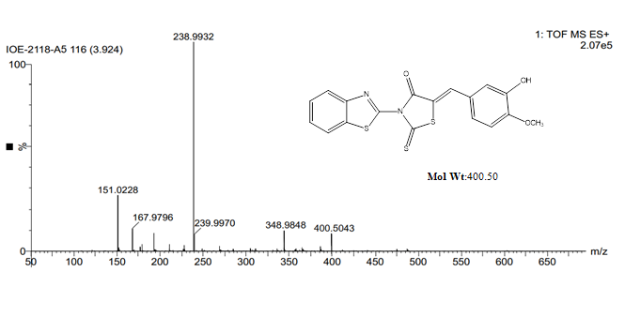

- A6: (Z)-3-(benzo[d]thiazol-2-yl)-5-(3,4-dimethoxybenzylidene)-2-thioxothiazolidin-4-one:

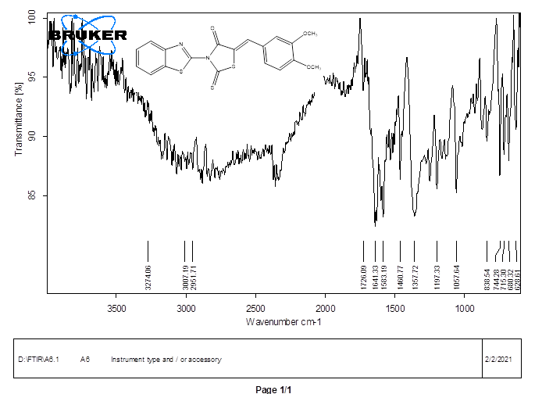
A6: (Z)-3-(benzo[d]thiazol-2-yl)-5-(3,4-dimethoxybenzylidene)-2-thioxothiazolidin-4-one:

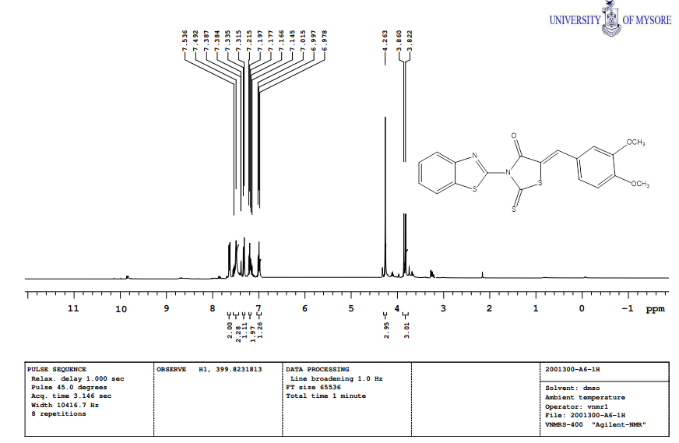

A6: (Z)-3-(benzo[d]thiazol-2-yl)-5-(3,4-dimethoxybenzylidene)-2-thioxothiazolidin-4-one

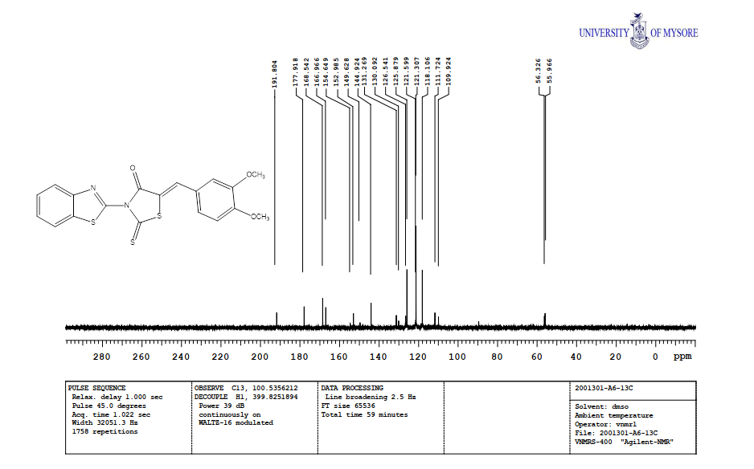

A6: (Z)-3-(benzo[d]thiazol-2-yl)-5-(3,4-dimethoxybenzylidene)-2-thioxothiazolidin-4-one

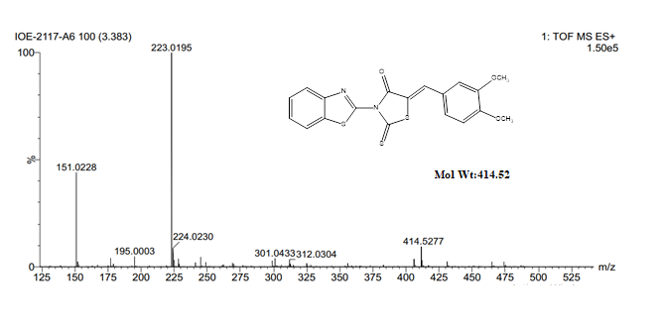

Compound A7: (Z)-3-(benzo[d]thiazol-2-yl)-5-(4-methoxybenzylidene)-2-thioxothiazolidin-4-one
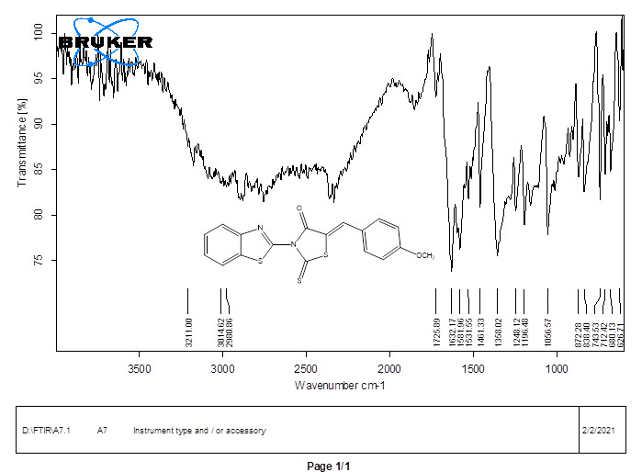
(Z)-3-(benzo[d]thiazol-2-yl)-5-(4-methoxybenzylidene)-2-thioxothiazolidin-4-one

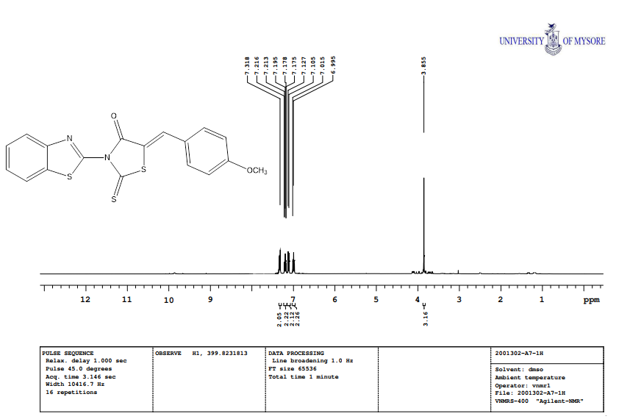
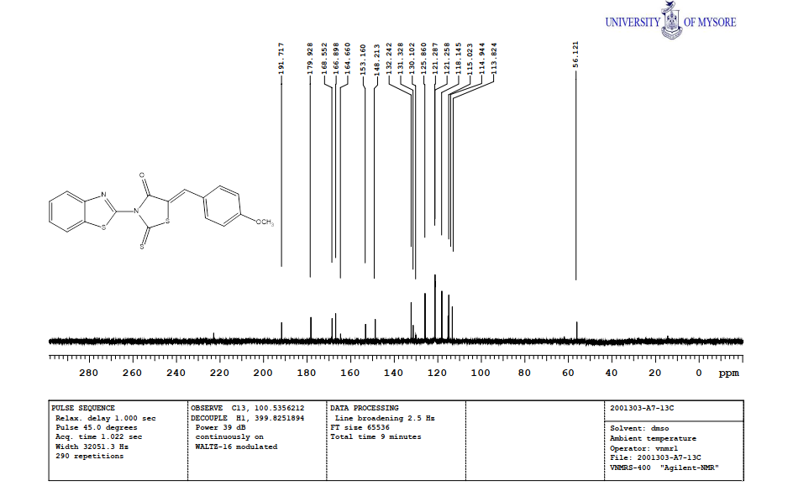
(Z)-3-(benzo[d]thiazol-2-yl)-5-(4-methoxybenzylidene)-2-thioxothiazolidin-4-one
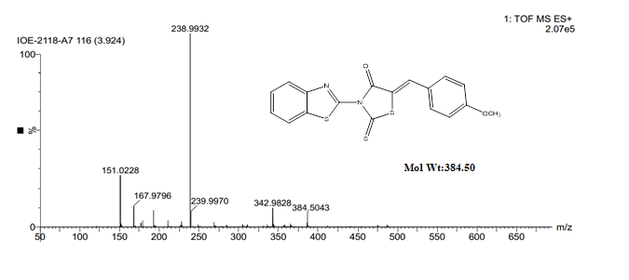

Compound A8: (Z)-3-(benzo[d]thiazol-2-yl)-5-(4-(dimethylamino) benzylidene)-2-thioxothiazolidin-4-one:
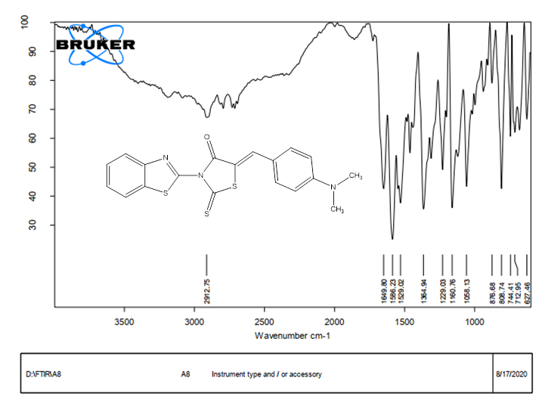
(Z)-3-(benzo[d]thiazol-2-yl)-5-(4-(dimethylamino) benzylidene)-2-thioxothiazolidin-4-one
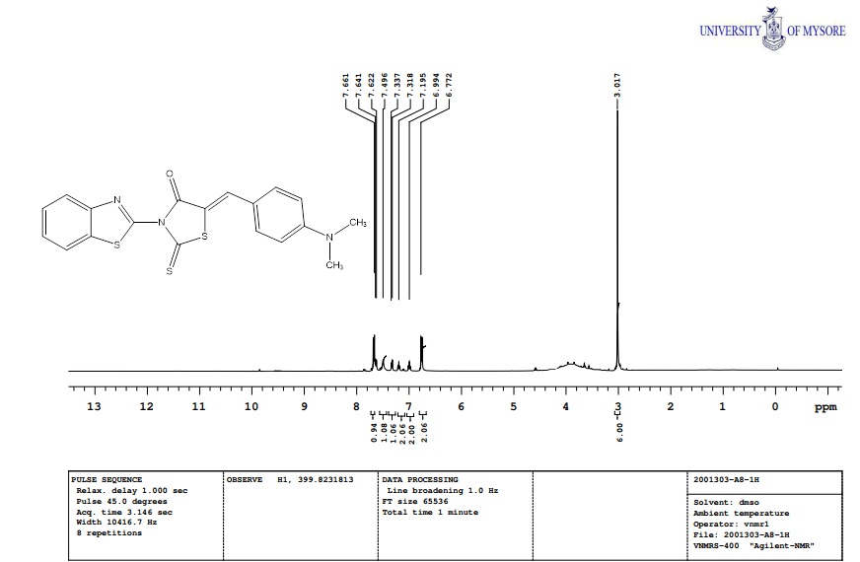
(Z)-3-(benzo[d]thiazol-2-yl)-5-(4-(dimethylamino) benzylidene)-2-thioxothiazolidin-4-one
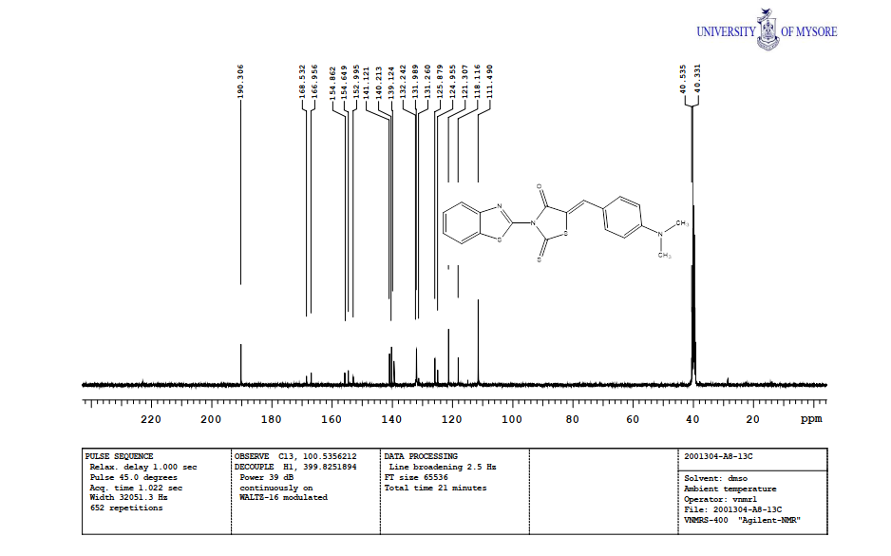
(Z)-3-(benzo[d]thiazol-2-yl)-5-(4-(dimethylamino) benzylidene)-2-thioxothiazolidin-4-one

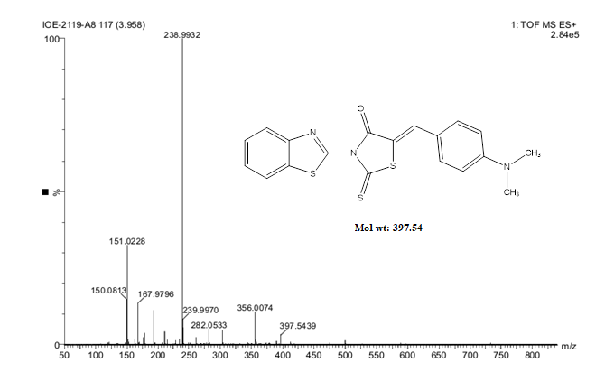

Compound A9: (Z)-3-(benzo[d]thiazol-2-yl)-5-(4-hydroxybenzylidene)-2-thioxothiazolidin-4-one:
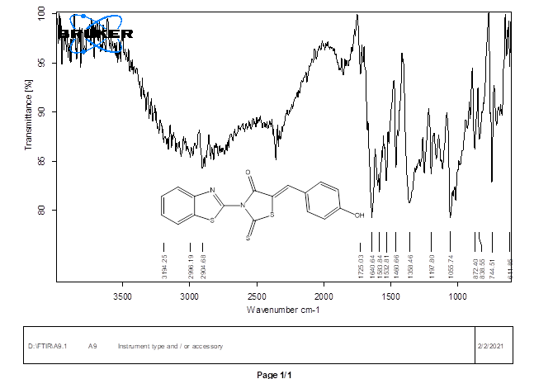
(Z)-3-(benzo[d]thiazol-2-yl)-5-(4-hydroxybenzylidene)-2-thioxothiazolidin-4-one
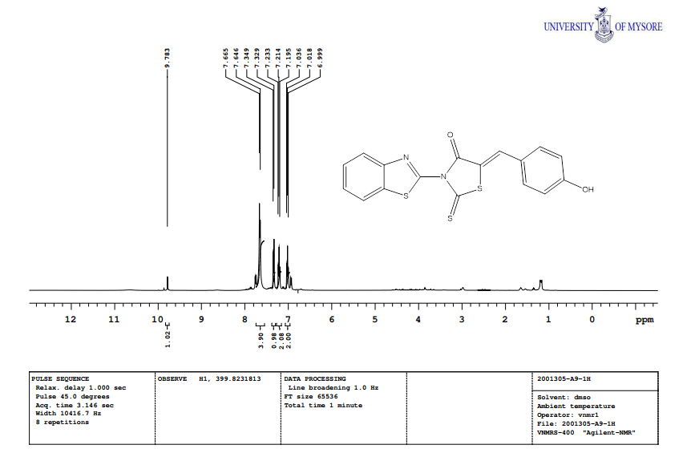
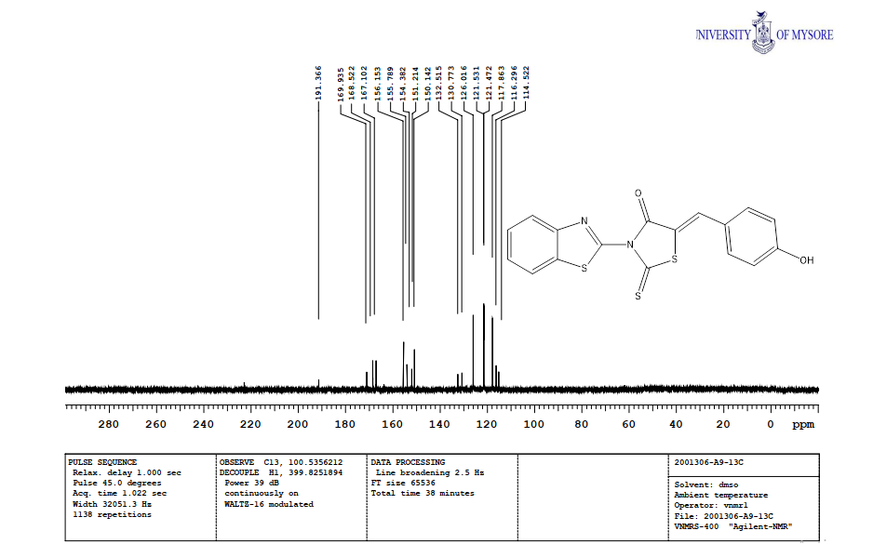
Compound A9: (Z)-3-(benzo[d]thiazol-2-yl)-5-(4-hydroxybenzylidene)-2-thioxothiazolidin-4-one
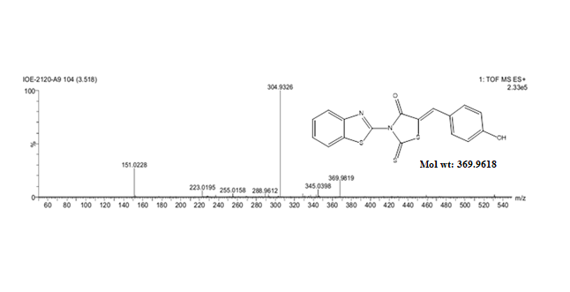

Compound A10: (Z)-3-(benzo[d]thiazol-2-yl)-5-(2-hydroxybenzylidene)-2-thioxothiazolidin-4-one
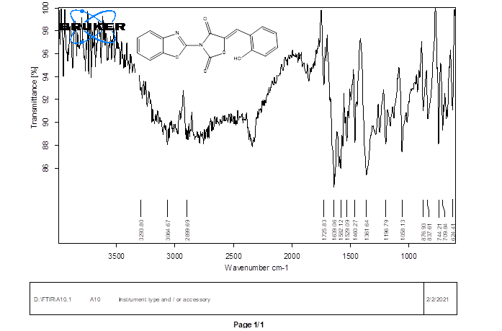
Compound A10: (Z)-3-(benzo[d]thiazol-2-yl)-5-(2-hydroxybenzylidene)-2-thioxothiazolidin-4-one
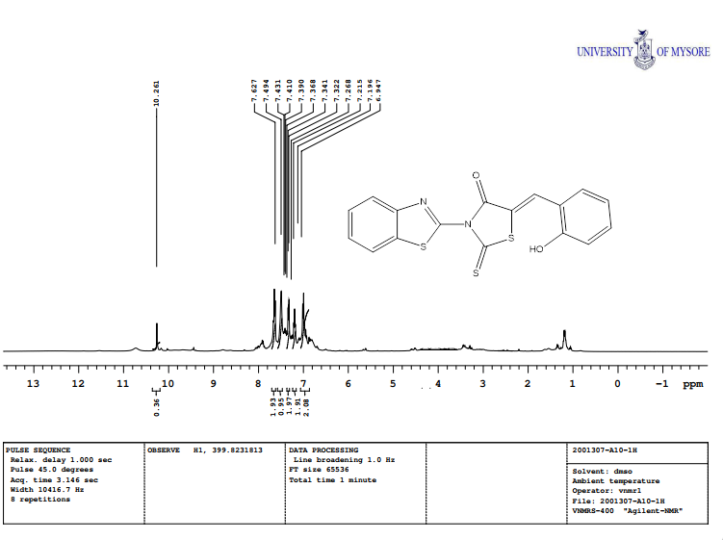
Compound A10: (Z)-3-(benzo[d]thiazol-2-yl)-5-(2-hydroxybenzylidene)-2-thioxothiazolidin-4-one
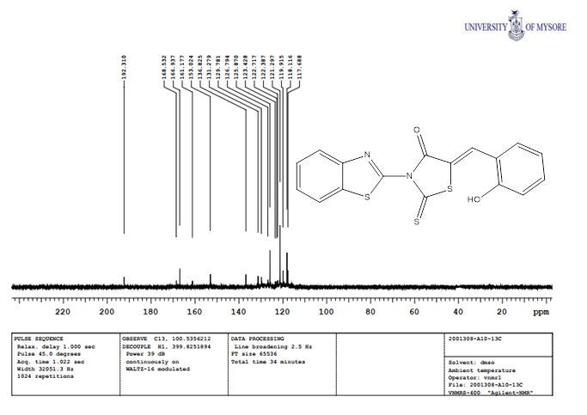
Compound A10: (Z)-3-(benzo[d]thiazol-2-yl)-5-(2-hydroxybenzylidene)-2-thioxothiazolidin-4-one
