Metabolomics investigation of biochemical variations in two representative aged Fujian teas
Zhen Yan^{1#}, Biao Huang^{2#}, Wei Li², Ziwen Ren², Qiufang Zhu², Yiquan Feng¹, Lingli Deng^{1*}
¹ School of Artificial Intelligence and Information Engineering, East China University of Technology, Nanchang 330013, China
² Research Institute of Agricultural Quality Standards and Testing Technology, Fujian Academy of Agricultural Sciences, Fujian Key Laboratory of Agro-products Quality & Safety, Fuzhou, Fujian 350003, China
* Correspondence: lldeng@ecut.edu.cn
#These authors contributed equally to this work.
Supplementary Table S1 Sample information
‘Da Hong Pao’ oolong tea | Storage year | ‘Lapsang Souchong’ black tea | Storage year
OT1 | 1 | BT1 | 1
OT2 | 2 | BT2 | 2
OT3 | 3 | BT3 | 3
OT4 | 4 | BT4 | 4
OT5 | 5 | BT5 | 5
OT6 | 6 | BT6 | 6
OT7 | 7 | BT7 | 7
OT8 | 8 | BT8 | 8
OT9 | 9 | BT9 | 9
OT10 | 10 | BT10 | 10

Supplementary Table S2 UPLC-MS/MS parameters for the analysis phenolic acids by multiple reaction monitoring (MRM) mode
Components | RT  (min) | Precursor ion (m/z) | Product ion  (m/z) | Voltage (V) | Energy (eV)
3,5-dihydroxybenzoic acid | 2.61 | 152.9 | 108.8*,80.9 | -40 | 14, 18
Chlorogenic acid | 3.26 | 353.2 | 191.0*,92.9 | -30 | 16, 28
p-hydroxybenzoic acid | 3.66 | 136.9 | 92.9*,137.4 | -36 | 12, 16
Syringic acid | 4.00 | 197.0 | 181.9*,123.0 | -48 | 14,26
Vanillic acid | 3.99 | 167.0 | 151.9*,108.0 | -36 | 14,18
p-coumaric acid | 4.31 | 163.0 | 119.0*,93.3 | -44 | 16,26
3-hydrocycinnamic acid | 4.61 | 163.0 | 119.0*, 93.3 | -44 | 16, 26
Salicylic acid | 5.16 | 136.9 | 92.9*,137.4 | -36 | 16,12
Isochlorogenic acid | 4.35 | 514.9 | 352.9*, 190.8 | -32 | 16.20
Gallic acid | 1.68 | 168.8 | 125.0*,79.0 | -36 | 16,24

Supplementary Table S3 LC-MS/MS parameters for the analysis of catechins, caffeine&theanine by multiple reaction monitoring (MRM) mode
Components | RT  (min) | Precursor ion (m/z) | Product ion  (m/z) | Voltage (V) | Energy (eV)
Gallocatechin (GC) | 1.87 | 307.2. | 139.0*,163.0 | 32 | 18,16
Epigallocatechin (EGC) | 2.49 | 307.2. | 139.0*,163.0 | 32 | 18,16
Catechin (C) | 2.56 | 291.2 | 139.0*,123.0 | 30 | 12,14
Epigallocatechin gallate (EGCG) | 2.85 | 459.2. | 289.1*,139.0 | 36 | 16,26
Epicatechin (EC) | 3.04 | 291.2 | 139.0*,123.0 | 30 | 12,14
Gallocatechin gallate (GCG) | 3.05 | 459.2. | 289.1*,139.0 | 36 | 16,26
Epicatechin gallate (ECG) | 3.30 | 443.2 | 123.0*,139.0 | 32 | 24,20
Caffeine (CAF) | 3.02 | 195.0 | 42.0*,109.8 | 36 | 24,20
Theanine (Thea) | 0.70 | 175.0 | 84.0*,130.0 | 28 | 20,16
Note: * Quantitative ions.

Supplementary Table S4 Content of Phenolic Acid Compounds in Oolong Tea (mg/kg)
Sample | OT1 | OT2 | OT3 | OT4 | OT5 | OT6 | OT7 | OT8 | OT9 | OT10
3,5-dihydroxybenzoic acid | 15.73 | 22.44 | 12.34 | 29.89 | 18.45 | 18.44 | 32.31 | 24.10 | 32.64 | 33.70
Chlorogenic acid | 96.99 | 104.53 | 45.36 | 45.99 | 51.47 | 103.25 | 86.57 | 44.17 | 176.85 | 110.60
p-hydroxybenzoic acid | 2.98 | 4.99 | 4.47 | 8.01 | 4.97 | 4.77 | 8.20 | 7.71 | 9.91 | 8.33
Syringic acid | 31.28 | 17.01 | 5.79 | 74.80 | 11.41 | 12.71 | 11.31 | 9.46 | 100.98 | 8.05
Vanillic acid | 3.16 | 3.59 | 6.07 | 7.35 | 6.85 | 6.82 | 13.21 | 13.78 | 11.79 | 10.97
p-coumaric acid | 16.10 | 8.75 | 9.74 | 6.41 | 4.95 | 11.11 | 7.03 | 4.60 | 6.00 | 14.77
3-hydrocycinnamic acid | 8.49 | 1.60 | 1.98 | 1.20 | 0.72 | 3.74 | 2.87 | 0.38 | 1.05 | 4.17
Salicylic acid | 20.39 | 21.44 | 19.47 | 21.06 | 14.76 | 31.34 | 30.84 | 11.74 | 23.41 | 26.05
Isochlorogenic acid | 3.08 | 4.42 | 1.49 | 0.81 | 1.51 | 3.09 | 2.31 | 0.82 | 5.04 | 5.06
Gallic acid | 2635.56 | 3874.24 | 3180.19 | 3552.05 | 3400.55 | 4139.26 | 4436.48 | 3412.00 | 4158.76 | 4513.86

Supplementary Table S5 Contents of Caffeine, Theanine and Catechin Compounds in Oolong Tea (%)
Sample | OT1 | OT2 | OT3 | OT4 | OT5 | OT6 | OT7 | OT8 | OT9 | OT10
CAF | 1.01 | 1.15 | 1.11 | 1.10 | 1.21 | 1.36 | 1.31 | 1.40 | 1.35 | 1.12
Thea | 0.53 | 0.42 | 0.35 | 0.41 | 0.40 | 0.31 | 0.16 | 0.10 | 0.18 | 0.20
C | 1.14 | 0.92 | 0.80 | 0.49 | 0.66 | 0.72 | 0.61 | 0.57 | 0.66 | 0.57
EC | 0.93 | 0.53 | 0.51 | 0.25 | 0.30 | 0.61 | 0.37 | 0.27 | 0.31 | 0.50
GC | 2.51 | 2.13 | 1.51 | 0.99 | 1.44 | 1.55 | 1.48 | 1.17 | 1.40 | 1.29
EGC | 3.77 | 2.30 | 1.77 | 0.86 | 1.15 | 2.22 | 1.55 | 0.93 | 1.17 | 1.90
EGCG | 12.95 | 10.53 | 9.62 | 5.24 | 6.55 | 10.30 | 9.36 | 5.99 | 7.03 | 9.33
ECG | 0.26 | 0.32 | 0.33 | 0.32 | 0.36 | 0.21 | 0.28 | 0.37 | 0.40 | 0.17
GCG | 1.67 | 1.37 | 1.32 | 0.53 | 1.00 | 1.41 | 1.27 | 0.57 | 1.02 | 1.07

Supplementary Table S6 Content of Phenolic Acid Compounds in Black Tea (mg/kg)
Sample | BT1 | BT2 | BT3 | BT4 | BT5 | BT6 | BT7 | BT8 | BT9 | BT10
3,5-dihydroxybenzoic acid | 45.81 | 1.58 | 4.46 | 20.59 | 15.42 | 18.49 | 27.43 | 21.12 | 29.60 | 28.62
Chlorogenic acid | 86.17 | 14.73 | 29.75 | 68.25 | 49.02 | 69.90 | 44.50 | 34.96 | 27.06 | 28.81
p-hydroxybenzoic acid | 4.54 | 5.72 | 5.65 | 5.24 | 7.03 | 5.70 | 6.55 | 5.43 | 5.65 | 4.72
Syringic acid | 14.07 | 2.81 | 15.65 | 5.29 | 10.60 | 8.38 | 22.07 | 5.12 | 21.73 | 15.67
Vanillic acid | 1.42 | 2.10 | 1.98 | 1.76 | 3.65 | 1.50 | 2.13 | 3.90 | 2.31 | 3.17
p-coumaric acid | 28.99 | 44.76 | 39.60 | 35.57 | 31.78 | 38.87 | 23.60 | 37.26 | 19.75 | 19.54
3-hydrocycinnamic acid | 4.96 | 7.41 | 10.71 | 4.40 | 14.06 | 5.89 | 10.13 | 5.43 | 3.64 | 3.42
Salicylic acid | 32.25 | 18.54 | 33.21 | 22.16 | 18.59 | 28.00 | 14.69 | 18.92 | 20.15 | 19.92
Isochlorogenic acid | 5.74 | 0.48 | 3.91 | 0.38 | 5.18 | 1.07 | 4.34 | 0.82 | 1.60 | 1.26
Gallic acid | 3470.07 | 3438.34 | 2949.46 | 4068.31 | 4173.91 | 4384.66 | 4625.39 | 4063.42 | 4066.07 | 4355.85

Supplementary Table S7 Contents of Caffeine, Theanine and Catechin Compounds in Black Tea (%)
Sample | BT1 | BT2 | BT3 | BT4 | BT5 | BT6 | BT7 | BT8 | BT9 | BT10
CAF | 1.67 | 1.49 | 1.89 | 2.15 | 2.34 | 2.36 | 2.23 | 2.04 | 2.17 | 2.05
Thea | 1.00 | 3.13 | 2.34 | 3.00 | 4.37 | 4.08 | 2.21 | 2.63 | 1.62 | 1.39
C | 0.17 | 0.01 | 0.07 | 0.1 | 0.05 | 0.08 | 0.04 | 0.05 | 0.04 | 0.04
EC | 0.32 | 0.03 | 0.11 | 0.11 | 0.07 | 0.09 | 0.07 | 0.07 | 0.07 | 0.07
GC | 0.10 | 0.06 | 0.07 | 0.09 | 0.07 | 0.06 | 0.06 | 0.06 | 0.05 | 0.06
EGC | 0.31 | 0.12 | 0.21 | 0.26 | 0.14 | 0.20 | 0.13 | 0.19 | 0.11 | 0.12
EGCG | 2.23 | 0.71 | 1.07 | 1.74 | 0.90 | 1.74 | 1.09 | 1.29 | 0.79 | 0.80
ECG | 1.47 | 0.15 | 0.46 | 0.43 | 0.62 | 0.84 | 0.64 | 0.59 | 0.69 | 0.70
GCG | 0.09 | 0.05 | 0.11 | 0.25 | 0.08 | 0.18 | 0.13 | 0.09 | 0.09 | 0.07

Supplementary Table S8 The average content of various compounds
Sample | Non ester catechins | Ester catechins | Phenolic acids
OT1 | 8.35 | 14.88 | 2833.76
OT2 | 5.88 | 12.22 | 4063.00
OT3 | 4.59 | 11.28 | 3286.90
OT4 | 2.59 | 6.10 | 3747.56
OT5 | 3.55 | 7.91 | 3515.64
OT6 | 5.10 | 11.92 | 4334.53
OT7 | 4.02 | 10.90 | 4631.14
OT8 | 2.95 | 6.93 | 3528.77
OT9 | 3.55 | 8.44 | 4526.44
OT10 | 4.27 | 10.57 | 4735.57
BT1 | 0.90 | 3.78 | 3694.02
BT2 | 0.21 | 0.91 | 3536.47
BT3 | 0.46 | 1.65 | 3094.38
BT4 | 0.57 | 2.43 | 4231.95
BT5 | 0.33 | 1.60 | 4329.25
BT6 | 0.44 | 2.76 | 4562.45
BT7 | 0.31 | 1.86 | 4780.84
BT8 | 0.37 | 1.98 | 4196.37
BT9 | 0.28 | 1.58 | 4197.56
BT10 | 0.29 | 1.57 | 4480.98

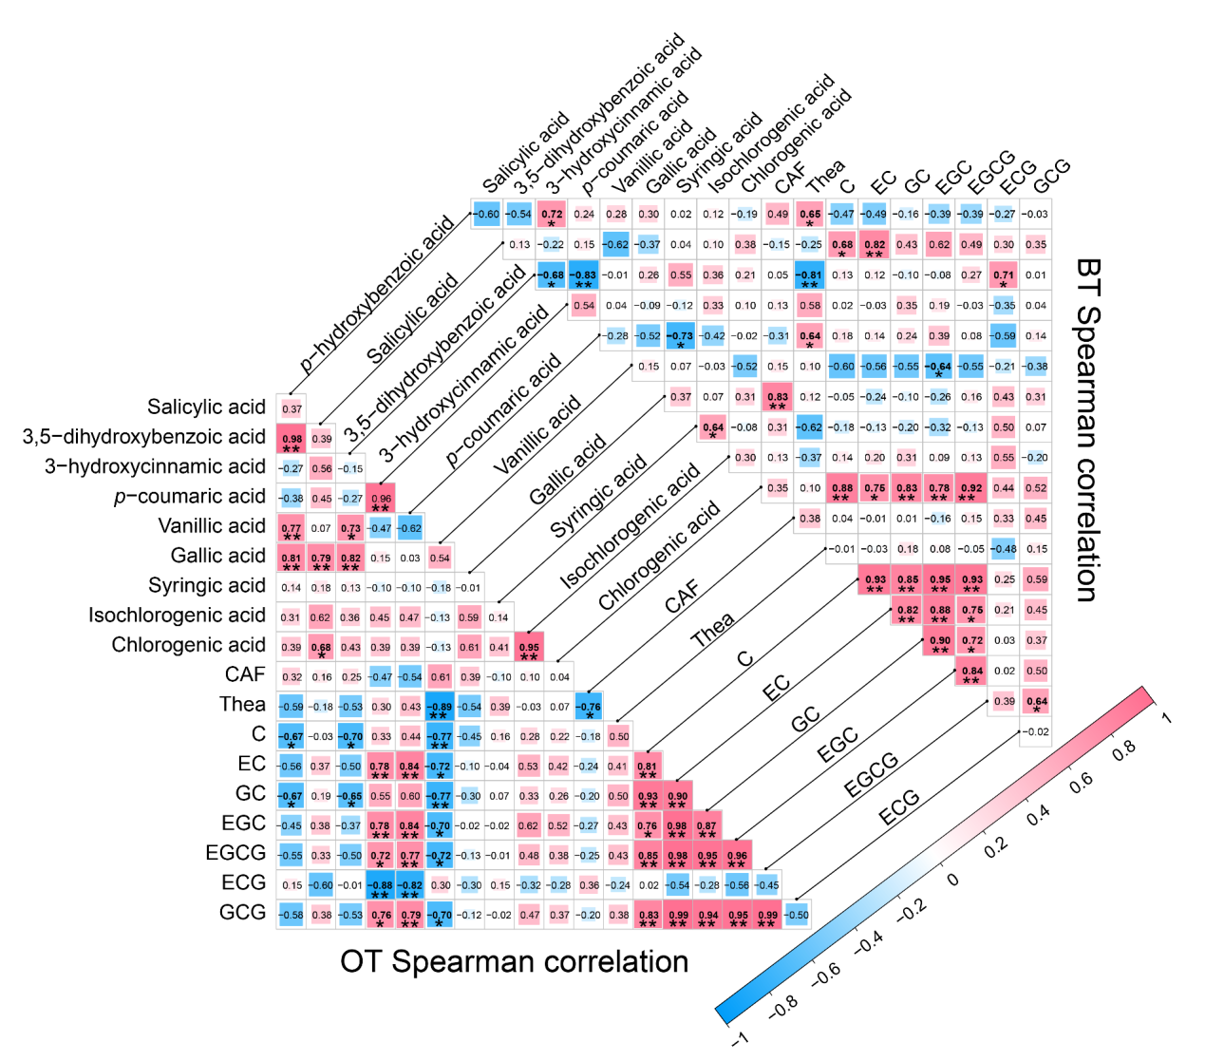
Supplementary Fig. S1 Spearman correlation networks of compound abundances. lower Correlation derived from the OT sample group; upper Correlation derived from the BT sample group. * indicate p < 0.05 and ** indicate p < 0.01

