supplemental figures

Metagenomic analysis reveals the microbiome and antibiotic resistance genes in Guangdong yellow-feathered indigenous chicken
Yibin Xu^{1,2}, Lijin Guo^{1,2}, Yulin Huang^{1,2}, Siyu Zhang^{1,2}, Xiquan Zhang^{1,2*}, Qinghua Nie^{1,2*}

¹Lingnan Guangdong Laboratory of Modern Agriculture & State Key Laboratory for Conservation and Utilization of Subtropical Agro-bioresources, College of Animal Science, South China Agricultural University, Guangzhou 510642, Guangdong, China

²Guangdong Provincial Key Lab of AgroAnimal Genomics and Molecular Breeding and Key Lab of Chicken Genetics, Breeding and Reproduction, Ministry of Agriculture, Guangzhou, 510642, Guangdong, China.
*Correspondence: Qinghua Nie (E-mail: nqinghua@scau.edu.cn).
Address: College of Animal Science, South China Agricultural University, Guangzhou 510642, Guangdong Province, China.

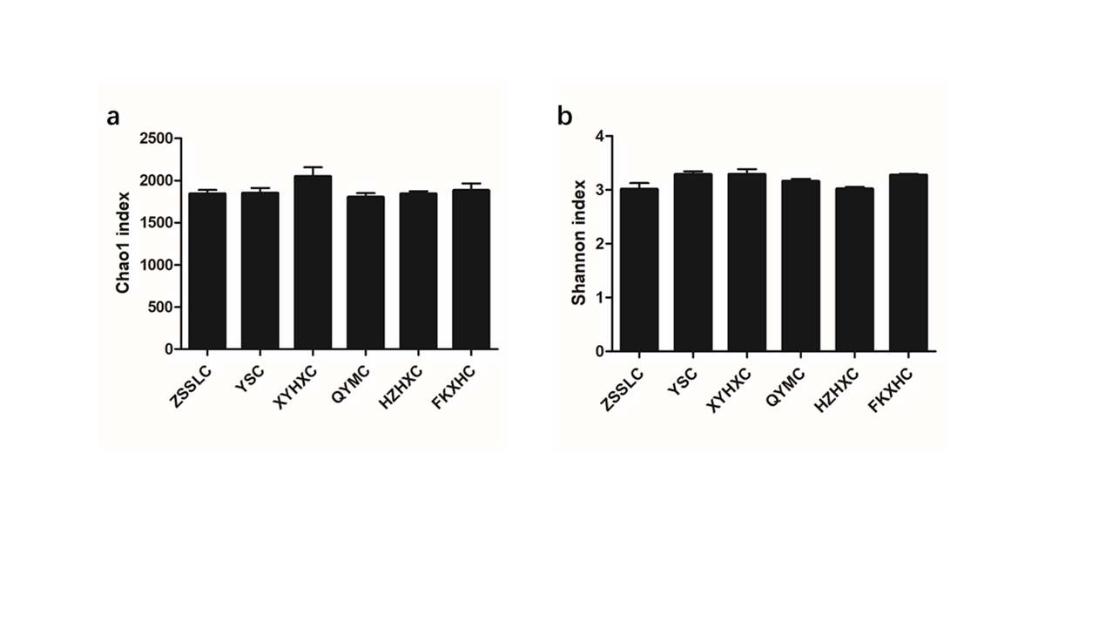
Figure S1. alpha diversity of bacterial communities (a) Chao1 index, (b) Shannon index. Data are expressed as means ± SEM, *p < 0.05; **p < 0.01; ***p < 0.001.

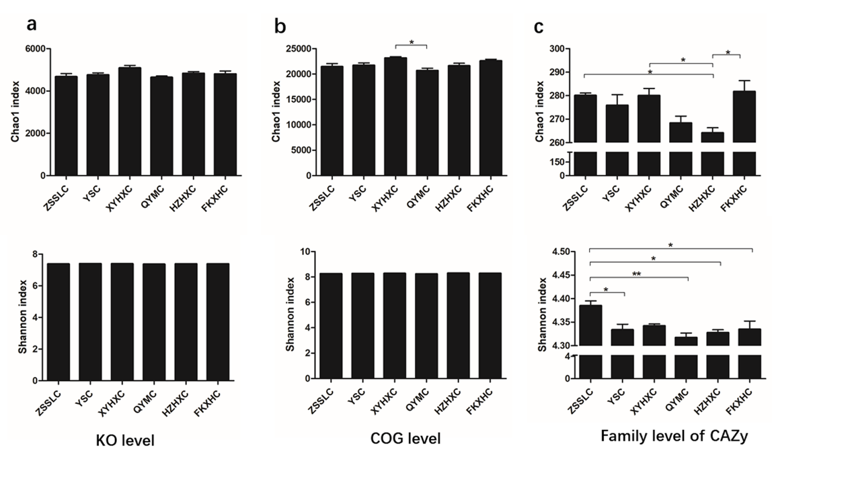
Figure S2. Alpha diversity (chao1 and shannon indies) analysis of (a) KO level, (b) COG level and (c) family level of CAZy. Data are expressed as means ± SEM, *p < 0.05; **p < 0.01; ***p < 0.001.

