Mechanistic Investigation of Borax Concentration on the Stability and Physicochemical Properties of Cold Cream Emulsions
Uditi Handa¹*, Anuj Malik², Anil Kumar³
¹Guru Gobind Singh College of Pharmacy, Yamuna Nagar, Haryana, India; ²M.M. College of Pharmacy, M.M. (DU), Mullana, Ambala, Haryana, India; ³Geeta Institute of Pharmacy, Geeta University, Naultha (Panipat).

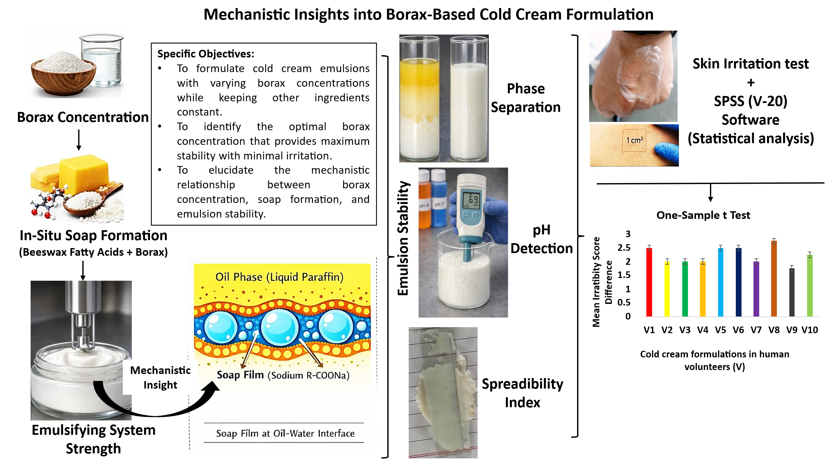
Conclusion: The study confirms borax concentration as a key factor governing cold cream stability and biocompatibility.

