Supporting material
Spatial Segmentation and Controllable Connection Enabled Hollow Microsphere-Carbon Distributed RLC Networks for Multifunctional EM/Thermal Regulation
Guangyan Cheng, Hongxiu Wu, Ping Wang, Jingjie Zhang*, Zhenguo An*
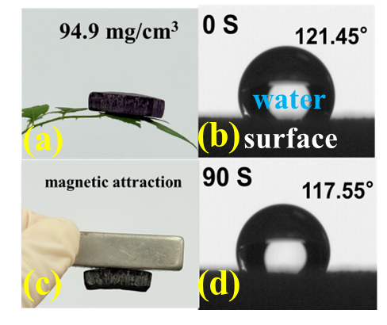
Figure S1. a) and c) digital photographs illustrating the lightweight design and magnetic response of CNGA.
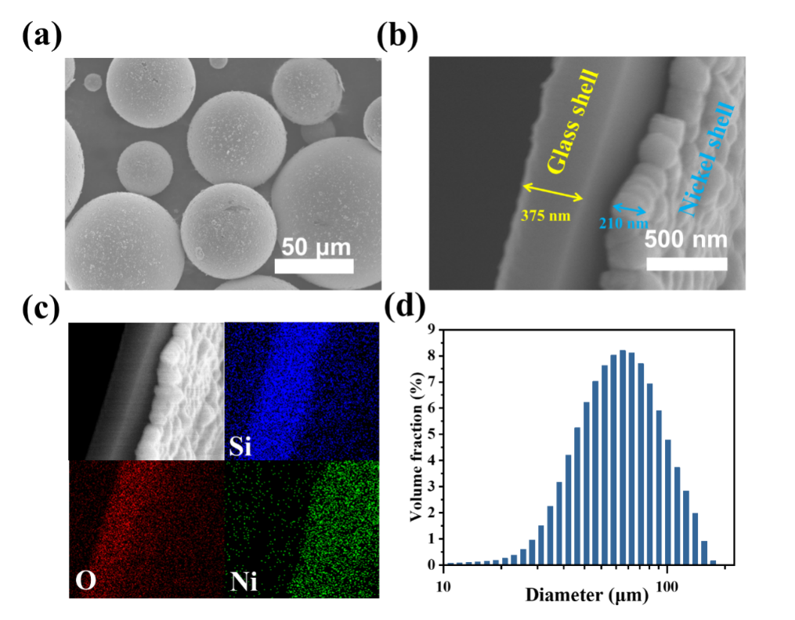
Figure S2. a) SEM image of DSHM. b) Double-shell fracture cross-section diagram for DSHM. c) EDS images of double-shell structure. d) Particle size distribution diagram of DSHM.
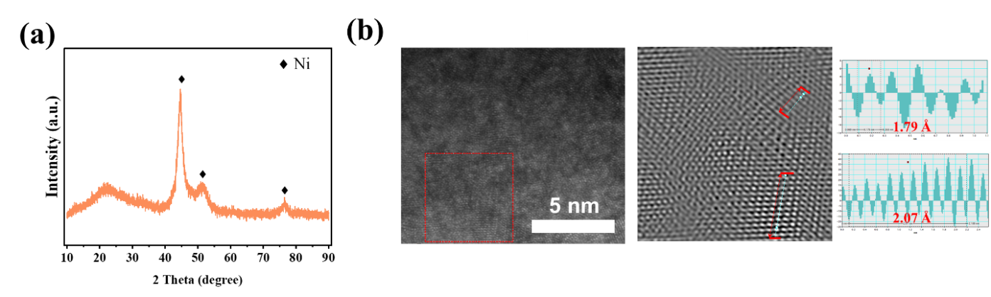
Figure S3. a) XRD image of DSHM. b) HRTEM and lattice spacing measurement images of DSHM.
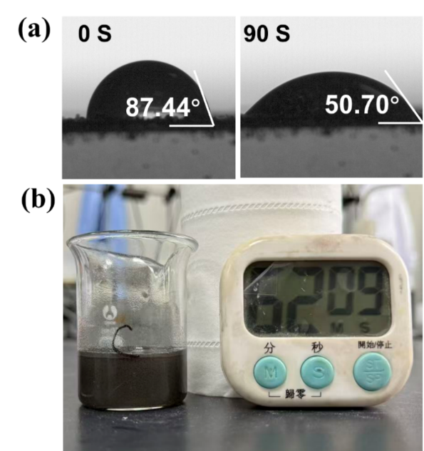
Figure S4. a) Contact angle photographs of DSHM and a chitosan-acetic acid solution after 0 and 90 seconds. b) Digital photo that remain stable for one hour after mixing.
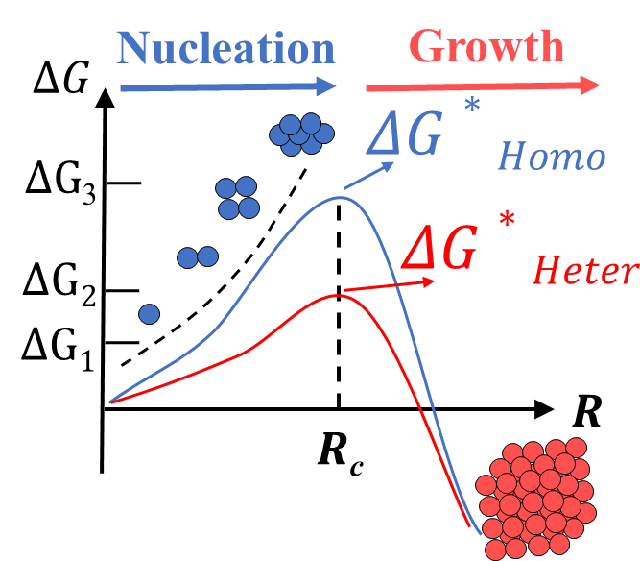
Figure S5 Homogeneous and heterogeneous nucleation barriers
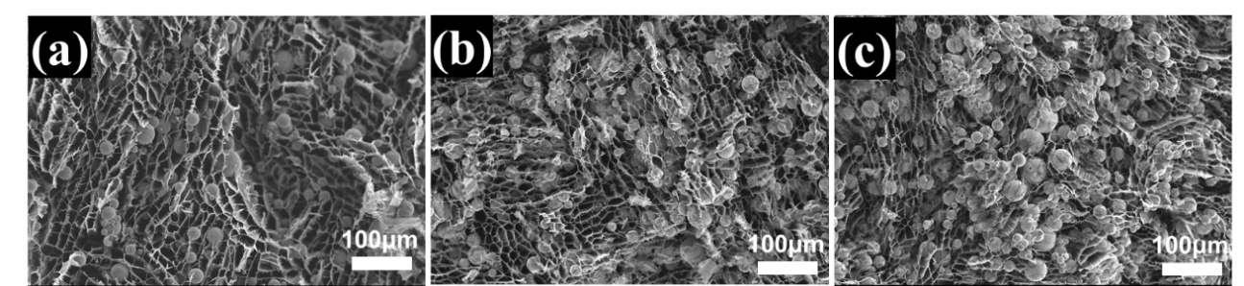
Figure S6. a) - c) SEM images of radial cross-sections of CNGA675-1, CNGA675-2 and CNGA675-4. d) - f) The aperture sizes of CNGA675-1 and CNGA675-2. e) Interlayer spacing of CNGA675-4
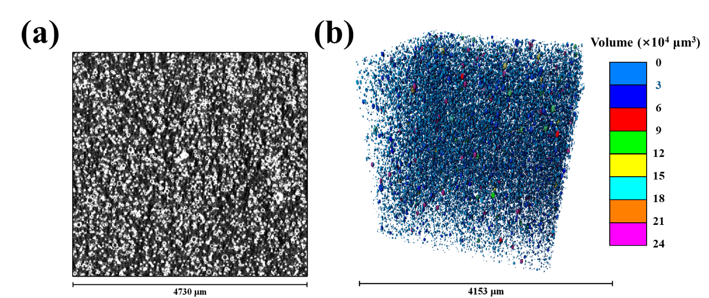
Figure S7. a) micro-CT XZ cross-sectional image of CNGA675-1. b) Three-dimensional reconstruction analysis of the internal cavities of the microspheres.
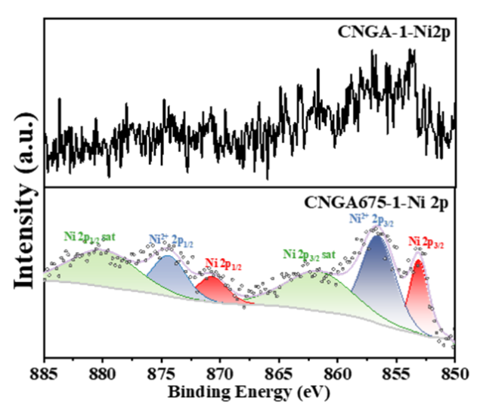
Figure S8. High-resolution Ni2p spectra of CNGA675.

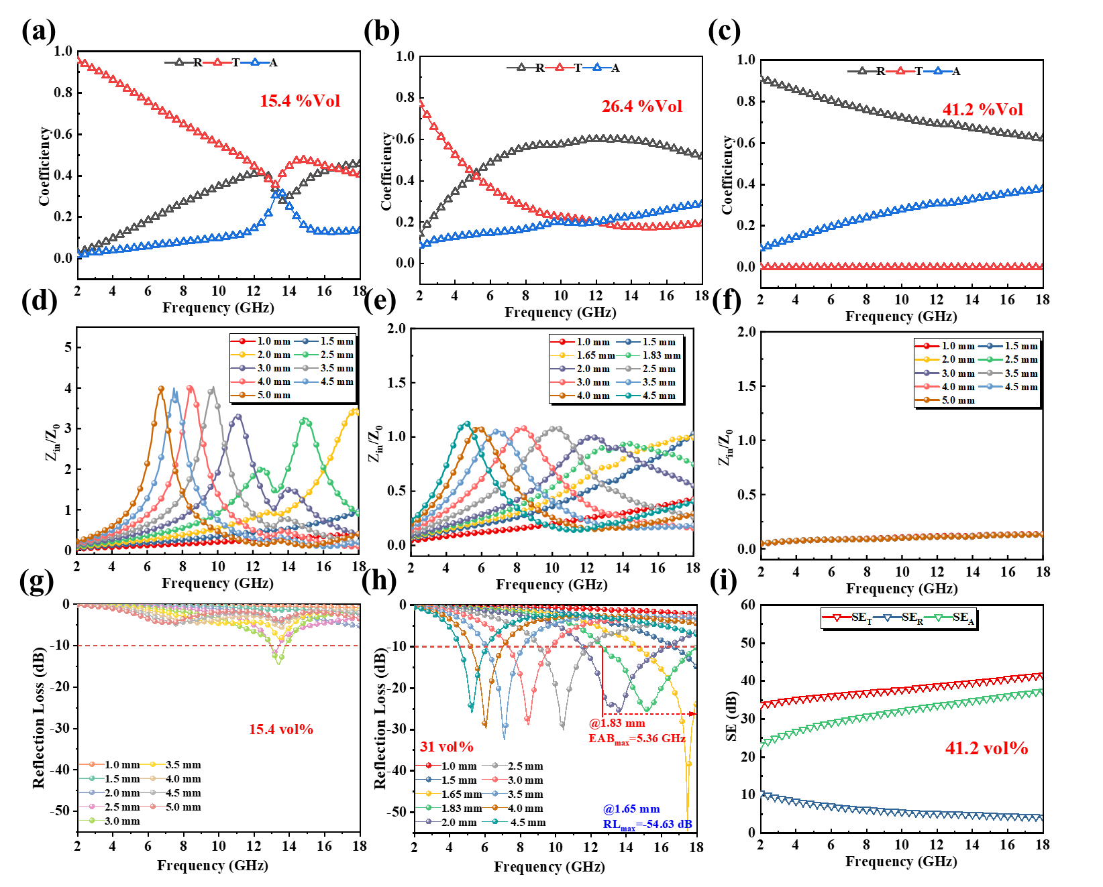
Figure S9. a) – c) The reflection coefficient (R), transmission coefficient (T), and absorption coefficient (A) of DSHM in the volume fractions of 15.4%, 26.4%, and 41.2%. d) - f) Impedance matching of DSHM in the volume fractions of 15.4%, 26.4%, and 41.2%. g) - h) RL values of DSHM in the volume fractions of 15.4% and 26.4% at different thicknesses. i) The SE values of DSHM in the volume fraction of 46%.

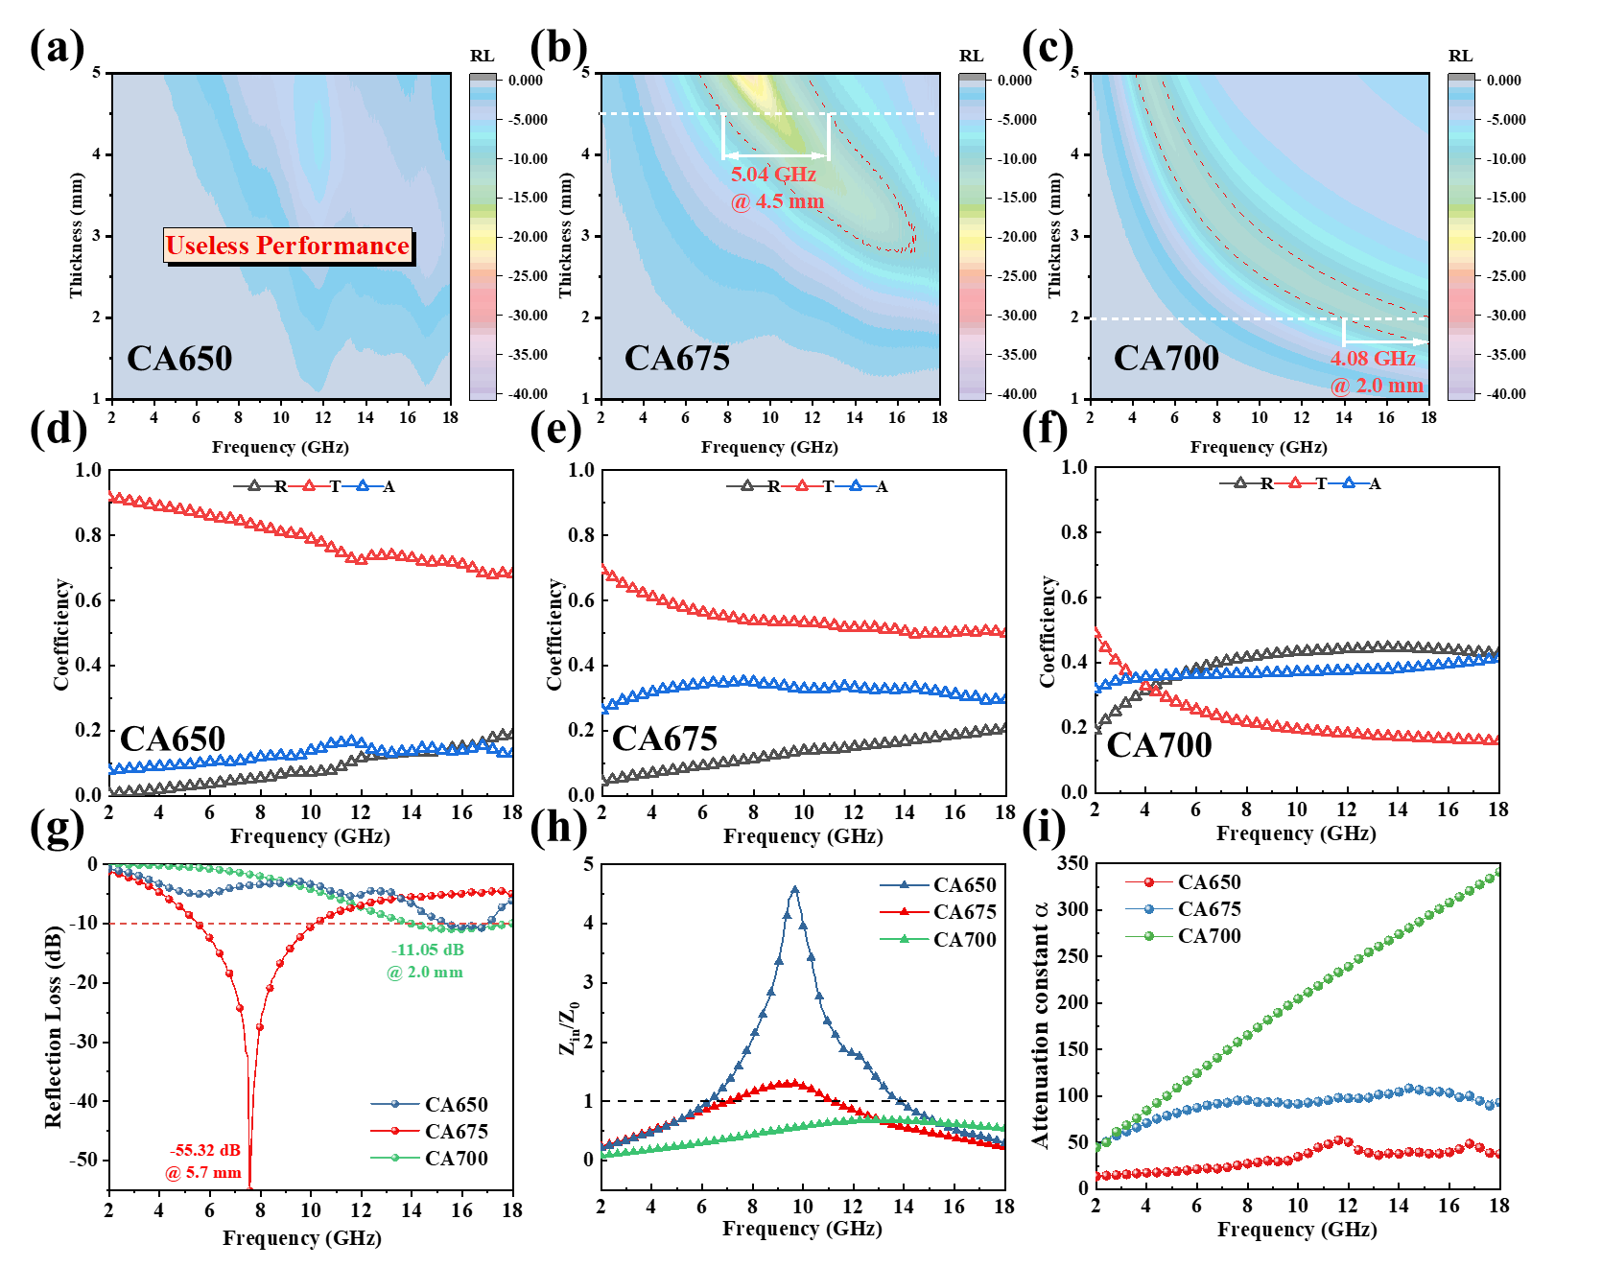
Figure S10. a) – c) 2D RL contour maps of CA650, CA675 and CA700. d) - e) The reflection coefficient (R), transmission coefficient (T), and absorption coefficient (A) of CA650, CA675, CA700. g) RL _{min} values of CA650, CA675, CA700. h) The impedance matching performance of CA650, CA675, CA700 at the thickness achieving RL_{min}. i) The attenuation constants of CA650, CA675, CA700.

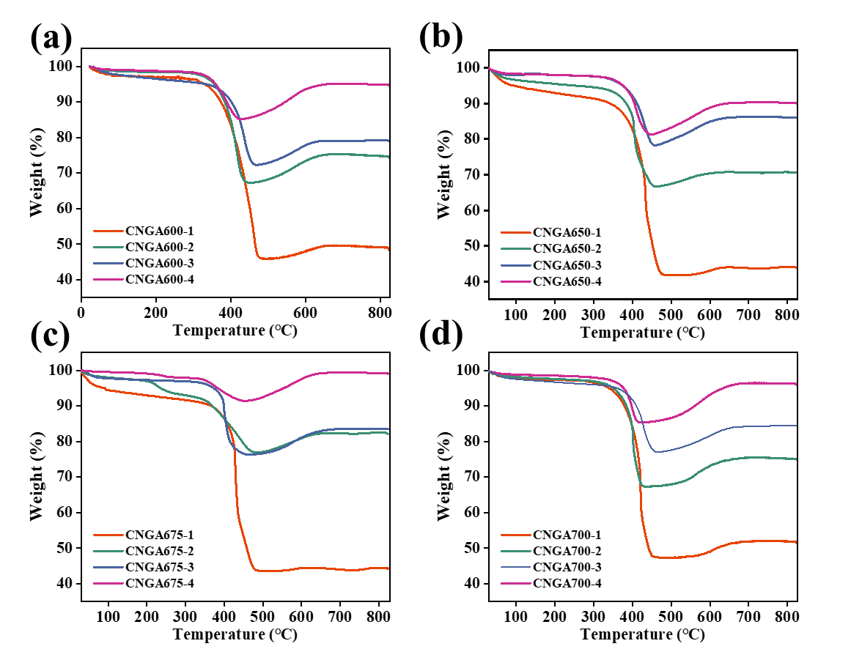
Figure S11. TGA curves of CNGA-1 to CNGA-4 at 600, 650, 675, 700 carbonization degrees.
$m_{0}=m_{C}+m_{NGHM}$ （S1）
$m_{N\dot{i}}=\frac{k_{NGHM}}{k_{Ni}}×m_{NGHM}$ （S2）
$m_{f}=m_{0}-m_{c}+m_{N_{i}}×k_{Ni}$ （S3）
$w_{Ni}=\frac{m_{Ni}}{m_{0}}=\frac{m_{f}}{m_{0}}×\frac{1}{\frac{k_{NGHM}}{k_{Ni}}+k_{Ni}}$ （S4）
$w_{C}={1-w}_{Ni}×\frac{k_{Ni}}{k_{NGHM}}$ （S5）
$w_{Glass}={1-w}_{Ni}-w_{C}$ （S6）
$v_{C}=\frac{ρ_{bulk}}{ρ_{C}}×w_{C}$ （S7）
$v_{Ni}=\frac{ρ_{bulk}}{ρ_{Ni}}×w_{Ni}$ （S8）
$v_{Ni}=\frac{ρ_{bulk}}{ρ_{Glass}}×w_{Glass}$ （S9）
Equation S1 to S9 are used to calculate the volume fractions of carbon, nickel, glass and DSHM. Where m₀, m_{c}, m_{Ni}, m_{DSHM}, m_{Glass}, m_{f} represents the masses of the original aerogel, carbon, nickel, DSHM, Glass and final species, respectively; k_{DSHM}, k_{Ni} represent the mass fraction of weight increase (upon heating) of DSHM, Ni; ρ_{bulk}, ρ_{Ni}, ρ_{C}, ρ_{Glass} are the bulk density of aerogel and the real density of nickel, carbon and Glass; w_{c}/v_{c} w_{Ni}/v_{Ni}, w_{Glass}/v_{Glass} represent the mass and volume fraction of carbon, nickel and Glass, respectively.
Figure S12. The volume fractions of carbon, nickel, glass and DSHM.
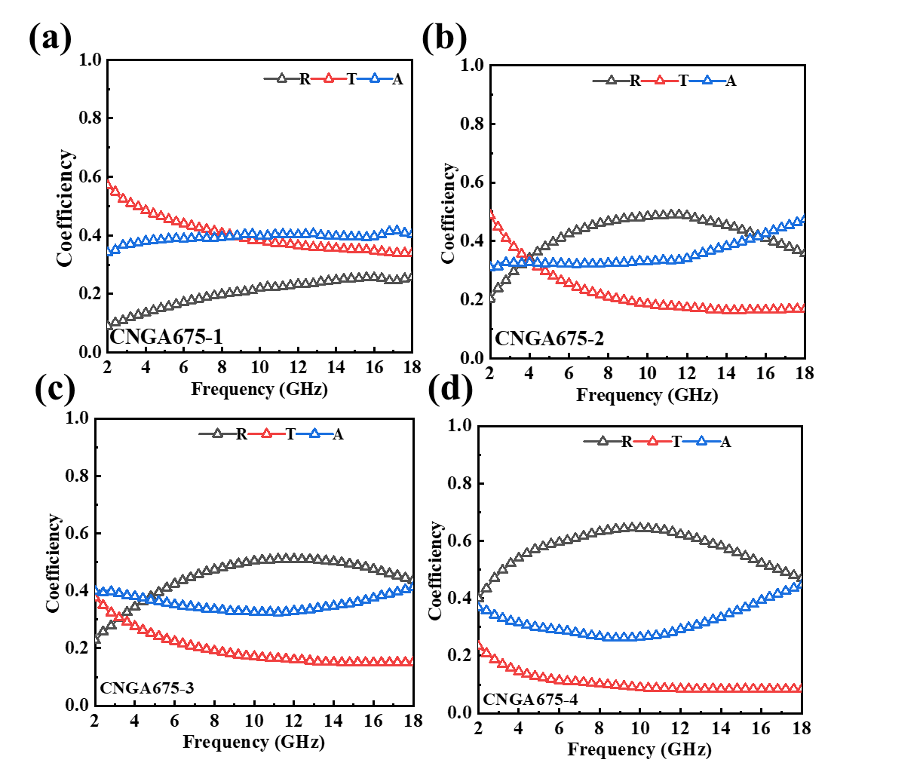
Figure S13. (a-d) The reflection coefficient (R), transmission coefficient (T) and absorption coefficient (A) for CNGA675-1 to CNGA675-4.
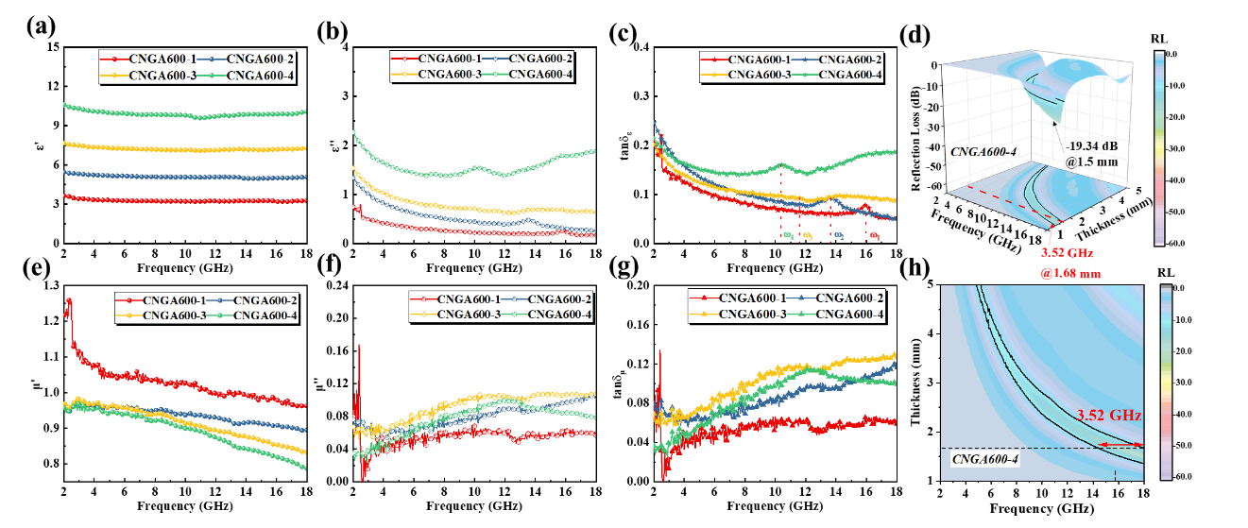
Figure S14. a) - b) Real and imaginary parts of permittivity, c) Dielectric loss tangent of CNGA600-1 to CNGA600-4; d) 3D RL contour maps for CNGA600-4; e) - f) Real and imaginary parts of magnetic permeability, g) magnetic loss tangent of CNGA600-1 to CNGA600-4; h) 2D RL contour maps for CNGA600-4.
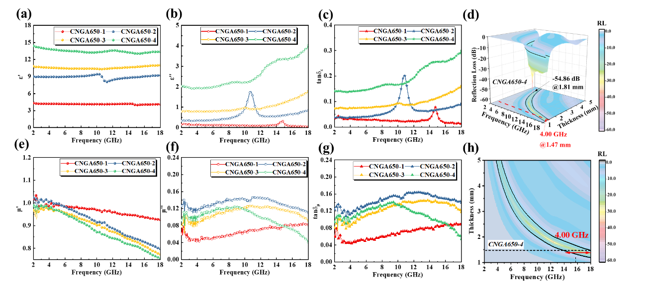
Figure S15. a) - b) Real and imaginary parts of permittivity, c) Dielectric loss tangent of CNGA650-1 to CNGA650-4; d) 3D RL contour maps for CNGA650-4; e) - f) Real and imaginary parts of magnetic permeability, g) magnetic loss tangent of CNGA650-1 to CNGA650-4; h) 2D RL contour maps for CNGA650-4.

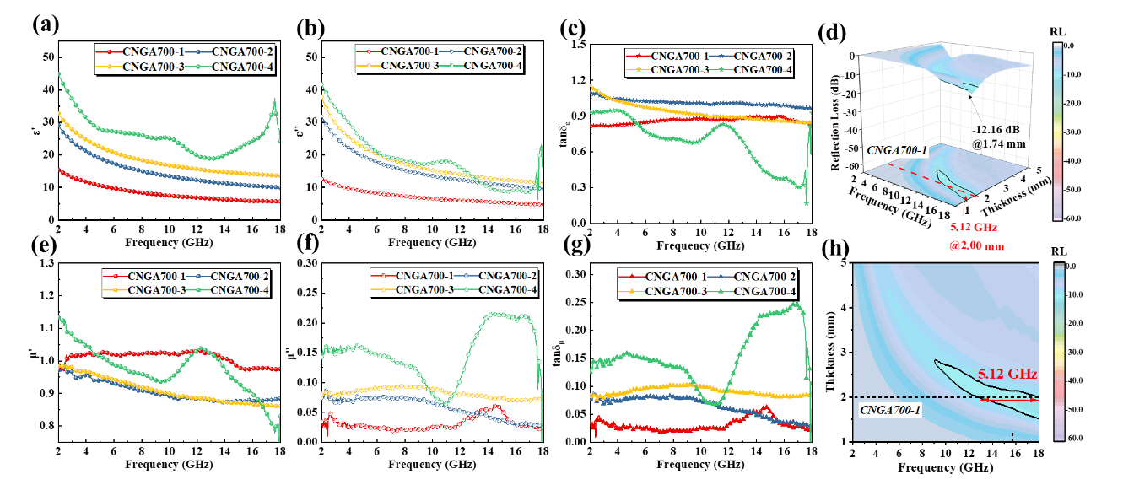Figure S16. a) - b) Real and imaginary parts of permittivity, c) Dielectric loss tangent of CNGA700-1 to CNGA700-4; d) 3D RL contour maps for CNGA600-4; e) - f) Real and imaginary parts of magnetic permeability, g) magnetic loss tangent of CNGA700-1 to CNGA700-4; h) 2D RL contour maps for CNGA700-1.
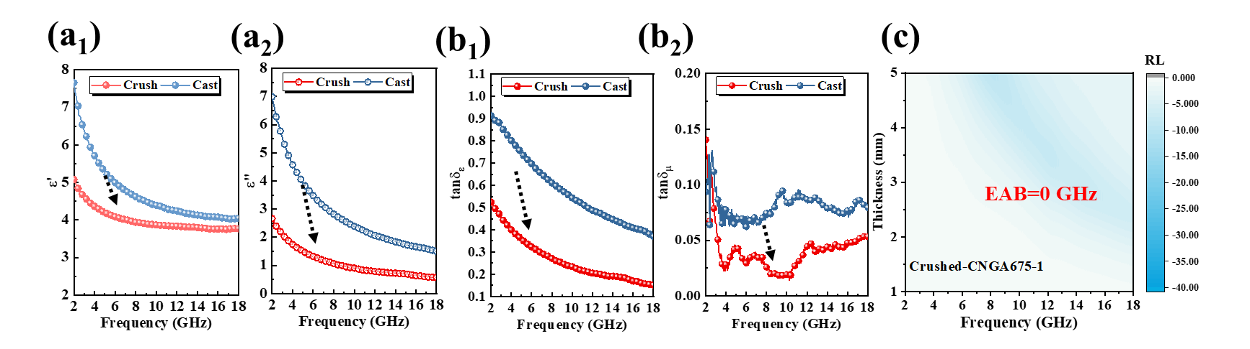
Figure S17. Comparison of measured permittivity a₁) - a₂) and dielectric loss tangent b₁) - b₂) between sampling via casting and crush mixing. c) 2D RL contour map of CNGA675-1 via crush mixing sampling

