Supplementary Tables
Supplementary Table 1. Primer sequences used for quantitative real-time PCR.
Name |  | （5’-3’） | Size（bp）
PXR | F | TCCTGAGGTTCAACACGATG | 98
PXR | R | TTTCTGGAAGCCACCATTAG | 98
Nrf2 | F | TAATACGGAAAACAAGCAGCAGG | 228
Nrf2 | R | AAGGTGGGATTTGAGTCTAAGGAG | 228
GRP78 | F | ACTAAAATGAAGGAGACTGCTGAGG | 108
GRP78 | R | ATCTTTGGTTGCTTGTCGCTG | 108
GAPDH | F | CGGTGCTGAGTATGTCGTGGAGTC | 100
GAPDH | R | GGCGGAGATGATGACCCTTTTG | 100
16S | F | AGAGTTTGATCMTGGCTCAG | 1465
16S | R | GGTTACCTTGTTACGACTT | 1465

Supplementary Table 2. Antibodies used for immunofluorescence and western blot analysis.
IF
Anti-information
Name of primary antibody | Primary antibody source species | producer | number | dilution rate
CD4 | Mouse | proteintech | 67786-1-Ig | 1:400
CYP3A4 | Rabbit | proteintech | 18227-1-AP | 1:200
UGT1A6 | Rabbit | ABclonal | A17166 | 1:200
HSD17B6 | Rabbit | proteintech | 11855-1-AP | 1:200
SRD5A3 | Rabbit | absin | abs109671 | 1:100
Anti-Second Antibody Information
Name of secondary antibody | Source species of secondary antibody | producer | number | dilution rate
Multi-rAb® CoraLite® Plus 488-Goat Anti-Mouse Recombinant Secondary Antibody (H+L) | Goat | proteintech | RGAM002 | 1：500
Multi-rAb® CoraLite® Plus 594-Goat Anti-Rabbit Recombinant Secondary Antibody (H+L) | Goat | proteintech | RGAR004 | 1：500
Multi-rAb® CoraLite® Plus 488-Goat Anti-Rabbit Recombinant Secondary Antibody (H+L) | Goat | proteintech | RGAR002 | 1：500
WB
Anti-information
Name of primary antibody | Primary antibody source species | producer | number | dilution rate
Cleaved-Caspase3 | Rabbit | Affinity | AF7022 | 1:500
SRD5A3 | Rabbit | Absin | abs109671 | 1:1000
UGT1A6 | Rabbit | Proteintech | 23765-1-AP | 1:1000
GAPDH | Mouse | Proteintech | 60004-1-Ig | 1：2000
CYP3A4 | Rabbit | Proteintech | 18227-1-AP | 1:1000
HSD17B6 | Rabbit | Proteintech | 11855-1-AP | 1:1000
Anti-Second Antibody Information
Name of secondary antibody | Source species of secondary antibody | producer | number | dilution rate
goat anti-rabbit IgG-HRP | Goat | Proteintech | RGAR001 | 1：4000
goat anti-mouse IgG-HRP | Goat | Proteintech | RGAM001 | 1：4000

Supplementary Table 3. NT database alignment results for species identification of E. hirae Y-HS
SeqID | Accession | start | end | length | Identity | Evalue | Species
chr | CP109802.1 | 931,424 | 1,174,944 | 243,533 | 99.857 | 0 | Enterococcus hirae
chr | CP109802.1 | 2,559,939 | 2,758,616 | 198,729 | 99.899 | 0 | Enterococcus hirae
chr | CP109802.1 | 584,766 | 718,768 | 134,049 | 99.859 | 0 | Enterococcus hirae
chr | CP109802.1 | 2,080,056 | 2,191,390 | 111,368 | 99.883 | 0 | Enterococcus hirae
chr | CP109802.1 | 1,940,237 | 2,042,453 | 102,219 | 99.902 | 0 | Enterococcus hirae
plasmid1 | CP068123.1 | 1,975 | 20,477 | 18,508 | 99.805 | 0 | Enterococcus hirae
plasmid1 | CP068123.1 | 21,496 | 38,524 | 17,046 | 98.486 | 0 | Enterococcus hirae
plasmid1 | CP068123.1 | 41,904 | 50,317 | 8,414 | 99.905 | 0 | Enterococcus hirae
plasmid1 | CP068123.1 | 50,318 | 51,668 | 1,352 | 96.672 | 0 | Enterococcus hirae
plasmid1 | CP068123.1 | 51,874 | 52,705 | 832 | 96.514 | 0 | Enterococcus hirae

Supplementary Table 4. Genomic safety assessment of E. hirae Y-HS
Category | Gene/Feature | Detection | Location
Acquired resistance genes | vanA, vanB, ermB, tetM, mecA, qnr | Not detected | —
Enterococcal virulence factors | cylA, esp, ace, gelE, asal | Not detected | —
Intrinsic resistance genes | efrA/efrB, pmrA, arlR/arlS, rpoB, gyrA/gyrB, parC/parE, dfrE, AAC(6')-Iid, lmrD, mdtG | Detected | Chromosome
Plasmid content | Transferable resistance/virulence genes | Not detected | Plasmid

Supplementary Table 5. Probiotic-associated genes identified in the genome of E. hirae Y-HS

Category | Gene | Product
Adhesion | efaA | Endocarditis-specific antigen
Adhesion | ebp | Endocarditis and biofilm-associated pilus
Adhesion | pilB | Type IV pilus assembly protein
Adhesion | ecbA | Collagen-binding adhesin
Stress survival | bsh | Bile salt hydrolase
Stress survival | groEL | Chaperonin GroEL
Stress survival | clp family | ATP-dependent Clp protease
Capsule/Biofilm | cps | Capsule biosynthesis protein
Capsule/Biofilm | galU | UTP-glucose-1-phosphate uridylyltransferase
Capsule/Biofilm | rfb | dTDP-rhamnose biosynthesis protein

Supplementary Figures
Fig. S1. Quality control assessment of transcriptomic datasets. (a) Density plot showing the distribution of gene expression values across all samples from GSE179285 after normalization. The overlapping curves with similar shapes and peaks indicate uniform expression patterns and high data comparability among samples. (b) Boxplot of gene expression distributions across all samples after normalization. The similar medians and interquartile ranges confirm consistent expression levels and good data quality for downstream analysis. (c) Principal Component Analysis (PCA) plot of samples. The first principal component (Dim1) and second principal component (Dim2) explained 16.3% and 8.9% of the total variance, respectively. Healthy control samples (blue dots) and UC patient samples (yellow triangles) showed a clear separation trend along the Dim1 axis, indicating significant differences in gene expression patterns between the two groups. However, partial overlap in the central region suggests considerable heterogeneity within UC samples. This result provides a foundation for subsequent differential expression analysis and functional studies.
Fig. S2. Biochemical characterization of the bacterial strain. (a) Growth kinetics of strain Y-HS cultured in MRS broth, depicting optical density at 600 nm (OD600) over time. (b) Hemolytic activity assay performed on Columbia blood agar. The absence of a clear zone around colonies indicates γ-hemolysis (non-hemolytic phenotype). (c)-(f) Antibiotic susceptibility profile of Y-HS determined by the Kirby-Bauer disk diffusion method on Mueller-Hinton (MH) agar, demonstrating susceptibility to (c) Minocycline, clarithromycin, gatifloxacin, erythromycin, (d) Ampicillin, tetracycline, teicoplanin, vancomycin, (e) Levofloxacin, doxycycline, chloramphenicol, rifampin, and (f) Penicillin, fosfomycin, streptomycin, nitrofurantoin.
Fig. S3. Bioinformatics analysis of differentially expressed genes in ulcerative colitis. (a) Volcano plot illustrating 768 differentially expressed genes (DEGs) identified from the GSE179285 dataset. Genes with |log₂ fold change| > 0.5 and an adjusted P-value < 0.05 are highlighted in red (upregulated) and green (downregulated). (b) Hierarchical clustering heatmap of the top 50 DEGs, showing clear separation between UC patient and healthy control samples. (c) Gene Ontology (GO) enrichment analysis of DEGs across biological process, cellular component, and molecular function categories. (d) Kyoto Encyclopedia of Genes and Genomes (KEGG) pathway enrichment analysis. (e)-(f) Gene set enrichment analysis (GSEA) plots depicting significant enrichment of hallmark pathways, including (e) "Chemical carcinogenesis-DNA adducts" and (f) "Drug metabolism via cytochrome P450," in the UC patient group.
Fig. S4. Complete uncropped western blot images. Full membranes corresponding to Fig. 9a showing immunodetection of CYP3A4 (~53 kDa), UGT1A6 (~70 kDa), HSD17B6 (~35 kDa), SRD5A3 (~42 kDa), Cleaved-Caspase3 (~17 kDa) and GAPDH (~37 kDa) in colon tissue samples from all experimental groups. Lane assignments: 1, Control; 2, DSS model; 3, DSS + Low-dose Y-HS; 4, DSS + Medium-dose Y-HS; 5, DSS + High-dose Y-HS. Molecular weight markers are indicated on the left.

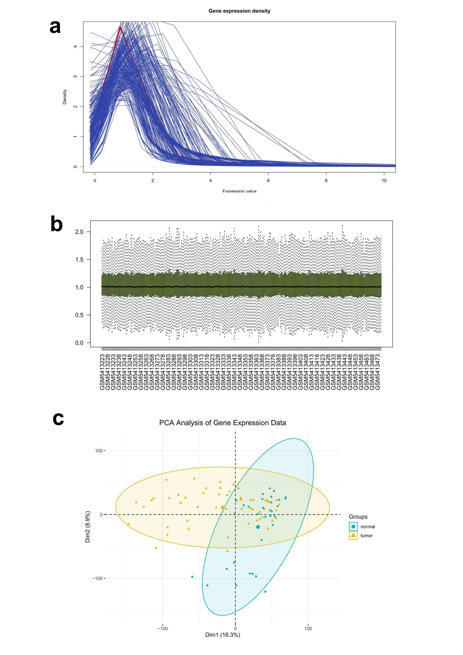
Fig. S1.

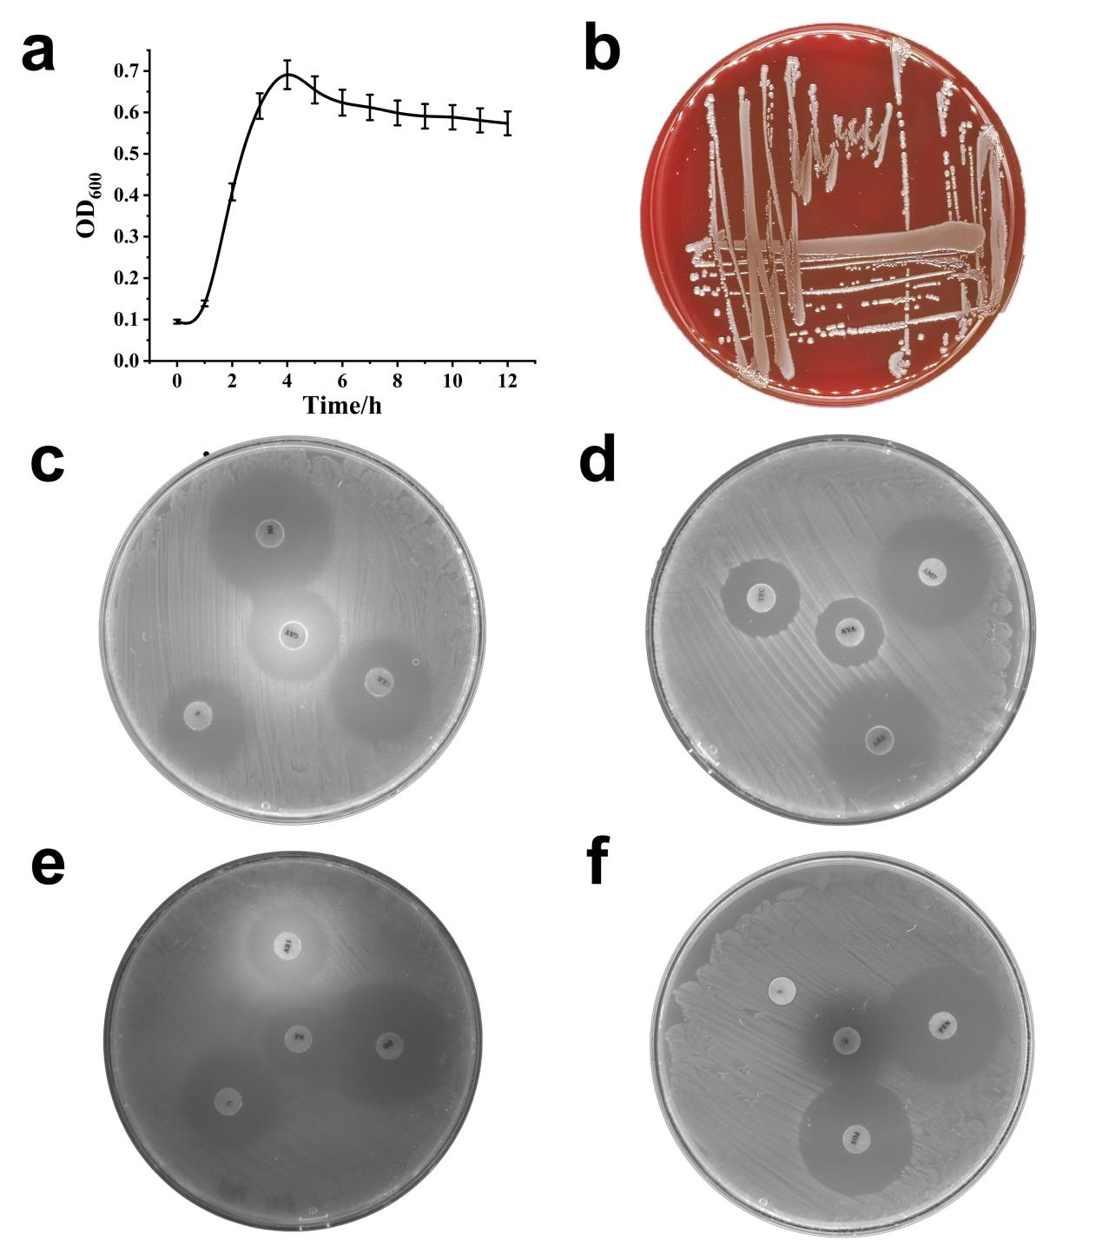
Fig. S2.

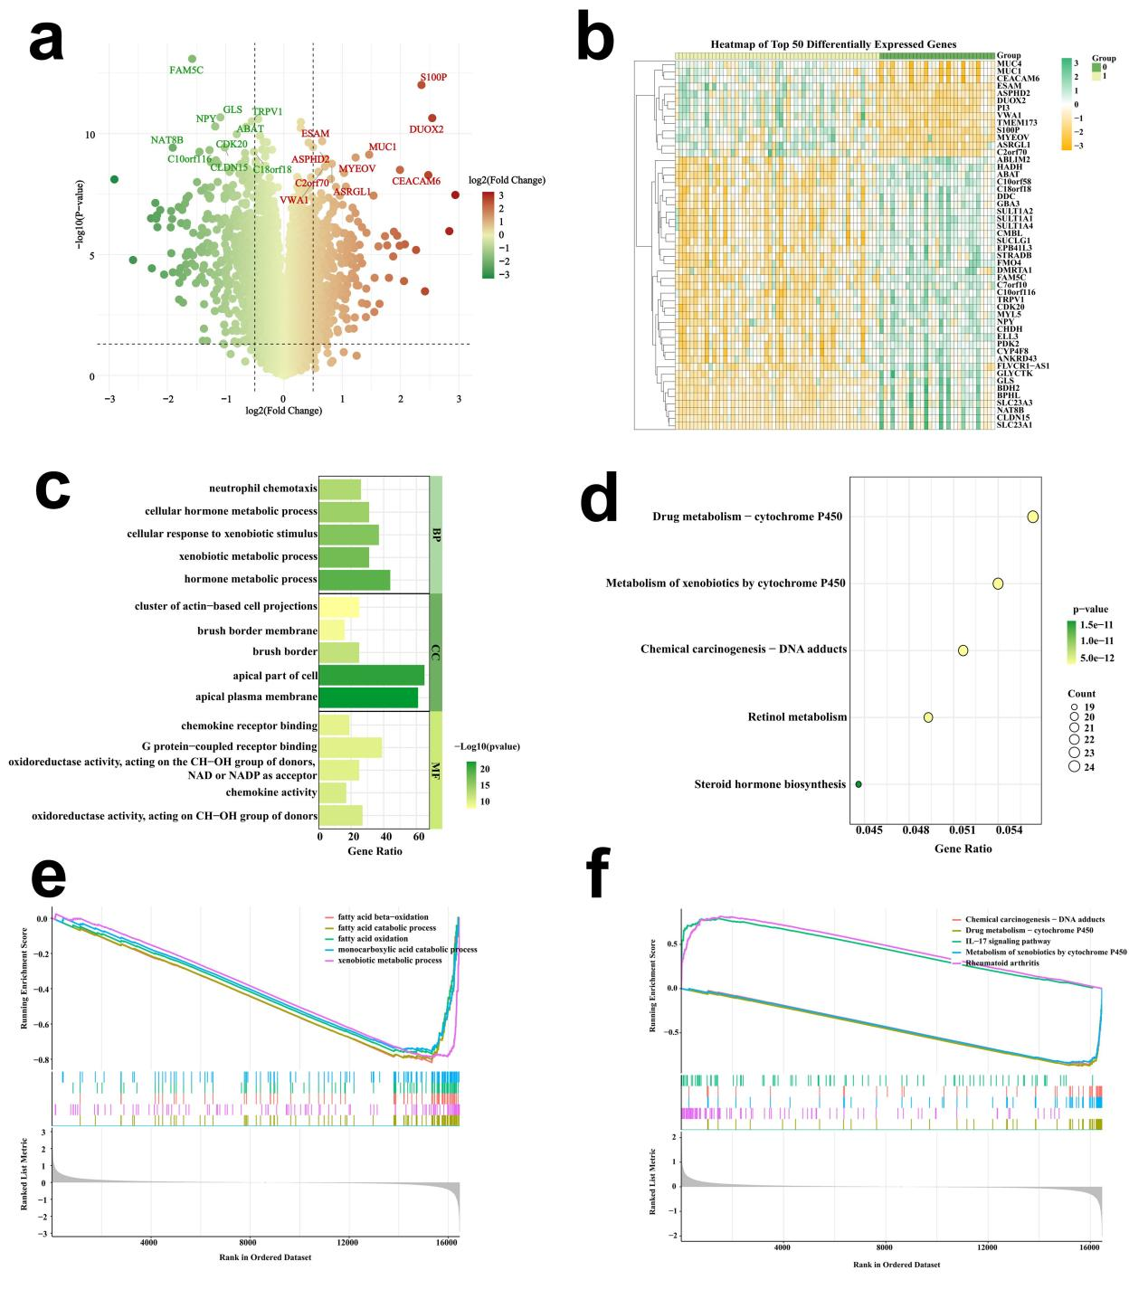
Fig. S3.

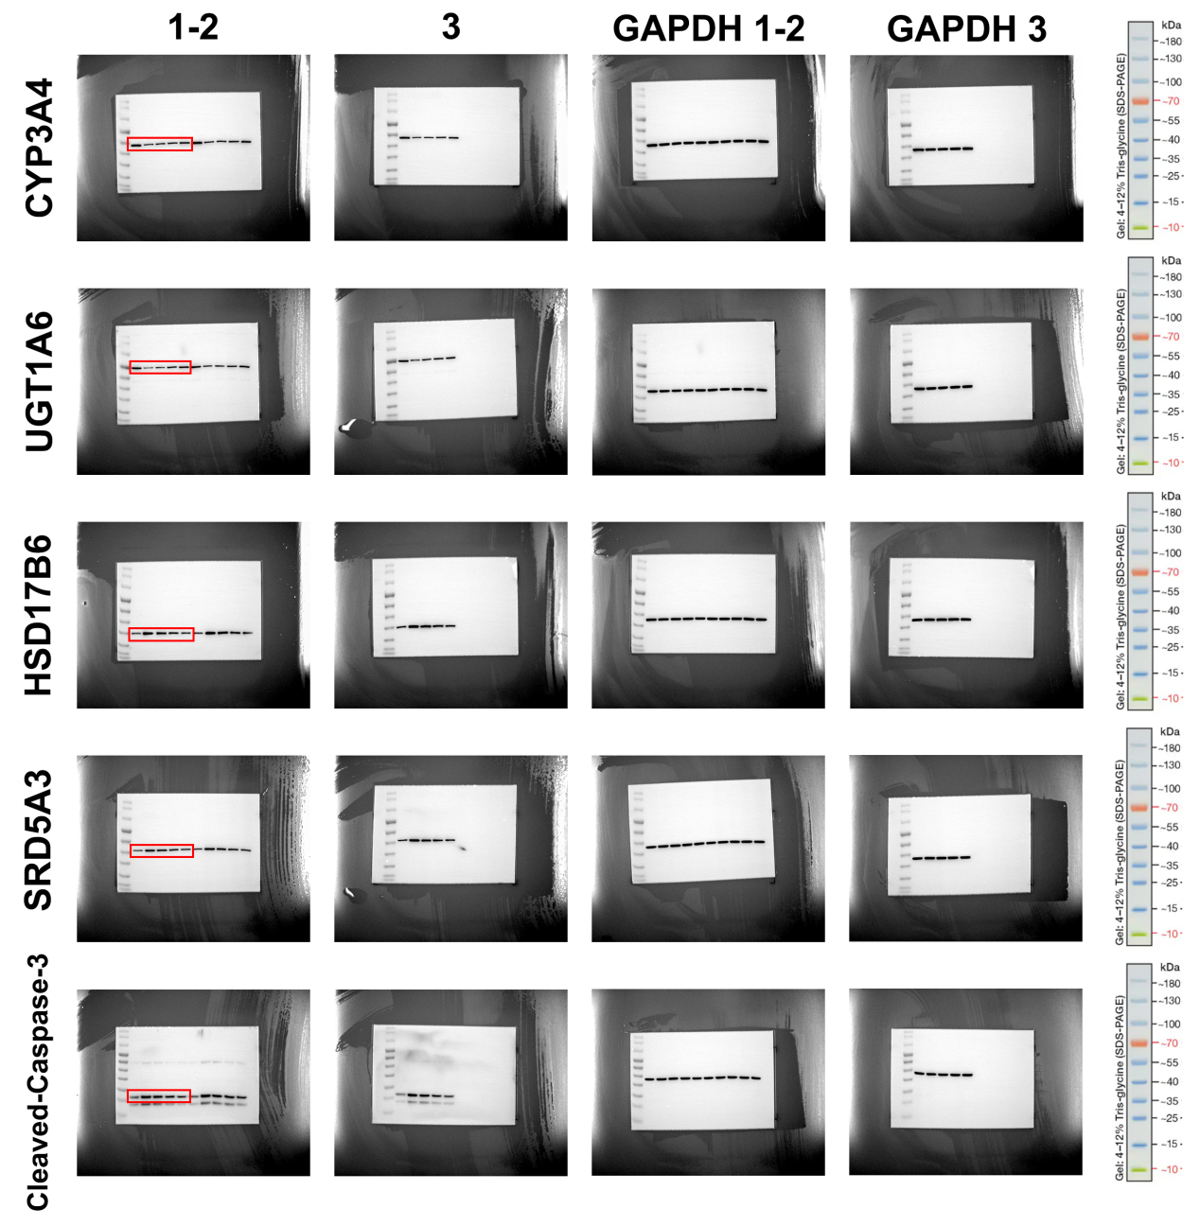
Fig. S4.

