Figure S1. Sequencing depth coverage of the E. chloranthoides chloroplast genome.
The Illumina short reads were mapped to the assembled chloroplast genome, and the sequencing depth coverage profile was generated using qualimap (v.2.2.2-dev).
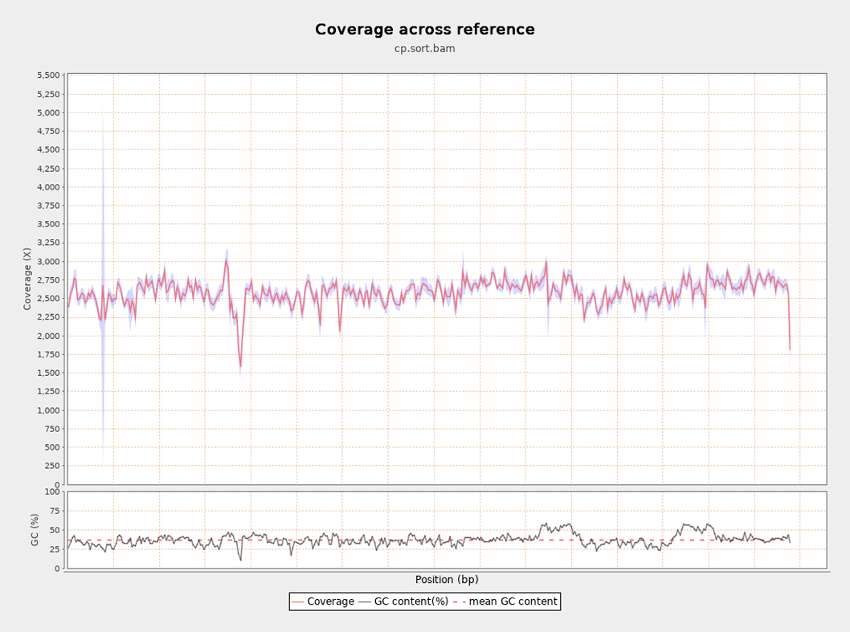

Figure S2. Sequencing depth coverage of the E. chloranthoides mitochondrial genome.
The Oxford Nanopore long-reads were mapped to the assembled mitochondrial genome, and the sequencing depth coverage profile was generated using qualimap (v.2.2.2-dev).
A. Contig1 of the mitochondrial genome
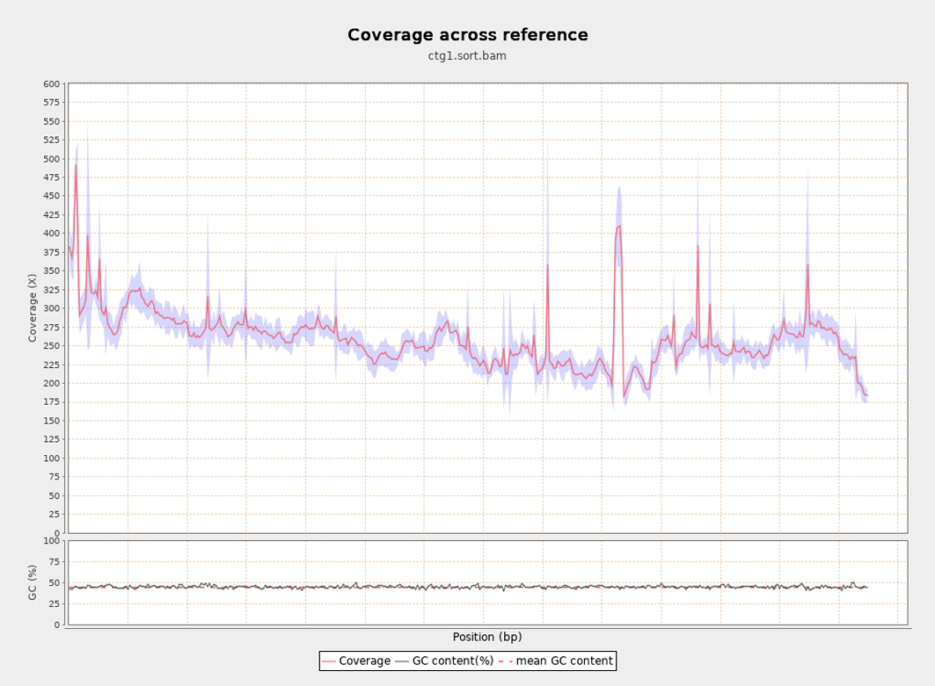
B. Contig2 of the mitochondrial genome
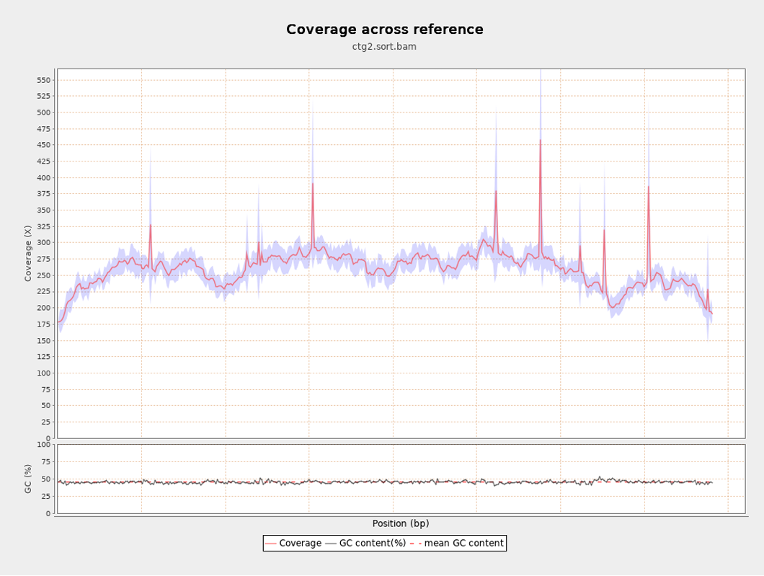

C. Contig3 of the mitochondrial genome
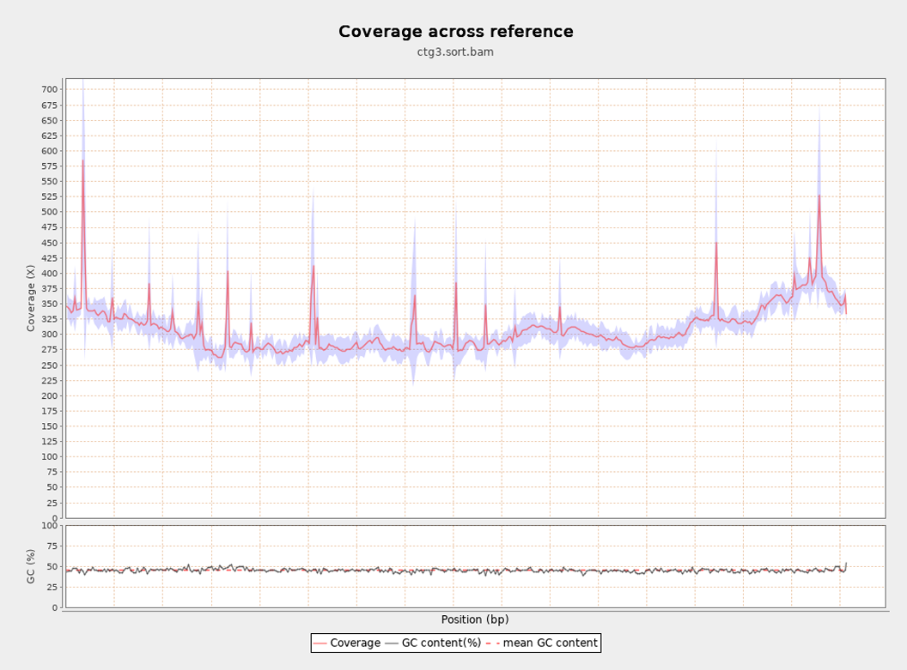
D. Contig4 of the mitochondrial genome
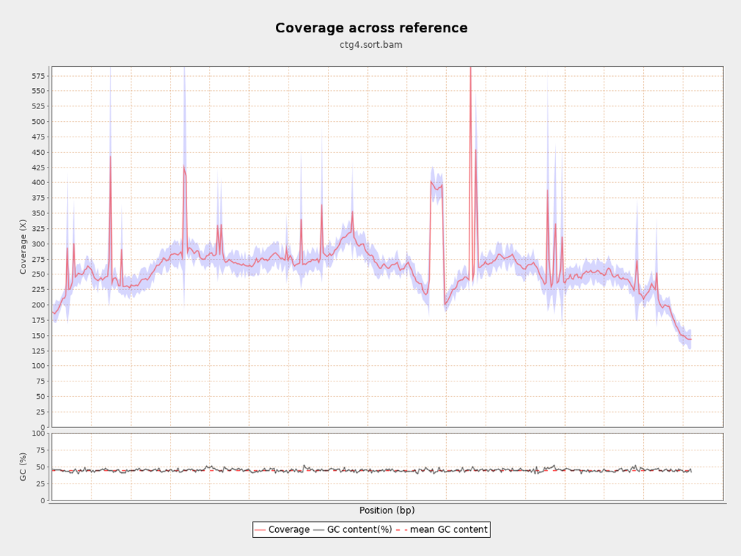

E. Contig5 of the mitochondrial genome
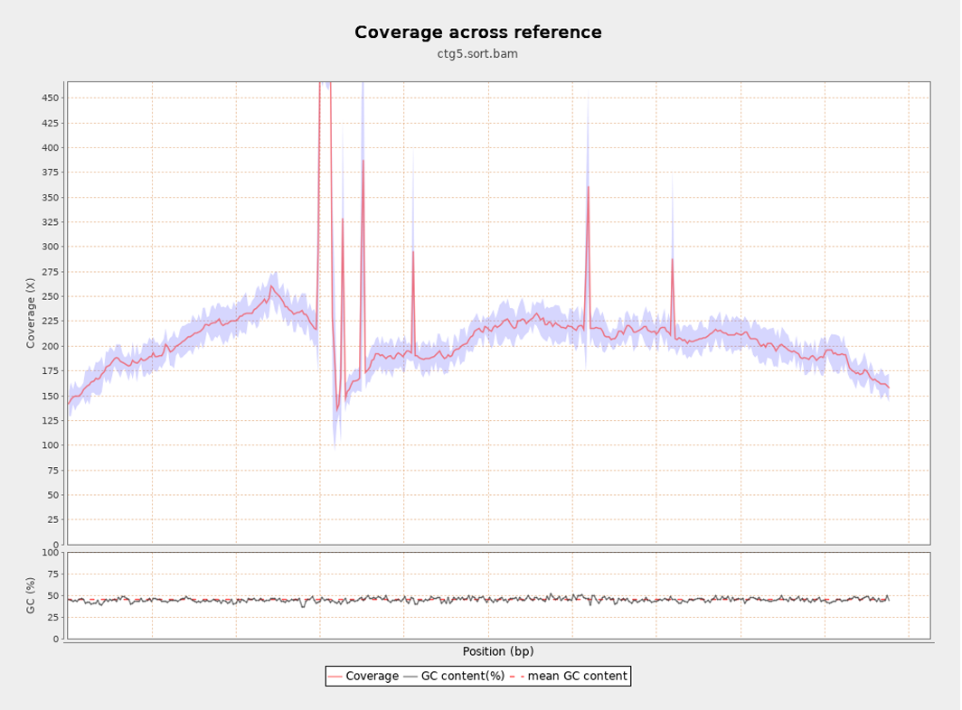
F. Contig6 of the mitochondrial genome
