Supplemental Information
SI1: Seasonality of SST Response in CESM2 4xAbruptCO2 Experiment
To test whether the seasonality of the SST response is due to a transient rather than equilibrated state, we also investigate the seasonal response of the CESM2 Abrupt4xCO2 simulation in Fig. S1. The Abrupt4xCO2 experiment is branched from the PI-Control simulation at year 501; the time monthly timeseries of SST are plotted for both simulations in Fig. 3a. The annual mean SST increases by 4°C in about a decade (likely due to the rapid response of the surface ocean) followed by gradual warming over the next thousand years (presumably as the deep ocean responds). By the end of the 1000yr simulation the annual SST approaches equilibrium. Like the HIST, DAMIP, and SSP585 experiments, the 4xAbruptCO2 simulation shows a consistent seasonal response (Fig. S1a) throughout the entire simulation with a maximum SST response during late boreal summer (September) and minimum response during boreal late winter / early spring (March).
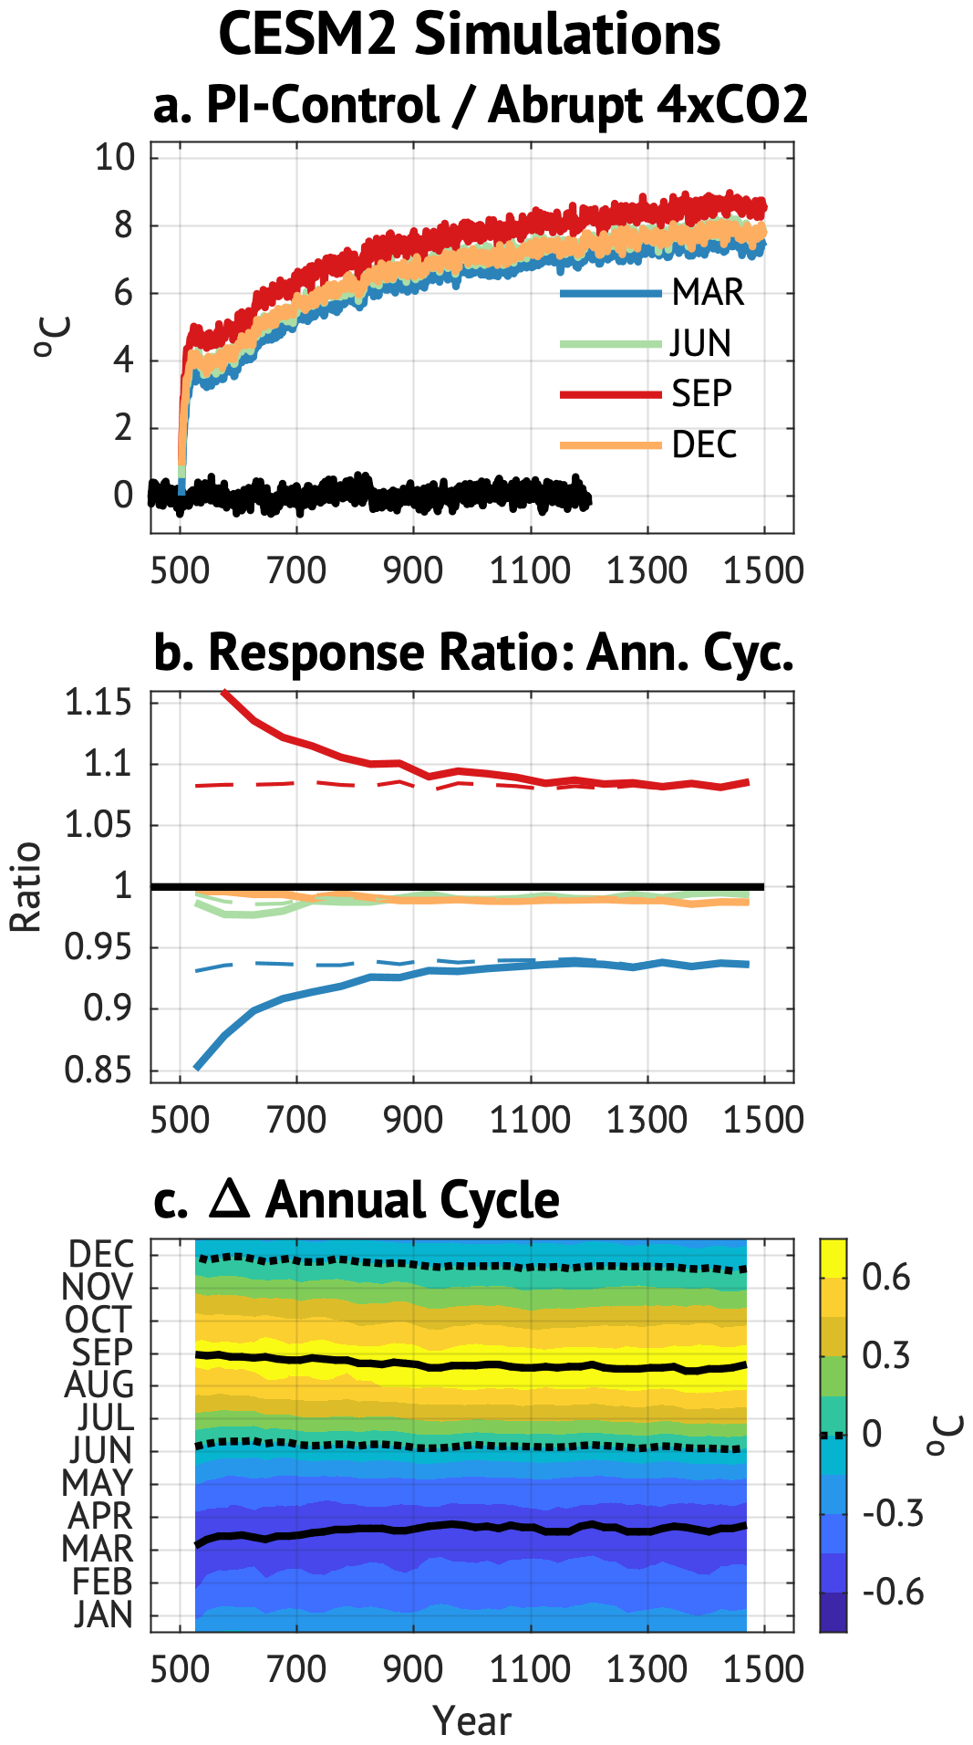
Figure S1: Mid-latitude SST in the CESM2 4xAbruptCO2 simulations. (a) Seasonal SST over the mid-latitude oceans. (b) Ratio of seasonal SST change to annual SST change (solid lines), and ratio of SST change to equilibrated (last 100yr) annual SST change (dashed lines). (c) Change in annual cycle of SST.
The seasonality of the response in the Abrupt4xCO2 simulation is further illustrated in Fig. S1b (solid lines) by calculating the response ratio of each month’s change for a given 50yr period $ΔT_{i}(t_{yr})$ to the annual mean change for a given period $Δ\overline{T}(t_{yr})$:
$$RR_{i}\left(t_{yr}\right)=\frac{ΔT_{i}\left(t_{yr}\right)}{Δ\overline{T}\left(t_{yr}\right)}$$
The response ratio is largest immediately after the imposed forcing and asymptotes toward a steady ratio as the annual mean temperature asymptotes. The response ratio can be decomposed into contributions from changes in the annual cycle (the numerator) and the mean annual change (both the numerator and denominator). The long-term change, though, is largely due to the changing annual mean rather than a changing annual cycle: the evolving annual cycle (calculated over successive 50yr windows) is plotted in Fig. S1c and shows very little change through time. Further, when the response ratio is recalculated as the ratio of the annual cycle in Fig. S1c to the equilibrated change (the temperature change over the last 100yr of the Abrupt4xCO2 simulation), the response ratio (Fig. S1b, dashed lines) remains steady throughout the simulation indicating that the seasonal response is rapid and consistent. This suggests the seasonal response is controlled by upper ocean coupled processes and motivates the use of the seasonally entraining MLM.
SI2: MLM Response to Impulsive Forcing
An example of the entraining mixed layer response to a constant impulse of forcing during January is depicted in Fig. S2. The forcing induces an immediate positive temperature anomaly in the mixed layer which begins to damp in the ensuing February through June through surface heat fluxes. As the mixed layer shoals from March through August, water – and its associated heat content – is sequestered below the mixed layer where it is shielded from surface heat fluxes (blue lines in Fig. S2a) until it is re-entrained into the mixed layer as the mixed layer deepens from August through the following March. This process continues, effectively prolonging the damping time scale of vertically integrated heat content anomalies (see Deser et al. 2003). The seasonality of the surface heat flux (positive upward) feedback is illustrated in Fig. 4a and shows that surface fluxes damp surface temperature anomalies most effectively during boreal winter and least effectively during boreal summer.

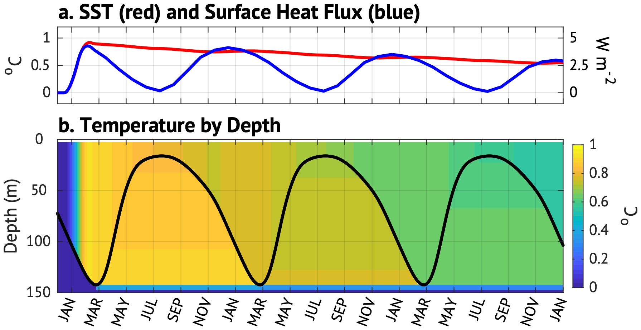
Figure S2: Entraining mixed layer model response to an impulse forcing during January of year 1. (a) SST (red) and surface heat flux (blue). (b) Vertical structure of (black line) the MLM mixed layer depth and (shading) ocean temperature through time.

SI3: Feedback Parameter Derivation
The latent and sensible heat flux parameters are calculated using a Taylor expansion of the seasonal bulk turbulent heat fluxes:
$$\begin{aligned}\begin{matrix}LH\left(\overline{t}\right)≈\overline{LH}\left(\overline{t}\right)+{\left.\frac{dLH}{dT_{s}}\right|}_{\overline{T_{s}}\left(\overline{t}\right)}T_{s}^{'}\left(t\right)+… \\ SH\left(\overline{t}\right)≈\overline{SH}\left(\overline{t}\right)+{\left.\frac{dSH}{dT_{s}}\right|}_{\overline{T_{s}}\left(\overline{t}\right)}T_{s}^{'}\left(t\right)+…\end{matrix}\#\left(A1\right)\end{aligned}$$
where $T_{s}$ is the SST [equal to $T_{ML}$ in (1)], overbars denote climatological averages for a given calendar month (indicated by $\overline{t}$), and the prime indicates the departure from climatology. The feedback parameters $λ_{LH}$ and $λ_{SH}$ are equal to the derivatives on the right hand side of (A1) and assume no change in the climatological values for the bulk transfer coefficient, wind speed, and air density.
The bulk formula for latent heat flux is:
$$\begin{aligned}LH={L_{v}C}_{E}ρ_{a}\left|U\right|\left(q_{sat}\left(T_{s}\right)-rq_{sat}\left(T_{a}\right)\right) \end{aligned}$$
where $L_{v}$ is the latent heat of vaporization, $C_{E}$ is a stability-dependent transfer coefficient, $U$ is the scalar wind speed, $ρ_{a}$ is the air density, $q_{sat}\left(T\right)$ is the saturated specific humidity at temperature $T$, and $r$ is the near-surface relative humidity. To calculate its partial derivative, assumptions must be made about changes in the air-sea temperature difference, the relative humidity, and the stability parameter. Here, we assume no change in wind, stability parameter, or relative humidity. Following the derivation in (Lorenz et al. 2010) we take the logarithm and derivative of $LH$ yielding
$$\begin{aligned}\frac{1}{LH}\frac{dLH}{dT_{s}}=\frac{\left({\left.\frac{dq_{s}}{dT}\right|}_{T=T_{s}}-r{\left.\frac{dq_{s}}{dT}\right|}_{T=T_{a}}\frac{dT_{a}}{dT_{s}}\right)}{q_{s}\left(T_{s}\right)-rq_{s}(T_{a})}\#\left(A2\right)\end{aligned}$$
Noting that the Clausius-Clapeyron rate $α=\frac{1}{q_{s}}\frac{dq_{s}}{dT}=\frac{L_{v}}{R_{v}T^{2}}$, assuming that $α\left(T_{s}\right)≈α\left(T_{a}\right)$, and defining $γ=dT_{a}/dT_{s}$as the ratio of air temperature change to ocean surface temperature change, we can rewrite (A2) as:
$$\begin{aligned}\frac{1}{LH}\frac{dLH}{dT_{s}}=\frac{\left(αq_{s}(T_{s})-rα{γq}_{s}(T_{a})\right)}{q_{s}\left(T_{s}\right)-rq_{s}(T_{a})}\end{aligned}$$
Upon adding and subtracting $rαq_{s}(T_{a})$ in the numerator, we find:
$$\begin{aligned}λ_{LH}≡\frac{∂LH}{∂T_{s}}=α\left[1-\frac{\left(γ-1\right)rq_{sat}\left(T_{a}\right)}{q_{sat}\left(T_{s}\right)-rq_{sat}\left(T_{a}\right)}\right]⋅LH\#\left(A3\right)\end{aligned}$$

The sensible heat flux feedback parameter is also derived from the bulk formula:
$$\begin{aligned}SH={c_{p}C}_{E}ρ_{a}|U|\left(T_{s}-T_{a}\right) \end{aligned}$$
Again, assuming no change in wind or stability:
$$\begin{aligned}λ_{SH}≡\frac{dSH}{dT_{s}}={c_{p}C}_{E}ρ_{a}\left|U\right|\left(1-γ\right).\#\left(A4\right)\end{aligned}$$
This shows that the mean upward sensible heat flux is reduced when $γ>1$ as air temperature warms more than SST, reducing the (absolute) air-sea temperature difference. The latent and sensible heat flux parameters are calculated using climatological values for density and wind speed, calculated from the iCOADS data set (Freeman et al. 2017). Values estimated from the CESM Historical simulation are similar.
The latent heat flux feedback parameter (A3) contains two terms that are multiplied by the mean (seasonal) latent heat flux itself. The first is simply the Clausius-Clapeyron rate $α$; for mid-latitude conditions $α≈6.2\%$, which indicates that a uniform warming of the ocean and atmosphere will produce a fractional increase in the mean latent heat flux. The second term is proportional to the air-sea temperature change $γ$: when $γ=1$ the latent heat flux changes at the Clausius-Clapeyron rate. When $γ>1$ the equilibrated atmosphere warms more than the ocean, reducing the absolute air-sea temperature difference, which reduces the vertical moisture gradient, and hence reduces the change in upward latent heat flux per unit change in surface temperature. The sensible heat flux parameter (A4) is proportional to $1-γ$, which implies no change in sensible heat flux if $γ=1$, and a reduction in sensible heat flux when $γ>1$ (for $γ>1$ the atmosphere warms more than the ocean, and hence a warming of the surface counterintuitively implies a downward change in sensible heat flux).
While the air-sea temperature change $γ$ does have a large effect on the mean temperature change, it has very little effect on the fractional seasonal response (the amplitude of the seasonal response relative to the mean response; see SI1). The assumption that $\frac{dT_{a}}{dT_{s}}≈1$ implies that the ocean/atmosphere system is effectively in equilibrium, which reduces damping of the ocean (Barsugli and Battisti 1998). This assumption distinguishes the feedback parameter used herein from other estimates based on natural variability (Frankignoul and Kestenare 2002; Park et al. 2005; Liu et al. 2023). The CMIP3 climate models simulate $γ≈1.064$ (Lorenz et al. 2010) which reduces the negative latent heat flux feedback and produces a positive sensible heat flux feedback; for reference, the CESM Abrupt4xCO2 simulation approaches $γ≈1.07$ by year 1000 over the study region, which is the value we use herein.

SI4: Sensitivity to $γ$
While the annual mean response of the oceanic mixed layer (Fig. S3a) is sensitive to the value of $γ$ ($γ=dT_{a}/dT_{s}$) the seasonality of the response (Fig. S3b) is relatively insensitive. The seasonal feedback parameter was recalculated using values of $γ$ ranging from $γ=0.8$ to $γ=1.16$ and the MLM was run to equilibrium with constant 1 W m² forcing. The resulting annual mean temperature is plotted as a function of $γ$ in Fig. S3a, and shows that the annual mean response is sensitive to $γ$. The seasonal response ratio (see section SI1) is plotted in Fig. S3b and is largely insensitive to values of $γ$.
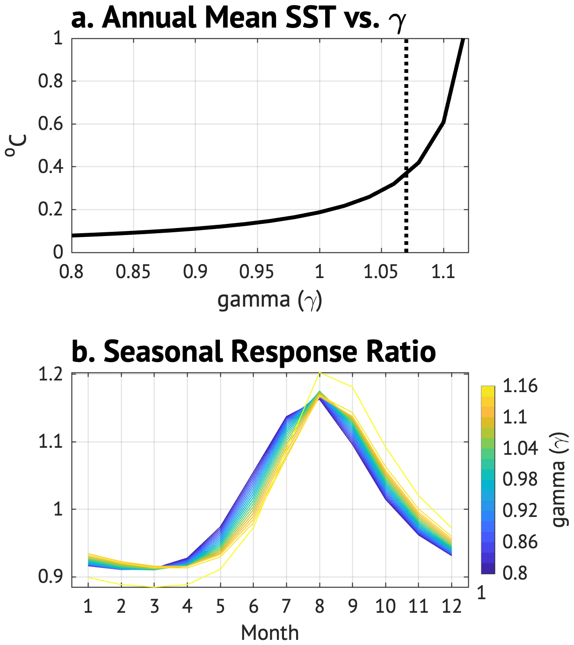
Figure S3: MLM equilibrium sensitivity to different values of $γ$. (a) Annual mean MLM SST as a function of $γ$. (b) Seasonal response ratio (see SI1) for different values of $γ$. Different colors indicate different values for $γ$.

SI5: Seasonality of Radiative Forcing
The seasonality of radiative forcing is inferred from the RFMIP simulations (Table 1) by subtracting the PIC-Cont simulation from the PIC-AER or PIC-GHG simulations. In these simulations the atmospheric component of CESM2 (CAM5) is run for 30yr using fixed SST taken from the PI-Control simulation. The PIC-Cont simulation uses preindustrial values for aerosol and greenhouse gas emissions and concentrations, while the PIC-AER and PIC-GHG use aerosol emissions or greenhouse gas emissions / concentrations set at 2000 levels. The differences in surface radiation between the CESM2 PIC-AER (Fig. S4a) or PIC-GHG (Fig. S4b) simulations and the PIC-Cont simulation represents forcing (as opposed to internal feedbacks) as the surface SST is not allowed to adjust. We note that these analyses do not produce a pure “external” forcing as internal and non-local feedbacks are clearly present (e.g. cloud feedbacks, and non-local effects from land adjustment). As such we use these simulations to qualitatively infer seasonality rather than strictly separating forcing from feedback. For reference, analysis of the CESM2 HIST-AER and HIST-GHG simulations produce very similar results though these simulations are more strongly influenced by the adjusted climate state. Specific components of the forcing include the net clear-sky (ClrSky) forcing, net cloud radiative effects (CRE; defined as the difference between all-sky and clear-sky surface radiation); and the total change in surface radiation (sum of ClrSky and CRE total radiation). The total forcing from the PIC-AER simulation is used to estimate seasonality of forcing from aerosols, and the ClrSky forcing is used to estimate greenhouse gas forcing.
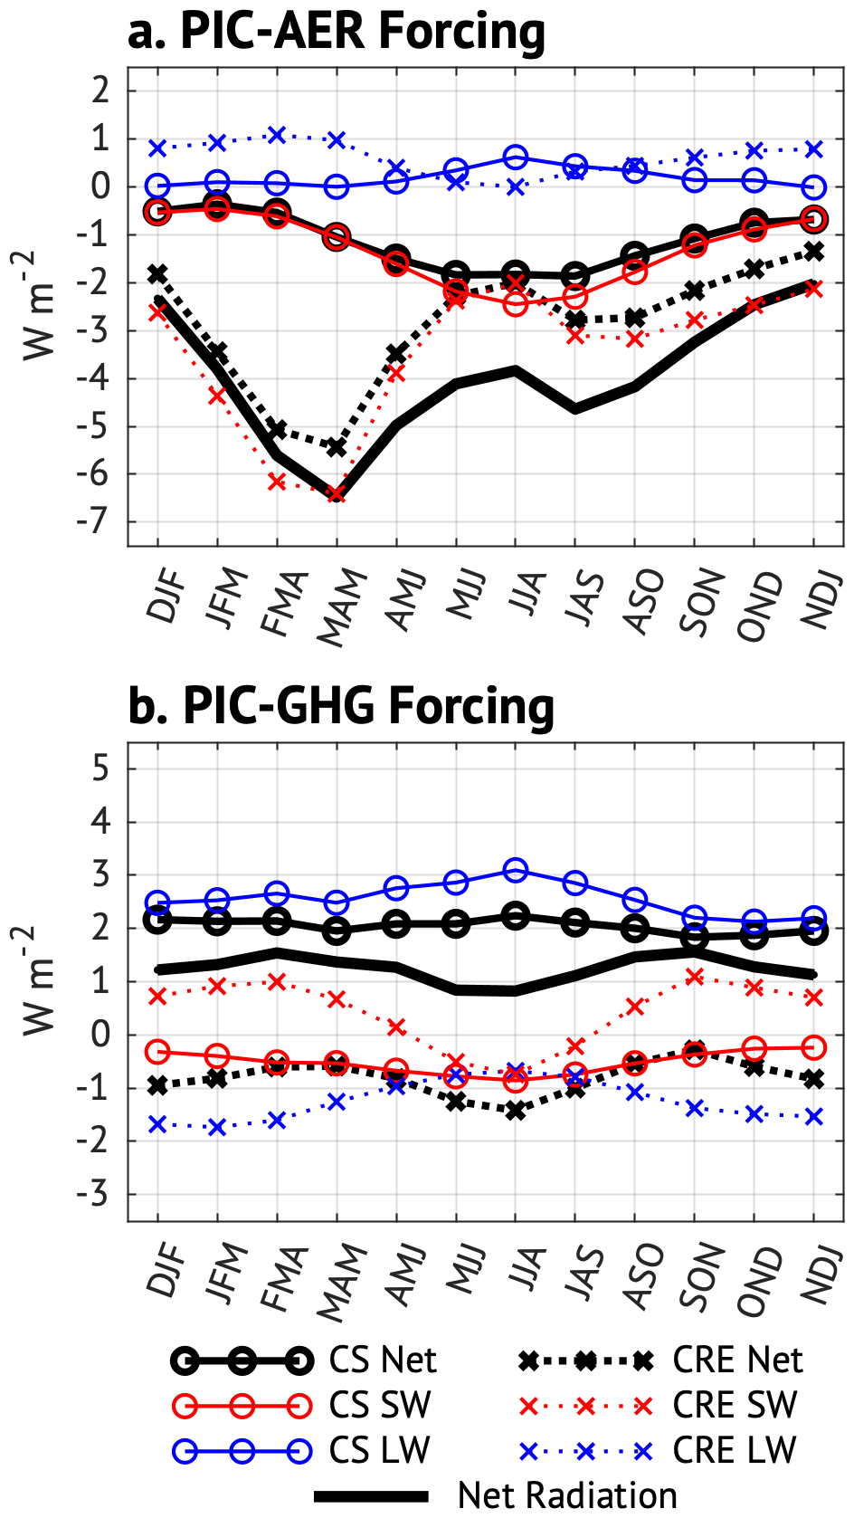
Figure S4: Seasonality of forcing. Radiative changes from (a) PIC-AER minus PIC-Cont (b) PIC-GHG minus PIC-Cont simulations. Forcing is divided into clear sky (CS) and cloud radiative effects (CRE); terms are labelled below the figure. Positive denotes a net flux into the ocean.

The PIC-AER simulation (Fig. S4a) shows a strong seasonal cycle in radiative forcing that is dominated by the shortwave CRE in all seasons except the boreal summer, when the ClrSky effect is comparable. The CRE has maximum amplitude during boreal spring (MAM) with a small secondary peak in boreal fall while the ClrSky seasonality has largest amplitude during boreal summer (JJA). These results match directly simulated shortwave ClrSky and CRE over the North Atlantic (Rathod et al. 2025) and Pacific (Zweifel et al. 2025), and satellite-based estimates of ClrSky sulfate aerosol optical depth and forcing (Matus et al. 2019). The resulting seasonality in total forcing shows largest (negative) forcing of about -6.5 Wm⁻² during boreal Spring (MAM) and weakest forcing of about -2 Wm² (ratio of about 3.25) during late boreal fall and early winter (NDJ). The weak ClrSky longwave effect (Fig. S2) and importance of shortwave forcing (including direct and cloud indirect) in the PIC-AER simulation suggest that the total shortwave radiative changes in the PIC-AER simulation may be more representative of actual forcing from aerosols rather than feedbacks.
Radiative changes in the PIC-GHG simulation (Fig. S4b) show very different seasonality than the PIC-AER simulation, though it is still difficult to disentangle the forcing from feedback due to the dominance of longwave terms. To avoid potential cloud feedbacks, we use the ClrSky forcing to infer seasonality (Fig. 8) though in nature clouds may mask that forcing (Sledd and L’Ecuyer 2019; Mosso et al. 2024). The PIC-GHG simulation shows nearly constant ClrSky changes of about 2 Wm^{‑2}. The CRE changes do show some seasonality that is consistent with the HIST-GHG simulation, but even if the CRE effects are included the seasonality of the total radiation change is weak compared to the PIC-AER simulation.

SI6: Models used in this analysis
We acknowledge the World Climate Research Programme, which, through its Working Group on Coupled Modelling, coordinated and promoted CMIP6. We thank the climate modeling groups for producing and making available their model output, the Earth System Grid Federation (ESGF) for archiving the data and providing access, and the multiple funding agencies who support CMIP6 and ESGF.

Data produced by the following modeling efforts were used in this analysis:
- ACCESS-CM2: Dix, M. et al. CSIRO-ARCCSS ACCESS-CM2 model output prepared for CMIP6 ScenarioMIP. Earth System Grid Federation https://doi.org/10.22033/ESGF/CMIP6.2285 (2019).
- ACCESS-ESM1-5: Ziehn, T. et al. CSIRO ACCESS-ESM1.5 model output prepared for CMIP6 ScenarioMIP. Earth System Grid Federation https://doi.org/10.22033/ESGF/CMIP6.2291 (2019).
- AWI-CM-1-1-MR: Semmler, T. et al. AWI AWI-CM1.1MR model output prepared for CMIP6 ScenarioMIP. Earth System Grid Federation https://doi.org/10.22033/ESGF/CMIP6.376 (2019).
- AWI-ESM-1-1-LR: Semmler, T. et al. AWI AWI-ESM1.1LR model output prepared for CMIP6 CMIP. Earth System Grid Federation https://doi.org/10.22033/ESGF/CMIP6.3134 (2019).
- BCC-CSM2-MR: Xin, X. et al. BCC BCC-CSM2MR model output prepared for CMIP6 ScenarioMIP. Earth System Grid Federation https://doi.org/10.22033/ESGF/CMIP6.1732 (2019).
- BCC-ESM1: Wu, T. et al. BCC BCC-ESM1 model output prepared for CMIP6 CMIP. Earth System Grid Federation https://doi.org/10.22033/ESGF/CMIP6.1728 (2018).
- CAMS-CSM1-0: Rong, X. CAMS-CSM1.0 model output prepared for CMIP6 ScenarioMIP. Earth System Grid Federation https://doi.org/10.22033/ESGF/CMIP6.9754 (2019).
- CAS-ESM2-0: Chinese Academy of Sciences (CAS). CAS CAS-ESM2.0 model output prepared for CMIP6 ScenarioMIP. Earth System Grid Federation https://doi.org/10.22033/ESGF/CMIP6.14365 (2020).
- CESM2: Danabasoglu, G. NCAR CESM2 model output prepared for CMIP6 ScenarioMIP. Earth System Grid Federation https://doi.org/10.22033/ESGF/CMIP6.7748 (2019).
- CESM2-FV2: National Center for Atmospheric Research (NCAR). NCAR CESM2-FV2 model output prepared for CMIP6 ScenarioMIP. Earth System Grid Federation https://doi.org/10.22033/ESGF/CMIP6.14366 (2022).
- CESM2-WACCM: Danabasoglu, G. NCAR CESM2-WACCM model output prepared for CMIP6 ScenarioMIP. Earth System Grid Federation https://doi.org/10.22033/ESGF/CMIP6.10111 (2019).
- CESM2-WACCM-FV2: Danabasoglu, G. NCAR CESM2-WACCM-FV2 model output prepared for CMIP6 CMIP. Earth System Grid Federation https://doi.org/10.22033/ESGF/CMIP6.10098 (2019).
- CIESM: Huang, W. THU CIESM model output prepared for CMIP6 ScenarioMIP. Earth System Grid Federation https://doi.org/10.22033/ESGF/CMIP6.9248 (2019).
- CMCC-CM2-HR4: Cherchi, A. et al. CMCC CMCC-CM2-HR4 model output prepared for CMIP6 CMIP. Earth System Grid Federation https://doi.org/10.22033/ESGF/CMIP6.1359 (2019).
- CMCC-CM2-SR5: Lovato, T. & Peano, D. CMCC CMCC-CM2-SR5 model output prepared for CMIP6 ScenarioMIP. Earth System Grid Federation https://doi.org/10.22033/ESGF/CMIP6.1360 (2020).
- CMCC-ESM2: Lovato, T. et al. CMCC CMCC-ESM2 model output prepared for CMIP6 ScenarioMIP. Earth System Grid Federation https://doi.org/10.22033/ESGF/CMIP6.13195 (2021).
- CNRM-CM6-1: Voldoire, A. CNRM-CERFACS CNRM-CM6-1 model output prepared for CMIP6 ScenarioMIP. Earth System Grid Federation https://doi.org/10.22033/ESGF/CMIP6.643 (2019).
- CNRM-CM6-1-HR: Voldoire, A. CNRM-CERFACS CNRM-CM6-1-HR model output prepared for CMIP6 ScenarioMIP. Earth System Grid Federation https://doi.org/10.22033/ESGF/CMIP6.4011 (2019).
- CNRM-ESM2-1: Seferian, R. CNRM-CERFACS CNRM-ESM2-1 model output prepared for CMIP6 ScenarioMIP. Earth System Grid Federation https://doi.org/10.22033/ESGF/CMIP6.4172 (2019).
- CanESM5: Swart, N. C. et al. CCCma CanESM5 model output prepared for CMIP6 ScenarioMIP. Earth System Grid Federation https://doi.org/10.22033/ESGF/CMIP6.3615 (2019).
- CanESM5-CanOE: Swart, N. C. et al. CCCma CanESM5-CanOE model output prepared for CMIP6 ScenarioMIP. Earth System Grid Federation https://doi.org/10.22033/ESGF/CMIP6.3616 (2019).
- E3SM-1-0: Bader, D. C. et al. E3SM-Project E3SM1.0 model output prepared for CMIP6 ScenarioMIP. Earth System Grid Federation https://doi.org/10.22033/ESGF/CMIP6.15102 (2022).
- E3SM-1-0: Stevenson, S. et al. UCSB E3SM1.0 model output prepared for CMIP6 ScenarioMIP. Earth System Grid Federation https://doi.org/10.22033/ESGF/CMIP6.17065 (2023).
- E3SM-1-1: Bader, D. C. et al. E3SM-Project E3SM1.1 model output prepared for CMIP6 ScenarioMIP. Earth System Grid Federation https://doi.org/10.22033/ESGF/CMIP6.4527 (2020).
- E3SM-1-1-ECA: Bader, D. C. et al. E3SM-Project E3SM1.1-ECA model output prepared for CMIP6 ScenarioMIP. Earth System Grid Federation https://doi.org/10.22033/ESGF/CMIP6.4528 (2022).
- EC-Earth3: EC-Earth Consortium. EC-Earth-Consortium EC-Earth3 model output prepared for CMIP6 ScenarioMIP. Earth System Grid Federation https://doi.org/10.22033/ESGF/CMIP6.724 (2019).
- EC-Earth3-AerChem: EC-Earth Consortium. EC-Earth-Consortium EC-Earth3-AerChem model output prepared for CMIP6 ScenarioMIP. Earth System Grid Federation https://doi.org/10.22033/ESGF/CMIP6.725 (2020).
- EC-Earth3-CC: EC-Earth Consortium. EC-Earth-Consortium EC-Earth3-CC model output prepared for CMIP6 ScenarioMIP. Earth System Grid Federation https://doi.org/10.22033/ESGF/CMIP6.4700 (2021).
- EC-Earth3-Veg: EC-Earth Consortium. EC-Earth-Consortium EC-Earth3-Veg model output prepared for CMIP6 ScenarioMIP. Earth System Grid Federation https://doi.org/10.22033/ESGF/CMIP6.728 (2019).
- EC-Earth3-Veg-LR: EC-Earth Consortium. EC-Earth-Consortium EC-Earth3-Veg-LR model output prepared for CMIP6 ScenarioMIP. Earth System Grid Federation https://doi.org/10.22033/ESGF/CMIP6.4702 (2020).
- FGOALS-f3-L: YU, Y. CAS FGOALS-f3-L model output prepared for CMIP6 ScenarioMIP. Earth System Grid Federation https://doi.org/10.22033/ESGF/CMIP6.3354 (2019).
- FGOALS-g3: Li, L. CAS FGOALS-g3 model output prepared for CMIP6 ScenarioMIP. Earth System Grid Federation https://doi.org/10.22033/ESGF/CMIP6.3355 (2019).
- FIO-ESM-2-0: Song, Z. et al. FIO-QLNM FIO-ESM2.0 model output prepared for CMIP6 ScenarioMIP. Earth System Grid Federation https://doi.org/10.22033/ESGF/CMIP6.9202 (2019).
- GFDL-CM4: Guo, H. et al. NOAA-GFDL GFDL-CM4 model output prepared for CMIP6 CMIP. Earth System Grid Federation https://doi.org/10.22033/ESGF/CMIP6.1402 (2018).
- GFDL-ESM4: John, J. G. et al. NOAA-GFDL GFDL-ESM4 model output prepared for CMIP6 CMIP. Earth System Grid Federation https://doi.org/10.22033/ESGF/CMIP6.1407 (2018).
- GISS-E2-1-G: NASA Goddard Institute for Space Studies. NASA-GISS GISS-E2.1G model output prepared for CMIP6 ScenarioMIP. Earth System Grid Federation https://doi.org/10.22033/ESGF/CMIP6.7127 (2020).
- GISS-E2-1-H: NASA Goddard Institute for Space Studies. NASA-GISS GISS-E2.1H model output prepared for CMIP6 ScenarioMIP. Earth System Grid Federation https://doi.org/10.22033/ESGF/CMIP6.7128 (2020).
- GISS-E2-2-H: NASA Goddard Institute for Space Studies. NASA-GISS GISS-E2.2H model output prepared for CMIP6 CMIP. Earth System Grid Federation https://doi.org/10.22033/ESGF/CMIP6.10115 (2021).
- HadGEM3-GC31-LL: Good, P. MOHC HadGEM3-GC31-LL model output prepared for CMIP6 ScenarioMIP. Earth System Grid Federation https://doi.org/10.22033/ESGF/CMIP6.1567 (2019).
- HadGEM3-GC31-MM: Jackson, L. MOHC HadGEM3-GC31-MM model output prepared for CMIP6 ScenarioMIP. Earth System Grid Federation https://doi.org/10.22033/ESGF/CMIP6.6109 (2020).
- ICON-ESM-LR: Jungclaus, J. et al. MPI-M ICON-ESM-LR model output prepared for CMIP6 CMIP. Earth System Grid Federation https://doi.org/10.22033/ESGF/CMIP6.666 (2019).
- IITM-ESM: Panickal, S. et al. CCCR-IITM IITM-ESM model output prepared for CMIP6 ScenarioMIP. Earth System Grid Federation https://doi.org/10.22033/ESGF/CMIP6.11713 (2020).
- INM-CM4-8: Volodin, E. et al. INM INM-CM4-8 model output prepared for CMIP6 ScenarioMIP. Earth System Grid Federation https://doi.org/10.22033/ESGF/CMIP6.5076 (2019).
- INM-CM5-0: Volodin, E. et al. INM INM-CM5-0 model output prepared for CMIP6 ScenarioMIP. Earth System Grid Federation https://doi.org/10.22033/ESGF/CMIP6.5077 (2019).
- IPSL-CM5A2-INCA: Boucher, O. et al. IPSL IPSL-CM5A2-INCA model output prepared for CMIP6 ScenarioMIP. Earth System Grid Federation https://doi.org/10.22033/ESGF/CMIP6.13191 (2020).
- IPSL-CM6A-LR: Boucher, O. et al. IPSL IPSL-CM6A-LR model output prepared for CMIP6 ScenarioMIP. Earth System Grid Federation https://doi.org/10.22033/ESGF/CMIP6.1534 (2019).
- IPSL-CM6A-LR-INCA: Boucher, O. et al. IPSL IPSL-CM6A-LR-INCA model output prepared for CMIP6 CMIP. Earth System Grid Federation https://doi.org/10.22033/ESGF/CMIP6.13190 (2021).
- KACE-1-0-G: Byun, Y.-H. et al. NIMS-KMA KACE-1.0-G model output prepared for CMIP6 ScenarioMIP. Earth System Grid Federation https://doi.org/10.22033/ESGF/CMIP6.8377 (2019).
- KIOST-ESM: Kim, H.-J. et al. KIOST KIOST-ESM model output prepared for CMIP6 ScenarioMIP. Earth System Grid Federation https://doi.org/10.22033/ESGF/CMIP6.8459 (2019).
- MCM-UA-1-0: Stouffer, R. J. UA MCM-UA-1-0 model output prepared for CMIP6 ScenarioMIP. Earth System Grid Federation https://doi.org/10.22033/ESGF/CMIP6.9234 (2019).
- MIROC-ES2L: Tachiiri, K. et al. MIROC MIROC-ES2L model output prepared for CMIP6 ScenarioMIP. Earth System Grid Federation https://doi.org/10.22033/ESGF/CMIP6.5603 (2019).
- MIROC6: Shiogama, H. et al. MIROC MIROC6 model output prepared for CMIP6 ScenarioMIP. Earth System Grid Federation https://doi.org/10.22033/ESGF/CMIP6.5602 (2019).
- MPI-ESM-1-2-HAM: Tegen, I. et al. HAMMOZ-Consortium MPI-ESM1.2-HAM model output prepared for CMIP6 CMIP. Earth System Grid Federation https://doi.org/10.22033/ESGF/CMIP6.496 (2019).
- MPI-ESM1-2-HR: Schupfner, M. et al. DKRZ MPI-ESM1.2-HR model output prepared for CMIP6 ScenarioMIP. Earth System Grid Federation https://doi.org/10.22033/ESGF/CMIP6.2450 (2019).
- MPI-ESM1-2-HR: Steger, C. et al. DWD MPI-ESM1.2-HR model output prepared for CMIP6 ScenarioMIP. Earth System Grid Federation https://doi.org/10.22033/ESGF/CMIP6.1869 (2019).
- MPI-ESM1-2-LR: Schupfner, M. et al. DKRZ MPI-ESM1.2-LR model output prepared for CMIP6 ScenarioMIP. Earth System Grid Federation https://doi.org/10.22033/ESGF/CMIP6.15349 (2021).
- MPI-ESM1-2-LR: Wieners, K.-H. et al. MPI-M MPI-ESM1.2-LR model output prepared for CMIP6 ScenarioMIP. Earth System Grid Federation https://doi.org/10.22033/ESGF/CMIP6.793 (2019).
- MRI-ESM2-0: Yukimoto, S. et al. MRI MRI-ESM2.0 model output prepared for CMIP6 ScenarioMIP. Earth System Grid Federation https://doi.org/10.22033/ESGF/CMIP6.6343 (2019).
- NESM3: Cao, J. NUIST NESM3 model output prepared for CMIP6 ScenarioMIP. Earth System Grid Federation https://doi.org/10.22033/ESGF/CMIP6.2027 (2019).
- NorCPM1: Bethke, I. et al. NCC NorCPM1 model output prepared for CMIP6 CMIP. Earth System Grid Federation https://doi.org/10.22033/ESGF/CMIP6.502 (2019).
- NorESM2-LM: Seland, Ø. et al. NCC NorESM2-LM model output prepared for CMIP6 ScenarioMIP. Earth System Grid Federation https://doi.org/10.22033/ESGF/CMIP6.604 (2019).
- NorESM2-MM: Bentsen, M. et al. NCC NorESM2-MM model output prepared for CMIP6 ScenarioMIP. Earth System Grid Federation https://doi.org/10.22033/ESGF/CMIP6.608 (2019).
- SAM0-UNICON: Park, S. et al. SNU SAM0-UNICON model output prepared for CMIP6 CMIP. Earth System Grid Federation https://doi.org/10.22033/ESGF/CMIP6.2307 (2019).
- TaiESM1: Lee, W.-L. & Liang, H.-C. AS-RCEC TaiESM1.0 model output prepared for CMIP6 ScenarioMIP. Earth System Grid Federation https://doi.org/10.22033/ESGF/CMIP6.9688 (2020).
- UKESM1-0-LL: Good, P. et al. MOHC UKESM1.0-LL model output prepared for CMIP6 ScenarioMIP. Earth System Grid Federation https://doi.org/10.22033/ESGF/CMIP6.1567 (2019).
- UKESM1-0-LL: Shim, S. et al. NIMS-KMA UKESM1.0-LL model output prepared for CMIP6 ScenarioMIP. Earth System Grid Federation https://doi.org/10.22033/ESGF/CMIP6.2250 (2020).

