Supplementary file 1: Pass port data of 150 Vernonia galamensis samples used in the current study
Regional states | Zone | Woreda | Co-ordinates |  | Altitude | Accession codes | Sample sizes | Total/zone
Regional states | Zone | Woreda | Latitude | Longitude
Oromiya | Borena | Yabelo | 04°53’N | 38°08’E | 1092m | VgEt001-VgEt015 | 15 | 15
Oromiya | East Showa | Adami Tullu & Jido Kombolcha | 7°56’N | 38°43’E | 1643m | VgEt031-VgEt033 | 3 | 15
Oromiya | East Showa | Dugda | 8°9’N | 39°49’E | 1636m | VgEt034-VgEt038 | 5 | 15
Oromiya | East Showa | Bora | 8°10’N | 38°50’E | 1630m | VgEt039-VgEt045 | 7 | 15
Oromiya | West Arsi | Sheshemene Zuria | 07°28’N | 38°30’E | 2044m | VgEt046-VgEt047 | 6 | 15
Oromiya | West Arsi | Arsi Negele | 07°36’N | 38°60’E | 2143m | VgEt052-VgEt056 | 5 | 15
Oromiya | West Arsi | Shala | 07°47’N | 38°55’E | 2000m | VgEt057-VgEt060 | 4 | 15
Oromiya | East Harerghe | Bedeno | 09°06’N | 41°38’E | 2044m | VgEt061-VgEt065 | 5 | 16
Oromiya | East Harerghe | Malkabalo | 09°12’N | 41°25’E | 2750m | VgEt066-VgEt070 | 5 | 16
Oromiya | East Harerghe | Meta | 09°25'N | 41°34' E | 1574m | VgEt071-VgEt076 | 6 | 16
Oromiya | West Harerghe | Badessa | 08°56’N | 40°52’E | 1626m | VgEt077-VgEt079 | 3 | 14
Oromiya | West Harerghe | Chiro Zuria | 09°19’N | 42°27’E | 1889m | VgEt080-VgEt084 | 5 | 14
Oromiya | West Harerghe | Mieso | 09°13’N | 41°06’E | 1393m | VgEt085-VgEt090 | 6 | 14
Amhara | West Gojjam | Enemay | 10°27’N | 38°12’E | 2560m | VgEt091-VgEt104 | 14 | 14
Amhara | South Wollo | Debra Sina | 9°51’N | 39°36’E | 2630m | VgEt105-VgEt110 | 6 | 16
Amhara | South Wollo | Legambo | 11°0’N | 39°10’E | 1,866m | VgEt111-VgEt116 | 6 | 16
Amhara | South Wollo | Dessie Zuria | 11°8′N | 39°38′E | 2550m | VgEt117-VgEt120 | 4 | 16
Southern Nations, Nationalities and Peoples Regional state | Sidama | Aleta Wondo | 06°51’N | 37°45’E | 1780m | VgEt016-VgEt024 | 9 | 15
Southern Nations, Nationalities and Peoples Regional state | Sidama | Awassa Zuria | 7°15’N | 38°27’E | 1708m | VgEt025-VgEt030 | 6 | 15
Southern Nations, Nationalities and Peoples Regional state | Konso | Konso | 5°15′N | 37°29′E | 1650m | VgEt121-VgEt135 | 15 | 15
Southern Nations, Nationalities and Peoples Regional state | Derashe | Derashe | 6°18′N | 36°53′E | 1395m | VgEt136-VgEt150 | 15 | 15
Southern Nations, Nationalities and Peoples Regional state | Total
Southern Nations, Nationalities and Peoples Regional state | Total | 150

Supplementary 2
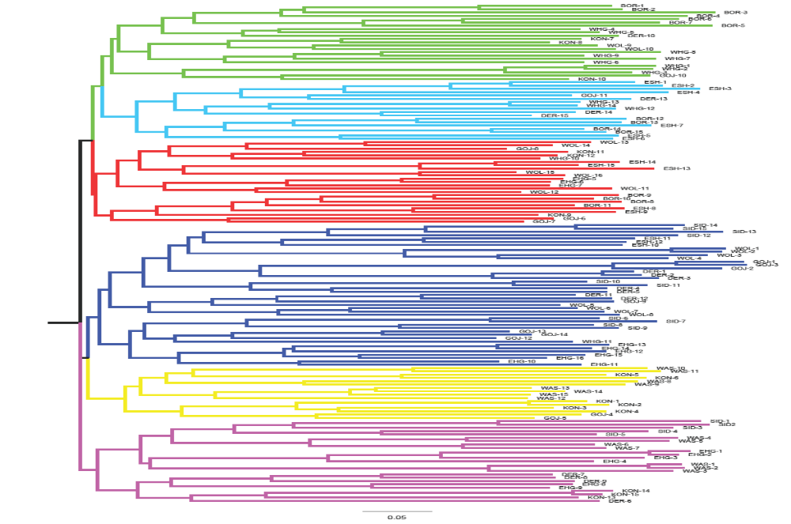
Figure S1. Unweighted neighbor joining based clustering of 150 Vernonia galamensis accessions for 20 polymorphic SSR markers. Key: BOR = Borena, SID = Sidama, ESH = East Showa, WAS = West Arsi, EHG = East Harerghe, WHG = West Harerghe, GOJ = Gojjam, WOL = Wollo, KON = Konso, DER = Derashie
Supplementary File 3
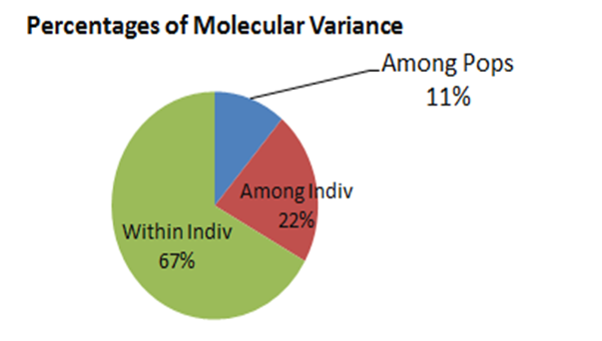
Figure S2. AMOVA variation pie chart for 150 Vernonia galamensis accessions from ten populations in Ethiopia

