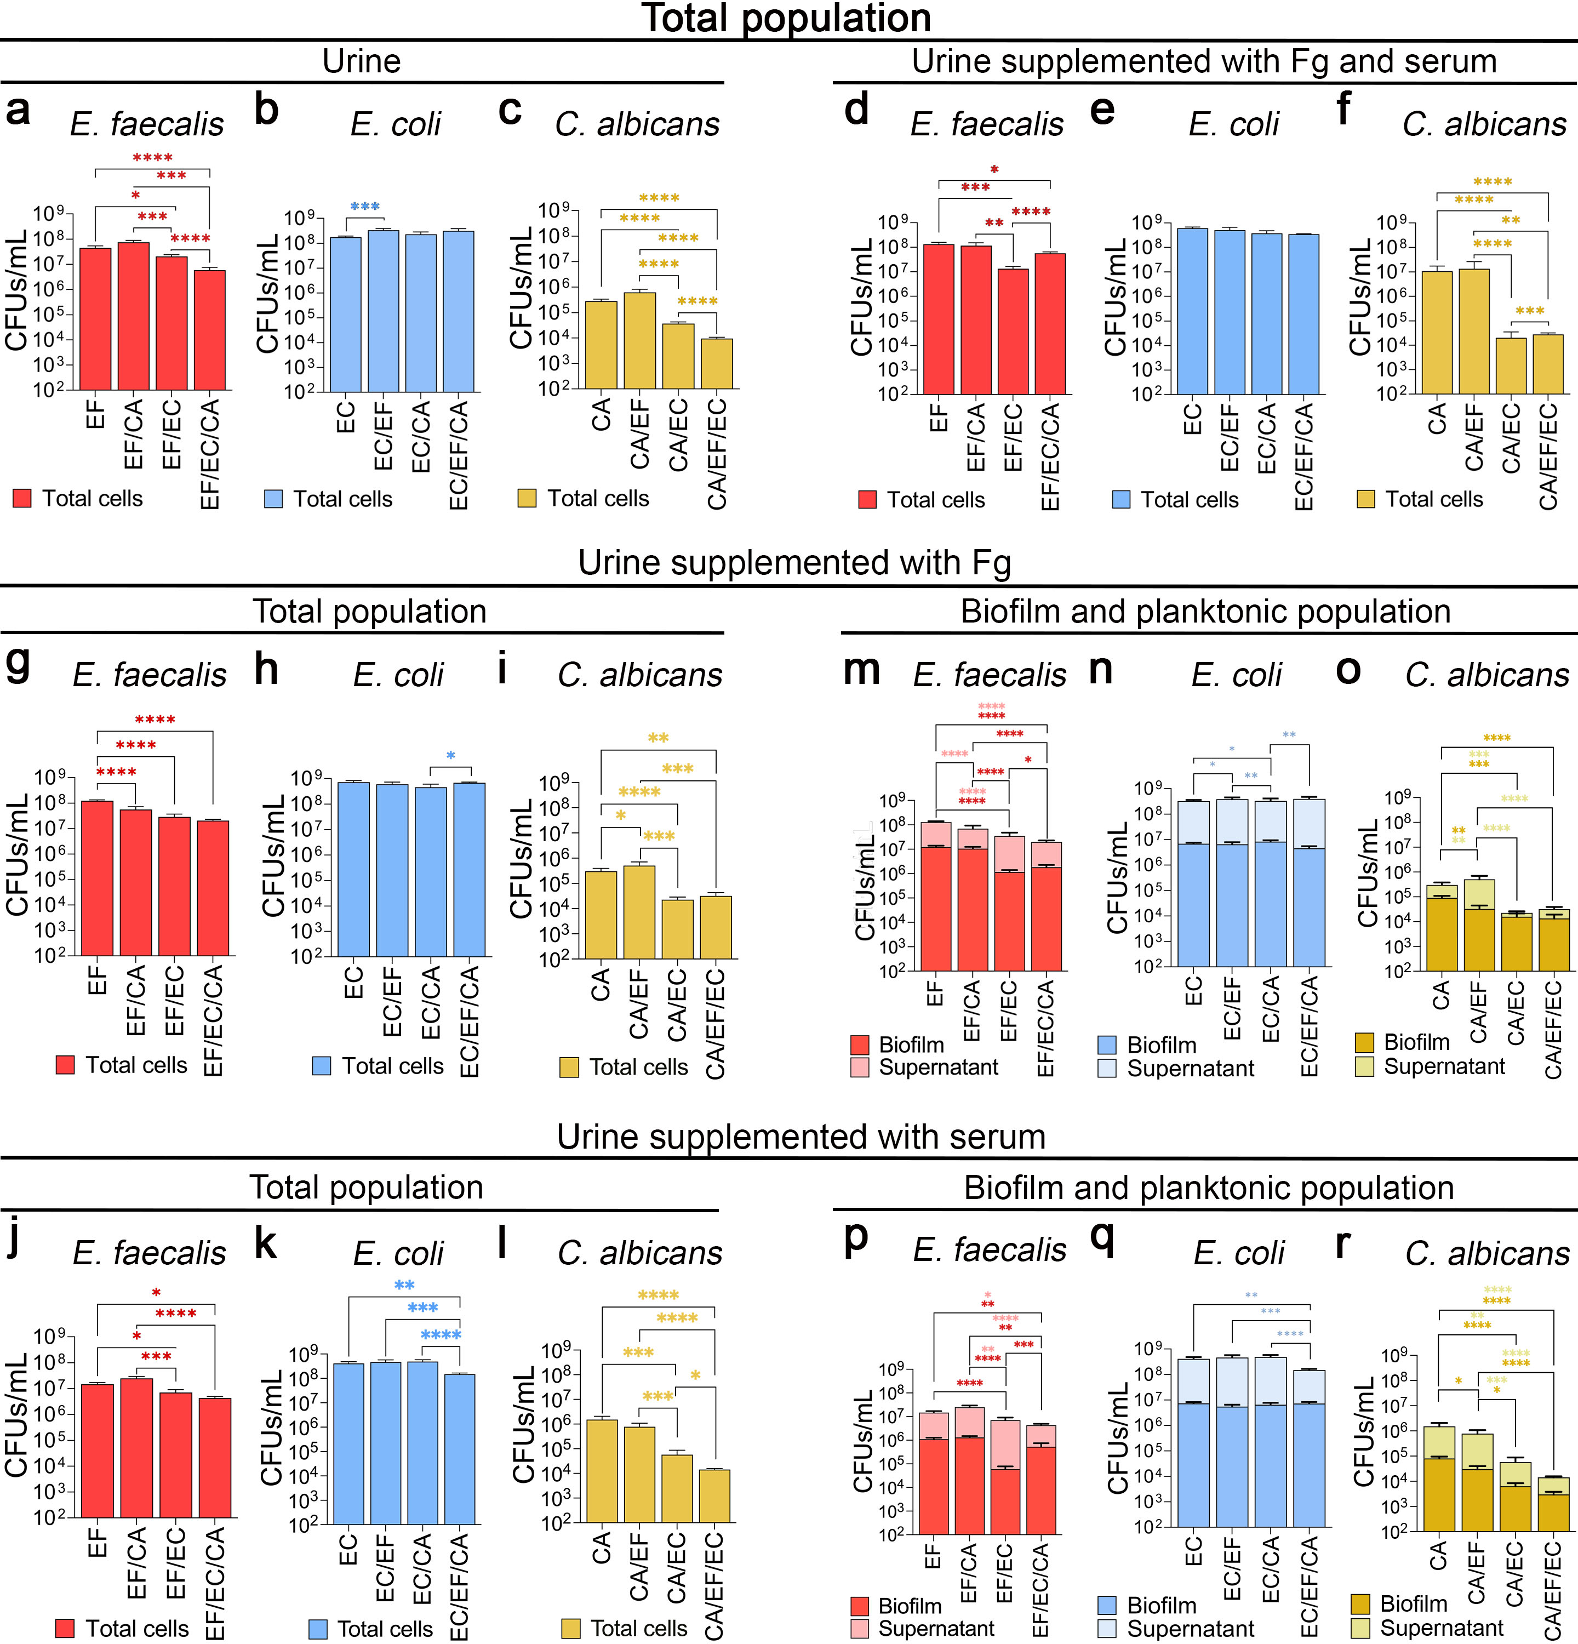Extended Data Figure 1. E. coli inhibits C. albicans growth regardless of additional supplementation in the urine at 48 hours. (a-f) Total cells in biofilms and supernatants (planktonic growth) of E. faecalis (EF), E. coli (EC), and C. albicans (CA) grown for 48 hours in human urine (a-c) and urine supplemented with Fg and serum (d-f). (g-l) Biofilm (dark bars) and supernatant (light bars) of E. faecalis (EF), E. coli (EC), and C. albicans (CA) grown for 48 hours in human urine supplemented with Fg (g-i) and urine supplemented with serum (j-l). (m-r) Total cells in biofilms and supernatants (planktonic growth) of E. faecalis (EF), E. coli (EC), and C. albicans (CA) grown for 48 hours in human urine supplemented with Fg (m-o) and urine supplemented with Fg and serum (p-r). Biofilms were grown on silicone disks covered with 1 mg/mL Fg overnight. Red/pink columns show EF biofilm/supernatant with EC (EF/EC), CA (EF/CA), or both (EF/EC/CA). Blue/light blue graphs show EC biofilm/supernatant with EF (EC/EF), CA (EC/CA), or both (EC/EF/CA). Yellow, light yellow columns show CA biofilm/supernatant with EF (CA/EF), EC (CA/EC), or both (CA/EF/EC). Differences between groups were tested for significance using the Mann-Whitney U test. *, P < 0.05; **, P < 0.005; ***, P < 0.0005; and ****, P < 0.0001.

Extended Data Figure 2. E. faecalis increases hyphae formation of C. albicans in E. coli-C. albicans biofilm and planktonic cultures. (a, b) Relative CFUs/mL and plated CFUs/mL from biofilm and supernatant grown for 48 hours in human urine. Relative CFUs/mL is based on quantitative PCR using ITS2 as a reference gene and C. albicans SC5314 efg1Δ/Δ strain as the standard (see Materials and Methods; Relative Hyphal Count using Imaging and qPCR). Differences between groups were tested for significance using the Mann-Whitney U test. *, P < 0.05; **, P < 0.005; ***, P < 0.0005; and ****, P < 0.0001.

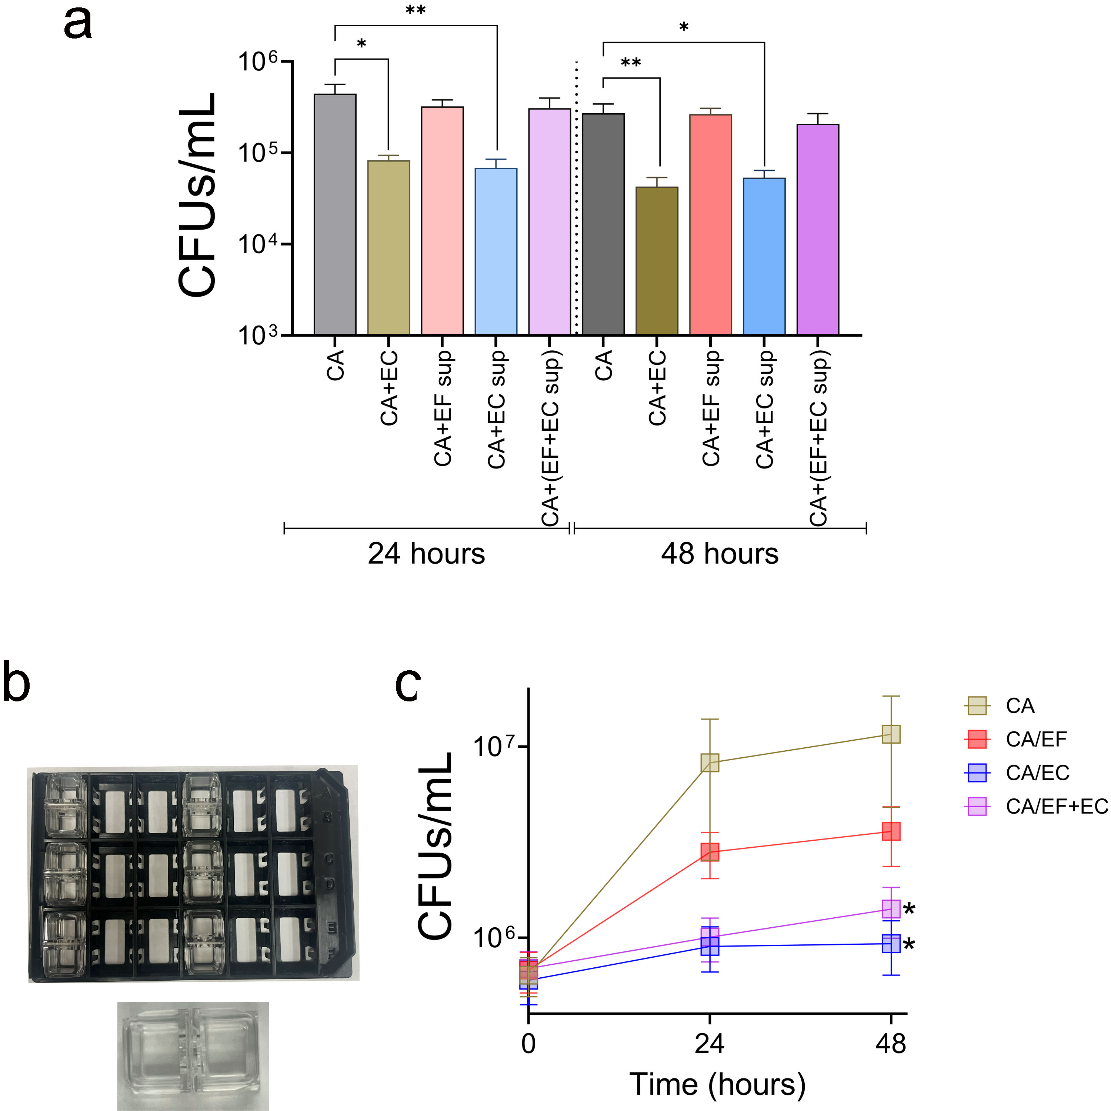

Extended Data Figure 3. E. coli inhibits C. albicans’ growth and biofilm through contact independent method and the addition of E. faecalis is able to rescue C. albicans’ growth. (a) For supernatants (sup), E. faecalis (EF) and/or E. coli (EC) was grown in urine for 48 hours and filter sterilized. Supernatants were concentrated and used to grow C. albicans for 24 or 48 hours on silicone disks at 37°C . Fungal CFUs were plated and counted after incubation. (b) Cultures were grown in Cerillo’s Duet Co-Culture System in sterilized urine for up to 48 hours at 37°C. Fungal CFUs were plated every 24 hours.

Extended Data Figure 4. Planktonic culture of C. albicans is negatively affected by the presence of E. coli while E. coli is not affected by C. albicans. (a-d) Planktonic fungal CFUs of C. albicans with (dash lines) or without (solid lines) E. coli in urine (with or without fibrinogen and/or serum supplementations). (e-h) Planktonic bacterial CFUs of E. coli with (dash lines) or without (solid lines) C. albicans in urine (with or without fibrinogen and/or serum supplementations). Cultures were grown in urine (blue), urine + 3 mg/mL Fibrinogen (Fg) (green), urine + 10% human serum (ser) (orange), and urine + Fg + ser (brown) containing microbes at a concentration of ~10⁴ CFUs. Cultures were grown in static condition and CFUs were plated at 0, 6, 12, 24, and 48 hours. The CFUs were standardized relative to the inoculums.

Extended Data Figure 5. Colocalization between E. coli and C. albicans increases in the bladder during triple-species co-infections. (a-c) Index of Correlation was quantified using Colocalization Colormap plugin on ImageJ based on three different bladder images of three days post catheterization and infection for each condition. Statistical analysis was performed using Mann-Whitney U test (P < 0.05; **, P < 0.005; ***, P < 0.0005; and ****, P < 0.0001).

Extended Data Figure 6. The order in which the biofilm grow is crucial for E. faecalis, but not E. coli. Sequential biofilms of E. faecalis (a) and E. coli (b) were grown for 48 hours (24 + 24 hours). (x→y) x represents microorganism grown in the first 24 hours and y represents microorganism grown in the next 24 hours. Statistical analysis was done using Mann-Whitney U test (P < 0.05; **, P < 0.005; ***, P < 0.0005; and ****, P < 0.0001). (c) Plated samples are the same CFUs as biofilm results in Fig. 5a,b for C. albicans and in Extended Data Figure 5a for E. faecalis, and Extended Data Figure 5b for E. coli. PCR data were obtained by extracting DNA from the sonicated samples of C. albicans biofilms and used them for qPCR. C. albicans strain that is unable to form hyphae, efg1Δ/Δ, was used as a standard for the qPCR and CFUs. ITS2 housekeeping gene was used as a reference for the quantification of cells.

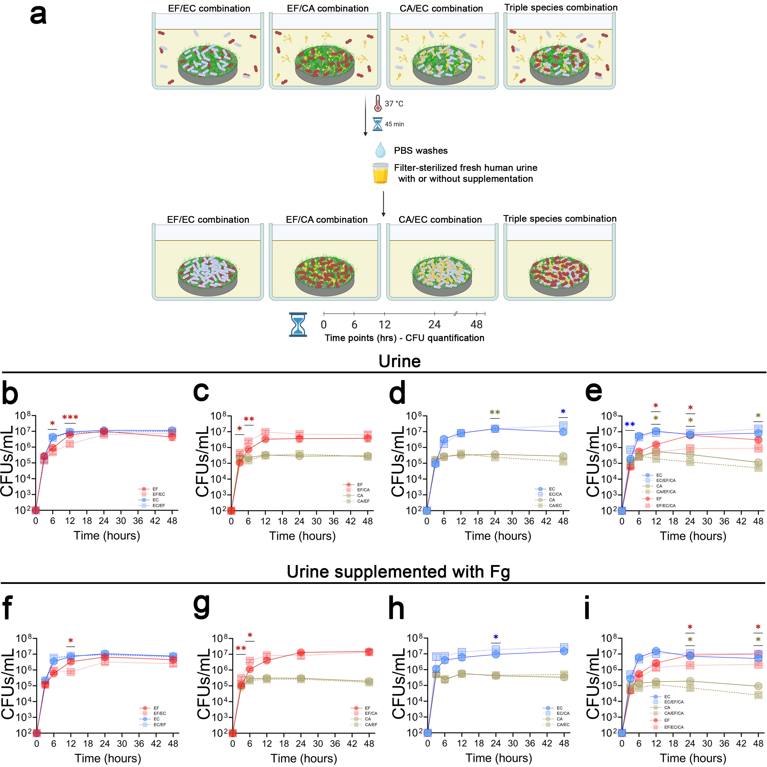
Extended Data Figure 7. C. albicans and E. faecalis compete with E. coli for adherence and higher inoculum with washes gave C. albicans and E. faecalis better chance at competing with E. coli. (a) Biofilms were form on silicone disks, similar to Fig. 1 and Extended Data Fig. 1, but with 10x the inoculum. After 45 minutes, biofilms were washed, and fresh urine were added to the wells. Biofilms were plated at different time points (0, 6, 12, 24, and 48 hours) to measure CFUs. (b, c, d, e) were grown in human urine and (f, g, h, i) were grown in human urine + Fibrinogen (Fg). Differences within each time points were tested for significance using the Mann-Whitney U test. *, P < 0.05; **, P < 0.005; ***, P < 0.0005; and ****, P < 0.0001. P-value colors represent the comparison between the different species: E. faecalis (red), E. coli (blue), and C. albicans (yellow).

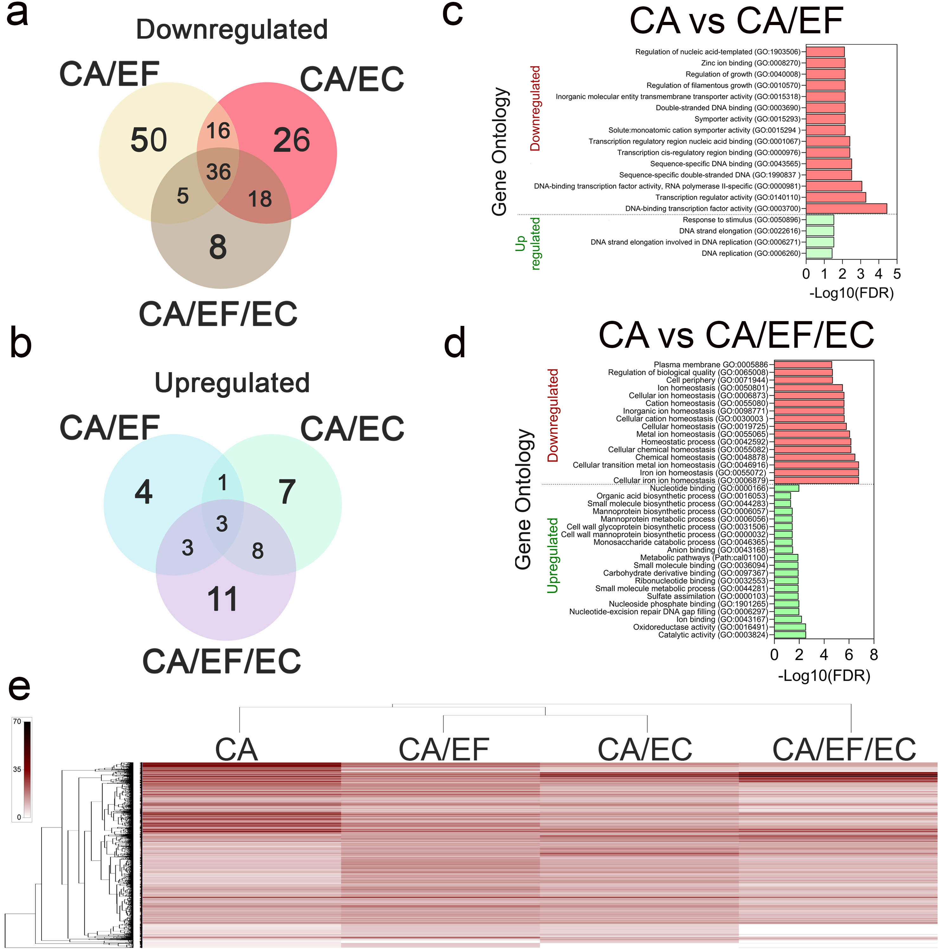Extended Data Figure 8. C. albicans transcriptomic profiles are different in mono- vs. polymicrobial biofilms. (a) Downregulated and (b) upregulated genes in C. albicans in polymicrobial biofilms compared to C. albicans monomicrobial biofilms. (c) Gene ontology of downregulated and upregulated C. albicans genes in C. albicans-E. faecalis co-biofilms. (d) Gene ontology of downregulated and upregulated C. albicans genes in triple-species biofilms (C. albicans-E. faecalis-E. coli). (e) Heat map of all differentially regulated genes of C. albicans in single, double, triple species biofilms. Venn diagrams were made using Evenn (ehbio.com). Gene Ontology graphs were made using ShinyGO and GraphPad Prism. Heatmaps were made using PRIMER 7 software.

Extended Data Figure 9. E. faecalis transcriptomic profiles are different in mono- vs. polymicrobial biofilms. (a) PCA plot of E. faecalis gene expressions in polymicrobial biofilms. (b) Downregulated and (c) upregulated genes in E. faecalis in polymicrobial biofilms compared to E. faecalis monomicrobial biofilms. (d-f) Volcano plots of differentially regulated genes of E. faecalis during co-biofilms with E. coli (EF/EC) (d), E. coli (EF/CA) (e), or both (EF/EC/CA) (f) in comparison with E. faecalis biofilms. Blue represents downregulated genes and red represents upregulated genes with a cutoff of 2 in -log(p-value) and 1 in log2foldchange. (g) Gene ontology of downregulated and upregulated E. faecalis genes in E. faecalis-E. coli co-biofilms. (h) Gene ontology of downregulated and upregulated E. faecalis genes in E. faecalis-C. albicans co-biofilms. (i) Gene ontology of downregulated and upregulated E. faecalis genes in triple-species biofilms (E. faecalis-E. coli-C. albicans). Venn diagrams were made using Evenn (ehbio.com). PCA plots and Gene Ontology graphs were made using ShinyGO and GraphPad Prism. (j) Heat map showing differential expression of E. faecalis virulence genes in co-culture biofilms.

Extended Data Figure 10. E. coli transcriptomic profiles are different in mono- vs. polymicrobial biofilms. (a) PCA plot of E. coli gene expressions in polymicrobial biofilms. (b) Downregulated and (c) upregulated genes in E. coli in polymicrobial biofilms compared to E. coli monomicrobial biofilms. (d-f) Volcano plots of differentially regulated genes of E. coli during co-biofilms with E. faecalis (EC/EF) (d), C. albicans (EC/CA) (e), or both (EC/EF/CA) (f) in comparison with E. coli biofilms. Blue represents downregulated genes and red represents upregulated genes with a cutoff of 2 in -log(p-value) and 1 in log2foldchange. (g) Gene ontology of downregulated and upregulated E. coli genes in E. coli-E. faecalis co-biofilms. (h) Gene ontology of downregulated and upregulated E. coli genes in E. coli-C. albicans co-biofilms. (i). Gene ontology of downregulated and upregulated E. coli genes in triple-species biofilms (E. coli-E. faecalis-C. albicans). Venn diagrams were made using Evenn (ehbio.com). PCA plots and Gene Ontology graphs were made using ShinyGO and GraphPad Prism. (j) Heat map showing differential expression of E. coli virulence genes in co-culture biofilms.

