Supplementary materials

Mapping the Chemical Language of Bacillus Consortia: Toward the Rational Design of Microbial Biostimulants

Musiwalo Samuel Mulaudzi¹, Lerato Pertunia Tshehlane^{1,2*}, Fidele Tugizimana^{1,2}*

GNPS2 Job links

Consortium 1 (two B. licheniformis strains, two B. laterosporus strains and one B. amyloliquefaciens strain)
Intracellular
https://gnps2.org/status?task=f09ae2bb1c0e466b91dcb37ef2d72dd1
Extracellular
https://gnps2.org/status?task=696bb53f2e3f4df49ef631865e48e2ba
Consortium 2 (B. subtilis strain, B. pumilus strain and B. amyloliquefaciens)
Intracellular
https://gnps2.org/status?task=0cead9d567eb490e86089224487154f7
Extracellular
https://gnps2.org/status?task=d3371a7a35094a54916c6b33f26ed2cf
Consortium 3 (two B. licheniformis strains, one B. laterosporus strain, and one B. megaterium)
Intracellular
https://gnps2.org/status?task=982024db1e634566bc710c7d42404984
Extracellular
https://gnps2.org/status?task=a12ef074257f4dadb8b3ef7d109806a1

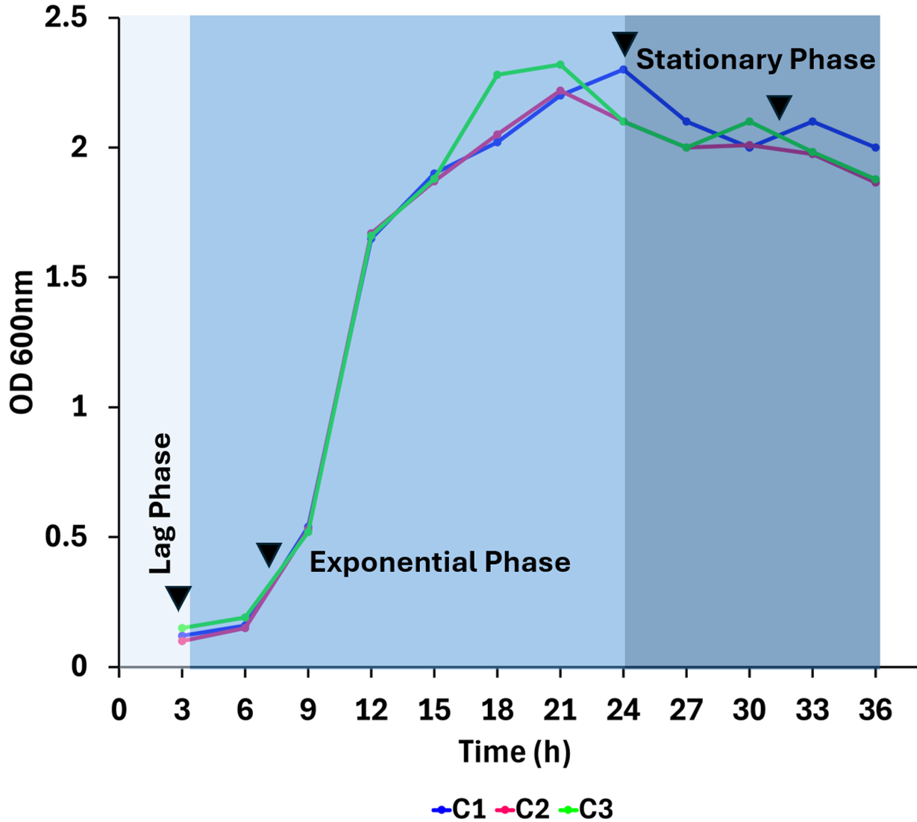
Figure S1. Growth kinetics of three Bacillus consortia monitored over a 36-hour culture period. Optical density at 600 nm (OD600) was measured at regular intervals for Consortium 1, Consortium 2, and Consortium 3. Arrowheads indicate the time points selected for metabolite extraction: 3 h (lag phase), 7.5 h (exponential phase), 24 h, and 31.5 h (stationary phase).
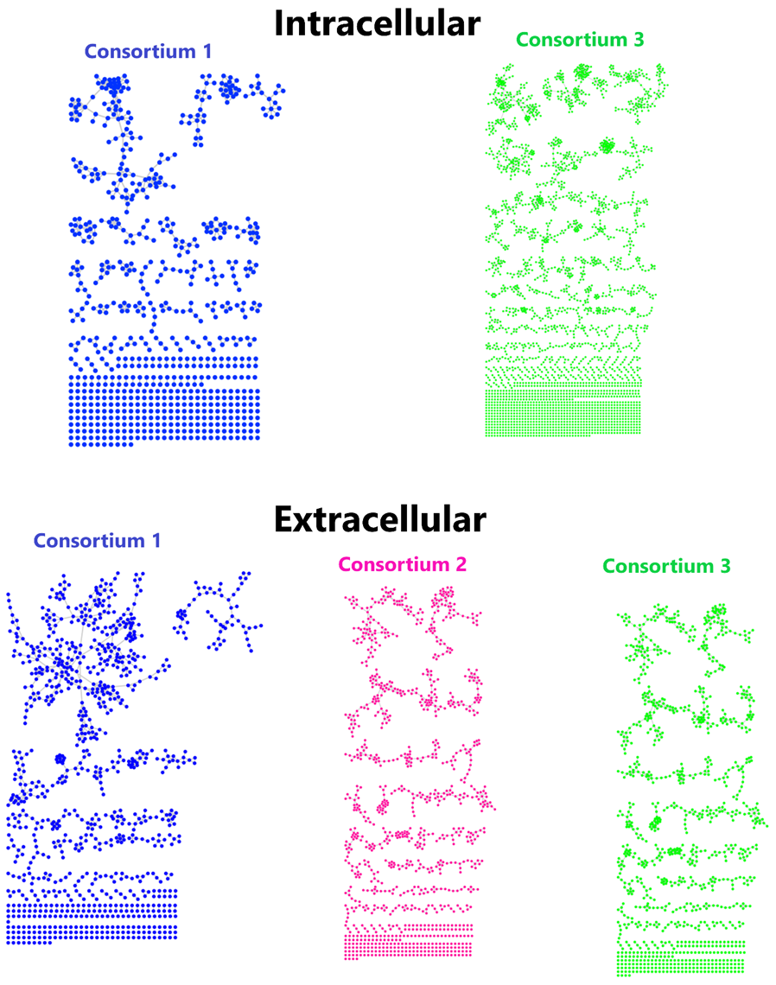
Figure S2. Feature-based molecular networking. The molecular network of MS/MS spectra generated from intracellular and extracellular extracts of consortia 1-3.

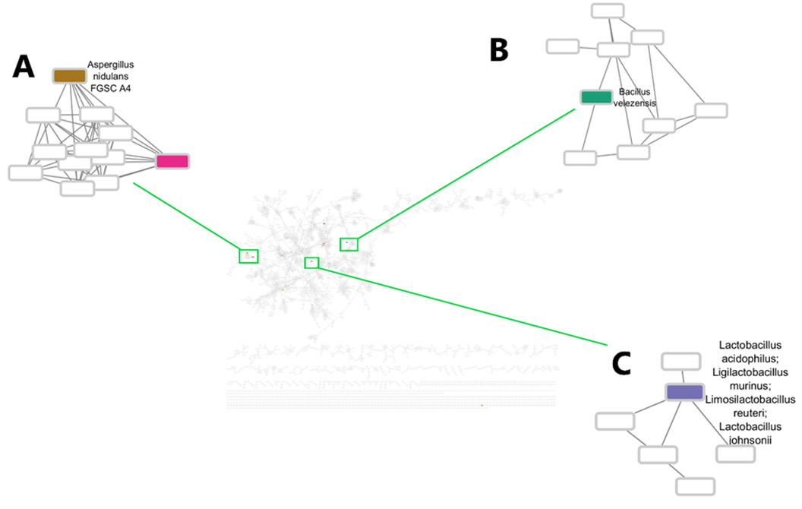

Figure S3. CMMC-KB. CMMC-KB generated from an intracellular milieu of consortium 3 with MS/MS spectra (nodes) associated with microbe name producing the compound depicted in Figure 3.
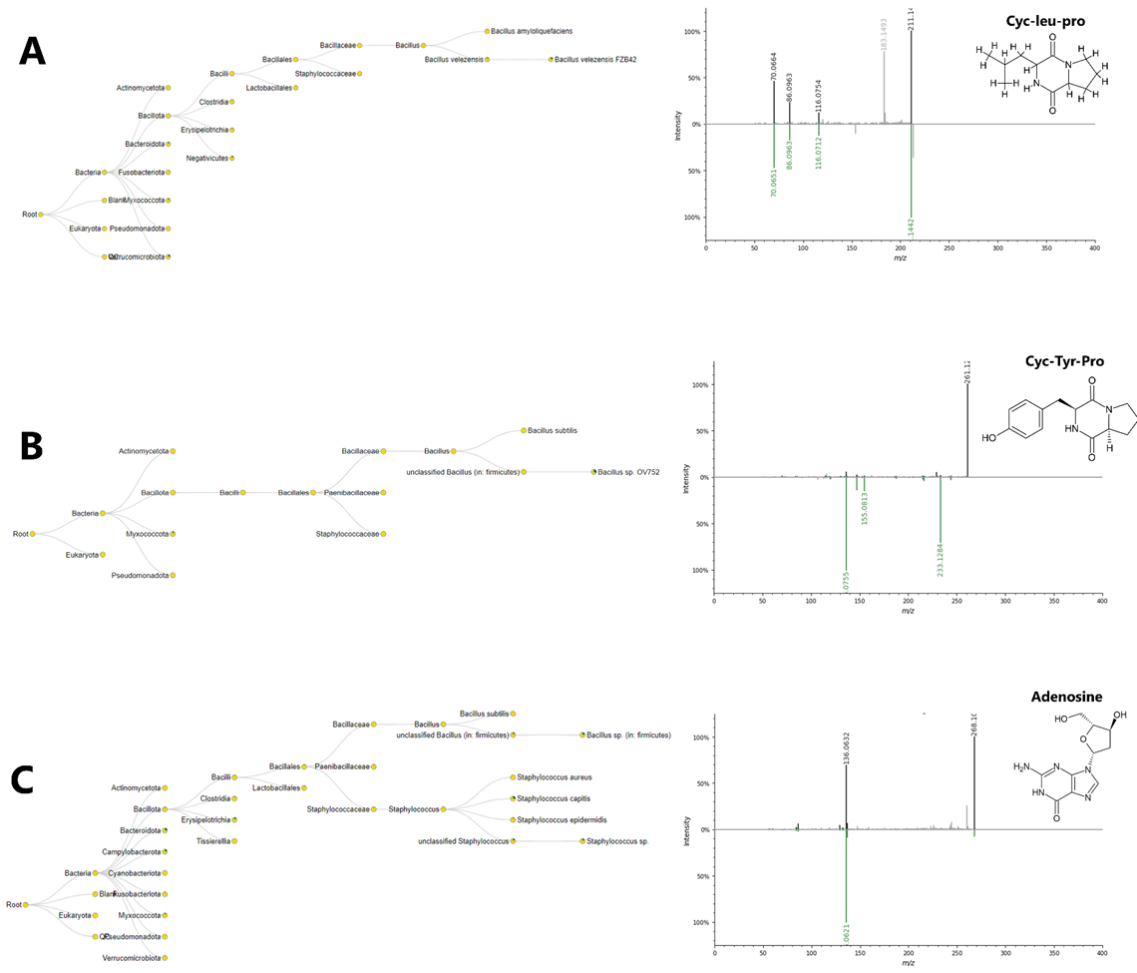
Figure S4. microbeMASST annotation: microbeMASST search output of cyclo-leu-pro, cyclo-tyrosine-proline and adenosine. Pie charts illustrate the proportion of MS/MS matches identified in the deposited reference database. Blue represents a match with a monoculture, while yellow indicates no match

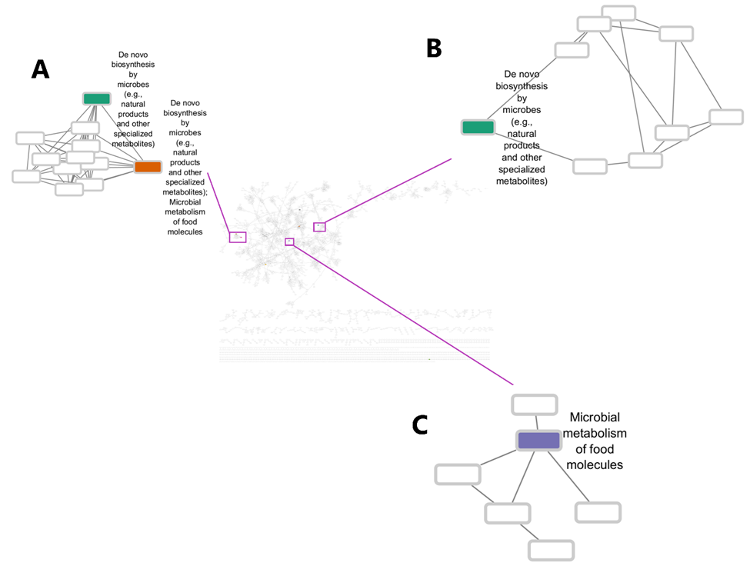
Figure S5. CMMC-KB-molecule origin. CMMC-KB generated from an intracellular milieu of consortium 3 MS/MS spectra (nodes) associated with the molecule origin of the compound depicted in Figure 3.

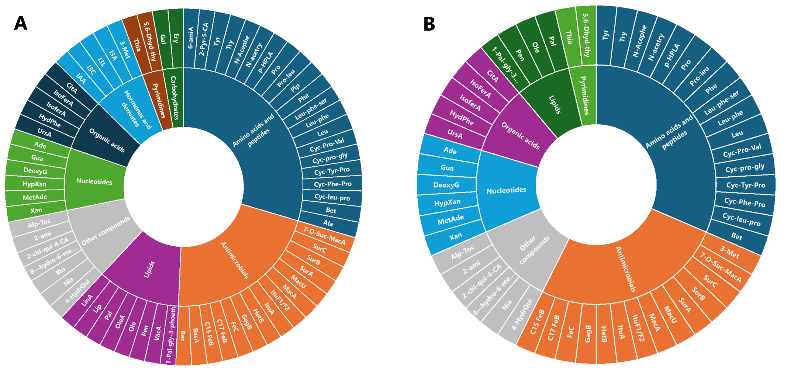

Figure S6. Intracellular and extracellular milieu metabolome coverage. The sunburst plot shows the distribution of annotated metabolites in the intracellular (A) and extracellular milieu (B) from the consortia 1, 2, and 3 and their assigned chemical classes. The identified classes include amino acids and peptides, antimicrobials, carbohydrates, phytohormones, lipids, nucleotides, organic acids, pyrimidines, and other compounds. However, carbohydrates and phytohormones were not identified in the extracellular milieu (B). Full names of metabolites displayed in the sunburst plot are provided in Table S1

Table S1. Putatively annotated metabolites in the extracellular and intracellular of consortium 1, consortium 2 and consortium 3. Presence () and absent (x) showing the distribution of metabolites among the consortia.
No. | Compound name | Abbrev | Formula | Rt (min) | m/z | Fragments | Adducts | Intra | Extra | Intra | Extra | Intra | Extra
Amino acids and peptides
1 | Alanylvaline | Ala | C8H16N2O3 | 0.90 | 189.12 | 70,84,112,118,130 | [M+H] +
2 | Betaine | Bet | C5H11NO2 | 0.88 | 118.08 | 58,59 | [M+H] +
3 | Cyclo (leucylprolyl) | Cyc-leu-pro | C11H18N2O2 | 11.91 | 211.14 | 70,86,110,183 | [M+H] +
4 | Cyclo (L-Phe-L- Pro) | Cyc-Phe-Pro | C14H16N2O2 | 8.78 | 245.12 | 70,215 | [M+H] +
5 | Cyclo (L-Tyr-L- Pro) | Cyc-Tyr-Pro | C14H16N2O3 | 5.40 | 261.12 | 136,233 | [M+H] +
6 | Cyclo(prolylglycyl) | Cyc-pro-gly | C₇H₁₀N₂O₂ | 9.12 | 155.08 | 70,98 | [M+H] +
7 | Cyclo(L-Pro-L-Val) | Cyc-Pro-Val | C₁₀H₁₆N₂O₂ | 11.27 | 197.12 | 70,98,124,169 | [M+H] +
8 | Leucine | Leu | C6H13NO2 | 1.85 | 132.10 | 86 | [M+H] +
9 | Leucyl- phenylalanine | Leu-phe | C15H22N2O | 1.80 | 279.13 | 261,254,251,132,86 | [M+H] +
10 | Leucyl- phenylalanyl-  serine | Leu-phe-ser | C18H27N3O5 | 1.82 | 366.21 | 86,132,166,235,279 | [M+H] +
11 | Phenylalanine | Phe | C9H11NO2 | 2.09 | 166.08 | 103,129 | [M+H] +
12 | Pipecolic acid | Pip | C6H11NO2 | 1.41 | 130.09 | 84 | [M+H] +
13 | L-proly-L- isoleucine | Pro-leu | C11H20N2O3 | 13.71 | 229.15 |  | [M+H] +
14 | Proline | Pro | C5H9NO2 | 0.86 | 116.07 | 70 | [M+H] +
15 | p- Hydroxyphenyllact  ic acid | p-HPLA | C9H10O4 | 1.67 | 165.05 | 119,123,137,147,148 | [M+H- H20] +
16 | N-acetlytryptophan | N-Acetry | C₁₃H₁₄N₂O₃ | 3.73 | 247.13 | 146,159,188, | [M+H}+
17 | N-acetlyphenylalanine | N-Acephe | C₁₁H₁₃NO | 11.74 | 230.11 | 144 | [M+NA] +
18 | Tryptophan | Try | C11H12N2O3 | 3.61 | 205.09 | 118,144,146,188,189 | [M+H] +
19 | Tyrosine | Tyr | C9H11NO4 | 1.64 | 182.08 | 91,119,123,147,165 | [M+H] +
20 | 2-Pyrrolidone-5- carboxylic acid | 2-Pyr-5-CA | C5H7NO3 | 11.28 | 130.05 | 56,70,84 | [M+H] +
21 | 6-Aminocaproic acid | 6-amiA | C6H13NO2 |  | 114.09 | 69,79,96,97 | [M+H- H20] +
Antimicrobials
22 | Bacilysocin | Bac | C21H43O9P | 20.80 | 471.27 | 453,435,299 | [M+H] +
23 | Basiliskamide A | BasA | C23H31NO4 | 9.00 | 386.20 | 149,216 | [M+H] +
24 | C15 Feng B | C15 FeB |  | 23.55 | 739.45
25 | C17 Feng B | C17 FeB |  | 23.78 | 753.45
26 | Feng C | FeC |  | 23.63 | 767.49
27 | Gageotetrin B | GagB | C38H70N4O9 |  | 728.46 | 639,597,464,313,299 | [M+H] +
28 | Hetiamacin B | HetB | C23H33N3O | 17.9 | 486.2 |  | [M+Na] +
29 | Iturin A1 | ItuA |  | 13.16 | 1030.56
30 | Iturin F1/F2 | ItuF1/F2 |  | 13.04 | 1101.59
31 | Macrolactin A | MacA | C24H34O5 | 18.31 | 425.22 | 349, 367, 385 | [M+NA] +
32 | Macrolactin U | MacU | C31H44O4 | 10.30 | 503.26 | 217,230 | [M+NA] +
33 | Surfactin A (C13) | SurA | C51H89N7O13 | 23.50 | 1030.64 | 1008.6,767,745,711,68  6, | [M+H] +
34 | Surfactin B (C14) | SurB | C52H91N7O13 | 23.89 | 1044.66 | 1022,1021,839,717,68  5 | [M+NA] +
35 | Surfactin C (C15) | SurC | C53H93N7O13 | 24.21 | 1058.67 | 1036,1018,685 | [M+NA] +
36 | 7-O-Succinyl macrolactin A | 7-O-Suc-MacA | C28H38O8 | 9.1 | 525.26 | 349,367,385 | [M+Na] +
Carbohydrates
37 | Erythrose | Ery | C₄H₈O₄ | 1.54 | 121.08 | 85 | [M+H]
38 | Galactose | Gal | C6H12O6 | 3.34 | 203.10 |  | [M+NH4] +
Phytohormones
39 | 3-Methyloxindole | 3-Met | C₉H₉NO |  | 148.06 | 123 | [M+H] +
40 | Indole-3- Acetamide | I3A | C10H10N2O |  | 197.06 |  | [M+NA] +
41 | Indole-3-lactic acid | I3L | C₁₁H₁₁NO₃ | 3.48 | 206.21 | 118,188 | [M+H]+
42 | Indole-3-carboxaldehyde | I3C | C₉H₇NO |  | 146.05 | 146 | [M+H] +
43 | Indoleacrylic acid | IAA | C11H9NO2 | 3.61 | 188.65 | 118,146 | [M+H] +
Lipids
44 | Linolenic acid | LinA | C18H30O2 |  | 279.23 | 81,95,243,261 | [M+H] +
45 | Lipoamide | Lip | C8H15NOS2 | 21.91 | 228.23 |  | [M+Na] +
46 | Palmitamide | Pal | C16H33NO |  | 256.26 | 102,88 | [M+H] +
47 | Oleic acid | OleA | C18H34O2 | 23.50 | 265.25 | 107,121,135 | [M+H- H2O] +
48 | Oleamide | Ole | C₁₈H₃₅NO | 23.46 | 282.27 | 184,266 | [M+H]
49 | Pentadecanoic acid | PenA | C₁₅H₃₀O₂ | 8.95 | 243.13 | 215 | [M+H]
50 | Vaccenic acid | VacA | C18H34O2 | 23.53 | 283.28 | 282 | [M+H] +
51 | 1-Palmitoyl-sn- glycero-3- phosphoethanola  mine | 1-Pal-gly-3-p | C21H44NO7P |  | 454.28 | 313,436 | [M+H] +
Nucleotides
52 | Adenine | Ade | C5H5N5 | 1.72 | 136.06 | 119 | [M+H] +
53 | Guanine | Gua | C5H5N5O | 0.96 | 152.03 | 110,135,136 | [M+H] +
54 | Deoxyguanosine | DeoxyG | C10H13N5O4 | 1.65 | 268.1 | 136, 268 | [M+H] +
55 | Hypoxanthine | Hypxan | C5H4N4O |  | 137.05 | 55,94,110 | [M+H]+
56 | Methyladenosine | MetAde | C11H15N5O4 |  | 282.28 | 265 | [M+H] +
57 | Xanthine | Xan | C5H4N4O2 | 0.93 | 153.04 | 110,136 | [M+H] +
Organic acids
58 | Citric acid | CitA | C6H8O7 | 9.06 | 215.02 |  | [M+NA] +
59 | Isoferulic acid | IsoFerA | C10H10O4 | 2.12 | 103.05 | 77,95 | [M+H] +
60 | Isoferulic acid | IsoferA | C10H10O4 | 19.79 | 212.09 | 156,170,184,198 | [M+NH4] +
61 | Hydroxyphenanzine | HydPhe | C₁₂H₈N₂O | 6.13 | 197.07 | 197 | [M+H] +
62 | Ursolic acid | UrsA | C₁₁H₁₁NO₃ | 10.25 | 457.28 | 317,333 | [M+H] +
Pyrimidines
63 | 5,6-  Dihydrothymine | 5,6-Dhyd-thy | C5H8N2O2 |  | 129.06 | 58,69,84,86,112 | [M+H] +
64 | Thiamine | Thia | C₁₂H₁₇ClN₄OS |  | 263.00 | 233 | [M-2H]-
Other compounds
65 | Alpha-Tocopherol | Alp-Toc | C29H50O2 |  | 453.39 |  | [M+NA] +
66 | 2-Aminophenol | 2-ami | C6H7NO |  | 110.06 | 65,92 | [M+H] +
67 | 2-(4 chlorophenyl) quinoline-4- carboxylic acid | 2-chl-qui-4-CA | C16H10ClNO2 | 20.90 | 284.29 |  | [M+H] +
68 | E)-8-(4-hydroxy-6- methoxy-7-methyl- 3- oxo-1H-2-  benzofuran5-yl)-  2,6-dimethyloct6- enoic acid | 8—hydro-6-me-met-3-oxo-2-ben-2,6-dimeeA | C20H26O6 |  | 385.24 | 229 | [M+NA] +
69 | Biotin | Bio | C10H16N2O3S | 5.49 | 262.12 | 261 | [M+NH4] +
70 | Niacin/vitamin B3 | Nia | C6H4NO2 |  | 124.04 | 80,96 | [M+H] +
71 | 4-  Hydroxyquinoline | 4-HydrQui | C9H7NO |  | 146.06 | 118 | [M+H] +

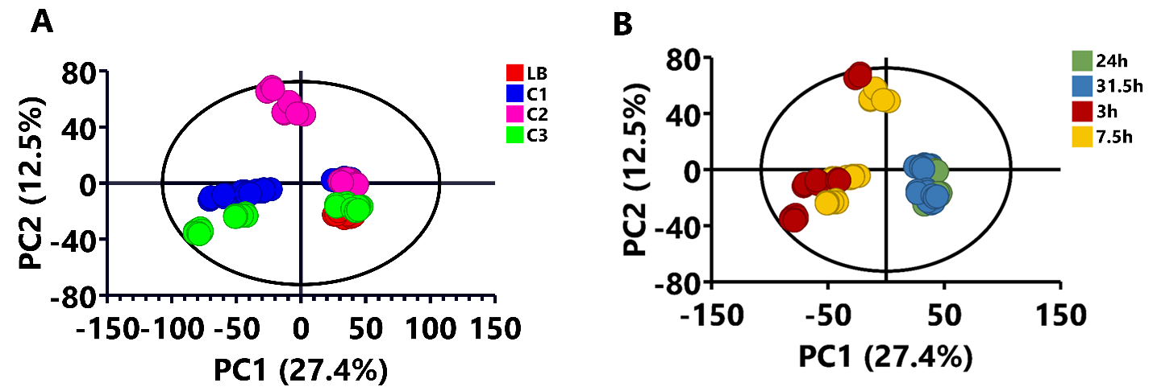

Figure S7. Unsupervised principal component analysis (PCA) score plots of extracellular milieu of different Bacillus consortia. (A) A 16-component PCA model explaining 78.6% of the total variation in the pareto-scaled, with 69% predictive power. (B) A 16-component PCA model explaining 79.3% of the total variation in the pareto scaled with 69.3% predictive power. (A) PCA score plot shows the sample grouping based on consortia and (B) showing sample grouping based on time points. Abbreviations: C1= consortium 1, C2= consortium 2, C3= consortium 3, LB= media 24h and 31.5h= stationary phase, 3h= lag phase and 7.5h= log phase.

