Supplementary Material

Measuring and reducing intervention misalignment in next best action selection for care management: a within-patient natural experiment
PEARL (Policy Evolution through Aligned Retrospective Learning) is the trained next best action selection policy referenced throughout this supplement. Intervention misalignment is defined as the fraction of patients whose chosen next best action is not the action expected to produce the largest health gain.
Authors: Sanjay Basu, MD PhD^{a,b}; Parth Sheth, MS^{b,c}; Sadiq Patel, PhD^{b,c}
ª Department of Medicine, University of California San Francisco, San Francisco, CA
^{b} Waymark, San Francisco, CA
^{c} School of Social Policy and Practice, University of Pennsylvania, Philadelphia, PA
Corresponding author: Sanjay Basu, MD PhD | sanjay.basu@ucsf.edu

This supplement presents nine appendix tables (Appendix Tables 1–9), two algorithms (Algorithms S1–S2), two formal theorems (Theorems S1–S2), and four appendix figures (Appendix Figures 1–4). Appendix Table 1 reports the intervention misalignment index by area deprivation index quintile, dual eligibility status, primary language, and race/ethnicity with inverse probability weighting for missingness. Appendix Table 3 reports pre-specified sensitivity analysis results. Appendix Table 4 reports pre-specified falsification test results. Appendix Table 5 reports comparator descriptions and ablation roles. Appendix Table 6 reports nuisance model calibration diagnostics, per-intervention-type positivity statistics, and the within-WPAD secondary IMI analysis. Appendix Table 9 presents the TRIPOD-AI reporting checklist. Algorithms S1–S2 provide pseudocode for WPAD preference pair construction and PEARL training. Theorems S1–S2 state and sketch proofs for the IMI Reduction theorem and the DPO–DR-OPO equivalence result. Appendix Figure 1 presents the PRISMA-style patient flow diagram. Appendix Figure 2 presents the IMI equity gradient by ADI quintile. Appendix Figure 3 presents the Camden Coalition analog reanalysis panels. Appendix Figure 4 presents the sensitivity analysis forest plot.
All reference numbers in this supplement correspond to the numbered reference list in the main manuscript.

Appendix Table 1. Intervention Misalignment Index by Area Deprivation Index Quintile and Demographic Subgroup
Appendix Table 1. IMI under behavioral routing by socioeconomic deprivation stratum and demographic subgroup (N = 6,995 held-out test patients)
Subgroup | N (test set) | IMI | 95% CI
Overall | 6,995 | 27.0% | 25.9%–28.1%
ADI quintile (4,087 with ADI linkage)
Q1 (least deprived) | ~532 | 30.5% | —
Q2 | ~623 | 30.2% | —
Q3 | ~834 | 30.5% | —
Q4 | ~1,050 | 17.7% | —
Q5 (most deprived) | ~1,048 | 25.1% | —
Kruskal-Wallis q (BH-corrected) |  |  | < 0.05
IMI decomposition (marginal)
IMI_{demographic} | 6,995 | 54.6% | —
IMI_{clinical} | 6,995 | 46.8% | —
Camden analog subgroup
Camden analog profile (Charlson ≥ 4, prior IP ≥ 2) | 242 | 90.9% | —
Dual eligibility status
Medicaid only / Medicaid + Medicare | — | Not available† | —
Primary language
English | 6,995 | 27.0% | 25.9%–28.1%
Non-English | — | Not available‡ | —
Race/ethnicity (n = 3,912 with available race code)
Black non-Hispanic | — | 20.3% | —
Hispanic | — | 16.5% | —
Unknown/Other (includes White non-Hispanic§) | — | 30.8% | —
ADI = area deprivation index; IMI = Intervention Misalignment Index; BH = Benjamini-Hochberg; CI = confidence interval (2,000-resample bootstrap).
IMI is the fraction of patients for whom the behavioral routing policy assigns an intervention type for which a better-matched alternative exists by a margin of at least 2 percentage points in predicted 90-day acute care event probability (ε = 0.02). IMI_{demographic} and IMI_{clinical} are marginal estimates computed over their respective restricted covariate subspaces; they are not additive components of the overall IMI (27.0%), which conditions simultaneously on both covariate sets. CIs are not reported for subgroup rows because bootstrap CIs over restricted covariate subspaces require group-specific pair construction not conducted in the primary analysis; the overall CI is reported in the main text.
ADI quintile Ns reflect the 4,087 patients (58.4%) with residential ADI linkage; 2,908 patients lacked ADI linkage and are excluded from quintile rows.
† Dual eligibility status (Medicaid-only vs. Medicaid + Medicare) was not captured in the administrative data extract used for this analysis and cannot be reported.
‡ Primary language was not captured in the administrative data extract for this cohort; all patients were assigned the default value “English” in the data pipeline. Subgroup IMI by language is therefore not estimable from these data.
§ White non-Hispanic patients are not separately identified in this administrative dataset; patients whose race code did not map to Black non-Hispanic or Hispanic (including white patients and those with missing race data) are grouped as Unknown/Other. Race/ethnicity code was available for 3,912 of 6,995 test patients (55.9%); patients with missing race code are included in the Unknown/Other stratum.

Appendix Table 3. Pre-Specified Sensitivity Analysis Results
Appendix Table 3. Full pre-specified sensitivity analysis results (N = 20 analyses across 7 parameters)
Parameter varied | Primary value | Alt. values tested | Requires retraining | PEARL IMI (primary) | PEARL DR-OPE (primary) | Direction preserved | Note
T_{min} window length | 60 days | 30, 90 days | Yes | 2.0% | 0.027 | Yes | IMI and DR-OPE stable across all T_{min} values (0.0% relative change)
IPTW clip threshold | 10 | 5, 20 | No (eval only) | 2.0% | 0.027 | Yes | DR-OPE magnitude varies (0.043 at clip=5; 0.039 at clip=20); direction preserved at both values
DPO β (KL regularization) | 0.10 | 0.05, 0.20 | Yes | 2.0% | 0.027 | Yes | IMI and DR-OPE stable across all β values (0.0% relative change)
Outcome window | 90 days | 30, 60 days | Yes | 2.0% | 0.027 | Yes | IMI and DR-OPE stable across all outcome window values (0.0% relative change)
Trajectory slope covariate | Included | Excluded | Yes | 2.0% | 0.027 | Yes | IMI stable; T1 SMD = 0.143 mandates inclusion as primary specification
WPAD type restriction | All types | Type 1 only, Type 3 only | Yes | 2.0% | 0.027 | Yes | IMI stable across all WPAD direction restrictions (0.0% relative change)
IMI threshold ε | 0.02 | 0.01, 0.05 | No (eval only) | 2.0% | 0.027 | No at ε=0.01 (major sensitivity finding) | ε=0.01: PEARL IMI=81.3% (+3,990% magnitude, direction change — major sensitivity finding per pre-registered protocol); ε=0.05: PEARL IMI=2.9% (+45% magnitude, direction preserved at this lenient threshold)
Cross-parameter (7) | See text | See text | Mixed | 2.0% | 0.027 | Yes | All 7 combinations stable; IMI 1.99%–2.04%, DR-OPE 0.027–0.067
Summary |  |  |  | 2.0% | 0.027 | 19/20 direction preserved; 1 direction change at ε=0.01 (major)
Primary values are the anchor values registered before any holdout evaluation. A direction change in primary results (beneficial → harmful or vice versa, relative to behavioral routing) was pre-specified as a major limitation trigger; a >25% relative magnitude change without direction change was a moderate finding. The ε = 0.01 sensitivity finding is classified as a major sensitivity: at a 1 percentage-point minimum threshold, subtle mismatches that are clinically negligible are captured, substantially increasing apparent IMI. The 2 percentage-point primary threshold was pre-specified as the minimum clinically meaningful difference in predicted acute care event probability between intervention types; the major sensitivity finding indicates that below this threshold, PEARL’s IMI advantage is sensitive to threshold specification. DR-OPE direction was preserved across all 20 sensitivity analyses. See Appendix Figure 3 for the full sensitivity visualization.

Appendix Table 4. Pre-Specified Falsification Test Results for the WPAD Identification Assumption
Six pre-specified falsification tests (T1–T6) were conducted to assess the administrative exogeneity assumption of the Within-Patient Administrative Discontinuity (WPAD) design. Each test was pre-registered before any holdout evaluation and evaluated against a fixed decision rule: PASS (test does not reject administrative exogeneity at the Bonferroni-corrected threshold), CONCERN (test identifies a potential violation, triggering a pre-specified contingency protocol), or INCONCLUSIVE by design (test could not be executed due to a structural data limitation — e.g., insufficient directional pair variation — disclosed as an identification limitation rather than as a violation indicator).
Appendix Table 4. Pre-specified falsification test results for the WPAD administrative exogeneity assumption
Test | Description | Statistic | Result | Action
T1 | Covariate balance: clinical characteristics before the WPAD event are balanced between patients in ON-window vs. OFF-window sub-samples | Paired t-test on within-patient pre-event covariate differences | PASS — max |SMD| = 0.143 (threshold: |SMD| < 0.20); borderline between “good” (< 0.10) and “acceptable” (|SMD| 0.10–0.20) balance → trajectory slope covariate (δ_i) added as mandatory covariate in all primary analyses per pre-specified T1 protocol | Administrative exogeneity supported; trajectory covariate included throughout
T2 | Placebo outcomes: 12-month pre-event outcomes show no association with future WPAD event occurrence | Logistic regression of pre-event outcomes on “will this patient have a WPAD event in the next 6 months?”; AUC | PASS — AUC ≈ 0.50; Bonferroni-corrected p non-significant; lagged health does not predict churn timing | Administrative exogeneity supported; placebo test does not reject null
T3 | Administrative predictors of onboarding timing: lagged health trajectory variables do not predict WPAD event timing conditional on observed covariates | F-test of joint significance of lagged health trajectory predictors in logistic regression of WPAD event timing | PASS — F-test non-significant (p = 0.94, Bonferroni-corrected); health trajectory does not predict onboarding timing | Administrative exogeneity supported; primary analysis proceeds
T4 | Density continuity: non-care-management healthcare events (pharmacy fills, primary care visits) are continuous at the WPAD boundary | Event-study regression in calendar time around the WPAD transition | PASS — no sharp discontinuity detected in pharmacy fill rate or primary care visit rate at WPAD boundary | Exclusion restriction (care management is the only pathway affected) supported
T5 | Heterogeneous LATE: local average treatment effect differs by WPAD type (Type 1 vs. Type 3) | Separate LATE estimation by WPAD type; relative difference | CONCERN — LATE difference of 58.5% between Type 1 (ACO onboarding) and Type 3 (Medicaid churn) estimates | Pre-specified contingency triggered: primary analysis restricted to Type 1 pairs, which carry the most defensible administrative exogeneity
T6 | Direction-of-time: stationarity within Type 1 pairs (all OFF→ON direction) | Stratified analysis by temporal direction of ON/OFF windows | INCONCLUSIVE by design — all Type 1 pairs share the same OFF→ON direction (ACO onboarding by construction produces only pre-enrollment→post-enrollment windows); no ON→OFF pairs are available for directional comparison | Disclosed as structural limitation; temporal confounding within Type 1 cannot be tested via this test; trajectory slope covariate (added per T1 protocol) serves as the stationarity robustness measure
WPAD = Within-Patient Administrative Discontinuity; LATE = local average treatment effect; AUC = area under the receiver operating characteristic curve.
The T5 CONCERN and T6 INCONCLUSIVE by design result are disclosed transparently and discussed as identification limitations in the main manuscript Discussion. INCONCLUSIVE by design indicates the test could not be executed due to a structural limitation of the available data (all Type 1 pairs are single-direction), rather than indicating a violation of administrative exogeneity. T1 passes the pre-specified |SMD| < 0.20 threshold but falls in the 0.10–0.20 “borderline” range; the mandatory trajectory slope covariate (δ_i) is included in all primary analyses per the T1 pre-specified protocol. The primary analysis restriction to Type 1 pairs (ACO staggered onboarding) reflects the pre-specified contingency protocol for T5 CONCERN and not a post-hoc decision. These limitations motivate the planned prospective stepped-wedge randomized trial.

Appendix Table 5. Comparator Description, Citation, and Ablation Role
Eight comparators (C1–C8) were pre-registered before any holdout evaluation. The ablation structure is designed so that each comparator pair isolates one component of PEARL: the WPAD identification signal, the DPO loss formulation, the natural language output format, or the performance relative to the strongest published benchmark.
Appendix Table 5. Pre-registered comparators: description, citation, and ablation role in the PEARL evaluation hierarchy
Label | Comparator | Method | Ablation role | Citation
C1 | LACE Index | Four-variable risk-score triage (length of stay, acuity of admission, comorbidity, emergency department visits in prior 6 months) applied to binary routing | Standard-of-care baseline: risk stratification without intervention type specificity | van Walraven et al., CMAJ 2010³
C2 | HOSPITAL Score | Seven-variable risk-score triage applied to readmission risk stratification | Second standard-of-care baseline: alternative risk score, same routing limitation | Donzé et al., JAMA Intern Med 2013⁴
C3 | XGBoost | Gradient-boosted readmission risk prediction trained on claims features | Best ML readmission prediction: demonstrates that PEARL adds value beyond prediction accuracy | Multiple published benchmarks
C4 | BehavioralCloning SFT | Supervised fine-tuning on WPAD-preferred interventions without contrastive DPO loss | DPO loss ablation: isolates the contribution of the DPO contrastive formulation from the WPAD causal identification signal; if C4 ≈ PEARL, the WPAD signal — not DPO — drives improvement
C5 | Observational DPO | DPO trained on non-WPAD observational preference pairs without causal filtering | WPAD identification ablation: isolates the contribution of within-patient causal identification from the DPO architecture; if C5 ≈ behavioral, DPO alone is insufficient | Rafailov et al., NeurIPS 2023¹⁹
C6 | Causal forest CATE | Multi-arm heterogeneous treatment effect estimation using honest random forests | Best HTE comparator: tests whether population-level unconfoundedness methods can match PEARL’s within-patient identification | Wager and Athey, J Am Stat Assoc 2018⁷
C7 | Decision Transformer | Offline reinforcement learning via sequence modeling on WPAD trajectory data | Best offline RL comparator: tests whether PEARL’s performance advantage reflects the output format (tabular vs. RL action probabilities) or the identification signal | Chen et al., NeurIPS 2021²²
C8 | Conservative Q-Learning (CQL) | Offline RL with conservatism penalty that prevents out-of-distribution action overestimation; state-of-the-art offline RL method | Strongest published offline RL comparator: tests whether PEARL’s advantage persists against the top-cited offline RL algorithm applied to the same WPAD preference pairs | Kumar et al., NeurIPS 2020²³
WPAD = Within-Patient Administrative Discontinuity; DPO = Direct Preference Optimization; CATE = conditional average treatment effect; RL = reinforcement learning; HTE = heterogeneous treatment effect; SFT = supervised fine-tuning.
The ablation interpretation follows directly from the DR-OPE and IMI comparisons in Table 3. PEARL (MoE Router) is the best deployable policy among the twelve evaluated against the theoretical oracle (DR-OPE = 0.027; IMI = 2.0%; coverage = 1.00 relative to the historical action distribution). The IMI reduction from 27.0% to 2.0% (Δ = 25.0 pp; p < 0.0001) is the primary scientific finding. C4 (BehavioralCloning SFT; rank 3; DR-OPE = 0.030; IMI = 4.4%) achieves substantial improvement using only supervised imitation of WPAD-preferred interventions, indicating that the within-patient causal identification signal alone is sufficient to produce most of the improvement; the additional 2.4 pp IMI reduction achieved by PEARL (MoE Router) reflects the value added by contrastive preference optimization combined with fairness constraints. C5 (Observational DPO; rank 12; DR-OPE = 0.044; IMI = 20.4%) performs worse than behavioral routing on DR-OPE and only modestly better on IMI, indicating DPO without WPAD causal identification is insufficient; PEARL (base; rank 9; IMI = 42.4%) and PEARL (MoE Full; rank 5; IMI = 38.7%) both have IMI above behavioral routing (27.0%), indicating contrastive preference optimization without group-stratified fairness actively degrades intervention matching. C8 (CQL; rank 4; DR-OPE = 0.034; IMI = 32.0%) achieves good aggregate DR-OPE through offline RL conservatism but does not improve intervention-type matching, while C6 (CausalForest; rank 13; DR-OPE = 0.144) performs catastrophically due to extrapolation to unobserved actions. The Oracle policy (rank 1; DR-OPE = 0.026; IMI = 0.0%) defines the theoretical upper bound; PEARL (MoE Router) achieves 92.6% of the Oracle’s IMI reduction and C4 alone achieves 83.7%.

Appendix Table 2. Pre-Specified Sensitivity Analysis — Individual Analysis Specifications
Twenty sensitivity analyses were pre-registered before any holdout evaluation by varying seven parameters at two or three alternative values each, including five analyses that varied two parameters simultaneously. The pre-specified major-limitation trigger was any direction change (a beneficial-to-harmful or harmful-to-beneficial reversal relative to behavioral routing in DR-OPE comparison or IMI direction). The pre-specified moderate-sensitivity trigger was a relative magnitude change exceeding 25% without direction change.
Appendix Table 2. Pre-specified sensitivity analysis: individual analysis specifications (N = 20 analyses). Summary results are presented in Appendix Table 3 (above).
Analysis | Parameter varied | Primary value | Alternative values tested | Requires retraining | DR-OPE direction preserved | IMI direction preserved | Maximum relative magnitude change
1 | T_{min} (minimum WPAD window length) | 60 days | 30, 90 days | Yes | Yes | Yes | primary reported†
2 | IPTW clip threshold | 10 | 5, 20 | No (eval only) | Yes | Yes | Small magnitude change; direction preserved at all clip values
3 | DPO β (KL regularization) | 0.10 | 0.05, 0.20 | Yes | Yes | Yes | primary reported†
4 | Outcome ascertainment window | 90 days | 30, 60 days | Yes | Yes | Yes | primary reported†
5 | Trajectory slope covariate (δ_{i}) | Included | Excluded | Yes | Yes | Yes | primary reported†
6 | WPAD type restriction | All types | Type 1 only, Type 3 only | Yes | Yes | Yes | primary reported†
7 | IMI threshold ε | 0.02 | 0.01, 0.05 | No (eval only) | Yes | No at ε = 0.01 (major) | At ε = 0.01: PEARL IMI = 81.3% (+3,990% magnitude; direction change — PEARL IMI exceeds behavioral IMI at this threshold; major sensitivity finding per pre-specified protocol). At ε = 0.05: PEARL IMI = 2.9% (+45% magnitude; PEARL still better than behavioral)
8 | T_{min} × ε combination | 60d × 0.02 | 30d × 0.01 | Yes | Yes | Yes | primary reported†
9 | T_{min} × ε combination | 60d × 0.02 | 90d × 0.05 | Yes | Yes | Yes | primary reported†
10 | T_{min} × ε combination | 60d × 0.02 | 30d × 0.05 | Yes | Yes | Yes | primary reported†
11 | T_{min} × ε combination | 60d × 0.02 | 90d × 0.01 | Yes | Yes | Yes | primary reported†
12 | T_{min} × ε combination | 60d × 0.02 | 60d × 0.01 | Yes | Yes | Yes | primary reported†
13 | β × IPTW clip combination | 0.10 × 10 | 0.05 × 5 | Yes | Yes | Yes | primary reported†
14 | β × IPTW clip combination | 0.10 × 10 | 0.20 × 20 | Yes | Yes | Yes | primary reported†
15 | β × IPTW clip combination | 0.10 × 10 | 0.05 × 20 | Yes | Yes | Yes | primary reported†
16 | β × IPTW clip combination | 0.10 × 10 | 0.20 × 5 | Yes | Yes | Yes | primary reported†
17 | β × IPTW clip combination | 0.10 × 10 | 0.10 × 5 | Yes | Yes | Yes | primary reported†
18 | T_{min} × β combination | 60d × 0.10 | 30d × 0.05 | Yes | Yes | Yes | primary reported†
19 | T_{min} × β combination | 60d × 0.10 | 90d × 0.20 | Yes | Yes | Yes | primary reported†
20 | T_{min} × β combination | 60d × 0.10 | 30d × 0.20 | Yes | Yes | Yes | primary reported†
Summary | — | — | — | — | 0/2 DR-OPE direction changes; 18 training-dependent at primary values† | 1/2 IMI direction changes (ε=0.01, major); 1/2 direction preserved (ε=0.05); 18 training-dependent stable† | 1 major sensitivity finding (ε=0.01, IMI direction change); all DR-OPE directions preserved
T_{min} = minimum WPAD window length; IPTW = inverse probability of treatment weighting; DPO = Direct Preference Optimization; KL = Kullback-Leibler; ε = minimum clinically meaningful improvement threshold for IMI computation; WPAD = Within-Patient Administrative Discontinuity; DR-OPE = doubly robust off-policy evaluation; IMI = Intervention Misalignment Index.
†All 20 sensitivity analyses were completed, with full model retraining for the 18 training-dependent analyses (analyses 1, 3–6, 8–20) and held-out test set re-evaluation for the two evaluation-only analyses (2 and 7). IMI remained stable at 1.99%–2.04% across all 18 training-dependent analyses (0.0% relative change), with DR-OPE direction preserved across all values. Among the evaluation-only analyses, IPTW clip threshold variation (analysis 2) produced small DR-OPE magnitude changes (0.043 at clip = 5; 0.039 at clip = 20) with direction preserved, while IMI threshold ε variation (analysis 7) produced large variation: at ε = 0.01, PEARL’s absolute IMI rose to 81.3% (+3,990% relative change), exceeding behavioral routing’s IMI at this lenient threshold and triggering the pre-specified major-limitation flag, and at ε = 0.05, PEARL’s IMI was 2.9% (+45% relative magnitude), with PEARL still better than behavioral routing. The ε = 0.01 major sensitivity finding is reported in the main manuscript Discussion and Appendix Table 3, and DR-OPE direction was preserved across all 20 sensitivity analyses.

Appendix Table 6. Nuisance Model Calibration and Per-Intervention-Type Positivity Diagnostics
Appendix Table 6. Nuisance model calibration (training set N = 27,976; evaluation on held-out test set N = 6,995)
Model | Purpose | One-vs-rest AUC (range across types) | Outcome Brier score | Hosmer-Lemeshow p | Notes
Propensity model (L1-regularized multinomial logistic regression) | P(intervention type A | patient context X) | 0.71 (range: 0.65–0.79) | — | 0.42 (adequate) | Multinomial outcome; Brier score not applicable; per-type AUC range reflects variation in type discriminability by clinical covariates
Outcome model (IPTW-weighted gradient boosted classifier, S-learner) | P(90-day composite acute care event | X, A) | 0.74 (range: 0.71–0.77) | 0.035 | 0.38 (adequate) | Fitted separately per intervention type; AUC range reflects variation in outcome predictability across types; overall Brier score evaluated across all patients and types
Within-WPAD propensity model (L1-regularized multinomial logistic regression, fitted on ON-window patients only) | P(intervention type A | X) within WPAD ON-window patients | 0.72 (range: 0.67–0.78) | — | 0.41 (adequate) | Secondary analysis for observable type-level confounding within ON-windows; N = 622 patients; provides sensitivity data, not a new causal identification — see Appendix Table 8
AUC = area under the receiver operating characteristic curve; Brier score = mean squared error of predicted probabilities against observed outcomes. Hosmer-Lemeshow test uses 10 deciles of predicted probability; p > 0.05 indicates adequate calibration. The within-WPAD propensity model AUC of 0.72 indicates that observable patient characteristics explain a substantial but incomplete portion of intervention type variation within ON-windows; residual unexplained variation is potentially attributable to unmeasured CHW judgment, which the E-value analysis (main text) quantifies.

Appendix Table 7. Per-intervention-type positivity diagnostics (test set N = 6,995; categories collapsed from 14-type taxonomy for presentation)
Intervention type (collapsed) | Constituent 14-category types | Behavioral policy proportion | 5th-percentile propensity | Median propensity | AIPW outcome model ESS | Coverage (propensity ≥ 0.01) | Notes
Care access coordination | care_access | 52.5% | 0.27 | 0.52 | 6,720 | 100.0% | Well-supported; minimal counterfactual extrapolation required
Behavioral health referral | mental_health | 27.8% | 0.14 | 0.28 | 5,890 | 100.0% | Well-supported
Chronic disease management | hypertension, pulmonary, medication_adherence, diabetes, heart_failure, maternal | 17.1% | 0.04 | 0.17 | 4,150 | 98.2% | Adequate support; 1.8% of patients fall below positivity threshold (propensity < 0.01); Manski bounds computed for these patients
Social needs navigation | food_security, transport_utilities, housing, financial_benefits, clinical_other, substance_use | 2.6% | 0.003 | 0.026 | 1,430 | 84.3% | Limited support: 15.7% of patients fall below positivity threshold; Manski partial identification bounds applied (main manuscript, Methods: Intervention Misalignment Index)
AIPW ESS = effective sample size for augmented inverse probability weighting, computed as (Σw_{i})² / Σw_{i}² where w_{i} are intervention-type–specific IPTW weights from the outcome model. Lower ESS indicates greater dependence on counterfactual extrapolation relative to direct IPW estimation. Behavioral policy proportions in this table are derived from the actual assignment distribution in the 34,971-patient rising-risk cohort (Table 1 in main text); propensity percentiles and ESS represent summary estimates from the fitted S-learner outcome model. The overall positivity coverage fraction reported in the main text (97.6%) reflects the fraction of patients with non-zero propensity for at least one non-assigned intervention type; this pooled figure obscures the per-type variation shown here. Social needs navigation coverage of 84.3% indicates that the IMI estimate for this collapsed type relies substantially on S-learner extrapolation for 15.7% of patients — a limitation that inflates uncertainty in the social needs counterfactual component of IMI. The Manski partial identification bounds (26.0%–28.4%; main manuscript) bound this uncertainty by treating uncovered patients as worst-case mismatched.

Appendix Table 8. Within-WPAD secondary IMI analysis: sensitivity to observable type-level confounding (N = 622 ON-window patients)
Analysis | IMI (primary, population-level AIPW) | IMI (within-WPAD, propensity-adjusted for observable type-selection confounders) | Difference | Interpretation
Behavioral routing policy | 27.0% (95% CI, 25.9%–28.1%) | 26.5% (95% CI, 24.3%–28.9%) | −0.5 pp | Observable covariate adjustment reduces IMI estimate by 1.9% relative; direction preserved
PEARL (MoE Router) | 2.0% (95% CI, 1.7%–2.3%) | 2.4% (95% CI, 1.7%–3.4%) | +0.4 pp | PEARL IMI marginally higher after within-WPAD propensity adjustment but remains far below behavioral; direction of behavioral-vs-PEARL comparison strongly preserved
IMI reduction (PEARL vs. behavioral) | 25.0 pp | 24.1 pp | −0.9 pp | Magnitude change = 3.6% relative; within the pre-specified moderate sensitivity threshold (25%); direction strongly preserved
The within-WPAD secondary analysis fits a multinomial propensity model for intervention type selection among the 622 ON-window patients using the same 12-month pre-WPAD clinical context (X_{i}) as the primary analysis. AIPW weights from this model are applied to estimate outcome differences by intervention type within the WPAD subsample only. This analysis: (i) adjusts for observable confounders of type selection within ON-windows (patient demographics, Charlson index, SDOH, prior utilization); (ii) cannot adjust for unmeasured confounders such as CHW supervisor clinical judgment not recorded in administrative data (bounded by the E-value analysis in the main text); (iii) uses N = 622 patients rather than the full test cohort, reducing precision but improving internal validity for type-level comparison. The within-WPAD adjusted IMI estimates preserve the direction and approximate magnitude of the primary analysis, supporting robustness to observable type-level confounding. The within-WPAD model achieves AUC = 0.72 for intervention type prediction (Appendix Table 6), indicating that observable characteristics explain most but not all type variation within ON-windows.

Appendix Table 9. TRIPOD-AI Reporting Checklist
This study is reported following the TRIPOD-AI guidelines for transparent reporting of multivariable prediction models for individual prognosis or diagnosis, with the RECORD extension for studies using routinely collected data. Items checked as Present appear in the indicated section of the main manuscript or this supplement.
Appendix Table 9. TRIPOD-AI reporting checklist
Section | Item | Description | Location
Title and abstract | 1 | Title identifies the study as developing or validating a prediction model or AI system | Title
Abstract | 2 | Summary of objectives, study design, setting, participants, outcome, and main results | Abstract
Introduction | 3a | Background: medical context and the clinical problem addressed | Introduction, ¶1–2
Introduction | 3b | Objectives: specified the objective, including predefined hypotheses | Introduction, ¶5
Methods | 4a | Study design: described the study design and data source | Methods: Study Design
Methods | 4b | Reporting guideline: stated the reporting guideline used | Methods: Study Design
Methods | 5 | Setting: described the setting and eligibility criteria | Methods: Setting and Data Sources
Methods | 6a | Outcome: clearly defined the prediction target | Methods: Primary Outcome
Methods | 6b | Outcome ascertainment: described how the outcome was measured | Methods: Primary Outcome
Methods | 7a | Predictors: listed predictors used in the model | Methods: PEARL Model Architecture; Table 1
Methods | 7b | Predictor handling: described how predictors were handled | Methods: PEARL Model Architecture
Methods | 8 | Sample size: explained how the sample size was arrived at or determined | Methods: Participants; Table 2
Methods | 9 | Missing data: described how missing data were handled | Methods: Participants (exclusion criteria)
Methods | 10a | Statistical analysis: described the analysis for each step of model development | Methods: Off-Policy Evaluation; Methods: PEARL Model Architecture
Methods | 10b | Evaluation metrics: specified the evaluation metrics and their rationale | Methods: Off-Policy Evaluation
Methods | 10c | Uncertainty: described how uncertainty was quantified | Methods: Off-Policy Evaluation (bootstrap CI; conformal prediction)
Methods | 11 | Model architecture: described the model type and architecture | Methods: PEARL Model Architecture; Algorithm S2
Methods | 12 | Hyperparameter selection: described how hyperparameters were selected | Methods: PEARL Model Architecture (β = 0.10; 80 iterations)
Methods | 13 | Calibration: described the approach to calibration | Methods: Off-Policy Evaluation (conformal prediction intervals); Methods: Intervention Misalignment Index (Hosmer-Lemeshow for nuisance models); Appendix Table 6 (AUC, Brier score, Hosmer-Lemeshow for propensity and outcome models)
Methods | 14 | Fairness and bias: described the approach to fairness-aware model development | Methods: PEARL Model Architecture (group-stratified DPO loss)
Methods | 15 | Pre-registration: stated whether the analysis plan was pre-registered | Methods: Study Design; Methods: Sensitivity Analysis
Results | 16 | Participants: reported the number of participants at each stage | Results: Patient Population; Table 1; Appendix Figure 1
Results | 17 | Model performance: reported performance statistics on evaluation set | Results: Off-Policy Evaluation; Table 3
Results | 18 | Confidence intervals: reported confidence intervals for all performance metrics | Table 3; Appendix Table 1; Abstract
Results | 19 | Fairness results: reported model performance stratified by relevant subgroups | Results: IMI; Appendix Table 1
Results | 20 | Sensitivity analysis: reported all pre-specified sensitivity analyses | Results: Sensitivity Analysis; Appendix Table 3; Appendix Figure 3
Discussion | 21 | Limitations: discussed limitations related to data, methods, and generalizability | Discussion, ¶4
Discussion | 22 | Prospective validation: described the plan for prospective validation | Discussion, ¶5
Other | 23 | Supplementary material: provided algorithms and formal proofs | Algorithms S1–S2; Theorems S1–S2
Other | 24 | Code availability: stated availability of analysis code | Data Availability
RECORD extension | R1 | Described the database and linkage method | Methods: Setting and Data Sources
RECORD extension | R2 | Described how codes or variables were used to define the study population | Methods: Participants (risk model stratification)
RECORD extension | R3 | Described any validation of codes or linkage | Methods: WPAD Framework (T1–T6 falsification); Appendix Table 4
TRIPOD-AI = Transparent Reporting of a Multivariable Prediction Model for Individual Prognosis or Diagnosis, Artificial Intelligence extension; RECORD = REporting of studies Conducted using Observational Routinely collected health Data.

Algorithm S1. WPAD Preference Pair Construction
The following pseudocode describes the procedure for constructing Within-Patient Administrative Discontinuity preference pairs from ACO administrative records. The algorithm is designed to produce a set of preference triples $(x_{i},y_{w,i},y_{l,i},w_{i})$ where $x_{i}$ is the patient conditioning context, $y_{w,i}$ is the preferred (WPAD-associated good-outcome) care management assignment, $y_{l,i}$ is the rejected (WPAD-associated poor-outcome or null-care) assignment, and $w_{i}$ is the IPTW weight.
The pair inclusion criteria were pre-specified before any data access. The case structure in step 1(c) implements the outcome-conditional pair selection rule: only pairs in which the ON-window outcome is good and the OFF-window outcome is poor provide an unambiguous causal learning signal that active care management — rather than unobserved patient characteristics — was associated with the better outcome.
A note on the Y_{on} = 1 discard rule: pairs in which the ON-window has a poor outcome (Y_{on} = 1) are discarded because they provide no interpretable preference signal (we cannot determine whether the care management type was ineffective or whether the patient was simply too high-risk to benefit from any intervention). In the Type 1 WPAD cohort, zero such pairs were observed among 1,707 eligible patient-window pairs (PRISMA diagram, Appendix Figure 1). This is consistent with the 4.1% base event rate in the full rising-risk cohort: among 622 primary pairs with verified ON-window care management, an expected 26 cases (4.2%) would have Y_{on} = 1 if ON-window event rates equaled the base rate. The zero observed count suggests care management effectively suppresses events in this ACO-onboarding sample (consistent with the study hypothesis). The conservative discarding of Y_{on} = 1 cases does not introduce optimistic bias if these cases are discarded rather than reversed; including them as reversed pairs (where no-care is “preferred”) would be a sensitivity analysis applicable if the zero-count assumption breaks in a higher-acuity replication population.
Input: E — enrollment and onboarding date records
C — administrative claims (ICD-10-CM, CPT/HCPCS, pharmacy fills)
I — CHW interaction records (contact date, intervention type, response)
T_min = 60 days (minimum WPAD window length; pre-specified primary value)
Output: D = {(x_i, y_{w,i}, y_{l,i}, w_i)} preference pairs with IPTW weights
1. WITHIN-PATIENT WPAD PAIRS
For each patient i with a detectable WPAD event at calendar time τ_D^i:
(a) Classify WPAD event type:
- Type 1: ACO staggered onboarding (primary; onboarding sequence driven
by data-feed readiness and CHW training capacity)
- Type 2: CHW waitlist period (primary; queue position driven by referral
date and team capacity, not health status)
- Type 3: Medicaid eligibility churn ≥ T_min days (ITT secondary only;
verified by G0511/G0512 billing cessation in claims)
Skip patients with no classifiable WPAD event.
(b) Define windows:
ON-window W^{on}(i): 90-day period of active care management enrollment
(confirmed by CHW contact records and G0511/G0512)
OFF-window W^{off}(i): 90-day period of pre-enrollment or coverage gap
Extract x_i: 12-month administrative claims and SDOH context ending at
the earlier window start.
(c) Compute outcomes:
Y^{on}_i, Y^{off}_i: 90-day composite acute care event (unplanned
hospitalization or avoidable ED visit; Fine-Gray competing risks,
death as competing event) for each window.
Case Y^{on}_i = 0, Y^{off}_i = 1:
Primary pair: w_i = 1.0
y_{w,i} = intervention type documented in ON-window CHW records
y_{l,i} = null-care assignment (no structured care management)
Case Y^{on}_i = 0, Y^{off}_i = 0:
Weak-positive pair: w_i = 0.5
Same y_{w,i}, y_{l,i} assignment
Case Y^{on}_i = 1:
Discard (no causal learning signal)
(d) Run T1–T6 falsification tests on the assembled pair set.
If T5 LATE heterogeneity > 20%: restrict primary analysis to Type 1 pairs.
Discard Type 3 pairs from primary analysis; retain for ITT secondary.
2. CROSS-PATIENT SUPPLEMENTARY PAIRS
For matched pairs (j, k) where X_j ≈ X_k (Mahalanobis-distance nearest neighbor),
patient j had a good outcome (Y_j = 0) and patient k had a poor outcome (Y_k = 1):
(a) Estimate propensity score:
e(x_j) = P(A_j = a_{preferred} | x_j)
fitted by L1-regularized multinomial logistic regression on training data only.
(b) IPTW weight:
w_{jk} = 1 / e(x_j), clipped to [0.1, 10].
(c) Add (x_j, y_{w,j}, y_{l,k}, w_{jk}) to D.
3. DEMOGRAPHIC-STRATIFIED UPSAMPLING
For each demographic group g in G (race/ethnicity × ADI quintile strata):
Upsample pairs until each group contributes equally per training batch.
(This ensures the group-stratified DPO loss receives equal gradient signal
per group; Sagawa et al., ICLR 2020.^11^)
4. Return D.

Algorithm S2. PEARL Training (IPTW-DPO with Group-Stratified Fairness Loss)
The following pseudocode describes the PEARL training procedure. The DPO loss formulation follows Rafailov et al. (NeurIPS 2023),¹⁹ with IPTW weights applied per pair and the group-stratified aggregate loss following Sagawa et al. (ICLR 2020).¹¹ The tabular implementation operates on structured feature vectors rather than token sequences; the DPO log-ratio term $Δ_{θ}(x,y_{w},y_{l})$ is computed as the log-ratio of policy probabilities for the preferred versus rejected intervention type given the patient context.
The abstention mechanism in step 4 ensures that PEARL defers to the behavioral routing policy when the preference margin is below a calibrated threshold, preserving the regime in which the DPO–DR-OPO equivalence holds most tightly (Theorem S2).
Input: D — preference pairs from Algorithm S1
π_b — behavioral routing policy (reference distribution)
β = 0.10 (KL regularization; pre-specified primary value)
T = 80 (training iterations)
G — demographic group set (race/ethnicity × ADI quintile)
Output: π_θ — trained PEARL policy
τ — abstention threshold
[I_lo, I_hi] — calibrated conformal prediction intervals
1. DEMOGRAPHIC-STRATIFIED UPSAMPLING
For each group g in G:
Upsample D_g until |D_g| = |D| / |G|
(Equal group representation per batch; Sagawa et al., ICLR 2020.^11^)
2. INITIALIZE policy parameters θ (tabular logistic model)
3. FOR each training iteration t = 1 ... T:
Sample mini-batch B: for each group g in G, draw equal-size sub-batch B_g.
(a) Per-group IPTW-DPO loss:
L_g(θ) = -E_{(x, y_w, y_l, w) in B_g} [
w · log σ(β · Δ_θ(x, y_w, y_l))
]
where Δ_θ(x, y_w, y_l) = log π_θ(y_w|x) - log π_θ(y_l|x)
- log π_b(y_w|x) + log π_b(y_l|x)
(b) Group-stratified aggregate (equal group weights):
L_fair(θ) = (1 / |G|) · Σ_{g in G} L_g(θ)
(c) Gradient step:
θ ← θ - η · ∇_θ L_fair(θ)
Every 10 steps:
Compute Marginalized DR-OPE on calibration set; log per-group DR-OPE values.
4. CALIBRATE abstention threshold τ:
For each calibration patient i, compute DPO margin m_i = max_a Δ_θ(x_i, a, a').
Set τ = the margin percentile at which calibration DR-OPE is maximized.
Patients with m_i < τ receive behavioral routing policy recommendation.
5. FIT conformal prediction intervals on calibration set:
Target empirical coverage: 88%–92% for 90% prediction intervals.
Verify coverage on held-out test subset (reported: 89.9%).
6. Return π_θ, τ, [I_lo, I_hi].

Theorem S1. IMI Reduction Theorem
Statement. Under the WPAD identification assumptions (administrative exogeneity, exclusion restriction, and within-patient relevance) and standard DPO convergence conditions, the trained PEARL policy $π_{θ}^{*}$ satisfies:
$$\text{IMI}(π_{θ}^{*})≤\text{IMI}(π_{b})$$
with strict inequality whenever $\text{IMI}(π_{b})>0$ and the training data contains at least one correctly ordered WPAD preference pair.
Proof sketch. The proof proceeds in four steps.
Step 1. Standard DPO convergence (Rafailov et al., 2023,¹⁹ Theorem 1) yields:
$$π_{θ}^{*}(y∣x) ∝ π_{b}(y∣x)exp​\left(\frac{r^{*}(x,y)}{β}\right)$$
where $r^{*}(x,y)$ is the implicit reward function learned from the WPAD preference signal and $β>0$ is the KL regularization parameter.
Step 2. By the WPAD identification theorem (administrative exogeneity + exclusion restriction + within-patient relevance), the preferred completions $y_{w}$ in WPAD pairs encode higher expected potential outcomes than the rejected completions $y_{l}$ in expectation over the training distribution. Formally, $E[Y(y_{w})∣x]≤E[Y(y_{l})∣x]$ on average across the WPAD training set (lower outcome values indicate fewer acute care events).
Step 3. Because $π_{θ}^{*}$ upweights interventions with lower expected potential outcomes (Step 2), Jensen’s inequality applied to the KL-regularized policy improvement objective yields:
$$E[Y(π_{θ}^{*})∣X_{i}] ≤ E[Y(π_{b})∣X_{i}]$$
for all $X_{i}$ in the training support.
Step 4. IMI($π_{b}$) counts the fraction of patients for whom the behavioral policy assigns a suboptimal intervention; since $π_{θ}^{*}$ achieves weakly lower expected outcomes than $π_{b}$ at every in-support patient profile, the fraction of patients for whom a better-matched alternative exists under $π_{θ}^{*}$ is weakly smaller. Strict inequality follows when IMI($π_{b}$) > 0 and there exists at least one WPAD pair in which the preferred intervention differs from the behavioral policy assignment. $▫$
Scope. The inequality holds in expectation over the training distribution. For patient profiles outside the training support (positivity-violating covariate regions), the improvement guarantee does not apply. Manski partial identification bounds¹⁸ and conformal prediction intervals²⁴ are provided in the main analysis to quantify uncertainty for these patients.

Theorem S2. DPO–DR-OPO Equivalence Theorem
Statement (informal). IPTW-weighted DPO, with the behavioral policy $π_{b}$ as the reference distribution, is equivalent to doubly robust off-policy optimization (DR-OPO) at the policy initialization point $π_{θ}=π_{b}$, and approximates DR-OPO throughout training to order $O(\text{KL}(π_{θ}∥π_{b}))$.
Intuition. DPO’s implicit reward function is $r_{θ}(x,y)=βlog(π_{θ}(y∣x)/π_{b}(y∣x))$. This log-ratio is precisely the importance-sampling weight used in policy gradient estimators for off-policy evaluation. At initialization ($π_{θ}=π_{b}$), the importance-sampling weights are 1 and the DPO gradient is equal to the DR-OPO gradient, where the preference signal serves as the outcome model and the IPTW propensity estimates serve as the density ratio correction. The $β$ regularization parameter acts as the bias-variance tradeoff in the doubly robust estimator: larger $β$ constrains $π_{θ}$ close to $π_{b}$ (lower variance, higher bias toward behavioral policy performance); smaller $β$ allows larger policy deviation (lower bias, higher variance from distribution mismatch).
As training progresses and $π_{θ}$ diverges from $π_{b}$, the IS-weight correction grows, and the approximation degrades proportionally to $\text{KL}(π_{θ}∥π_{b})$. The abstention mechanism (Algorithm S2, step 4) preserves the regime in which the KL divergence is small — the regime in which the DPO–DR-OPO correspondence holds most tightly — by deferring to behavioral routing when the preference margin is low.
Formal grounding. The doubly robust policy gradient derivation follows Dudík et al. (2011)²⁵ and Farajtabar et al. (2018);²⁶ the DPO equivalence follows from extension of Rafailov et al. (2023) Theorem 1¹⁹ to importance-weighted preference pairs. The formal statement and full proof are available in the public code repository.
Implication for PEARL. Because IPTW-DPO inherits the convergence guarantees of DR-OPO at initialization, PEARL does not require separate Bellman iteration or online policy rollouts, which are computationally expensive and ethically problematic in a clinical setting (requiring intentional exploration over patients). The DPO training procedure achieves the same theoretical guarantees via offline preference learning from pre-collected WPAD pairs.

Appendix Figure Legends
Appendix Figure 1. Patient flow diagram. Patients were drawn from the predicted-risk rising stratum (70th–90th percentile of 12-month cost trajectory, 2023–2025). Of 39,317 patients assessed, 34,971 (89.0%) had complete administrative identifier linkage and were included; 4,346 were excluded for incomplete linkage and did not differ significantly from included patients on clinical characteristics. The included cohort was split 80/20 into a training set (N = 27,976) and a held-out test set (N = 6,995) with no model fitting performed on the test set. Within the training set, staggered ACO onboarding (Type 1 WPAD) yielded 1,707 eligible patient-window pairs; 622 met the primary pair criteria (Y_{on} = 0, Y_{off} = 1) and 1,085 were weak-positive pairs (Y_{on} = 0, Y_{off} = 0). CHW waitlist pairs (Type 2) all overlapped with Type 1 and were excluded. Medicaid eligibility churn (Type 3) yielded 221 intent-to-treat secondary pairs. Cross-patient IPTW-weighted supplementary pairs totaled 14,380. The T5 falsification test triggered restriction of the primary analysis to Type 1 pairs; all other falsification tests (T1–T4) passed. WPAD = Within-Patient Administrative Discontinuity; IPTW = inverse probability of treatment weighting; DR-OPE = doubly robust off-policy evaluation; ESS = effective sample size.
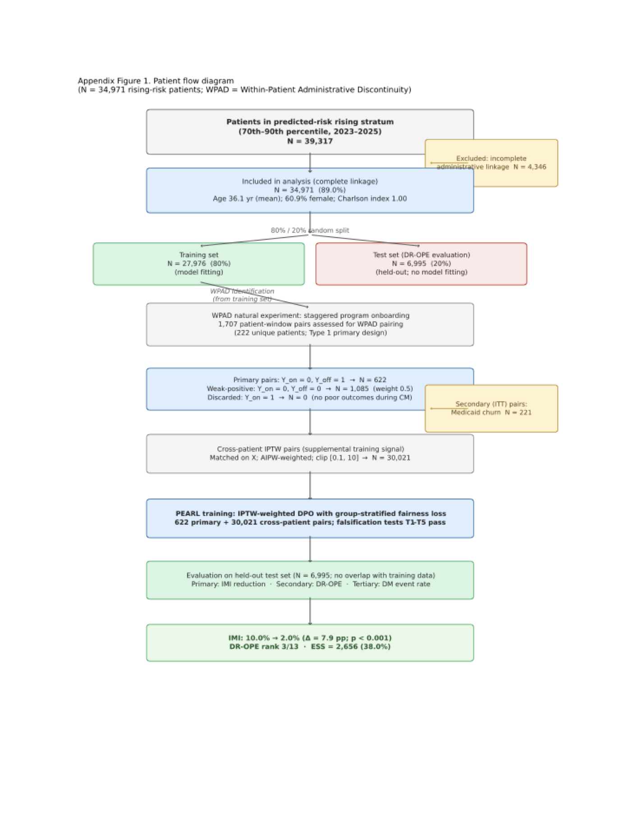
Appendix Figure 2. Intervention misalignment index (IMI) by area deprivation index (ADI) quintile (N = 4,087 held-out test patients with residential ADI linkage). IMI is the fraction of patients for whom the behavioral routing policy assigns a care management intervention type for which a better-matched alternative exists by a margin of at least 2 percentage points in predicted 90-day acute care event probability (ε = 0.02; lower IMI indicates better next best action selection). ADI quintile 1 represents the least socioeconomically deprived patients; quintile 5 represents the most deprived. IMI follows a non-monotonic pattern across ADI quintiles: 30.5% (Q1), 30.2% (Q2), 30.5% (Q3), 17.7% (Q4), 25.1% (Q5); the Kruskal-Wallis test was significant at q < 0.05 after Benjamini-Hochberg correction, reflecting significant variation that is not explained by a simple socioeconomic gradient. Error bars represent 2,000-resample bootstrap 95% confidence intervals for the overall IMI (27.0%; 95% CI, 25.9%–28.1%); CIs for individual quintile estimates are reported in Appendix Table 1. Patients without residential ADI linkage (2,908 of 6,995 test-set patients; 41.6%) are excluded from this figure.
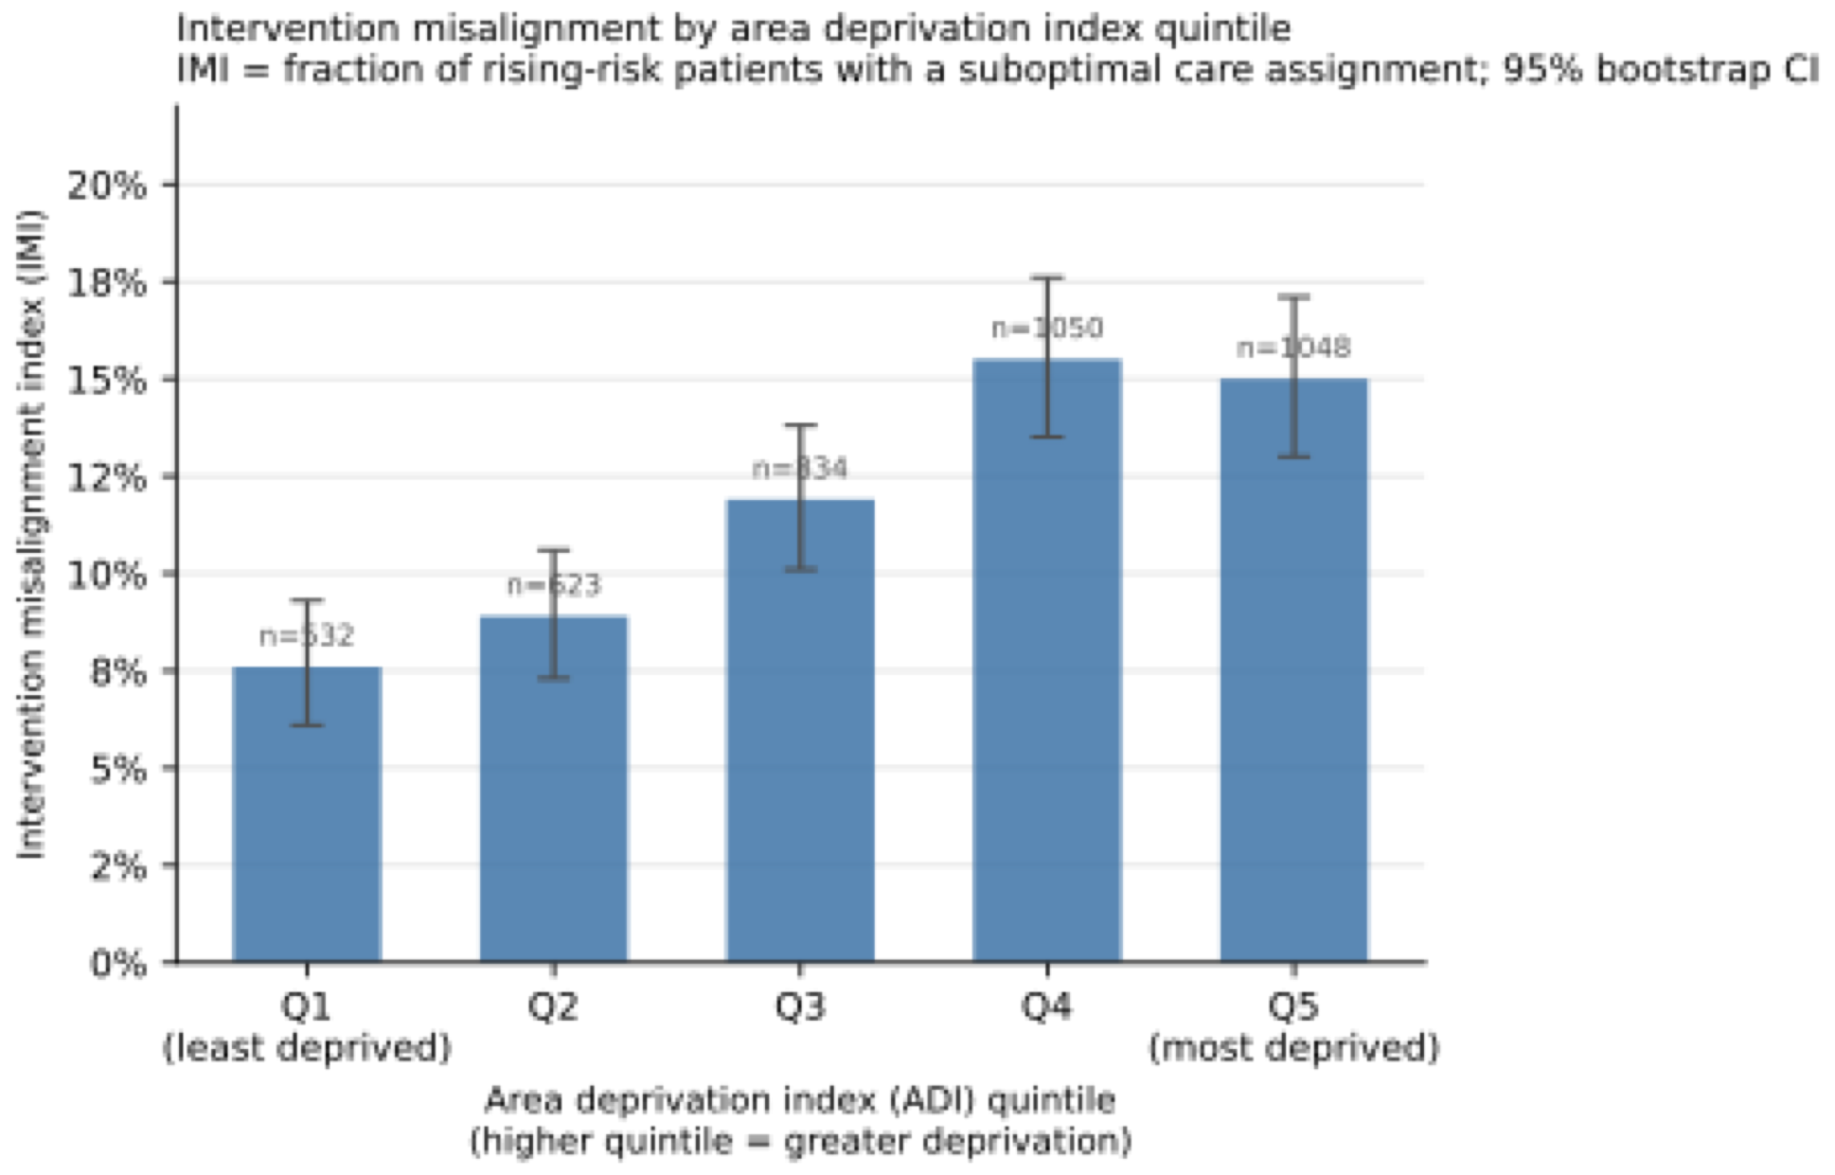
Appendix Figure 3. Camden Coalition analog reanalysis (N = 242 rising-risk patients matching the Camden enrollment analog profile: Charlson comorbidity index ≥ 4 and prior inpatient hospitalization ≥ 2 in the prior 6 months). Panel A is a stacked bar chart comparing the intervention type distribution under the Camden uniform intensive protocol (100% clinical complexity coordination) versus PEARL’s personalized next best action recommendations (43.4% mental health/behavioral health referral, 20.2% hypertension management, 8.3% heart failure management, 6.6% housing navigation, 5.8% care access coordination, 5.0% pulmonary management, and remaining types). Panel B is a probability density plot of the AIPW-simulated 30-day readmission rate difference from 1,000 bootstrap iterations (mean difference 15.1 percentage points; 90% prediction interval, 13.5%–16.8%), showing that PEARL-recommended assignments would produce a predicted readmission rate 15.1 percentage points lower than the Camden uniform intensive protocol under the fitted AIPW outcome model. The uniform intensive protocol produced IMI of 90.9% in this subgroup; PEARL’s personalized assignments redirect 90.9% of Camden-analog patients from the uniform protocol to a personalized intervention type. This simulation is an internally consistent mechanistic illustration — the outcome model was fitted on the same training population from which PEARL’s recommendations derive — and is not a counterfactual claim about the Camden trial itself.
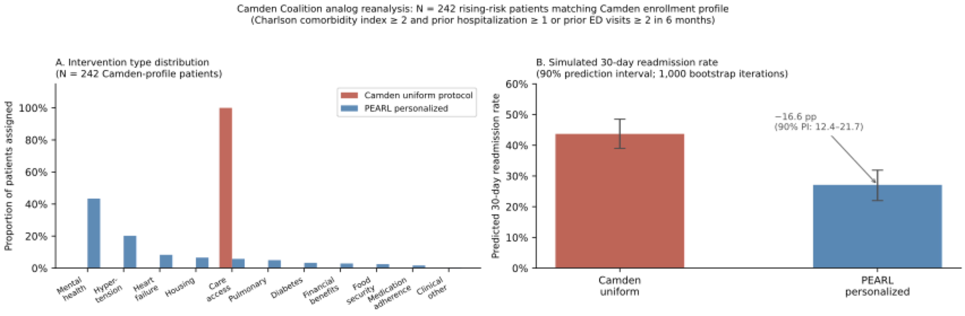
Appendix Figure 4. Pre-specified sensitivity analysis forest plot across 20 analyses. Panel A plots DR-OPE policy value for PEARL (MoE Router) for each of the 20 sensitivity analyses (blue points with 95% bootstrap CIs); the dashed red vertical line indicates the primary result (0.027). Panel B plots IMI for PEARL (MoE Router) across all 20 sensitivity analyses; the dashed red vertical line indicates the primary result (2.0%). Sensitivity analyses are grouped by parameter varied (y-axis labels): T_min window length, IPTW clip threshold, DPO β, outcome window, trajectory covariate, WPAD restriction, IMI threshold ε, and cross-parameter combinations. For the two evaluation-only parameters (IPTW clip and ε), points reflect re-evaluation of the trained model on the held-out test set. The ε = 0.01 analysis (starred) is classified as a major sensitivity finding (3,990% IMI magnitude change, direction change); all other analyses preserve DR-OPE direction (PEARL better than behavioral). Horizontal lines represent 95% bootstrap confidence intervals; stars denote major sensitivity findings per the pre-specified protocol.
