Insects as biosamplers of fine and ultrafine particles in urban environments

Meza-Figueroa D.^{1,7*}, Berrellez-Reyes, F.^{2,7}, Valencia-Meza, A.¹, Valdez-Ojeda, L. F.³, González-Grijalva, B.^{1,7}, Schiavo B.^{4,7}, Villarreal-Cantú, P.⁵, Ortega-Rosas, C.I.^{6,7}

¹ Departamento de Geología, Universidad de Sonora. Rosales y Encinas, Centro, Hermosillo, Sonora, México 83000
² Secretaría de Ciencia, Humanidades, Tecnología e Innovación, SECIHTI. Av. Insurgentes Sur 1582, Crédito Constructor, Benito Juárez, Ciudad de México 03940
³ Red de Ecoetología, Instituto de Ecología A.C. (INECOL) Carretera antigua a Coatepec 351, Col. El Haya, Xalapa, Veracruz, México 91073
⁴ Instituto de Geofísica, Universidad Nacional Autónoma de México, Mexico City, Mexico
⁵ Procuraduría Ambiental del Gobierno del Estado de Sonora, PROAES. Cuernavaca 54, San Benito, Hermosillo, Sonora, México 83190
⁶ Licenciatura en Ecología, Universidad Estatal de Sonora, Ley Federal del Trabajo SN. Col. Apolo, Hermosillo, Sonora, México
⁷ Laboratorio Nacional de Atmósfera y Clima LanCAC, Secretaría de Ciencia, Humanidades, Tecnología e Innovación, SECIHTI. Av. Insurgentes Sur 1582, Crédito Constructor, Benito Juárez, Ciudad de México 03940

Supplementary Material

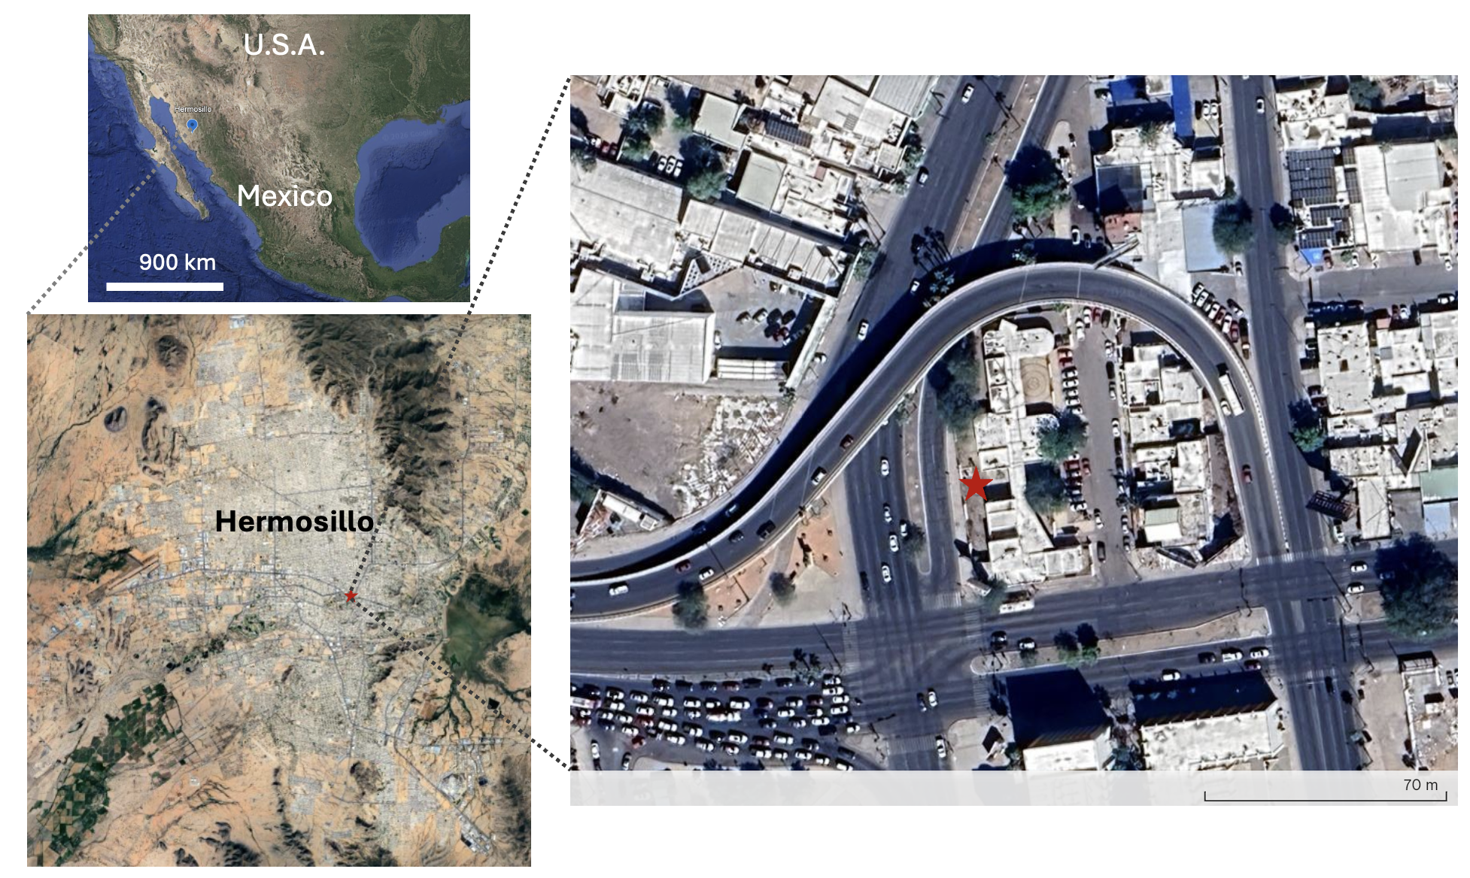
Figure S1. Location map of study site (shown as the red star).

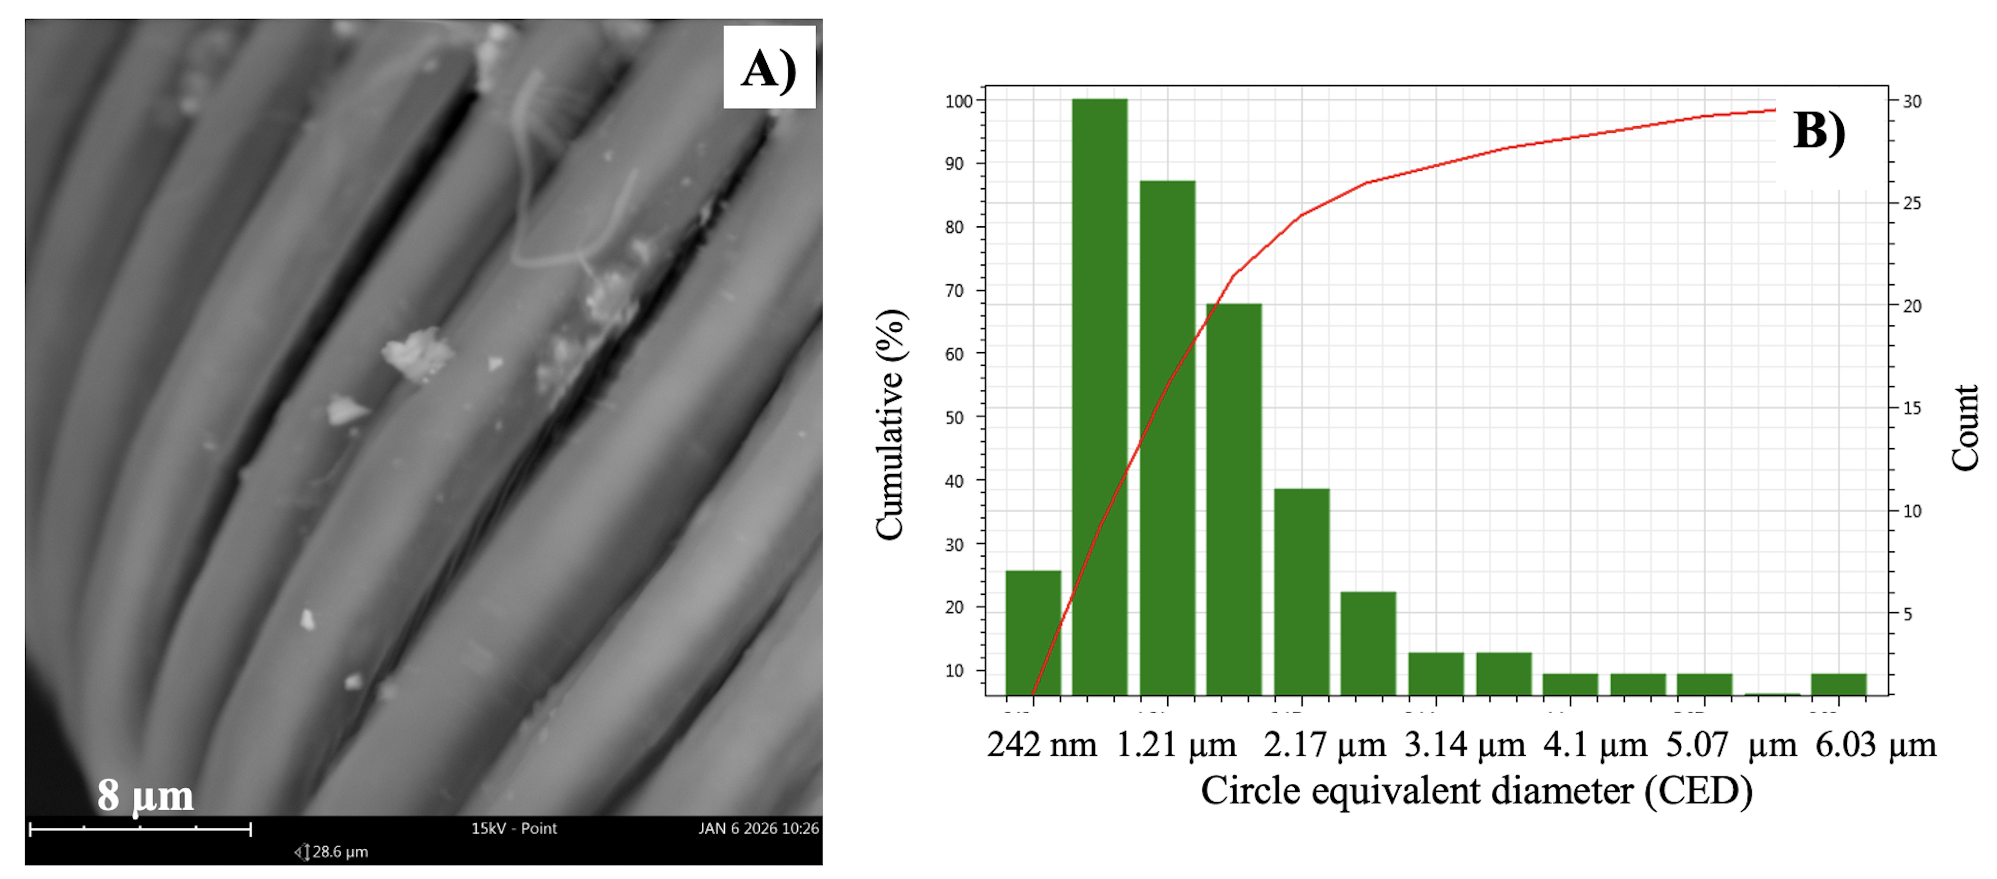
Figure S2. A) SEM-EDS image showing particles adhering to the legs of Apis. B) particle size distribution on the legs of Apis.

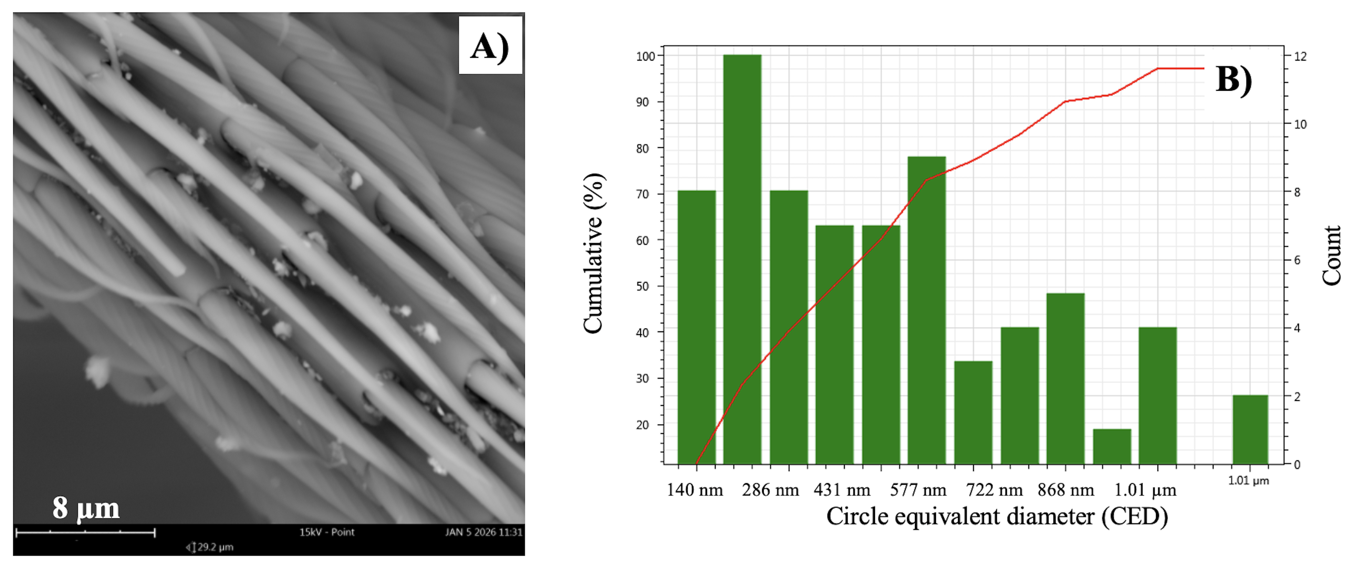
Figure S3. A) SEM-EDS image showing particles adhering to the legs of Cerceris. B) particle size distribution on the legs of Cerceris.

Table S1. Particle properties based on 3 images with a total of 115 particles found in legs from Apis
Properties weighted by volume |  |  | Properties weighted by count
Property | Median | Average | Property | Median | Average
Circle equivalent diameter | 4.85 µm | 4.55 µm | Circle equivalent diameter | 1.49 µm | 1.92 µm
Major axis | 5.56 µm | 6.25 µm | Major axis | 1.83 µm | 2.46 µm
Minor axis | 3.51 µm | 3.46 µm | Minor axis | 1.2 µm | 1.54 µm
Circumference | 18.5 µm | 18.6 µm | Circumference | 4.93 µm | 6.98 µm
Convex hull | 17.7 µm | 17.4 µm | Convex hull | 4.93 µm | 6.76 µm
Circumscribed circle equivalent | 6.57 µm | 7.23 µm | Circumscribed circle equivalent | 1.92 µm | 2.73 µm
Area | 18.5 µm² | 18.3 µm² | Area | 1.75 µm² | 4.15 µm²
Volume by area | 59.9 µm³ | 67.3 µm³ | Volume by area | 1.74 µm³ | 10.3 µm³
Pixel count | 2587 | 2584 | Pixel count | 332 | 796
Aspect ratio | 0.637 | 0.619 | Aspect ratio | 0.682 | 0.671
Circularity | 0.696 | 0.670 | Circularity | 0.866 | 0.835
Convexity | 0.952 | 0.949 | Convexity | 1 | 0.983
Elongation | 0.362 | 0.381 | Elongation | 0.318 | 0.329
Grayscale | 155 | 164 | Grayscale | 155 | 159

Table S2. Particle properties based on 3 images with a total of 70 particles found in legs from Cerceris
Properties weighted by volume |  |  | Properties weighted by count
Property | Median | Average | Property | Median | Average
Circle equivalent diameter | 791 nm | 779 nm | Circle equivalent diameter | 435 nm | 471 nm
Major axis | 1.1 µm | 1.05 µm | Major axis | 546 nm | 620 nm
Minor axis | 585 nm | 588 nm | Minor axis | 330 nm | 366 nm
Circumference | 3.04 µm | 2.86 µm | Circumference | 1.49 µm | 1.69 µm
Convex hull | 2.98 µm | 2.8 µm | Convex hull | 1.48 µm | 1.66 µm
Circumscribed circle equivalent | 1.17 µm | 1.15 µm | Circumscribed circle equivalent | 619 nm | 675 nm
Area | 0.49 µm² | 0.52 µm² | Area | 0.15 µm² | 0.22 µm²
Volume by area | 0.26 µm³ | 0.31 µm³ | Volume by area | 0.04 µm³ | 0.10 µm³
Pixel count | 2688 | 2816 | Pixel count | 932 | 1268
Aspect ratio | 0.599 | 0.583 | Aspect ratio | 0.638 | 0.636
Circularity | 0.769 | 0.749 | Circularity | 0.825 | 0.82
Convexity | 0.977 | 0.98 | Convexity | 1 | 0.99
Elongation | 0.396 | 0.417 | Elongation | 0.362 | 0.364
Grayscale | 149 | 151 | Grayscale | 135 | 142

