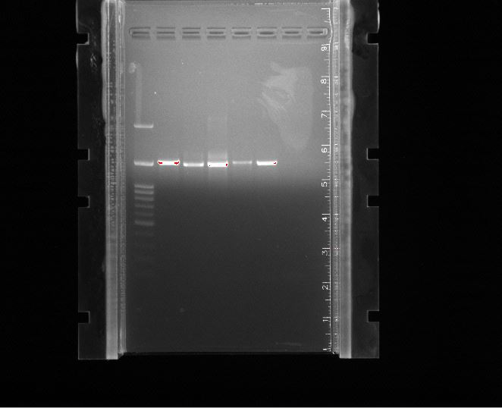
Supplementary File 1. DNA integrity was assessed using 1% agarose gel electrophoresis. From left to right, Lane 1 shows a 1 kb DNA ladder used (ready to load); Lane 2, horse manure co compost; Lane 3, swine (pig) manure co compost; Lane 4, cow manure co compost; Lane 5, poultry manure co compost; and Lane 6, the unamended control. Distinct DNA bands of approximately 8,000 base pair were observed in Lanes 2–6, confirming DNA integrity across the samples.

