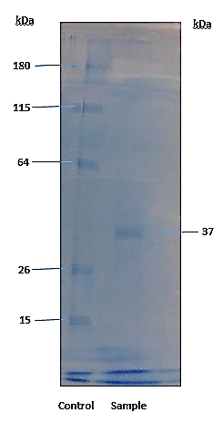
Supplementary S1. Purification of lignin peroxidase (LiP) from Phanerochaete chrysosporium.
SDS-PAGE gel demonstrating the purification steps. Lane M: Molecular weight marker; Lane 1: Crude culture supernatant; Lane 2: Protein precipitate after 60% ammonium sulfate saturation; Lane 3: Dialyzed and concentrated enzyme preparation showing a single dominant band at ~37 kDa, confirming homogeneity.

