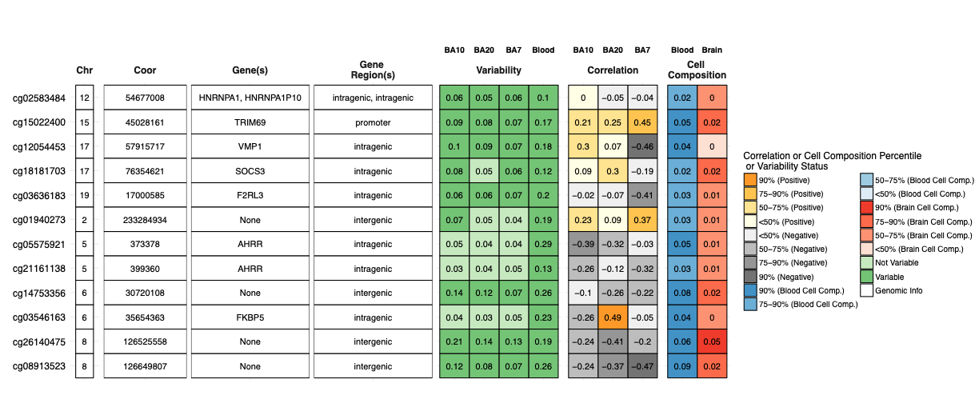
Blood–brain methylation portability of top CUD-associated CpG sites using BECon.
Top blood-identified CpG sites were queried in the BECon web application to assess cross-tissue methylation variability, blood–brain methylation correlations, and estimated cell-composition effects across dorsolateral/prefrontal cortical regions. Rows represent CpG sites identified in peripheral blood, with genomic annotation shown for chromosome, genomic coordinate, mapped gene, and gene-region context. Variability columns indicate whether each CpG is variable in BA10, BA20, BA7, and blood. Correlation columns show blood–brain methylation correlations for BA10, BA20, and BA7. Cell-composition columns indicate the estimated influence of blood and brain cellular composition on methylation levels at each CpG. Overall, most blood-identified CpGs showed weak or inverse blood–brain correlations, whereas a minority displayed moderate positive correlations across cortical regions. Smoking-associated loci, including AHRR and F2RL3, showed prominent blood cell-composition effects and limited cross-tissue portability, while selected immune- and stress-related loci, including SOCS3 and FKBP5, showed more consistent evidence of blood–brain methylation correspondence.

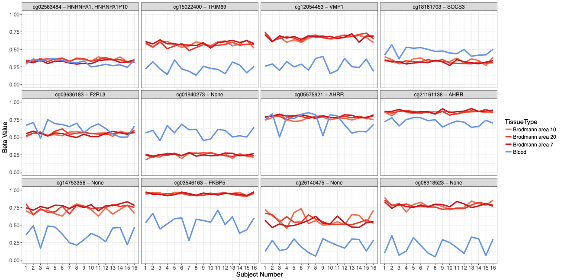
BECon-derived blood and brain methylation profiles of top CUD-associated CpG sites.
BECon visualization of DNA methylation beta values for selected top CpG sites identified in peripheral blood. Each panel represents one CpG site, labeled by Illumina probe ID and annotated gene when available. The x-axis shows the BECon subject index, and the y-axis shows methylation beta values. Lines indicate methylation profiles across blood and cortical brain regions, with blood shown in blue and Brodmann areas 10, 20, and 7 shown in red tones, as indicated in the figure legend. The plots illustrate the degree to which methylation levels at each blood-identified CpG show concordance or divergence across blood and cortical tissues. Several loci show relatively stable methylation across brain regions but marked blood–brain differences, consistent with tissue-specific methylation patterns and limited cross-tissue portability for a subset of CUD-associated peripheral CpGs.

