No. | Algorithm name | Abbreviations | R packages
1 | Partial Least Squares | PLS | caret
2 | Random Forest | RF | randomForest
3 | Decision Tree / Classification and Regression Tree | DTS | rpart
4 | Support Vector Machine (Radial Basis Kernel) | SVM | e1071
5 | Logistic Regression | Logistic | stats
6 | k-Nearest Neighbors | KNN | class
7 | Extreme Gradient Boosting | XGBoost | xgboost
8 | Gradient Boosting Machine | GBM | gbm
9 | Neural Network | NeuralNet | nnet
10 | Generalized Linear Model Boosting | glmBoost | mboost
Table S1. Machine-learning algorithms used in this study

Table S2. Primers used for RT-qPCR
No. | Gene | Primer | Sequence (5′–3′)
1 | RARRES2 | Forward | AGAAACCCGAGTGCAAAGTCA
2 | RARRES2 | Reverse | AGAACTTGGGTCTCTATGGGG
3 | PTHLH | Forward | ATTTACGGCGACGATTCTTCC
4 | PTHLH | Reverse | GCTTGGAGTTAGGGGACACC
5 | LDHA | Forward | ATGGCAACTCTAAAGGATCAGC
6 | LDHA | Reverse | CCAACCCCAACAACTGTAATCT
7 | GLUT1 | Forward | ATTGGCTCCGGTATCGTCAAC
8 | GLUT1 | Reverse | GCTCAGATAGGACATCCAGGGTA
9 | PKM2 | Forward | ATGTCGAAGCCCCATAGTGAA
10 | PKM2 | Reverse | TGGGTGGTGAATCAATGTCCA
11 | GAPDH | Forward | CTGGGCTACACTGAGCACC
12 | GAPDH | Reverse | AAGTGGTCGTTGAGGGCAATG

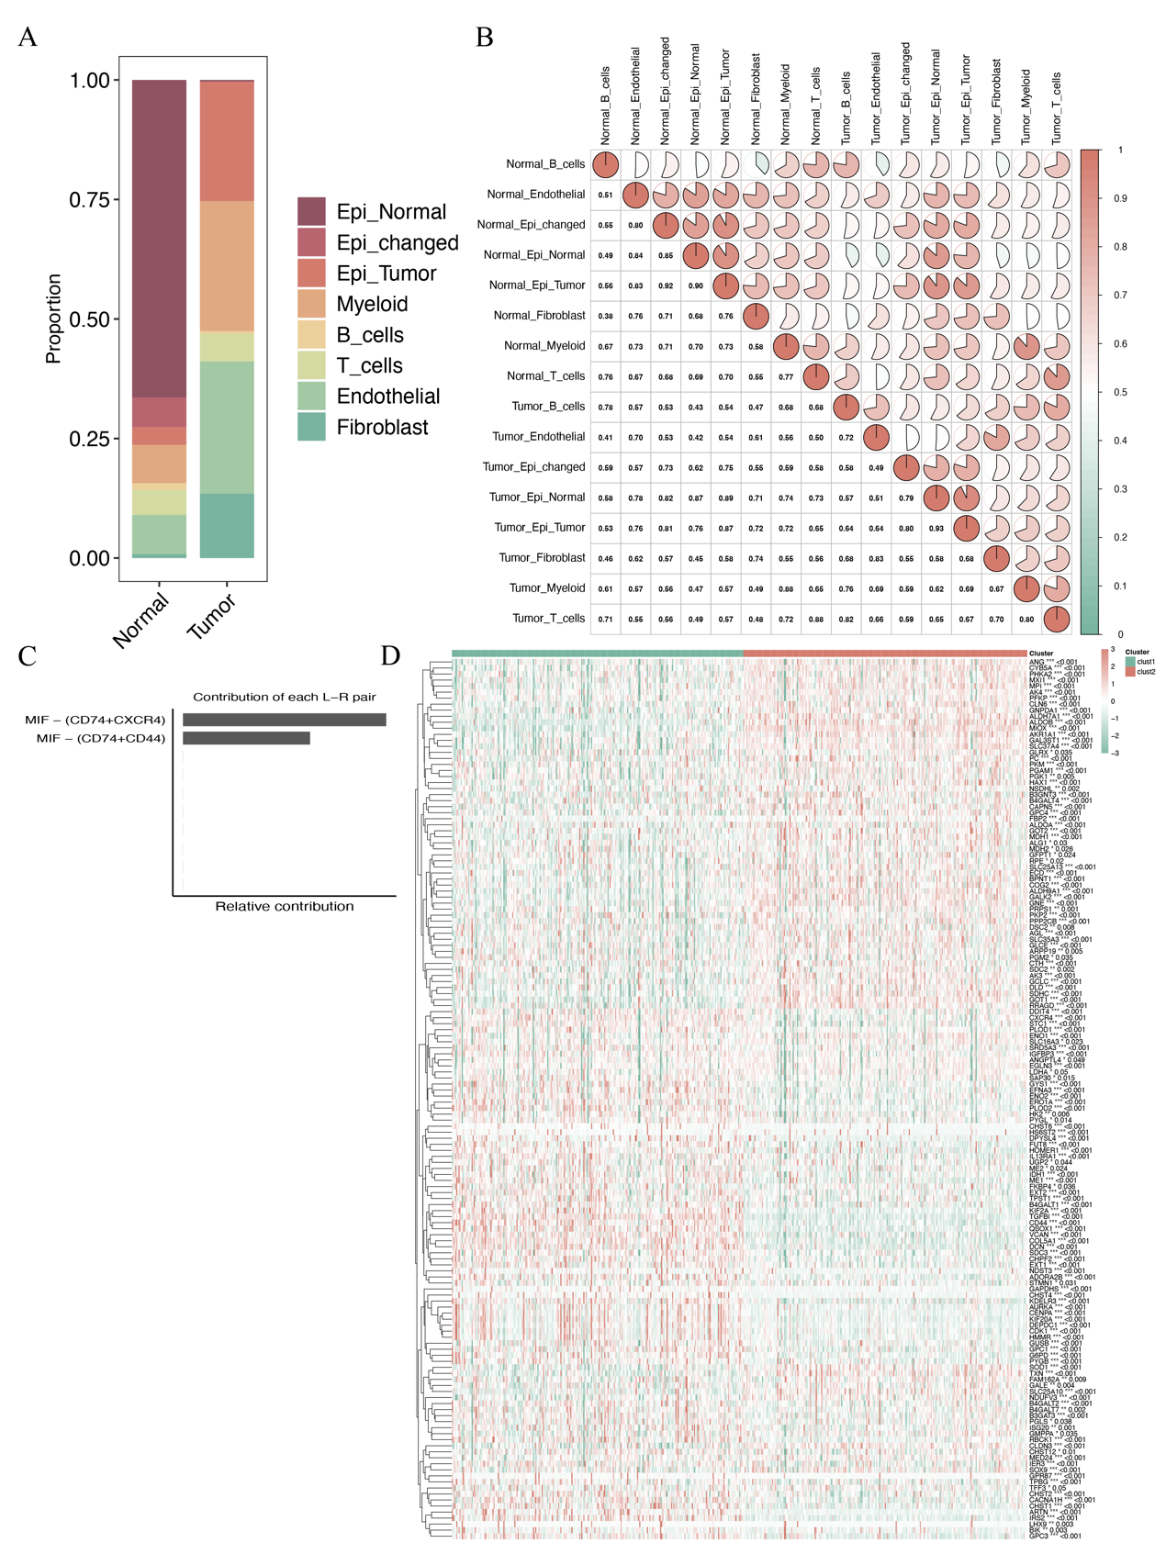
Supplementary Figure S1. Cell-type composition, transcriptomic similarity, and representative signaling features across conditions (A) Stacked bar plot summarizing the relative proportions of major cell populations and epithelial subtypes in Normal and Tumor samples. (B) Pairwise correlation matrix of averaged expression profiles across condition-specific cell groups, with correlation coefficients annotated. (C) Bar plot showing the relative contribution of individual ligand-receptor pairs to the MIF signaling pathway. (D) Unsupervised heatmap of subtype-associated gene expression patterns across samples.

