Supplementary Tables and Figures

Table S1. Data of RNA-seq in this study
Sample | Raw  Reads | Clean  Reads | Error  Rate (%) | Q20(%) | Q30(%) | GC  content (%) | Coverage
MH-panicle-rep1 | 69,750,648 | 69,028,601 | 0.01 | 96.68 | 91.81 | 49.02 | 53x
MH-panicle-rep2 | 66,898,732 | 66,244,106 | 0.01 | 96.75 | 91.94 | 49.59 | 52x
MH-young_leaf-rep1 | 69,972,520 | 69,328,773 | 0.03 | 97.49 | 93.48 | 45.78 | 53x
MH-young_leaf-rep2 | 68,017,224 | 67,357,457 | 0.03 | 97.24 | 92.94 | 45.91 | 52x
MH-root-rep1 | 71,355,101 | 70,353,068 | 0.01 | 97.00 | 92.50 | 49.60 | 54x
MH-root-rep2 | 81,017,424 | 79,729,247 | 0.02 | 94.78 | 88.39 | 49.48 | 61x
ZS-panicle-rep1 | 68,494,988 | 68,028,011 | 0.01 | 96.59 | 91.63 | 48.59 | 52x
ZS-panicle-rep2 | 75,335,387 | 74,559,808 | 0.01 | 96.89 | 92.29 | 50.31 | 57x
ZS-young_leaf-rep1 | 74,849,106 | 74,305,617 | 0.03 | 97.34 | 93.19 | 47.22 | 57x
ZS-young_leaf-rep2 | 72,444,163 | 71,844,388 | 0.03 | 97.38 | 93.26 | 47.45 | 55x
ZS-root-rep1 | 72,320,671 | 71,174,967 | 0.01 | 97.59 | 93.70 | 50.72 | 54x
ZS-root-rep2 | 76,087,567 | 75,077,463 | 0.01 | 97.45 | 93.47 | 50.36 | 57x
SY-panicle-rep1 | 76,735,606 | 76,101,702 | 0.01 | 96.90 | 92.37 | 48.61 | 58x
SY-panicle-rep2 | 70,934,603 | 70,310,723 | 0.01 | 96.71 | 91.94 | 49.47 | 54x
SY-young_leaf-rep1 | 71,070,379 | 70,423,639 | 0.03 | 97.39 | 93.30 | 45.78 | 54x
SY-young_leaf-rep2 | 68,095,109 | 67,775,062 | 0.03 | 97.09 | 92.69 | 45.48 | 52x
SY-root-rep1 | 71,007,755 | 69,860,766 | 0.01 | 97.50 | 93.62 | 48.95 | 53x
SY-root-rep2 | 82,370,593 | 81,022,123 | 0.01 | 97.63 | 93.87 | 49.48 | 62x

Table S2. Tissue distribution of ncRNAs
Tissue | circRNAs |  |  | lncRNAs
Tissue | MH63 | ZS97 | SY63 | MH63 | ZS97 | SY63
Panicle | 3367 | 2999 | 2898 | 10076 | 11652 | 12028
Leaf | 1160 | 977 | 1173 | 6149 | 6856 | 7185
Root | 1933 | 1245 | 1918 | 7517 | 8720 | 8870
Total | 5122 | 4273 | 4707 | 11,513 | 13,153 | 13,549

Table S3. Replicate distribution of circRNAs
Replicates | circRNAs
Replicates | MH63 | ZS97 | SY63
Panicle-rep1 | 1850 | 1407 | 1728
Panicle-rep2 | 1976 | 1886 | 1447
Young_leaf-rep1 | 793 | 638 | 727
Young_leaf-rep2 | 741 | 632 | 756
Root-rep1 | 1169 | 815 | 1024
Root-rep2 | 1143 | 733 | 1181

Table S4. Software distribution of high-confidence circRNAs
Software | CIRI2 | CIRCexplorer2 | find_circ | CIRI2 & CIRCexplorer2 | CIRI2 & find_circ | CIRCexplorer2 & find_circ | CIRI2, CIRCexplorer2 & find_circ
MH63 | 1383 | 1296 | 1150 | 971 | 296 | 17 | 9
ZS97 | 1044 | 1187 | 1152 | 701 | 164 | 19 | 6
SY63 | 1234 | 1247 | 1203 | 760 | 237 | 17 | 9

Table S5. Alternative splicing of circRNAs
 | Number of parental genes | Parental genes with >1 circRNA | Parental genes of >1 circRNAs | Parental genes of 1 circRNAs
MH63 | 2860 | 732 | 33.6581‬% | 66.3419%
ZS97 | 2511 | 606 | 31.8219% | 68.1781%
SY63 | 2621 | 695 | 33.696% | 66.3040%

Table S6. Genomic distribution of circRNAs
 |  | MH63 |  |  | ZS97 |  |  | SY63
Chromosome | CircRNAs | bp/circRNA | Genes/circRNA | CircRNAs | bp/circRNA | Genes/circRNA | CircRNAs | bp/circRNA | Genes/circRNA
1 | 786 | 56631.4606 | 9.13867684 | 625 | 71171.7008 | 11.4864 | 722 | 61651.4238 | 9.94875346
2 | 608 | 60314.6053 | 9.73848684 | 571 | 65193.3503 | 10.8704028 | 541 | 67784.2514 | 10.9445471
3 | 643 | 61199.8289 | 9.7807154 | 555 | 70769.8018 | 11.2666667 | 583 | 67498.2676 | 10.787307
4 | 494 | 73213.0587 | 11.2935223 | 360 | 100975.158 | 15.5416667 | 455 | 79488.4637 | 12.2615385
5 | 417 | 74056.458 | 11.4028777 | 313 | 97543.9808 | 15.4440895 | 383 | 80630.6606 | 12.4151436
6 | 451 | 70183.6031 | 10.9844789 | 347 | 92511.4669 | 13.6541787 | 387 | 81790.1938 | 12.8010336
7 | 360 | 83030.6028 | 13.4277778 | 279 | 107750.713 | 17.7311828 | 324 | 92256.2253 | 14.9197531
8 | 332 | 89751.6175 | 13.7439759 | 296 | 102079.172 | 16.1148649 | 341 | 87382.8065 | 13.3812317
9 | 256 | 95048.3125 | 15.0976563 | 238 | 94757.5504 | 15.5630252 | 255 | 95421.051 | 15.1568627
10 | 271 | 92720.3469 | 14.1808118 | 241 | 106304.216 | 16.9958506 | 254 | 98926.0394 | 15.1299213
11 | 238 | 138164.58 | 19.3193277 | 212 | 150043.505 | 21.3537736 | 210 | 156586.524 | 21.8952381
12 | 266 | 98332.1654 | 14.056391 | 233 | 116304.322 | 17.3690987 | 246 | 106326.65 | 15.199187

Table S7. Genomic distribution of lncRNAs
 |  | MH63 |  |  | ZS97 |  |  | SY63
Chromosome | lncRNAs | bp/lncRNAs | Genes/lncRNAs | lncRNAs | bp/lncRNAs | Genes/lncRNAs | lncRNAs | bp/lncRNAs | Genes/lncRNAs
1 | 836 | 53244.4115 | 8.59210526 | 916 | 48561.4771 | 7.83733624 | 934 | 47657.7388 | 7.69057816
2 | 730 | 50234.6301 | 8.1109589 | 680 | 54743.2397 | 9.12794118 | 839 | 43708.3194 | 7.05721097
3 | 655 | 60078.6107 | 9.60152672 | 674 | 58274.8368 | 9.27744807 | 754 | 52190.305 | 8.34084881
4 | 860 | 42054.943 | 6.4872093 | 780 | 46603.9192 | 7.17307692 | 919 | 39355.0065 | 6.07072905
5 | 597 | 51727.8777 | 7.96482412 | 620 | 49243.9774 | 7.79677419 | 655 | 47147.3939 | 7.25954198
6 | 656 | 48251.2271 | 7.55182927 | 757 | 42406.181 | 6.25891678 | 784 | 40373.4758 | 6.31887755
7 | 577 | 51804.1889 | 8.37781629 | 661 | 45480.2557 | 7.48411498 | 702 | 42579.7963 | 6.88603989
8 | 664 | 44875.8087 | 6.87198795 | 654 | 46200.9709 | 7.29357798 | 796 | 37434.0917 | 5.73241206
9 | 521 | 46703.2015 | 7.4184261 | 481 | 46886.2723 | 7.7006237 | 564 | 43142.4965 | 6.85283688
10 | 441 | 56977.8095 | 8.71428571 | 446 | 57442.4126 | 9.1838565 | 503 | 49954.6998 | 7.64015905
11 | 827 | 39761.9952 | 5.5598549 | 746 | 42639.7091 | 6.06836461 | 920 | 35742.5761 | 4.99782609
12 | 883 | 29622.1472 | 4.23442809 | 812 | 33373.0382 | 4.98399015 | 947 | 27620.2281 | 3.94825766

Table S8. Conservation of lncRNAs and circRNAs in MH63 with other species
Proportion of conserved ncRNAs | circRNAs |  | lncRNAs
Proportion of conserved ncRNAs | Genome (%) | Sequence (%) | Genome (%) | Sequence (%)
ZS97 | 92 | 38.69 | 96 | 47
SY63 | - | 50.82 | - | 58
O.rufipogon | 87 | - | 93 | -
O.s.japonica | 86 | - | 94 | -
O.barthii | 80 | - | 88 | -
O.glaberrima | 73 | - | 82 | -
S.bicolor | 18 | - | 12 | -
S. italica | 18 | - | 15 | -
B.distachyon | 15 | - | 14 | -
Z.mays | 15 | - | 11 | -
P.trichocarpa | 2 | - | 1 | -
A.thaliana | 1 | - | 2 | -

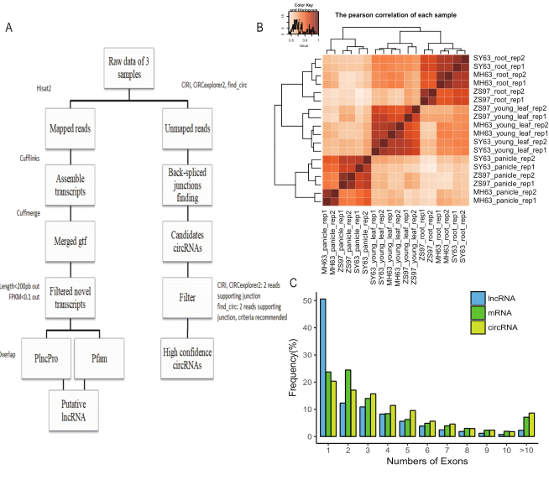
Figure S1. Workflow and characteristics of lncRNAs and circRNAs in rice. (a) Computational identification of lncRNAs and circRNAs. (b)The Pearson’s correlation of different samples. The distribution of exon number for circRNAs, lncRNAs and mRNAs in rice.

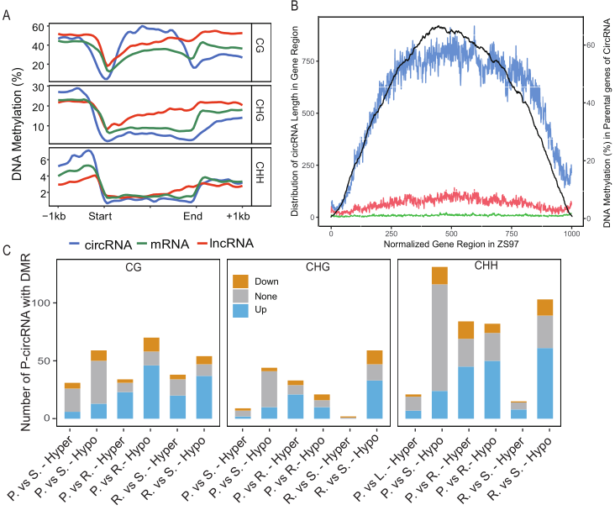
Figure S2. DNA methylation of P-circRNAs and lncRNA loci in ZS97. (a) CG, CHG and CHH DNA methylation densities in the parental genes of circRNAs (blue), lncRNAs locus (red) and PC genes (green) and their 1 kb up/down flanking regions in seedling of ZS97. (b) Distribution of the positions of circRNAs (black) and CG DNA methylation (red) in the parental genes normalized to 1 kb length in ZS97. (c) Histogram showing the number of P-circRNA containing hyper- and hypo-methylation on DMRs in body. P-circRNAs were classified into the same groups as a. DNA methylation (CG, CHG and CHH) profile of non-differently expressed (None, grey), upregulated (Up, orange), and downregulated (Down, blue) P-circRNAs in MH63. P. vs S. referred to the comparison between panicle and seedling. P. vs R. referred to the comparison between panicle and root. R. vs. S. referred to the comparison between root and seedling.

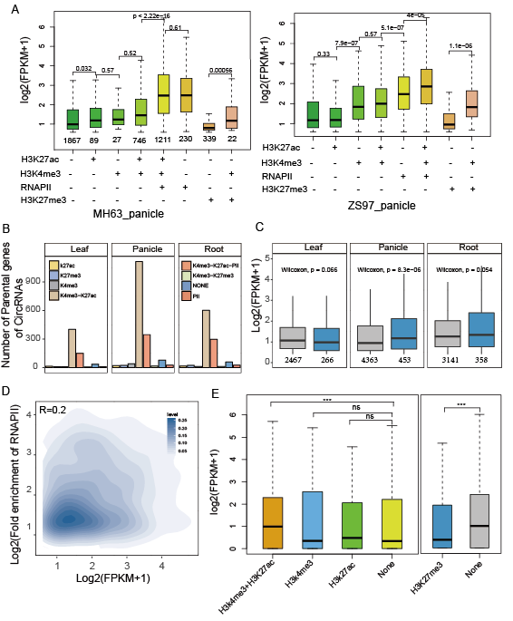
Figure S3. Comprehensive epigenome map of lncRNA and P-circRNA in different varieties. (a) Expression levels of lncRNA loci marked by different histone modifications and RNAPII in panicle of MH63 (left) and ZS97 (right). Numbers of locus with histones categories were shown. (b) Numbers of P-circRNA marked by different histone modifications and RNAPII of leaf (left), panicle (middle) and root (right) in MH63. (c) Comparison of the number and expression (FPKM) of lncRNAs marked or not-marked by H3K9me2. (d) The relationship between intensity of RNAPII and expression of lncRNA loci in seedling of MH63. (d) Expression levels of genes nearest lncRNA loci marked by RNAPII and histone modification. Wilcoxon’s test was used for all the tests in the figures, *** means P <0.001, ns means no significance.

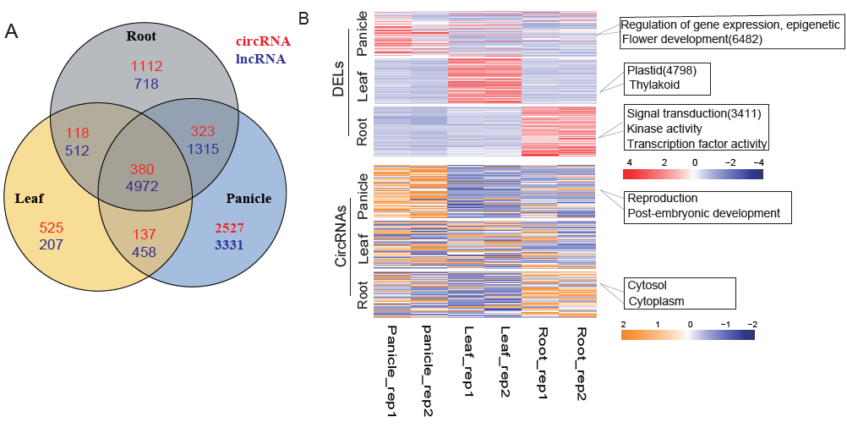
Figure S4. Tissue specificity of lncRNAs and circRNAs in MH63. (a) Number of lncRNAs and circRNAs in different tissues. (b) Differential expression analysis of lncRNAs and circRNAs in different tissues and replicates of MH63, and the results of GO analysis in each tissue.

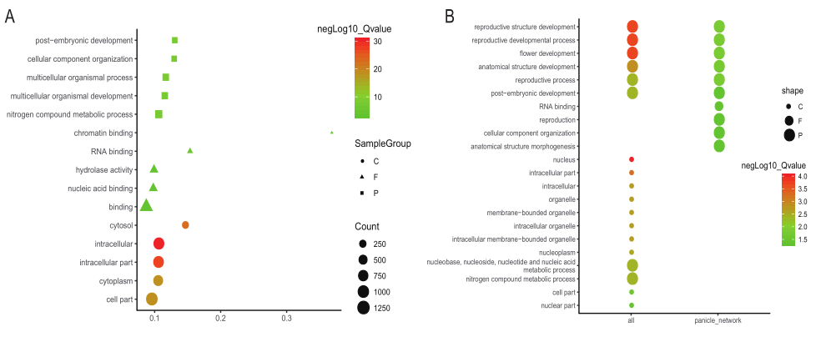
Figure S5. (a) GO of parental genes of circRNAs. GO terms are summarized in three categories: cellular component (C), molecular function (F) and biological process (P). (b) Gene ontology analysis of with the target genes of miRNAs in the ceRNA networks in MH63. GO terms are summarized in three categories: cellular component (C), molecular function (F) and biological process (P).

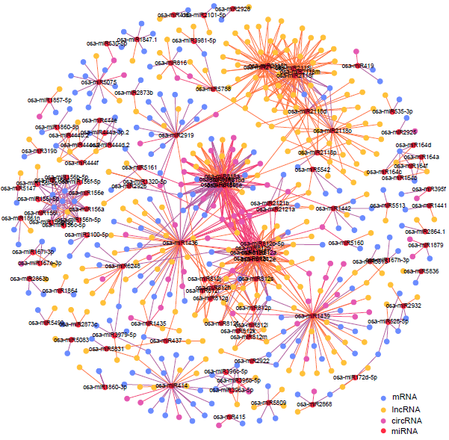
Figure S6. CeRNA network of DECs and DELs of panicle in MH63. Each color represents different interactions of a miRNA in the ceRNA network.

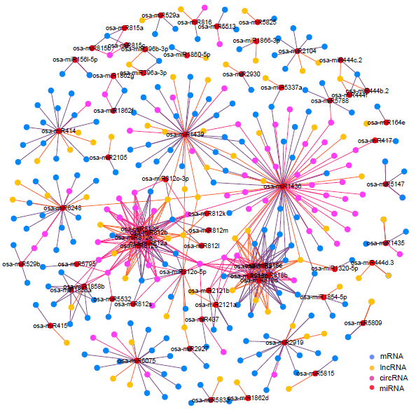

Figure S7. CeRNA network of DECs and DELs of seedling in MH63. Each color represents different interactions of a miRNA in the ceRNA network.

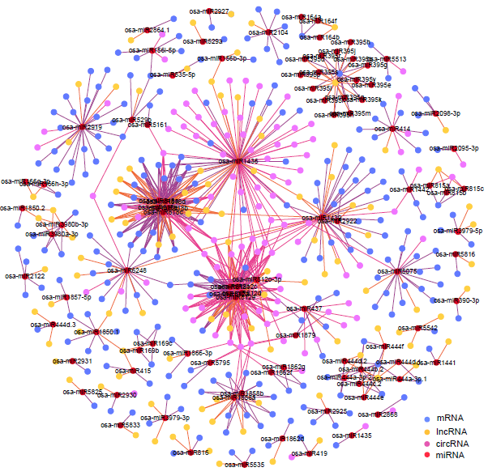
Figure S8. CeRA network of DECs and DELs of root in MH63. Each color represents the different interactions of a miRNA in the ceRNA network.

