SUPPLEMENTARY MATERIAL

Symbiodiniaceae diversity associated with mesophotic Leptoseris corals on eastern Australian reefs
Gijsbers JC^{1, 2}*, Nitschke MR³, Radice VZ⁴, Bongaerts P ¹

¹ California Academy of Sciences, San Francisco, California, USA
² Centro Interdisciplinario de Investigación para el Desarrollo Integral Regional (CIIDIR), Unidad Oaxaca, Instituto Politécnico Nacional, Oaxaca, México
³ Australian Institute of Marine Science, Townsville, Queensland, Australia
⁴ The University of Queensland, St. Lucia, Queensland, Australia
* Corresponding author: jgijsbers@calacademy.org
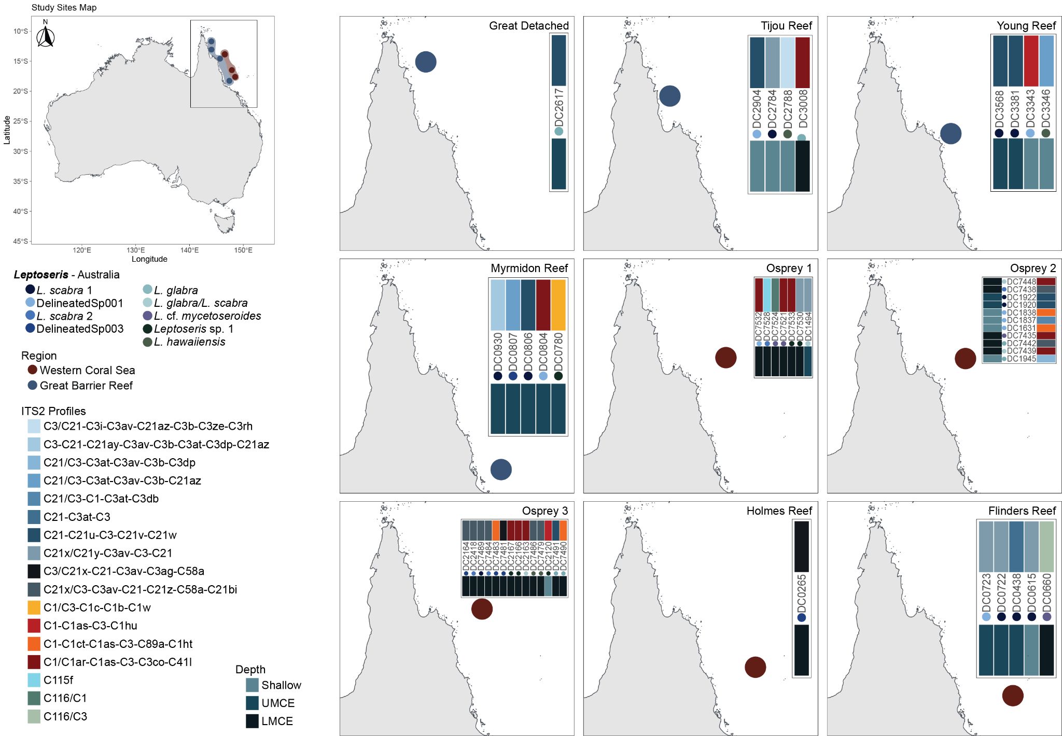
Figure S1. Geographic distribution of ITS2 profile diversity within the Leptoseris genus across Australian reefs. Schematic visualization of geographic patterns in the Great Barrier Reef and Western Coral Sea regions. For each site, the ITS2 profile is indicated at the top with the corresponding depth category at the bottom. Colored circles beneath each sample code represent the genetic lineage of the host, illustrating lineage distribution across sites and depth gradients.

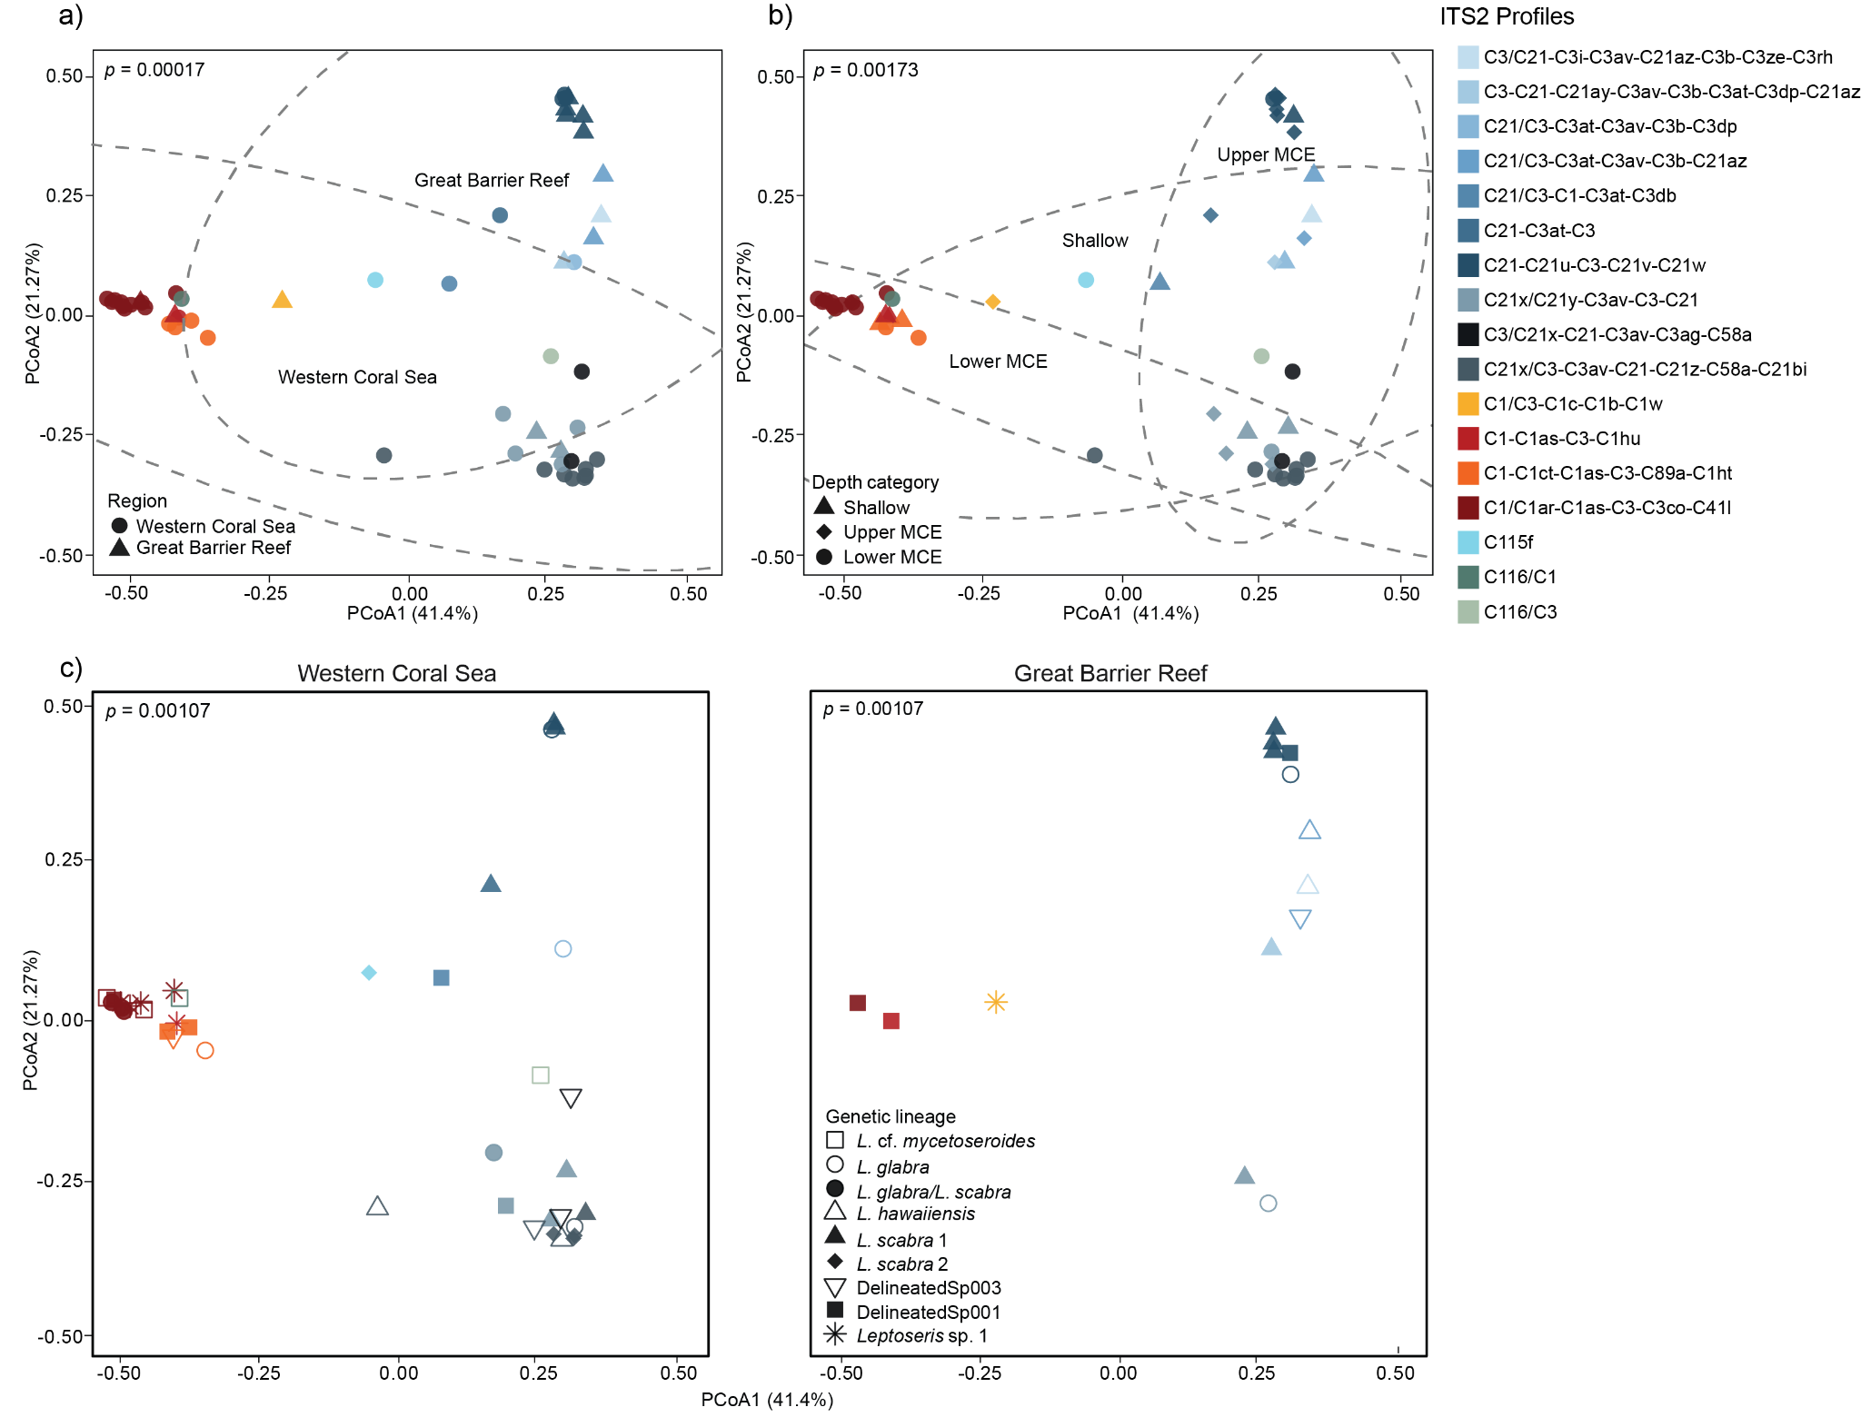
Figure S2. Principal coordinate analysis (PCoA) of ITS2 profiles diversity within Leptoseris species on Australian reefs. a) Comparison of ITS2 profile composition between the GBR and WCS regions; b) Variations in ITS2 profiles across depth categories, including shallow, upper, and lower mesophotic depths. c) Diversity of ITS2 profiles across nine genetic lineages within the Leptoseris genus by region. PERMANOVA results, indicating the statistical significance of differences, are displayed in the top left corner of each plot. PCoA plots include 95% confidence ellipses around groups, except for the genetic lineage plot, where some groups had too few points to calculate the ellipse.

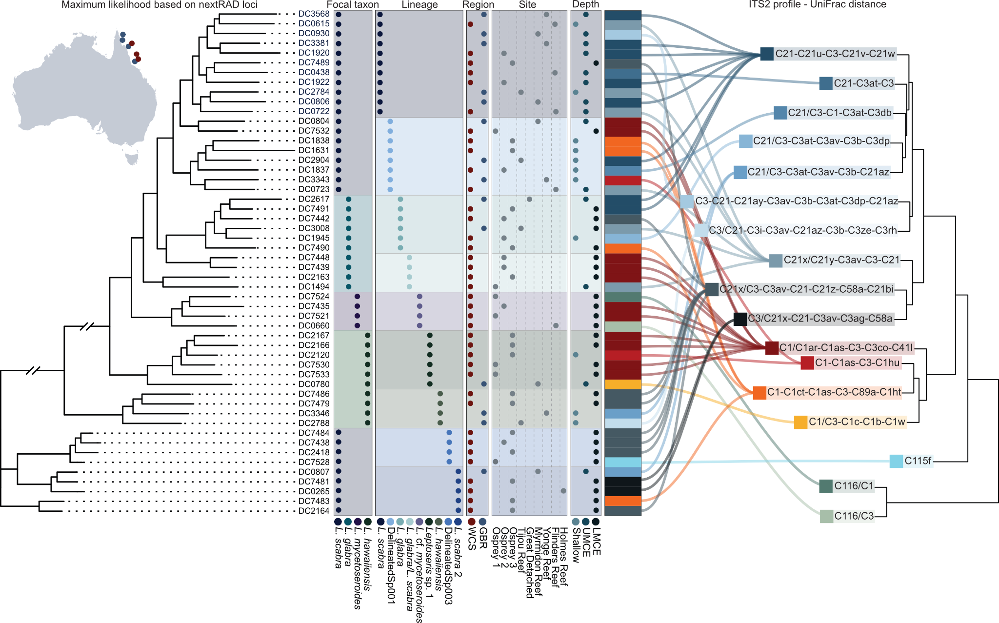
Figure S3. Tanglegram comparison of Symbiodiniaceae ITS2 community structure and Leptoseris spp. phylogenies. On the left, a maximum likelihood phylogeny of the Leptoseris genus based on nextRAD loci. On the right, a dendrogram based on UniFrac distances of the Symbiodiniaceae ITS2 profiles. Central columns represent metadata associated with individual colonies, including taxonomic identification, genetic lineage, sampling region, site, and depth category.

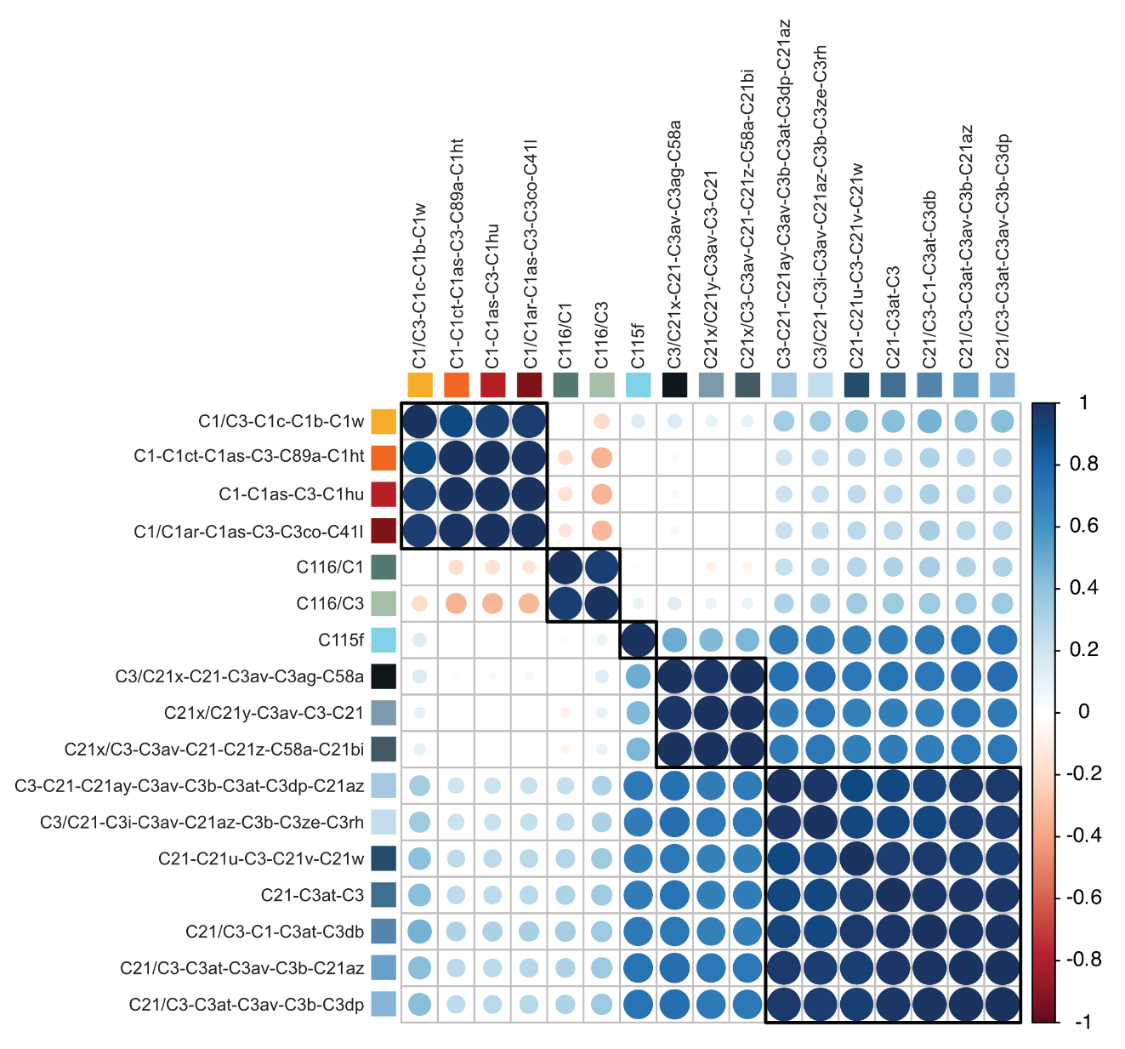
Figure S4. Pairwise UniFrac distances between symbiont ITS2 profiles. Pairwise correlation of UniFrac distances between ITS2 profiles, highlighting relationships and the degree of similarity among different symbiont types. Red shades indicate greater genetic distance between profiles, while blue colors indicate a stronger correlation.

Table S1. SymPortal statistics for Symbiodiniaceae samples within the Leptoseris genus across northeastern Australian reefs.
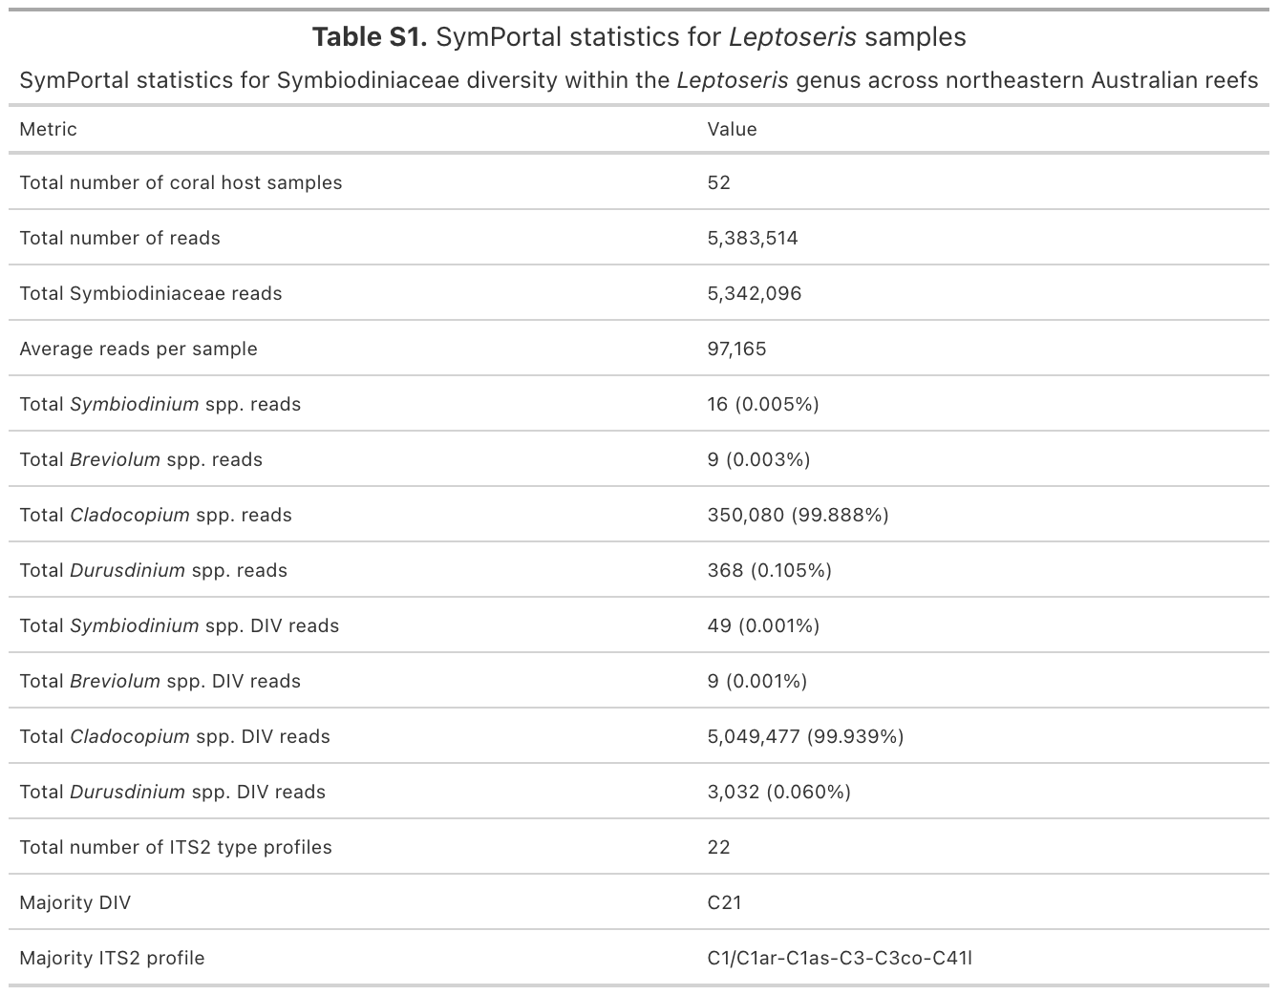

Table S2. Statistical analysis - PERMANOVA results for ITS2 sequence diversity across environmental variants and host genetic lineage.
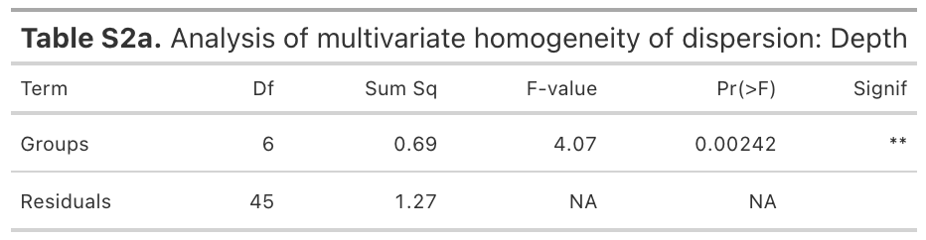
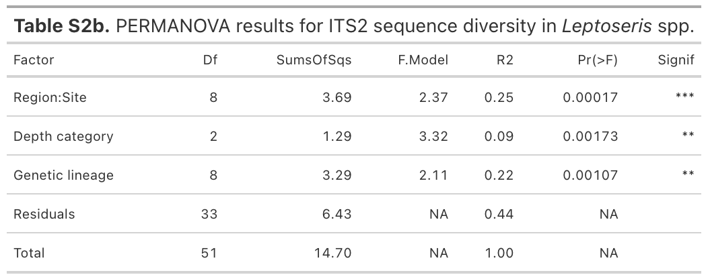

Table S3. Samples overview - samples included in this study with their corresponding ITS2 profile and COI haplotype.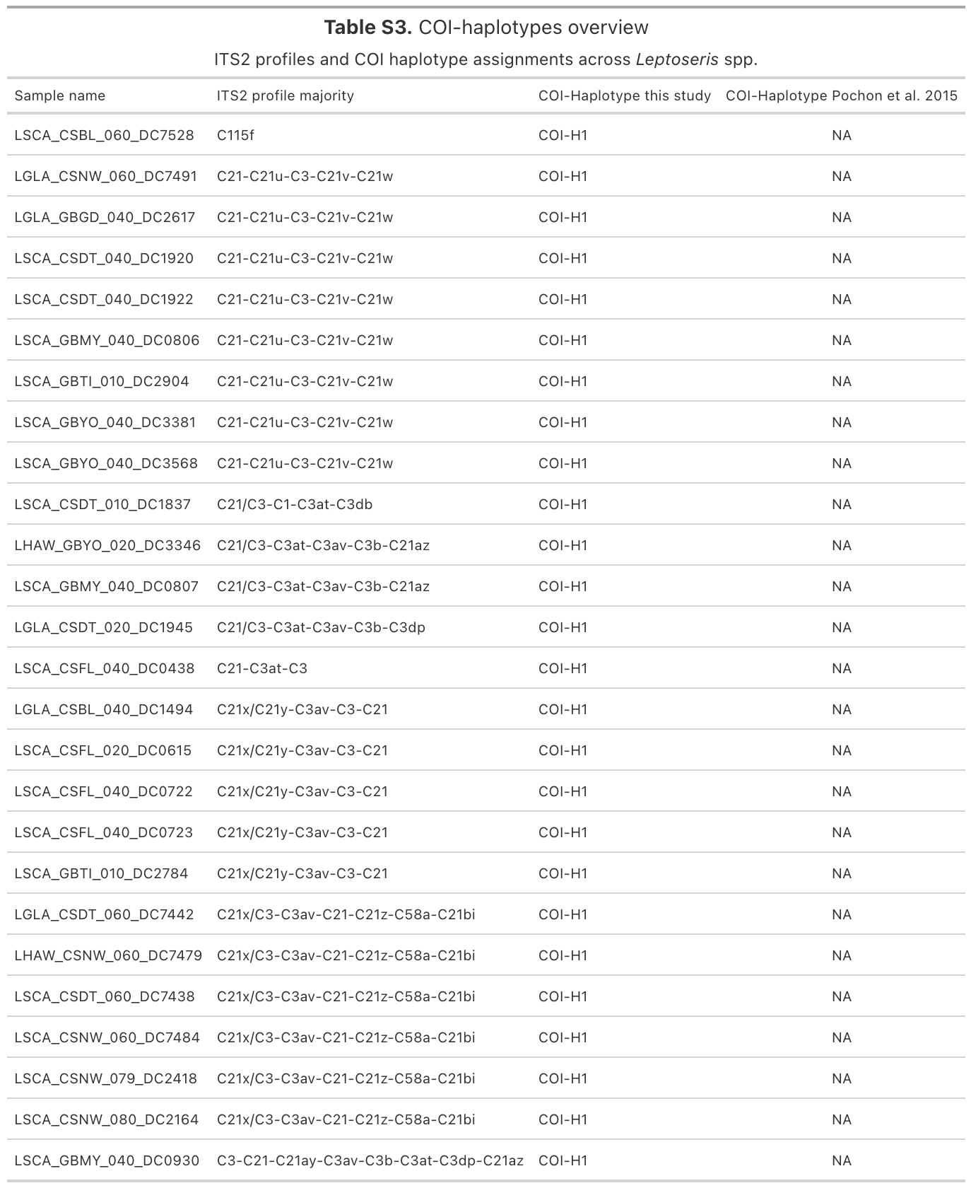

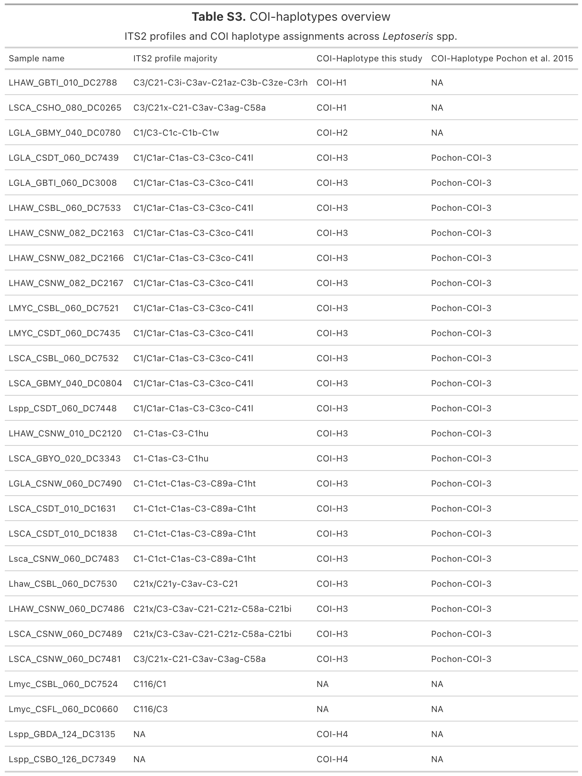

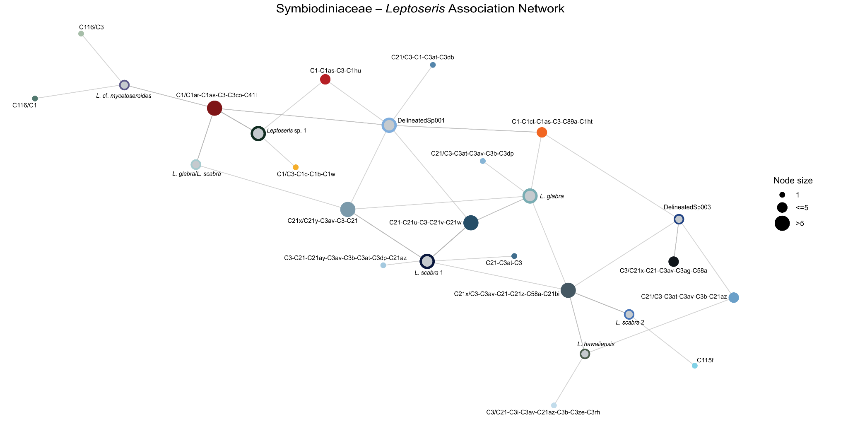
Figure S5. Symbiodiniaceae - Leptoseris species association network. Network illustrates specific associations between host genetic lineages and symbiont ITS2 profiles. Host genetic lineages are indicated by outlined circles, colored according to lineage identity color, while the ITS2 profile is represented by solid circles. Node size represents the frequency of occurrence. ITS2 profiles connected to multiple host lineages indicate profiles shared across hosts.

