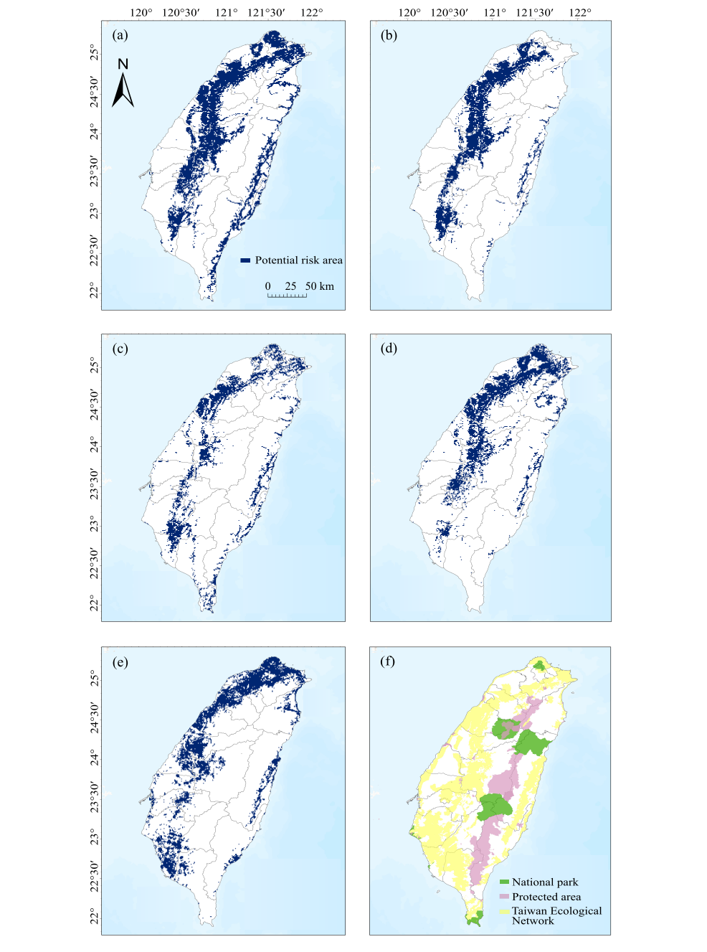
Supplementary Fig. 1 Binary maps of potential risk areas for dog attacks on (a) Reeves’ muntjac, (b) Chinese pangolin, (c) crab-eating mongoose, (d) ferret badger, and (e) masked palm civet; and (f) the spatial distribution of statutory protected areas and the Taiwan Ecological Network.
Table S1. Sources of species occurrence data (derived exclusively from camera trapping surveys).
Data source | Location | Year | No. of trapping sites
Chen et al., 2020 | Nantou County | 2018-2022 | 32
Cheng et al., 2021 | Taichung City | 2021-2022 | 10
Ho et al., 2024 | Kaohsiung City | 2020-2021 | 58
Li & Sun, 2024 | Tainan City and Kaohsiung City | 2022-2023 | 60
Li & Sun, 2023a | Taichung City | 2022-2023 | 47
Li & Sun, 2023b | Hualien County | 2021-2023 | 40
Lin et al., 2020 | Nantou County, Changhua County, and Miaoli County | 2012-2019 | 112
Liu et al., 2023 | Entire Taiwan | 2010-2021 | 692
Weng and Liu, 2020 | Entire Taiwan | 2018-2021 | 183
Yen et al., 2019 | Taipei City and New Taipei City | 2012-2017 | 140
Yen et al., 2018 | Hualien County | 2016-2017 | 38
Table S2. Environmental variables used in the study. Variables retained after the multicollinearity test are highlighted in bold.
Variables | Unit | Data Source
Climate |  | Taiwan Climate Change Projection Information and Adaptation Knowledge Platform https://tccip.ncdr.nat.gov.tw
Bio 1 = Annual Mean Temperature | °C
Bio 2 = Mean Diurnal Range | °C
Bio 5 = Max Temperature of Warmest Month | °C
Bio 6 = Max Temperature of Coldest Month | °C
Bio 7 = Temperature Annual Range | °C
Bio 8 = Mean Temperature of Wettest Quarter | °C
Bio 9 = Mean Temperature of Driest Quarter | °C
Bio 10 = Mean Temperature of Warmest Quarter | °C
Bio 11 = Mean Temperature of Coldest Quarter | °C
Bio 12 = Annual Precipitation | mm
Bio 13 = Precipitation of Wettest Month | mm
Bio 14 = Precipitation of Driest Month | mm
Bio 16 = Precipitation of Wettest Quarter | mm
Bio 17 = Precipitation of Driest Quarter | mm
Topography |  | DTM https://data.gov.tw/dataset/138563  OSM https://download.geofabrik.de/asia.html
Elevation | m
Standard deviation of elevation | m
Waterway density | km/km²
Land-cover |  | ESRI https://livingatlas.arcgis.com/landcover/
Forest coverage | %
Crop coverage | %
Rangeland coverage | %
Anthropogenic |  | OpenStreetMap https://download.geofabrik.de/asia.html
Road density | km/km²
Dog-related predictor
Probability of dog occurrence | 0-1 | Species Distribution Model from the current study
Dog density | no./km² | (Chao 2020)

Table S3. Summary of MaxEnt model results for species distribution, including model performance (AUC), thresholds used for binarization (minimum training presence), and the predicted distribution area for each focal species.
Species | Test AUC  (Mean ± SD) | Threshold | Area (km²)
Reeves’ muntjac | 0.798 ± 0.034 | 0.0832 | 26672
Chinese pangolin | 0.830 ± 0.039 | 0.0304 | 24685
Crab-eating mongoose | 0.828 ± 0.035 | 0.0464 | 26125
Ferret badger | 0.786 ± 0.035 | 0.0344 | 29781
Masked palm civet | 0.778 ± 0.034 | 0.0125 | 34510
Domestic dog | 0.773 ± 0.034 | - | -

Table S4. Relative contribution (%) of environmental predictor variables to the Species Distribution Models for the five native mammal species and free-roaming dogs.
Environmental variables | Reeves’ muntjac | Chinese pangolin | Crab-eating mongoose | Ferret badger | Masked palm civet | Domestic dogs
Forest coverage | 40.4 | 41.7 | 38.3 | 38 | 31.1 | 16
Road density | 13.9 | 23.6 | 23.8 | 23 | 28 | 55.4
Elevation | 8.6 | 13.2 | 9.1 | 9.6 | 10.9 | 8.5
Bio 7 | 9.5 | 3.8 | 5.9 | 7.5 | 7.5 | 4.5
Bio 2 | 8.4 | 8.8 | 7.9 | 2.2 | 5.0 | 3.2
Bio 17 | 6.9 | 1.5 | 10.3 | 3.5 | 4.4 | 2.3
Bio 12 | 4.4 | 0.3 | 1.1 | 8.3 | 7.5 | 4.5
Bio 16 | 6.1 | 3.7 | 2.5 | 5.1 | 3.6 | 0.9
Crop coverage | 1 | 2.3 | 0.8 | 1.7 | 1.6 | 3.2
Waterway density | 0.4 | 1 | 0.1 | 0.3 | 0.3 | 0.9
Rangeland coverage | 0.5 | 0.1 | 0.1 | 0.8 | 0.1 | 0.5

