Extended phenotypes buffer thermal extremes and shape multi-level responses to climate in a mound-building termite

APPENDIX S1
Table S1. Environmental characterization of Cornitermes cumulans colonies across the study gradient. Climatic descriptors include annual mean temperature (T_{mean}), mean diurnal temperature range (T_{diurnal}), maximum temperature of the warmest month (T_{max}), and annual precipitation (Prec). Vertical soil thermal profiles are represented by the soil temperature (°C) recorded at three depths (5 cm, 10 cm, and 15 cm) for each colony location. Geographic coordinates (Longitude and Latitude) and the respective municipality are provided for each sampling point.
Colony | Municipality | Longitude | Latitude | T_{mean} (ºC) | T_{diurnal} (ºC) | T_{max} (ºC) | Prec (mm) | Temp 5cm (ºC) | Temp 10cm (ºC) | Temp 15cm (ºC)
C1 | Ribeirão Preto | -47.855737 | -21.165347 | 22.04 | 12.09 | 29.31 | 1487.00 | 26.90 | 26.14 | 25.39
C2 | Ribeirão Preto | -47.855972 | -21.165463 | 22.04 | 12.09 | 29.31 | 1487.00 | 26.90 | 26.14 | 25.39
C3 | Ribeirão Preto | -47.856092 | -21.16499 | 22.04 | 12.09 | 29.31 | 1487.00 | 26.90 | 26.14 | 25.39
C4 | Ribeirão Preto | -47.856265 | -21.165905 | 22.04 | 12.09 | 29.31 | 1487.00 | 26.00 | 26.14 | 25.39
C5 | Ribeirão Preto | -47.863963 | -21.163905 | 22.04 | 12.09 | 29.31 | 1487.00 | 26.90 | 26.14 | 25.39
C6 | Ribeirão Preto | -47.864195 | -21.163863 | 22.04 | 12.09 | 29.31 | 1487.00 | 26.90 | 26.14 | 25.39
C7 | Pirassununga | -47.453845 | -21.960292 | 21.71 | 12.38 | 29.36 | 1342.00 | 25.05 | 24.37 | 23.71
C8 | Piracicaba | -47.460567 | -22.761223 | 20.58 | 11.09 | 28.15 | 1216.00 | 23.87 | 23.19 | 22.53
C9 | Campinas | -47.069384 | -22.769262 | 20.43 | 10.79 | 27.86 | 1274.00 | 23.44 | 22.78 | 22.14
C10 | Campinas | -47.069525 | -22.771522 | 20.43 | 10.79 | 27.86 | 1274.00 | 23.44 | 22.78 | 22.14
C11 | Campinas | -47.068559 | -22.773889 | 20.43 | 10.79 | 27.86 | 1274.00 | 23.44 | 22.78 | 22.14
C12 | Campinas | -47.067321 | -22.797304 | 20.48 | 10.74 | 27.91 | 1288.00 | 23.44 | 22.78 | 22.13
C13 | São Bernardo do Campo | -46.560739 | -23.678008 | 18.57 | 9.49 | 26.37 | 1591.00 | 23.19 | 22.60 | 22.01
C14 | São Bernardo do Campo | -46.560898 | -23.678074 | 18.57 | 9.49 | 26.37 | 1591.00 | 23.19 | 22.60 | 22.01
C15 | São Bernardo do Campo | -46.555878 | -23.676588 | 18.57 | 9.49 | 26.37 | 1591.00 | 23.19 | 22.60 | 22.01
C16 | São Bernardo do Campo | -46.555748 | -23.676316 | 18.57 | 9.49 | 26.37 | 1591.00 | 23.19 | 22.60 | 22.01
C17 | Santo Antônio do Pinhal | -45.651265 | -22.825123 | 16.37 | 11.15 | 25.73 | 1677.00 | 17.43 | 16.78 | 16.15
C18 | Santo Antônio do Pinhal | -45.651252 | -22.825069 | 16.37 | 11.15 | 25.73 | 1677.00 | 17.43 | 16.78 | 16.15
C19 | Santo Antônio do Pinhal | -45.651511 | -22.825118 | 16.37 | 11.15 | 25.73 | 1677.00 | 17.43 | 16.78 | 16.15

Table S2. Morphometric and cuticle lightness data for Cornitermes cumulans workers. Values represent measurements (mm) of head length and width, pronotum length and width, femur length, and total body length for each sampled colony. Cuticle lightness (0–255 scale) represents the average pigmentation intensity, where higher values indicate lighter cuticles (less melanized). Geographic location and municipality are provided for each colony.
Colony | Municipality | Longitude | Latitude | Head length (mm) | Head width (mm) | Pronotum length (mm) | Pronotum width (mm) | Femur length (mm) | Cuticle lightness
C1 | Ribeirão Preto | -47.855737 | -21.165347 | 1.06 | 1.33 | 0.29 | 0.65 | 0.81 | 191.40
C2 | Ribeirão Preto | -47.855972 | -21.165463 | 0.99 | 1.17 | 0.29 | 0.58 | 0.72 | 213.75
C3 | Ribeirão Preto | -47.856092 | -21.16499 | 0.84 | 1.00 | 0.23 | 0.51 | 0.65 | 133.40
C4 | Ribeirão Preto | -47.856265 | -21.165905 | 0.97 | 1.23 | 0.29 | 0.64 | 0.73 | 172.89
C5 | Ribeirão Preto | -47.863963 | -21.163905 | 0.94 | 1.08 | 0.25 | 0.63 | 0.70 | 184.10
C6 | Ribeirão Preto | -47.864195 | -21.163863 | 1.00 | 1.14 | 0.29 | 0.60 | 0.74 | 171.80
C7 | Pirassununga | -47.453845 | -21.960292 | 0.66 | 0.72 | 0.18 | 0.45 | 0.50 | 122.11
C8 | Piracicaba | -47.460567 | -22.761223 | 0.92 | 1.20 | 0.25 | 0.57 | 0.75 | 149.20
C9 | Campinas | -47.069384 | -22.769262 | 0.99 | 1.22 | 0.29 | 0.58 | 0.74 | 226.10
C10 | Campinas | -47.069525 | -22.771522 | 0.96 | 1.20 | 0.32 | 0.59 | 0.75 | 203.80
C11 | Campinas | -47.068559 | -22.773889 | 1.08 | 1.28 | 0.33 | 0.60 | 0.79 | 226.00
C12 | Campinas | -47.067321 | -22.797304 | 0.98 | 1.20 | 0.27 | 0.60 | 0.67 | 149.60
C13 | São Bernardo do Campo | -46.560739 | -23.678008 | 0.99 | 0.91 | 0.47 | 0.24 | 0.59 | 175.60
C14 | São Bernardo do Campo | -46.560898 | -23.678074 | 0.88 | 0.80 | 0.46 | 0.22 | 0.54 | 163.30
C15 | São Bernardo do Campo | -46.555878 | -23.676588 | 0.83 | 0.78 | 0.43 | 0.22 | 0.43 | 158.20
C16 | São Bernardo do Campo | -46.555748 | -23.676316 | 0.88 | 0.76 | 0.45 | 0.26 | 0.52 | 174.50
C17 | Santo Antônio do Pinhal | -45.651265 | -22.825123 | 1.05 | 1.25 | 0.29 | 0.64 | 0.74 | 185.13
C18 | Santo Antônio do Pinhal | -45.651252 | -22.825069 | 0.99 | 1.23 | 0.31 | 0.62 | 0.74 | 177.00
C19 | Santo Antônio do Pinhal | -45.651511 | -22.825118 | 0.92 | 1.17 | 0.26 | 0.54 | 0.65 | 160.30

Table S3. Edaphic properties across Cornitermes cumulans sampling sites: soil texture (clay content, %), chemical properties (pH), soil organic carbon (g kg⁻¹), and total nitrogen (g kg⁻¹). Geographic coordinates and municipality are provided for each corresponding mound.
Colony | Municipality | Longitude | Latitude | Clay content (%) | Soil pH | Soil organic carbon (g kg⁻¹) | Nitrogen (g kg⁻¹) | Bacterial Richness | β-glucosidase activity (U/mg protein)
C1 | Ribeirão Preto | -47.855737 | -21.165347 | 41.40 | 5.40 | 13.50 | 11.00 | 354.00 | 9.08
C2 | Ribeirão Preto | -47.855972 | -21.165463 | 41.40 | 5.40 | 13.50 | 11.00 | 522.00 | 9.40
C3 | Ribeirão Preto | -47.856092 | -21.16499 | 41.40 | 5.40 | 13.50 | 11.00 | 516.00 | 6.25
C4 | Ribeirão Preto | -47.856265 | -21.165905 | 41.40 | 5.40 | 13.50 | 11.00 | 599.00 | 6.52
C5 | Ribeirão Preto | -47.863963 | -21.163905 | 42.40 | 5.60 | 13.60 | 12.90 | 563.00 | 11.84
C6 | Ribeirão Preto | -47.864195 | -21.163863 | 42.40 | 5.60 | 13.60 | 12.90 | 577.00 | -
C7 | Pirassununga | -47.453845 | -21.960292 | 38.50 | 5.30 | 12.80 | 11.40 | 542.00 | 9.92
C8 | Piracicaba | -47.460567 | -22.761223 | 41.40 | 5.20 | 12.50 | 12.40 | 481.00 | 13.39
C17 | Santo Antônio do Pinhal | -45.651265 | -22.825123 | 34.10 | 5.00 | 19.10 | 19.60 | 384.00 | 5.93
C18 | Santo Antônio do Pinhal | -45.651252 | -22.825069 | 34.10 | 5.00 | 19.10 | 19.60 | 389.00 | 4.82
C19 | Santo Antônio do Pinhal | -45.651511 | -22.825118 | 34.10 | 5.00 | 19.10 | 19.60 | 363.00 | 4.85

Table S4. Physiological characterization of Cornitermes cumulans colonies across the study gradient. Variables include critical thermal maximum (CT_{max}) and operative body temperature of termite workers (T_{b}). Geographic coordinates (Latitude and Longitude) are provided for each sampled colony.
Colony | Municipality | Longitude | Latitude | CT_{max} (ºC) | T_{b} (ºC)
C1 | Ribeirão Preto | -47.855737 | -21.165347 | 40.00 | 24.92
C2 | Ribeirão Preto | -47.855972 | -21.165463 | 40.00 | 24.92
C3 | Ribeirão Preto | -47.856092 | -21.16499 | 35.00 | 24.92
C4 | Ribeirão Preto | -47.856265 | -21.165905 | 37.00 | 24.92
C5 | Ribeirão Preto | -47.863963 | -21.163905 | 40.00 | 24.92
C6 | Ribeirão Preto | -47.864195 | -21.163863 | 40.00 | 24.92
C7 | Pirassununga | -47.453845 | -21.960292 | 39.00 | 24.09
C8 | Piracicaba | -47.460567 | -22.761223 | 40.00 | 23.36
C9 | Campinas | -47.069384 | -22.769262 | 38.00 | 23.10
C10 | Campinas | -47.069525 | -22.771522 | 36.00 | 23.10
C11 | Campinas | -47.068559 | -22.773889 | 39.00 | 23.10
C12 | Campinas | -47.067321 | -22.797304 | 38.00 | 23.10
C13 | São Bernardo do Campo | -46.560739 | -23.678008 | 42.30 | 23.08
C14 | São Bernardo do Campo | -46.560898 | -23.678074 | 44.00 | 23.08
C15 | São Bernardo do Campo | -46.555878 | -23.676588 | 41.80 | 23.08
C16 | São Bernardo do Campo | -46.555748 | -23.676316 | 43.50 | 23.08
C17 | Santo Antônio do Pinhal | -45.651265 | -22.825123 | 38.50 | 18.91
C18 | Santo Antônio do Pinhal | -45.651252 | -22.825069 | 40.00 | 18.91
C19 | Santo Antônio do Pinhal | -45.651511 | -22.825118 | 33.00 | 18.91

Table S5. Results of the multiple linear regression model relating climatic variables to critical thermal maximum (CT_{max}) in Cornitermes cumulans colonies across the study gradient. Climatic predictors were standardized prior to analysis. The model explained a substantial proportion of the variation in CT_{max} (R²_{adj} = 0.57; F_{2,16} = 12.77; P < 0.001). Significant effects (P < 0.05) are shown in bold.
Predictor | Estimate (β) | Std. Error | t value | P
Intercept | 39.50 | 0.37 | 106.93 | < 0.001
Annual precipitation | 1.01 | 0.39 | 2.61 | 0.019
Mean diurnal temperature range | -1,44 | 0.39 | -3.71 | 0.018

Table S6. Results of the linear regression model relating mean diurnal temperature range to cuticle lightness in Cornitermes cumulans workers across the study gradient. The model explained a substantial proportion of the variation in cuticle lightness (R²_{adj} = 0.35; F_{1,7} = 10.59; P < 0.005). Significant effects (P < 0.05) are shown in bold.
Predictor | Estimate (β) | Std. Error | t value | P
Intercept | 107.25 | 4.39 | 24.45 | < 0.001
Mean diurnal temperature range | -14.67 | 4.51 | -3.26 | 0.005

Table S7. Results of the multiple linear regression model relating climatic variables to pronotum length in Cornitermes cumulans colonies across the study gradient. Climatic predictors were standardized prior to analysis. The model explained a substantial proportion of the variation in CT_{max} (R²_{adj} = 0.92; F_{3,15} = 65.82; P < 0.001). Significant effects (P < 0.05) are shown in bold.
Predictor | Estimate (β) | Std. Error | t value | P
Intercept | 0.32 | 0.005 | 57.78 | < 0.001
Annual mean temperature | 0.04 | 0.008 | 4.82 | < 0.001
Mean diurnal temperature range | -0.09 | 0.007 | -12.39 | < 0.001
Annual precipitation | 0.04 | 0.007 | 5.46 | < 0.001

Table S8. Gut bacterial richness (observed bacterial species) and digestive enzyme activity (β-glucosidase, U/mg protein) of Cornitermes cumulans workers. Geographic coordinates and municipality are provided for each corresponding colony.
Colony | Municipality | Longitude | Latitude | Bacterial Richness | β-glucosidase activity (U/mg protein)
C1 | Ribeirão Preto | -47.855737 | -21.165347 | 354.00 | 9.08
C2 | Ribeirão Preto | -47.855972 | -21.165463 | 522.00 | 9.40
C3 | Ribeirão Preto | -47.856092 | -21.16499 | 516.00 | 6.25
C4 | Ribeirão Preto | -47.856265 | -21.165905 | 599.00 | 6.52
C5 | Ribeirão Preto | -47.863963 | -21.163905 | 563.00 | 11.84
C6 | Ribeirão Preto | -47.864195 | -21.163863 | 577.00 | -
C7 | Pirassununga | -47.453845 | -21.960292 | 542.00 | 9.92
C8 | Piracicaba | -47.460567 | -22.761223 | 481.00 | 13.39
C17 | Santo Antônio do Pinhal | -45.651265 | -22.825123 | 384.00 | 5.93
C18 | Santo Antônio do Pinhal | -45.651252 | -22.825069 | 389.00 | 4.82
C19 | Santo Antônio do Pinhal | -45.651511 | -22.825118 | 363.00 | 4.85

Table S9. Standardized coefficients and model fit statistics for the predictors of β-glucosidase activity and gut bacterial richness in Cornitermes cumulans across a climate gradient. Significant effects (P < 0.05) are shown in bold.
Model β-glucosidase | Predictor | Estimate (β) | Std. Error | t value | P
R² adj = 0.67, F_{2,7} = 19.47, P = 0.013 | Intercept | 32.36 | 13.91 | 2.33 | 0.053
R² adj = 0.67, F_{2,7} = 19.47, P = 0.013 | Annual precipitation | -0.02 | 0.003 | -4.41 | 0.023
Model richness | Predictor | Estimate (β) | Std. Error | t value | P
R² adj = 0.44, F_{2,7} = 8.10, P = 0.050 | Intercept | -18.29 | 173.39 | -0.11 | 0.919
R² adj = 0.44, F_{2,7} = 8.10, P = 0.050 | Annual mean temperature | 24.29 | 8.54 | 2.85 | 0.022

Table S10. Results of redundancy analyses (RDA) testing the effect of mean diurnal temperature range (bio_2) on gut microbial community composition across taxonomic resolutions. Partial RDA models include spatial structure as a covariate (MEM1). Variance refers to the constrained variance explained by the predictor. Significant effects (P < 0.05) are shown in bold.
Taxonomic level | Model | Predictor | Variance | F | P | R²adj
Phylum | RDA | bio_2 | 0.01674 | 3.089 | 0.014 | 0.173
Phylum | Partial RDA (MEM1) | bio_2 | 0.00424 | 0.725 | 0.514 | -
Genus | RDA | bio_2 | 0.04050 | 2.431 | 0.015 | 0.125
Genus | Partial RDA (MEM1) | bio_2 | 0.01251 | 0.688 | 0.487 | -
ASV | RDA | bio_2 | 0.05221 | 2.298 | 0.021 | 0.115
ASV | Partial RDA (MEM1) | bio_2 | 0.01523 | 0.630 | 0.660 | 0.059

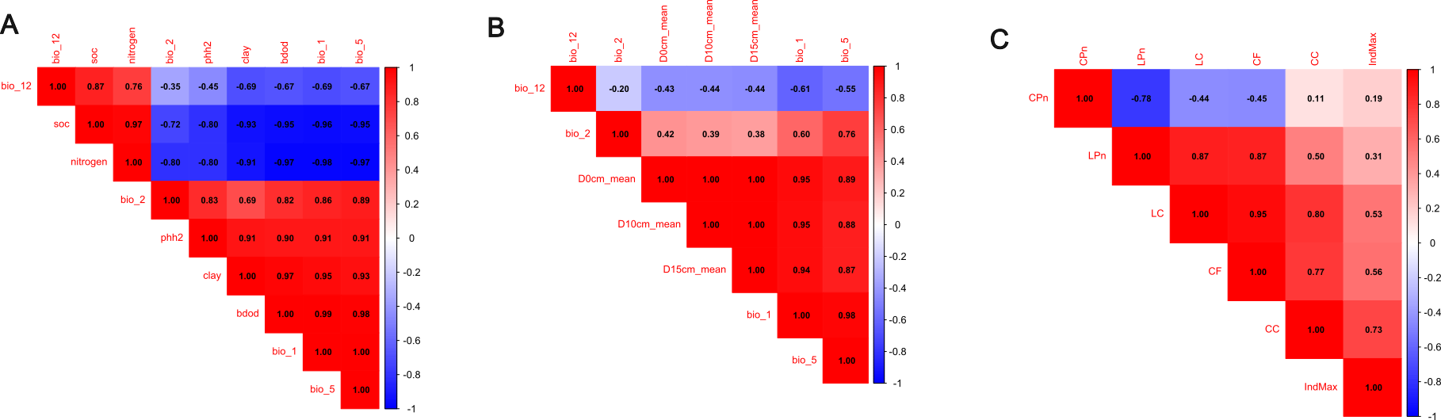
Figure S1. Correlation matrices among environmental and morphological variables across sampling sites. (A) Climatic and edaphic variables, (B) climatic and thermal predictors, and (C) morphological traits of Cornitermes cumulans workers. Pearson’s correlation coefficients are shown for each comparison, with color gradients indicating the strength and direction of correlations. See text for abreviations.

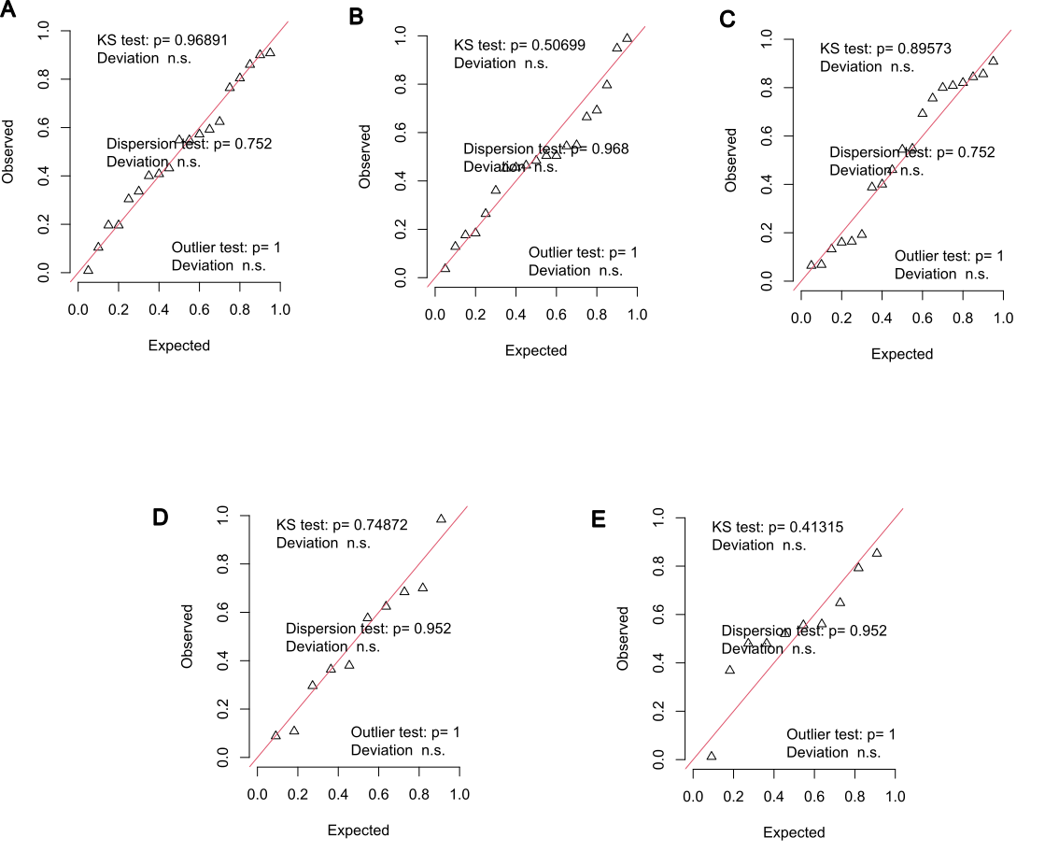
Figure S2. Diagnostic plots for the linear models constructed for evaluating Cornitermes cumulans physiological and morphological estimates in response to climatic factors across a latitudinal gradient. In each model, response variable was (A) critical thermal maximum (CT_{max}), (B) Cuticle lightness, (C) pronotum length, (D) β-glucosidase activity, and (E) bacterial richness. In each plot is shown a qq-plot to detect overall deviations from the expected distribution, including tests for correct distribution (KS test), dispersion and outliers. n.s.= non-significant.
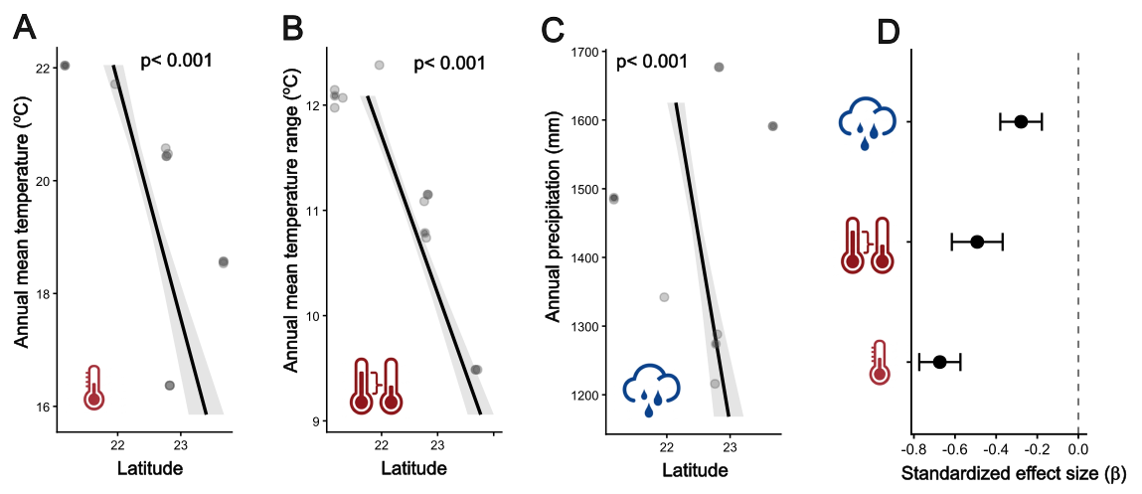
Figure S3. Climatic variation along the latitudinal gradient. Relationships between latitude and (A) annual mean temperature (BIO1), (B) temperature seasonality (BIO4), and (C) annual precipitation (BIO12). Lines show partial effects from linear models (±95% CI). (D) Standardized regression coefficients (β ± SE) for environmental predictors.

