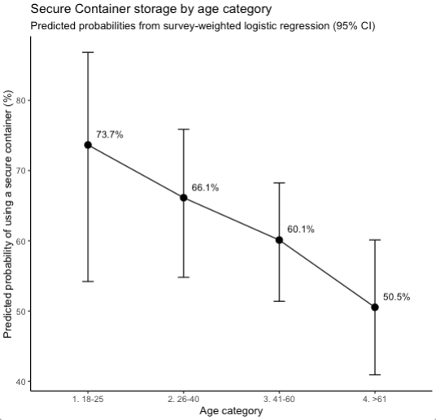

Supplemental Figure 1: Predicted probability of secure container firearm storage by age category. Survey-weighted predicted probabilities of reporting use of a secure firearm storage container (safe, lockbox, or gun case) across age categories, estimated from a survey-weighted logistic regression model. Points represent predicted probabilities, with vertical error bars indicating 95% confidence intervals.

