Reprogramming fucose metabolism in Kosakonia sp. CCTCC M2018092 for glucose-driven fucosylated human milk oligosaccharide biosynthesis
Zhenghao Yin^{a,b}, Zhi Liª, Wei Maª, Jinkang Liª, Fulin Li^{a,b}, Xingran Xuª, Mingjin Yang^{c}, Xiang Zou^{a,b*}
ªCollege of Pharmaceutical Sciences, Southwest University, Chongqing 400715, China
^{b}National Citrus Engineering Research Center, Chongqing 400700, China
^{c}College of Engineering and Technology, Southwest University, Chongqing 400715, China

*Corresponding Author: Prof. Xiang Zou
College of Pharmaceutical Sciences, Southwest University 2 Tian Sheng Road, Beibei, Chongqing 400715, People’s Republic of China
Fax: +86-23-68251225
E-mail address: zhx1030@swu.edu.cn

Supplementary Table 1. Glucose consumption reactions in GSMM
Reaction ID | Equation
GLCE | 1.00 glc__D [C_c] ⇌1.00 glc_D_B [C_c]
HEX1 | 1.00 atp [C_c] + 1.00 glc__D [C_c] → 1.00 adp [C_c] + 1.00 g6p [C_c] + 1.00 h [C_c]
XYL12 | 1.00 glc__D [C_c] ⇌1.00 fru [C_c]
GLCabc | 1.00 atp [C_c] + 1.00 h2o [C_c] + 1.00 glc__D [C_e] → 1.00 adp [C_c] + 1.00 glc__D [C_c] + 1.00 h [C_c] + 1.00 pi [C_c]
GLCpts | 1.00 pep [C_c] + 1.00 glc__D [C_e] → 1.00 g6p [C_c] + 1.00 pyr [C_c]
GLCtex | 1.00 glc__D [C_e] ⇌1.00 glc__D [C_p]
GLCDpp | 1.00 q8 [C_c] + 1.00 glc__D [C_p] + 1.00 h2o [C_p] → 1.00 q8h2 [C_c] + 1.00 glcn [C_p] + 1.00 h [C_p]
GLCabcpp | 1.00 atp [C_c] + 1.00 h2o [C_c] + 1.00 glc__D [C_p] → 1.00 adp [C_c] + 1.00 glc__D [C_c] + 1.00 h [C_c] + 1.00 pi [C_c]
GLCptspp | 1.00 pep [C_c] + 1.00 glc__D [C_p] → 1.00 g6p [C_c] + 1.00 pyr [C_c]
GLCt2pp | 1.00 glc__D [C_p] + 1.00 h [C_p] → 1.00 glc__D [C_c] + 1.00 h [C_c]
GLCADpts | 1.00 pep [C_c] + 1.00 glc__aD [C_e] → 1.00 pyr [C_c] + 1.00 g6p_A [C_c]

Supplementary Table 2. Strains and plasmids used in this study
Strains or plasmids | Characteristics | Source
Kosakonia sp. CCTCC M2018092 | Wild type | ¹
Escherichia coli DH10B | A commonly used laboratory cloning strain | Preserved in laboratory
K01 | Kosakonia sp. ΔwcaJ | This study
K02 | Kosakonia sp. ΔwcaJΔlacZ | This study
K03 | Kosakonia sp. ΔwcaJΔlacZ carrying pET-TMfutC，kan resistance | This study
K04 | Kosakonia sp. ΔwcaJΔlacZΔptsG carrying pET-TMfutC，kan resistance | This study
K05 | Kosakonia sp. ΔwcaJΔlacZΔptsGΔccr carrying pET-TMfutC，kan resistance | This study
K05 (P_{J23}) | Kosakonia sp. ΔwcaJΔlacZΔptsGΔccr carrying pET-JMfutC，kan resistance | This study
K06 | Kosakonia sp. ΔwcaJΔlacZΔptsGΔccrΔwcaH carrying pET-JMfutC，kan resistance | This study
K07 | Kosakonia sp. ΔwcaJΔlacZΔptsGΔccrΔganA carrying pET-JMfutC，kan resistance | This study
K08 | Kosakonia sp. ΔwcaJΔlacZΔptsGΔccrΔarcA carrying pET-JMfutC，kan resistance | This study
K09 | Kosakonia sp. ΔwcaJΔlacZΔptsGΔccrΔedd carrying pET-JMfutC，kan resistance | This study
K10 | Kosakonia sp. ΔwcaJΔlacZΔptsGΔccrΔpgm carrying pET-JMfutC，kan resistance | This study
K11 | Kosakonia sp. ΔwcaJΔlacZΔptsGΔccrΔpfkA carrying pET-JMfutC，kan resistance | This study
K12 | Kosakonia sp. ΔwcaJΔlacZΔptsGΔccrΔganAΔeddΔpgmΔpfkA carrying pET-JMfutC，kan resistance | This study
K12 (MBP-105) | Kosakonia sp. ΔwcaJΔlacZΔptsGΔccrΔganAΔeddΔpgmΔpfkA carrying pET-5MfutC，kan resistance | This study
K12 (MBP-108) | Kosakonia sp. ΔwcaJΔlacZΔptsGΔccrΔganAΔeddΔpgmΔpfkA carrying pET-8MfutC，kan resistance | This study
K12 (Infb-105) | Kosakonia sp. ΔwcaJΔlacZΔptsGΔccrΔganAΔeddΔpgmΔpfkA carrying pET-5bfutC，kan resistance | This study
K12 (Infb-108) | Kosakonia sp. ΔwcaJΔlacZΔptsGΔccrΔganAΔeddΔpgmΔpfkA carrying pET-8bfutC，kan resistance | This study
K13 | Kosakonia sp. ΔwcaJΔlacZΔptsGΔccrΔganAΔeddΔpgmΔpfkA-P_{J23117}-glk carrying pET-JMfutC，kan resistance | This study
K14 | Kosakonia sp. ΔwcaJΔlacZΔptsGΔccrΔganAΔeddΔpgmΔpfkA-P_{J23109}-glk carrying pET-JMfutC，kan resistance | This study
K15 | Kosakonia sp. ΔwcaJΔlacZΔptsGΔccrΔganAΔeddΔpgmΔpfkA carrying pET-JMZfutC，kan resistance | This study
K16 | Kosakonia sp. ΔwcaJΔlacZΔptsGΔccrΔganAΔeddΔpgmΔpfkAΔgcd carrying pET-JMfutC，kan resistance | This study
K17 | Kosakonia sp. ΔwcaJΔlacZΔptsGΔccrΔganAΔeddΔpgmΔpfkAΔgltA carrying pET-JMfutC，kan resistance | This study
K18 | Kosakonia sp. ΔwcaJΔlacZΔptsGΔccrΔganAΔeddΔpgmΔpfkAΔgcdΔgltA-P_{J23109}-glk carrying pET-JMfutC，kan resistance | This study
K19 | Kosakonia sp. ΔwcaJΔlacZΔptsGΔccrΔganAΔeddΔpgmΔpfkAΔgcd-ΔgltA-P_{J23109}-  glk carrying pET-8bfutC，kan resistance | This study
K20 | Kosakonia sp. ΔwcaJΔlacZΔptsGΔccrΔganAΔeddΔpgmΔpfkAΔgcd-P_{fliC}-gltA-P_{J23109}-  glk carrying pET-8bfutC，kan resistance | This study
K21 | Kosakonia sp. ΔwcaJΔlacZΔptsGΔccrΔganAΔeddΔpgmΔpfkAΔgcd-P_{fliC}-gltA-P_{J23109}-  glk carrying pET-8bfutA，kan resistance | This study
pET-TMfutC | pET28a-P_{tac}-MBP-futC-lacY gene，kan resistance | This study
pET-JMfutC | pET28a-P_{J23114}-MBP-futC-P_{J23115}-lacY gene，kan resistance | This study
pET-JMZfutC | pET28a-P_{J23114}-MBP-futC-P_{J23115}-lacY-P_{J23114}-zwf gene，kan resistance | This study
pET-5MfutC | pET28a-P_{J23105}-MBP-futC-P_{J23115}-lacY gene，kan resistance | This study
pET-8MfutC | pET28a-P_{J23108}-MBP-futC-P_{J23115}-lacY gene，kan resistance | This study
pET-5bfutC | pET28a-P_{J23105}-Infb-futC-P_{J23115}-lacY gene，kan resistance | This study
pET-8bfutC | pET28a-P_{J23108}-Infb-futC-P_{J23115}-lacY gene，kan resistance | This study
pET-8MfutA | pET28a-P_{J23108}-MBP-futA-P_{J23115}-lacY gene，kan resistance | This study

1. Niu S, Ma W, Jin M, Chen J, Li S, Zou X. Complete genome sequence of Kosakonia sp. strain CCTCC M2018092, a fucose-rich exopolysaccharide producer. Microbiol. Resour. Announce. 8, e00567–e00619 (2019).

Supplementary Table 3. Primers used in this study
Primers | Sequence（5´-3´）
ΔwcaJ-LA-F | cgagtcggtgctttttttgagatctgaattaccagcggcacaaagttattcg
ΔwcaJ-LA-R | gtcaacaaagcggcgtattaagga
ΔwcaJ-RA-F | taatacgccgctttgttgactcgctgcacgatagagattaacg
ΔwcaJ-RA-R | gtagggataacagggtaatagatctaagctacctcaaaccgctgaaactgg
ΔlacZ-LA-F | cgagtcggtgctttttttgagatctgaattctgcatcgcgctgataacctt
ΔlacZ-LA-R | cgctccagcacgtcataaaaca
ΔlacZ-RA-F | ttttatgacgtgctggagcgtgacgcgtatcacaggatggaa
ΔlacZ-RA-R | gtagggataacagggtaatagatctaagcttccgtattcaaaacggttcgca
ΔptsG-LA-F | cgagtcggtgctttttttgagatctgaattaccgggatgatttctatgctg
ΔptsG-LA-R | tgcaggtctccgtaatcagca
ΔptsG-RA-F | tgctgattacggagacctgcagtgcgctgggtgtgattattctc
ΔptsG-RA-R | gtagggataacagggtaatagatctaagctgaagtacactgtcgcgctgg
Δcrr-LA-F | cgagtcggtgctttttttgagatctgaatttgaactggcgaagctgaaagatc
Δcrr-LA-R | gatcttctcctaagcagtaatttgggc
Δcrr-RA-F | cccaaattactgcttaggagaagatcgcgctctacagtctaaaaaaaatggc
Δcrr-RA-R | gtagggataacagggtaatagatctaagctcggtaattgtcgccatcatttgcg
ΔwcaH-LA-F | cgagtcggtgctttttttgagatctgaattgctgaccattttctccagccg
ΔwcaH-LA-R | ccgcgcctatttcctcgacg
ΔwcaH-RA-F | cgtcgaggaaataggcgcggccgtggcaaaatcttcatgactt
ΔwcaH-RA-R | gtagggataacagggtaatagatctaagctgctgaacctgttagatgccgc
ΔganA-LA-F | cgagtcggtgctttttttgagatctgaattgcaggccaatatggatgacat
ΔganA-LA-R | gggtagctgtcccaggagataaagtcgatctattcattcctgaaatttacaacacga
ΔganA-RA-F | gatcgactttatctcctgggaca
ΔganA-RA-R | gtagggataacagggtaatagatctaagcttctgctggtcgaagataatcgc
ΔarcA-LA-F | cgagtcggtgctttttttgagatctgaattagatgttaacagaacgggcatat
ΔarcA-LA-R | gtttgctacctaaattgccaactaaatcg
ΔarcA-RA-F | tcgatttagttggcaatttaggtagcaaacttcagtcgcgtgctgagc
ΔarcA-RA-R | gtagggataacagggtaatagatctaagcttactgctgcttgatgcggt
Δedd-LA-F | cgagtcggtgctttttttgagatctgaattctcactgctgacagtattcgcga
Δedd-LA-R | tcgcgtgaacgttcaataatgcg
Δedd-RA-F | cgcattattgaacgttcacgcgaggatcgtgattgcgtggtagtg
Δedd-RA-R | gtagggataacagggtaatagatctaagctgagagataccgccagtcggg
Δpgm-LA-F | cgagtcggtgctttttttgagatctgaattagcattactctgagttttgccgc
Δpgm-LA-R | tgcttcgtccttttaatgcaagg
Δpgm-RA-F | ccttgcattaaaaggacgaagcagacaccaacgtcaccaaagtg
Δpgm-RA-R | gtagggataacagggtaatagatctaagcttcgtgcagaccatcaacaaacca
ΔpfkA-LA-F | cgagtcggtgctttttttgagatctgaattctgggtatcggcggctatatctt
ΔpfkA-LA-R | cgatggagatacgctggtgtgagactacctctgaacttaggaatgca
ΔpfkA-RA-F | tcacaccagcgtatctccatcg
ΔpfkA-RA-R | gtagggataacagggtaatagatctaagctgtcaattttgatgacaccagcctgc
Δgcd-LA-F | cgagtcggtgctttttttgagatctgaattcactcaacgattatgcaatccgc
Δgcd-LA-R | gatcgtcgtcagcattatcaatagc
Δgcd-RA-F | gctattgataatgctgacgacgatctgattacatcgtggcgtttgctc
Δgcd-RA-R | gtagggataacagggtaatagatctaagctgctctatgtcatcgccagcgac
ΔgltA-LA-F | cgagtcggtgctttttttgagatctgaattcagccaaaatccataaacatgtggc
ΔgltA-LA-R | aggtgatggttgctttcttatcagc
ΔgltA-RA-F | ataagaaagcaaccatcacctgcgtcagctctataccggttac
ΔgltA-RA-R | gtagggataacagggtaatagatctaagctggcgggtgagatacccgaaac
q-rpoA-F | cggtgagagttcagggtaaagatg
q-rpoA-R | gtcaggtggcagatcacatgc
q-k-manB-F | gtatcgaagtgaccgccagc
q-k-manB-R | gtgttgatgtagccaagcagatgg
q-k-manC-F | ctatcgactacgcggtgatgg
q-k-manC-R | cggattcggcatagacgtagc
q-k-gmd-F | cgttgcggtctccttcgaatc
q-k-gmd-R | caggccatacagctcagaggtg
q-k-fcl-F | gaccaggtctacctggcagc
q-k-fcl-R | caggacgaaccgaggaacaacag
q-s-manB-F | cgcgacctcatatctgaagctc
q-s-manB-R | cattaagaccgctttcgcagc
q-s-manC-F | gctgaagctgtcgtcgtacc
q-s-manC-R | gattatctatccctaccgctgccac
q-s-gmd-F | cctgacgactacgtgattgctac
q-s-gmd-R | gaagtaacgcgggtcaacagagac
q-s-fcl-F | ctgttattcctcggatcgtcatgc
q-s-fcl-R | caggttggtcggcattacagag

Figures legends
Supplementary Figure 1 Viscosity differences in fermentation broths between the ΔwcaJ mutant strain and the wild-type strain
Supplementary Figure 2 The protein expression of FutC at different temperatures
Supplementary Figure 3 Optimization of initial carbon-to-nitrogen (C/N) ratio in a 5-L fermenter. a. Batch fermentation under the initial C/N ratio of 12:1. b. Batch fermentation under the initial C/N ratio of 6:1. c. Batch fermentation under the initial C/N ratio of 3:1. All data were derived from three independent samples.
Supplementary Figure 4 Optimization of fed-batch fermentation in a 5L bioreactor. a. Fed-batch fermentation for 2′-FL production by the K12 at low glucose concentration. b. Fed-batch fermentation for 2′-FL production by the K12 at high glucose concentration. c. Fed-batch fermentation for 2′-FL production by the K16 at high glucose concentration. All data were derived from three independent samples.
Supplementary Figure 5 HPLC analysis and MS identification of 3-FL in fermentation broth a. HPLC analysis of 3-FL standard and fermentation broth sample. b. MS identification of 3-FL standard. c. MS identification of 3-FL in fermentation broth.

Supplementary Fig. 1

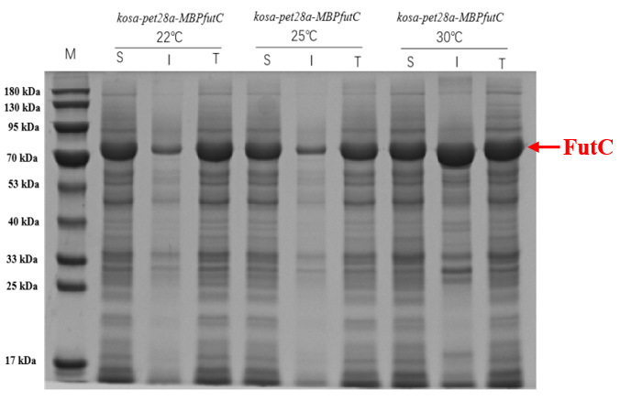

Supplementary Fig. 2

Supplementary Fig.3

Supplementary Fig.4

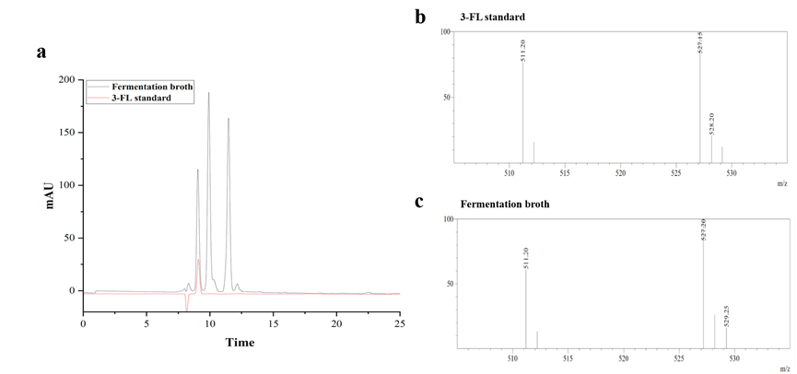

Supplementary Fig.5

