Supplementary Methods
Logistic mixed effects modeling
To account for the hierarchical structure of the data and the non-independence of observations, we fitted mixed-effect logistic regression models for four binary outcomes, namely, qPCR-confirmed any malaria infection, qPCR P. vivax infection, qPCR P. falciparum infection and seropositivity. Individuals are nested within households and households were nested within clusters, creating a three-level data structure. Accordingly, we specified random intercepts at both the cluster and household levels, with households treated as nested within clusters. This approach appropriately models within-household and within-cluster correlation, which makes the model a nested (multilevel) mixed-effects logistic regression model.
The model is expressed as:
$$\operatorname{logit}{\{}P(Y_{ijk}=1)\}=β_{0}+βX_{ijk}+u_{k}+v_{jk}$$
Where $Y_{ijk}$ denotes the outcome for individuals in household within cluster $k$, $X_{ijk}$represents the vector of fixed effect covariates, $v_{jk}$is the random intercept for household nested within cluster $k$.
Covariate Selection
We first conducted bivariate mixed-effects logistic regression analysis for each outcome, including one exploratory variable at a time while retaining the same random-effects structure (Cluster and household). Covariates with a p-value <0.20 in bivariate analyses were retained for multivariable modeling.
To evaluate differences in antibody responses across infection and age groups, the median fluorescence intensity (MFI) values for each antigen were log-transformed. Participants were first categorized by qPCR infection status result and pairwise comparisons were performed using the non-parametric Mann-Whitney U test with p < 0.05 considered statistically significant. Additionally, participants were stratified into four age categories: <5, 5-15, 15-24 and >25 years, to investigate age-related variations and Mann-Whitney U tests were conducted comparing the < 5-year group with each older age category.
At the cluster level, P. vivax PCR prevalence and seroprevalence were computed, the latter based on the 8 antigen seroprevalence. To account for imperfect sensitivity and specificity of the serological classification, measured seroprevalence was defined as the true seroprevalence multiplied by the sensitivity of the sero-classifier, plus the complement of the true seroprevalence multiplied by one minus the specificity.
Seroprevalence Adjustment for classifier performance
The observed seroprevalence estimates were adjusted to account for imperfection in the sero-classifier using the Rogan-Galden estimator. $P_{\text{obs}}$ denotes the observed seroprevalence, $Se$ is the test sensitivity, and $Sp$ is the test specificity. The adjusted (true) seroprevalence $P_{\text{true}}$was calculated as:
$$P_{\text{true}}=\frac{P_{\text{obs}}-(1-Sp)×100}{Se+Sp-1}$$
The random -forest classifier for the serology had both sensitivity and specificity of 80% ($Se$ = 0.80, $Sp$ = 0.80). The adjusted estimates were limit to range from 0 to 100%. In addition to avoid inflation of the adjusted estimates at very low observed prevalence, where correlation may be unstable, adjusted seroprevalence was set to zero when the observed seroprevalence was below 20%. Pearson correlation coefficients were the calculated to assess the association between cluster level PCR prevalence and seroprevalence, with corresponding p-values reported.
Spatial clustering of infection
Spatial clustering analysis was conducted using cluster level estimates of qPCR Plasmodium vivax prevalence and seroprevalence, each georeferenced by global positioning system (GPS) coordinates (Latitude and Longitude). Each cluster represented a distinct location. R software was using for clustering analysis. To ensure valid distance based spatial statistics, geographic coordinates were projected to a metric coordinate reference system using a Universal Transverse Mercator (UTM) projection. The UTM zone was selected based on the longitudinal centroid of the study area. The metric projection was exclusively used for spatial autocorrelation analyses, while the WGS84 coordinates were retained for visualization.
Spatial weights matrix
Spatial relationships between clusters were defined using a k-nearest neighbors’ approach, which is appropriate for the irregularly space point data. For each location, the six nearest neighboring clusters (k = 6) were identified based on Euclidean distance in the projected coordinate system. The resulting neighbor structure was converted into row-standardized spatial wights matrix (W), ensuring that the influence of neighboring observations summed to one for each location.
Global spatial autocorrelation
Global spatial autocorrelation was assessed separately for qPCR Plasmodium vivax prevalence and seroprevalence using Global Moran’s I. The formula is defined as:
$$I=\frac{n}{\sum_{i}{\sum_{j}{w_{ij}}}}\frac{\sum_{i}{\sum_{j}{w_{ij}}}(x_{i}-\bar{x})(x_{j}-\bar{x})}{\sum_{i}{(x_{i}-\bar{x})^{2}}}$$
When $n$ is the number of spatial units, $x_{i}$ and $x_{j}$ are observed values at location $i$ and $j$, $\bar{x}$ is the mean of the variable of interest, and the $w_{ij}$ represents elements of the spatial wights matrix. Statistical significance was assessed using permutation-based hypothesis testing, with a two-sided significance threshold of P < 0.05.

Local spatial autocorrelation (LISA)
To identify localized spatial clustering, Local indicators of Spatial Association (LISA) were computed using Local Moran’s I for each cluster. Local Moran’s I quantify the degree to which each observation is spatially associated with its neighbors. For each location, Local Moran’s I is given by:
$$I_{i}=(x_{i}-\bar{x})\sum_{j}{w_{ij}}(x_{j}-\bar{x})$$
qPCR P. vivax prevalence and seroprevalence values were standardized (z-scores) prior to classification. Statistical significance of local statistics was evaluated at P < 0.05. Significant LISA results were classified into four standard spatial association categories based on the sign of the standardized value at each location and its spatial lag. Locations with non-significant Local Moran’s I were classified as not significant.

Supplementary Figures
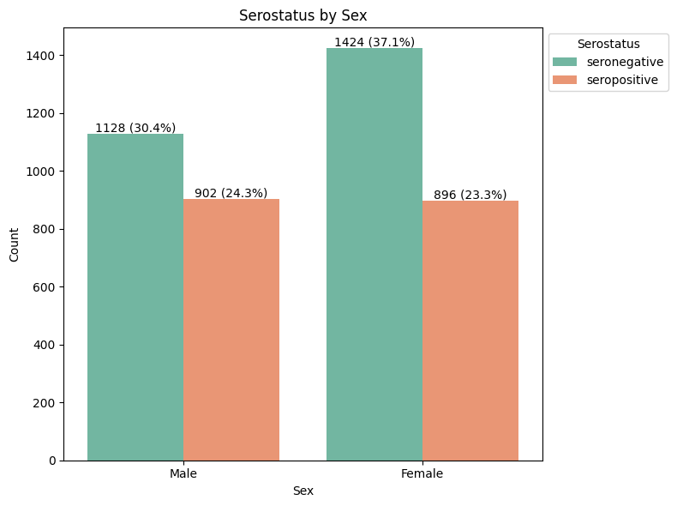
Supplementary Figure 1. Serological infection status stratified by sex (male and female participants).

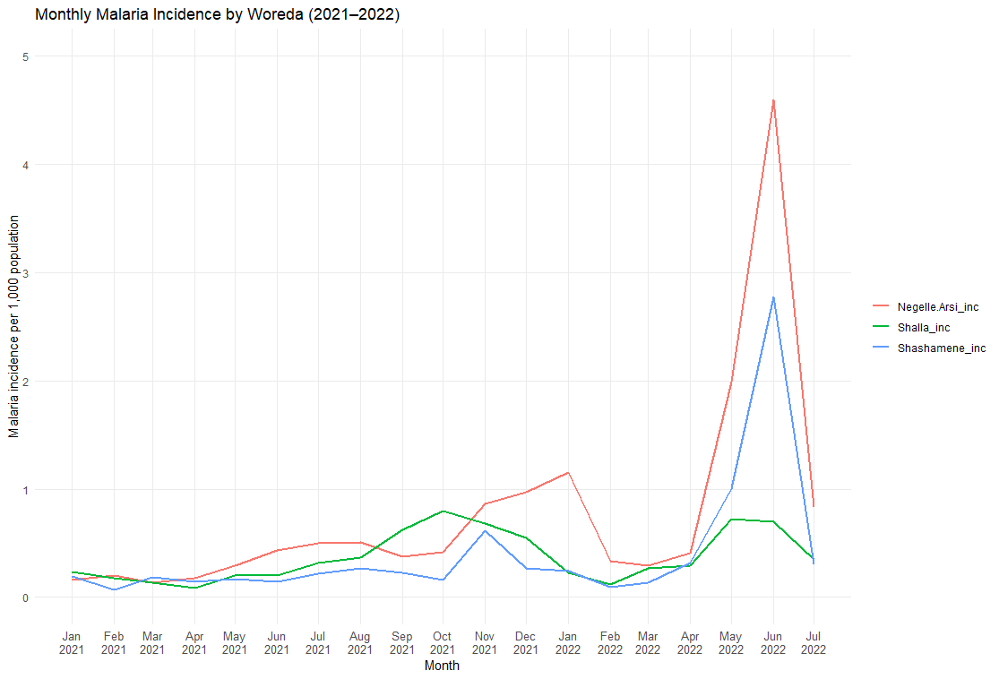
Supplementary Figure 2. Monthly malaria incidence in three selected woredas from 2021 to 2022, showing temporal trends consistent with sampling observations, with case numbers increasing after June in both years.

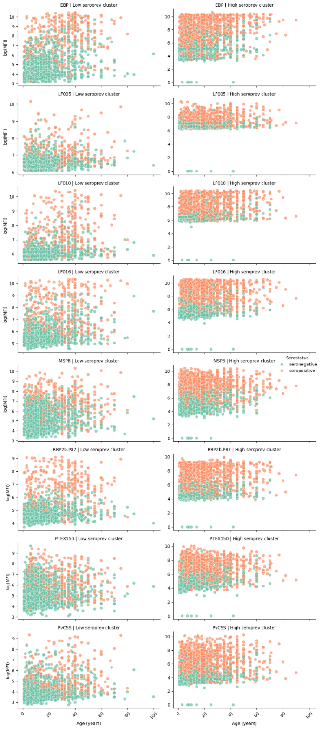

Supplementary Figure 3. Geographic distribution of clusters, showing higher seroprevalence in southern clusters and lower seroprevalence in northern clusters. Most seronegative participants were concentrated in the northern clusters.

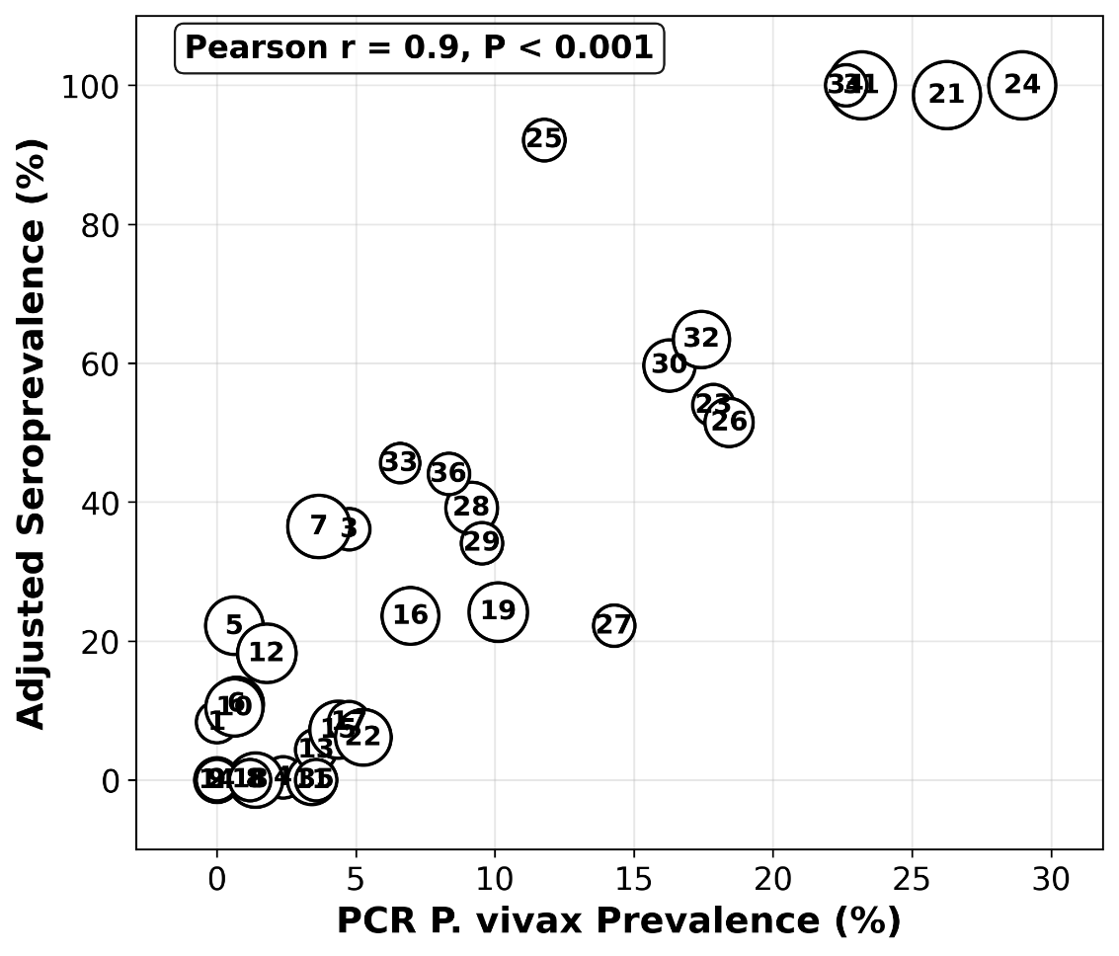
Supplementary Figure 4. Correlation between PCR-confirmed Plasmodium vivax prevalence and adjusted seroprevalence, accounting for assay sensitivity and specificity (both 80%) using the Rogan–Gladen estimator.

Variation in antigen-specific antibody levels by infection type and age
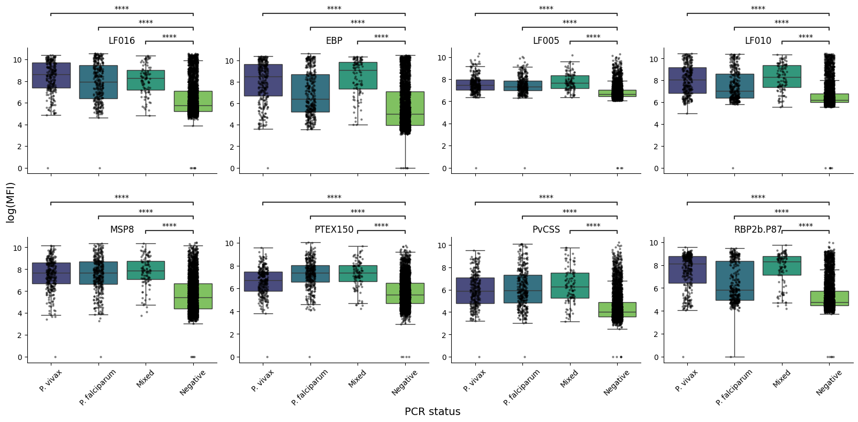
Antibody responses against the 8-specific antigens were compared across PCR-confirmed P. vivax, P. falciparum, mixed and PCR-negative individuals using log-transformed MFI. Individuals with P. vivax, P. falciparum, or mixed infections showed significantly higher antibody reactivity compared with PCR-negative individuals (Mann-Whitney test, ****p< 0.0001). P. vivax infection consistently demonstrated the highest median log MFI values.
Supplementary Figure 5. Distribution of log-transformed median fluorescence intensity (MFI) across PCR-defined infection groups. Antibody responses for each antigen are shown among individuals with Plasmodium vivax, Plasmodium falciparum, mixed infections, and PCR-negative status. Each point represents an individual sample; boxes indicate the interquartile range, with medians shown as horizontal lines.
Antibody response also increased with age for all antigens. Antibody responses were consistently lowest among children younger than 5 years and rose progressively across older age groups, reflecting cumulative exposure. Strong and statistically significant differences were observed between the <5 years group and all older categories for all antigens for PvMSP1-19, PvEBP, PvMSP8, PvPTEX150 and PvRBP2b-P87 (Mann-Whitney U test; ****p < 0.0001), followed by moderate differences for Pv-fam-a and PvCSS (**p < 0.01).
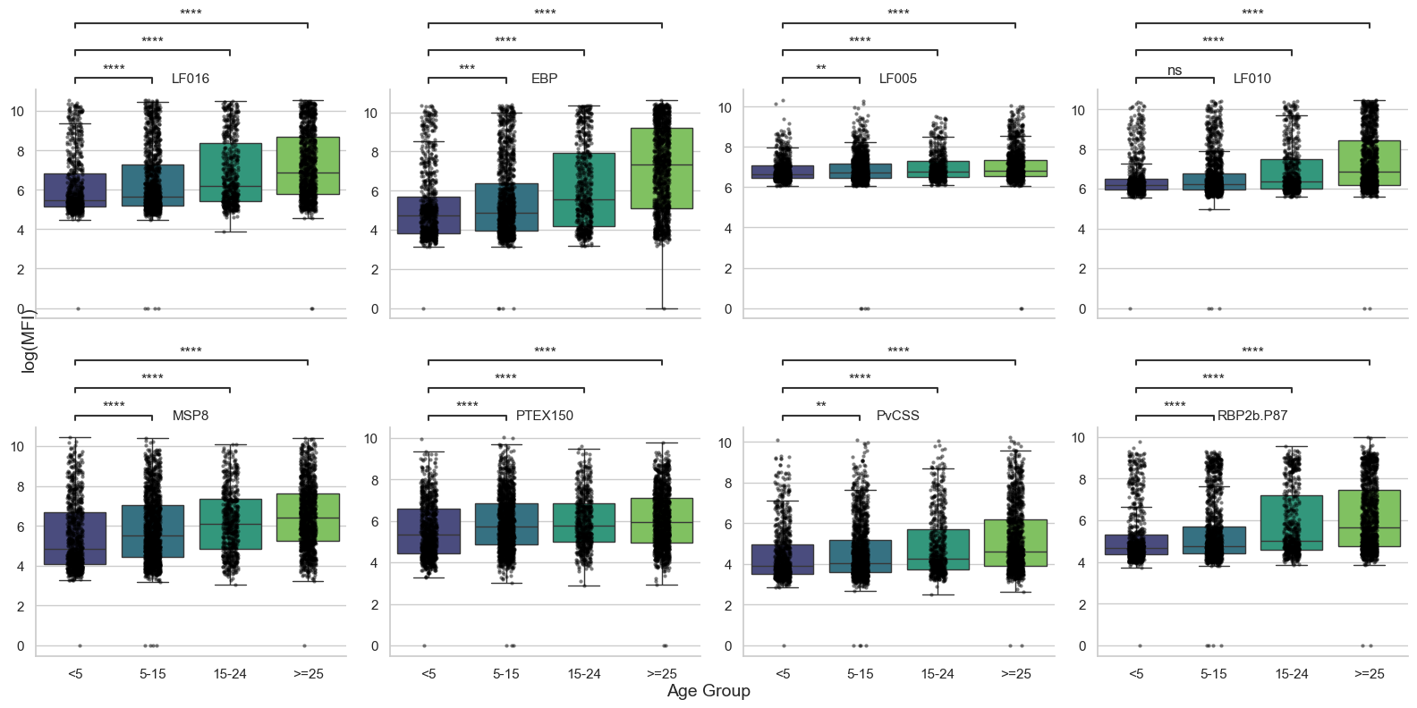
Supplementary Figure 6. Age-associated variation in log-transformed median fluorescence intensity (MFI) across eight Plasmodium vivax antigens. Individual points represent samples; boxes denote the interquartile range, with medians shown as horizontal lines. Statistical comparisons were performed between children aged <5 years and each older age group using the Mann–Whitney U test (**p < 0.01, ****p < 0.0001).

