Supplementary Figure S1
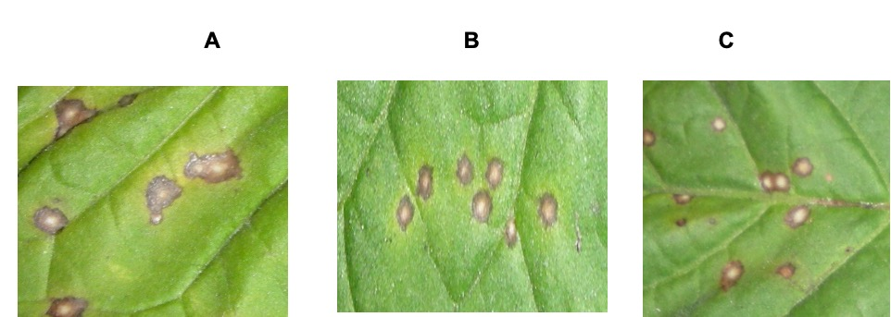

Supplementary Figure 1. Pre-treatment of tobacco plants with purified ASA showed disease resistance against TMV similar to aspirin standard. A. TMV infection control. B. Tobacco leaves pre-treated with Aspirin standard showing decrease in TMV lesion size. C. Tobacco leaves pre-treated with purified natural aspirin showing decrease in TMV lesion size similar to standard aspirin.

