Supplementary material

Supplementary figures:

Supplementary figure 1: Multiple sequence alignment of the ITS region for three Monographella isolates. Dot (.) indicate consensus sequences

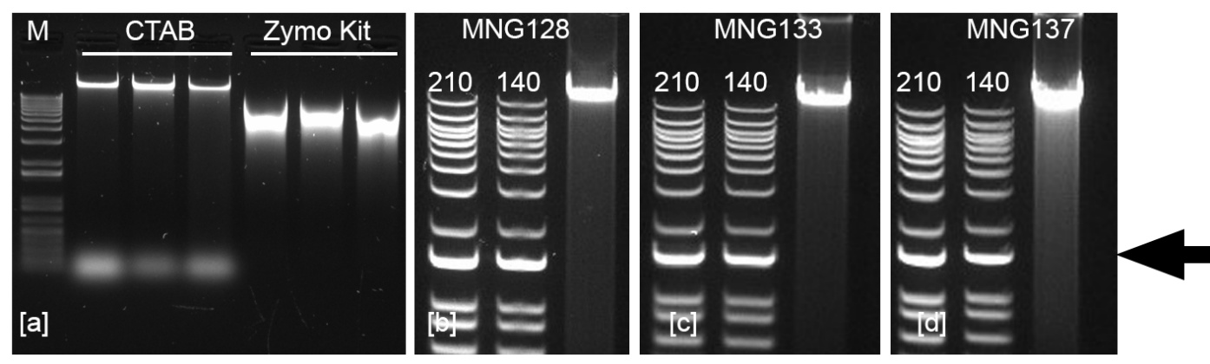
Supplementary figure 2: a) Comparison of DNA extracted with the kit and our in-house method; b-d) Semi-quantitative estimation of the DNA concentration by comparing the relative band intensity to the 1500 bp reference band, marked by the arrow, of the ladder. When 10 µl of Ladder (50 ng/µl) was loaded in a single lane, the 1500 bp band represents approximately 70 ng. Accordingly, 30 and 20 µl of ladder was loaded to adjacent lanes and have been labelled as 210 and 140.

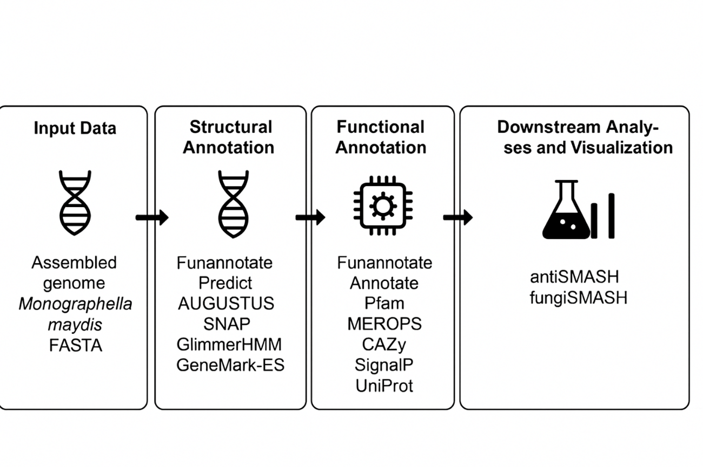
Supplementary figure 3: Workflow for the M. maydis genome reads

Supplementary tables:

Supplementary table 1. BUSCO completeness metrics for the M. maydis assembly. (Sordariomycetes_odb10, n=1706).
Metric | Value
Number of scaffolds | 71
Number of contigs | 71
Total assembly length | 39,490,855 bp
Percent gaps | 0.000%
Scaffold N50 | 3 Mb
Contig N50 | 3 Mb

Supplementary table 2. QUAST assembly statistics for M. maydis genome.
Metric | Value
Number of contigs | 71
Number of contigs (≥ 1,000 bp) | 71
Number of contigs (≥ 5,000 bp) | 52
Number of contigs (≥ 10,000 bp) | 43
Number of contigs (≥ 25,000 bp) | 21
Number of contigs (≥ 50,000 bp) | 19
Total length | 39,490,855 bp
Total length (>= 1,000 bp) | 39,490,855 bp
Total length (>= 5,000 bp) | 39,437,013 bp
Total length (>= 10,000 bp) | 39,378,515 bp
Total length (>= 25,000 bp) | 39,028,991 bp
Total length (>= 50,000 bp) | 38,963,950 bp
Largest contig | 5,468,643 bp
GC content | 54.21%
N50 | 3,014,066 bp
N90 | 1,142,210 bp
auN | 2,871,792 bp
L50 | 6
L90 | 14
Number of N’s | 0

Supplementary table 3. Repeatedness of the M. maydis genome.
Repeat class | Number of elements | Length (bp) | % of genome
Retroelements | 631 | 763,099 | 1.93
SINEs | 0 | 0 | 0.00
Penelope | 123 | 234,811 | 0.59
LINEs | 17 | 22,314 | 0.06
LTR elements | 491 | 505,974 | 1.28
Ty1/Copia | 87 | 216,728 | 0.55
Gypsy/DIRS1 | 390 | 286,848 | 0.73
DNA transposons | 759 | 816,884 | 2.07
Tc1-IS630-Pogo | 759 | 816,884 | 2.07
Rolling-circle elements | 0 | 0 | 0.00
Unclassified repeats | 2,057 | 579,207 | 1.47
Total interspersed repeats | — | 2,159,190 | 5.47
Simple repeats | 13,063 | 495,950 | 1.26
Low complexity regions | 705 | 31,492 | 0.08

