Supplementary Information
The global limits of sustainable irrigation as an adaptation to climate change

Contents
Supplementary Figures 2
Supplementary Tables 9
Supplementary Text 13
Supplementary text 1: Suitability irrigation maps 13
Supplementary text 2: Hydroclimatic deficit drivers 16
Supplementary text 3: Review of national adaptation plans (NAPs) 19
References 24

Supplementary Figures

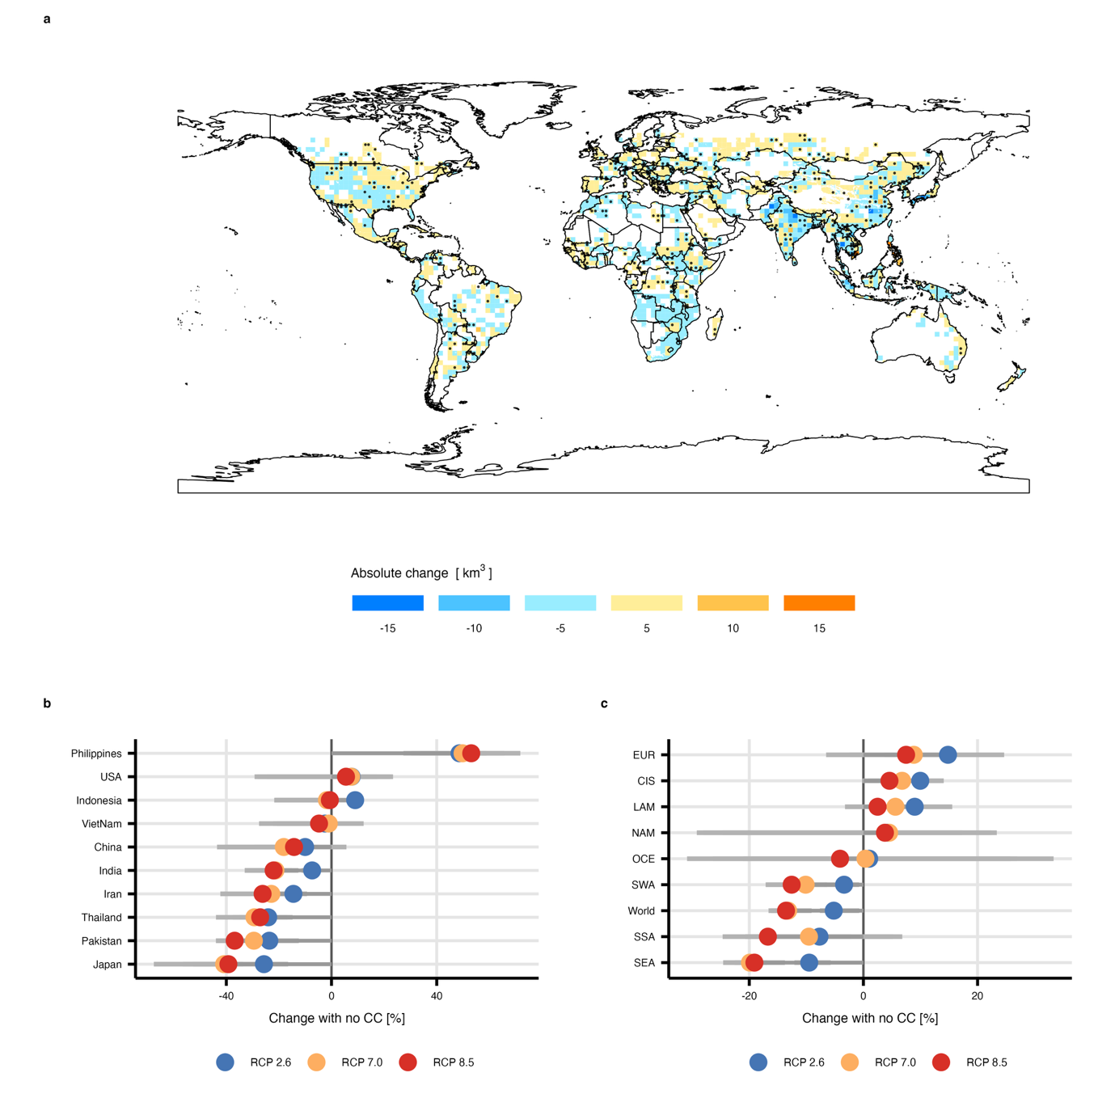
Supplementary Fig. 1| Irrigation water withdrawal changes in 2050. a, Spatial distribution of absolute changes in irrigation water withdrawals (km³) in 2050 relative to a no-climate-change baseline under RCP7.0. The blue shading indicates decreases, whereas the yellow to orange shading indicates increases. The black dots mark grid cells where at least 70% of the climate models agree on the direction of change. Values represent the means across five global climate models (n = 5). b, Percentage change in irrigation water withdrawals in 2050 relative to the no-climate-change baseline for the ten countries with the greatest withdrawals under RCP2.6 (blue circles), RCP7.0 (orange circles), and RCP8.5 (red circles). c, Percentage change in irrigation water withdrawals for major macroregions under the same scenarios. The vertical black line indicates zero change. The points to the right of zero indicate increased withdrawals relative to the baseline, whereas the points to the left indicate reductions.

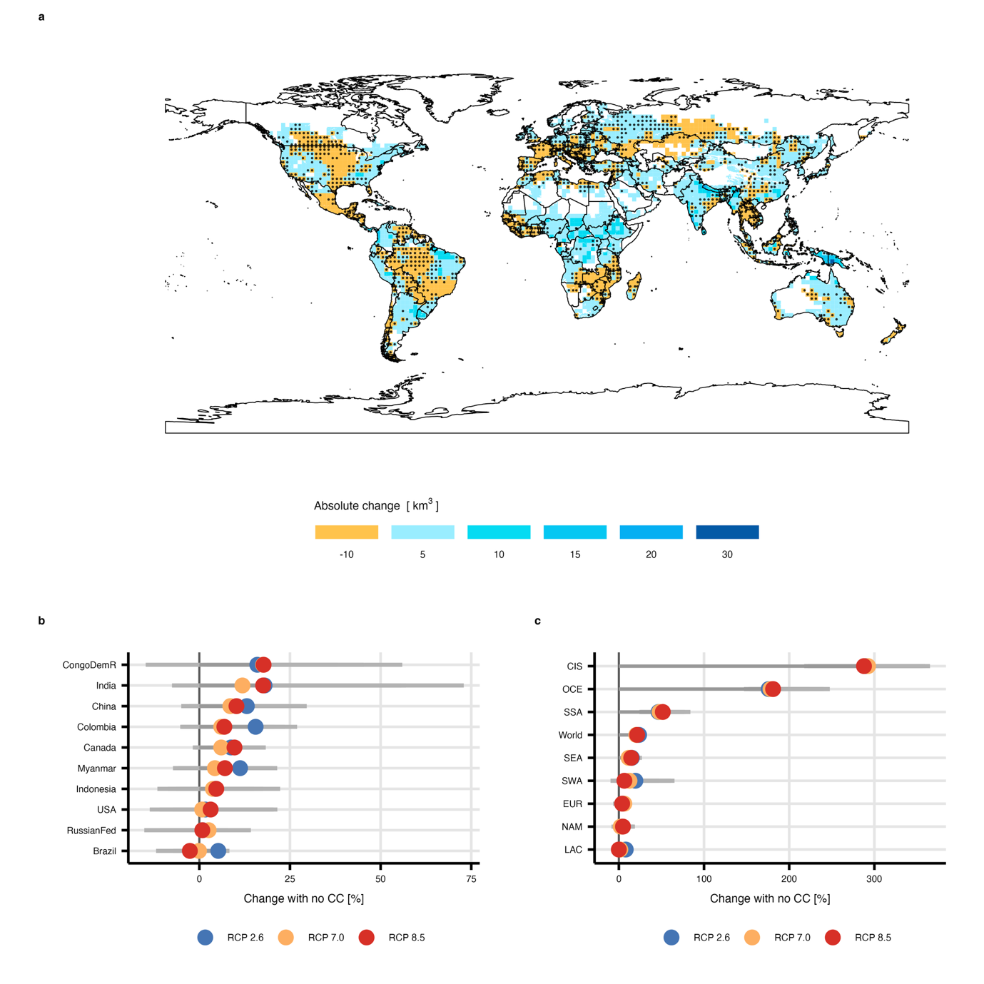

Supplementary Fig. 2| Surface water withdrawal changes in 2050. a, Spatial distribution of absolute changes in surface water withdrawals (km³) in 2050 relative to a no-climate-change baseline under RCP7.0. Light yellow shading indicates decreases, whereas light to dark blue shading indicates increases. The black dots mark grid cells where at least 70% of the climate models agree on the direction of change. Values represent the means across five global climate models (n = 5). b, Percentage change in surface water withdrawals in 2050 relative to the no-climate-change baseline for the ten countries with the greatest withdrawals under RCP2.6 (blue circles), RCP7.0 (orange circles), and RCP8.5 (red circles). c, Percentage change in surface water withdrawals for major macroregions under the same scenarios. The vertical black line indicates zero change. The points to the right of zero indicate increased withdrawals relative to the baseline, whereas the points to the left indicate reductions.

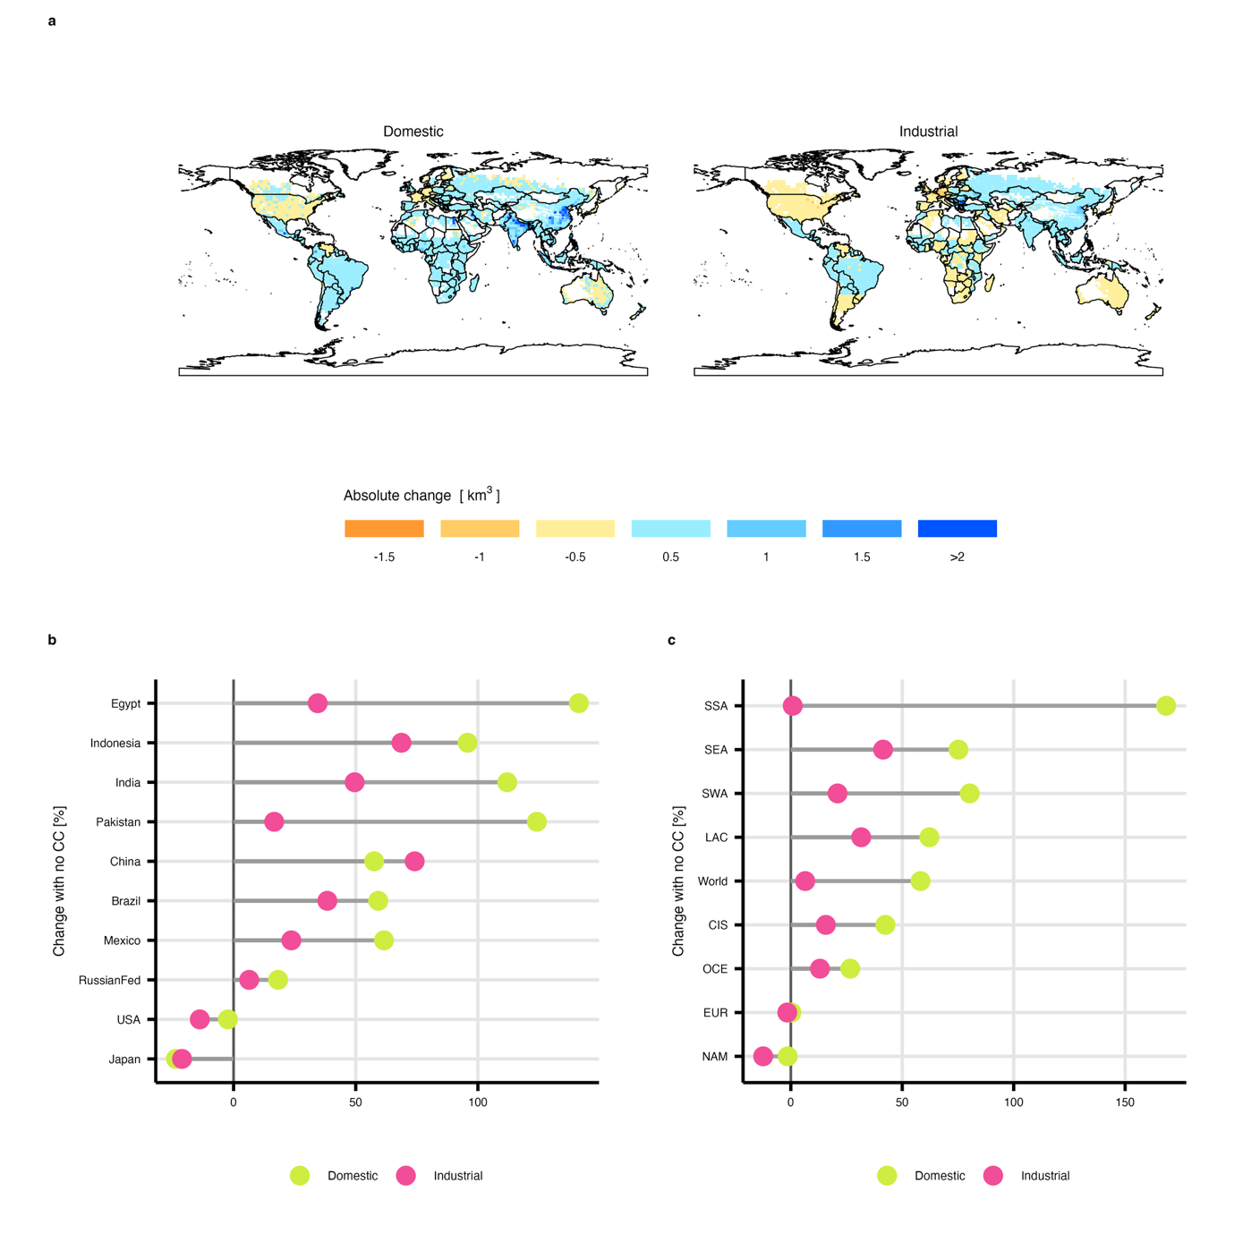Supplementary Fig. 3| Changes in nonagricultural water demand in 2050 under SSP2. a, Spatial distribution of absolute changes in domestic and industrial water demand (km³) in 2050 relative to 2020 under SSP2. Orange shading indicates decreases, whereas light to dark blue shading indicates increasing demand. b, Percentage change in domestic (green circles) and industrial (pink circles) water demand by major countries in 2050 relative to 2020. c, Percentage change in domestic (green circles) and industrial (pink circles) water demand by macroregion in 2050 relative to 2020. The vertical black line indicates zero change.

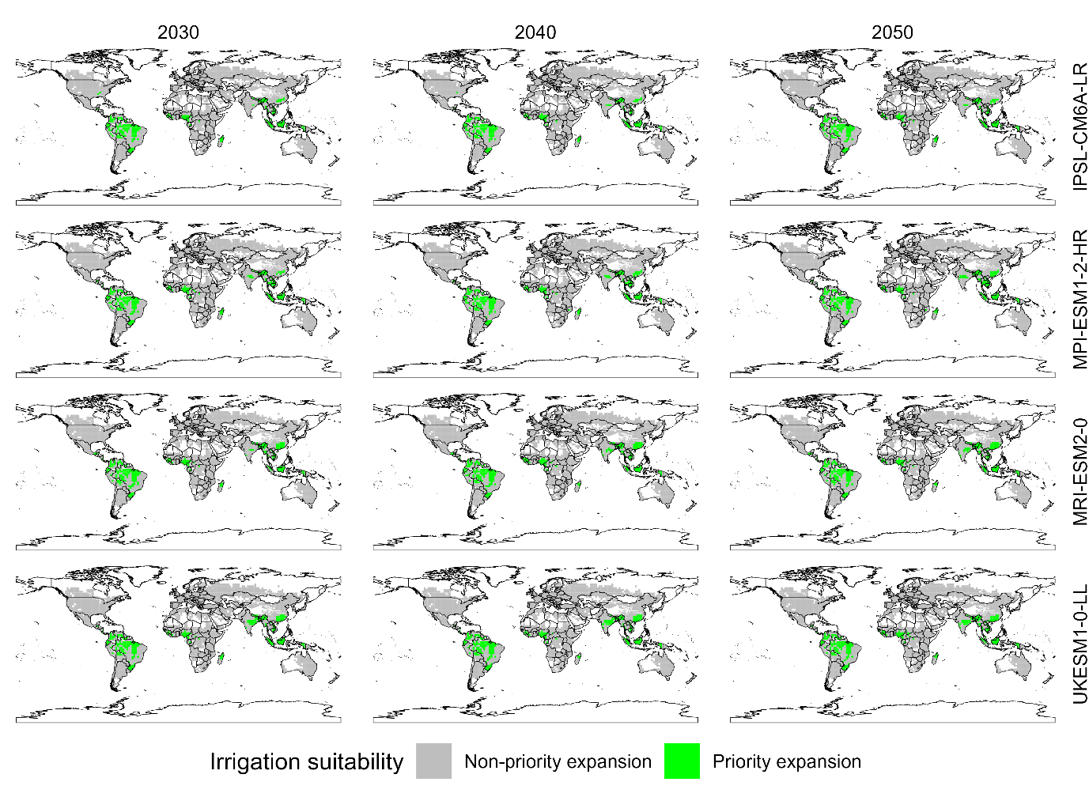
Supplementary Fig. 4| Climate-driven suitability for irrigation expansion under RCP2.6. Global maps show grid cells prioritized for irrigation expansion under the low-emissions scenario RCP2.6 in 2030, 2040, and 2050 across four global climate models (IPSL-CM6A-LR, MPI-ESM1-2-HR, MRI-ESM2-0, and UKESM1-0-LL). The green cells indicate locations where biophysical conditions allow sustainable irrigation expansion, while the gray cells represent areas where expansion is not prioritized in GLOBIOM.

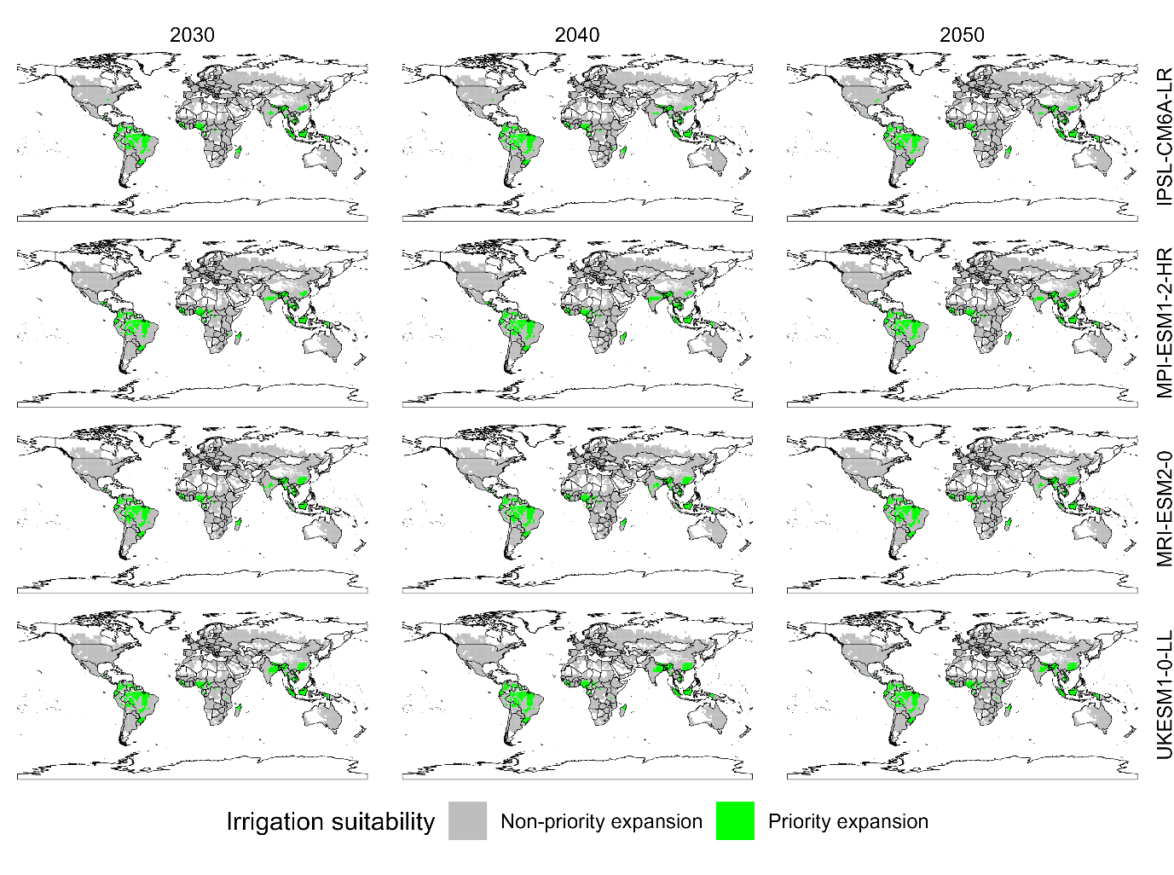
Supplementary Fig. 5| Climate-driven suitability for irrigation expansion under RCP2.6. Global maps show grid cells prioritized for irrigation expansion under the low-emissions scenario RCP2.6 in 2030, 2040, and 2050 across four global climate models (IPSL-CM6A-LR, MPI-ESM1-2-HR, MRI-ESM2-0, and UKESM1-0-LL). The green cells indicate locations where biophysical conditions allow sustainable irrigation expansion, while the gray cells represent areas where expansion is not prioritized in GLOBIOM.

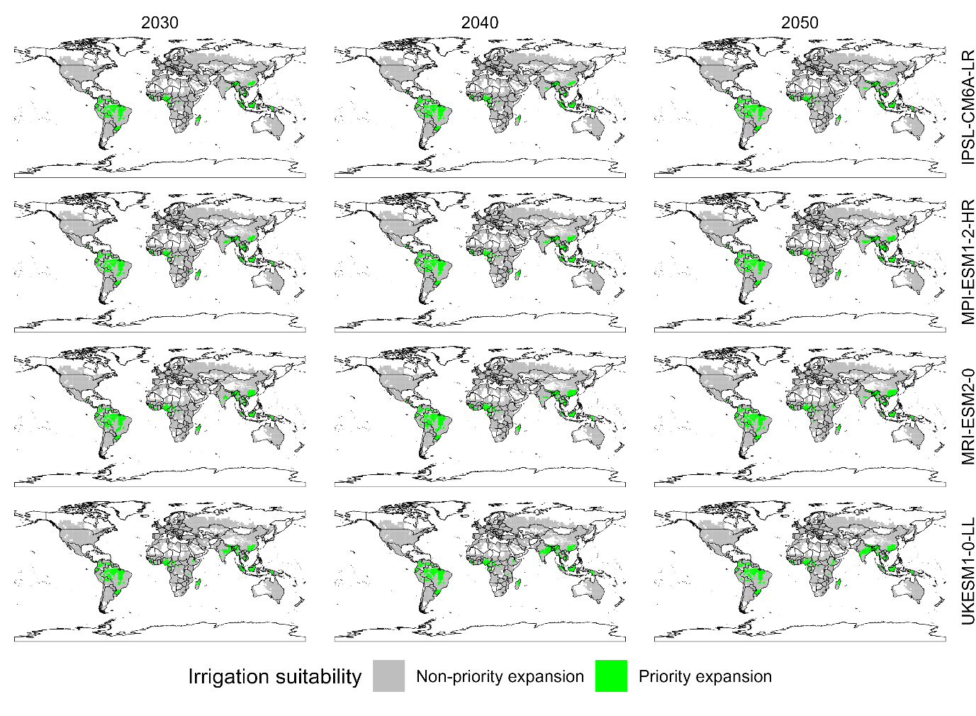
Supplementary Fig. 6 | Climate-driven suitability for irrigation expansion under RCP8.5. Global maps show grid cells prioritized for irrigation expansion under the low-emissions scenario RCP2.6 in 2030, 2040, and 2050 across four global climate models (IPSL-CM6A-LR, MPI-ESM1-2-HR, MRI-ESM2-0, and UKESM1-0-LL). The green cells indicate locations where biophysical conditions allow sustainable irrigation expansion, while the gray cells represent areas where expansion is not prioritized in GLOBIOM.

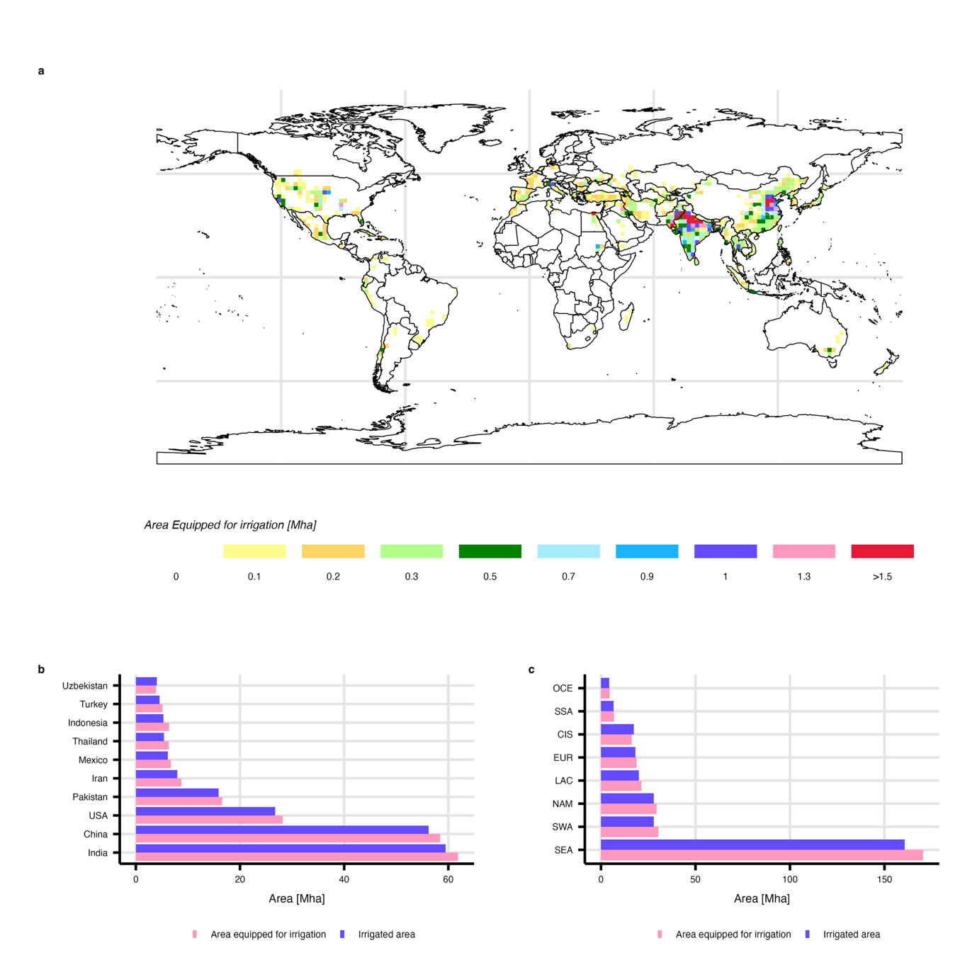
Supplementary Fig. 7 | Global distribution and regional patterns of the irrigated area and area equipped for irrigation. a, Global map of the area equipped for irrigation (AEI, Mha) at the grid cell resolution, showing strong spatial clustering in South and East Asia, with smaller hotspots in North America, the Mediterranean, and parts of South America. b, Country-level comparison of the irrigated area and AEI for the ten largest contributors, highlighting close agreement among major producers (e.g., India, China and the USA) but systematic gaps in several countries and reflecting differences between infrastructure capacity and actual water use. c, Regional aggregation of the irrigated area and AEI, showing that South and Southeast Asia dominate global totals, while other regions contribute more modest shares. Across scales, the AEI consistently exceeds or closely tracks the irrigated area, indicating the extent to which irrigation infrastructure constrains or enables water use.

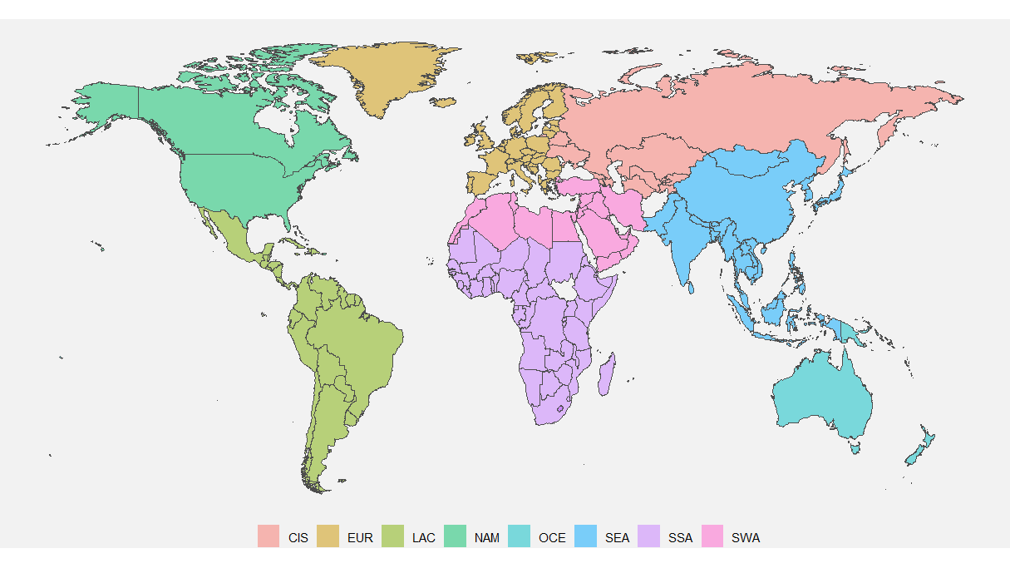
Supplementary Fig. 8 | Macroregional classification used for aggregated results. World map showing the macroregions used throughout the analysis: the Commonwealth of Independent States (CIS, salmon), the Europe economic area (EUR, mustard), Latin America and the Caribbean (LAC, light green), North America (NAM, green), Oceania (OCE, teal), Southeast Asia (SEA, blue), Sub-Saharan Africa (SSA, purple), and Southwest Asia and North Africa (SWA, pink).

Supplementary Tables
Supplementary Table 1 | Regional water withdrawals, environmental flow requirements and sectoral water use in 2050 under climate scenarios. Regional totals of surface water availability, environmental flow requirements, irrigation water withdrawals, and nonagricultural water withdrawals (domestic and industrial) in 2050 under RCP2.6, RCP7.0 and RCP8.5. Values are reported in cubic kilometers (km³) and represent the means across five global climate models (n = 5). Totals are aggregated at the macroregional level, which is consistent with the regional classification used throughout the analysis.
 | Surface water |  |  | Environmental Flow Requirements |  |  | Irrigation Water Withdrawals |  |  | Nonagricultural Water Withdrawals
 | RCP2.6 | RCP7.0 | RCP8.5 | RCP2.6 | RCP7.0 | RCP8.5 | RCP2.6 | RCP7.0 | RCP8.5 | Domestic | Industrial
SWA | 559 | 527 | 499 | 224 | 211 | 199 | 245 | 228 | 222 | 77 | 20
EUR | 1776 | 1792 | 1749 | 710 | 717 | 699 | 49 | 47 | 46 | 61 | 231
OCE | 1852 | 1866 | 1886 | 741 | 746 | 755 | 8 | 8 | 8 | 4 | 0.1
CIS | 2135 | 2147 | 2120 | 854 | 859 | 848 | 117 | 114 | 112 | 50 | 138
NAM | 3395 | 3351 | 3439 | 1358 | 1340 | 1376 | 228 | 228 | 228 | 66 | 238
SSA | 8164 | 8227 | 8444 | 3266 | 3291 | 3378 | 84 | 83 | 76 | 53 | 3
LAC | 12667 | 11920 | 11715 | 5067 | 4768 | 4686 | 208 | 201 | 195 | 92 | 29
SEA | 12780 | 12355 | 12696 | 5112 | 4942 | 5078 | 1589 | 1406 | 1420 | 499 | 208
World | 43328 | 42184 | 42548 | 17331 | 16874 | 17019 | 2529 | 2315 | 2307 | 902 | 866

Supplementary Table 2 | Regressions of economic responses to climate change impact by macroregion for irrigated systems. Intercepts (Int) and slope coefficients (Slope) from univariate regressions of irrigated production (PROD_IR), the irrigated area (ARIR), irrigation water use (WATR), water use efficiency (WUE)y, the endogenous irrigated yield (YIIR), and total trade (imports (IMPO) and exports (EXPO)) against climate change impacts on irrigated yield changes (YEXO_I) across macroregions. Slopes represent the elasticities of each response to climate-driven irrigated yield impacts, pooling climate scenarios and general circulation models. Statistical significance is denoted by * p < 0.1, ** p < 0.05, and *** p < 0.01.
 |  | YIIR | ARIR | PROD_IR | WATR | WUE | IMPO | EXPO
CIS | Int | -14.594*** | -23.331*** | -44.291*** | 0.217 | -15.174*** | -20.193*** | -44.804***
CIS | Slope | 0.209 | -2.396*** | -3.409*** | -0.678** | 0.686** | -3.337*** | -0.274
EUR | Int | 6.704 | 32.340** | 11.011 | 15.069 | -8.337 | 25.412*** | 10.448*
EUR | Slope | 1.305 | 0.553 | 0.3 | -0.67 | 2.038 | -1.932** | 0.633
LAC | Int | 14.691*** | 12.329*** | 32.970*** | 5.562*** | 8.958*** | 25.852*** | 3.952***
LAC | Slope | 1.202*** | 0.223 | 0.01 | -0.154 | 1.268*** | -0.304 | -0.277
NAM | Int | 0.389 | 5.157 | -0.297 | -4.19 | 9.080* | 6.355*** | 2.235
NAM | Slope | 0.974*** | -2.071* | -0.675 | -2.782*** | 3.967*** | -0.494 | 2.671***
OCE | Int | -6.865*** | 8.046** | 76.493*** | 1.965 | 1.883 | -5.363** | 25.415***
OCE | Slope | 1.080*** | -0.718*** | -0.831** | -0.911*** | 1.991*** | 0.06 | 0.287**
SEA | Int | 2.103*** | 0.105 | 3.521*** | -17.019*** | 23.466*** | 1.301*** | 4.633***
SEA | Slope | 0.743*** | 0.309* | 0.752*** | 0.646 | -0.052 | -0.447*** | 0.745**
SSA | Int | 2.682*** | -28.640*** | -1.81 | -7.632*** | 12.185*** | 2.115 | 13.018***
SSA | Slope | 0.351 | -4.306*** | -4.446*** | -4.845*** | 6.998*** | 0.95 | -1.183
SWA | Int | -16.436*** | 7.797* | -6.555* | 5.248* | -21.035*** | 4.397 | 21.423*
SWA | Slope | 0.556** | 0.409* | 0.643*** | 0.837*** | -0.149 | -0.153 | -0.719
World | Int | 2.827*** | 2.605*** | 6.964*** | -10.590*** | 15.276*** | 5.852*** | 5.852***
World | Slope | 0.739*** | -0.245 | 0.157 | 0.076 | 0.722 | -0.352*** | -0.352***

Supplementary Table 3 | Regressions of economic responses to climate change impacts by macroregion for rainfed systems. Intercepts (Int) and slope coefficients (Slope) from univariate regressions of rainfed production (PROD_RF), the rainfed area (ARRF), the endogenous rainfed yield (YIRF), and total trade (imports (IMPO) and exports (EXPO)) against climate change impacts on irrigated yield changes (YEXO_RF) across macroregions. Slopes represent the regression of each response to climate-driven impacts on the rainfed yield, pooling across climate scenarios and general circulation models. Statistical significance is denoted by * p < 0.1, ** p < 0.05, and *** p < 0.01.
 |  | YIRF | ARRF | PROD_RF | IMPO | EXPO
CIS | Int | 4.995*** | -6.428*** | -1.343 | 6.544*** | -41.997***
CIS | Slope | 1.172*** | 0.866*** | 1.960*** | -1.875*** | 0.007
EUR | Int | 4.858*** | -14.982*** | -8.837*** | 17.208*** | 15.317***
EUR | Slope | 0.906*** | -0.002 | 0.881*** | -0.608*** | -0.049
LAC | Int | 4.844*** | -6.081*** | -10.200*** | 25.881*** | 4.064***
LAC | Slope | 0.224* | -0.433*** | -0.096 | -0.254* | -0.138
NAM | Int | 5.177*** | -9.386*** | -5.872** | 6.990*** | -1.379
NAM | Slope | 0.899*** | 0.659** | 1.546*** | -0.325* | 1.693***
OCE | Int | 14.192*** | 4.935*** | -3.772* | -5.810** | 22.711***
OCE | Slope | -0.085 | -0.031 | 0.815*** | 0.085 | 0.481***
SEA | Int | 2.960** | -7.339*** | -4.653*** | 2.166*** | 1.248
SEA | Slope | 1.258*** | -0.01 | 0.911*** | -0.354** | 1.060***
SSA | Int | 1.707*** | -0.59 | 0.791 | 1.004 | 11.961***
SSA | Slope | 1.003*** | -0.422*** | 0.696** | 0.427 | 0.036
SWA | Int | 13.917*** | 7.875*** | 30.938*** | 6.323*** | 37.279***
SWA | Slope | 1.147*** | 0.376** | 1.767*** | -0.31 | 1.956***
World | Int | 4.949*** | -6.041*** | -4.333*** | 6.535*** | 6.535***
World | Slope | 0.821*** | -0.199* | 0.636*** | -0.183* | -0.183*

Supplementary Table 4 | Macroregional aggregation and GLOBIOM market region mapping. Definitions of the macroregions used in the analysis, their corresponding GLOBIOM market regions, and the countries included within each aggregation. The table provides the regional structure underlying all the aggregated results reported in the main and supplementary figures.
Macro Region | Name | GLOBIOM Market region | Countries
CIS | Commonwealth of Independent States | Former_USSR | Belarus, Moldova, Azerbaijan, Kazakhstan, Turkmenistan, Uzbekistan, Armenia, Georgia, Kyrgyzstan, Tajikistan
CIS | Commonwealth of Independent States | RussiaReg | Russia
CIS | Commonwealth of Independent States | UkraineReg | Ukraine
LAC | Latin America and the Caribbean | ArgentinaReg | Argentina
LAC | Latin America and the Caribbean | BrazilReg | Brazil
LAC | Latin America and the Caribbean | MexicoReg | Mexico
LAC | Latin America and the Caribbean | RCAM | Bahamas, Belize, Costa Rica, Cuba, Dominican Republic, El Salvador, Guadeloupe, Guatemala, Jamaica, Nicaragua, Panama, Trinidad and Tobago
LAC | Latin America and the Caribbean | RSAM | Bolivia, Chile, Colombia, Ecuador, Guyana, Paraguay, Peru, Suriname, Uruguay, Venezuela
NAM | North America | CanadaReg | Canada
NAM | North America | USAReg | United States, Puerto Rico
SSA | Sub-Saharan Africa | CongoBasin | Cameroon, Central African Republic, Congo Republic, Democratic Republic of Congo, Equatorial Guinea, Gabon
SSA | Sub-Saharan Africa | SouthAfrReg | South Africa
SSA | Sub-Saharan Africa | EasternAf | Burundi, Ethiopia, Kenya, Tanzania, Uganda, Rwanda
SSA | Sub-Saharan Africa | WesternAf | Benin, Burkina Faso, Cape Verde, Chad, Côte d'Ivoire, Djibouti, Eritrea, Gambia, Ghana, Guinea, Guinea-Bissau, Liberia, Mali, Mauritania, Niger, Nigeria, Senegal, Sierra Leone, Somalia, Sudan, Togo
SSA | Sub-Saharan Africa | SouthernAf | Angola, Botswana, Comoros, Lesotho, Madagascar, Malawi, Mauritius, Mozambique, Namibia, Reunion, Swaziland, Zambia, Zimbabwe
SEA | Southeast Asia | ChinaReg | China
SEA | Southeast Asia | IndiaReg | India
SEA | Southeast Asia | RSEA_OPA | Brunei Darussalam, Myanmar, Philippines, Singapore, Timor-Leste, Thailand
SEA | Southeast Asia | RSAS | Bangladesh, Bhutan, Nepal, Pakistan, Sri Lanka
SEA | Southeast Asia | IndonesiaReg | Indonesia
SEA | Southeast Asia | SouthKorea | South Korea
SEA | Southeast Asia | MalaysiaReg | Malaysia
SEA | Southeast Asia | JapanReg | Japan
SEA | Southeast Asia | RSEA_PAC | Cambodia, DPR of Korea, Laos, Mongolia, Viet Nam
SWA | Southwest Asia and North Africa | MiddleEast | Bahrain, Iran, Iraq, Israel, Jordan, Kuwait, Lebanon, Oman, Palestine, Qatar, Saudi Arabia, Syria, United Arab Emirates, Yemen
SWA | Southwest Asia and North Africa | NorthernAf | Algeria, Egypt, Libya, Morocco, Tunisia, Western Sahara
SWA | Southwest Asia and North Africa | TurkeyReg | Turkey
EUR | Europe economic area | RCEU | Albania, Bosnia and Herzegovina, Republic of North Macedonia, Montenegro, Serbia,
EUR | Europe economic area | ROWE | United Kingdom of Great Britain and Northern Ireland, Greenland, Iceland, Norway, Switzerland
EUR | Europe economic area | Each EU member state | Denmark, Finland, Ireland, Sweden, Cyprus, Greece, Italy, Malta, Portugal, Spain, Estonia, Latvia, Lithuania, Bulgaria, Czech Republic, Hungary, Poland, Romania, Slovakia, Slovenia, Austria, Belgium, France, Germany, Luxembourg, Netherlands
OCE | Oceania | AustraliaReg | Australia
OCE | Oceania | NewZealandReg | New Zealand
OCE | Oceania | Pacific_Island | Fiji, French Polynesia, New Caledonia, Papua New Guinea, Samoa, Solomon Islands, Vanuatu

Supplementary Text

Supplementary text 1: Suitability irrigation maps

We developed spatially explicit irrigation suitability maps by integrating hydrological, agronomic, and irrigation infrastructure from the proposed EPIC-CWATM-GLOBIOM modeling framework. We combined three datasets: (1) hydrological water availability from CWATM, (2) projected irrigation benefits for crop production from EPIC-IIASA, and (3) the presence of existing irrigation infrastructure¹.

Sustainable water for irrigation expansion

To quantify the water available for irrigation expansion, we calculated a spatially explicit indicator of sustainable water for irrigation expansion (SWIRR) at the level of the GLOBIOM grid cell$i$ in year $y$ at the crop aggregated $crp$ as follows:

$${SWIRR}_{iycrp}= {SF}_{iy}- {EFR}_{iy}- {OTHWW}_{iy}- {WAIR}_{iycrp. 2000}$$

SWIRR values were computed for each grid cell, global circulation model (GCM), climate scenario (RCP), and year. The resulting dataset represents the volume of water potentially available for irrigation expansion (km³) as the residual use after meeting the needs of the environment, nonagricultural users, and the irrigation demand projected by EPIC-IIASA, using the cropland distribution of 2000.

To identify spatial patterns in sustainable water availability, we applied a local Moran’s I hotspot analysis via queen contiguity spatial weights. This analysis identifies statistically significant spatial clusters of high or low SWIRR values relative to neighboring land units. The local indicators of spatial association (LISA) classified each grid cell into cluster types, including high–high, low–low, and nonsignificant categories. High–high clusters represent areas where large amounts of sustainable water for irrigation expansion occur in spatially contiguous regions, whereas low–Low clusters indicate areas where irrigation expansion would likely be constrained by water scarcity.

The hotspot classification was calculated separately for each RCP, GCM, and time step. The resulting cluster classifications were used to identify locations where irrigation expansion is hydrologically sustainable. High–high clusters indicate regions with favorable hydrological conditions for irrigation expansion, whereas low–low clusters indicate potential water scarcity hotspots where irrigation expansion would likely be unsustainable.

Irrigation benefits for crop production
Irrigation yield benefits were calculated as the relative difference between irrigated and rainfed crop yields. For each crop c, spatial unit i, and year y, the irrigation yield benefit was defined as follows:

$${YC}_{icy}=\frac{{IRRY}_{icy}- {RNFY}_{icy}}{{RNFY}_{icy}}$$

where ${IRRY}_{icy}$ represents the irrigated yield and ${RNFY}_{icy}$ represents the rainfed yield. This metric quantifies the proportional yield gain attributable to irrigation relative to rainfed production conditions. To assess changes over time, the irrigation yield benefit in each projection year was normalized relative to the historical baseline period (2000–2010). The relative change in irrigation yield benefit was calculated as follows:

$${∆YC}_{icy}=\frac{{YC}_{icy}}{{YC}_{ic(2000-2010)}}$$

where ${YC}_{ic(2000-2010)}$ represents the mean irrigation yield benefit during the baseline period 2000–2010 for crop c and spatial unit i. This normalization makes it possible to compare projected irrigation benefits across time by expressing them relative to historical conditions, thereby capturing how the effectiveness of irrigation as an adaptation strategy evolves under future climate scenarios.

Area equipped for irrigation
We used a time series of the area equipped for irrigation and the actually irrigated area from 1900 to 2015 1. The area equipped for irrigation (AEI) was derived at the GLOBIOM grid cell level by combining a historical annual dataset with a spatial dataset representing the extent of irrigation for the period 2000–2008. The mean irrigated area equipped for irrigation was calculated as the temporal average over the period 1985–2015. This resulting AEI variable was subsequently used as an indicator of the presence of irrigation infrastructure in the suitability analysis.
Irrigation expansion suitability was defined as a composite condition combining hydrological availability, agronomic benefits, and existing infrastructure at the GLOBIOM grid cell level. A location was considered suitable for irrigation expansion only when all three criteria were simultaneously satisfied. First, sufficient water availability for irrigation expansion was required, represented by positive values of the sustainable water indicator (${ SWIRR}_{iycrp}>0$) and spatial clustering in “high–high” regions, indicating locally and regionally favorable hydrological conditions. Second, irrigation needed to provide a positive agronomic benefit, defined as an increase in yield relative to baseline conditions (${∆YC}_{icy}>0$). Third, the presence of existing irrigation infrastructure was required, represented by a positive area equipped for irrigation (AEI > 0). Formally, irrigation suitability was defined as a binary condition where suitability is achieved only if all three constraints are met simultaneously; otherwise, locations are classified as not suitable for expansion. This framework ensures that irrigation expansion is prioritized in areas where water resources are available, that irrigation improves crop productivity, and that infrastructure conditions enable feasible implementation.

$$Irrigation Suitability = \left\{\begin{aligned}{ SWIRR}_{iycrp}>0 ∧high-high \\ {∆YC}_{icy}>0 \\ AEI>0\end{aligned}\right.$$

Supplementary Fig. 10 highlights a consistent spatial pattern of irrigation expansion suitability across climate scenarios, with the most suitable areas concentrated in the Global South, particularly in regions of Latin America, Sub-Saharan Africa, and South and Southeast Asia. These regions emerge as priority areas where hydrological availability and agronomic benefits align to support irrigation expansion. Across models, the extent of suitable areas generally increases under higher-emission scenarios, although this response is model dependent. Notably, the GFDL-ESM4 model exhibits suitability for irrigation expansion only under the most extreme scenario (RCP8.5) by 2100, with no suitable areas under lower-emission pathways. As a result, this model was not present in the maps of suitability by 2050 (Supplementary Figs. 4–6), which present results based on the four remaining climate models.

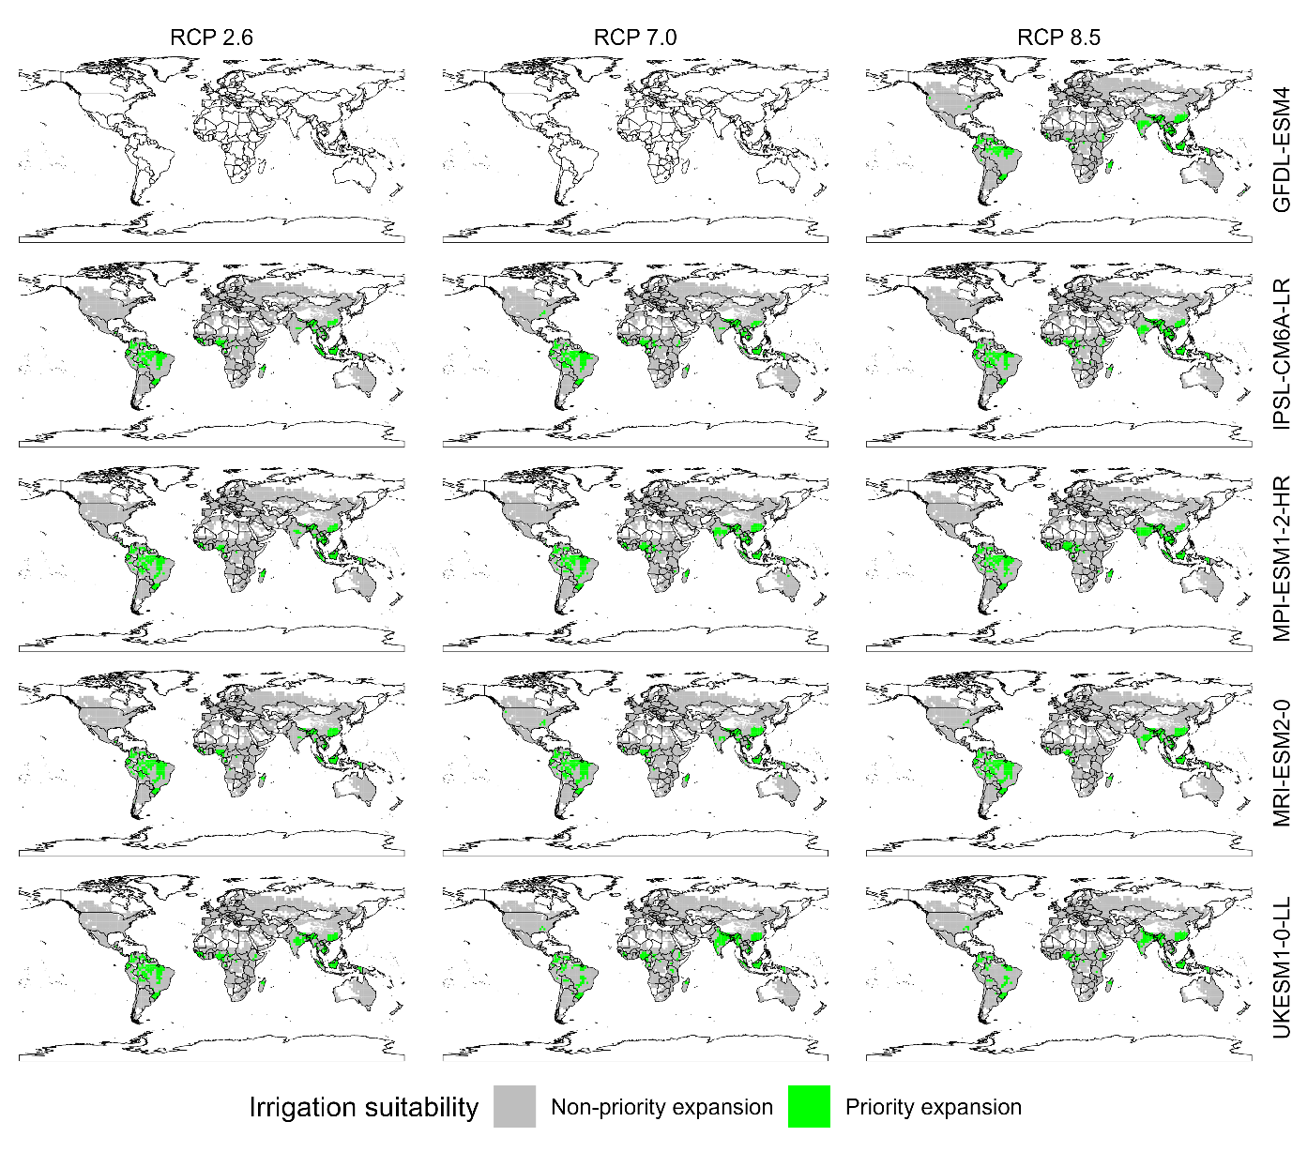
Supplementary Fig. 10 | Climate-driven suitability for irrigation expansion by 2100 across emission scenarios. Global maps show grid cells prioritized for irrigation expansion by 2100 under three climate scenarios (RCP2.6, RCP7.0, and RCP8.5) across five global climate models (GFDL-ESM4, IPSL-CM6A-LR, MPI-ESM1-2-HR, MRI-ESM2-0, and UKESM1-0-LL). The green cells indicate locations where biophysical conditions support sustainable irrigation expansion, whereas the gray cells represent areas where expansion is not prioritized.

Supplementary text 2: Hydroclimatic deficit drivers

Two climate-related factors may control the need for supplementary water application for crops, either because of a decrease in precipitation on croplands or because of an increase in evapotranspiration due to a change in atmospheric evaporative demand. These climatic variables are driven by the selection of general circulation models (GCMs). To identify the dominant hydroclimatic drivers of water deficit across global croplands, we quantified the relative influence of precipitation supply and atmospheric evaporative demand using a correlation-based dominance framework.

For each grid cell and year, the hydroclimatic deficit was defined as the difference between potential evapotranspiration (PET)² and precipitation (PREC):

$$D_{iy }= {PET}_{iy}- {PREC}_{iy}$$

where $D_{iy }$ represents the atmospheric water deficit conditions when evaporative demand exceeds water supply. We then assessed the contribution of each component by computing Kendall’s rank correlation coefficient ($τ$) between the deficit time series and its two drivers. Kendall’s $τ$ measures the strength of the monotonic association between two variables. For each grid cell, we calculated $τ_{PET}= τ({PET}_{iy},D_{iy })$ and $τ_{PREC}= τ({PREC}_{iy},D_{iy })$. A dominance index ($DI$) was then derived as the difference between these correlations: $DI= τ_{PET}- τ_{PREC}$​. Negative $DI$ values indicate precipitation-driven deficits, whereas positive values indicate deficits dominated by atmospheric evaporative demand. Grid cells were further classified as precipitation driven, PET driven, or mixed depending on the magnitude and sign of DI. This framework enables a consistent comparison of hydroclimatic deficit drivers across regions, climate models and scenarios.

Across all climate scenarios, hydroclimatic deficits over global croplands are predominantly precipitation driven, with large contiguous regions in the Americas, Europe, Sub-Saharan Africa, and East and Southeast Asia consistently classified as PREC dominated (blue) (Supplementary Fig. 11). In contrast, PET-driven deficits (red) are spatially concentrated in arid and semiarid regions, notably across North Africa, the Southwest Asia, Central Asia, and parts of Australia, where high evaporative demand exerts stronger control over water deficits. Regions of mixed influence (orange) appear primarily along transitional climatic zones, including parts of southern Africa, western North America, and eastern Australia. A comparison of the scenarios reveals a modest but consistent expansion of PET-driven areas under higher radiative forcing. From RCP2.6 to RCP8.5, PET dominance intensifies particularly across North Africa, the M Southwest Asia, and Central Asia and emerges more clearly in parts of southern Africa and Australia. However, the overall global pattern remains robust, with precipitation variability continuing to dominate hydroclimatic deficits across the majority of cropland regions. Despite increasing atmospheric water demand under warming, water deficits remain largely constrained by precipitation supply, while PET-driven limitations become more prominent in already water-stressed regions.

The cumulative distributions highlight a consistent but nonnegligible role of GCM structural uncertainty in shaping the dominance of hydroclimatic deficit drivers (Supplementary Fig. 12). While all models agree that most cropland areas remain precipitation driven (DI < 0), the position and slope of the curves vary systematically across GCMs. For example, GFDL-ESM4 consistently exhibits a stronger shift toward negative DI values, indicating a higher prevalence of precipitation-controlled deficits, whereas models such as MPI-ESM1-2-HR and, to a lesser extent, MRI-ESM2-0 show distributions closer to the DI = 0 threshold, suggesting a greater influence of atmospheric evaporative demand. This intermodel spread is most pronounced under RCP2.6, where differences in the lower tail of the distribution indicate contrasting sensitivities to precipitation variability. Under higher forcing scenarios (RCP7.0 and RCP8.5), the curves converge somewhat but still retain distinct offsets, indicating persistent differences in how the models represent the balance between water supply and atmospheric demand. Importantly, the fraction of cropland classified as PET driven varies across GCMs by ~10–15%, underscoring that model structure influences not only the magnitude but also the spatial extent of emerging PET-driven deficits. Despite these differences, all models consistently show only a gradual expansion of the influence of PET with warming, reinforcing the robustness of precipitation as the dominant control while highlighting uncertainty in the rate and extent of the transition toward PET-driven regimes.

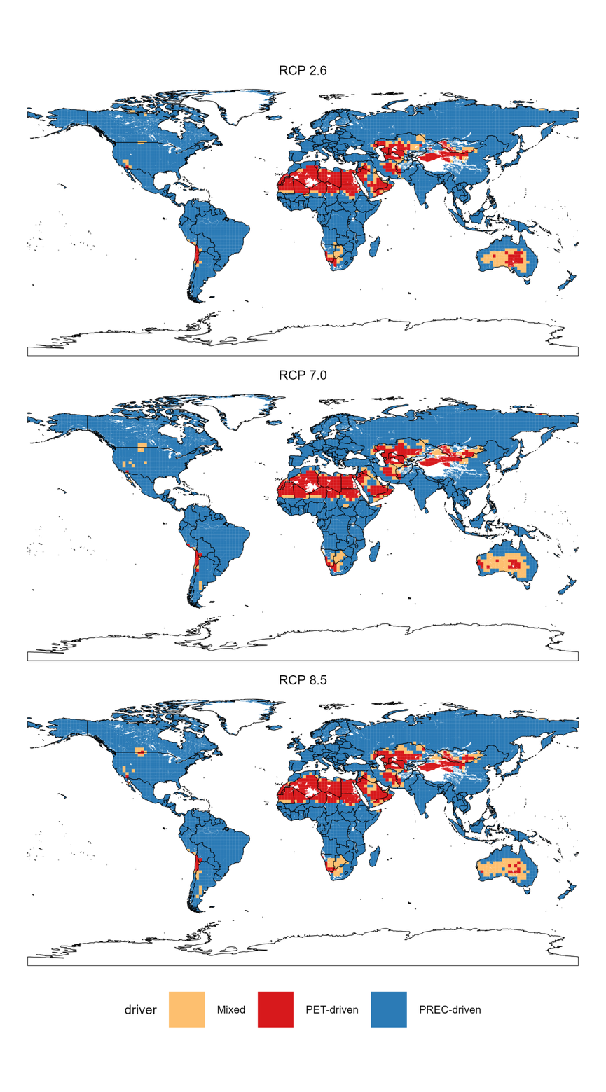

Supplementary Fig. 11 | Global dominance of hydroclimatic deficit drivers across climate scenarios. Spatial distribution of dominant hydroclimatic deficit drivers across global croplands for the three climate scenarios. Grid cells are classified as precipitation driven (blue), PET driven (red), or mixed control (orange) based on the sign and magnitude of the dominance index.

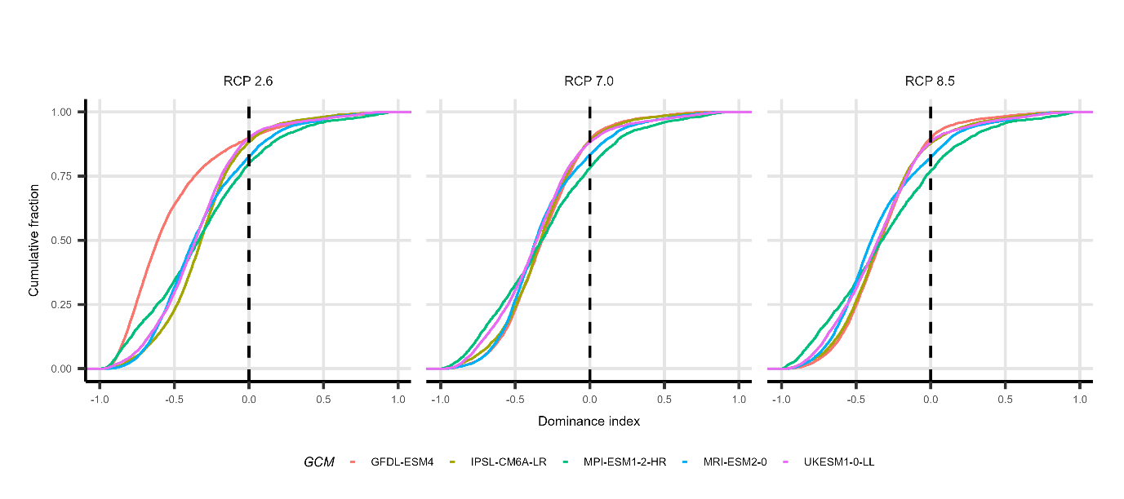

Supplementary Fig. 12 | Global cumulative distribution functions of the dominance index. Cumulative distribution functions of the dominance index (DI) across global cropland grid cells under three climate scenarios (RCP2.6, RCP7.0 and RCP8.5) for five global climate models (GFDL-ESM4, IPSL-CM6A-LR, MPI-ESM1-2-HR, MRI-ESM2-0 and UKESM1-0-LL). Negative values indicate precipitation-driven deficits, whereas positive values indicate PET-driven deficits. The dashed vertical line indicates that DI = 0.

Supplementary text 3: Review of national adaptation plans (NAPs)
National adaptation plans (NAPs) are national policy instruments established under the United Nations Framework Convention on Climate Change (UNFCCC) to support countries in identifying and addressing medium- and long-term climate change adaptation needs. The objective of NAPs is to reduce vulnerability to climate change impacts by strengthening adaptive capacity and resilience and to integrate adaptation into national development planning across sectors and governance levels. Unlike project-based adaptation initiatives, NAPs are strategic national frameworks designed to mainstream adaptation into key sectors such as agriculture, water, infrastructure, health, and energy.
The NAP process is primarily targeted at supporting countries in the Global South, particularly those classified as least developed countries (LDCs) and small island developing states (SIDSs), while also being encouraged for other developing (non-Annex I) Parties. Annex I Parties, which generally represent developed countries in the Global North, are not required to prepare NAPs; instead, they are expected to submit adaptation communications. Nevertheless, some developed countries have also developed NAP-like strategies or national adaptation plans.

Systematic screening and classification of irrigation-related adaptation measures
To assess how irrigation and agricultural water management are framed within national climate adaptation strategies, we conducted a structured review of officially submitted NAPs and nationally endorsed NAP-equivalent adaptation planning documents. We compiled a dataset covering 86 countries for which official NAPs, NAP updates, sectoral NAPs, or formally endorsed NAP-equivalent strategies were available as of 2024. Documents were retrieved from the UNFCCC report portal (https://unfccc.int/reports). When multiple documents existed for a country (for example, updated NAPs, agriculture-specific NAPs or sectoral adaptation plans), all versions were included and cross-referenced to capture policy evolution. Only officially endorsed national-level documents were considered.
Each document was screened via a predefined keyword protocol designed to capture references to irrigation and agricultural water management (Supplementary Table 5). The screening was conducted across the full document, including annexes and implementation sections. Mentions of water scarcity or drought were recorded only when they were linked to a specific adaptation intervention.
The extracted measures were coded via a standardized classification framework consisting of five mutually exclusive categories (Supplementary Table 6). For each coded measure, we recorded whether quantitative targets were specified. When available, numerical information, such as irrigated area expansion, water savings, storage capacity, investment amounts or implementation timelines, was extracted and standardized (Supplementary Table 6).
Supplementary Table 5 | Keyword protocol and coding framework used to identify irrigation-related adaptation measures in national adaptation plans (NAPs).
Cluster | Keyword Group | Example Terms to Search | Linked Coding Category | Operational Coding Rule | Exclusions/Notes
A | Irrigation – General | irrigation, irrigated land, irrigation scheme, irrigation systems, irrigation coverage, command area | (i), (ii), (iv) | Code based on context (expansion vs. efficiency vs. infrastructure) | Do not auto-code without contextual interpretation
B | Irrigation Expansion | expand irrigation, new irrigation schemes, increase irrigated area, extend irrigation coverage, develop irrigation in rainfed areas | (i) Irrigation Expansion | Explicit increase in irrigated area (ha or %) | If no area increase mentioned → not expansion
C | Efficiency & Modernization | irrigation efficiency, drip irrigation, sprinkler systems, precision irrigation, canal lining, reduce losses, modernization | (ii) Irrigation Efficiency Improvements | Measures improving water use per unit area without increasing irrigated land | If area expansion is simultaneous → dual tag (primary = dominant objective)
D | Agricultural Water Management | agricultural water management, on-farm water management, irrigation scheduling, water productivity | (ii) or (v) | Code as efficiency if technical; demand management if behavioral/agronomic | Requires interpretation
E | Water Scarcity & Climate Stress | water scarcity, drought, water stress, variability, declining rainfall, reduced river flow | Context variable (driver) | Record as justification driver, not adaptation category | Do not code as measure
F | Infrastructure & Storage | reservoir, dam, canal rehabilitation, storage infrastructure, conveyance system, diversion structures | (iv) Water Storage and Infrastructure Development | Physical infrastructure to store, regulate, or deliver water | Must serve agriculture explicitly to be coded
G | Groundwater Use | groundwater abstraction, boreholes, aquifer recharge, tube wells | (i), (iv), or (iii) | Expansion if increasing extraction; infrastructure if recharge; governance if regulation | Note sustainability concerns separately
H | Non-Conventional Water | desalination, wastewater reuse, recycled water, treated wastewater, brackish water use | (i), (iv), or (v) | Code depending on function (new supply vs. conservation) | Often multicategory
I | Governance & Allocation | water rights, allocation reform, pricing reform, water user associations, river basin management | (iii) Governance and Allocation Reforms | Institutional or regulatory change | Exclude infrastructure-only measures
J | Demand Management & Conservation | water conservation, crop switching, drought-resistant crops, deficit irrigation, rainwater harvesting | (v) Demand Management or Conservation Strategies | Reducing demand or changing agricultural practices | If infrastructure-heavy → reconsider category

Supplementary Table 6 | Classification framework used to code irrigation-related adaptation measures identified in national adaptation plans (NAPs). The table defines the five coding categories used in the review, including their definitions, inclusion and exclusion criteria, and the types of quantitative targets recorded when reported in policy documents.
Category | Definition | Inclusion Criteria | Exclusion Criteria | Quantitative Targets to Record
(i) Irrigation Expansion | Increasing irrigated area or introducing irrigation where absent | New schemes, increased coverage, area targets | Efficiency upgrades without an area increase | Hectares added, % increase, investment cost, timeline
(ii) Irrigation Efficiency Improvements | Increasing water productivity without expanding area | Drip, sprinkler, canal lining, modernization | Area expansion | % efficiency gain, water saved (m³), reduced losses
(iii) Governance & Allocation Reforms | Institutional or regulatory measures | Water pricing, allocation rules, basin governance | Physical infrastructure alone | Pricing levels, allocation quotas, implementation year
(iv) Water Storage & Infrastructure Development | Physical infrastructure to store or distribute water | Dams, reservoirs, irrigation canals, recharge structures | Purely institutional reforms | Storage capacity (m³), number of structures, investment
(v) Demand Management/Conservation | Reducing agricultural water demand | Crop switching, conservation agriculture, deficit irrigation | Supply expansion | % demand reduction, crop area shifts, water savings

Irrigation strategies in National Adaptation Plans
The reviewed countries span all major global regions, although their representation is uneven. The largest share of NAPs in the dataset comes from SSA, with 31 countries, reflecting the strong engagement of LDCs in the NAP process. LAC represents the second largest group with 14 countries, followed by EUR with 12 countries and SEA with 11 countries. SWA accounts for 7 countries, while NAM contributes 3 countries. OCE is represented by 6 countries, mostly small island developing states, and two countries belong to the CIS.
Across regions, irrigation-related adaptation strategies are most frequently emphasized in SSA and SEA, where irrigation expansion, water harvesting, and irrigation infrastructure development are typically framed as key measures to increase food security and buffer rainfall variability. In contrast, EUR and other Annex I countries more frequently emphasize water governance reforms, drought planning frameworks, and irrigation efficiency improvements rather than large-scale irrigation expansion.
Despite the widespread inclusion of irrigation in agricultural adaptation planning, explicit quantitative irrigation targets remain relatively uncommon, with most NAPs framing irrigation within broader water resource management or agricultural resilience strategies rather than specifying measurable goals for irrigation expansion or efficiency.
Supplementary Table 7 | Main irrigation adaptation strategies identified in national adaptation plans (NAPs). Summary the dominant irrigation and agricultural water management strategies reported across the reviewed NAPs, including their descriptions, the typical regions where they are observed, the number of countries reporting the measure, and the share of NAPs in which each strategy appears
Irrigation adaptation strategy | Description | Typical regions where observed | Countries (n) | Share of NAPs
Irrigation expansion | Development of new irrigation schemes or expansion of irrigated areas | SSA, SEA and LAC | 28 | 33%
Water storage and infrastructure development | Construction or rehabilitation of reservoirs, canals, water harvesting, and irrigation infrastructure | SSA, SEA, and LAC | 36 | 42%
Irrigation efficiency improvements | Modern irrigation technologies, improved conveyance systems, precision irrigation, modernization of irrigation networks | SWA, EUR, CIS, and SEA | 19 | 22%
Governance and water allocation reforms | Integrated water resource management, water allocation reform, drought governance frameworks | EUR, and LAC | 24 | 28%
Demand management and conservation strategies | Water pricing, water-saving policies, drought preparedness planning | EUR, NAM, and OCE | 14 | 16%
Quantified irrigation targets | Explicit numerical targets for irrigation expansion, infrastructure, or efficiency improvements | Limited number of countries mainly LDCs | 9 | 10%

References

1. Mehta, P. et al. Half of twenty-first century global irrigation expansion has been in water-stressed regions. Nat. Water 2, 254–261 (2024).
2. Ensemble of CMIP6 derived reference and potential evapotranspiration with radiative and advective components | Scientific Data. https://www.nature.com/articles/s41597-023-02290-0.

