PROGRAM OF 10 “I-RECONSTRUCTION” SESSIONS FOR WORKING WITH ANXIETY
Sessions 1–3: Working with DESIRE
● Session 1: Introduction and Working with Desire
Introduction to group work, discussion of rules and goals. A brief overview of how the research process will take place.
“Introduction”: Participants introduce themselves by sharing their expectations regarding the work and the emotions associated with it. They will also attempt to formulate a request in the format: “I want…”
Educational component regarding the quality of requests in anxiety-related work.
Within the “I-Reconstruction” method, we distinguish several types of requests that should be additionally analyzed and processed rather than accepted in their original form, since they may lead to the consequences described above.
Classification of Destructive Requests (author: Pavlenko T. V.)
- Conditional Request
“I want to be healthy if my husband starts earning more money.”
Here we can see that the condition for the client’s recovery is what she considers to be her husband’s sufficient income. In other words: “If you want to see me healthy, fulfill the condition — earn more money.”
- Request of Despair
For example: “I want to lose at least one kilogram.”
Here we see that the client does not believe in the result or the success of their actions and appeals to a certain understanding of beauty. Thus, we arrive at a completely different request aimed at believing in one’s own beauty and attractiveness.
- Self-Suggestion Request
The client has convinced themselves that they have a problem or has labeled their condition as problematic (for example, due to social influence suggesting that they should want to lose weight or be dissatisfied with their body — the so-called “fashion of suffering”).
- Anxiety-Based Request
Usually, this type of request provokes even greater emotional distress than before because behind the proposed solution hides the most important issue that the person is not ready to reveal.
For example: “I want to learn to control hunger.”
Therefore, with such requests, sabotage in therapy is almost inevitable.
- Suicidal Request
An example would be: “I want not to eat.”
Why is this considered suicidal? Because if a person does not eat, they cannot survive.
- Request for Condition Deterioration
These are requests aimed at worsening the client’s condition rather than recovery.
For example: “I want my liver to hurt less.”
As we can see, there is no actual desire for healing.
- Diagnostic Request
The client perceives problems within themselves and assigns diagnoses that may not exist. In a state of anxiety, the individual may independently seek treatment methods in order to calm their worries and, as a result, harm their health.
Characteristics of a Constructive Request:
- Connection with reality and realistic attainability;
- Psychological competence;
- Safety for both the individual and others.
Discussion of each participant’s requests and conclusions.
Session 2: Prohibition of Desire
Identification of hidden prohibitions and blocks that interfere with awareness and realization of desires. Continuation of work on the request.
Theoretical component. Introduction to the Pain Model within the “I-Reconstruction” method.
Practical component. Working with the pain model together with participants and constructing a constructive request.
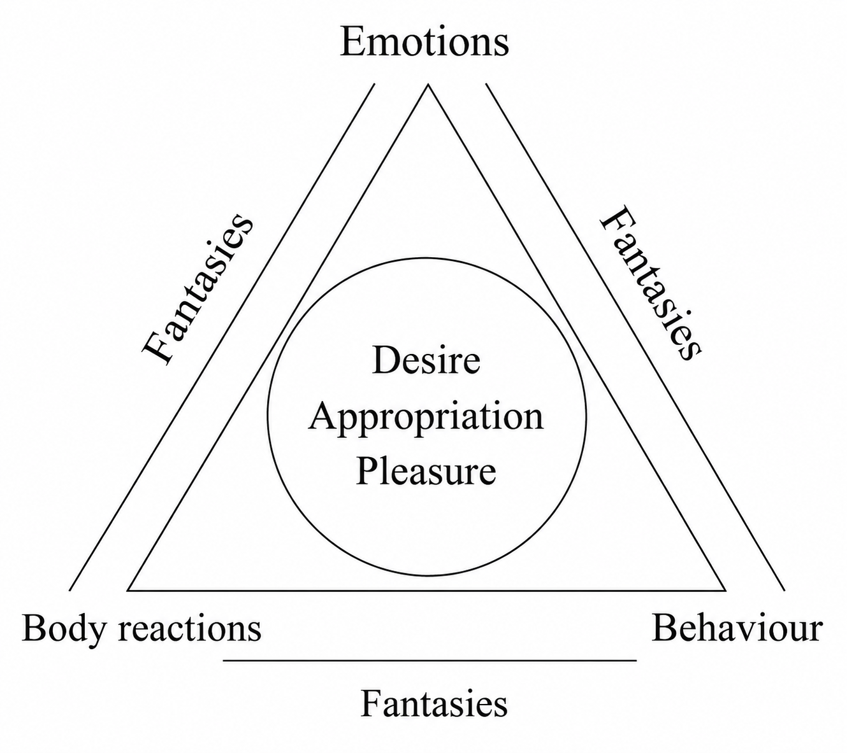
This stage involves studying the client’s fantasies about themselves and their condition. Usually, the client already has some understanding of what is happening to them and speaks about the causes, although without full awareness. At this stage, you also form your own hypotheses regarding the person’s condition and symptomatology.
The basic questions at this stage are:
- What do you think is happening to you right now?
- How do you understand your condition?
- What does wanting this (request) mean to you?
- What does having this (request) mean to you?
- What does using this (the result of resolving the request) mean to you?
As we can see, the questions at this stage are structured according to the components of the personality structure.
At this stage, the request itself may also change depending on which construct prohibitions will become the focus of the work.
Formation of a new request for future sessions in the format “I want…”. Verification of the request for signs of constructiveness. Discussion and conclusions.
Session 3. Working with Desires Through Fantasies
By a preverbal act, we understand a specific situation demonstrated by the client in order to provide themselves with safety and relieve tension, in the same way it was achieved during a particular preverbal period (definition by Pavlenko T. V.). Acts are formed based on attitudes toward the first zones of interaction (for example, breathing immediately after birth) and are expressed through interactions with desire, appropriation, and pleasure in adulthood. Visually, acts can be identified through the client’s attitude toward breathing, analysis of eating behavior, visual contact, etc. (elimination acts, baby-talk behavior in childhood).
Preverbal acts can clearly be traced in a person’s actions in specific situations. They may appear as reactions to stimuli, verbal communication, or stressful states. For example, when frightened, a person may want to sleep or curl up into a ball, replaying a situation in which similar behavior once helped them cope with the same emotion. A person may also constantly tense their body without understanding why, bump into surfaces, or suddenly begin to panic for no apparent reason — all of these situations reflect experiences that once occurred but were never processed.
Preverbal acts can conditionally be divided into three groups:
● Behavioral acts, where behavior itself is the key element in analyzing unconscious material (night binge eating, chronic masturbation, diarrhea in certain circumstances, workaholism, unconsciously harming one’s body);
● Emotional acts, where the key element is the chronic nature of a certain emotion (persistent anxiety states, “joy without reason,” chronic guilt) and the external manifestations prompted by this emotion;
● Bodily acts, where primary importance is given to bodily reactions (night binge eating as an attempt to harm the body, inclination toward damaging procedures, adopting certain postures, freezing reactions).
Each of these types of acts is always accompanied by fantasies about one’s condition, which can additionally be used in therapy even if the fantasy has no connection to reality.
Reenactment of an act is a form of self-protective strategy in situations where it is difficult to cope with stress (and even joy may be experienced as stress) or events that the individual has identified as negative. In addition, an act may function as a “way of life,” meaning it acquires a reflexive character. For example, if a mother fed a child whenever the child became angry, then in adulthood anger may immediately trigger eating behavior. Therapy clients may not even realize that their eating problems are connected to a habit that simply needs to be changed.
Sometimes acts may be reenacted “in reverse” — the phenomenon of the “anti-act.” Usually, this is reflected in phrases such as “I’m not like my parents” or “I have strong moral principles.” In other words, the person does everything contrary to what they actually want or what circumstances require in order to conceal some personally significant meaning. Such acts are usually socially oriented.
For example: “I want to buy the cheaper item” (whether because I simply want it or because I want to save money), “but I will buy the more expensive one” (anti-behavior), “because the salesperson will think I don’t have money” (social orientation). Usually, such behavior has nothing to do with the person’s real situation, yet they repeatedly reenact it based on unconscious experience.
In this example, we are dealing specifically with a behavioral act accompanied by a fantasy that someone will think badly of the person and that such an attitude must be avoided — even at the cost of their own desire and money.
Within the preverbal act lies the so-called “symbol of life,” or what we also call the “permitted theme.” This is the way the client allows themselves to function in the world with a minimal level of tension and anxiety while bypassing all prohibitions. The symbol of life, like the act itself, is formed during the preverbal period and is based on how others related to the core personality constructs.
Another component of the act is the “experience of the first support.” This is the understanding of reality formed during the first days of the person’s life. It is the psychological foundation that helps a person withstand difficult periods and maintain the awareness: “I exist,” “I am alive.” In our case, this concerns DAP (Desire, Appropriation, Pleasure).
The psyche’s support system is formed depending on the first relatively prolonged states experienced by the infant (remembering that the baby does not know they have a long life ahead of them — the first days in the maternity ward are experienced as life itself), for example, three days without the mother immediately after birth. Even if everything afterward was “relatively fine,” this first support remains primary, and within the client’s unconscious it is perceived as the key survival mechanism.
Very often, such a support system is no longer relevant in adulthood, yet for the individual it remains fundamental, and this experience influences the formation of fantasies about their condition.
The experience of the first support is best reflected in attitudes toward the construct of appropriation. If a person has a prohibition against appropriation in conscious adulthood, they will use childish forms that have not yet come under prohibition (putting random things into the mouth — eating behavior disorders, fixation on oral pleasure; appropriating something “bad” as a way to appropriate one’s own “self” in defiance of parents).
When working with behavioral acts, it is important to understand the client’s “pain.”
Among the causes of pain is the violation of the individual’s basic needs for the right to desire, appropriate, and experience pleasure. Trauma may affect all three levels or only one of them. Another important cause of pain is internal conflict, either within one level (for example: “I want it, but I will be punished” — desire level) or between levels (“I may want it” — desire level — “but I see no point in it because I am not allowed to have it” — appropriation level).
Technique: “Fantasy Analysis”
Part 1
- Choose a fantasy that most often accompanies you (or appears within a specific request).
- Describe it according to the Pain Model.
- Formulate a hypothesis about which act may be reenacted here.
Part 2
Scheme for analyzing an act based on one of the hypotheses (continuing pair work).
- Describe the image.
- Is it alive, already breathing, or still in the womb?
- When does this happen to a person?
- When could this happen to a child?
- Read (or listen to) what has been written — what might it resemble?
- Reenactment of the act (described in more detail in Module 5).
Describe how the event should have ended in order for it to feel safe and beneficial for you. Recreate this physically right now, in whatever amount is necessary until it feels sufficient.
Conclusions and discussion.
Sessions 4–6: Working with APPROPRIATION
Session 4–5: Appropriation of One’s Own Body and Space
Exploring the concept of appropriation is central in anxiety work, since anxiety is often connected to the loss of control over the body and situations. These experiences are frequently associated with pain by the individual.
In the “I-Reconstruction” psychotherapy method, “pain” refers to emotional experiences, bodily symptoms, and fantasies perceived by the individual as unpleasant and which find destructive expression in emotional, physical, and behavioral spheres. Based on their attitude toward desire, appropriation, and pleasure, as well as previous experiences of external reactions to them, a person constructs fantasies about what is “good” and what is “bad” in life.
Among the causes of pain is the violation of the individual’s basic needs for the right to desire, appropriate, and experience pleasure. Trauma may occur on all three levels or only on one of them.
Today we will focus specifically on appropriation as a cause of anxiety development.
Technique: “Reality of the Symptom”
Goal: working with the client’s symptom, their real attitude toward it, and their readiness for recovery. The principle of reality is used within this technique.
Materials: A4 paper, pencil or colored pencils.
Instructions
Stage 1. Diagnostic Stage
- Ask the client to draw the following states on one sheet using real, non-human images from nature.
The following states should be depicted (preferably in relation to their construct):
- Me before the appearance of pain;
- Me during the emergence of pain;
- Me in pain;
- Pain passing away;
- Me healthy.
Basic questions for analyzing the drawn images:
• What did you draw? Why?
• What do you know about this image?
• What are its functions?
• What are its possibilities?
• What are its limitations?
• What does all of this mean in the context of the situation you depicted?
Stage 2. Redrawing
What does redrawing mean within the context of this technique?
We may encounter situations (in my therapy practice this occurs in about 90% of cases) where the images representing healing and health are destructive for the client.
In other words, the state of health itself may be subconsciously experienced as threatening due to childhood experiences, or the client may currently be in a life situation where “being healthy” feels morally dangerous.
Our task, through redrawing and analysis of new images, is to develop the client’s readiness for recovery or identify situations that create tension and therefore trigger the symptom.
The instructions for creating the new drawing remain the same as in point №1, but now the client relies on the knowledge previously gained about themselves.
You may also redraw only one separate image and then glue it over the previously prepared drawing. At this stage, it is important to analyze the resulting collage anew and pay attention to changes in the client’s condition.
During the process, there may be many layers of redrawn and glued images. At the end of each consultation, it is important for the client to summarize the work completed.
Session 6. Refusal of Appropriation
Identification and processing of the reasons why a person refuses appropriation, which may manifest as self-sacrifice, asceticism, etc.
Discussion with clients about their fantasies regarding appropriating what they desire in the context of their request.
Practical Component
Technique: “Animal Image”
Goal: analysis of the reality of the client’s request, work with their real desires, fears, possibilities, prohibitions, and the formation of solutions and resources.
Type of Method: Art Therapy
Materials: A4 paper, pen
Instructions:
- After formulating the request together with the client, ask them to draw themselves within this request (in the unresolved problem) in the form of a real animal.
Important! Only the animal should be depicted, without any surrounding conditions or objects. If it does not work, the drawing should be redone until it does. It is normal for the animal to change during this process.
- Analyze the drawing using guiding questions:
• What animal did you draw? Why do you think so?
• Was it easy for you to create the drawing?
• What did you feel while drawing the animal?
• Tell me about this animal. What do you know about it? (The narration should come from a childlike perspective — what the client has known about this animal since childhood.)
• What qualities does this animal have that you like?
• For what qualities could this animal be judged? Why?
• What does this animal have that others do not?
• How do you relate to this animal’s desires? How does it fulfill them?
• How does the animal obtain what it wants? How do you feel about that?
• How does this animal relate to its own pleasure?
• Which behavioral strategies of the animal did you not notice before but now consider important? What do they mean to you?
- Move directly to working with the client’s personality.
• How did your words about the animal become a discovery for you? Why?
• What interesting things did you express?
• Which aspects of the animal were easy to talk about? Which were difficult? What does this mean to you?
• How does each aspect illustrate your life? What does it say about your request?
• What permissions, possibilities, and new behavioral strategies are hidden here?
• How can you identify and use them in life to resolve your request?
- Discussion of new discoveries, possibilities, strategies (preferably written down), and the fears associated with them.
Discussion of these discoveries may continue in the next session, but already within the context of pleasure.
Sessions 7–9: Working with PLEASURE
Session 7. Discovering Pleasure
Integration of the theme of appropriation with the experience of pleasure.
Practical Component. Discussion of the discoveries from the previous session in the context of experiencing pleasure. Participants share what it means for them to experience pleasure and how they fantasize about the pleasure connected with resolving their request.
Session 8. Theory of Pleasure
Theoretical Component
In the “I-Reconstruction” psychotherapy method, pleasure is defined as a feeling of physiological and psychological relaxation associated with fulfilling a desire and appropriating the desired object within the boundaries determined by the individual’s internal motives.
The experience of pleasure accompanies eating, drinking, sexual activity, and breathing. This type of pleasure is easier to understand. However, there are elements of pleasure that cannot be evaluated solely from the perspective of physiology or materiality. For example, pleasure derived from the results of one’s work, interaction with another person, etc.
In addition, there is so-called sadistic pleasure, or pleasure derived from self-destruction, which may be incomprehensible both to the individual and society. However, we may consider it destructive only if the individual who experiences such forms of pleasure perceives them as destructive.
Levels of Pleasure
- Bodily Level
Pleasure at this level is the most intense, vivid, and accessible. It primarily includes sexual pleasure, pleasure related to eating, warmth, and rest (Freud, Winnicott). Behind the pleasures of this level stands desire, which society seeks to control because social systems often perceive desire and pleasure as something destructive while simultaneously striving toward them. Therefore, bodily pleasure (as well as any other form of pleasure) often begins to follow the reality principle while avoiding the pleasure principle (Sigmund Freud).
- Behavioral Level
This aspect of the pleasure principle concerns how a person acts in order to satisfy their needs and prolong pleasure. Therefore, a person’s actions are directed toward achieving these goals. A person will do what they believe contributes to pleasure, although such actions are often destructive.
- Emotional Level
At this level, we may observe a wide variety of emotions arising during pleasure or its absence. However, states such as shame and envy are especially common. These emotions may emerge as defensive reactions toward another person (not necessarily a real one) or society for satisfying personal needs, as well as a means of manipulation aimed at achieving pleasure.
These two states are described in more detail in my book “Shaming the Illness: Working with Shame and Envy in Psychosomatics.” Shame, envy, and the anxiety connected with them are frequent indicators of a prohibition against pleasure.
The prohibition of pleasure arises as a result of traumatic experiences and is usually unconscious. Signs of an unconscious prohibition against pleasure include rigid moral principles (a set of beliefs often mistaken for moral principles) that exclude pleasure as such, while all of the individual’s energy becomes directed toward aggressively enforcing these principles on other people (Fig. 2).
The prohibition of pleasure manifests in the eating sphere (guilt related to food, anorexia, bulimia, compulsive overeating), the sexual sphere, and in the rejection of bodily pleasure in favor of traumatic procedures (for example, injection-based procedures or plastic surgery instead of a relaxing massage). A person may consciously strive for pleasure while simultaneously taking no action toward it because feelings of shame, guilt, or fear arise immediately.
It is also important to note that a person’s reaction to pleasure may be either positive or negative; however, the key factor in the formation of the prohibition is the individual’s own reaction. For example, when a mother praises her child, the child may experience excitement or joy of such intensity that they are unable to tolerate it, become frightened by these feelings, and decide that it is better to avoid them.
However, such reactions usually carry a negative emotional tone and contribute to painful feelings and destructive attitudes toward oneself and the world.

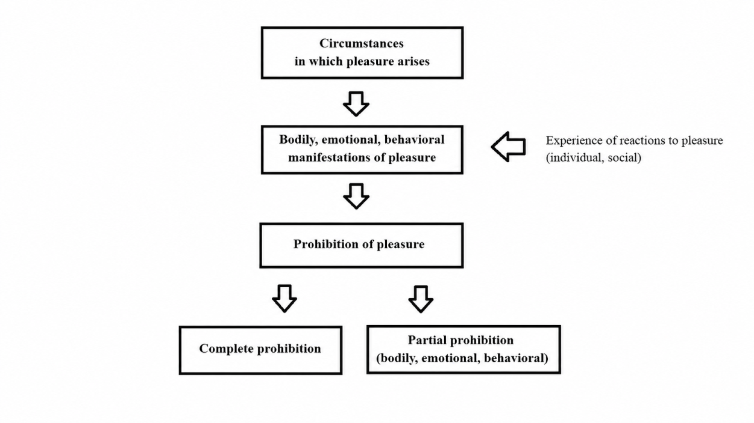
Figure 2. Representation of Trauma within the Pleasure Construct According to the “I-Reconstruction” Psychotherapy Method (Pavlenko T. V.).
Practical Component. Discussion of the group participants’ personal discoveries.
Session 9
Technique: “Image of the Resolved Request”
Type of Technique: Art Therapy
This technique allows not only the demonstration of the client’s real attitude toward their request, desire, fantasies about pleasure and appropriation, but also the exploration of fears and attitudes toward responsibility.
Instructions:
- Ask the client to draw on an A4 sheet a situation in which their request has already been resolved. The drawing may include circumstances and other people besides the client.
- Ask the client to draw their state after the request has been resolved on a smaller sheet in any form convenient for them (preferably A6 format). This may be either an image of the client as a person or any other object. No additional objects or circumstances should be included.
- Ask the client to place the drawing symbolizing their state after the request is resolved onto the drawing symbolizing the situation, in any place they find appropriate.
Questions for Analysis:
- Tell me what you wanted to depict in each drawing.
- Carefully examine the resulting collage of drawings. What have you created as a result?
- What do you feel while looking at the drawing? What feelings had you fantasized about before this? What does this mean to you?
- Tell me what you like about the resulting drawing. What do you dislike? Why?
- In the context of your request, what does it mean to experience such feelings during the process of resolving it? How do you relate to this?
- How does what you have learned about yourself now influence the definition of your request (desire)? Would you like to change it?
- What does this mean in your life?
Session 10: Closure and Summarizing
Today we will integrate the experience you have gained and move closer toward your request. Therefore, after a short sharing session, we will work with the body in a group format.
Preparatory Exercises
- Standing position. Rise onto your toes while placing one hand on the top of your head, then drop onto your heels. Repeat 3–5 times. GROUNDING.
- Stand up and tap your heels against the floor. GROUNDING.
- Standing position. Move around the room by rolling from heel to toe while looking around and naming objects you see. REALITY TESTING.
- Standing position. Place your fingers on both sides of the diaphragm and expand the chest. Complete 5 breathing cycles. CONTAINER EXPANSION.
- Standing position. Place your hands on your ribs. Breathe for 5 cycles. CONTAINER EXPANSION.
- Standing position. Place your hands in the armpit area. Breathe into your hands 5 times. CONTAINER EXPANSION.
- Standing position. Engage the muscles of the pelvis and thighs, raise one hand with the palm facing outward, and say “STOP.” Perform 5 cycles with one hand and 5 with the other. Observe the difference. BOUNDARIES.
- Slowly perform cross-body elbow-to-knee movements (right elbow to left knee, left elbow to right knee). Perform 5 cycles on each side. Remember to breathe. CENTERING.
- Standing position. Find a point with your eyes and fix your gaze on it. Slowly turn your body first in one direction, then the other, without taking your eyes off the point. Return to the starting position. Then, using only your eyes, trace the horizon line in one direction, return to the point, then in the other direction, and return again to the point. Close your eyes and gently press your palms against your eyelids. Open your eyes. REORIENTATION.
- Imagine how your feelings have changed from the beginning of the work until now. Feel the emotions that have visited you throughout the process. Set the intention to learn how to experience joy from your emotions, your body, and your activity in all of their manifestations. Imagine what your life will be like with your request resolved.
- Recreate the situation physically. Imagine yourself within it.
Do what your body wants.
Final analysis of the group work and discussion of the group’s results.

