Impact of soybean meal enzymatic treatment on chicken caecal microbiota and intestinal epithelial cells

Lauriane Plouhinec^{1,4}, Marc Maresca², Julie Saget³, Virginie Neugnot⁴, Estelle Devillard³, Jean-Guy Berrin^{1,*}, Mickael Lafond^{1,*}

¹Aix-Marseille Univ, INRAE, BBF, Biodiversité et Biotechnologie Fongiques, 13009 Marseille, France
²Aix Marseille Univ, CNRS, Centrale Marseille, iSM2, 13013 Marseille, France
³Adisseo France S.A.S., European R&I Centre ELISE, 69190 Saint-Fons, France
⁴Adisseo France S.A.S, CINAbio, INSA Toulouse, 31400 Toulouse, France

*corresponding authors:
Jean-Guy Berrin (jean-guy.berrin@inrae.fr)
Mickael Lafond (michael.lafond@univ-amu.fr)

Supplementary information
SUPPLEMENTARY TABLE S1. Experimental conditions used for in vitro intestinal cell lines assays. Quantities of SBM are expressed as mg of dry matter in the reaction. Quantities of Rovabio™ Advance and secretomes are expressed as mg of total proteins in the reaction. (*) This condition corresponds to the negative control containing the reaction buffer only (i.e., 50 mM sodium acetate pH 5.2). SBM: soybean meal; At: A. terreus; Tv: T. versatilis.
Condition | SBM | Rovabio™ Advance | Secretome At | Secretome Tv
Control* | - | - | - | -
Rovabio | - | 0.9 mg | - | -
Secretome At | - | - | 0.3 mg | -
Secretome Tv | - | - | - | 0.3 mg
Rovabio + Secretome At | - | 0.9 mg | 0.3 mg | -
Rovabio + Secretome Tv | - | 0.9 mg | - | 0.3 mg
SBM | 75 mg | - | - | -
SBM + Rovabio | 75 mg | 0.9 mg | - | -
SBM + Secretome At | 75 mg | - | 0.3 mg | -
SBM + Secretome Tv | 75 mg | - | - | 0.3 mg
SBM + Rovabio + Secretome At | 75 mg | 0.9 mg | 0.3 mg | -
SBM + Rovabio + Secretome Tv | 75 mg | 0.9 mg | - | 0.3 mg

SUPPLEMENTARY TABLE S2. Experimental conditions used for in vitro caecal fermentations. Quantities of SBM and wheat are expressed as mg of dry matter in the reaction. Quantities of Rovabio™ Advance and secretomes are expressed as mg of total proteins in the reaction. (*) This condition corresponds to the negative control containing the reaction buffer only (i.e., 50 mM sodium acetate pH 5.2). SBM: soybean meal; At: A. terreus; Tv: T. versatilis.
Condition | SBM | Wheat | Rovabio™ Advance | Secretome At | Secretome Tv
Control* | - | - | - | - | -
Rovabio | - | - | 0.9 mg | - | -
Secretome At | - | - | - | 0.3 mg | -
Secretome Tv | - | - | - | - | 0.3 mg
Rovabio + Secretome At | - | - | 0.9 mg | 0.3 mg | -
Rovabio + Secretome Tv | - | - | 0.9 mg | - | 0.3 mg
SBM | 75 mg | - | - | - | -
Wheat | - | 75 mg | - | - | -
SBM + Rovabio | 75 mg | - | 0.9 mg | - | -
SBM + Secretome At | 75 mg | - | - | 0.3 mg | -
SBM + Secretome Tv | 75 mg | - | - | - | 0.3 mg
SBM + Rovabio + Secretome At | 75 mg | - | 0.9 mg | 0.3 mg | -
SBM + Rovabio + Secretome Tv | 75 mg | - | 0.9 mg | - | 0.3 mg

SUPPLEMENTARY TABLE S3. SCFA concentrations in the caecal fermentation supernatants. Quantification was done by GC-MS after 24h fermentation, as described in the Methods section. Means and standard deviations were calculated from biological replicates (n = 4). Statistical analyses were performed using one-way ANOVA and Tukey post-hoc. Groups indicated by different letters are statistically different (p < 0.05). (*) This condition corresponds to the negative control containing the reaction buffer only (i.e., 50 mM sodium acetate pH 5.2). SBM: soybean meal; At: A. terreus; Tv: T. versatilis.
 | Acetate (mg/mL) |  | Propionate (mg/mL) |  |  | Butyrate (mg/mL)
Sample | Mean | SD |  | Mean | SD |  | Mean | SD
Control* | 1.41 ª | 0.10 |  | 0.17 ª | 0.06 |  | 0.26 ª | 0.03
Rovabio | 1.49 ª | 0.10 |  | 0.19 ª | 0.06 |  | 0.27 ª | 0.03
Secretome At | 1.51 ª | 0.11 |  | 0.18 ª | 0.07 |  | 0.28 ª | 0.03
Secretome Tv | 1.43 ª | 0.16 |  | 0.17 ª | 0.07 |  | 0.26 ª | 0.04
Rovabio + Secretome At | 1.61 ª | 0.02 |  | 0.20 ª | 0.07 |  | 0.29 ª | 0.05
Rovabio + Secretome Tv | 1.60 ª | 0.09 |  | 0.20 ª | 0.07 |  | 0.28 ª | 0.05
Wheat | 3.46 ^{c} | 0.26 |  | 0.97 ^{d} | 0.27 |  | 0.73 ^{c} | 0.11
Wheat + Rovabio | 3.65 ^{c} | 0.28 |  | 1.55 ^{e} | 0.26 |  | 1.03 ^{d} | 0.25
SBM | 2.67 ^{b} | 0.14 |  | 0.39 ^{ab} | 0.11 |  | 0.46 ^{ab} | 0.03
SBM + Rovabio | 3.24 ^{c} | 0.19 |  | 0.61 ^{bc} | 0.11 |  | 0.57 ^{bc} | 0.05
SBM + Secretome At | 3.35 ^{c} | 0.16 |  | 0.66 ^{bcd} | 0.11 |  | 0.62 ^{bc} | 0.03
SBM + Secretome Tv | 3.32 ^{c} | 0.30 |  | 0.64 ^{bc} | 0.07 |  | 0.59 ^{bc} | 0.06
SBM + Rovabio + Secretome At | 3.52 ^{c} | 0.21 |  | 0.73 ^{cd} | 0.09 |  | 0.64 ^{bc} | 0.05
SBM + Rovabio + Secretome Tv | 3.47 ^{c} | 0.15 |  | 0.73 ^{cd} | 0.13 |  | 0.62 ^{bc} | 0.02

SUPPLEMENTARY TABLE S4. Taxonomic classification statistics. This table contains data provided by BaseClear; the service provider responsible for performing the metabarcoding analysis of the chicken caecal contents. For each sample, the table displays the number of classified and unclassified reads, alongside alpha diversity indices such as richness (Chao) and diversity (Simpson and Shannon) index (Xia and Sun, 2023). All values represent means calculated from biological replicates (n = 4). (*) This condition corresponds to the negative control containing the reaction buffer only (i.e., 50 mM sodium acetate pH 5.2). SBM: soybean meal; At: A. terreus; Tv: T. versatilis.
Sample | Classified reads | Unclassified reads | Chao index | Simpson index | Shannon index
Control* | 11732 | 27 | 229.5 | 0.0479 | 5.51
Rovabio | 11745 | 24 | 242.8 | 0.0492 | 5.49
Secretome At | 11712 | 25 | 235.8 | 0.0482 | 5.51
Secretome Tv | 11624 | 32 | 235.1 | 0.0488 | 5.49
Rovabio + Secretome At | 11641 | 21 | 238.3 | 0.0464 | 5.55
Rovabio + Secretome Tv | 11767 | 28 | 238.0 | 0.0467 | 5.54
SBM | 11679 | 25 | 231.4 | 0.0512 | 5.34
Wheat | 11568 | 22 | 202.2 | 0.0666 | 4.96
SBM + Rovabio | 11750 | 22 | 222.0 | 0.0526 | 5.24
SBM + Secretome At | 11691 | 20 | 225.9 | 0.0544 | 5.24
SBM + Secretome Tv | 11619 | 20 | 220.5 | 0.0524 | 5.26
SBM + Rovabio + Secretome At | 11598 | 24 | 218.8 | 0.0528 | 5.25
SBM + Rovabio + Secretome Tv | 11633 | 23 | 223.5 | 0.0521 | 5.26

SUPPLEMENTARY TABLE S5. Linear discriminant analysis effect size (LEfSe) comparison of differentially abundant bacterial families detected in the samples. This table presents the relative abundance of the top 17 bacterial families detected in the control and in the microbiota exposed to SBM or wheat. Means and standard deviations were calculated from biological replicates (n = 4). (*) This condition corresponds to the negative control containing the reaction buffer only (i.e., 50 mM sodium acetate pH 5.2). SBM: soybean meal.
Sample | Control* |  | SBM |  | Wheat |  | LDA score | p-value
Family | Mean | SD | Mean | SD | Mean | SD | LDA score | p-value
Lachnospiraceae | 34.06% | 1.53% | 33.86% | 1.46% | 39.15% | 3.31% | 4.42 | 0.059
Ruminococcaceae | 18.14% | 0.95% | 16.13% | 0.63% | 12.34% | 1.25% | 4.47 | 0.007
Peptostreptococcaceae | 13.34% | 0.55% | 9.95% | 0.97% | 7.42% | 1.31% | 4.48 | 0.007
Lactobacillaceae | 11.30% | 0.58% | 17.09% | 1.30% | 24.33% | 2.99% | 4.82 | 0.007
Enterobacteriaceae | 6.85% | 1.01% | 8.05% | 1.11% | 4.34% | 0.58% | 4.27 | 0.012
Erysipelotrichaceae | 4.17% | 0.42% | 3.04% | 0.22% | 2.98% | 0.40% | 3.79 | 0.023
Eubacteriaceae | 2.58% | 0.27% | 2.11% | 0.12% | 1.56% | 0.13% | 3.72 | 0.009
unclassified Clostridiales | 2.57% | 0.21% | 2.01% | 0.24% | 1.45% | 0.43% | 3.76 | 0.017
Clostridiaceae | 1.84% | 0.14% | 1.68% | 0.09% | 1.48% | 0.18% | 3.28 | 0.063
Gracilibacteraceae | 1.12% | 0.15% | 0.67% | 0.08% | 0.55% | 0.08% | 3.52 | 0.012
Enterococcaceae | 0.52% | 0.11% | 2.13% | 0.67% | 2.44% | 1.07% | 3.98 | 0.023
Christensenellaceae | 0.47% | 0.04% | 0.41% | 0.08% | 0.27% | 0.03% | 3.02 | 0.018
Defluviitaleaceae | 0.41% | 0.11% | 0.38% | 0.03% | 0.25% | 0.03% | 2.92 | 0.024
Eggerthellaceae | 0.38% | 0.05% | 0.33% | 0.03% | 0.23% | 0.08% | 2.89 | 0.077
Oscillospiraceae | 0.29% | 0.10% | 0.61% | 0.25% | 0.16% | 0.09% | 3.36 | 0.017
Clostridiales Family XIII  Incertae Sedis | 0.25% | 0.09% | 0.28% | 0.01% | 0.15% | 0.04% | 2.81 | 0.058
Paenibacillaceae | 0.19% | 0.03% | 0.15% | 0.04% | 0.02% | 0.01% | 2.93 | 0.015

SUPPLEMENTARY TABLE S6. Linear discriminant analysis effect size (LEfSe) comparison of differentially abundant bacterial families detected in the samples after treatment with Rovabio™ Advance. This table presents the relative abundance of the top 17 bacterial families detected in the microbiota exposed to SBM or wheat, with and without treatment with Rovabio™ Advance. Means and standard deviations were calculated from biological replicates (n = 4). SBM: soybean meal.
Sample | SBM |  | SBM + Rovabio |  | Wheat |  | Wheat + Rovabio |  | LDA score | p-values
Family | Mean | SD | Mean | SD | Mean | SD | Mean | SD | LDA score | p-values
Lachnospiraceae | 33.85% | 1.46% | 33.20% | 1.94% | 39.15% | 3.31% | 34.65% | 0.74% | 4.47 | 0.072
Ruminococcaceae | 16.13% | 0.63% | 14.74% | 1.82% | 12.34% | 1.25% | 10.71% | 1.37% | 4.44 | 0.009
Peptostreptococcaceae | 9.95% | 0.97% | 8.97% | 0.91% | 7.42% | 1.30% | 7.20% | 1.07% | 4.15 | 0.020
Lactobacillaceae | 17.08% | 1.30% | 20.20% | 1.58% | 24.33% | 2.99% | 29.01% | 2.51% | 4.78 | 0.004
Enterobacteriaceae | 8.05% | 1.11% | 7.78% | 0.82% | 4.34% | 0.58% | 3.54% | 0.21% | 4.36 | 0.006
Erysipelotrichaceae | 3.04% | 0.22% | 2.92% | 0.13% | 2.98% | 0.40% | 2.56% | 0.42% | 3.39 | 0.142
Eubacteriaceae | 2.11% | 0.12% | 2.15% | 0.37% | 1.56% | 0.13% | 1.24% | 0.32% | 3.67 | 0.010
unclassified Clostridiales | 2.01% | 0.24% | 1.73% | 0.32% | 1.45% | 0.43% | 1.28% | 0.30% | 3.57 | 0.074
Clostridiaceae | 1.68% | 0.09% | 1.62% | 0.30% | 1.48% | 0.18% | 1.54% | 0.14% | 3.02 | 0.442
Gracilibacteraceae | 0.67% | 0.08% | 0.60% | 0.11% | 0.55% | 0.08% | 0.42% | 0.05% | 3.10 | 0.023
Enterococcaceae | 2.13% | 0.67% | 2.97% | 0.99% | 2.44% | 1.07% | 5.99% | 1.52% | 4.29 | 0.017
Christensenellaceae | 0.41% | 0.08% | 0.35% | 0.05% | 0.27% | 0.03% | 0.27% | 0.07% | 2.88 | 0.022
Defluviitaleaceae | 0.38% | 0.03% | 0.44% | 0.10% | 0.25% | 0.03% | 0.24% | 0.02% | 3.00 | 0.009
Eggerthellaceae | 0.33% | 0.03% | 0.34% | 0.15% | 0.22% | 0.08% | 0.24% | 0.08% | 2.78 | 0.146
Oscillospiraceae | 0.61% | 0.25% | 0.55% | 0.24% | 0.16% | 0.09% | 0.11% | 0.02% | 3.40 | 0.010
Clostridiales Family XIII  Incertae Sedis | 0.28% | 0.01% | 0.22% | 0.06% | 0.15% | 0.04% | 0.14% | 0.05% | 2.86 | 0.018
Corynebacteriaceae | 0.17% | 0.03% | 0.15% | 0.02% | 0.13% | 0.05% | 0.10% | 0.01% | 2.54 | 0.065

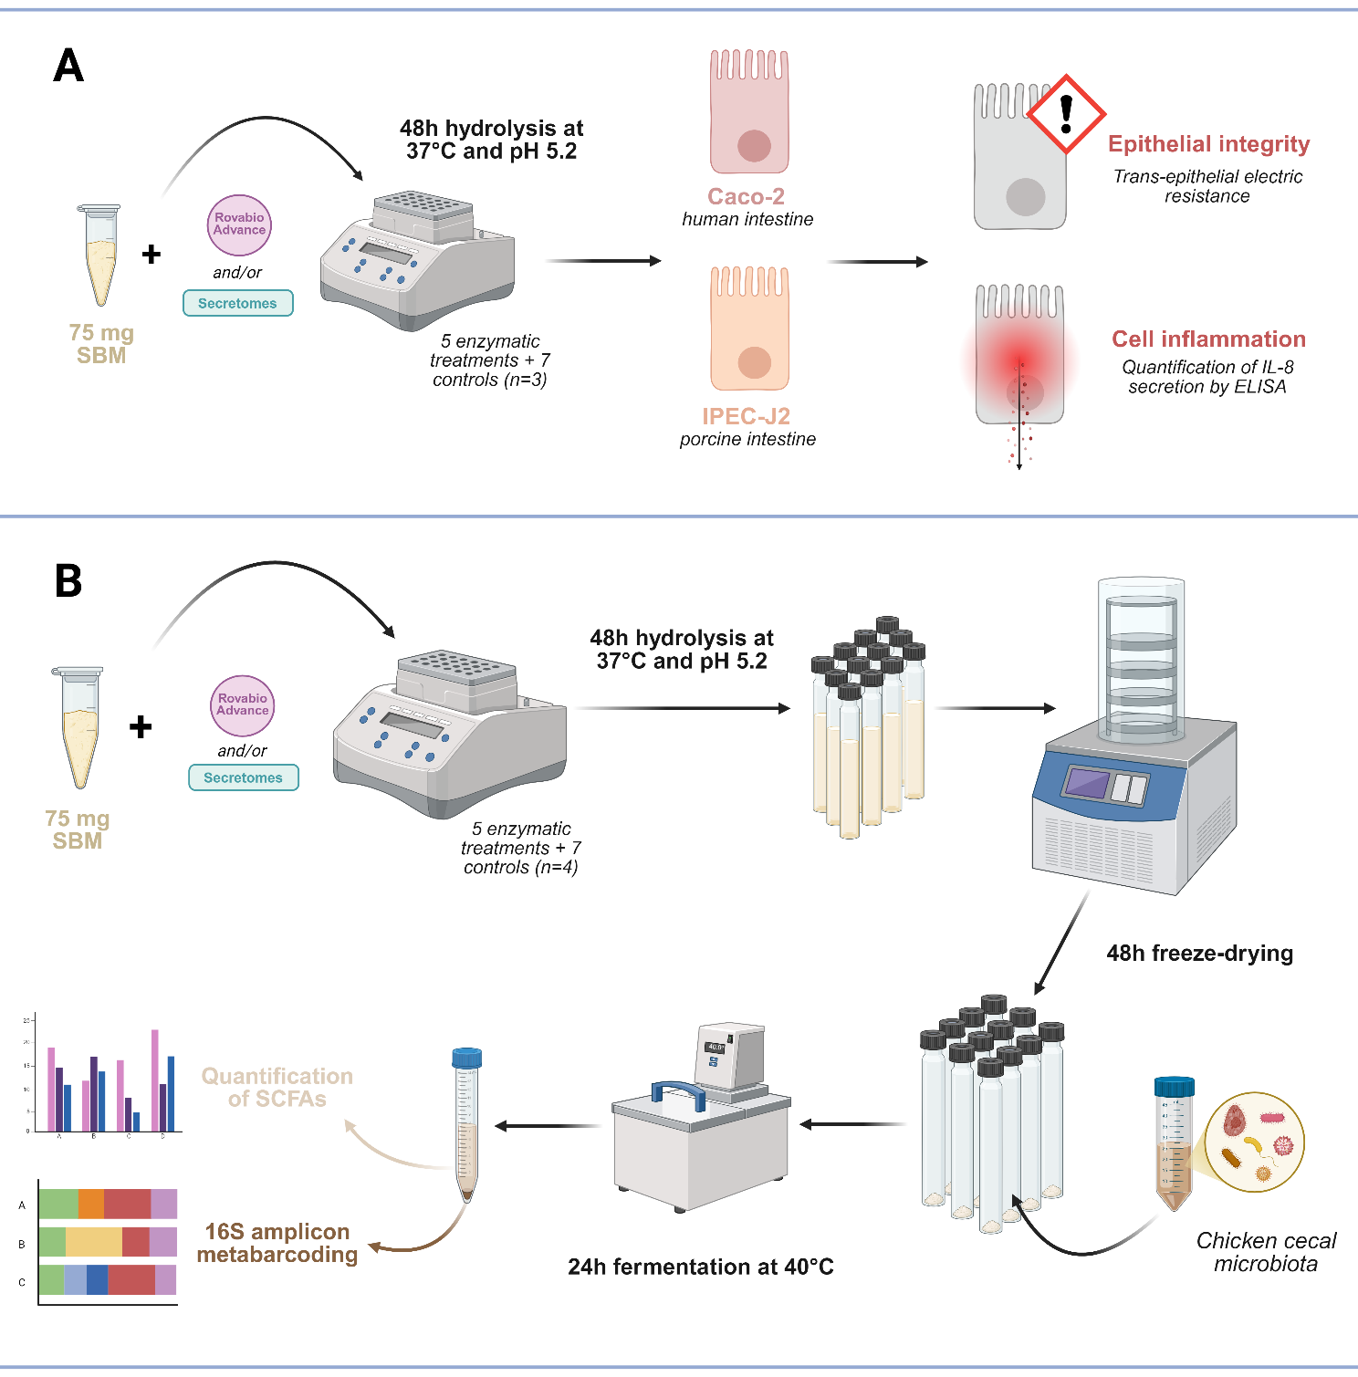
SUPPLEMENTARY FIGURE S1. Overview of the experimental design for the in vitro evaluation of SBM on intestinal health. This figure was designed using BioRender software app.biorender.com. SBM: soybean meal; SCFAs: short-chain fatty acids.

SUPPLEMENTARY FIGURE S2. Effect of enzymatic cocktails on in vitro epithelial integrity and cytokine production. (A,B) Trans-epithelial electric resistance after 12h exposure on (A) Caco-2 model and (B) IPEC-J2 model. (C,D) IL-8 secretion after 12h exposure on (C) Caco-2 model and (D) IPEC-J2 model. Values are presented as means ± SD (biological replicates, n = 3). “Untreated” corresponds to the reference control (i.e., cells in culture media). Samples were tested at different dilutions in the culture media (from 1:80 to 1:10), to assess the dose effect. Statistical analyses were performed using two-way ANOVA and Tukey post-hoc. Groups indicated by different letters are statistically different (p-value < 0.05).

SUPPLEMENTARY FIGURE S3. Monitoring of in vitro caecal fermentations. (A) Pressure measurement (mbar) at 2, 4, 6 and 24h of fermentation. (B) pH of the fermentation supernatants after 24h. Values are presented as means ± SD (biological replicates, n = 4). Statistical analyses were performed using one-way ANOVA and Tukey post-hoc. Groups indicated by different letters are statistically different (p < 0.05). (*) This condition corresponds to the negative control containing the reaction buffer only (i.e., 50 mM sodium acetate pH 5.2). SBM: soybean meal; At: A. terreus; Tv: T. versatilis.

References
Xia, Y., Sun, J., 2023. Alpha Diversity, in: Xia, Y., Sun, J. (Eds.), Bioinformatic and Statistical Analysis of Microbiome Data: From Raw Sequences to Advanced Modeling with QIIME 2 and R. Springer International Publishing, Cham, pp. 289–333. https://doi.org/10.1007/978-3-031-21391-5_9

