Supplemental Figures:
Figure S1. Annotation of different cell types in AOSD patients and healthy controls. (A) TSNE presentation of different clusters, disease group, and cell populations. (D-E) nGenes, nUMIs, percent of mitochondial UMIs and UMIs per genes in each celltypes.

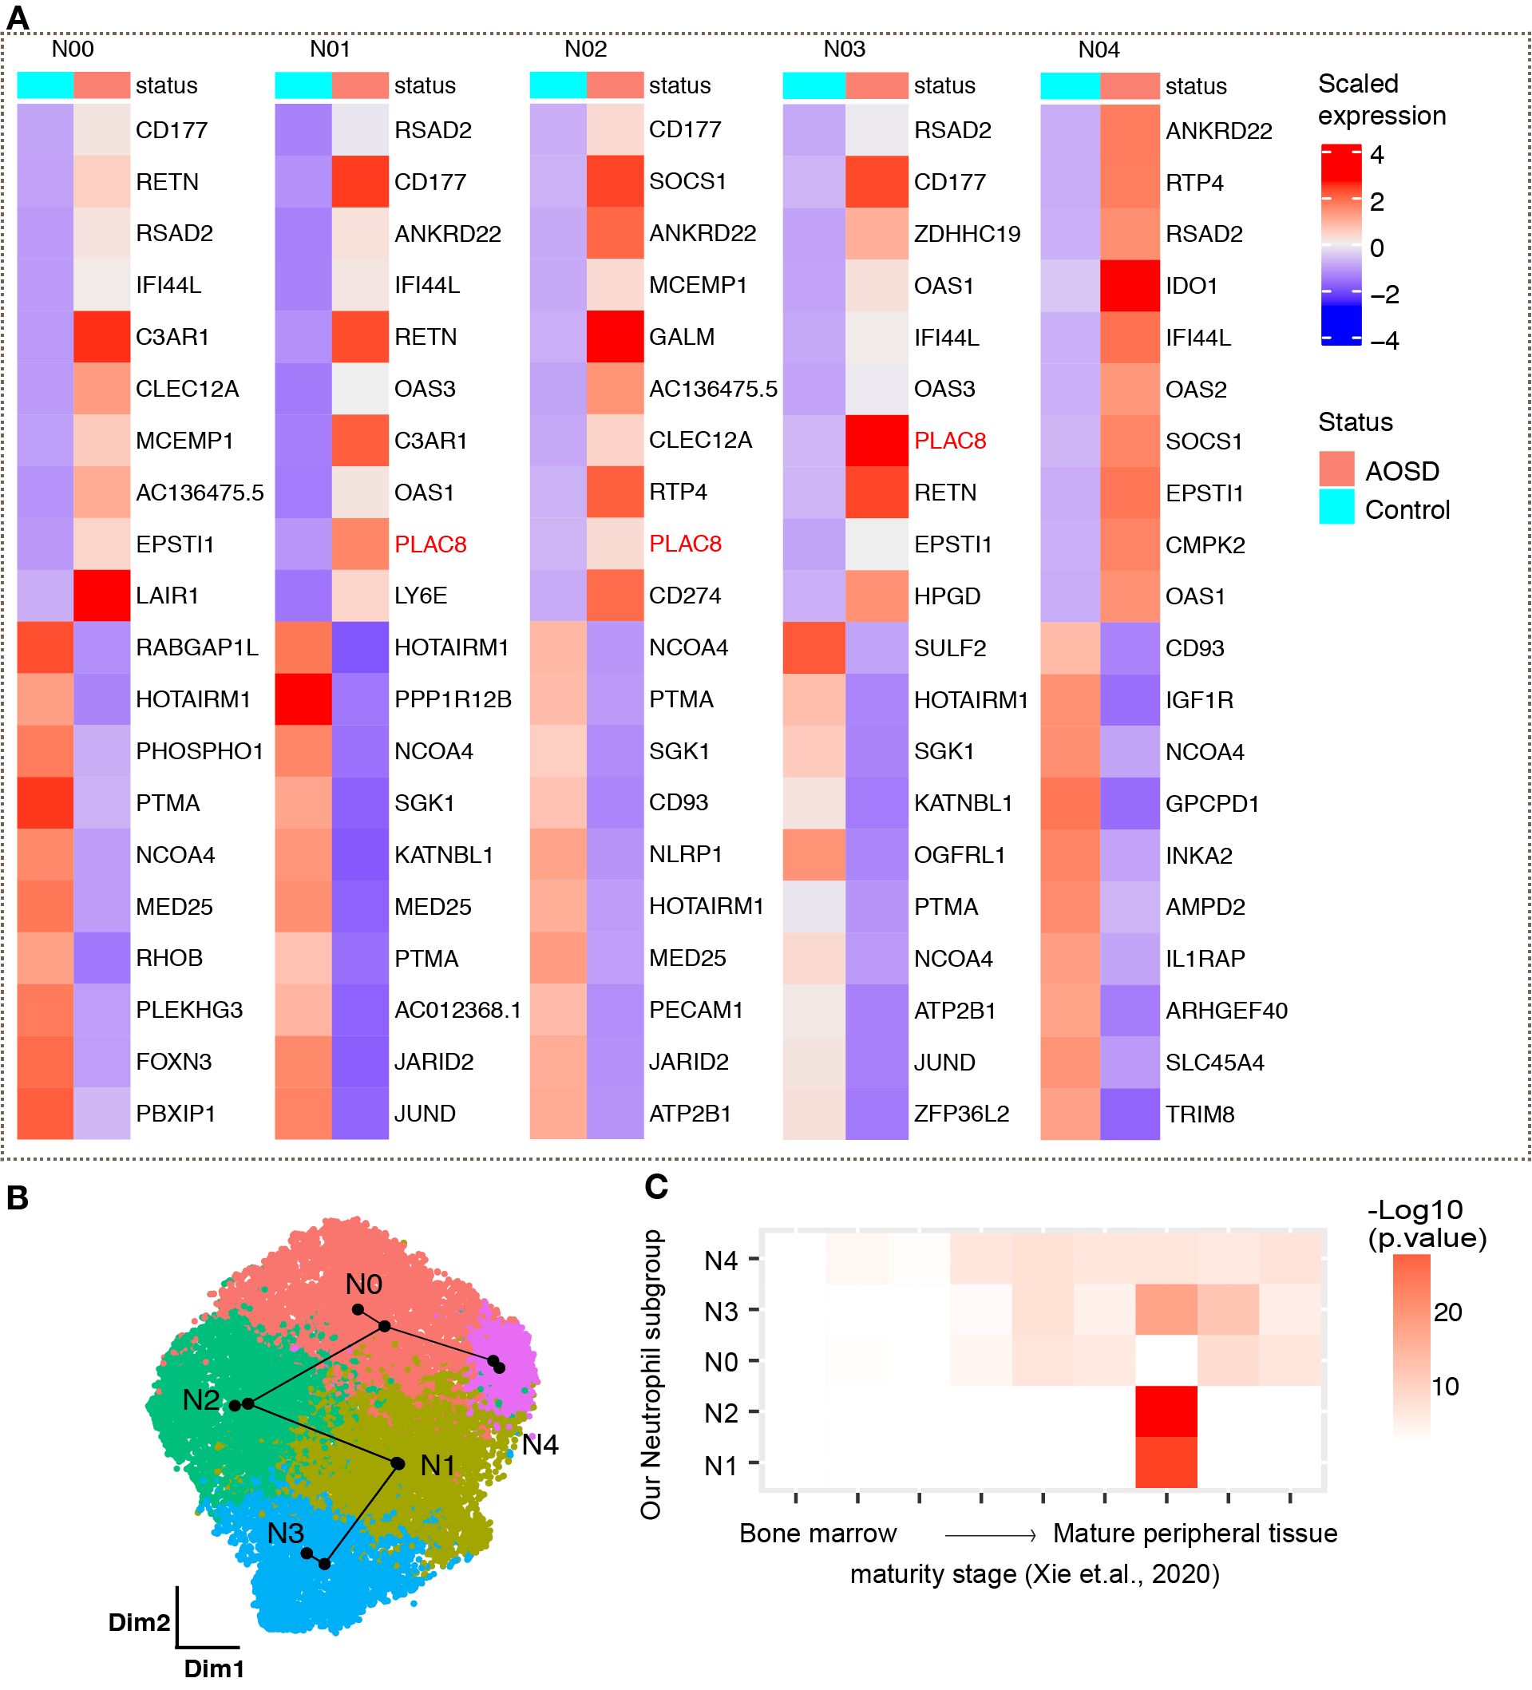
Figure S2. Annotation and differential expression between AOSD patients and healthy controls in the neutrophil subgroup. (A) Top 10 differentially expressed genes (DEGs) in neutrophil clusters. Red characters denote the AOSD related genes identified in previous studies. (B) Trajectory inference analysis demonstrating the heterogeneity of neutrophil clusters (via Slingshot, using healthy cells as the root). (C) Maturation heterogeneity in our neutrophil subgroup compared to the public neutrophil maturation dataset (Xie et al., 2020) (Fisher’s exact test, one-sided, p<0.05, OR>1).

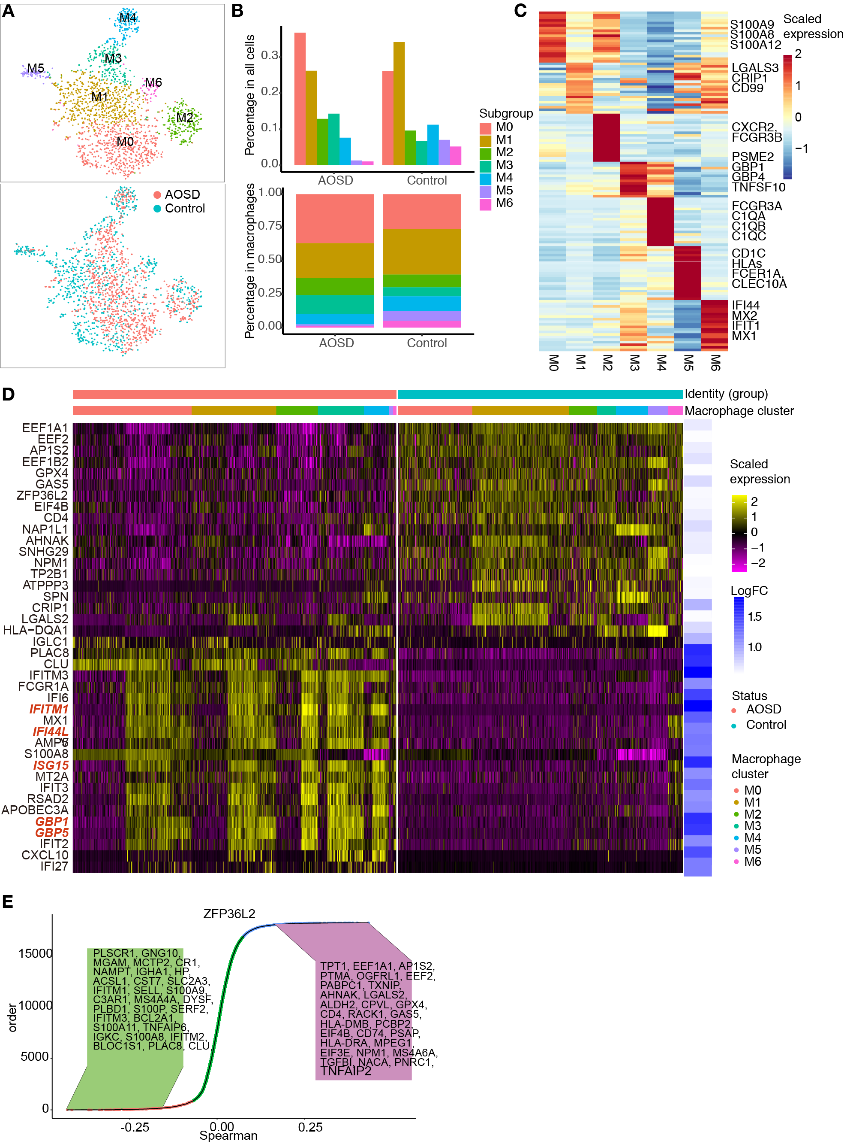
Figure S3. Heterogeneity of macrophages in AOSD. (A) TSNE presentation of macrophage subgroups M0-M6 and TSNE presentation of AOSD patient and control macrophages. (B) Cell percentage of the macrophage subgroups in control and AOSD patient samples in all cells and in macrophages. (C) Signature genes in each macrophage subgroups. (D) DEGs between sepsis patients and healthy controls in macrophage. (E) Spearman correlation between expressions of ZFP36L2 or RGS2 and other genes in Macrophage subsets. Genes are ranked by their increasing correlation coefﬁcient (Spearman), and top 30 genes are labeled. Genes with a Q-value < 0.05 are shown in red or blue points.

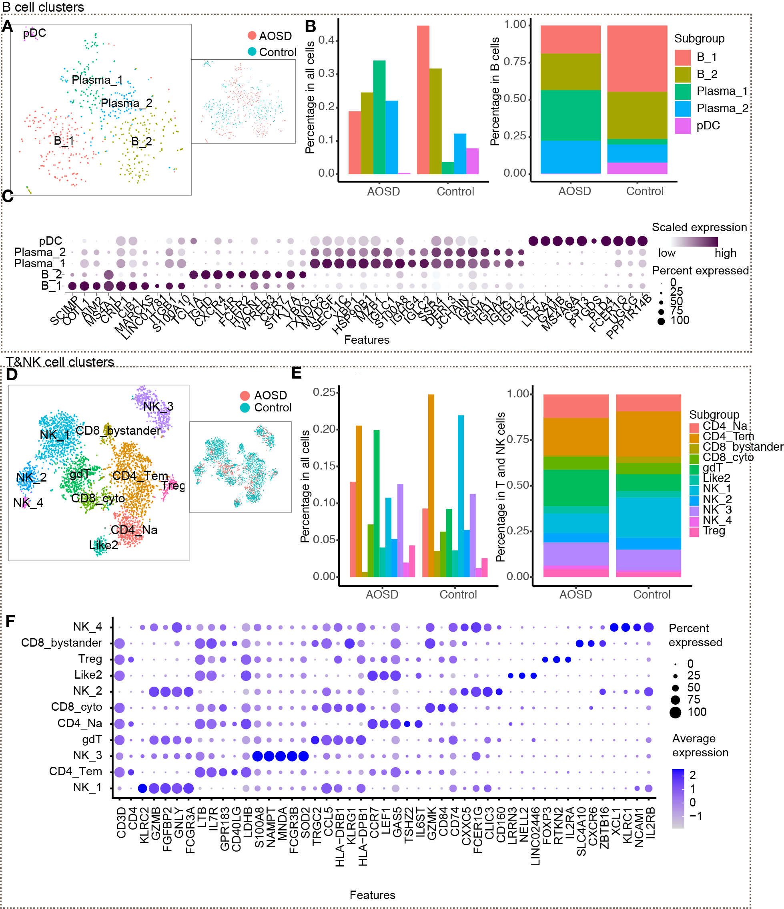
Figure S4. Heterogeneity of B cells, T and NK cells in AOSD. (A) TSNE presentation of B cells subgroups and TSNE presentation of AOSD patient and control B cells. (B) Cell percentage of the B cells subgroups in control and AOSD patient samples in all cells and in B cells. (C) Signature genes in each B cells subgroups. (D) TSNE presentation of T and NK cells subgroups and TSNE presentation of AOSD patient and control T and NK cells. (E) Cell percentage of the T and NK cells subgroups in control and AOSD patient samples in all cells and in T and NK cells. (F) Signature genes in each T and NK cells subgroups.

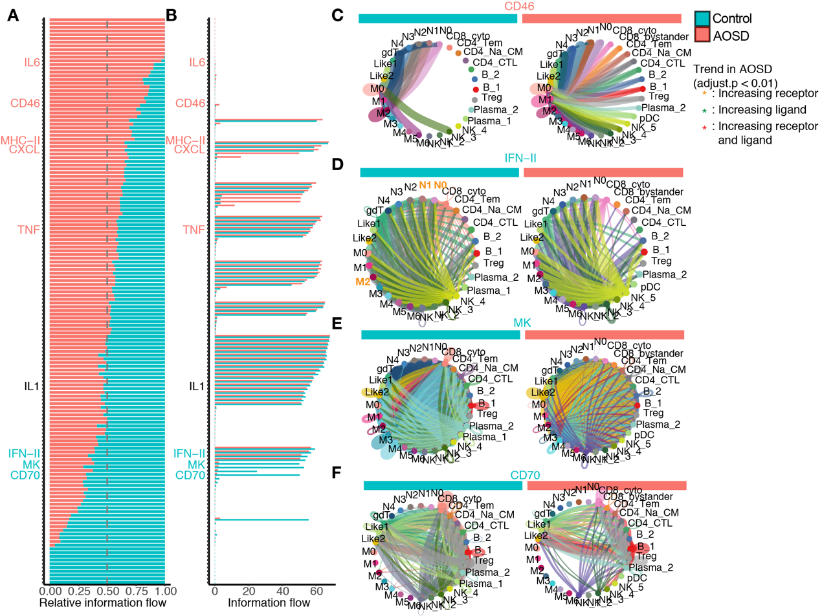
Figure S5. Cell interaction reveals changes in signaling pathway in AOSD. (A-B) Relative information flow of pathways (A) and information flow of pathways (B). Blue/red bar denotes AOSD/control group. (C-F) CD46, IFN-II, MK, CD70 signaling pathway change in AOSD and control, order by information flow strength. The purple bar denotes patient cell signaling importance. In IFN-II pathway, orange characters denote increased cell signal importance in receptor in AOSD, green characters denote increased cell signal importance in ligand in AOSD, and red characters denote increased cell signal importance in both receptor and ligand in AOSD.

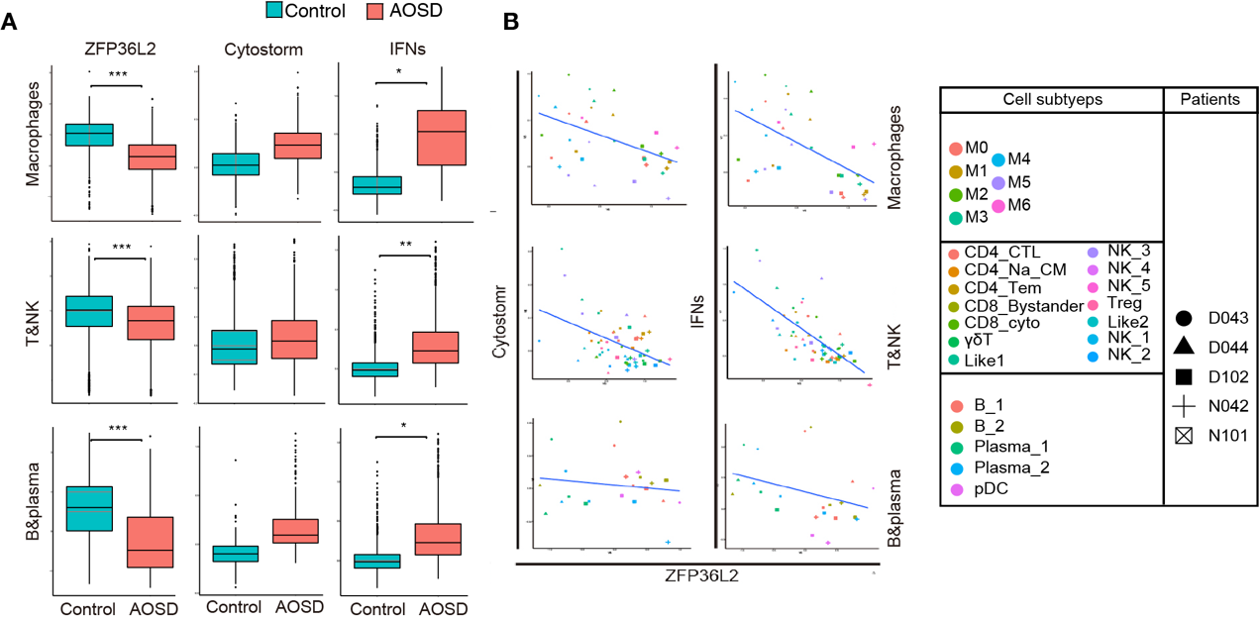
Figure S6. The scores of ZFP36L2, cytostorm and IFN pathways in macrophages, T and Nk cells, and B cells. (A) Boxplots comparing the scores of ZFP36L2, cytostorm and IFN pathways in macrophages, T and Nk cells, and B cells in the control and AOSD groups. P values were calculated using the Mann-Whitney U test. ****, p < 0.0001. (B) Scatterplots displaying the scores of cytostorm, IFNs pathways in macrophages, T and Nk cells, and B cells relative to ZFP36L2. Cell subtypes are represented by different colors. Subjects are denoted by different shapes. Cell subtypes are represented by different colors. Subjects are denoted by different shapes.

Supplementary tables:
Table S1. Clinical features for AOSD patients and healthy volunteers.
The demographic and clinical characteristics of these patients are listed in online supplemental table 1. The main symptoms of the whole body are fever, typical rash, arthritis, sore throat, lymphadenopathy and splenomegaly. All three patients had very high levels of ferritin, C-reactive protein (CRP), and lactate dehydrogenase (LDH) along with leukocytosis and elevated erythrocyte sedimentation rate (ESR)
 | Patients | HC
Gender | Female | Female
Age | 45-55y | 45-55y
Fever (Tmax,°C) | Yes (100%) | No
Rash | Yes(100%) | No
Arthritis | Yes(100%) | No
Lymphadenopathy | Yes(100%) | No
Splenomegaly | Yes(100%) | No
Hepatomegaly | Yes(33%) | No
Sore throat | Yes(33%) | No
WBC (x10^9/L ) | High(16.2±5.8) | Normal (5.1±0.8)
Neutrophils (%) | High (82.1±3.6) | Normal (64±2.8)
Hb (g/dl) | Low (99±5.7) | Normal (128±9.9)
ALT/AST (IU/L) | Elevated | Normal
LDH (IU/L ) | High (392±209) | Normal (111±21)
Ferritin (ng/mL) | High (2775±1881) | Normal (88±50)
ESR (mm/h) | High (80±4) | Normal (5.5±0.7)
CRP (mg/l) | High (96±75) | Normal (1.5±0.7)
RF | Negative | Negative
ANA | Negative | Negative
T -spot | Negative | Negative
EB V IgM | Negative | Negative
CM V IgM | Negative | Negative
PET-CT | NM | NA
Bone marrow biopsy | NM | NA
Skin rash biopsy | NM | NA
WBC: white blood cell, Hb: Hemoglobin，ALT: Alanine aminotransferase，
AST: Aspartate aminotransferase, LDH: Lactate dehydrogenase, ESR: erythrocyte sedimentation rate, CRP; C reactive protein, RF: rheumatoid factor, ANA: antinuclear antibody, EBV: Epstein-Barr virus, CMV: Cytomegalovirus, PET-CT: positron emission tomography with computerized tomography, NM: Non-malignancy
Table S2. Analysis characteristics of scRNA-seq samples involved in this study.
 | Patients | Controls
Sample | Blood | Blood
Total cells | 79,920 | 14,253
Range | 4,230-15,062 | 3,125-11,128

