Supporting Information for Scientific Reports
A Part Per Trillion Isotope Ratio Analysis of ⁹⁰Sr/⁸⁸Sr using Energy-Filtered Thermal ionization mass spectrometry
Shigeyuki Wakaki^{1†}, Jo Aoki^{2†}, Ryoya Shimode², Katsuhiko Suzuki^{3†}, Takashi Miyazaki^{4†}, Jenny Roberts⁵, Hauke Vollstaedt⁵, Satoshi Sasaki⁶ and Yoshitaka Takagai^{2,7†*}
1 Kochi Institute for Core Sample Research, Japan Agency for Marine-Earth Science and Technology (JAMSTEC), 200 Monobe Otsu, Nankoku, Kochi 783-8502, JAPAN
2 Faculty of Symbiotic Systems Science, Cluster of Science and Technology, Fukushima University, 1 Kanayagawa, Fukushima 960-1296, Japan
3 Submarine Resources Research Center, JAMSTEC, 2-15 Natushima, Yokosuka, Kanagawa 237-0061, Japan
4 Volcanoes and Earth’s Interior Research Center, JAMSTEC, 2-15 Natushima, Yokosuka, Kana-gawa 237-0061, Japan
5 Thermo Fisher Scientific Bremen GmbH, Hanna-Kunath-Str. 11, Bremen 28199, Germany
6 Thermo Fisher Scientific K.K, 4-2-8 Shibaura, Minato-ku, Tokyo 208-0023, Japan
7 Institute of Environmental Radioactivity, Fukushima University, 1 Kanayagawa, Fukushima, 960-1296 Japan.
*To whom correspondence should be addressed: E-mail: s015@ipc.fukushima-u.ac.jp
† These authors contributed equally to this work

Table of Contents
Section Page
- Mass spectrum of ⁸⁸Sr and the effect of RPQ lenses (Figure S1) S2
- Mass spectrum in the vicinity of m/z = 90 (Figure S2) S3
- Transition of Noise signal during Sr isotope ratio measurement (Figure S3) S4
- Measured ⁹⁰Sr/⁸⁸Sr ratios of NIST SRM987 (Figure S4) S5
- ⁹⁰Sr activity parameters of the environmental samples (Table S1) S6
- ⁹⁰Sr/⁸⁸Sr ratios of the environmental samples (Table S2) S7
- Measured ⁹⁰Sr/⁸⁸Sr ratios of the environmental samples (Figure S5) S8
- Detector configuration of TIMS measurements (Table S3) S9

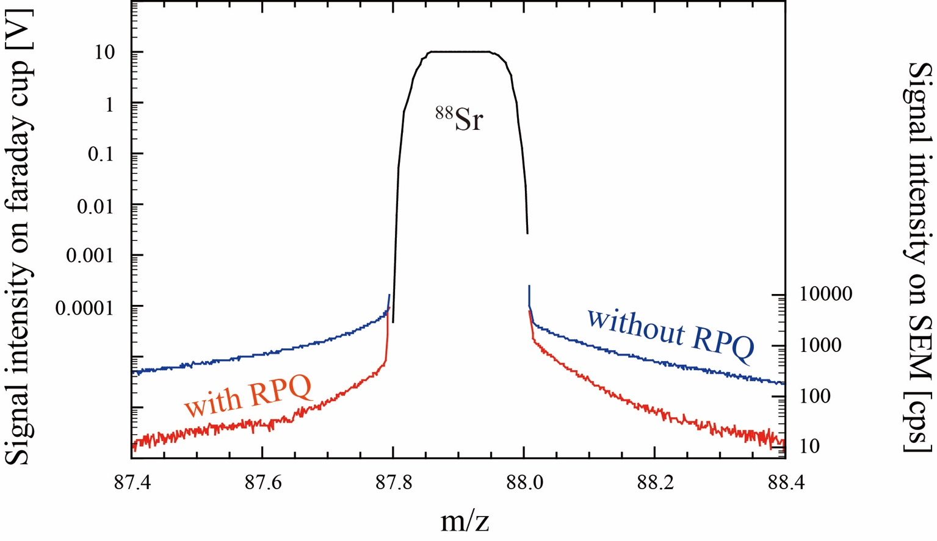
Figure S1. Mass spectrum in the vicinity of m/z 88 showing the flat-top peak of ⁸⁸Sr measured by the center Faraday cup (black lines). The ⁸⁸Sr peak tails on the low- and high-mass sides is also shown. Peak tails measured by SEM without the RPQ are shown in blue lines and peak tails measured by SEM with the RPQ are shown in red lines.

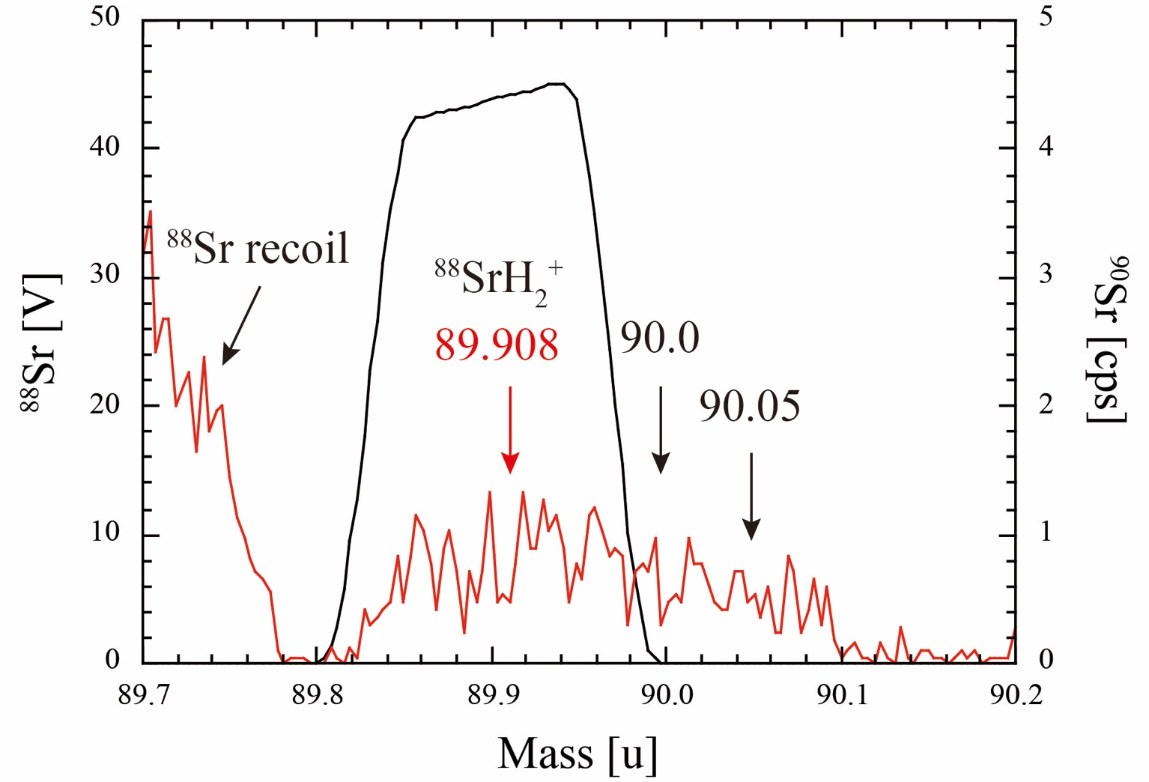
Figure S2. Mass spectrum of ⁹⁰Sr noise observed in ⁹⁰Sr-free NIST SRM987. The black line represents the ⁸⁸Sr spectrum as measured by the L1 Faraday cup, and the red line represents the noise spectrum as measured by RPQ-SEM. The signal at m/z 89.7–89.78 corresponds to the recoil of the ⁸⁸Sr ions in the collector housing. The intensity level of the ⁸⁸Sr peak tail is represented by signals on m/z 89.78–89.82 and 90.1–90.2. With intensity levels lower than 1cps, the mass spectrum of ⁸⁸SrH₂⁺ with m/z 89.908 and those of the organics with m/z 90.0 and 90.05 were observed.

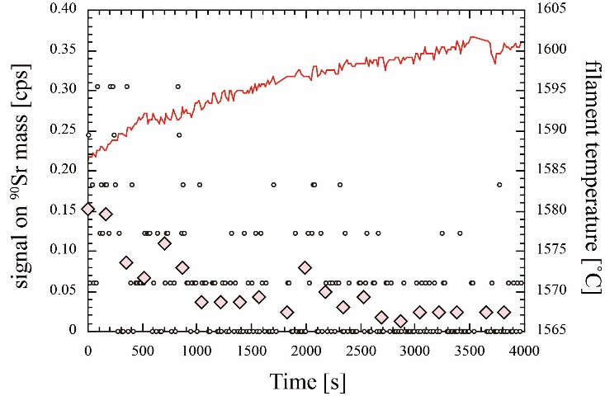
Figure S3. The transition of the noise signal intensities on ⁹⁰Sr during measurement of ⁹⁰Sr-free NIST SRM987 is plotted against the elapsed time. Small circles are raw data of each measurement cycle and pink diamonds are the average of 10 cycles. Changes in filament temperature during the measurement were plotted together in a red line.

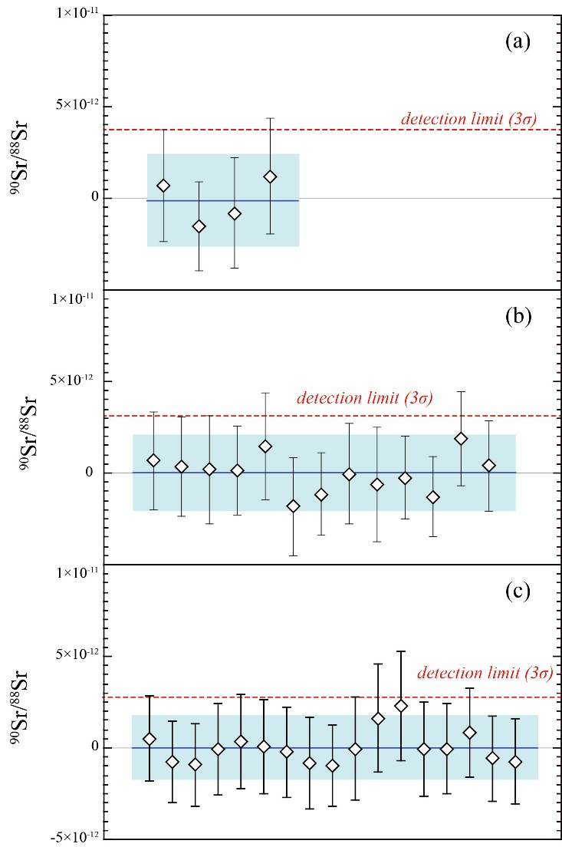

Figure S4. The noise corrected ⁹⁰Sr/⁸⁸Sr ratio of NIST SRM987 was measured in (a) Bremen, (b) Fukushima-1, and (c) Fukushima-2 sessions. White diamonds represent a single measurement. The blue line and blue band represent the average and 2 SD range of the multiple measurements. The red dotted line represents the detection limit of ⁹⁰Sr/⁸⁸Sr, defined as the 3-standard deviation of the multiple NIST SRM987 measurements.

Table S1. Summary of literature ⁹⁰Sr activity parameters of the environmental samples¹⁾.

sample | sample type | ⁹⁰Sr | Sr | status of | reference date
 |  | [Bq/kg] | [mg/kg] | ⁹⁰Sr activity | for ⁹⁰Sr activity
NASS-6 | seawater | ― | 7.48²⁾ | ― | ―
JCp-1 | coral | ― | 7271 (218) | ― | ―
IAEA 156 | clover | 14.8 (3.0) | 33.5 (2.0) | recommended value | August 1 1986
IAEA 330 | spinach | 20.1 (4.2) | 44.0 (2.6) | certified value | October 15 2007
Ash 1 | Crayfish | 110 (8) | 1344 (66) | measured value | July 12 2013
Ash2 | Smallmouth bass | 25 (2) | 414 (28) | measured value | July 12 2013

- All the errors in the parenthesis are 2SD.
- Wakaki, S.; Obata, H.; Tazoe, H.; Ishikawa, T. Precise and Accurate Analysis of Deep and Surface Seawater Sr Stable Isotopic Composition by Double-Spike Thermal Ionization Mass Spectrometry. Geochem. J. 2017, 51 (3), 227–239. https://doi.org/10.2343/geochemj.2.0461.

Table S2. Detailed results of ⁹⁰Sr/⁸⁸Sr measurements of the environmental samples.

sample | session | reference date | Reference ⁹⁰Sr/⁸⁸Sr ¹⁾ | ⁸⁸Sr [V] | ⁹⁰Sr [cps] ²⁾ | ⁹⁰Sr/⁸⁸Sr ²⁾ | number of analysis
NASS-6 | Fukushima-2 | June 5th, 2021 | ― | 25.3 | 0.0000 (37) | -0.1 (2.5) × 10⁻¹² | 5
JCp-1 | Fukushima-1 | April 3rd, 2021 | ― | 26.9 | 0.0003 (48) | 0.3 (2.9) × 10⁻¹² | 8
 | Fukushima-2 | June 5th, 2021 | ― | 25.3 | 0.0008 (54) | 0.5 (3.4) × 10⁻¹² | 5
IAEA 156 | Fukushima-2 | June 5th, 2021 | 4.4 (0.9) × 10⁻¹¹ | 26.8 | 0.0546 (51) | 3.26 (0.30) × 10⁻¹² | 6
IAEA 330 | Bremen | January 22nd, 2020 | 7.9 (1.7) × 10⁻¹¹ | 20.6 | 0.0886 (192) | 6.7 (1.3) × 10⁻¹¹ | 4
 | Fukushima-2 | June 5th, 2021 | 7.6 (1.7) × 10⁻¹¹ | 25.9 | 0.0928 (43) | 5.76 (0.43) × 10⁻¹¹ | 5
Crayfish | Fukushima-1 | April 3rd, 2021 | 1.57 (0.15) × 10⁻¹¹ | 28.0 | 0.0241 (90) | 1.38 (0.53) × 10⁻¹¹ | 6
 | Fukushima-2 | June 5th, 2021 | 1.56 (0.15) × 10⁻¹¹ | 25.7 | 0.0210 (44) | 1.32 (0.42) × 10⁻¹¹ | 6
Smallmouth bass | Fukushima-1 | April 3rd, 2021 | 1.16 (0.11) × 10⁻¹¹ | 27.9 | 0.0244 (71) | 1.40 (0.39) × 10⁻¹¹ | 6
 | Fukushima-2 | June 5th, 2021 | 1.15 (0.11) × 10⁻¹¹ | 26.3 | 0.0217 (44) | 1.33 (0.27) × 10⁻¹¹ | 6
All the errors in the parenthesis are 2SD.
1) Decay corrected to the reference date.
2) Noise corrected values using the average ⁹⁰Sr count rate of NIST SRM 987 measurements.

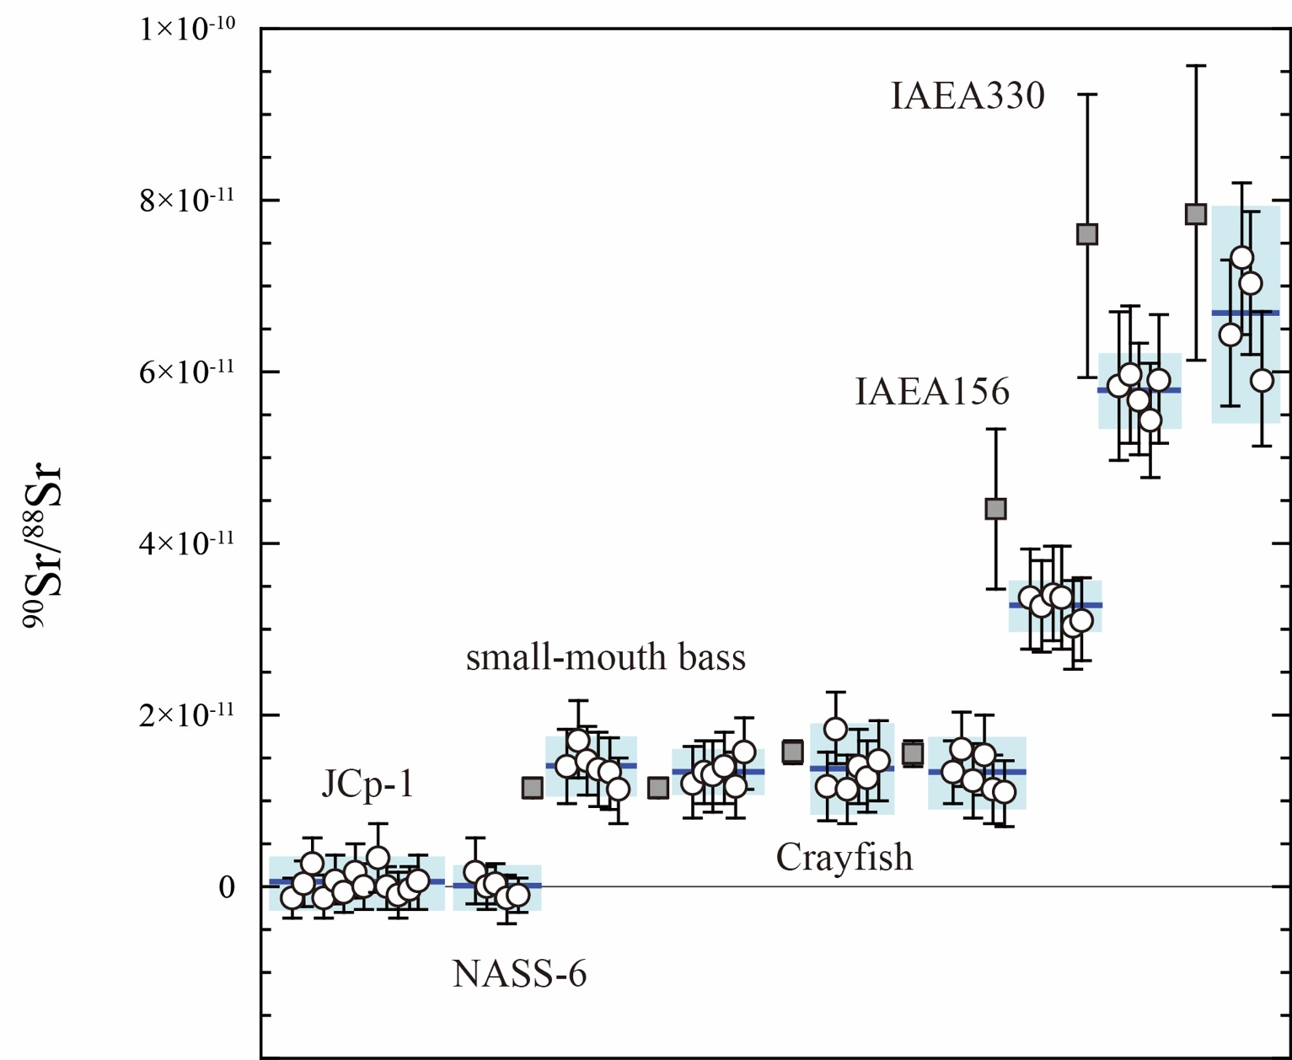

Figure S5. The noise corrected ⁹⁰Sr/⁸⁸Sr ratio of the environmental samples. White circles represent a single measurement. Blue lines and blue bands represent the average and 2 SD range of the multiple measurements. Grey square represents the decay corrected reference ⁹⁰Sr/⁸⁸Sr ratios.

Table S3 Detector configuration for ⁹⁰Sr/⁸⁸Sr measurement
Collector | L4 | L3 | L2 | L1 | C
Isotope | ⁸⁴Sr* | ⁸⁶Sr | ⁸⁷Sr | ⁸⁸Sr | ⁹⁰Sr
Detector type | FC | FC | FC | FC | RPQ-SEM
* ⁸⁴Sr is not measured with TIMS TRITON XT at Bremen.

