Beyond PAM: Digital photography and RGB color analysis as a cost-effective method for coral bleaching assessment

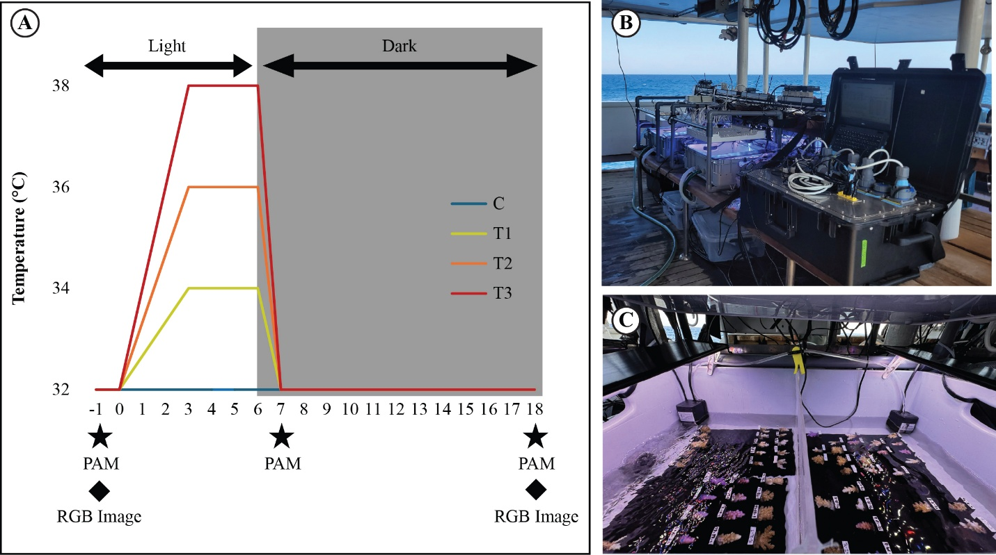
Figure S1. (A) Temperature profiles across the four treatment groups during the 18-hour acute thermal stress assay. White and gray backgrounds indicate the light (0–6 h) and dark (6–18 h) periods, respectively. Stars (★) indicate Fv/Fm measurements with the HEXAGON-IMAGING-PAM and diamonds (◆) indicate RGB image acquisition timepoints. (B) Overview of the modified CBASS setup deployed during the experiment. (C) Interior view of a representative tank showing coral fragments arranged on acrylic plates, with submersible pumps providing uniform water circulation.

Table S1. List of color indices used in this study (In Supplementary File 2)

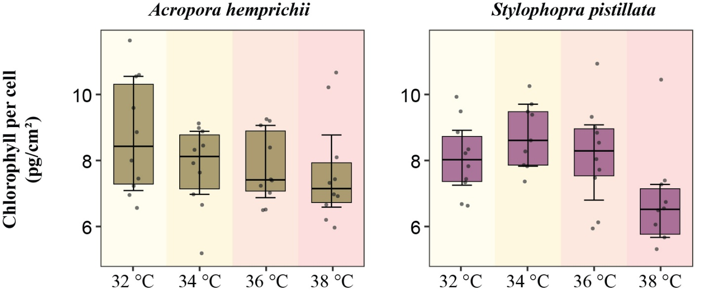
Figure S2. Treatment effects on total chlorophyll content per symbiont cell. Boxes represent the interquartile range (IQR) with the median line; jittered points represent individual fragments; vertical lines represent bootstrapped median 95% confidence intervals (CI). Background colors indicate treatment temperature, ranging from light yellow (32 °C, control) to light red (38 °C, highest thermal stress). Treatments did not differ significantly (Dunn test, BH-adjusted p > 0.05).
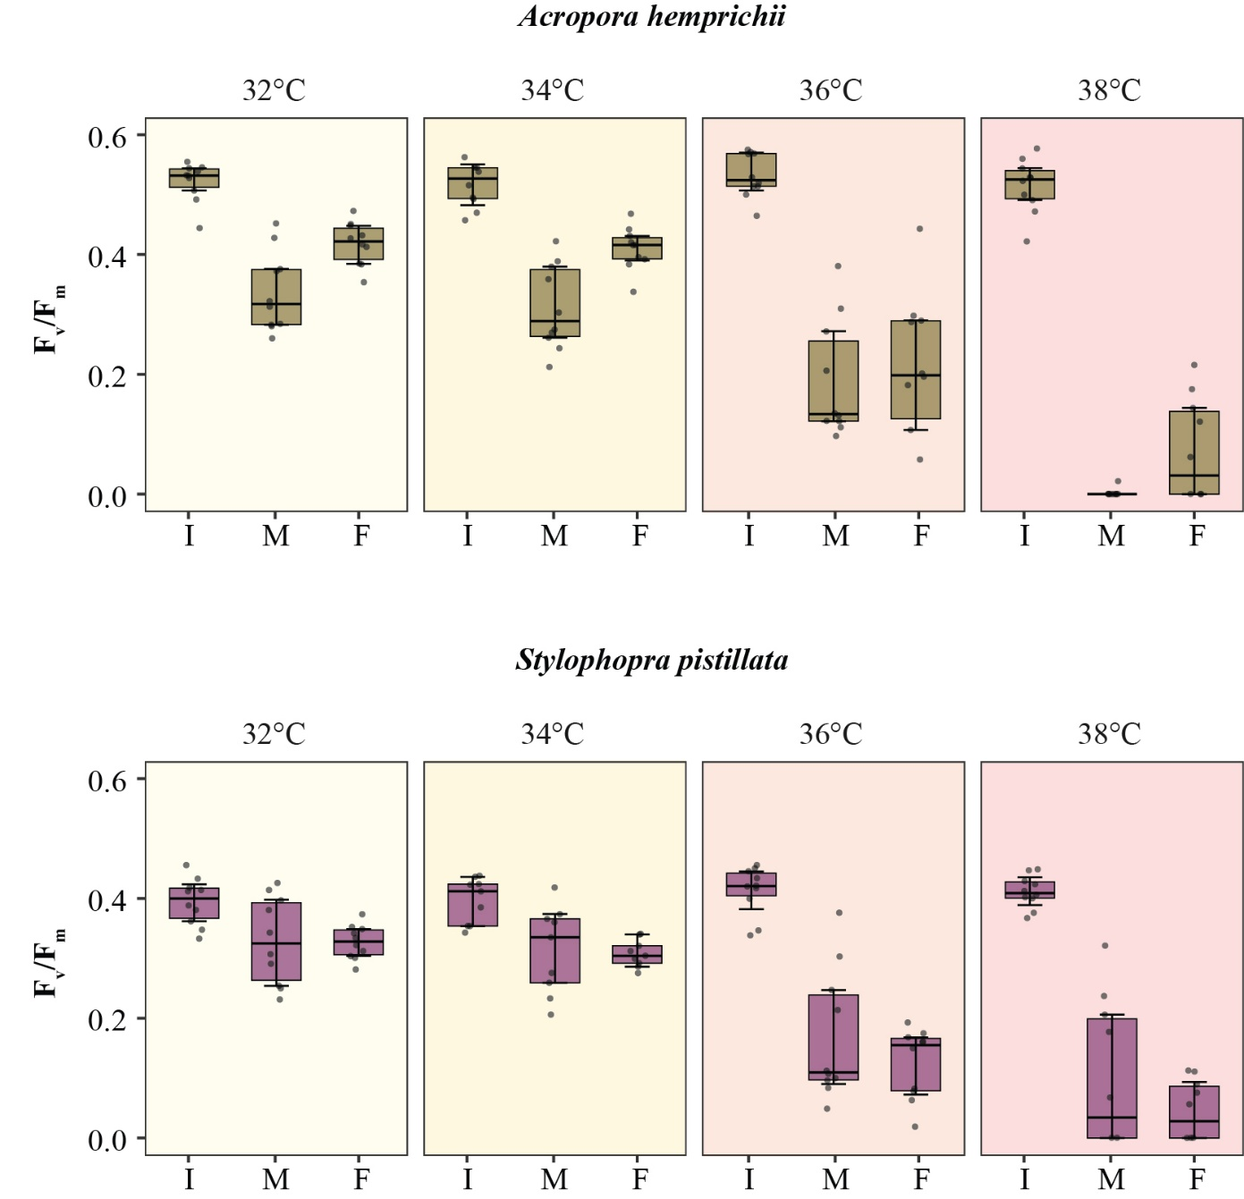
Figure S3. F_{v}/F_{m} trajectories across timepoints, Initial (I), Middle (M), and Final (F), per treatment. Boxes represent the interquartile range (IQR) with the median line; jittered points represent individual fragments; vertical lines represent bootstrapped median 95% confidence intervals (CI). Background colors indicate treatment temperature, ranging from light yellow (32 °C, control) to light red (38 °C, highest thermal stress). Treatments correspond to 32 °C (C), 34 °C (T1), 36 °C (T2), and 38 °C (T3).

Table S2. Ranking of color indices per physiological variable. (In Supplementary File 2).

Table S3. Ranking of color indices based on their correlation strength in symbiont density and total chlorophyll content. (In Supplementary File 2).

Table S4. Variance partitioning of symbiont density between D_toWhite and DeltaE76 using an RDA-based linear decomposition. Values represent adjusted R² fractions corresponding to the total variance explained by each predictor, their shared explained variance, unique contributions, and residual unexplained variance. Near-zero unique fractions indicate substantial redundancy between indices.
Fraction | Description | Adjusted R²
Total explained by D_toWhite | D_toWhite (alone) | 0.413
Total explained by DeltaE76 | DeltaE76 (alone) | 0.423
Shared fraction | D_toWhite ∩ DeltaE76 | 0.410
Unique to D_toWhite | D_toWhite \ DeltaE76 | 0.002
Unique to DeltaE76 | DeltaE76 \ D_toWhite | 0.012
Residual | Unexplained | 0.574

Table S5. Spearman correlation matrix (ρ) showing pairwise associations among physiological metrics in A. hemprichii. Metrics include final Fv/Fm (FvFm_F), intermediate Fv/Fm at 7 h (FvFm_M), RGB-derived bleaching distance (D_toWhite_F), symbiont density, total chlorophyll content, and host protein content. Correlations were computed using pairwise complete observations.
 | FvFm_F | FvFm_M | D_toWhite_F | Symbiont density | Total chlorophyll content | Host protein content
FvFm_F | 1.000
FvFm_M | 0.651 | 1.000
D_toWhite_F | 0.733 | 0.477 | 1.000
Symbiont density | 0.558 | 0.387 | 0.829 | 1.000
Total chlorophyll content | 0.581 | 0.428 | 0.861 | 0.949 | 1.000
Host protein content | 0.684 | 0.726 | 0.725 | 0.646 | 0.663 | 1.000

Table S6. Spearman correlation matrix showing pairwise associations among physiological metrics in S. pistillata. Metrics include final Fv/Fm (FvFm_F), intermediate Fv/Fm at 7 h (FvFm_M), RGB-derived bleaching distance (D_toWhite_F), symbiont density, total chlorophyll content, and host protein content. Correlations were computed using pairwise complete observations.
 | FvFm_F | FvFm_M | D_toWhite_F | Symbiont density | Total chlorophyll content | Host protein content
FvFm_F | 1.000
FvFm_M | 0.575 | 1.000
D_toWhite_F | 0.678 | 0.426 | 1.000
Symbiont density | 0.540 | 0.543 | 0.718 | 1.000
Total chlorophyll content | 0.677 | 0.571 | 0.741 | 0.933 | 1.000
Host protein content | 0.855 | 0.587 | 0.616 | 0.505 | 0.640 | 1.000

Table S7. Spearman correlation matrix showing pairwise associations among total chlorophyll content, chlorophyll a, and chlorophyll c. Correlations were computed using pairwise complete observations.
 | Total chlorophyll content | Chlorophyll a | Chlorophyll c
Total chlorophyll content | 1
Chlorophyll a | 0.998 | 1
Chlorophyll c | 0.993 | 0.988 | 1

Table S8. Spearman correlation matrix showing pairwise associations among F_{v}/F_{m} across timepoints. Metrics include single timepoint (Final and Middle) and the ratio of these with the initial timepoint. Correlations were computed using pairwise complete observations.
 | FvFm_Middle | FvFm_Final | Ratio_F/I | Ratio_M/I
FvFm_Middle | 1
FvFm_Final | 0.619 | 1
Ratio_F/I | 0.640 | 0.877 | 1
Ratio_M/I | 0.949 | 0.502 | 0.629 | 1

