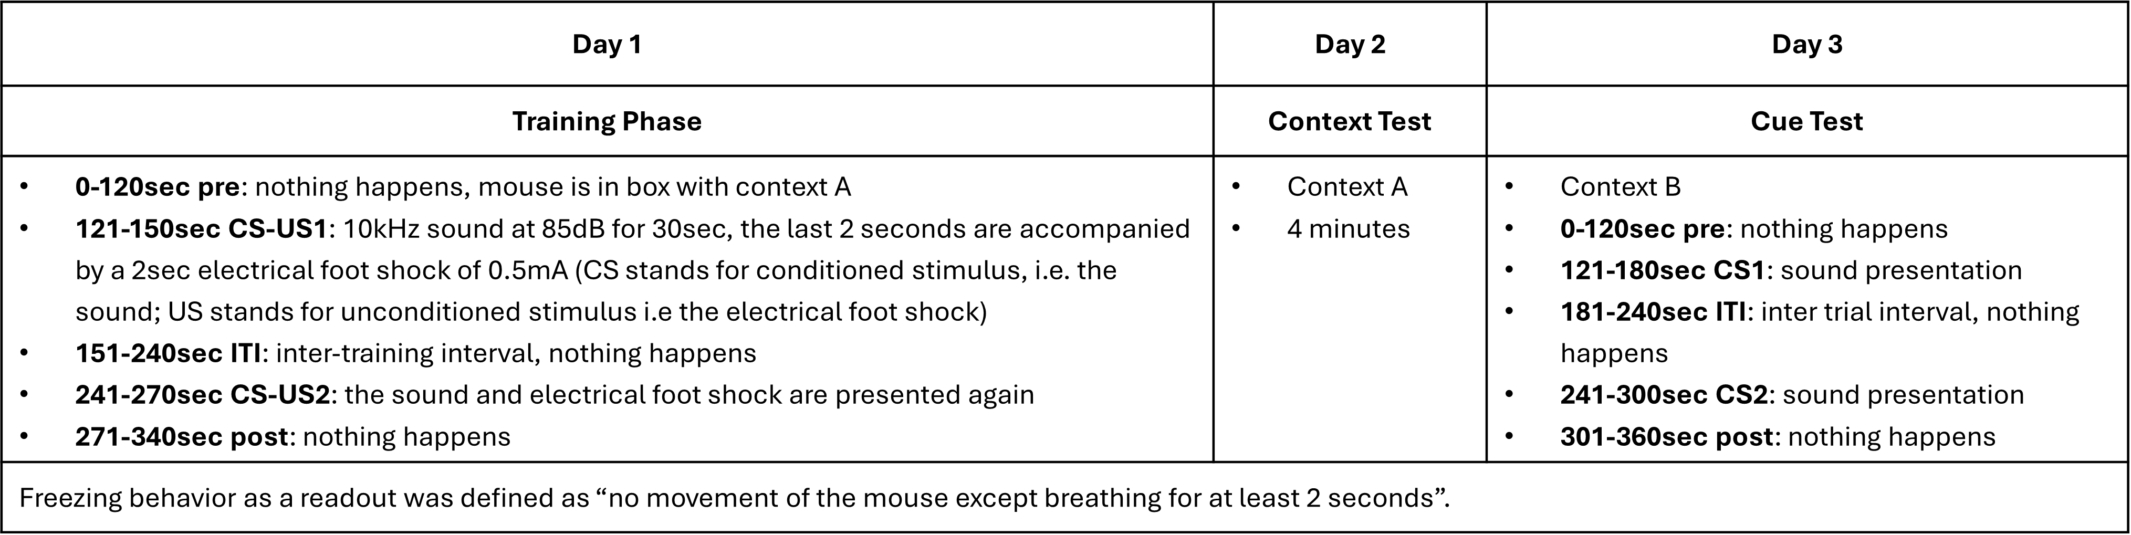
Supplemental Table 3: detailed schedule for the contextual and cue fear conditioning test regimen

