SUPPLEMENTAL FIGURES
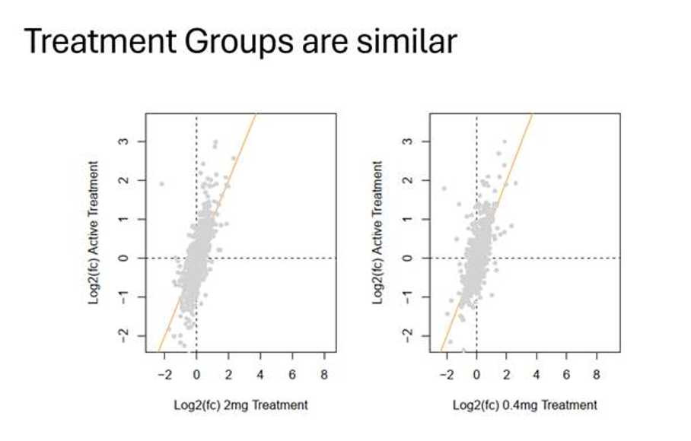
Supplemental Figure 1: Comparison of the effect of the single doses and the combined doses. Combined analysis of proteomics data is blotted against the 0.4 or 2.0 results alone to show that treatment groups are similar and can be combined to increase group size and statistical power.

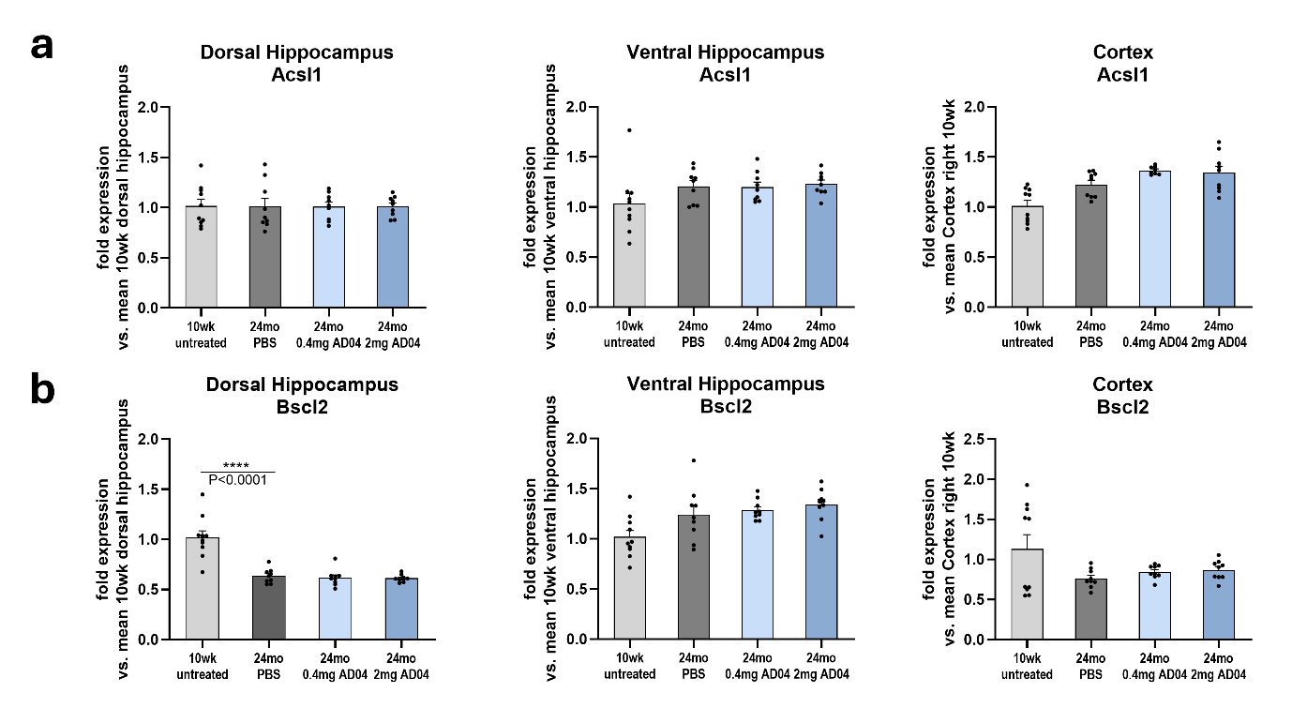
Supplemental Figure 2: Analysis of Acsl1 and Bscl2 expression in brain. (a) Acsl1 and (b) Bscl2 expression was analyzed by RT-qPCR in dorsal and ventral hippocampi and cortex of young, untreated mice and aged (24 months) mice either treated with AD04TM or untreated (n=9-10/group; ****=p<0.0001).

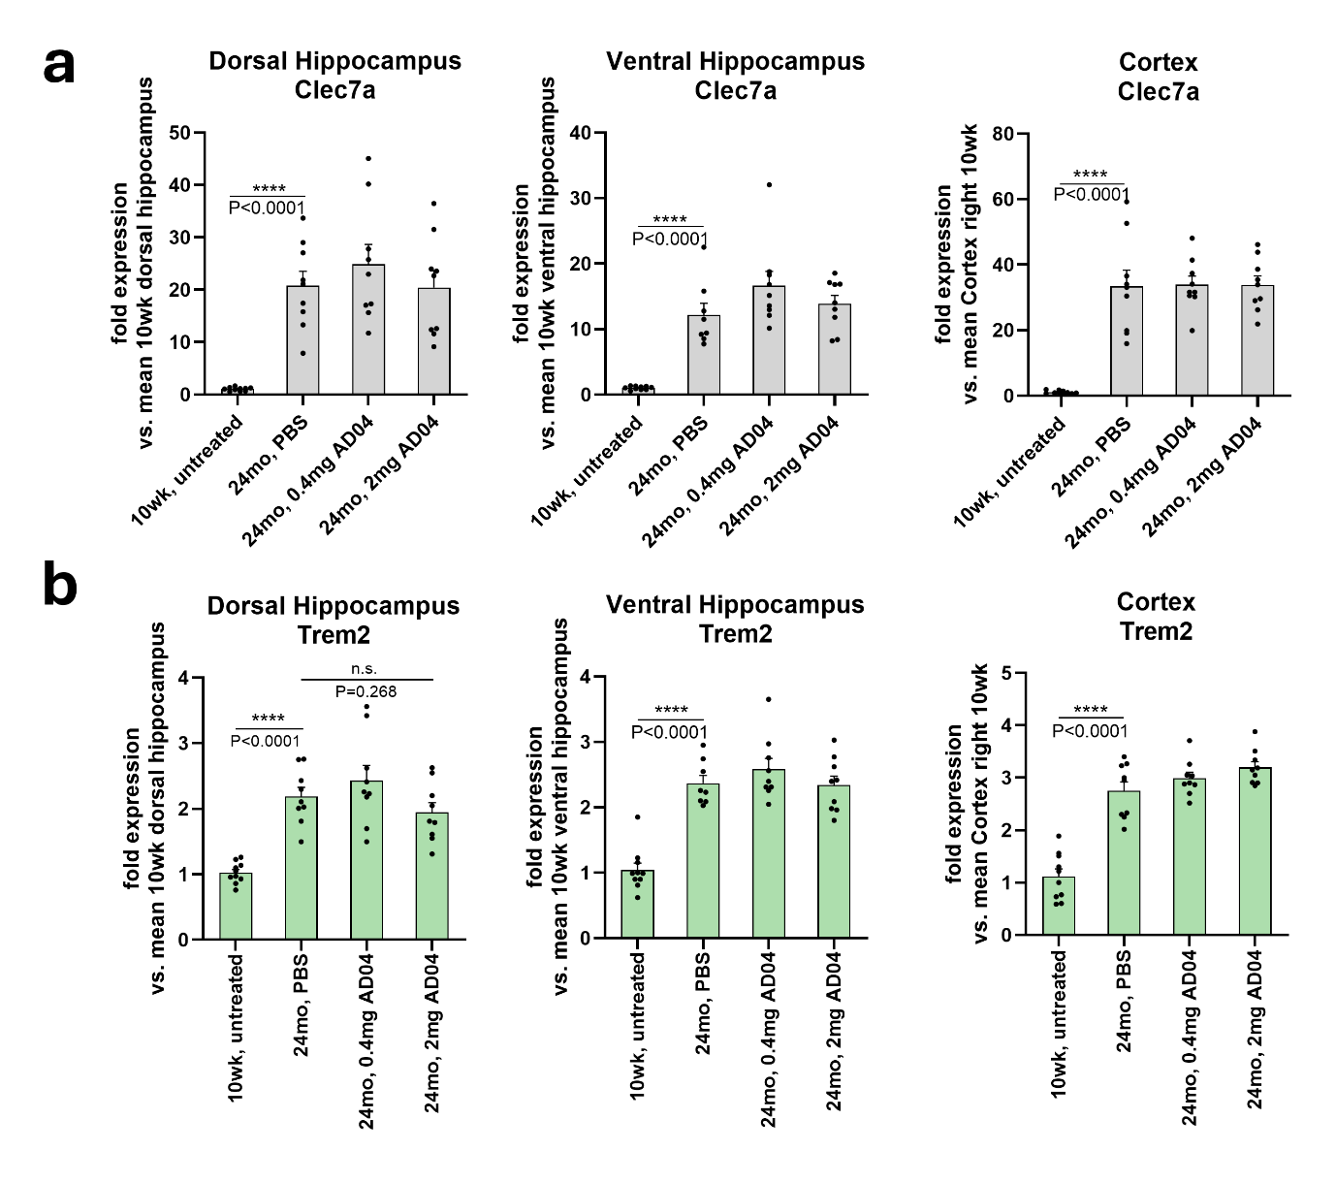
Supplemental Figure 3: Expression of Clec7a and Trem2 in mouse brains. Expression of (a) Clec7a and (b) Trem2 was analyzed by RT-qPCR in dorsal and ventral hippocampi and cortex of young, untreated mice and aged (24 months) mice either treated with AD04TM or untreated (n=9-10/group; ****=p<0.0001).

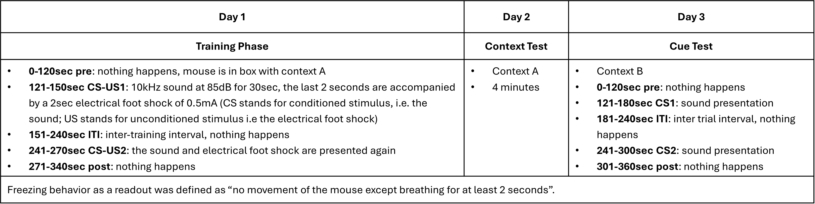
Supplemental Table 3: detailed schedule for the contextual and cue fear conditioning test regimen.

