Supplemental Data
Human cortical astrocytes express type 1 cannabinoid receptor at mRNA and protein levels
Meena Kumari
Department of Anatomy and Physiology, College of Veterinary Medicine, Kansas State University, Manhattan, KS 66506, USA.

Contact Information of Corresponding Author:
Meena Kumari, Ph.D.
202 Coles Hall
Anatomy and Physiology, CVM
Kansas State University
Manhattan, KS 66503
Tel: (785)532-3115
Fax: (785)532-4557
Email: mkumari@vet.ksu.edu
ORCID ID: 0000-0002-7886-4883

Running Title: CB₁R expression in human astrocytes

Supplementary Figure 1: Olig2 expressing cells absent in human cortical astrocyte cultures.
Human cortical astrocytes cultured on glass coverslips were rinsed with pre-warmed PBS (to 37 °C) once and fixed for 10 min in freshly prepared 4% formaldehyde in PBS. Fixed cells were washed and permeabilized in 0.1% Triton X100 in PBS (PBST) for 3 min. After washing, cells were blocked in 5% goat serum in PBS (blocking buffer) for 2h and then incubated with anti-olig2 in blocking buffer (1:40 dilution) overnight at 4 °C in a humid atmosphere. Next day, cells were washed three times with PBST and incubated with Alexa 594 conjugated chicken anti-goat secondary antibody (1:250 dilution in blocking buffer). Negative controls were incubated with 5% GS/0.1% BSA/PBS in lieu of primary antibody. Cells were washed, counterstained with DAPI, and mounted in FluorSave (Calbiochem) prior to capturing images with 40x oil (EC Plan-Neofluar 40x/1.30 Oil M27) objective under Zeiss confocal microscope (Carl Zeiss, LSM 700).
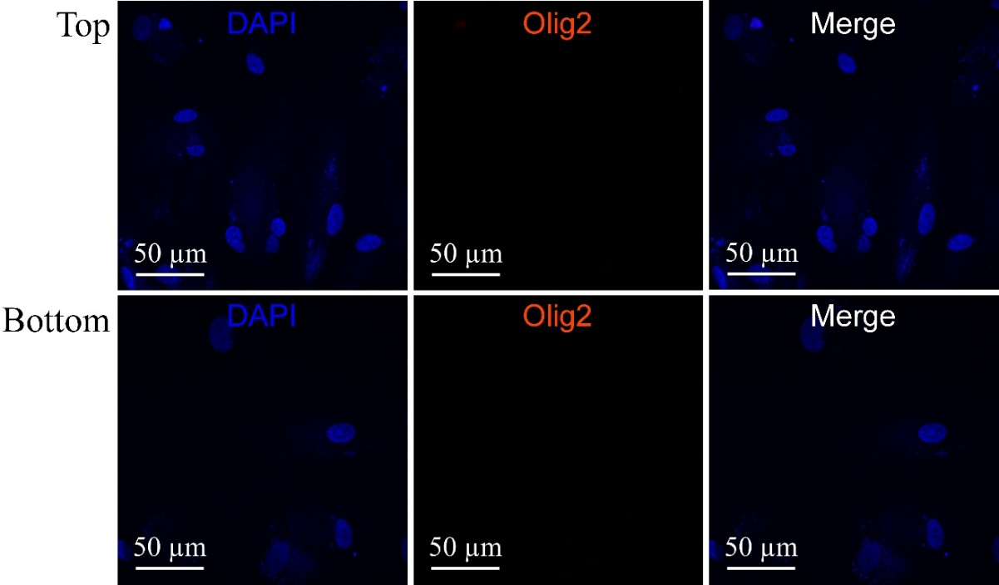

Figure S1: Olig2 expressing cells absent in human cortical astrocyte cultures. Oilg2 was detected using immunocytochemistry method. Astrocytes incubated with blocking buffer served as negative control (Top panel). Astrocytes incubated with anti-olig2 had no olig2 positive cells (Bottom panel). Scale bars show magnification.

Above experiment was repeated using anti-Iba-1 to detect microglia as contaminating cells in human astrocyte cultures. No Iba-1 positive cells were observed in astrocyte cultures. Data was similar to olig2 results and hence images not included here.

Supplementary Figures S2 and S3: Olig2 and Iba-1 expressing cells in the normal adult rat brain.
Normal adult rat brain sections were used as positive controls for detecting olig2 and Iba-1 positive cells. Paraffin embedded rat brain sections available in the laboratory from previous studies were used. Brain sections were processed by histopathology lab for detection of oligodendrocytes (olig2 positive cells) and microglia (Iba-1 positive cells) by immunohistochemistry using anti-olig2 (Figure S2) and anti-Iba-1 (Figure S3). Incubation with primary antibody was followed by horseradish peroxidase conjugated secondary antibody for olig2 and alkaline phosphatase (AP) conjugated secondary antibody for Iba-1. For olig2, antigen-antibody binding was detected by incubation of sections with 3,3'-diaminobenzidine (DAB). An insoluble dark brown precipitate produced due to oxidation of DAB indicated olig2 positive cells. For Iba-1, antigen-antibody binding was detected by incubation of sections with fast red as a chromogen. An insoluble fuchsin-red precipitate in cells indicated Iba-1 positive cells. Sections were counterstained with hematoxylin. Sections mounted on glass slides were scanned using Aperio Digital Pathology Slide Scanner (Leica Biosystems) using the Aperio iQC software. Scalebars were inserted using caliper annotation tool in Apario image scope and images were downloaded as png files at 0.8X (whole brain section) and 40X (a close-up of immunostained cells) digital magnification.
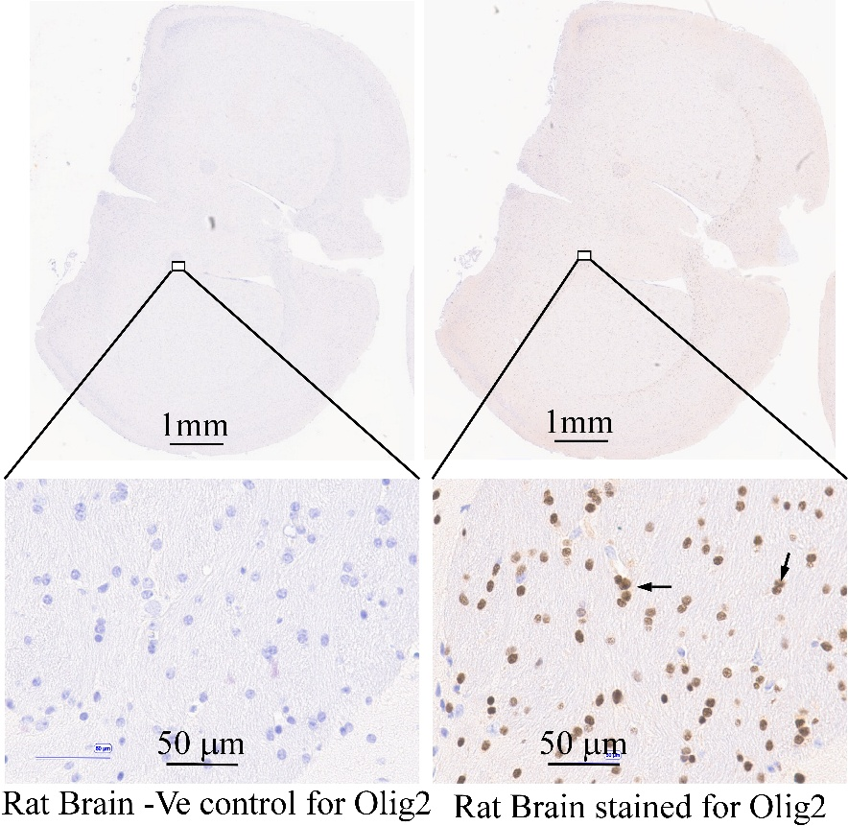

Figure S2: Olig2 positive cells in the rat brain section. Top images show the cross section of rat brain. A small region (rectangle) in each brain section was viewed at 40X to detect olig2 expressing cells. A dark brown color (arrows in the bottom right panel) indicates olig2 positive oligodendrocytes. Negative controls (-Ve control) that lack olig2 positive cells, were incubated with blocking buffer in lieu of anti-olig2 (the bottom left panel). Nuclei were stained with hematoxylin. Scale bars show magnification.

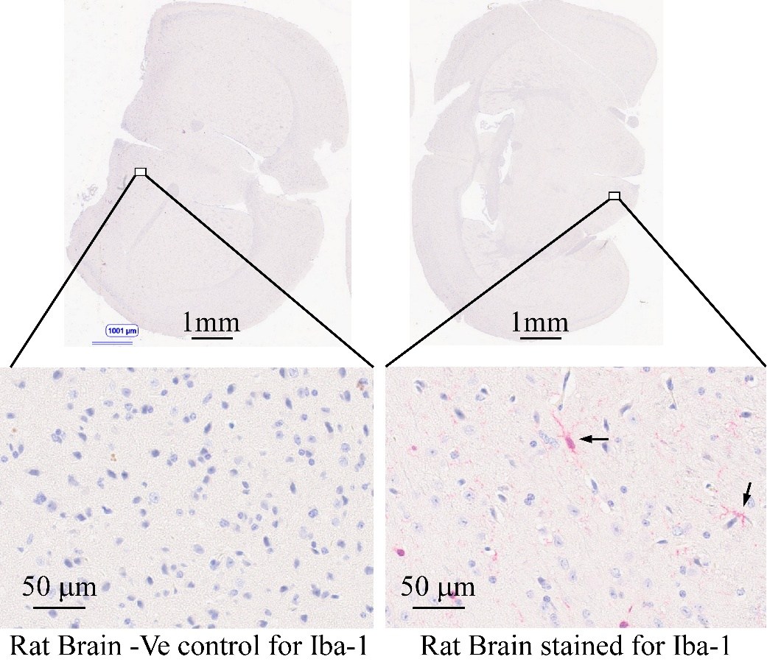

Figure S3: Iba-1 positive cells in the rat brain section. Top images show the cross section of rat brain. A small region (rectangle) in each brain section was viewed at 40X to detect Iba-1 expressing cells. Cells displaying fuchsin-red color are microglia detected in the rat brain section (arrows in the bottom right panel). Negative controls (-Ve control) that lack Iba-1 positive cells, were incubated with blocking buffer in lieu of anti-Iba-1 (the left bottom panel). Nuclei were stained with hematoxylin. Scale bars show magnification.

