Supplemental Information
Table 1. Univariate analysis of overall guideline awareness. Chi-square frequency analyses were performed stratified by the number of correct responses (all items, 4, 5, and 8 questions).
Variables | Clinician Demographics (n=1586) | All incorrect  (n=1001) | One item correct (n=231) | Two items correct (n=292) | All correct (n=62) | χ² | P
Sex |  |  |  |  |  | 5.255 | 0.154
Male | 685(43.19) | 453(45.25) | 94(40.69) | 116(39.73) | 22(35.48)
Female | 901(56.81) | 548(54.75) | 137(59.31) | 176(60.27) | 40(64.52)
Education Level |  |  |  |  |  | 149.184 | ＜.001
Master's degree or above | 857(54.04) | 458(45.75) | 107(46.32) | 238(81.51) | 54(87.10)
Bachelor's degree or below | 729(45.96) | 543(54.25) | 124(53.68) | 54(18.49) | 8(12.90)
Professional Title |  |  |  |  |  | 77.662 | ＜.001
Chief / Associate Chief Physician | 800(50.44) | 431(43.06) | 121(52.38) | 201(68.84) | 47(75.81)
Attending Physician or below | 786(49.56) | 570(56.94) | 110(47.62) | 91(31.16) | 15(24.19)
General Hospital |  |  |  |  |  | 20.352 | ＜.001
Tertiary Hospital | 803(88.93) | 508(85.81) | 123(91.11) | 139(97.89) | 33(97.06)
Secondary Hospital or below | 100(11.07) | 84(14.19) | 12(8.89) | 3(2.11) | 1(2.84)
Infectious Disease / Hepatology Specialty Hospital |  |  |  |  |  | 11.944 | 0.005
Tertiary Hospital | 659(96.49) | 392(95.84) | 89(92.71) | 150(100.00) | 28(100.00)
Secondary Hospital or below | 24(3.51) | 17(4.16) | 7(7.29) | 0(0.00) | 0(0.00)
Department |  |  |  |  |  | 49.664 | ＜.001
Hepatology-related Departments | 1322(83.35) | 784(78.32) | 212(91.77) | 268(91.78) | 58(93.55)
Other Departments | 264(16.65) | 217(21.68) | 19(8.23) | 24(8.22) | 4(6.45)
Geographic Region |  |  |  |  |  | 20.391 | 0.060
North | 516(32.53) | 308(30.77) | 88(38.10) | 94(32.19) | 26(41.94)
East | 265(16.71) | 179(17.88) | 29(12.55) | 47(16.10) | 10(16.13)
South | 223(14.06) | 141(14.09) | 32(13.85) | 44(15.07) | 6(9.68)
West | 363(22.89) | 226(22.58) | 64(27.71) | 60(20.55) | 13(20.97)
Central | 219(13.81) | 147(14.69) | 18(7.79) | 47(16.10) | 7(11.29)

Table 2. Univariate analysis for item 4 of guideline knowledge.
Variables | Clinician Demographics (n=1586) | Incorrect (n=1236) | Correct (n=350) | χ² | P
Sex |  |  |  | 3.437 | 0.064
Male | 685(43.19) | 549(44.42) | 136(38.86)
Female | 901(56.81) | 687(55.58) | 214(61.14)
Education Level |  |  |  | 147.245 | ＜.001
Master's degree or above | 857(54.04) | 568(45.95) | 289(82.57)
Bachelor's degree or below | 729(45.96) | 668(54.05) | 61(17.43)
Professional Title |  |  |  | 70.749 | ＜.001
Chief / Associate Chief Physician | 800(50.44) | 554(44.82) | 246(70.29)
Attending Physician or below | 786(49.56) | 682(55.18) | 104(29.71)
General Hospital |  |  |  | 16.683 | ＜.001
Tertiary Hospital | 803(88.93) | 634(86.85) | 169(97.69)
Secondary Hospital or below | 100(11.07) | 96(13.15) | 4(2.31)
Infectious Disease / Hepatology Specialty Hospital |  |  |  | 8.701 | 0.003
Tertiary Hospital | 659(96.49) | 482(95.26) | 177(100.00)
Secondary Hospital or below | 24(3.51) | 24(4.74) | 0(0.00)
Department |  |  |  | 24.195 | ＜.001
Hepatology-related Departments | 1322(83.35) | 1000(80.91) | 322(92.00)
Other Departments | 264(16.65) | 236(19.09) | 28(8.00)
Geographic Region |  |  |  | 1.563 | 0.815
North | 516(32.53) | 399(32.28) | 117(33.43)
East | 265(16.71) | 208(16.83) | 57(16.29)
South | 223(14.06) | 173(14.00) | 50(14.29)
West | 363(22.89) | 290(23.46) | 73(20.86)
Central | 219(13.81) | 166(13.43) | 53(15.14)

Table 3. Univariate analysis for item 5 of guideline knowledge.
Variables | Clinician Demographics  (n=1586) | Incorrect (n=1223) | Correct  (n=363) | χ² | P
Sex |  |  |  | 2.765 | 0.096
Male | 685(43.19) | 542(44.32) | 143(39.39)
Female | 901(56.81) | 681(55.68) | 220(60.61)
Education Level |  |  |  | 149.213 | ＜.001
Master's degree or above | 857(54.04) | 559(45.71) | 298(82.09)
Bachelor's degree or below | 729(45.96) | 664(54.29) | 65(17.91)
Professional Title |  |  |  | 71.834 | ＜.001
Chief / Associate Chief Physician | 800(50.44) | 546(44.64) | 254(69.97)
Attending Physician or below | 786(49.56) | 677(55.36) | 109(30.03)
General Hospital |  |  |  | 18.589 | ＜.001
Tertiary Hospital | 803(88.93) | 623(86.65) | 180(97.83)
Secondary Hospital or below | 100(11.07) | 96(13.35) | 4(2.17)
Infectious Disease / Hepatology Specialty Hospital |  |  |  | 8.834 | 0.003
Tertiary Hospital | 659(96.49) | 480(95.24) | 179(100.00)
Secondary Hospital or below | 24(3.51) | 24(4.76) | 0(0.00)
Department |  |  |  | 27.069 | ＜.001
Hepatology-related Departments | 1322(83.35) | 987(80.70) | 335(92.29)
Other Departments | 264(16.65) | 236(19.30) | 28(7.71)
Geographic Region |  |  |  | 2.989 | 0.560
North | 516(32.53) | 391(31.97) | 125(34.44)
East | 265(16.71) | 208(17.01) | 57(15.70)
South | 223(14.06) | 172(14.06) | 51(14.05)
West | 363(22.89) | 289(23.63) | 74(20.39)
Central | 219(13.81) | 163(13.33) | 56(15.43)

Table 4. Univariate analysis for item 8 of guideline knowledge.
Variables | Clinician Demographics  (n=1586) | Incorrect (n=1298) | Correct  (n=288) | χ² | P
Sex |  |  |  | 2.243 | 0.134
Male | 685(43.19) | 572(44.07) | 113(39.24)
Female | 901(56.81) | 726(55.93) | 175(60.76)
Education Level |  |  |  | 0.097 | 0.756
Master's degree or above | 857(54.04) | 699(53.85) | 158(54.86)
Bachelor's degree or below | 729(45.96) | 599(46.15) | 130(45.14)
Professional Title |  |  |  | 5.953 | 0.015
Chief / Associate Chief Physician | 800(50.44) | 636(49.00) | 164(56.94)
Attending Physician or below | 786(49.56) | 662(51.00) | 124(43.06)
General Hospital |  |  |  | 2.016 | 0.156
Tertiary Hospital | 803(88.93) | 652(88.23) | 151(92.07)
Secondary Hospital or below | 100(11.07) | 87(11.77) | 13(7.93)
Infectious Disease / Hepatology Specialty Hospital |  |  |  | 2.030 | 0.154
Tertiary Hospital | 659(96.49) | 542(96.96) | 117(94.35)
Secondary Hospital or below | 24(3.51) | 17(3.04) | 7(5.65)
Department |  |  |  | 19.019 | ＜.001
Hepatology-related Departments | 1322(83.35) | 1057(81.43) | 265(92.01)
Other Departments | 264(16.65) | 241(18.57) | 23(7.99)
Geographic Region |  |  |  | 16.372 | 0.003
North | 516(32.53) | 404(31.12) | 112(38.89)
East | 265(16.71) | 226(17.41) | 39(13.54)
South | 223(14.06) | 186(14.33) | 37(12.85)
West | 363(22.89) | 287(22.11) | 76(26.39)
Central | 219(13.81) | 195(15.02) | 24(8.33)

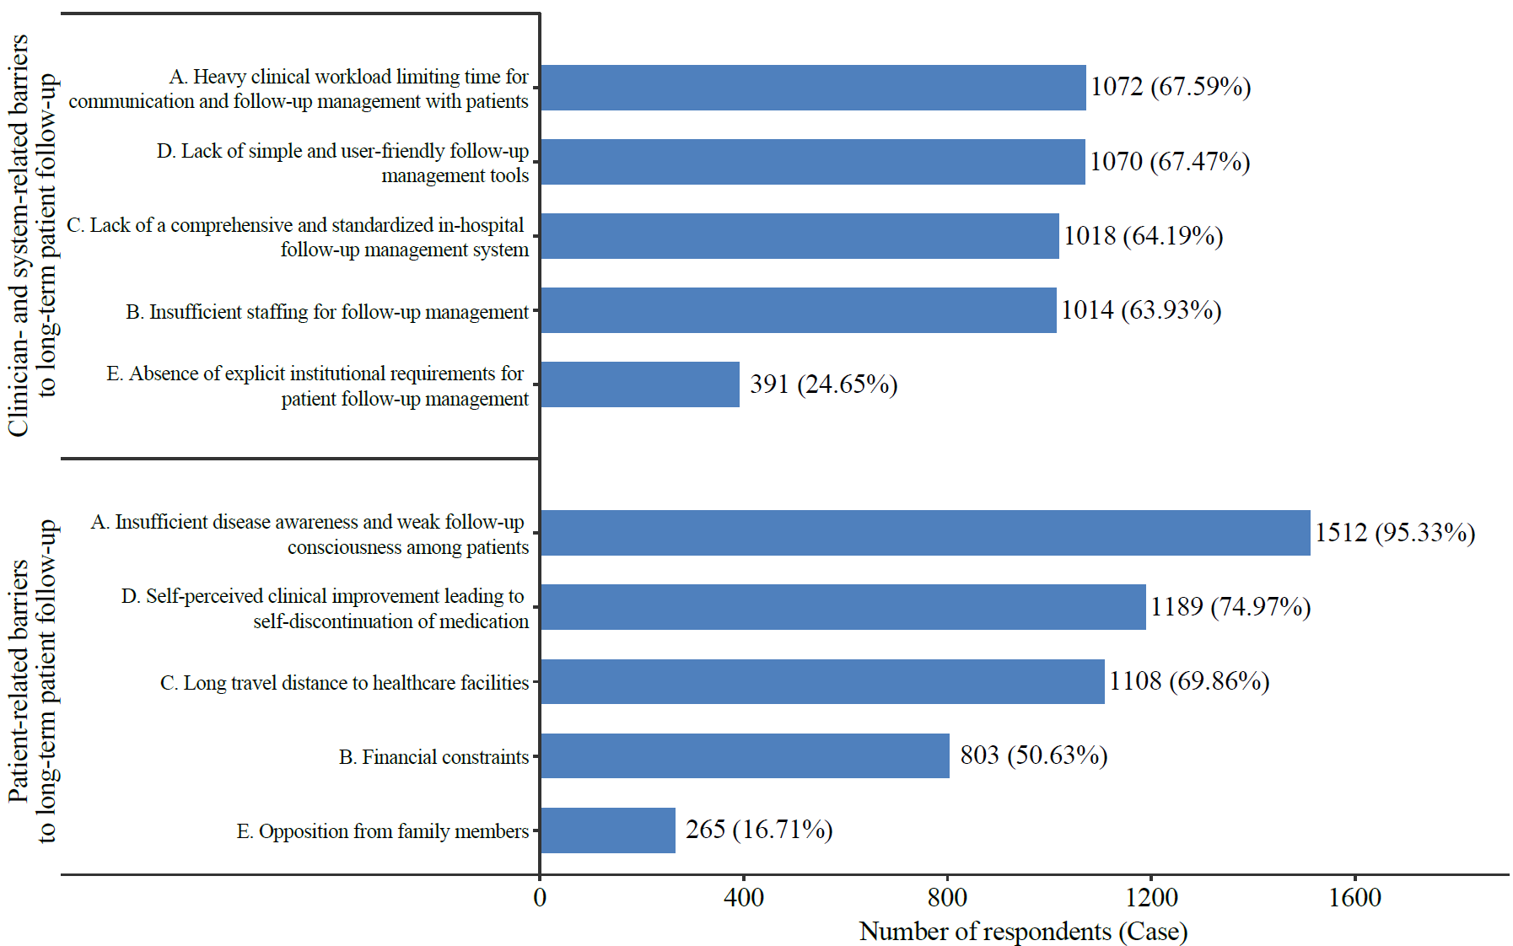
Figure 1. Bar chart of factors affecting long-term patient follow-up management as reported by Chinese clinicians. The x-axis represents the number and proportion of respondents for each factor, stratified by source of influence: clinician-related vs patient-related barriers.

