Table 1. Leaf Doctor Measurement for Leaf Samples across 6 Estates
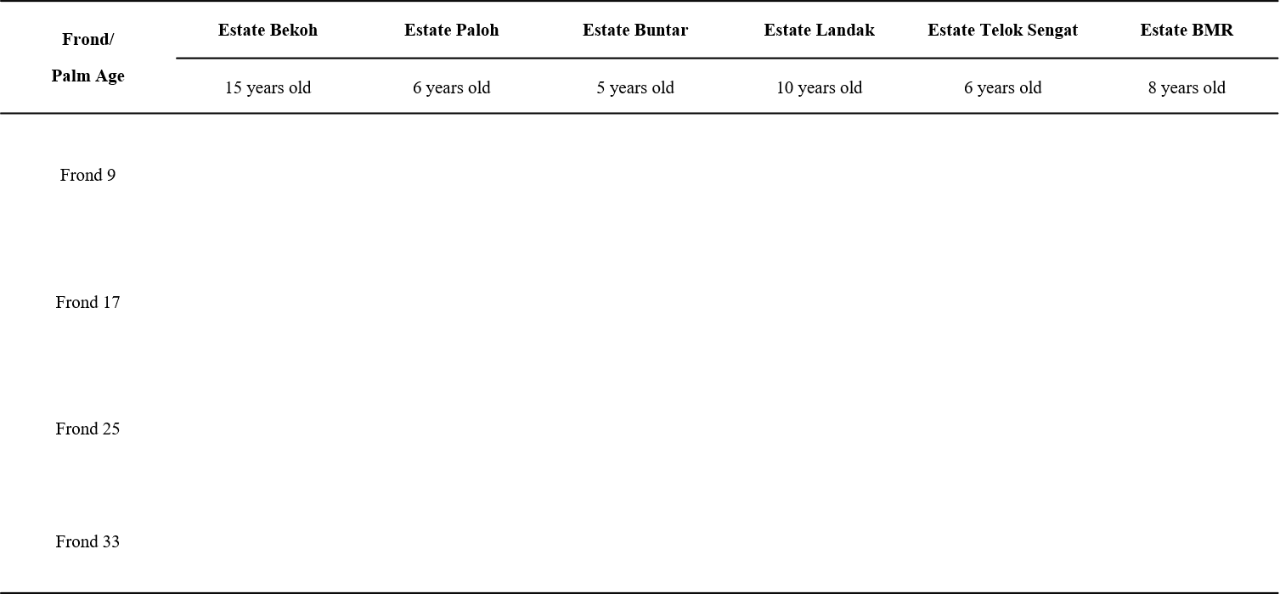
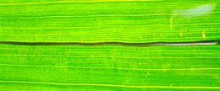
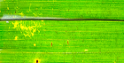
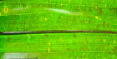
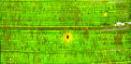
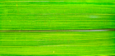
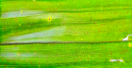
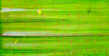
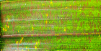
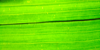
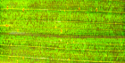
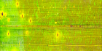
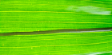
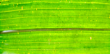
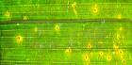
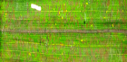
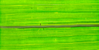
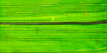
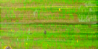
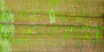
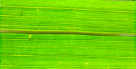
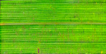
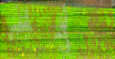
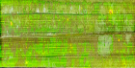

Table 2. Percentage of symptomatic leaf area for each frond (F9, F17, F25, F33) across different estates, assessed using Leaf Doctor. Values are presented as mean ± standard deviation (SD) (n = 18).
Estate | % Symptomatic | % Symptomatic | % Symptomatic | % Symptomatic
Estate | F9 | F17 | F25 | F33
Buntar | 1%±0.004 | 22%±0.024 | 35%±0.043 | 71%±0.069
Paloh | 3%±0.011 | 17%±0.025 | 29%±0.029 | 59%±0.053
Bekoh | 2%±0.007 | 13%±0.023 | 32%±0.037 | 64%±0.039
Landak | 2%0.007 | 22%±0.029 | 36%±0.036 | 71%±0.069
Telok Sengat | 1%±0.006 | 17%±0.035 | 60%±0.049 | 84%±0.041
BMR (Home) | 4%±0.015 | 18%±0.048 | 63%±0.047 | 81%±0.072

Table 3. Grouping of locations based on Dunn’s post Hoc Test. Values followed by different letters within each column are significantly different according to Dunn’s post-hoc test with Bonferroni adjustment (p<0.05) following Kruskal-Wallis analysis. (Adjusted P <0.05).
Estates | Mild | Moderate | Severe
Bekoh | a | a | a
Buntar | b | b | b
Landak | b | b | b
Telok Sengat | ab | b | c
Paloh | ab | b | bc
BMR | ab | c | bc

Fronds | Estate Bekoh | Estate Paloh | Estate Buntar | Estate Landak | Estate Teluk Sengat | Estate BMR
Frond 9 | 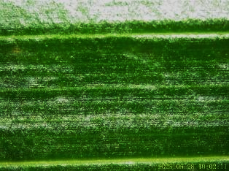 | 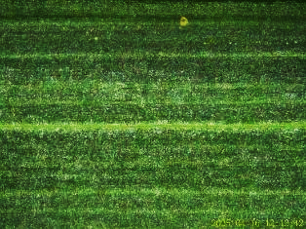 | 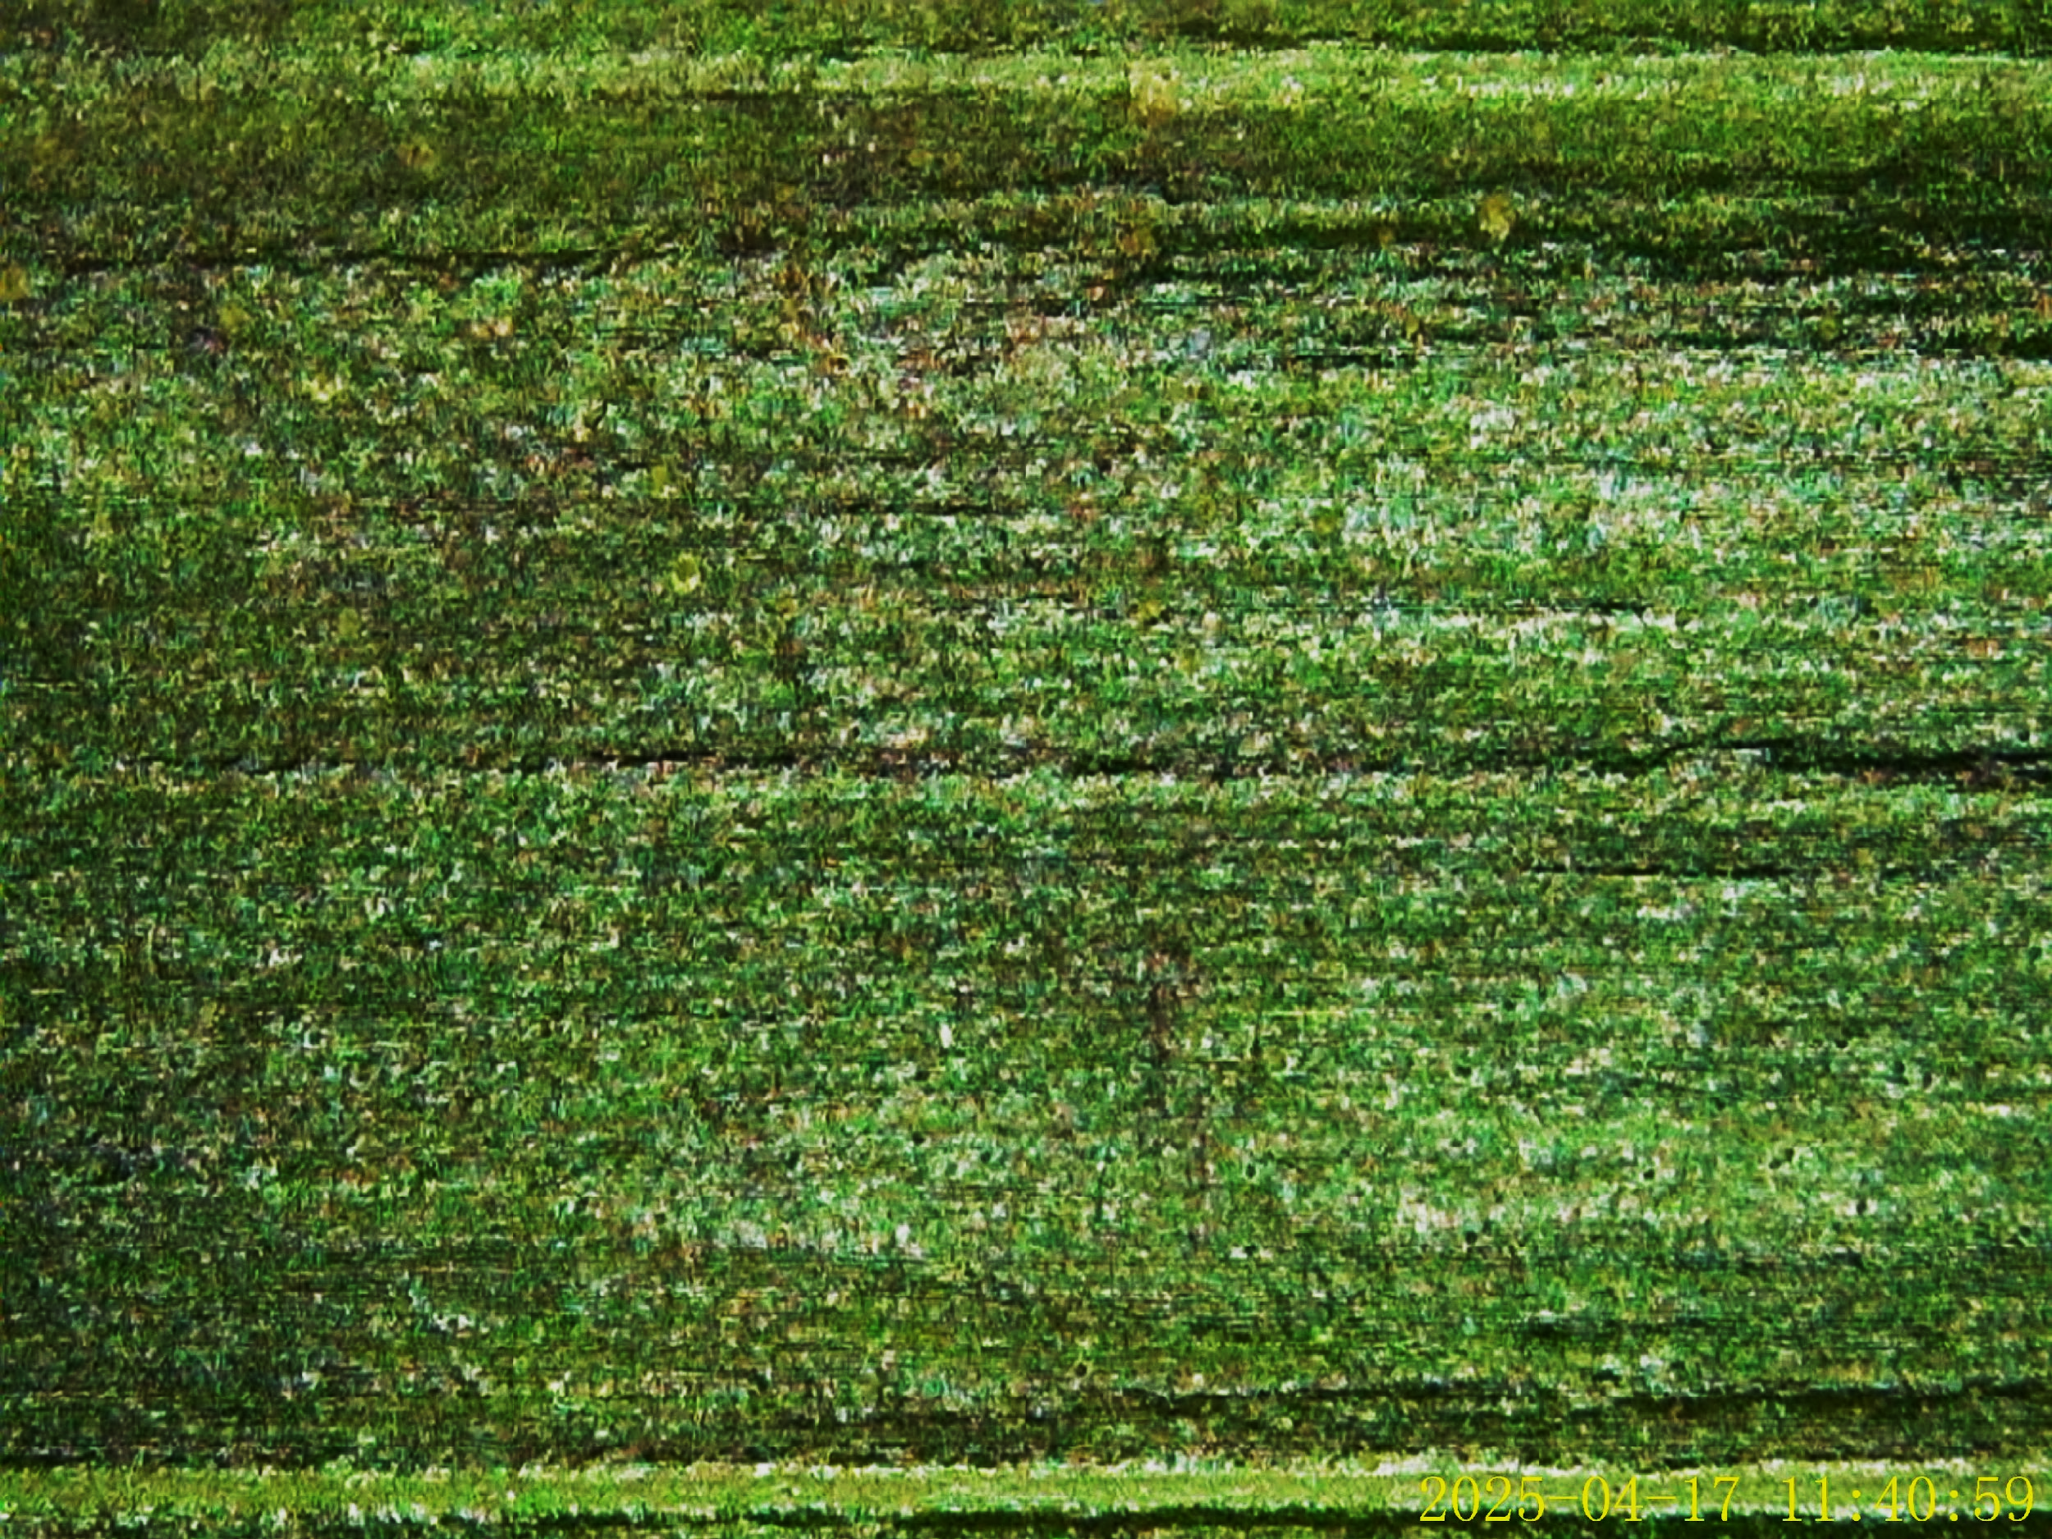 | 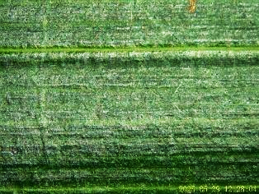 | 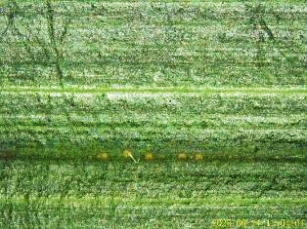 | 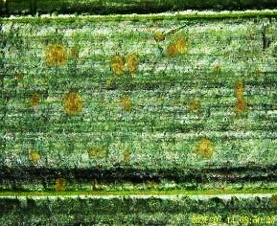
Frond 17 | 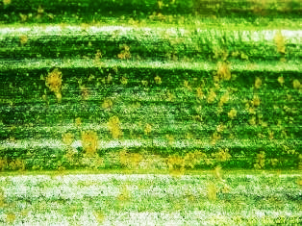 | 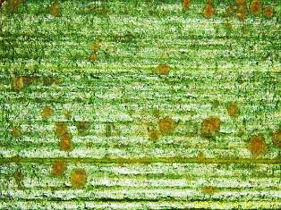 | 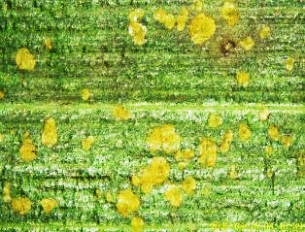 | 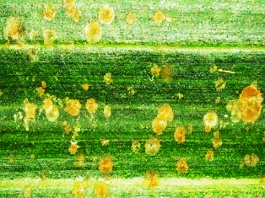 | 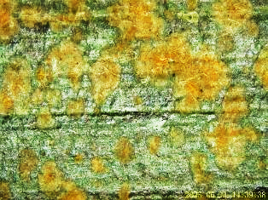 | 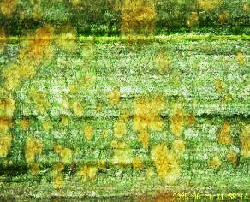
Frond 25 | 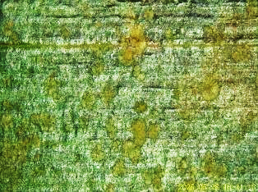 | 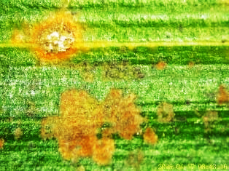 | 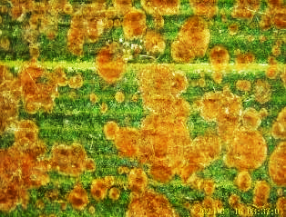 | 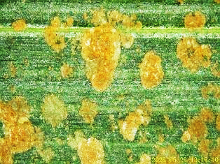 |  | 
Frond 33 |  | 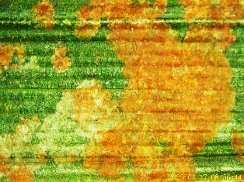 |  |  | 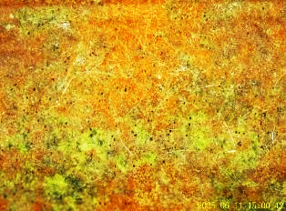 | 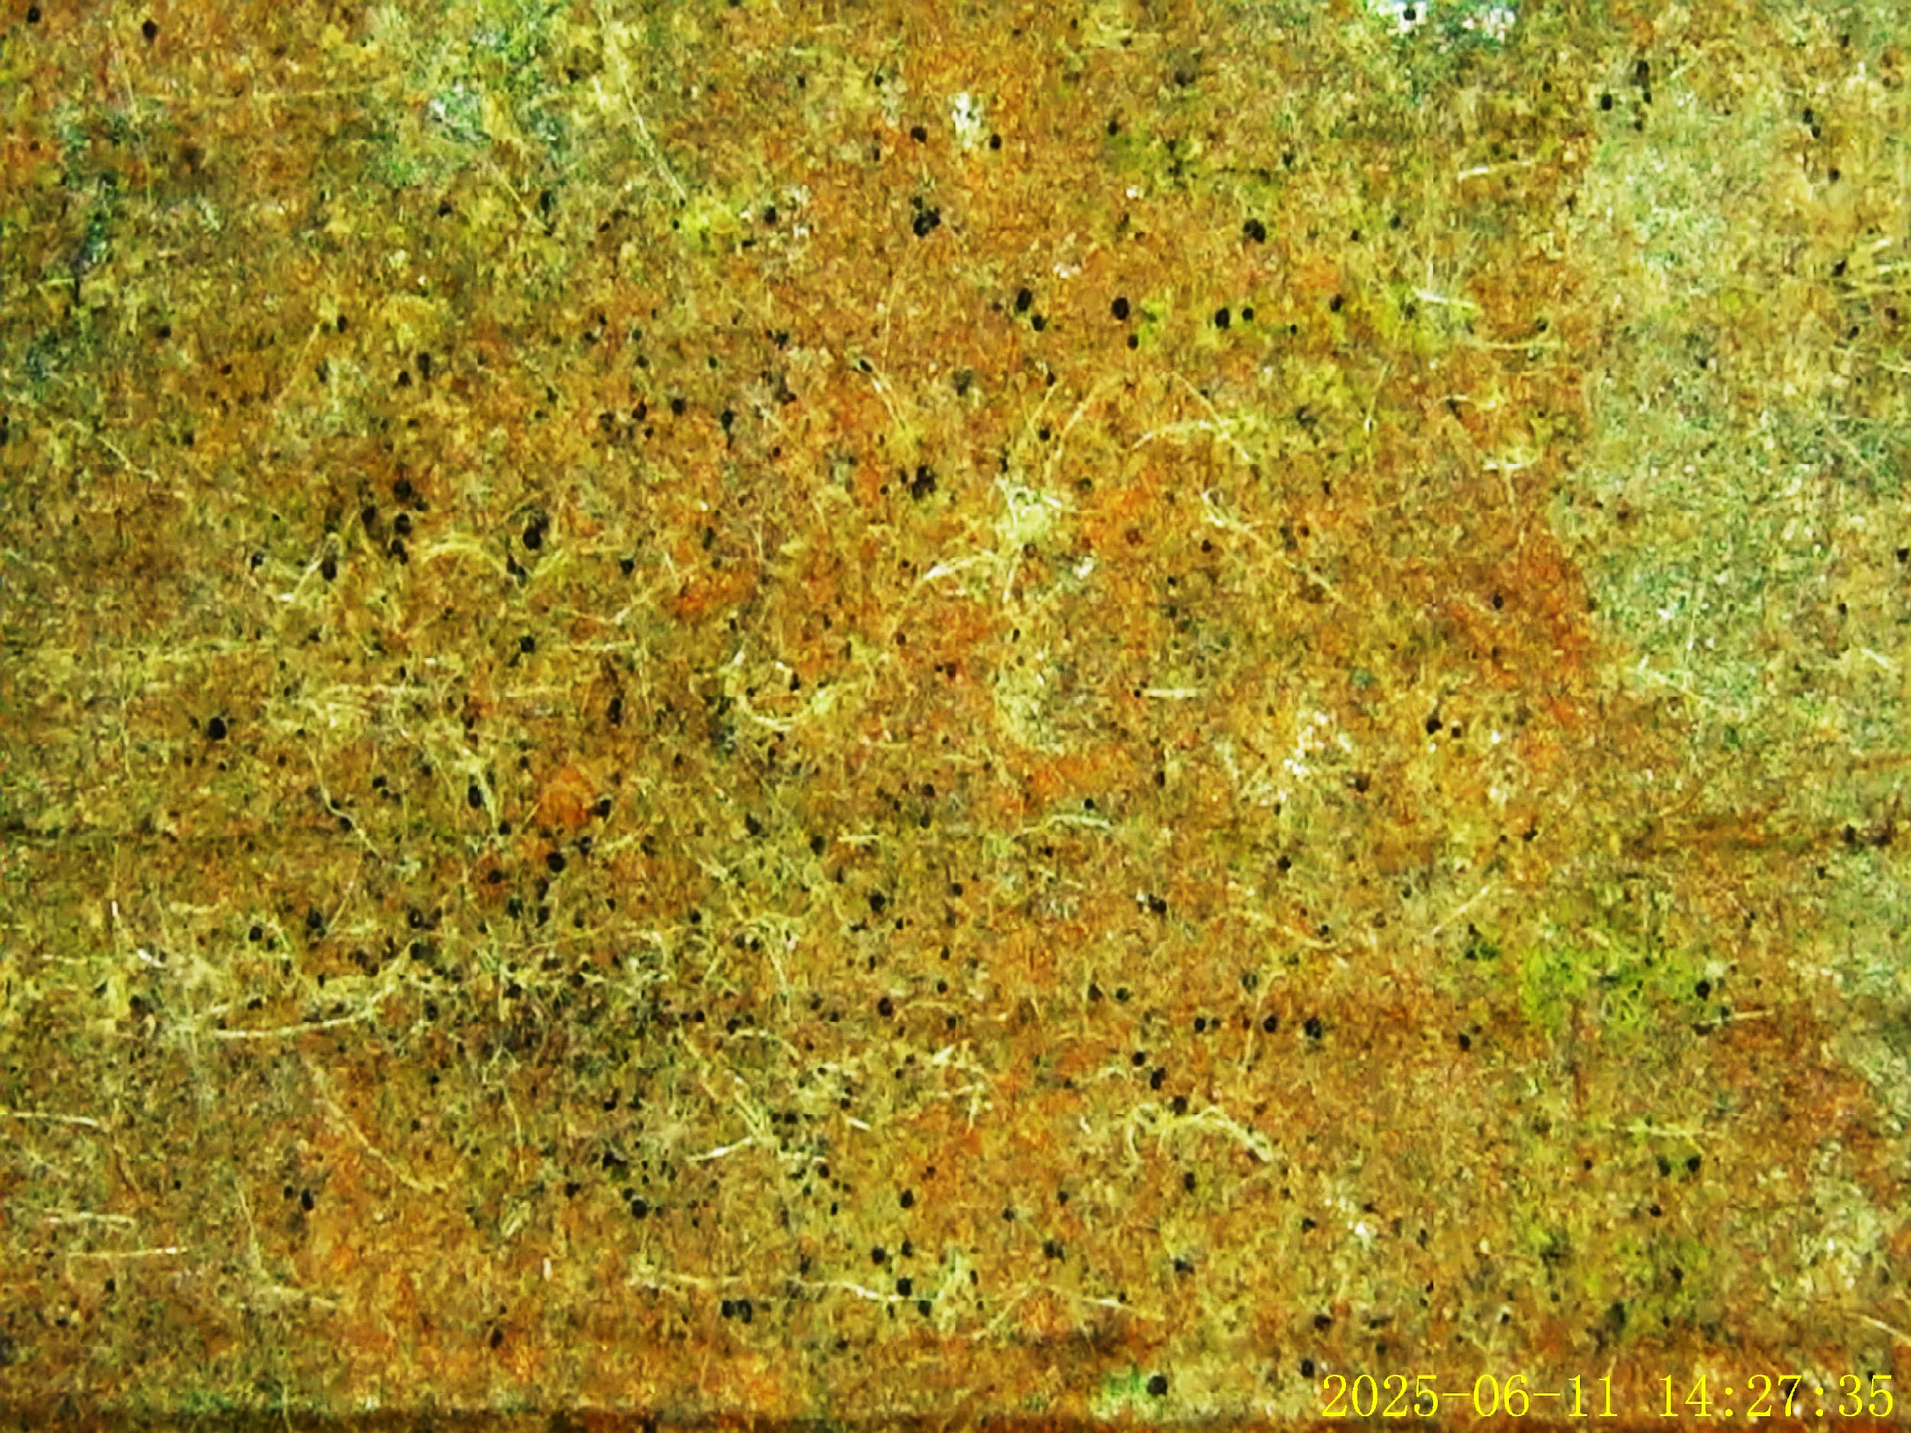
Table 4. Stereomicroscopic observation for Leaf Samples across 6 Estates

