Variable | No. of Missing Values | Missing Proportion (%)
PSA_B | 14881 | 15.99
ALCO_AMOUNT_B1 | 5271 | 5.67
EGFR | 4105 | 4.41
alco_b1 | 1616 | 1.74
SBP_B | 1488 | 1.60
DBP_B | 1486 | 1.60
HDL_B | 1189 | 1.28
SMOK_B1 | 762 | 0.82
LDL_B | 748 | 0.80
TG_B | 528 | 0.57
Supplementary Table 1. Proportion of missing values in selected baseline variables

Supplementary Table 2. Confusion Matrices of Ridge Model With and Without PSA Variable (Test Set)
 | Predicted Negative | Predicted Positive | Total
Without PSA variable
Actual Negative | 14,821 (TN) | 3,614 (FP) | 18,435
Actual Positive | 21 (FN) | 136 (TP) | 157
With PSA variable
Actual Negative | 14,837 (TN) | 3,598 (FP) | 18,435
Actual Positive | 16 (FN) | 141 (TP) | 157
TN: True Negative; TP: True Positive; FN: False Negative; FN: False Positive

Supplementary Table 3. Confusion Matrices of Random Forest Model With and Without PSA Variable (Test Set)
 | Predicted Negative | Predicted Positive | Total
Without PSA variable
Actual Negative | 14,821 (TN) | 3,614 (FP) | 18,435
Actual Positive | 21 (FN) | 136 (TP) | 157
With PSA variable
Actual Negative | 14,837 (TN) | 3,598 (FP) | 18,435
Actual Positive | 16 (FN) | 141 (TP) | 157
TN: True Negative; TP: True Positive; FN: False Negative; FN: False Positive

Supplementary Table 4. Confusion Matrices of LightGBM Model With and Without PSA Variable (Test Set)
 | Predicted Negative | Predicted Positive | Total
Without PSA variable
Actual Negative | 14,799 (TN) | 3,636 (FP) | 18,435
Actual Positive | 20 (FN) | 137 (TP) | 157
With PSA variable
Actual Negative | 14,819 (TN) | 3,616 (FP) | 18,435
Actual Positive | 15 (FN) | 142 (TP) | 157

Supplementary Table 5. Confusion Matrices of XGBoost Model With and Without PSA Variable (Test Set)
 | Predicted Negative | Predicted Positive | Total
Without PSA variable
Actual Negative | 14,762 (TN) | 3,673 (FP) | 18,435
Actual Positive | 25 (FN) | 132 (TP) | 157
With PSA variable
Actual Negative | 14,829 (TN) | 3,606 (FP) | 18,435
Actual Positive | 13 (FN) | 144 (TP) | 157

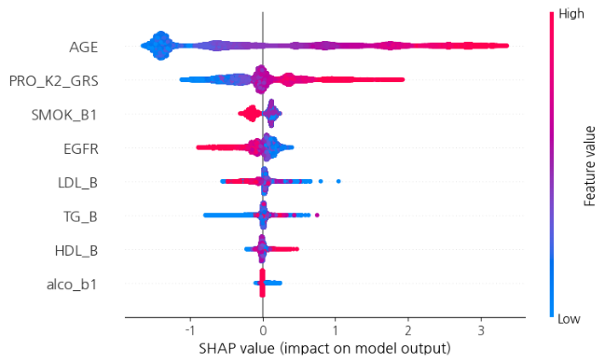 | 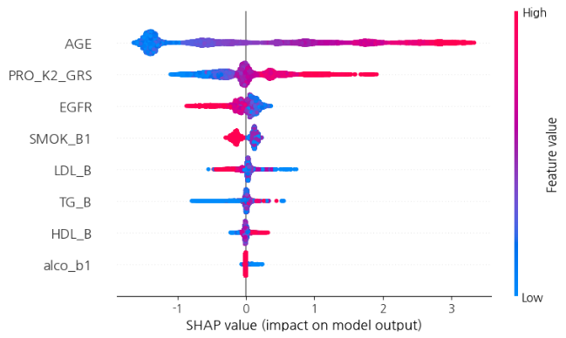
Supplementary figure 2. SHAP Summary Plot of the LightGBM Model on the Training Set | Supplementary figure 3. SHAP Summary Plot of the LightGBM Model on the Test Set

