Table S1 Baseline characteristics of the participants classified by eGDR
Characteristics | Overall  N=7,472 | high eGDR  N=4,179 | low eGDR  N=3,293 | p-value
Age, years (median(IQR)) | 58.00 (52.00，65.00) | 56.00 (50.00，62.00) | 60.00 (54.00，67.00) | <0.001
Age, n (%) |  |  |  | <0.001
Age<75 | 7,010 (93.8%) | 4,002 (95.8%) | 3,008 (91.3%)
Age≥75 | 462 (6.2%) | 177 (4.2%) | 285 (8.7%)
Hukou, n (%) |  |  |  | <0.001
Others | 1,313 (18%) | 642 (15%) | 671 (20%)
Agriculture | 6,159 (82%) | 3,537 (85%) | 2,622 (80%)
Gender, n (%) |  |  |  | 0.002
Female | 3,844 (51%) | 2,082 (50%) | 1,762 (54%)
Male | 3,628 (49%) | 2,097 (50%) | 1,531 (46%)
Marry, n (%) |  |  |  | <0.001
Others | 824 (11%) | 358 (8.6%) | 466 (14%)
Married | 6,648 (89%) | 3,821 (91.4%) | 2,827 (86%)
Education, n (%) |  |  |  | <0.001
Elementary school  and below | 5,125 (69%) | 2,767 (66.2%) | 2,358 (71.6%)
Secondary school | 2,238 (30%) | 1,355 (32.4%) | 883 (26.8%)
College and above | 109 (1.0%) | 57 (1.4%) | 52 (1.6%)
BMI, kg/m2 (Median(IQR)) | 23.20 (20.97，25.75) | 22.37 (20.42，24.43) | 24.58 (22.01，27.35) | <0.001
Smoke, n (%) |  |  |  | 0.005
No | 4,462 (60%) | 2,437 (58%) | 2,025 (61%)
Yes | 3,010 (40%) | 1,742 (42%) | 1,268 (39%)
Drink, n (%) |  |  |  | <0.001
No | 4,907 (66%) | 2,669 (64%) | 2,238 (68%)
Yes | 2,565 (34%) | 1,510 (36%) | 1,055 (32%)
Hypertension, n (%) |  |  |  | <0.001
No | 4,477 (60%) | 4,171 (99.8%) | 306 (9.3%)
Yes | 2,995 (40%) | 8 (0.2%) | 2,987 (90.7%)
Diabetes, n (%) |  |  |  | <0.001
No | 6,260 (84%) | 3,743 (90%) | 2,517 (76%)
Yes | 1,212 (16%) | 436 (10%) | 776 (24%)
Dyslipidemia, n (%) |  |  |  | <0.001
No | 3,911 (52%) | 2,503 (60%) | 1,408 (43%)
Yes | 3,561 (48%) | 1,676 (40%) | 1,885 (57%)
Height, cm (Median(IQR)) | 158.00 (152.30，164.40) | 158.30 (152.60，164.30) | 157.90 (152.00，164.40) | 0.078
Weight, kg (Median(IQR)) | 58.20 (51.50，65.80) | 56.20 (50.40，62.70) | 61.30 (53.50，70.00) | <0.001
Waist, cm (Median(IQR)) | 85.00 (78.00，92.00) | 82.00 (76.40，88.00) | 89.20 (82.00，97.00) | <0.001
FBG, mg/dl (Median(IQR)) | 102.42 (94.50，113.40) | 100.62 (93.06，109.62) | 105.12 (96.48，118.62) | <0.001
HbA1c, mg/dl (Median(IQR)) | 5.10 (4.90，5.40) | 5.10 (4.90，5.40) | 5.20 (4.90，5.50) | <0.001
TC, mg/dl (Median(IQR)) | 190.98 (167.78，215.34) | 187.50 (165.08，211.47) | 194.85 (171.26，220.75) | <0.001
TG, mg/dl (Median(IQR)) | 105.32 (74.34，153.99) | 94.69 (69.03，138.95) | 119.47 (83.19，177.00) | <0.001
HDL, mg/dl (Median(IQR)) | 49.48 (40.59，59.92) | 51.42 (42.14，61.86) | 47.17 (38.66，57.22) | <0.001
LDL, mg/dl (Median(IQR)) | 114.43 (93.56，137.63) | 112.50 (92.01，134.15) | 117.14 (95.49，141.50) | <0.001
Abbreviations:eGDR:estimated glucose disposal rate;Hukou:the system of household registration;BMI:body mass index;FBG:fasting blood glucose;HbA1c:glycated hemoglobin;TC:total cholesterol;TG:triglyceride;HDL:high density lipoprotein cholesterol;LDL:low density lipoprotein cholesterol

Table S2 Baseline characteristics of the participants classified by ABSI
Characteristics | Overall  N=7,472 | low ABSI  N=5,883 | high ABSI  N=1,589 | p-value
Age, years (median(IQR)) | 58.00 (52.00，65.00) | 57.00 (50.00，63.00) | 63.00 (57.00，70.00) | <0.001
Age, n (%) |  |  |  | <0.001
Age<75 | 7,010 (93.8%) | 5,658 (96.2%) | 1,352 (85%)
Age≥75 | 462 (6.2%) | 225 (3.8%) | 237 (15%)
Hukou, n (%) |  |  |  | 0.93
Others | 1,313 (18%) | 1,035 (18%) | 278 (17%)
Agriculture | 6,159 (82%) | 4,848 (82%) | 1,311 (83%)
Gender, n (%) |  |  |  | <0.001
Female | 3,844 (51%) | 2,826 (48%) | 1,018 (64%)
Male | 3,628 (49%) | 3,057 (52%) | 571 (36%)
Marry, n (%) |  |  |  | <0.001
Others | 824 (11%) | 560 (9.5%) | 264 (17%)
Married | 6,648 (89%) | 5,323 (90.5%) | 1,325 (83%)
Education, n (%) |  |  |  | <0.001
Elementary school  and below | 5,125 (68.6%) | 3,850 (65.4%) | 1,275 (80.2%)
Secondary school | 2,238 (29.9%) | 1,934 (32.9%) | 304 (19.2%)
College and above | 109 (1.5%) | 99 (1.7%) | 10 (0.6%)
BMI, kg/m2 (Median(IQR)) | 23.20 (20.97，25.75) | 23.31 (21.10，25.89) | 22.79 (20.39，25.19) | <0.001
Smoke, n (%) |  |  |  | <0.001
No | 4,462 (60%) | 3,409 (58%) | 1,053 (66%)
Yes | 3,010 (40%) | 2,474 (42%) | 536 (34%)
Drink, n (%) |  |  |  | <0.001
No | 4,907 (66%) | 3,752 (64%) | 1,155 (73%)
Yes | 2,565 (34%) | 2,131 (36%) | 434 (27%)
Hypertension, n (%) |  |  |  | <0.001
No | 4,477 (60%) | 3,658 (62%) | 819 (52%)
Yes | 2,995 (40%) | 2,225 (38%) | 770 (48%)
Diabetes, n (%) |  |  |  | <0.001
No | 6,260 (84%) | 4,991 (85%) | 1,269 (80%)
Yes | 1,212 (16%) | 892 (15%) | 320 (20%)
Dyslipidemia, n (%) |  |  |  | <0.001
No | 3,911 (52%) | 3,138 (53%) | 773 (49%)
Yes | 3,561 (48%) | 2,745 (47%) | 816 (51%)
Height, cm (Median(IQR)) | 158.00 (152.30，164.40) | 158.90 (153.10，164.90) | 155.50 (149.60，161.70) | <0.001
Weight, kg (Median(IQR)) | 58.20 (51.50，65.80) | 59.00 (52.50，66.60) | 54.90 (48.30，62.70) | <0.001
Waist, cm (Median(IQR)) | 85.00 (78.00，92.00) | 83.20 (77.00，90.00) | 90.20 (84.30，97.00) | <0.001
FBG, mg/dl (Median(IQR)) | 102.42 (94.50，113.40) | 102.24 (94.14，112.77) | 103.68 (95.22，116.10) | <0.001
HbA1c, mg/dl (Median(IQR)) | 5.10 (4.90，5.40) | 5.10 (4.90，5.40) | 5.20 (4.90，5.50) | <0.001
TC, mg/dl (Median(IQR)) | 190.98 (167.78，215.34) | 189.43 (166.62，214.18) | 195.62 (171.26，221.14) | <0.001
TG, mg/dl (Median(IQR)) | 105.32 (74.34，153.99) | 102.66 (72.57，150.45) | 111.51 (79.65，162.84) | <0.001
HDL, mg/dl (Median(IQR)) | 49.48 (40.59，59.92) | 49.48 (40.59，60.31) | 48.71 (40.21，59.15) | 0.046
LDL, mg/dl (Median(IQR)) | 114.43 (93.56，137.63) | 113.66 (92.98，136.47) | 117.53 (95.49，141.11) | <0.001
Abbreviations:ABSI:A body shape index;Hukou:the system of household registration;BMI:body mass index;FBG:fasting blood glucose;HbA1c:glycated hemoglobin;TC:total cholesterol;TG:triglyceride;HDL:high density lipoprotein cholesterol;LDL:low density lipoprotein cholesterol

Table S3 Baseline characteristics of the participants classified by BRI
Characteristics | Overall  N=7,472 | low BRI  N=4,816 | high BRI  N=2,656 | p-value
Age, years (median(IQR)) | 58.00 (52.00，65.00) | 57.00 (51.00，64.00) | 59.00 (52.00，65.00) | <0.001
Age, n (%) |  |  |  | 0.14
Age<75 | 7,010 (93.8%) | 4,533 (94.1%) | 2,477 (93.3%)
Age≥75 | 462 (6.2%) | 283 (5.9%) | 179 (6.7%)
Hukou, n (%) |  |  |  | <0.001
Others | 1,313 (18%) | 767 (16%) | 546 (21%)
Agriculture | 6,159 (82%) | 4,049 (84%) | 2,110 (79%)
Gender, n (%) |  |  |  | <0.001
Female | 3,844 (51%) | 1,996 (41%) | 1,848 (70%)
Male | 3,628 (49%) | 2,820 (59%) | 808 (30%)
Marry, n (%) |  |  |  | 0.009
Others | 824 (11%) | 497 (10%) | 327 (12%)
Married | 6,648 (89%) | 4,319 (90%) | 2,329 (88%)
Education, n (%) |  |  |  | <0.001
Elementary school  and below | 5,125 (68.6%) | 3,223 (66.9%) | 1,902 (71.6%)
Secondary school | 2,238 (29.9%) | 1,513 (31.4%) | 725 (27.3%)
College and above | 109 (1.5%) | 80 (1.7%) | 29 (1.1%)
BMI, kg/m2 (Median(IQR)) | 23.20 (20.97，25.75) | 21.79 (20.11，23.51) | 26.41 (24.56，28.39) | <0.001
Smoke, n (%) |  |  |  | <0.001
No | 4,462 (60%) | 2,509 (52%) | 1,953 (74%)
Yes | 3,010 (40%) | 2,307 (48%) | 703 (26%)
Drink, n (%) |  |  |  | <0.001
No | 4,907 (66%) | 2,898 (60%) | 2,009 (76%)
Yes | 2,565 (34%) | 1,918 (40%) | 647 (24%)
Hypertension, n (%) |  |  |  | <0.001
No | 4,477 (60%) | 3,294 (68%) | 1,183 (45%)
Yes | 2,995 (40%) | 1,522 (32%) | 1,473 (55%)
Diabetes, n (%) |  |  |  | <0.001
No | 6,260 (84%) | 4,182 (87%) | 2,078 (78%)
Yes | 1,212 (16%) | 634 (13%) | 578 (22%)
Dyslipidemia, n (%) |  |  |  | <0.001
No | 3,911 (52%) | 2,918 (61%) | 993 (37%)
Yes | 3,561 (48%) | 1,898 (39%) | 1,663 (63%)
Height, cm (Median(IQR)) | 158.00 (152.30，164.40) | 159.90 (154.00，165.50) | 155.00 (150.00，161.00) | <0.001
Weight, kg (Median(IQR)) | 58.20 (51.50，65.80) | 55.50 (49.60，62.00) | 64.40 (56.90，72.40) | <0.001
Waist, cm (Median(IQR)) | 85.00 (78.00，92.00) | 80.00 (75.50，85.00) | 94.00 (90.00，99.00) | <0.001
FBG, mg/dl (Median(IQR)) | 102.42 (94.50，113.40) | 100.98 (93.24，110.56) | 105.48 (96.66，117.72) | <0.001
HbA1c, mg/dl (Median(IQR)) | 5.10 (4.90，5.40) | 5.10 (4.90，5.40) | 5.20 (4.90，5.50) | <0.001
TC, mg/dl (Median(IQR)) | 190.98 (167.78，215.34) | 187.89 (165.08，211.08) | 196.78 (173.20，223.84) | <0.001
TG, mg/dl (Median(IQR)) | 105.32 (74.34，153.99) | 92.93 (68.14，136.29) | 127.44 (91.82，187.62) | <0.001
HDL, mg/dl (Median(IQR)) | 49.48 (40.59，59.92) | 52.19 (42.91，62.73) | 45.23 (37.11，54.12) | <0.001
LDL, mg/dl (Median(IQR)) | 114.43 (93.56，137.63) | 112.11 (91.24，133.38) | 120.23 (97.81，144.59) | <0.001
Abbreviations:BRI:body roundness index;Hukou:the system of household registration;BMI:body mass index;FBG:fasting blood glucose;HbA1c:glycated hemoglobin;TC:total cholesterol;TG:triglyceride;HDL:high density lipoprotein cholesterol;LDL:low density lipoprotein cholesterol

Table S4 Baseline characteristics of the participants classified by CVAI
Characteristics | Overall  N=7,472 | low CVAI  N=3,686 | high CVAI  N=3,786 | p-value
Age, years (median(IQR)) | 58.00 (52.00，65.00) | 56.00 (50.00，63.00) | 60.00 (53.00，66.00) | <0.001
Age, n (%) |  |  |  | <0.001
Age<75 | 7,010 (93.8%) | 3,524 (95.6%) | 3,486 (92.1%)
Age≥75 | 462 (6.2%) | 162 (4.4%) | 300 (7.9%)
Hukou, n (%) |  |  |  | <0.001
Others | 1,313 (18%) | 451 (12%) | 862 (23%)
Agriculture | 6,159 (82%) | 3,235 (88%) | 2,924 (77%)
Gender, n (%) |  |  |  | <0.001
Female | 3,844 (51%) | 1,727 (47%) | 2,117 (56%)
Male | 3,628 (49%) | 1,959 (53%) | 1,669 (44%)
Marry, n (%) |  |  |  | <0.001
Others | 824 (11%) | 355 (9.6%) | 469 (12%)
Married | 6,648 (89%) | 3,331 (90.4%) | 3,317 (88%)
Education, n (%) |  |  |  | 0.043
Elementary school  and below | 5,125 (68.6%) | 2,546 (69.1%) | 2,579 (68.1%)
Secondary school | 2,238 (29.9%) | 1,099 (29.8%) | 1,139 (30.1%)
College and above | 109 (1.5%) | 41 (1.1%) | 68 (1.8%)
BMI, kg/m2 (Median(IQR)) | 23.20 (20.97，25.75) | 21.24 (19.75，22.82) | 25.47 (23.54，27.60) | <0.001
Smoke, n (%) |  |  |  | <0.001
No | 4,462 (60%) | 2,024 (55%) | 2,438 (64%)
Yes | 3,010 (40%) | 1,662 (45%) | 1,348 (36%)
Drink, n (%) |  |  |  | <0.001
No | 4,907 (66%) | 2,271 (62%) | 2,636 (70%)
Yes | 2,565 (34%) | 1,415 (38%) | 1,150 (30%)
Hypertension, n (%) |  |  |  | <0.001
No | 4,477 (60%) | 2,673 (73%) | 1,804 (48%)
Yes | 2,995 (40%) | 1,013 (27%) | 1,982 (52%)
Diabetes, n (%) |  |  |  | <0.001
No | 6,260 (84%) | 3,310 (90%) | 2,950 (78%)
Yes | 1,212 (16%) | 376 (10%) | 836 (22%)
Dyslipidemia, n (%) |  |  |  | <0.001
No | 3,911 (52%) | 2,600 (71%) | 1,311 (35%)
Yes | 3,561 (48%) | 1,086 (29%) | 2,475 (65%)
Height, cm (Median(IQR)) | 158.00 (152.30，164.40) | 158.10 (152.60，164.00) | 158.00 (152.00，165.00) | 0.54
Weight, kg (Median(IQR)) | 58.20 (51.50，65.80) | 53.40 (48.30，58.50) | 64.50 (57.50，71.50) | <0.001
Waist, cm (Median(IQR)) | 85.00 (78.00，92.00) | 78.20 (74.00，82.40) | 91.60 (87.20，97.00) | <0.001
FBG, mg/dl (Median(IQR)) | 102.42 (94.50，113.40) | 99.90 (92.34，108.54) | 105.48 (96.84，118.08) | <0.001
HbA1c, mg/dl (Median(IQR)) | 5.10 (4.90，5.40) | 5.10 (4.80，5.40) | 5.20 (4.90，5.50) | <0.001
TC, mg/dl (Median(IQR)) | 190.98 (167.78，215.34) | 186.34 (163.92，209.92) | 195.23 (171.26，221.14) | <0.001
TG, mg/dl (Median(IQR)) | 105.32 (74.34，153.99) | 82.31 (62.83，112.39) | 134.52 (98.24，197.35) | <0.001
HDL, mg/dl (Median(IQR)) | 49.48 (40.59，59.92) | 56.06 (47.17，66.88) | 43.69 (36.34，51.80) | <0.001
LDL, mg/dl (Median(IQR)) | 114.43 (93.56，137.63) | 110.76 (91.24，132.22) | 118.69 (95.97，142.27) | <0.001
Abbreviations:CVAI:Chinese Visceral Adiposity Index;Hukou:the system of household registration;BMI:body mass index;FBG:fasting blood glucose;HbA1c:glycated hemoglobin;TC:total cholesterol;TG:triglyceride;HDL:high density lipoprotein cholesterol;LDL:low density lipoprotein cholesterol

Table S5 Baseline characteristics of the participants classified by CI
Characteristics | Overall  N=7,472 | low CI  N=4,945 | high CI  N=2,527 | p-value
Age, years (median(IQR)) | 58.00 (52.00，65.00) | 57.00 (50.00，63.00) | 61.00 (55.00，68.00) | <0.001
Age, n (%) |  |  |  | <0.001
Age<75 | 7,010 (93.8%) | 4,740 (95.9%) | 2,270 (90%)
Age≥75 | 462 (6.2%) | 205 (4.1%) | 257 (10%)
Hukou, n (%) |  |  |  | <0.001
Others | 1,313 (18%) | 802 (16%) | 511 (20%)
Agriculture | 6,159 (82%) | 4,143 (84%) | 2,016 (80%)
Gender, n (%) |  |  |  | <0.001
Female | 3,844 (51%) | 2,273 (46%) | 1,571 (62%)
Male | 3,628 (49%) | 2,672 (54%) | 956 (38%)
Marry, n (%) |  |  |  | <0.001
Others | 824 (11%) | 490 (9.9%) | 334 (13%)
Married | 6,648 (89%) | 4,455 (90.1%) | 2,193 (87%)
Education, n (%) |  |  |  | <0.001
Elementary school  and below | 5,125 (68.6%) | 3,230 (65.3%) | 1,895 (75%)
Secondary school | 2,238 (29.9%) | 1,631 (33%) | 607 (24%)
College and above | 109 (1.5%) | 84 (1.7%) | 25 (1.0%)
BMI, kg/m2 (Median(IQR)) | 23.20 (20.97，25.75) | 22.55 (20.59，24.82) | 24.59 (22.17，27.16) | <0.001
Smoke, n (%) |  |  |  | <0.001
No | 4,462 (60%) | 2,772 (56%) | 1,690 (67%)
Yes | 3,010 (40%) | 2,173 (44%) | 837 (33%)
Drink, n (%) |  |  |  | <0.001
No | 4,907 (66%) | 3,074 (62%) | 1,833 (73%)
Yes | 2,565 (34%) | 1,871 (38%) | 694 (27%)
Hypertension, n (%) |  |  |  | <0.001
No | 4,477 (60%) | 3,239 (66%) | 1,238 (49%)
Yes | 2,995 (40%) | 1,706 (34%) | 1,289 (51%)
Diabetes, n (%) |  |  |  | <0.001
No | 6,260 (84%) | 4,284 (87%) | 1,976 (78%)
Yes | 1,212 (16%) | 661 (13%) | 551 (22%)
Dyslipidemia, n (%) |  |  |  | <0.001
No | 3,911 (52%) | 2,823 (57%) | 1,088 (43%)
Yes | 3,561 (48%) | 2,122 (43%) | 1,439 (57%)
Height, cm (Median(IQR)) | 158.00 (152.30，164.40) | 159.00 (153.10，164.90) | 156.50 (150.90，163.00) | <0.001
Weight, kg (Median(IQR)) | 58.20 (51.50，65.80) | 57.30 (51.10，64.40) | 60.50 (52.60，69.15) | <0.001
Waist, cm (Median(IQR)) | 85.00 (78.00，92.00) | 81.00 (76.00，86.80) | 93.00 (88.00，98.80) | <0.001
FBG, mg/dl (Median(IQR)) | 102.42 (94.50，113.40) | 101.52 (93.78，111.24) | 104.58 (95.94，117.36) | <0.001
HbA1c, mg/dl (Median(IQR)) | 5.10 (4.90，5.40) | 5.10 (4.90，5.40) | 5.20 (4.90，5.50) | <0.001
TC, mg/dl (Median(IQR)) | 190.98 (167.78，215.34) | 187.89 (165.85，212.63) | 196.01 (172.04，221.52) | <0.001
TG, mg/dl (Median(IQR)) | 105.32 (74.34，153.99) | 97.35 (69.92，142.49) | 120.36 (84.07，177.00) | <0.001
HDL, mg/dl (Median(IQR)) | 49.48 (40.59，59.92) | 51.42 (41.75，61.47) | 46.39 (37.89，56.44) | <0.001
LDL, mg/dl (Median(IQR)) | 114.43 (93.56，137.63) | 112.89 (92.40，134.54) | 118.30 (95.49，142.08) | <0.001
Abbreviations:CI:conicity index;Hukou:the system of household registration;BMI:body mass index;FBG:fasting blood glucose;HbA1c:glycated hemoglobin;TC:total cholesterol;TG:triglyceride;HDL:high density lipoprotein cholesterol;LDL:low density lipoprotein cholesterol

Table S6 Baseline characteristics of the participants classified by WHtR
Characteristics | Overall  N=7,472 | low WHtR  N=4,728 | high WHtR  N=2,744 | p-value
Age, years (median(IQR)) | 58.00 (52.00，65.00) | 57.00 (51.00，64.00) | 59.00 (52.00，65.00) | <0.001
Age, n (%) |  |  |  | 0.068
Age<75 | 7,010 (93.8%) | 4,454 (94.2%) | 2,556 (93.1%)
Age≥75 | 462 (6.2%) | 274 (5.8%) | 188 (6.9%)
Hukou, n (%) |  |  |  | <0.001
Others | 1,313 (18%) | 746 (16%) | 567 (21%)
Agriculture | 6,159 (82%) | 3,982 (84%) | 2,177 (79%)
Gender, n (%) |  |  |  | <0.001
Female | 3,844 (51%) | 1,948 (41%) | 1,896 (69%)
Male | 3,628 (49%) | 2,780 (59%) | 848 (31%)
Marry, n (%) |  |  |  | 0.011
Others | 824 (11%) | 488 (10%) | 336 (12%)
Married | 6,648 (89%) | 4,240 (90%) | 2,408 (88%)
Education, n (%) |  |  |  | <0.001
Elementary school  and below | 5,125 (68.6%) | 3,169 (67%) | 1,956 (71.3%)
Secondary school | 2,238 (29.9%) | 1,481 (31.4%) | 757 (27.6%)
College and above | 109 (1.5%) | 78 (1.6%) | 31 (1.1%)
BMI, kg/m2 (Median(IQR)) | 23.20 (20.97，25.75) | 21.76 (20.08，23.45) | 26.35 (24.48，28.32) | <0.001
Smoke, n (%) |  |  |  | <0.001
No | 4,462 (60%) | 2,452 (52%) | 2,010 (73%)
Yes | 3,010 (40%) | 2,276 (48%) | 734 (27%)
Drink, n (%) |  |  |  | <0.001
No | 4,907 (66%) | 2,837 (60%) | 2,070 (75%)
Yes | 2,565 (34%) | 1,891 (40%) | 674 (25%)
Hypertension, n (%) |  |  |  | <0.001
No | 4,477 (60%) | 3,246 (69%) | 1,231 (45%)
Yes | 2,995 (40%) | 1,482 (31%) | 1,513 (55%)
Diabetes, n (%) |  |  |  | <0.001
No | 6,260 (84%) | 4,112 (87%) | 2,148 (78%)
Yes | 1,212 (16%) | 616 (13%) | 596 (22%)
Dyslipidemia, n (%) |  |  |  | <0.001
No | 3,911 (52%) | 2,874 (61%) | 1,037 (38%)
Yes | 3,561 (48%) | 1,854 (39%) | 1,707 (62%)
Height, cm (Median(IQR)) | 158.00 (152.30，164.40) | 160.00 (154.00，165.50) | 155.10 (150.00，161.10) | <0.001
Weight, kg (Median(IQR)) | 58.20 (51.50，65.80) | 55.40 (49.60，61.80) | 64.20 (56.80，72.23) | <0.001
Waist, cm (Median(IQR)) | 85.00 (78.00，92.00) | 80.00 (75.40，84.60) | 94.00 (89.80，99.00) | <0.001
FBG, mg/dl (Median(IQR)) | 102.42 (94.50，113.40) | 100.98 (93.24，110.52) | 105.48 (96.66，117.72) | <0.001
HbA1c, mg/dl (Median(IQR)) | 5.10 (4.90，5.40) | 5.10 (4.90，5.40) | 5.20 (4.90，5.50) | <0.001
TC, mg/dl (Median(IQR)) | 190.98 (167.78，215.34) | 187.89 (165.08，211.08) | 196.39 (173.20，223.45) | <0.001
TG, mg/dl (Median(IQR)) | 105.32 (74.34，153.99) | 92.93 (68.14，135.40) | 127.44 (91.15，188.51) | <0.001
HDL, mg/dl (Median(IQR)) | 49.48 (40.59，59.92) | 52.19 (42.91，63.02) | 45.23 (37.11，54.12) | <0.001
LDL, mg/dl (Median(IQR)) | 114.43 (93.56，137.63) | 111.73 (91.24，132.99) | 120.23 (97.71，144.20) | <0.001
Abbreviations:WHtR:waist–height ratio;Hukou:the system of household registration;BMI:body mass index;FBG:fasting blood glucose;HbA1c:glycated hemoglobin;TC:total cholesterol;TG:triglyceride;HDL:high density lipoprotein cholesterol;LDL:low density lipoprotein cholesterol

Table S7 Baseline characteristics of the participants classified by eGDR and ABSI
Characteristics | Overall  N=7,472 | high eGDR and low ABSI  N=3,479 | low eGDR and low ABSI  N=2,404 | high eGDR and high ABSI  N=700 | low eGDR and high ABSI  N=889 | p-value
Age, years (median(IQR)) | 58.00 (52.00，65.00) | 55.00 (49.00，61.00) | 59.00 (53.00，65.00) | 61.00 (56.00，69.00) | 65.00 (59.00，72.00) | <0.001
Age, n (%) |  |  |  |  |  | <0.001
Age<75 | 7,010 (93.8%) | 3,383 (97.2%) | 2,275 (94.6%) | 619 (88%) | 733 (82%)
Age≥75 | 462 (6.2%) | 96 (2.8%) | 129 (5.4%) | 81 (12%) | 156 (18%)
Hukou, n (%) |  |  |  |  |  | <0.001
Others | 1,313 (18%) | 540 (16%) | 495 (21%) | 102 (15%) | 176 (20%)
Agriculture | 6,159 (82%) | 2,939 (84%) | 1,909 (79%) | 598 (85%) | 713 (80%)
Gender, n (%) |  |  |  |  |  | <0.001
Female | 3,844 (51%) | 1,662 (48%) | 1,164 (48%) | 420 (60%) | 598 (67%)
Male | 3,628 (49%) | 1,817 (52%) | 1,240 (52%) | 280 (40%) | 291 (33%)
Marry, n (%) |  |  |  |  |  | <0.001
Others | 824 (11%) | 264 (7.6%) | 296 (12%) | 94 (13%) | 170 (19%)
Married | 6,648 (89%) | 3,215 (92.4%) | 2,108 (88%) | 606 (87%) | 719 (81%)
Education, n (%) |  |  |  |  |  | <0.001
Elementary school  and below | 5,125 (68.6%) | 2,225 (64%) | 1,625 (67.6%) | 542 (77.4%) | 733 (82.5%)
Secondary school | 2,238 (29.9%) | 1,199 (34.4%) | 735 (30.6%) | 156 (22.3%) | 148 (16.6%)
College and above | 109 (1.5%) | 55 (1.6%) | 44 (1.8%) | 2 (0.3%) | 8 (0.9%)
BMI, kg/m2 (Median(IQR)) | 23.20 (20.97，25.75) | 22.54 (20.62，24.65) | 24.83 (22.14，27.62) | 21.35 (19.63，23.56) | 23.96 (21.64，26.51) | <0.001
Smoke, n (%) |  |  |  |  |  | <0.001
No | 4,462 (60%) | 2,003 (58%) | 1,406 (58%) | 434 (62%) | 619 (70%)
Yes | 3,010 (40%) | 1,476 (42%) | 998 (42%) | 266 (38%) | 270 (30%)
Drink, n (%) |  |  |  |  |  | <0.001
No | 4,907 (66%) | 2,174 (62%) | 1,578 (66%) | 495 (71%) | 660 (74%)
Yes | 2,565 (34%) | 1,305 (38%) | 826 (34%) | 205 (29%) | 229 (26%)
Hypertension, n (%) |  |  |  |  |  | <0.001
No | 4,477 (60%) | 3,471 (99.8%) | 187 (7.8%) | 700 (100%) | 119 (13%)
Yes | 2,995 (40%) | 8 (0.2%) | 2,217 (92.2%) | 0 (0%) | 770 (87%)
Diabetes, n (%) |  |  |  |  |  | <0.001
No | 6,260 (84%) | 3,127 (90%) | 1,864 (78%) | 616 (88%) | 653 (73%)
Yes | 1,212 (16%) | 352 (10%) | 540 (22%) | 84 (12%) | 236 (27%)
Dyslipidemia, n (%) |  |  |  |  |  | <0.001
No | 3,911 (52%) | 2,089 (60%) | 1,049 (44%) | 414 (59%) | 359 (40%)
Yes | 3,561 (48%) | 1,390 (40%) | 1,355 (56%) | 286 (41%) | 530 (60%)
Height, cm (Median(IQR)) | 158.00 (152.30，164.40) | 158.90 (153.05，164.70) | 158.90 (153.10，165.00) | 155.60 (150.40，161.93) | 155.30 (149.00，161.50) | <0.001
Weight, kg (Median(IQR)) | 58.20 (51.50，65.80) | 57.10 (51.25，63.40) | 62.90 (55.00，71.90) | 52.25 (46.50，58.00) | 58.10 (50.70，66.00) | <0.001
Waist, cm (Median(IQR)) | 85.00 (78.00，92.00) | 81.00 (75.60，87.00) | 87.50 (80.00，95.00) | 87.00 (82.00，92.20) | 93.50 (87.50，100.20) | <0.001
FBG, mg/dl (Median(IQR)) | 102.42 (94.50，113.40) | 100.62 (92.88，109.62) | 104.76 (96.48，117.77) | 100.80 (93.60，109.89) | 106.20 (96.84，121.86) | <0.001
HbA1c, mg/dl (Median(IQR)) | 5.10 (4.90，5.40) | 5.10 (4.90，5.40) | 5.20 (4.90，5.50) | 5.10 (4.90，5.40) | 5.20 (5.00，5.60) | <0.001
TC, mg/dl (Median(IQR)) | 190.98 (167.78，215.34) | 185.95 (164.69，211.08) | 193.30 (170.49，219.20) | 191.37 (168.56，216.11) | 198.71 (174.36，224.61) | <0.001
TG, mg/dl (Median(IQR)) | 105.32 (74.34，153.99) | 93.81 (69.03，137.18) | 117.71 (82.08，176.12) | 100.89 (72.57，144.26) | 121.25 (86.73，178.77) | <0.001
HDL, mg/dl (Median(IQR)) | 49.48 (40.59，59.92) | 51.42 (42.33，61.86) | 47.17 (38.66，57.22) | 51.42 (42.14，61.86) | 47.17 (38.27，57.22) | <0.001
LDL, mg/dl (Median(IQR)) | 114.43 (93.56，137.63) | 111.73 (91.62，133.76) | 116.75 (95.10，140.34) | 115.59 (93.17，138.02) | 119.07 (97.04，143.82) | <0.001
Abbreviations:eGDR:estimated glucose disposal rate;ABSI:A body shape index;Hukou:the system of household registration;BMI:body mass index;FBG:fasting blood glucose;HbA1c:glycated hemoglobin;TC:total cholesterol;TG:triglyceride;HDL:high density lipoprotein cholesterol;LDL:low density lipoprotein cholesterol

Table S8 Baseline characteristics of the participants classified by eGDR and BRI
Characteristics | Overall  N=7,472 | high eGDR and low BRI  N=3,261 | low eGDR and low BRI  N=1,555 | high eGDR and high BRI  N=918 | low eGDR and high BRI  N=1,738 | p-value
Age, years (median(IQR)) | 58.00 (52.00，65.00) | 56.00 (50.00，62.00) | 61.00 (55.00，68.00) | 57.00 (50.00，63.00) | 60.00 (54.00，67.00) | <0.001
Age, n (%) |  |  |  |  |  | <0.001
Age<75 | 7,010 (93.8%) | 3,123 (95.8%) | 1,410 (90.7%) | 879 (95.8%) | 1,598 (91.9%)
Age≥75 | 462 (6.2%) | 138 (4.2%) | 145 (9.3%) | 39 (4.2%) | 140 (8.1%)
Hukou, n (%) |  |  |  |  |  | <0.001
Others | 1,313 (18%) | 473 (15%) | 294 (19%) | 169 (18%) | 377 (22%)
Agriculture | 6,159 (82%) | 2,788 (85%) | 1,261 (81%) | 749 (82%) | 1,361 (78%)
Gender, n (%) |  |  |  |  |  | <0.001
Female | 3,844 (51%) | 1,391 (43%) | 605 (39%) | 691 (75%) | 1,157 (67%)
Male | 3,628 (49%) | 1,870 (57%) | 950 (61%) | 227 (25%) | 581 (33%)
Marry, n (%) |  |  |  |  |  | <0.001
Others | 824 (11%) | 269 (8.2%) | 228 (15%) | 89 (9.7%) | 238 (14%)
Married | 6,648 (89%) | 2,992 (91.8%) | 1,327 (85%) | 829 (90.3%) | 1,500 (86%)
Education, n (%) |  |  |  |  |  | <0.001
Elementary school  and below | 5,125 (68.6%) | 2,127 (65.2%) | 1,096 (70.5%) | 640 (69.7%) | 1,262 (72.6%)
Secondary school | 2,238 (29.9%) | 1,084 (33.3%) | 429 (27.6%) | 271 (29.5%) | 454 (26.1%)
College and above | 109 (1.5%) | 50 (1.5%) | 30 (1.9%) | 7 (0.8%) | 22 (1.3%)
BMI, kg/m2 (Median(IQR)) | 23.20 (20.97，25.75) | 21.63 (19.99，23.32) | 22.13 (20.38，23.94) | 25.55 (24.04，27.15) | 27.03 (25.04，29.00) | <0.001
Smoke, n (%) |  |  |  |  |  | <0.001
No | 4,462 (60%) | 1,732 (53%) | 777 (50%) | 705 (77%) | 1,248 (72%)
Yes | 3,010 (40%) | 1,529 (47%) | 778 (50%) | 213 (23%) | 490 (28%)
Drink, n (%) |  |  |  |  |  | <0.001
No | 4,907 (66%) | 1,965 (60%) | 933 (60%) | 704 (77%) | 1,305 (75%)
Yes | 2,565 (34%) | 1,296 (40%) | 622 (40%) | 214 (23%) | 433 (25%)
Hypertension, n (%) |  |  |  |  |  | <0.001
No | 4,477 (60%) | 3,253 (99.8%) | 41 (2.6%) | 918 (100%) | 265 (15%)
Yes | 2,995 (40%) | 8 (0.2%) | 1,514 (97.4%) | 0 (0%) | 1,473 (85%)
Diabetes, n (%) |  |  |  |  |  | <0.001
No | 6,260 (84%) | 2,926 (90%) | 1,256 (81%) | 817 (89%) | 1,261 (73%)
Yes | 1,212 (16%) | 335 (10%) | 299 (19%) | 101 (11%) | 477 (27%)
Dyslipidemia, n (%) |  |  |  |  |  | <0.001
No | 3,911 (52%) | 2,087 (64%) | 831 (53%) | 416 (45%) | 577 (33%)
Yes | 3,561 (48%) | 1,174 (36%) | 724 (47%) | 502 (55%) | 1,161 (67%)
Height, cm (Median(IQR)) | 158.00 (152.30，164.40) | 159.60 (154.00，165.40) | 160.10 (154.10，166.00) | 153.65 (149.53，158.90) | 155.80 (150.33，162.00) | <0.001
Weight, kg (Median(IQR)) | 58.20 (51.50，65.80) | 54.90 (49.40，61.10) | 56.90 (50.25，63.60) | 60.90 (55.40，67.07) | 66.50 (58.30，74.90) | <0.001
Waist, cm (Median(IQR)) | 85.00 (78.00，92.00) | 79.60 (75.00，84.00) | 81.80 (76.40，86.00) | 91.55 (88.50，95.00) | 96.40 (91.00，101.00) | <0.001
FBG, mg/dl (Median(IQR)) | 102.42 (94.50，113.40) | 100.08 (92.70，109.26) | 102.78 (94.86，115.02) | 102.15 (94.32，111.42) | 107.46 (98.28，122.40) | <0.001
HbA1c, mg/dl (Median(IQR)) | 5.10 (4.90，5.40) | 5.10 (4.90，5.30) | 5.10 (4.90，5.40) | 5.10 (4.90，5.40) | 5.30 (5.00，5.70) | <0.001
TC, mg/dl (Median(IQR)) | 190.98 (167.78，215.34) | 185.95 (163.53，209.15) | 191.37 (168.94，214.56) | 192.91 (170.88，219.59) | 198.71 (175.13，225.39) | <0.001
TG, mg/dl (Median(IQR)) | 105.32 (74.34，153.99) | 89.39 (66.38，130.98) | 101.78 (72.57，147.79) | 113.28 (82.31，169.48) | 136.29 (97.35，199.12) | <0.001
HDL, mg/dl (Median(IQR)) | 49.48 (40.59，59.92) | 52.96 (43.69，63.02) | 51.03 (41.75，61.86) | 47.17 (38.27，56.06) | 44.07 (36.34，52.58) | <0.001
LDL, mg/dl (Median(IQR)) | 114.43 (93.56，137.63) | 110.95 (90.85，131.83) | 114.05 (92.78，136.08) | 119.07 (97.52，142.66) | 121.01 (97.91，146.13) | <0.001
Abbreviations:eGDR:estimated glucose disposal rate;BRI:body roundness index;Hukou:the system of household registration;BMI:body mass index;FBG:fasting blood glucose;HbA1c:glycated hemoglobin;TC:total cholesterol;TG:triglyceride;HDL:high density lipoprotein cholesterol;LDL:low density lipoprotein cholesterol

Table S9 Baseline characteristics of the participants classified by eGDR and CVAI
Characteristics | Overall  N=7,472 | high eGDR and low CVAI  N=2,662 | low eGDR and low CVAI  N=1,024 | high eGDR and high CVAI  N=1,517 | low eGDR and high CVAI  N=2,269 | p-value
Age, years (median(IQR)) | 58.00 (52.00，65.00) | 55.00 (49.00，61.00) | 59.00 (54.00，66.00) | 58.00 (51.00，64.00) | 61.00 (54.00，67.00) | <0.001
Age, n (%) |  |  |  |  |  | <0.001
Age<75 | 7,010 (93.8%) | 2,571 (96.6%) | 953 (93.1%) | 1,431 (94.3%) | 2,055 (90.6%)
Age≥75 | 462 (6.2%) | 91 (3.4%) | 71 (6.9%) | 86 (5.7%) | 214 (9.4%)
Hukou, n (%) |  |  |  |  |  | <0.001
Others | 1,313 (18%) | 326 (12%) | 125 (12%) | 316 (21%) | 546 (24%)
Agriculture | 6,159 (82%) | 2,336 (88%) | 899 (88%) | 1,201 (79%) | 1,723 (76%)
Gender, n (%) |  |  |  |  |  | <0.001
Female | 3,844 (51%) | 1,268 (48%) | 459 (45%) | 814 (54%) | 1,303 (57%)
Male | 3,628 (49%) | 1,394 (52%) | 565 (55%) | 703 (46%) | 966 (43%)
Marry, n (%) |  |  |  |  |  | <0.001
Others | 824 (11%) | 205 (7.7%) | 150 (15%) | 153 (10%) | 316 (14%)
Married | 6,648 (89%) | 2,457 (92.3%) | 874 (85%) | 1,364 (90%) | 1,953 (86%)
Education, n (%) |  |  |  |  |  | <0.001
Elementary school  and below | 5,125 (68.6%) | 1,783 (67%) | 763 (74.5%) | 984 (64.9%) | 1,595 (70.3%)
Secondary school | 2,238 (29.9%) | 846 (31.8%) | 253 (24.7%) | 509 (33.5%) | 630 (27.8%)
College and above | 109 (1.5%) | 33 (1.2%) | 8 (0.8%) | 24 (1.6%) | 44 (1.9%)
BMI, kg/m2 (median(IQR)) | 23.20 (20.97，25.75) | 21.20 (19.69，22.78) | 21.39 (19.88，22.89) | 24.65 (23.14，26.36) | 26.15 (24.01，28.36) | <0.001
Smoke, n (%) |  |  |  |  |  | <0.001
No | 4,462 (60%) | 1,484 (56%) | 540 (53%) | 953 (63%) | 1,485 (65%)
Yes | 3,010 (40%) | 1,178 (44%) | 484 (47%) | 564 (37%) | 784 (35%)
Drink, n (%) |  |  |  |  |  | <0.001
No | 4,907 (66%) | 1,643 (62%) | 628 (61%) | 1,026 (68%) | 1,610 (71%)
Yes | 2,565 (34%) | 1,019 (38%) | 396 (39%) | 491 (32%) | 659 (29%)
Hypertension, n (%) |  |  |  |  |  | <0.001
No | 4,477 (60%) | 2,654 (99.7%) | 19 (1.9%) | 1,517 (100%) | 287 (13%)
Yes | 2,995 (40%) | 8 (0.3%) | 1,005 (98.1%) | 0 (0%) | 1,982 (87%)
Diabetes, n (%) |  |  |  |  |  | <0.001
No | 6,260 (84%) | 2,441 (91.7%) | 869 (85%) | 1,302 (86%) | 1,648 (73%)
Yes | 1,212 (16%) | 221 (8.3%) | 155 (15%) | 215 (14%) | 621 (27%)
Dyslipidemia, n (%) |  |  |  |  |  | <0.001
No | 3,911 (52%) | 1,917 (72%) | 683 (67%) | 586 (39%) | 725 (32%)
Yes | 3,561 (48%) | 745 (28%) | 341 (33%) | 931 (61%) | 1,544 (68%)
Height, cm (Median(IQR)) | 158.00 (152.30，164.40) | 158.30 (152.80，164.00) | 157.40 (152.00，164.20) | 158.10 (152.30，165.20) | 158.00 (152.00，164.50) | 0.20
Weight, kg (Median(IQR)) | 58.20 (51.50，65.80) | 53.40 (48.50，58.38) | 53.20 (47.80，59.00) | 62.70 (56.70，68.30) | 65.90 (58.30，73.70) | <0.001
Waist, cm (Median(IQR)) | 85.00 (78.00，92.00) | 78.00 (74.00，82.10) | 79.00 (74.60，83.00) | 89.70 (86.00，93.20) | 93.50 (88.40，99.70) | <0.001
FBG, mg/dl (Median(IQR)) | 102.42 (94.50，113.40) | 99.00 (91.98，107.46) | 101.70 (93.55，111.64) | 103.32 (95.58，113.94) | 107.10 (98.10，122.76) | <0.001
HbA1c, mg/dl (Median(IQR)) | 5.10 (4.90，5.40) | 5.10 (4.80，5.30) | 5.10 (4.90，5.40) | 5.10 (4.90，5.40) | 5.20 (5.00，5.60) | <0.001
TC, mg/dl (Median(IQR)) | 190.98 (167.78，215.34) | 184.79 (163.15，208.38) | 189.43 (167.01，213.79) | 191.37 (168.94，216.88) | 197.55 (174.36，223.07) | <0.001
TG, mg/dl (Median(IQR)) | 105.32 (74.34，153.99) | 81.42 (61.95，111.29) | 84.07 (63.72，114.39) | 129.21 (93.81，188.51) | 139.83 (100.89，202.66) | <0.001
HDL, mg/dl (Median(IQR)) | 49.48 (40.59，59.92) | 56.06 (47.17，66.50) | 57.22 (47.94，68.04) | 44.07 (36.34，52.19) | 43.69 (36.34，51.80) | <0.001
LDL, mg/dl (Median(IQR)) | 114.43 (93.56，137.63) | 110.18 (90.85，131.44) | 111.92 (92.78，133.76) | 116.75 (94.72，138.79) | 120.23 (97.04，143.82) | <0.001
Abbreviations:eGDR:estimated glucose disposal rate;CVAI:Chinese visceral adiposity index;Hukou:the system of household registration;BMI:body mass index;FBG:fasting blood glucose;HbA1c:glycated hemoglobin;TC:total cholesterol;TG:triglyceride;HDL:high density lipoprotein cholesterol;LDL:low density lipoprotein cholesterol

Table S10 Baseline characteristics of the participants classified by eGDR and CI
Characteristics | Overall  N=7,472 | high eGDR and low CI  N=3,188 | low eGDR and low CI  N=1,757 | high eGDR and high CI  N=991 | low eGDR and high CI  N=1,536 | p-value
Age, years (median(IQR)) | 58.00 (52.00，65.00) | 55.00 (49.00，61.00) | 59.00 (53.00，65.00) | 60.00 (54.00，66.00) | 62.00 (56.00，69.00) | <0.001
Age, n (%) |  |  |  |  |  | <0.001
Age<75 | 7,010 (93.8%) | 3,092 (97%) | 1,648 (93.8%) | 910 (91.8%) | 1,360 (89%)
Age≥75 | 462 (6.2%) | 96 (3.0%) | 109 (6.2%) | 81 (8.2%) | 176 (11%)
Hukou, n (%) |  |  |  |  |  | <0.001
Others | 1,313 (18%) | 473 (15%) | 329 (19%) | 169 (17%) | 342 (22%)
Agriculture | 6,159 (82%) | 2,715 (85%) | 1,428 (81%) | 822 (83%) | 1,194 (78%)
Gender, n (%) |  |  |  |  |  | <0.001
Female | 3,844 (51%) | 1,472 (46%) | 801 (46%) | 610 (62%) | 961 (63%)
Male | 3,628 (49%) | 1,716 (54%) | 956 (54%) | 381 (38%) | 575 (37%)
Marry, n (%) |  |  |  |  |  | <0.001
Others | 824 (11%) | 250 (7.8%) | 240 (14%) | 108 (11%) | 226 (15%)
Married | 6,648 (89%) | 2,938 (92.2%) | 1,517 (86%) | 883 (89%) | 1,310 (85%)
Education, n (%) |  |  |  |  |  | <0.001
Elementary school  and below | 5,125 (68.6%) | 2,036 (63.9%) | 1,194 (68%) | 731 (73.8%) | 1,164 (75.8%)
Secondary school | 2,238 (29.9%) | 1,105 (34.6%) | 526 (29.9%) | 250 (25.2%) | 357 (23.2%)
College and above | 109 (1.5%) | 47 (1.5%) | 37 (2.1%) | 10 (1.0%) | 15 (1.0%)
BMI, kg/m2 (median(IQR)) | 23.20 (20.97，25.75) | 22.16 (20.30，24.16) | 23.50 (21.24，26.14) | 23.20 (20.90，25.14) | 25.96 (23.20，28.24) | <0.001
Smoke, n (%) |  |  |  |  |  | <0.001
No | 4,462 (60%) | 1,788 (56%) | 984 (56%) | 649 (65%) | 1,041 (68%)
Yes | 3,010 (40%) | 1,400 (44%) | 773 (44%) | 342 (35%) | 495 (32%)
Drink, n (%) |  |  |  |  |  | <0.001
No | 4,907 (66%) | 1,960 (61%) | 1,114 (63%) | 709 (72%) | 1,124 (73%)
Yes | 2,565 (34%) | 1,228 (39%) | 643 (37%) | 282 (28%) | 412 (27%)
Hypertension, n (%) |  |  |  |  |  | <0.001
No | 4,477 (60%) | 3,180 (99.7%) | 59 (3.4%) | 991 (100%) | 247 (16%)
Yes | 2,995 (40%) | 8 (0.3%) | 1,698 (96.6%) | 0 (0%) | 1,289 (84%)
Diabetes, n (%) |  |  |  |  |  | <0.001
No | 6,260 (84%) | 2,875 (90.2%) | 1,409 (80%) | 868 (88%) | 1,108 (72%)
Yes | 1,212 (16%) | 313 (9.8%) | 348 (20%) | 123 (12%) | 428 (28%)
Dyslipidemia, n (%) |  |  |  |  |  | <0.001
No | 3,911 (52%) | 1,978 (62%) | 845 (48%) | 525 (53%) | 563 (37%)
Yes | 3,561 (48%) | 1,210 (38%) | 912 (52%) | 466 (47%) | 973 (63%)
Height, cm (Median(IQR)) | 158.00 (152.30，164.40) | 159.00 (153.20，164.83) | 158.80 (153.00，165.00) | 156.20 (150.90，162.00) | 156.70 (150.75，163.50) | <0.001
Weight, kg (Median(IQR)) | 58.20 (51.50，65.80) | 56.20 (50.50，62.42) | 59.70 (52.50，67.40) | 56.50 (50.10，63.35) | 63.80 (54.98，73.40) | <0.001
Waist, cm (Median(IQR)) | 85.00 (78.00，92.00) | 79.80 (75.00，85.00) | 83.40 (77.50，89.40) | 90.00 (84.80，94.00) | 96.00 (90.00，101.53) | <0.001
FBG, mg/dl (Median(IQR)) | 102.42 (94.50，113.40) | 100.44 (92.70，109.26) | 103.86 (95.76，115.74) | 101.52 (94.05，111.15) | 107.28 (97.56，123.30) | <0.001
HbA1c, mg/dl (Median(IQR)) | 5.10 (4.90，5.40) | 5.10 (4.90，5.40) | 5.20 (4.90，5.40) | 5.10 (4.90，5.40) | 5.30 (5.00，5.70) | <0.001
TC, mg/dl (Median(IQR)) | 190.98 (167.78，215.34) | 185.37 (164.30，210.70) | 191.75 (169.72，216.88) | 192.14 (169.33，216.11) | 198.71 (174.74，223.94) | <0.001
TG, mg/dl (Median(IQR)) | 105.32 (74.34，153.99) | 92.04 (67.26，133.63) | 109.74 (77.00，161.07) | 107.08 (76.11，152.22) | 130.98 (92.04，191.38) | <0.001
HDL, mg/dl (Median(IQR)) | 49.48 (40.59，59.92) | 52.19 (43.30，62.63) | 49.10 (40.59，59.92) | 48.33 (40.21，59.15) | 44.85 (37.11，54.12) | <0.001
LDL, mg/dl (Median(IQR)) | 114.43 (93.56，137.63) | 111.34 (91.24，132.60) | 115.59 (94.72，138.79) | 116.37 (93.75，138.79) | 120.23 (96.26，144.59) | <0.001
Abbreviations:eGDR:estimated glucose disposal rate;CI:conicity index;Hukou:the system of household registration;BMI:body mass index;FBG:fasting blood glucose;HbA1c:glycated hemoglobin;TC:total cholesterol;TG:triglyceride;HDL:high density lipoprotein cholesterol;LDL:low density lipoprotein cholesterol

Table S11 Baseline characteristics of the participants classified by eGDR and WHtR
Characteristics | Overall  N=7,472 | high eGDR and low WHtR  N=3,213 | low eGDR and low WHtR  N=1,515 | high eGDR and high WHtR  N=966 | low eGDR and high WHtR  N=1,778 | p-value
Age, years (median(IQR)) | 58.00 (52.00，65.00) | 56.00 (50.00，62.00) | 61.00 (55.00，68.00) | 57.00 (50.00，63.00) | 60.00 (54.00，67.00) | <0.001
Age, n (%) |  |  |  |  |  | <0.001
Age<75 | 7,010 (93.8%) | 3,079 (95.8%) | 1,375 (90.8%) | 923 (95.5%) | 1,633 (91.8%)
Age≥75 | 462 (6.2%) | 134 (4.2%) | 140 (9.2%) | 43 (4.5%) | 145 (8.2%)
Hukou, n (%) |  |  |  |  |  | <0.001
Others | 1,313 (18%) | 464 (14%) | 282 (19%) | 178 (18%) | 389 (22%)
Agriculture | 6,159 (82%) | 2,749 (86%) | 1,233 (81%) | 788 (82%) | 1,389 (78%)
Gender, n (%) |  |  |  |  |  | <0.001
Female | 3,844 (51%) | 1,364 (42%) | 584 (39%) | 718 (74%) | 1,178 (66%)
Male | 3,628 (49%) | 1,849 (58%) | 931 (61%) | 248 (26%) | 600 (34%)
Marry, n (%) |  |  |  |  |  | <0.001
Others | 824 (11%) | 267 (8.3%) | 221 (15%) | 91 (9.4%) | 245 (14%)
Married | 6,648 (89%) | 2,946 (91.7%) | 1,294 (85%) | 875 (90.6%) | 1,533 (86%)
Education, n (%) |  |  |  |  |  | <0.001
Elementary school  and below | 5,125 (68.6%) | 2,096 (65.2%) | 1,073 (70.8%) | 671 (69.5%) | 1,285 (72.3%)
Secondary school | 2,238 (29.9%) | 1,069 (33.3%) | 412 (27.2%) | 286 (29.6%) | 471 (26.5%)
College and above | 109 (1.5%) | 48 (1.5%) | 30 (2.0%) | 9 (0.9%) | 22 (1.2%)
BMI, kg/m2 (Median(IQR)) | 23.20 (20.97，25.75) | 21.59 (19.95，23.28) | 22.08 (20.34，23.85) | 25.49 (23.95，27.03) | 26.95 (24.96，28.94) | <0.001
Smoke, n (%) |  |  |  |  |  | <0.001
No | 4,462 (60%) | 1,700 (53%) | 752 (50%) | 737 (76%) | 1,273 (72%)
Yes | 3,010 (40%) | 1,513 (47%) | 763 (50%) | 229 (24%) | 505 (28%)
Drink, n (%) |  |  |  |  |  | <0.001
No | 4,907 (66%) | 1,933 (60%) | 904 (60%) | 736 (76%) | 1,334 (75%)
Yes | 2,565 (34%) | 1,280 (40%) | 611 (40%) | 230 (24%) | 444 (25%)
Hypertension, n (%) |  |  |  |  |  | <0.001
No | 4,477 (60%) | 3,205 (99.8%) | 41 (2.7%) | 966 (100%) | 265 (15%)
Yes | 2,995 (40%) | 8 (0.2%) | 1,474 (97.3%) | 0 (0%) | 1,513 (85%)
Diabetes, n (%) |  |  |  |  |  | <0.001
No | 6,260 (84%) | 2,887 (90%) | 1,225 (81%) | 856 (89%) | 1,292 (73%)
Yes | 1,212 (16%) | 326 (10%) | 290 (19%) | 110 (11%) | 486 (27%)
Dyslipidemia, n (%) |  |  |  |  |  | <0.001
No | 3,911 (52%) | 2,060 (64%) | 814 (54%) | 443 (46%) | 594 (33%)
Yes | 3,561 (48%) | 1,153 (36%) | 701 (46%) | 523 (54%) | 1,184 (67%)
Height, cm (Median(IQR)) | 158.00 (152.30，164.40) | 159.60 (154.00，165.40) | 160.20 (154.25，166.00) | 153.95 (149.80，159.00) | 155.90 (150.40，162.00) | <0.001
Weight, kg (Median(IQR)) | 58.20 (51.50，65.80) | 54.90 (49.30，61.00) | 56.80 (50.20，63.50) | 60.80 (55.32，67.00) | 66.40 (58.10，74.60) | <0.001
Waist, cm (Median(IQR)) | 85.00 (78.00，92.00) | 79.40 (75.00，84.00) | 81.40 (76.20，86.00) | 91.30 (88.20，95.00) | 96.00 (91.00，101.00) | <0.001
FBG, mg/dl (Median(IQR)) | 102.42 (94.50，113.40) | 100.26 (92.70，109.26) | 102.78 (94.86，114.75) | 102.06 (94.14，111.60) | 107.46 (98.28，122.40) | <0.001
HbA1c, mg/dl (Median(IQR)) | 5.10 (4.90，5.40) | 5.10 (4.90，5.30) | 5.10 (4.90，5.40) | 5.10 (4.90，5.40) | 5.30 (5.00，5.70) | <0.001
TC, mg/dl (Median(IQR)) | 190.98 (167.78，215.34) | 185.57 (163.53，209.15) | 191.37 (168.94，214.56) | 192.91 (170.88，219.59) | 197.94 (174.74，225.00) | <0.001
TG, mg/dl (Median(IQR)) | 105.32 (74.34，153.99) | 89.39 (66.38，130.10) | 101.78 (72.57，147.79) | 113.28 (81.64，169.92) | 136.29 (97.35，199.12) | <0.001
HDL, mg/dl (Median(IQR)) | 49.48 (40.59，59.92) | 52.96 (43.69，63.40) | 51.03 (41.75，61.86) | 47.17 (38.27，56.35) | 44.07 (36.34，52.58) | <0.001
LDL, mg/dl (Median(IQR)) | 114.43 (93.56，137.63) | 110.57 (90.85，131.83) | 113.66 (92.98，136.08) | 119.07 (97.04，142.27) | 120.62 (97.81，145.75) | <0.001
Abbreviations:eGDR:estimated glucose disposal rate;WHtR:waist–height ratio;Hukou:the system of household registration;BMI:body mass index;FBG:fasting blood glucose;HbA1c:glycated hemoglobin;TC:total cholesterol;TG:triglyceride;HDL:high density lipoprotein cholesterol;LDL:low density lipoprotein cholesterol

Table S12 Joint effects of ABSI, BRI, CVAI, CI, and WHtR with eGDR on frailty
 | Case | Crude |  | Model 1 |  | Model 2 |  | Model 3
 |  | HR(95%CI) | P-value | HR(95%CI) | P-value | HR(95%CI) | P-value | HR(95%CI) | P-value
eGDR and ABSI
high eGDR and low ABSI | 371 (10.66%) | Ref |  | Ref |  | Ref |  | Ref
low eGDR and low ABSI | 329 (13.69%) | 1.32 (1.14–1.53) | <0.001 | 1.29 (1.11–1.49) | <0.001 | 1.38 (1.18–1.61) | <0.001 | 1.78 (1.30–2.44) | <0.001
high eGDR and high ABSI | 137 (19.57%) | 1.97 (1.62–2.39) | <0.001 | 1.72 (1.41–2.10) | <0.001 | 1.52 (1.24–1.86) | <0.001 | 1.49 (1.22–1.82) | <0.001
low eGDR and high ABSI | 175 (19.69%) | 2.03 (1.70–2.43) | <0.001 | 1.61 (1.33–1.94) | <0.001 | 1.57 (1.30–1.90) | <0.001 | 1.94 (1.41–2.67) | <0.001
eGDR and BRI
high eGDR and low BRI | 373 (11.44%) | Ref |  | Ref |  | Ref |  | Ref
low eGDR and low BRI | 219 (14.08%) | 1.28 (1.08–1.51) | 0.004 | 1.25 (1.06–1.48) | 0.008 | 1.26 (1.07–1.49) | 0.007 | 1.64 (1.18–2.29) | 0.003
high eGDR and high BRI | 135 (14.71%) | 1.31 (1.08–1.60) | 0.007 | 1.08 (0.88–1.32) | 0.448 | 1.47 (1.18–1.84) | <0.001 | 1.48 (1.19–1.85) | <0.001
low eGDR and high BRI | 285 (16.40%) | 1.49 (1.28–1.74) | <0.001 | 1.23 (1.05–1.44) | 0.012 | 1.85 (1.51–2.27) | <0.001 | 2.30 (1.65–3.19) | <0.001
eGDR and CVAI
high eGDR and low CVAI | 317 (11.91%) | Ref |  | Ref |  | Ref |  | Ref
low eGDR and low CVAI | 149 (14.55%) | 1.25 (1.03–1.52) | 0.023 | 1.24 (1.02–1.50) | 0.034 | 1.21 (0.99–1.47) | 0.058 | 1.61 (1.14–2.28) | 0.007
high eGDR and high CVAI | 191 (12.59%) | 1.07 (0.89–1.28) | 0.472 | 1.01 (0.84–1.20) | 0.953 | 1.32 (1.08–1.61) | 0.006 | 1.31 (1.07–1.61) | 0.009
low eGDR and high CVAI | 355 (15.65%) | 1.37 (1.18–1.60) | <0.001 | 1.21 (1.03–1.41) | 0.017 | 1.73 (1.42–2.10) | <0.001 | 2.20 (1.58–3.07) | <0.001
eGDR and CI
high eGDR and low CI | 341 (10.70%) | Ref |  | Ref |  | Ref |  | Ref
low eGDR and low CI | 247 (14.06%) | 1.36 (1.16–1.60) | <0.001 | 1.33 (1.13–1.56) | <0.001 | 1.40 (1.18–1.65) | <0.001 | 1.86 (1.33–2.60) | <0.001
high eGDR and high CI | 167 (16.85%) | 1.64 (1.36–1.97) | <0.001 | 1.44 (1.19–1.73) | <0.001 | 1.41 (1.17–1.71) | <0.001 | 1.40 (1.16–1.69) | <0.001
low eGDR and high CI | 257 (16.73%) | 1.65 (1.40–1.94) | <0.001 | 1.38 (1.17–1.63) | <0.001 | 1.55 (1.30–1.86) | <0.001 | 1.95 (1.42–2.66) | <0.001
eGDR and WHtR
high eGDR and low WHtR | 369 (11.48%) | Ref |  | Ref |  | Ref |  | Ref
low eGDR and low WHtR | 217 (14.32%) | 1.30 (1.10–1.53) | 0.002 | 1.27 (1.08–1.51) | 0.005 | 1.28 (1.08–1.51) | 0.005 | 1.68 (1.21–2.34) | 0.002
high eGDR and high WHtR | 139 (14.39%) | 1.28 (1.05–1.55) | 0.015 | 1.05 (0.86–1.28) | 0.635 | 1.41 (1.13–1.75) | 0.002 | 1.41 (1.13–1.76) | 0.002
low eGDR and high WHtR | 287 (16.14%) | 1.46 (1.25–1.70) | <0.001 | 1.20 (1.02–1.40) | 0.027 | 1.76 (1.43–2.16) | <0.001 | 2.21 (1.59–3.08) | <0.001
Model1 adjusted for age and gender;Model2 adjusted for age,gender,hukou,education,marital status,smoking status,drinking status and BMI;Model3 adjusted for factors in model2 and history of hypertension,diabetes,dyslipidemia.
Abbreviations:eGDR:estimated glucose disposal rate;ABSI:A body shape index;BRI:body roundness index;CVAI:Chinese visceral adiposity index;CI:conicity index;WHtR:waist–height ratio

Table S13 Association of ABSI, BRI, CVAI, CI, WHtR, and eGDR with Frailty Risk Considering the Influence of Interaction Terms
 | Case | Crude |  | Model 1 |  | Model 2 |  | Model 3
 |  | HR(95%CI) | P-value | HR(95%CI) | P-value | HR(95%CI) | P-value | HR(95%CI) | P-value
eGDR and ABSI
high eGDR | 508 (12.16%) | Ref |  | Ref |  | Ref |  | Ref
low eGDR | 504 (15.31%) | 1.32(1.14-1.53) | <0.001 | 1.29(1.11-1.49) | <0.001 | 1.38(1.18-1.61) | <0.001 | 1.78(1.30-2.44) | <0.001
low ABSI | 700 (11.9%) | Ref |  | Ref |  | Ref |  | Ref
high ABSI | 312 (19.63%) | 1.97(1.62-2.39) | <0.001 | 1.72(1.41-2.10) | <0.001 | 1.52(1.24-1.86) | <0.001 | 1.49(1.22-1.82) | <0.001
eGDR and BRI
high eGDR | 508 (12.16%) | Ref |  | Ref |  | Ref |  | Ref
low eGDR | 504 (15.31%) | 1.28(1.08-1.51) | 0.004 | 1.25(1.06-1.48) | 0.008 | 1.26(1.07-1.49) | 0.007 | 1.64(1.18-2.29) | 0.003
low BRI | 592 (12.29%) | Ref |  | Ref |  | Ref |  | Ref
high BRI | 420 (15.81%) | 1.31(1.08-1.60) | 0.007 | 1.08(0.88-1.32) | 0.448 | 1.47(1.18-1.84) | <0.001 | 1.48(1.19-1.85) | <0.001
eGDR and CVAI
high eGDR | 508 (12.16%) | Ref |  | Ref |  | Ref |  | Ref
low eGDR | 504 (15.31%) | 1.25(1.03-1.52) | 0.023 | 1.24(1.02-1.50) | 0.034 | 1.21(0.99-1.47) | 0.058 | 1.61(1.14-2.28) | 0.007
low CVAI | 466 (12.64%) | Ref |  | Ref |  | Ref |  | Ref
high CVAI | 546 (14.42%) | 1.07(0.89-1.28) | 0.472 | 1.01(0.84-1.20) | 0.953 | 1.32(1.08-1.61) | 0.006 | 1.31(1.07-1.61) | 0.009
eGDR and CI
high eGDR | 508 (12.16%) | Ref |  | Ref |  | Ref |  | Ref
low eGDR | 504 (15.31%) | 1.36(1.16-1.60) | <0.001 | 1.33(1.13-1.56) | <0.001 | 1.40(1.18-1.65) | <0.001 | 1.86(1.33-2.60) | <0.001
low CI | 588 (11.89%) | Ref |  | Ref |  | Ref |  | Ref
high CI | 424 (16.78%) | 1.64(1.36-1.97) | <0.001 | 1.44(1.19-1.73) | <0.001 | 1.41(1.17-1.71) | <0.001 | 1.40(1.16-1.69) | <0.001
eGDR and WHtR
high eGDR | 508 (12.16%) | Ref |  | Ref |  | Ref |  | Ref
low eGDR | 504 (15.31%) | 1.30(1.10-1.53) | 0.002 | 1.27(1.08-1.51) | 0.005 | 1.28(1.08-1.51) | 0.005 | 1.68(1.21-2.34) | 0.002
low WHtR | 586 (12.39%) | Ref |  | Ref |  | Ref |  | Ref
high WHtR | 426 (15.52%) | 1.28(1.05-1.55) | 0.015 | 1.05(0.86-1.28) | 0.635 | 1.41(1.13-1.75) | 0.002 | 1.41(1.13-1.76) | 0.002
Model1 adjusted for age and gender;Model2 adjusted for age,gender,hukou,education,marital status,smoking status,drinking status and BMI;Model3 adjusted for factors in model2 and history of hypertension,diabetes,dyslipidemia.
Abbreviations:eGDR:estimated glucose disposal rate;ABSI:A body shape index;BRI:body roundness index;CVAI:Chinese visceral adiposity index;CI:conicity index;WHtR:waist–height ratio

Table S14 Predictive performance of ABSI,BRI,CVAI,CI,WHtR and eGDR for frailty
 | NRI (95%CI) | p value | IDI (95%CI) | p value
basic model | Reference |  | Reference
basic model + eGDR | 0.147(0.077-0.213) | <0.001 | 0.001(0.000-0.005) | 0.119
basic model + ABSI | 0.171(0.094-0.233) | <0.001 | 0.002(0.000-0.006) | 0.070
basic model + BRI | 0.164(0.079-0.218) | <0.001 | 0.002(0.000-0.005) | 0.040
basic model + CVAI | 0.110(0.045-0.183) | <0.001 | 0.002(0.000-0.005) | 0.010
basic model + CI | 0.181(0.103-0.249) | <0.001 | 0.001(0.000-0.004) | 0.179
basic model + WHtR | 0.144(0.061-0.200) | <0.001 | 0.001(0.000-0.004) | 0.080
basic model + ABSI + eGDR | 0.132(0.048-0.246) | <0.001 | 0.005(0.002-0.010) | <0.001
basic model + BRI + eGDR | 0.187(0.081-0.240) | <0.001 | 0.003(0.001-0.008) | <0.001
basic model + CVAI + eGDR | 0.137(0.077-0.204) | <0.001 | 0.003(0.001-0.008) | <0.001
basic model + CI + eGDR | 0.153(0.046-0.233) | <0.001 | 0.004(0.001-0.008) | <0.001
basic model + WHtR + eGDR | 0.152(0.073-0.230) | <0.001 | 0.003(0.000-0.007) | 0.010
The basic model was adjusted for age,gender,hukou,education,marital status,smoking status,drinking status,BMI,and history of hypertension,diabetes,dyslipidemia. P value<0.05 was considered to statistical significance.

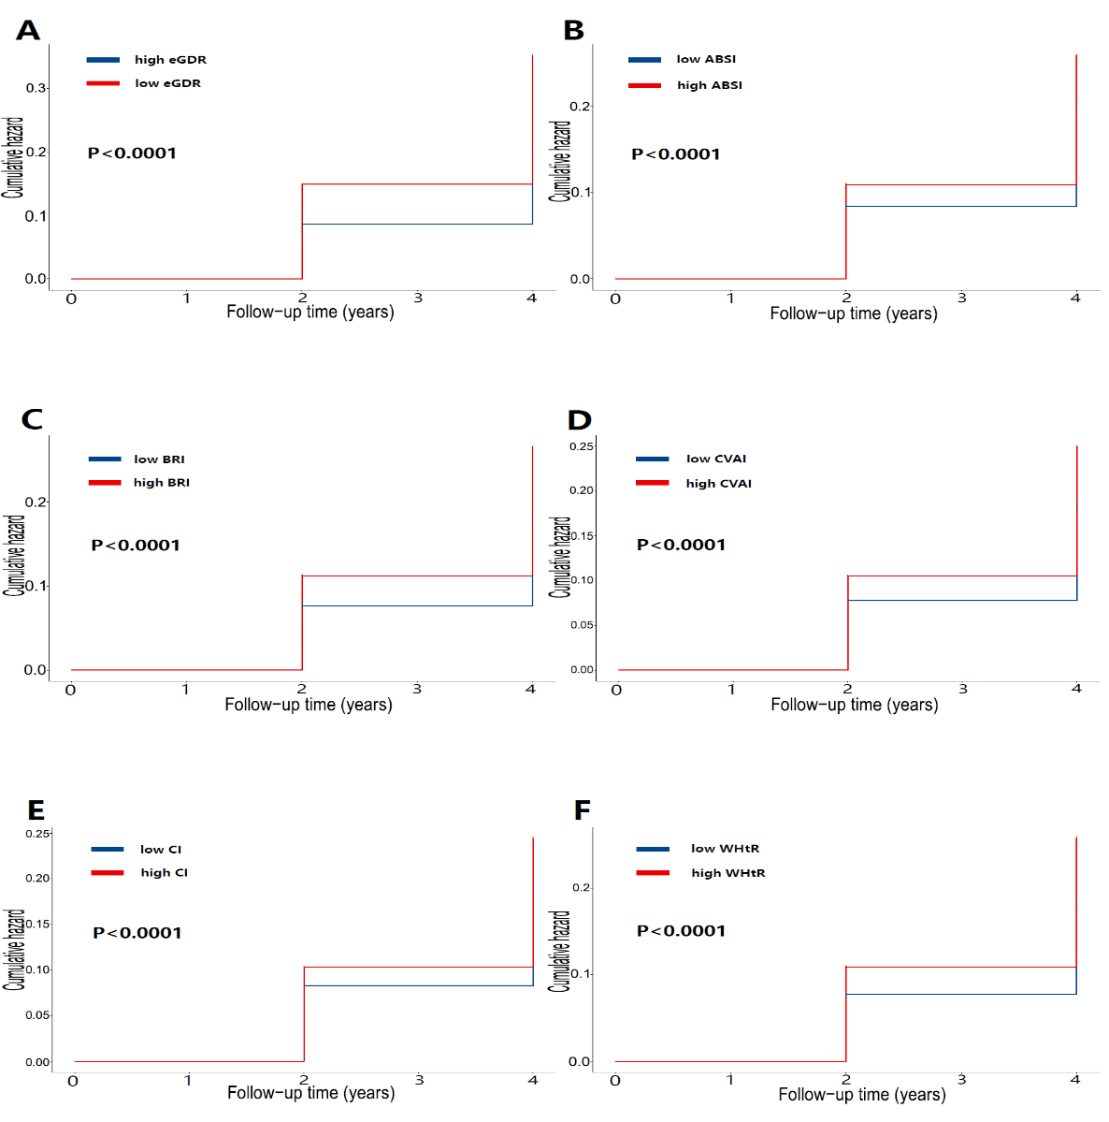
Fig. S1 Kaplan–Meier plot of frailty incidence by eGDR(A),ABSI(B),BRI(C),CVAI(D),CI(E) and WHtR(F).

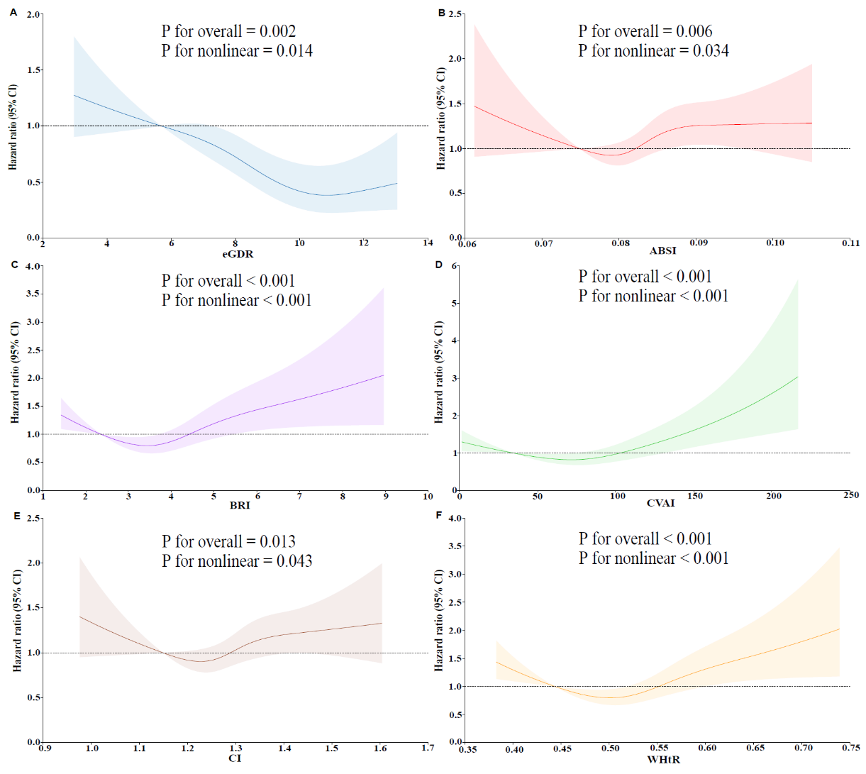
Fig. S2 The RCS analysis of frailty incidence by eGDR(A),ABSI(B),BRI(C),CVAI(D),CI(E) and WHtR(F). Graphs show HRs for frailty incidence based on Cox hazaeds regression model3(adjusted for age,gender,hukou,education,marital status,smoking status,drinking status,BMI,and history of hypertension,diabetes,dyslipidemia).Solid lines indicate HRs.Shadow shapes indicate 95% CIs.

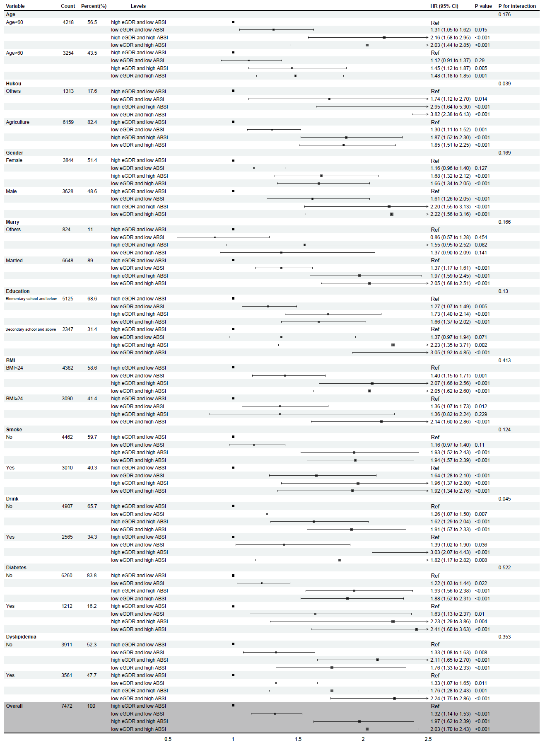
Fig. S3 Subgroup analysis of the joint associations of eGDR and ABSI with frailty. Abbreviations:eGDR:estimated glucose disposal rate;ABSI:A body shape index

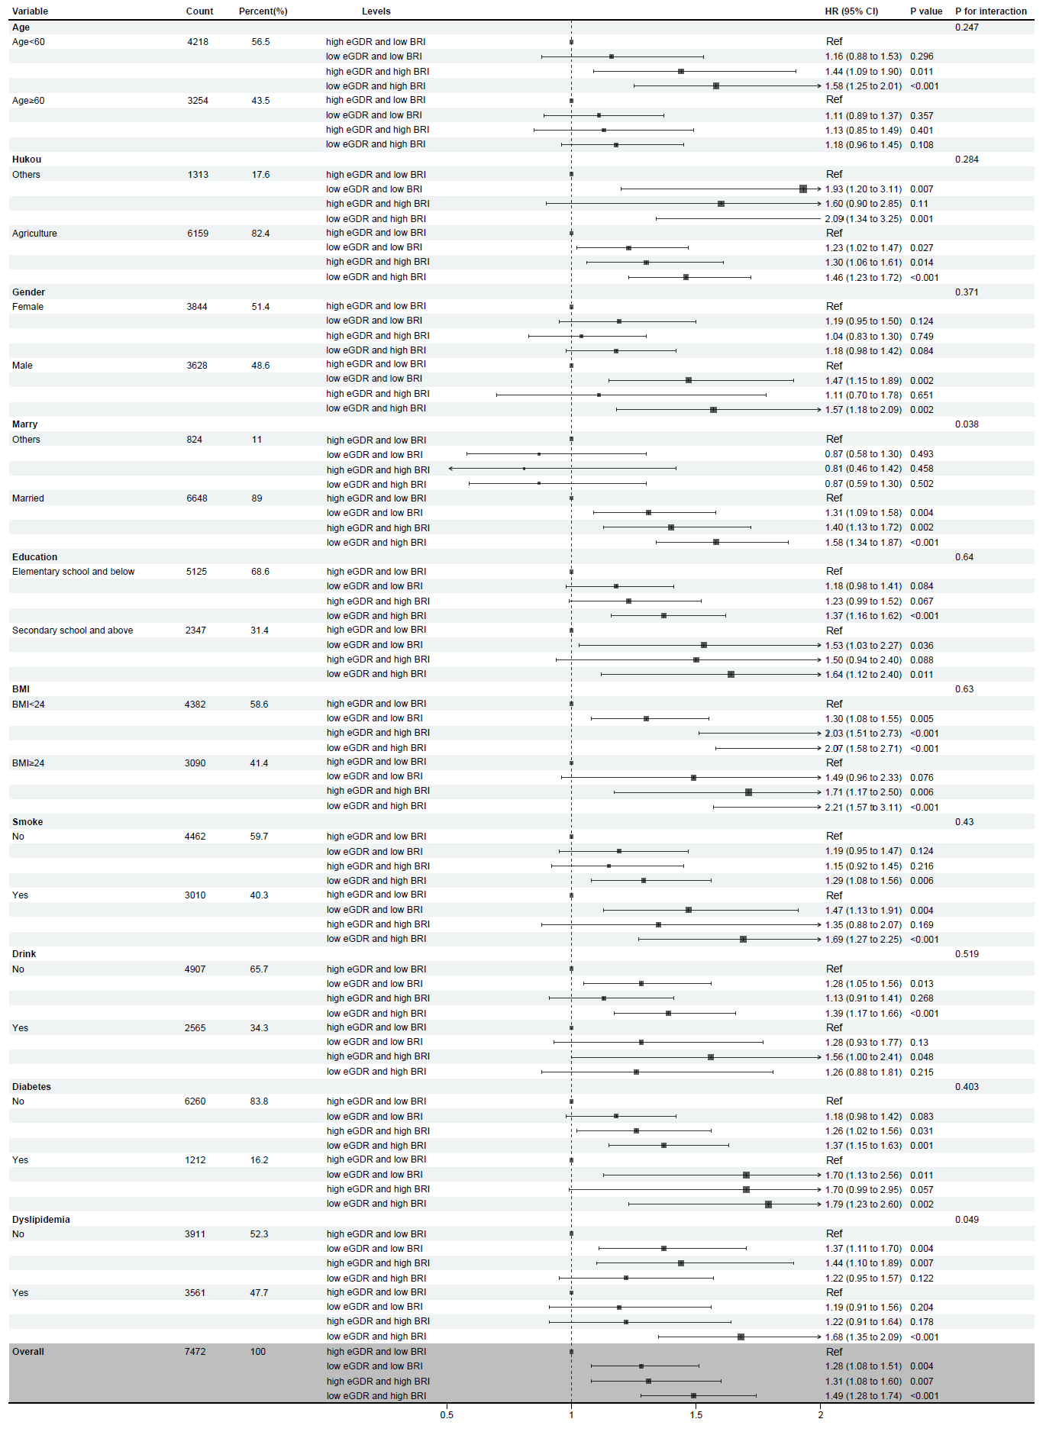
Fig. S4 Subgroup analysis of the joint associations of eGDR and BRI with frailty. Abbreviations:eGDR:estimated glucose disposal rate;BRI:body roundness index

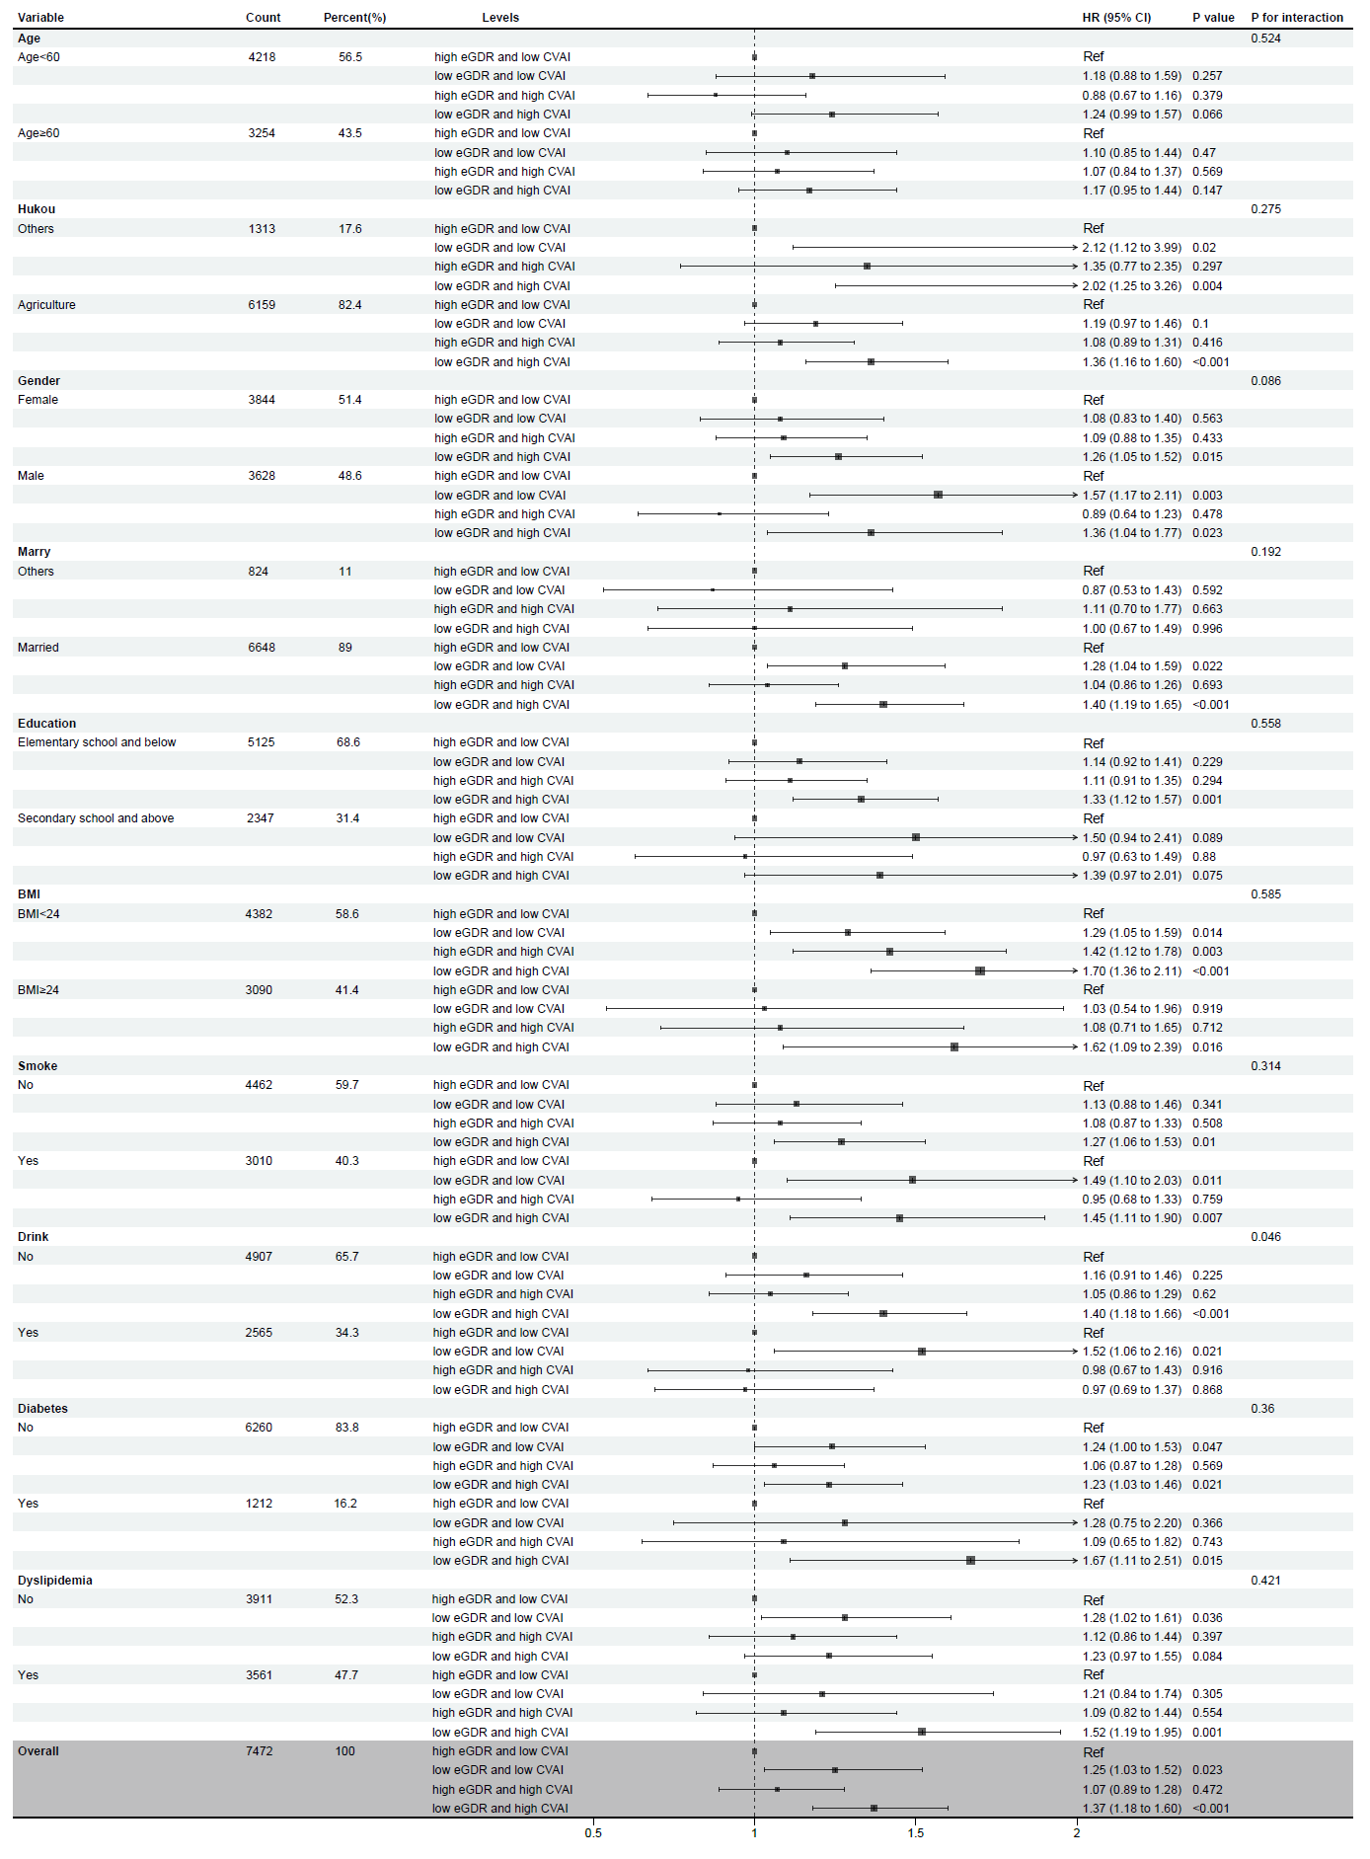
Fig. S5 Subgroup analysis of the joint associations of eGDR and CVAI with frailty. Abbreviations:eGDR:estimated glucose disposal rate;CVAI:Chinese visceral adiposity index

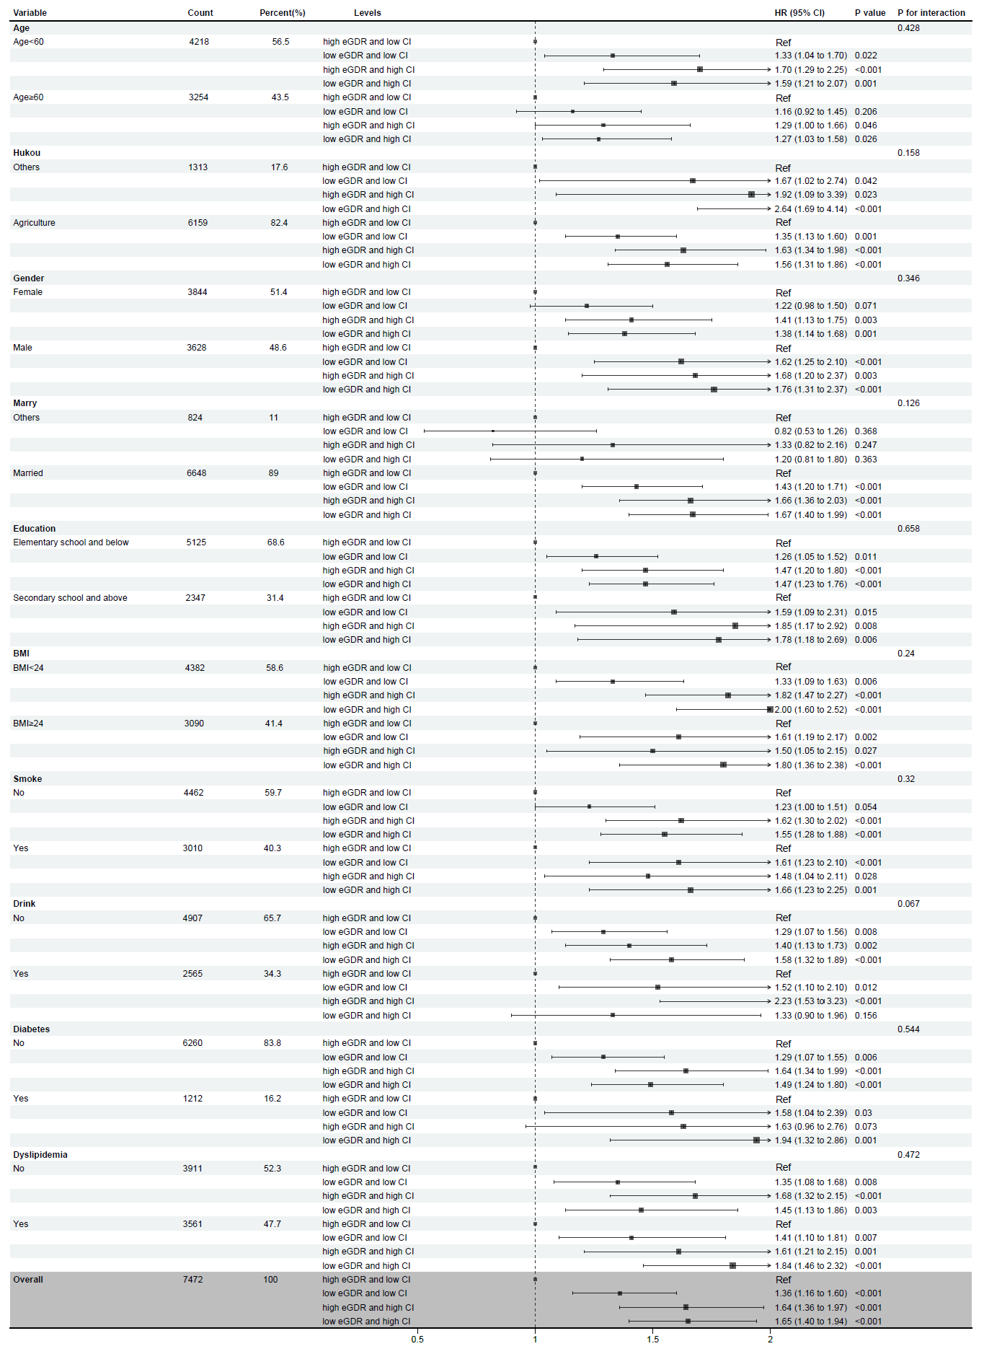
Fig. S6 Subgroup analysis of the joint associations of eGDR and CI with frailty. Abbreviations:eGDR:estimated glucose disposal rate;CI:conicity index

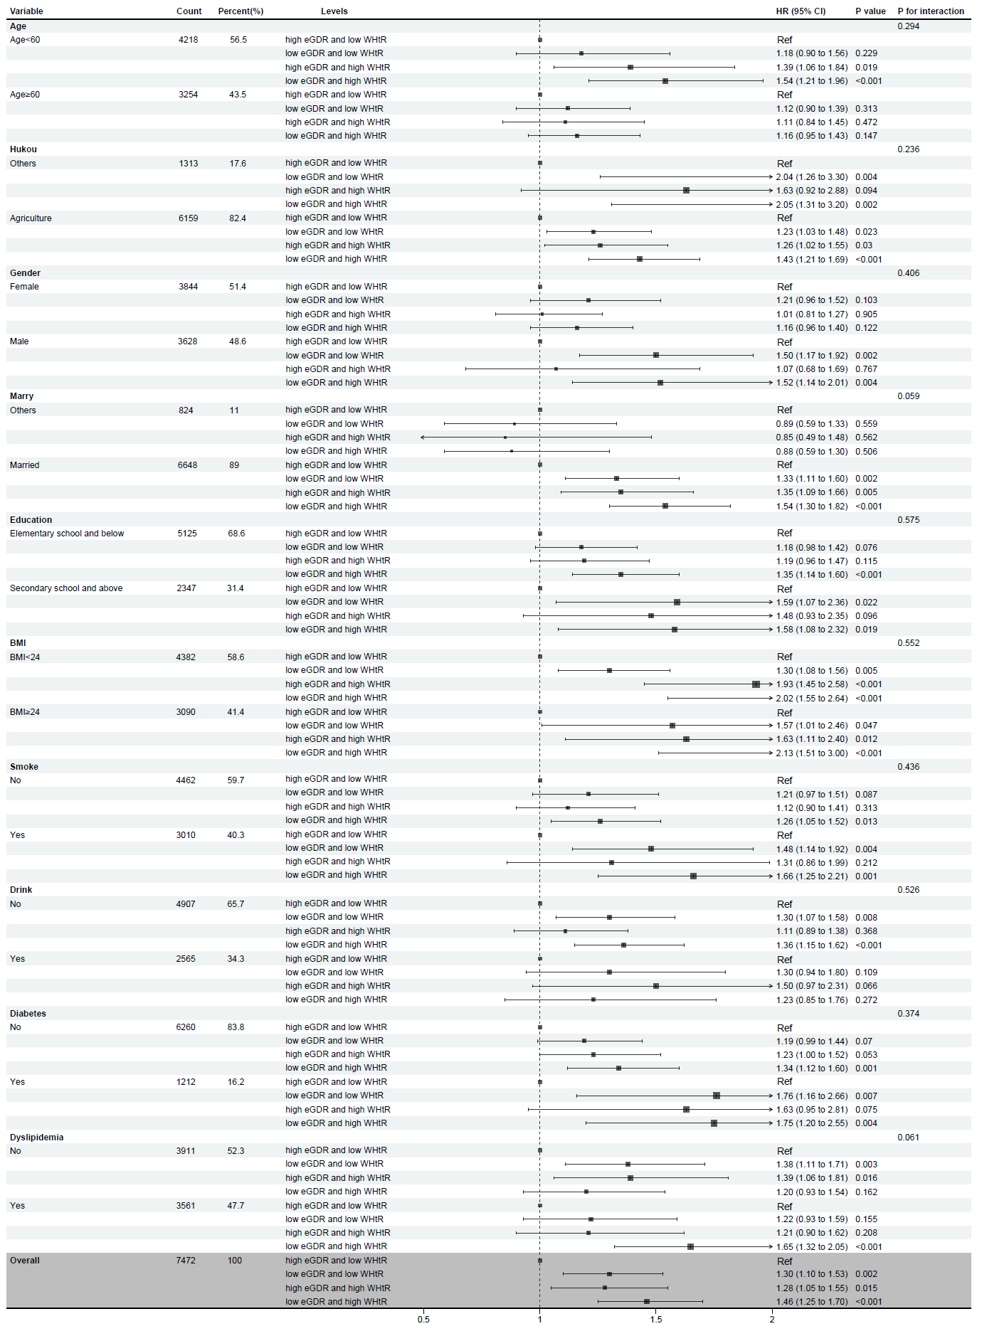
Fig. S7 Subgroup analysis of the joint associations of eGDR and WHtR with frailty. Abbreviations:eGDR:estimated glucose disposal rate;WHtR:waist–height ratio

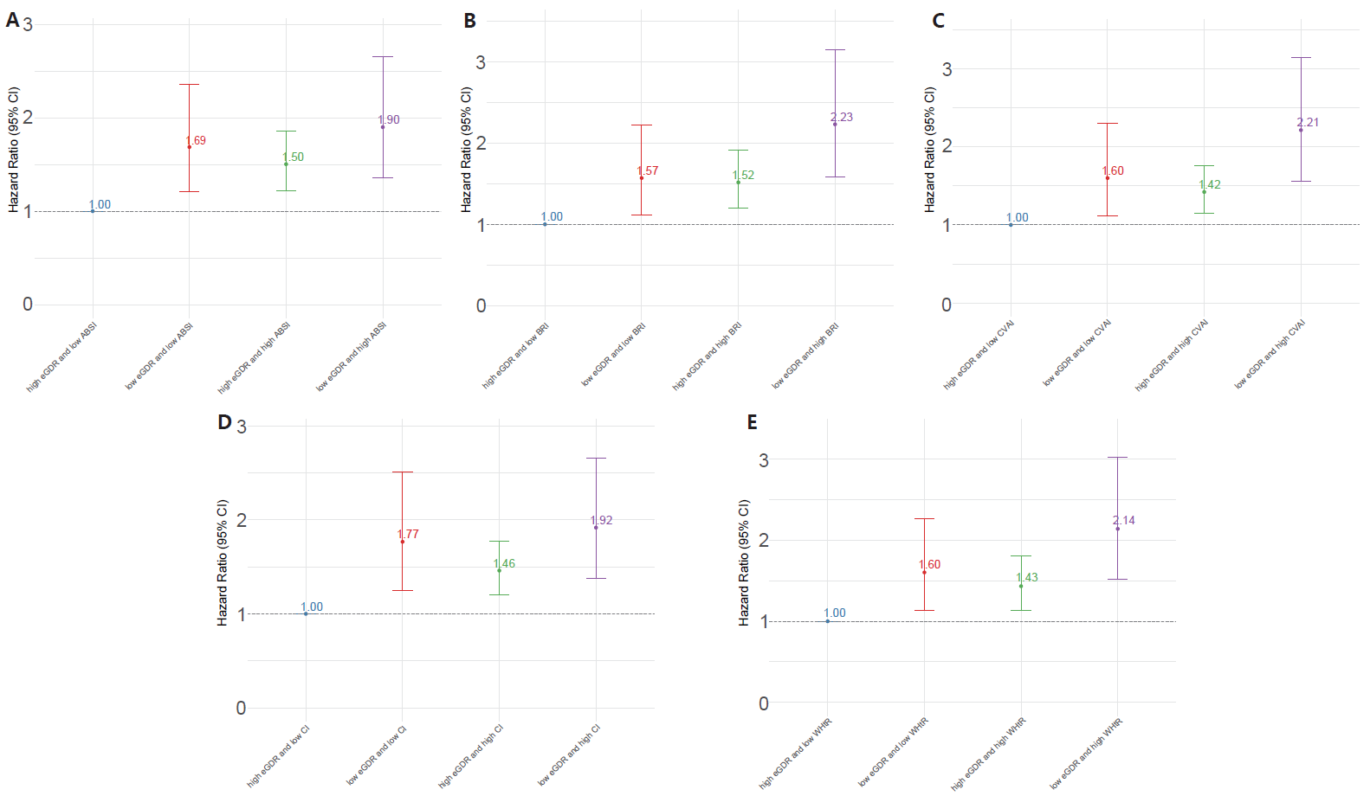
Fig. S8 Sensitivity analysis of the combined effects of eGDR and obesity-related indicators on frailty risk after excluding participants with non-fasting blood samples at baseline.(A)eGDR and ABSI;(B)eGDR and BRI;(C)eGDR and CVAI;(D)eGDR and CI;(E)eGDR and WHtR.The model was adjusted for age,gender,hukou,education,marital status,smoking status,drinking status,BMI,and history of hypertension,diabetes,dyslipidemia.

