Supplementary Materials for

Application of vision transformers to protein-ligand affinity prediction.

Jakub Poziemski¹ and Pawel Siedlecki¹*

¹ Institute of Biochemistry and Biophysics, Polish Academy of Sciences, Warsaw, Poland
* corresponding author: pawel@ibb.waw.pl

Datasets analysis
Comparison of training, validation and two test sets (CASF_2016 and CoreSet_2013) with respect to affinity values (S1) ligand similarity (S2) and datasets ligand diversity (S3).

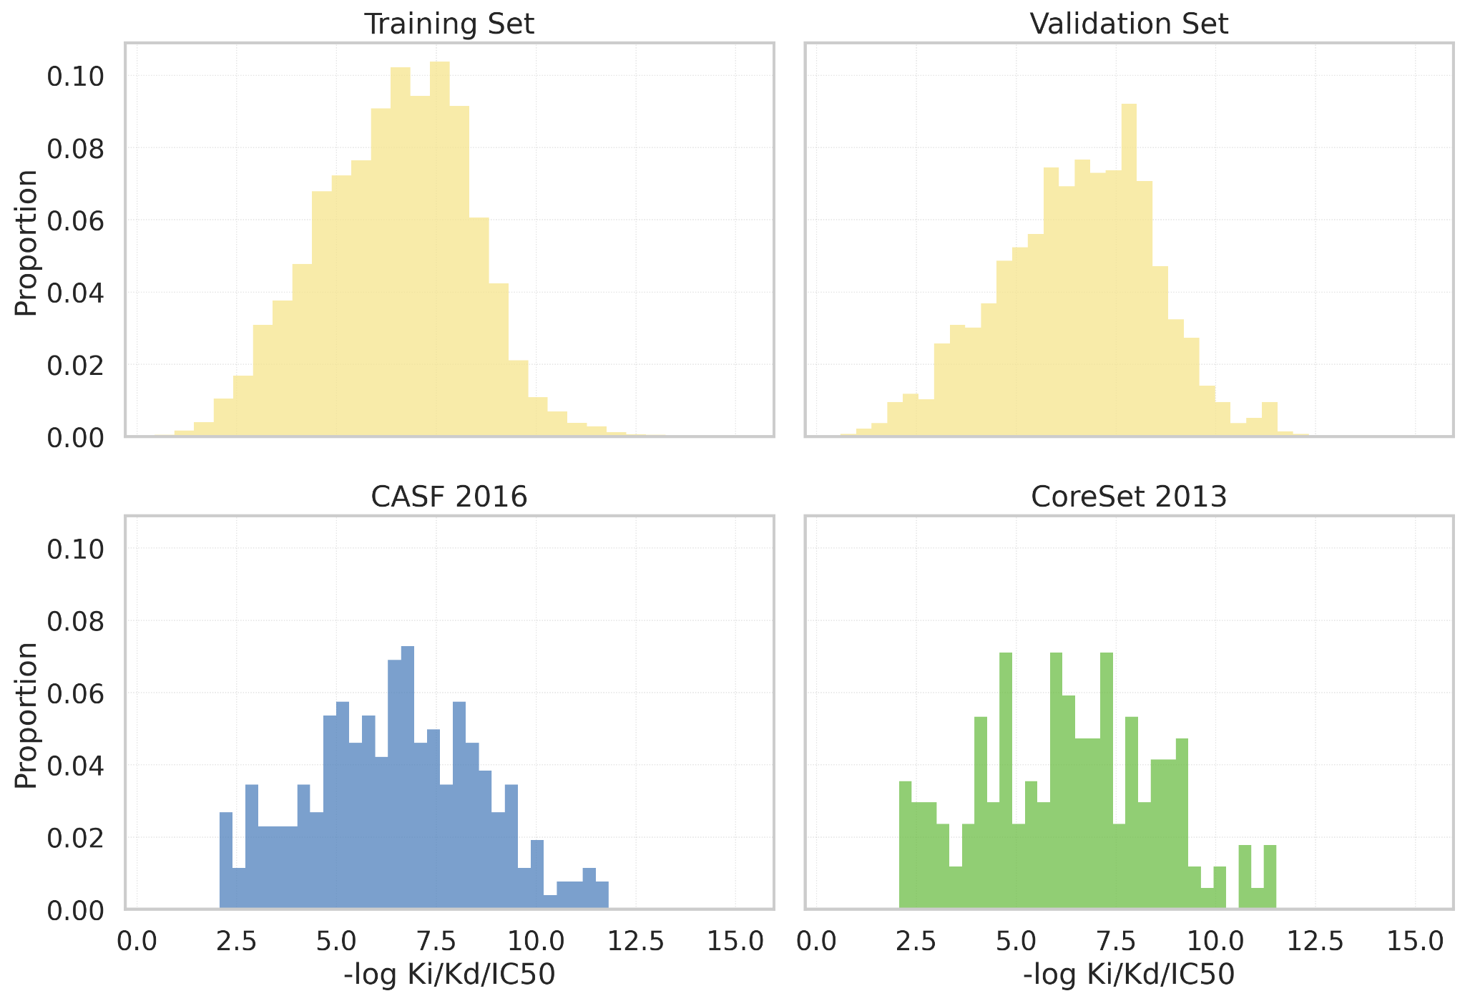

Supplementary Figure S1. Distribution of affinity values across training, validation and test sets.

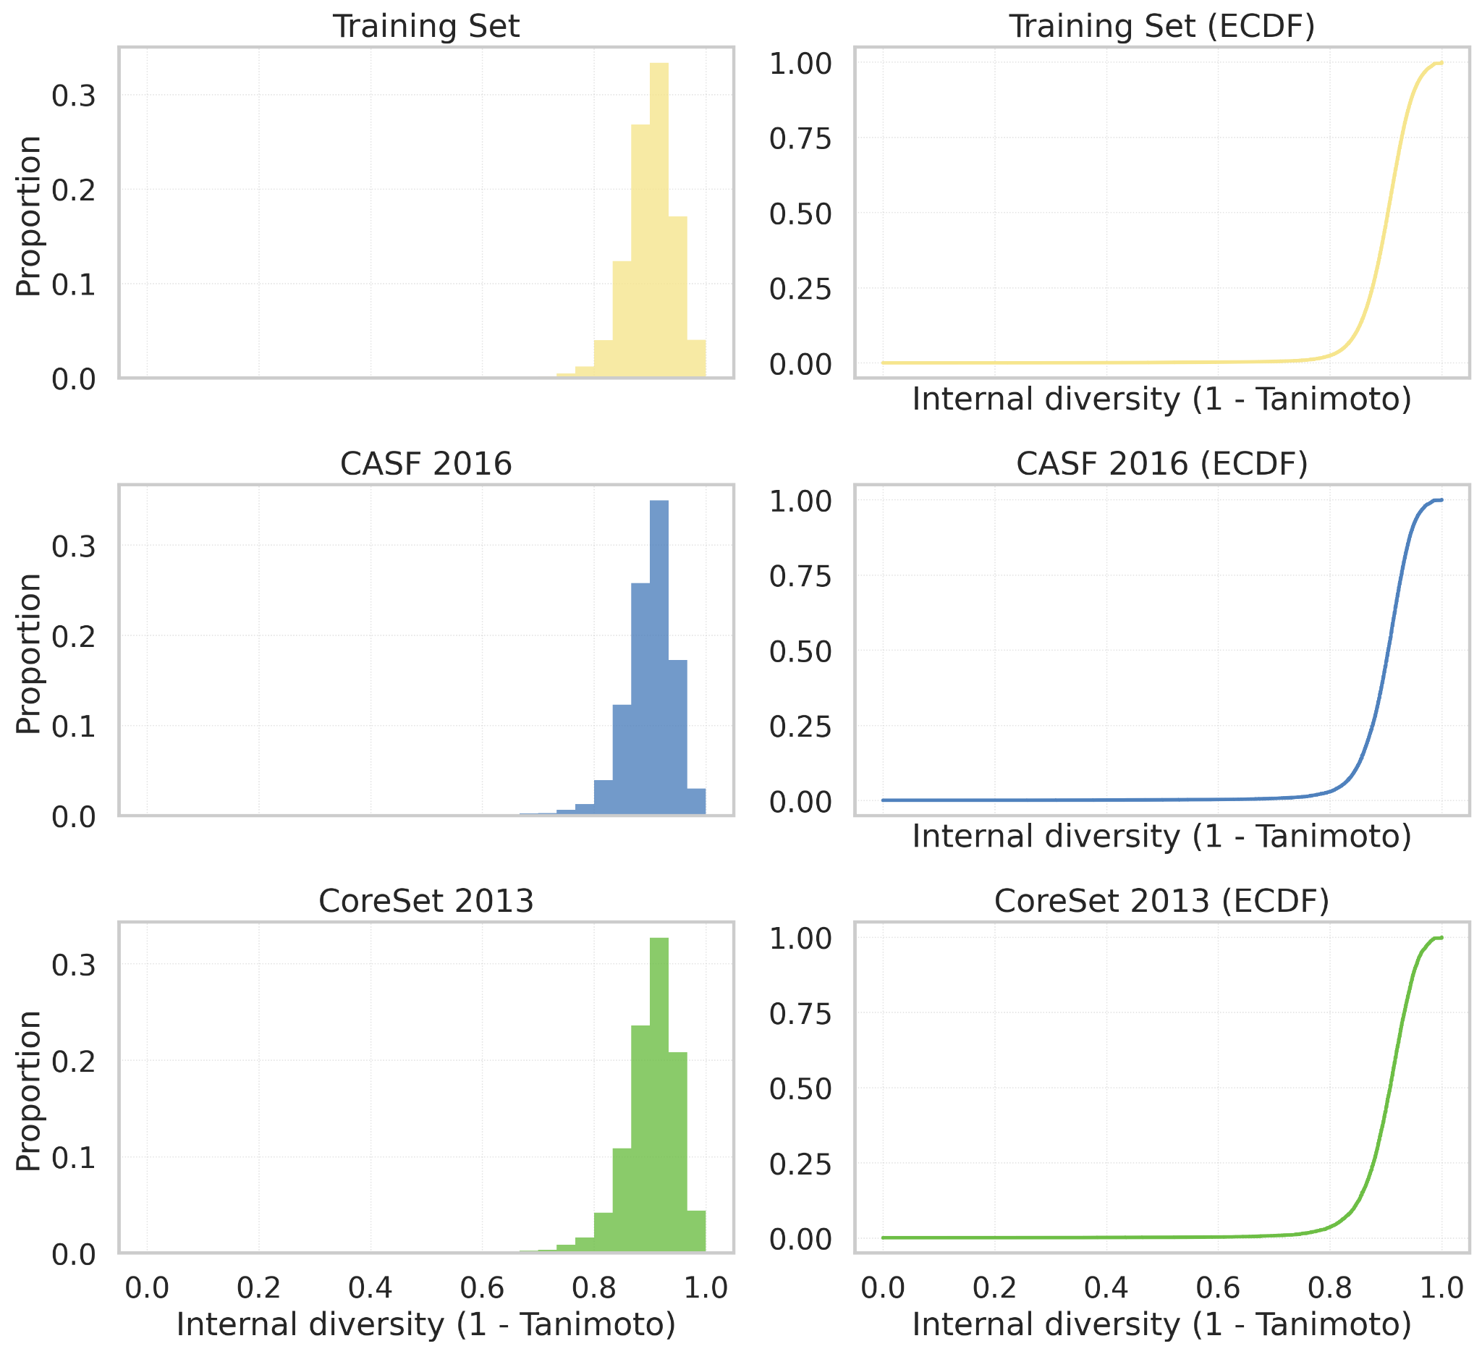

Supplementary Figure S2. Ligand internal diversity assessment. Internal ligand diversity within the training set (top row) and two test sets: CASF_2016 (middle row) and CoreSet_2013 (bottom row).

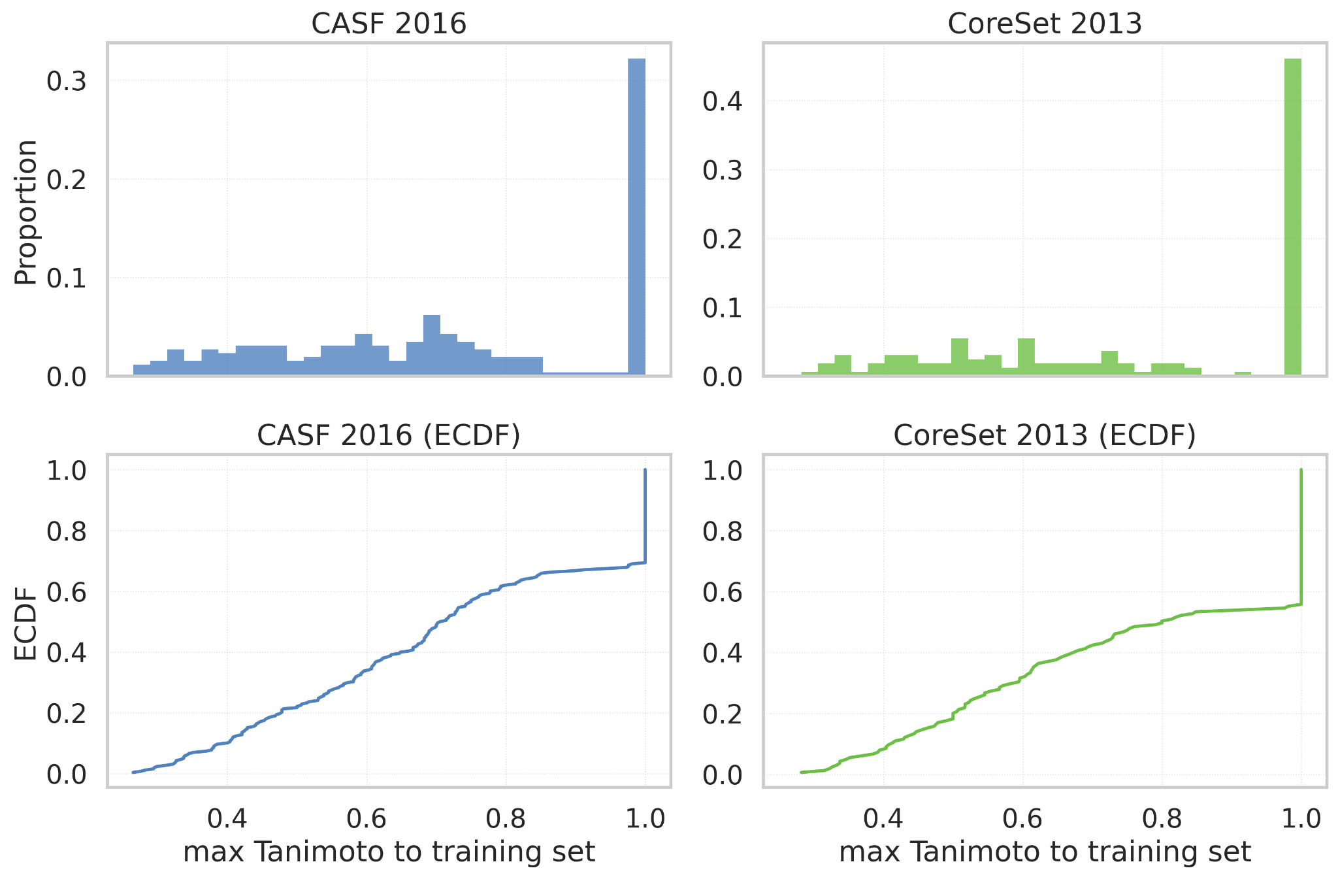

Supplementary Figure S3: Ligand similarity between training and test sets. Distribution of the maximum Tanimoto similarity (ECFP4 1024 bit) to the training set, computed as the nearest-neighbor similarity for ligands from CASF_2016 and CoreSet_2013. The top row shows histogram proportions, the bottom row plots a cumulative proportion with the empirical cumulative distribution function (ECDF).

Selected for generalization |  | Most similar target in training set
PDB_ID | Ligand_res_ID | PDB_ID | Ligand_res_ID | Similarity
2cbv | CGB | 4ufl | DZX | 0.26
3ui7 | C1L | 5hlp | 65A | 0.28
3acw | 651 | 4mmm | BP7 | 0.28
3pyy | 3YY | 3f81 | STT | 0.29
3uuo | 0CV | 6d59 | FVJ | 0.29
4mme | 29Q | 5ea6 | 5NP | 0.30
4qd6 | 30T | 2xj1 | XJ1 | 0.31
5aba | UL7 | 4agm | P86 | 0.32
4jfs | 16Z | 1sv3 | ANN | 0.32
3jya | LWG | 5aqn | JG8 | 0.33
3g2z | GZ2 | 3p2h | NOO | 0.33
3gy4 | PBZ | 5mnc | ANL | 0.33
2xnb | Y8L | 2xmy | CDK | 0.34
2p4y | C03 | 4g2r | H1L | 0.34
4wiv | 3P2 | 6g2c | EHT | 0.34
3fur | Z12 | 2bz5 | AB4 | 0.34
4ih5 | 12R | 3wf5 | FZ8 | 0.34
1mq6 | XLD | 1mq5 | XLC | 0.35
3k5v | STJ | 3exo | 5MS | 0.37
3jvr | AGX | 6f8b | CXH | 0.38

Supplementary Table S1: Selected CASF 2016 structures for testing ligand generalization. ‘Similarity’ refers to maximum Tanimoto similarity for a single training example.

Selected for generalization | Most similar targets in training set
PDB_ID | PDB_ID | TM-Score | PDB_ID | TM-Score | PDB_ID | TM-Score
4u4s | 4x48 | 0.9859 | 4u4x | 0.9686 | 3qxm | 0.3671
1sqa | 1sqo | 0.9992 | 1owe | 0.9989 | 3v7t | 0.3205
1owh | 1owe | 0.9995 | 1sqo | 0.9985 | 3v7t | 0.3205
2x0y | 2vur | 0.9979 | 2xpk | 0.9883 | 4ibe | 0.2624
2j62 | 2xpk | 0.9986 | 2vur | 0.9877 | 4ibe | 0.2663
4gqq | 1u2y | 0.9775 | 4gqr | 0.9775 | 1swi | 0.3558
2cbj | 2xpk | 0.9956 | 2vur | 0.9894 | 4ibe | 0.2668
1xd0 | 1u2y | 0.9996 | 4gqr | 0.9974 | 1swi | 0.3506
1u33 | 4gqr | 0.9987 | 1u2y | 0.9984 | 1swi | 0.3553
1sqa | 1sqo | 0.9992 | 1owe | 0.9989 | 3v7t | 0.3205
1qi0 | 8a3h | 0.9918 | 5a3h | 0.9917 | 2bfr | 0.3630
1kel | 1flr | 0.9701 | 2cgr | 0.7629 | 4jn2 | 0.5503
3l4u | 3l4x | 0.9994 | 3l4y | 0.9994 | 3ctt | 0.9993
2qmj | 3l4x | 0.9999 | 3l4y | 0.9997 | 3ctt | 0.9997
3l4w | 3ctt | 0.9991 | 3l4x | 0.9991 | 3l4y | 0.9991
2vo5 | 2vmf | 0.9959 | 2vqt | 0.9948 | 2vjx | 0.9948
2vot | 2vqt | 0.9987 | 2vjx | 0.9985 | 2vmf | 0.9984
2vl4 | 2vmf | 0.9984 | 2vjx | 0.9981 | 2vqt | 0.9981
Supplementary Table S2: Selected structures for testing generalization based on protein structure similarity (based on TM-Score).

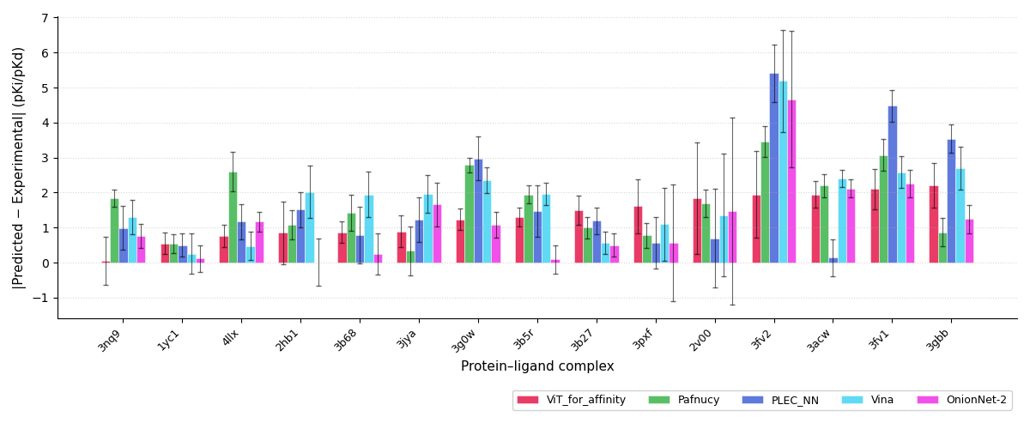
Supplementary Figure S4: Mean prediction based on 10 cluster representative conformations derived from MD simulation.

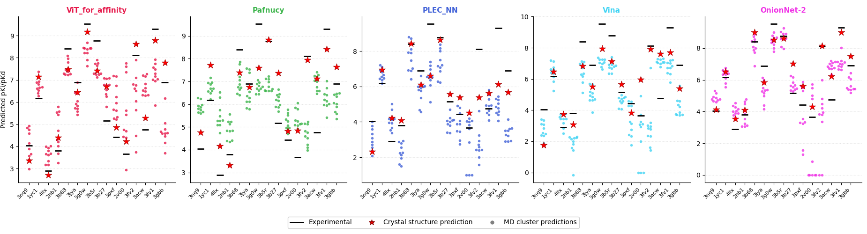

Supplementary Figure S5: Detailed analysis of affinity prediction for each model tested. Predicted affinity values are shown for each of the 10 representative conformations derived from MD simulations.

