Additional file 1
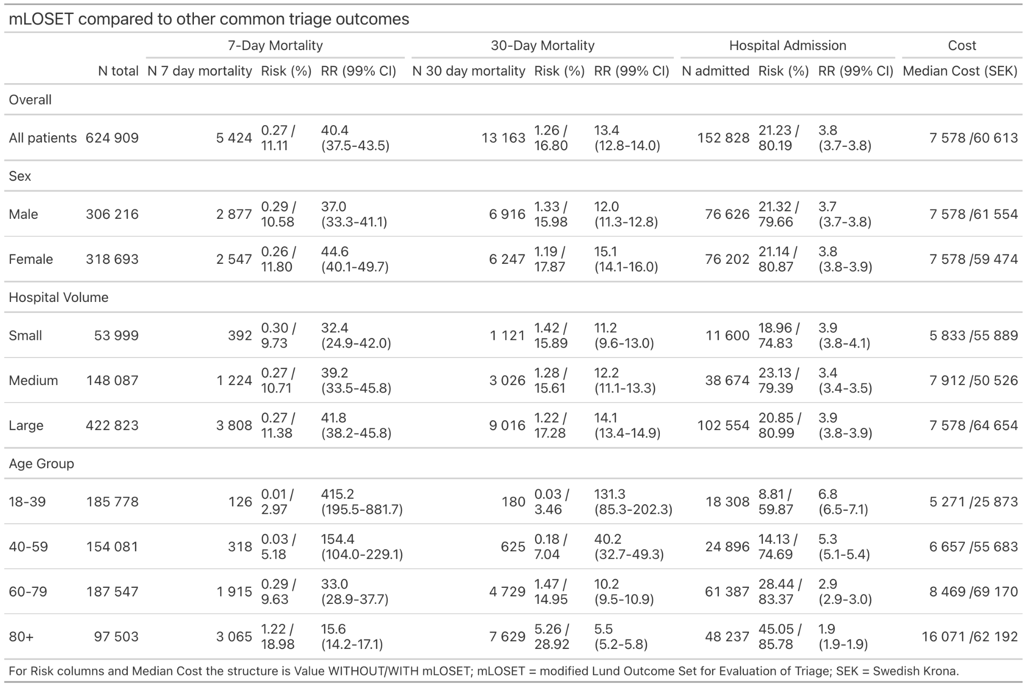
Additional file 1, Table 1. Risk ratios (RR) with 99% confidence intervals (CI) comparing mLOSET-positive to mLOSET-negative patients, stratified by sex, hospital volume (small/medium/large based on annual census), and age group (18–39, 40–59, 60–79, ≥80 years). Three analyses presented as in the main Table 1. mLOSET = modified Lund Outcome Set for Evaluation of Triage; ICU = Intensive Care Unit; RR = Risk Ratio; CI = Confidence Interval.
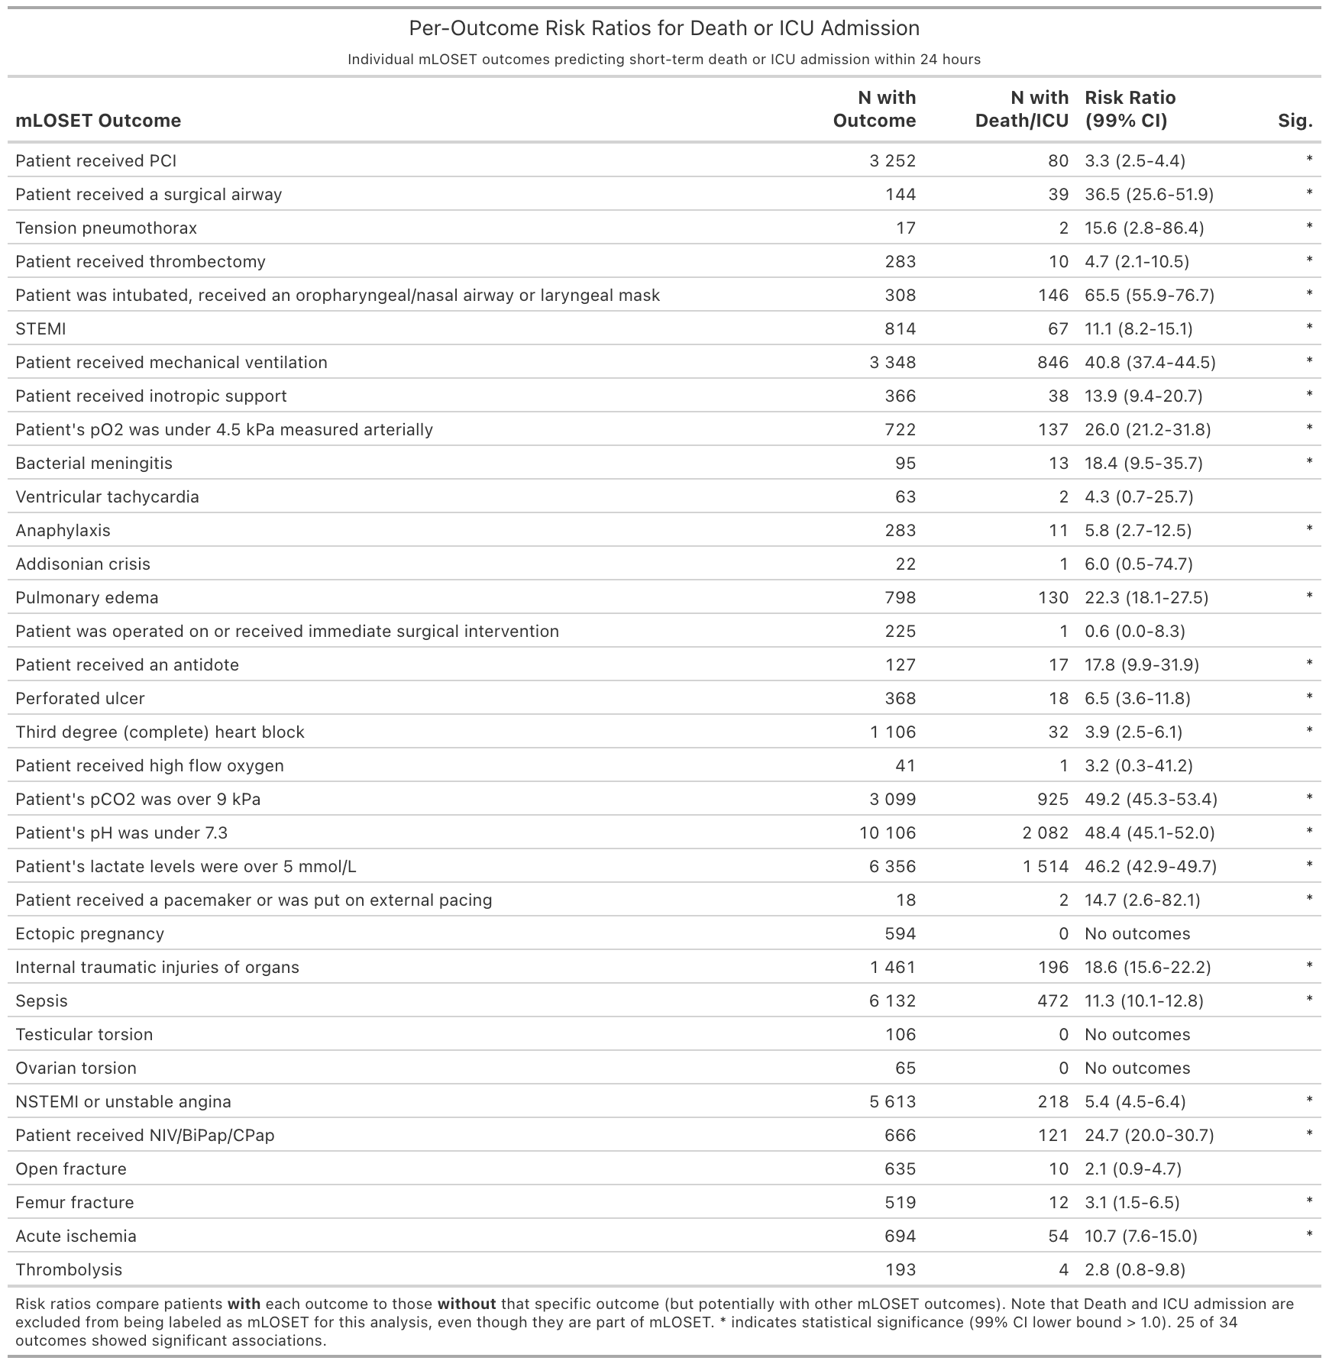
Additional file 1, Table 2. Risk ratios (RR) with 99% confidence intervals (CI) for each of the 34 individual mLOSET outcomes (mortality and ICU criteria excluded), comparing the risk of same- or next-day mortality and ICU admission in patients with each specific criterion to those without it. Asterisk (*) indicates statistical significance at the 99% level (CI lower bound >1.0). mLOSET = modified Lund Outcome Set for Evaluation of Triage; ICU = Intensive Care Unit; RR = Risk Ratio; CI = Confidence Interval.
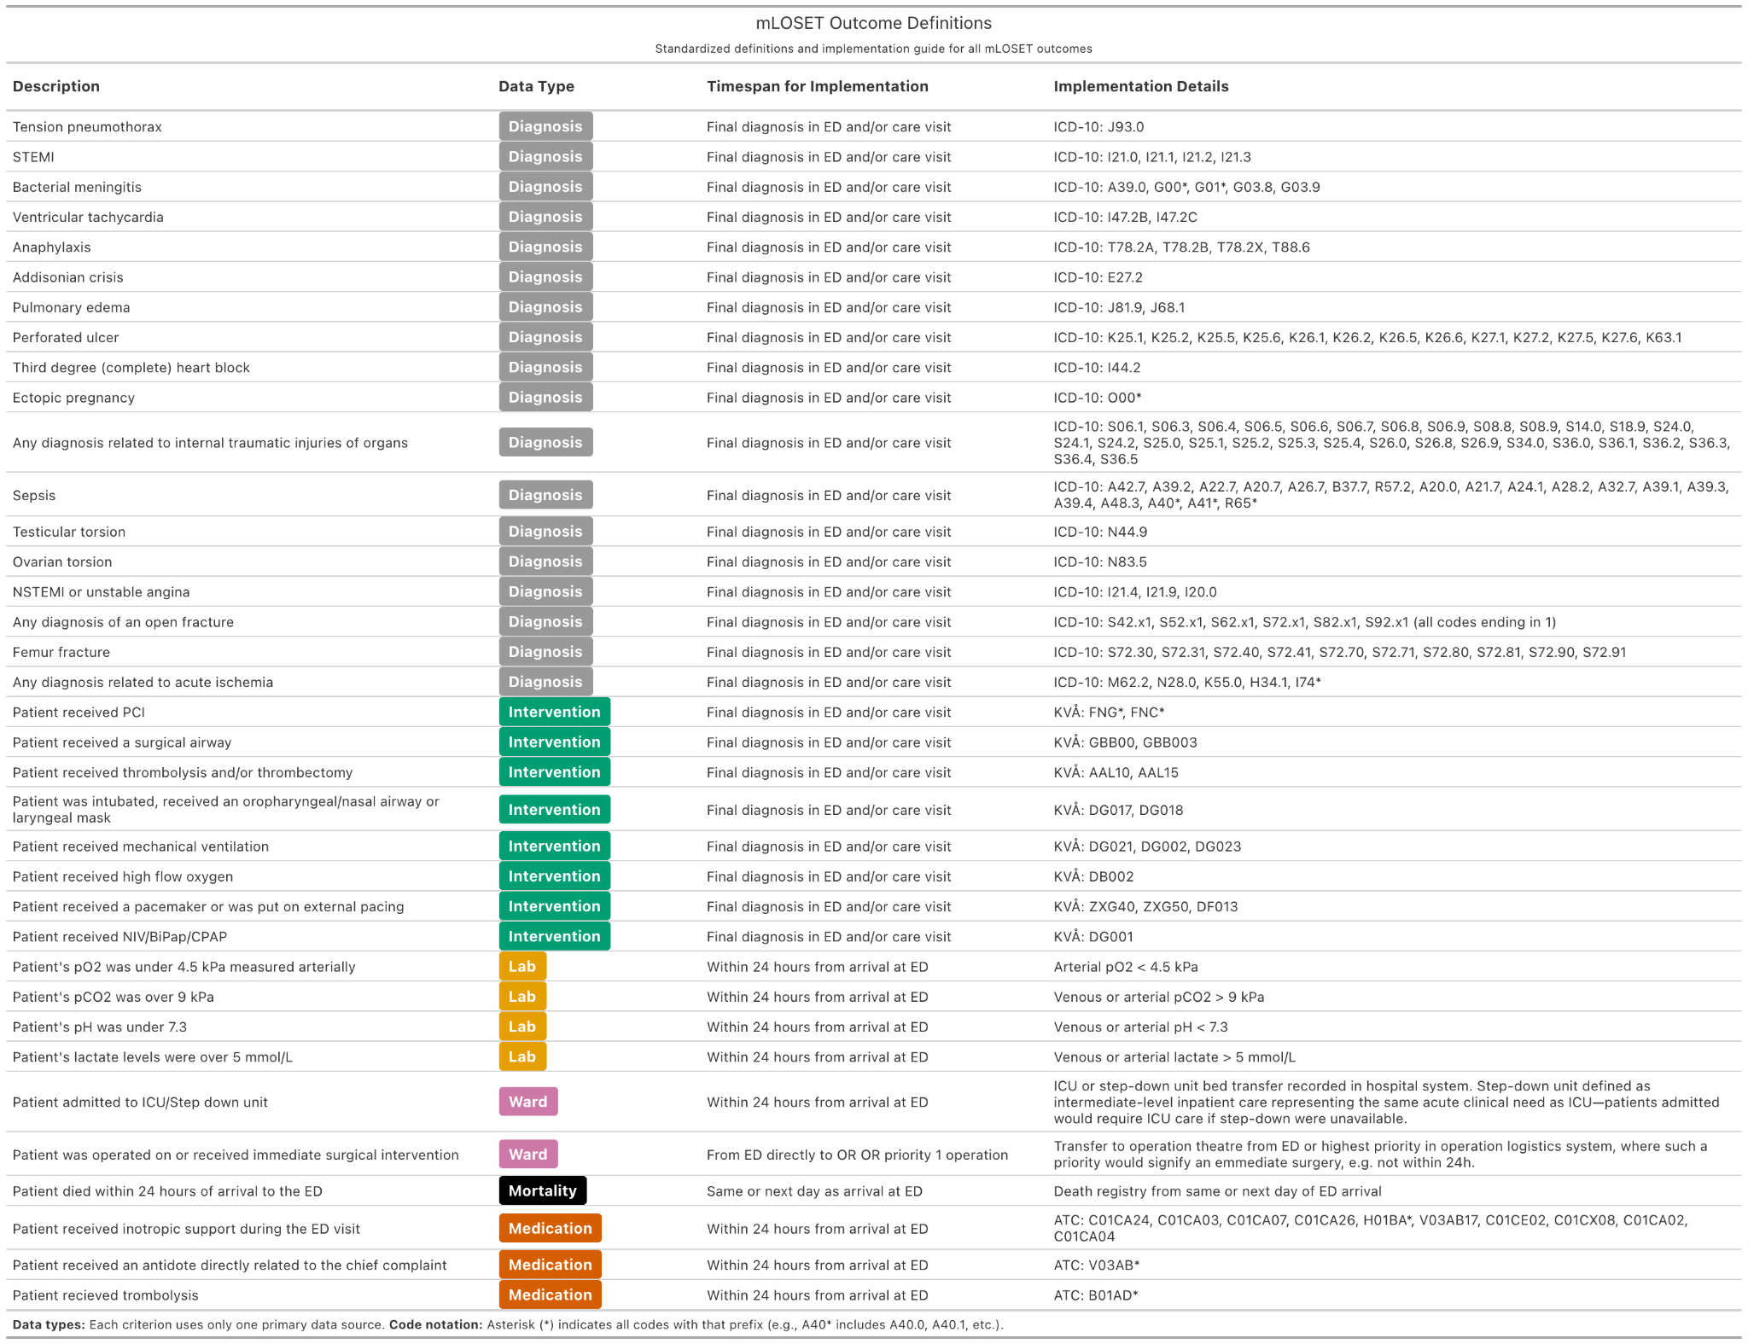
Additional file 1, Table 3: Standardised definitions for all 36 mLOSET outcomes, including the data source type required, the applicable timeframe, and the specific codes or thresholds used for implementation. ICD-10 codes follow the International Classification of Diseases, 10th Revision. Procedure codes follow the Swedish KVÅ classification. ATC codes follow the Anatomical Therapeutic Chemical classification. Asterisk (*) in code strings denotes all sub-codes with that prefix. mLOSET = modified Lund Outcome Set for Evaluation of Triage; ICD-10 = International Classification of Diseases, 10th Revision; KVÅ = Klassifikation av Vårdåtgärder; ATC = Anatomical Therapeutic Chemical.

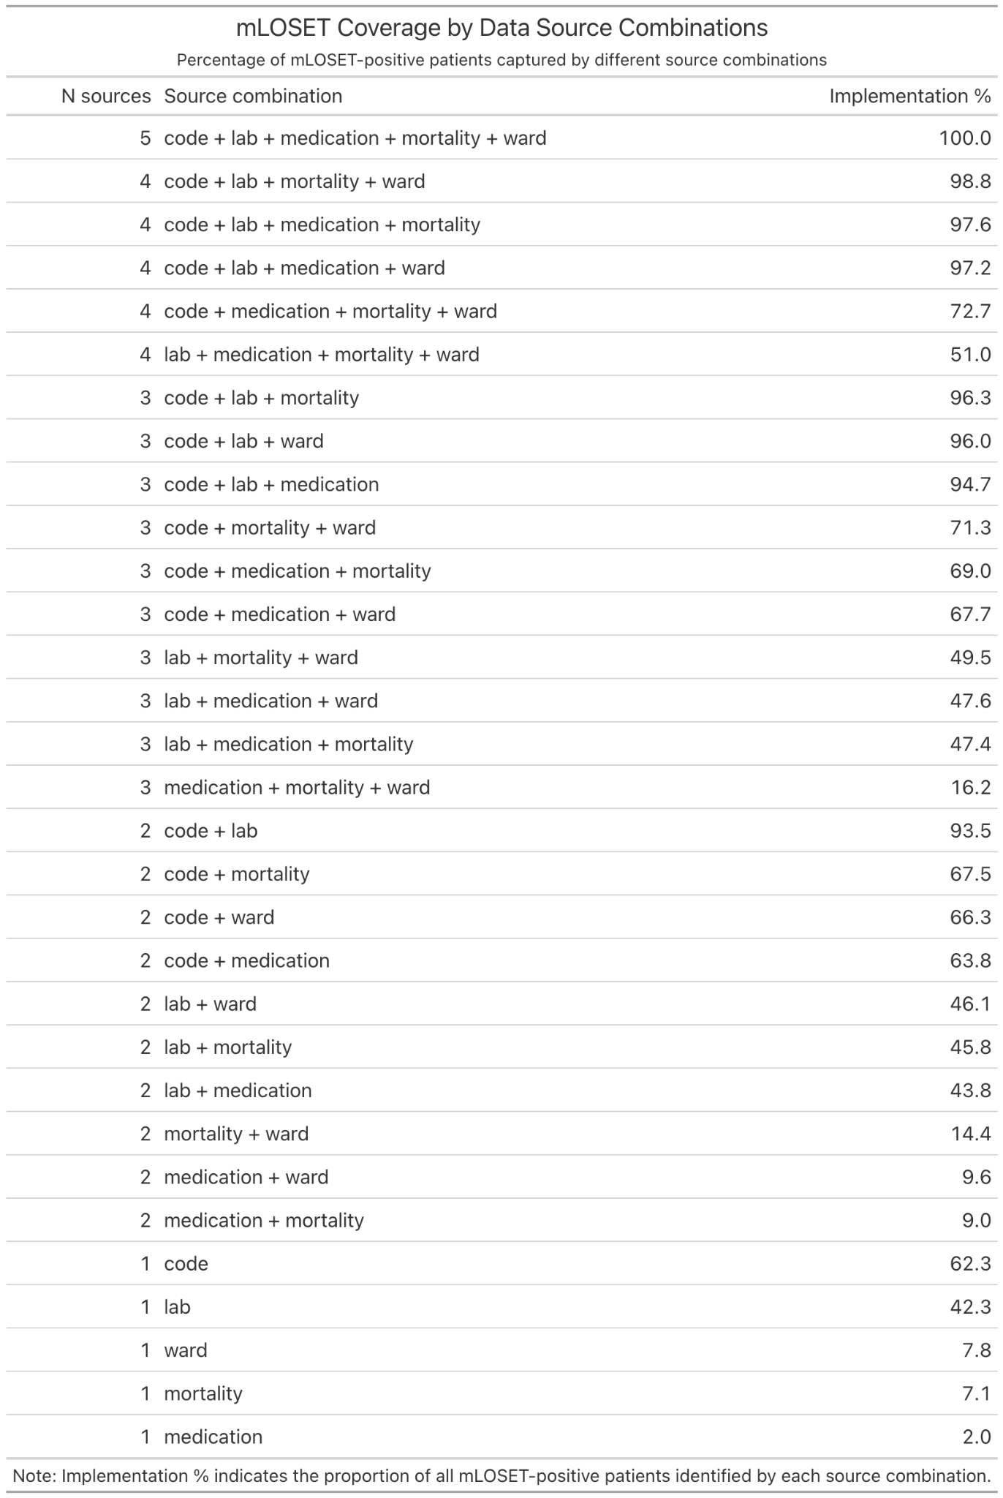
Additional file 1, Table 4: All 31 possible combinations of the five data source types (diagnostic/procedure codes, laboratory values, mortality data, ward transfer records, and medication records) and the percentage of mLOSET-positive patients each combination would identify. mLOSET = modified Lund Outcome Set for Evaluation of Triage.
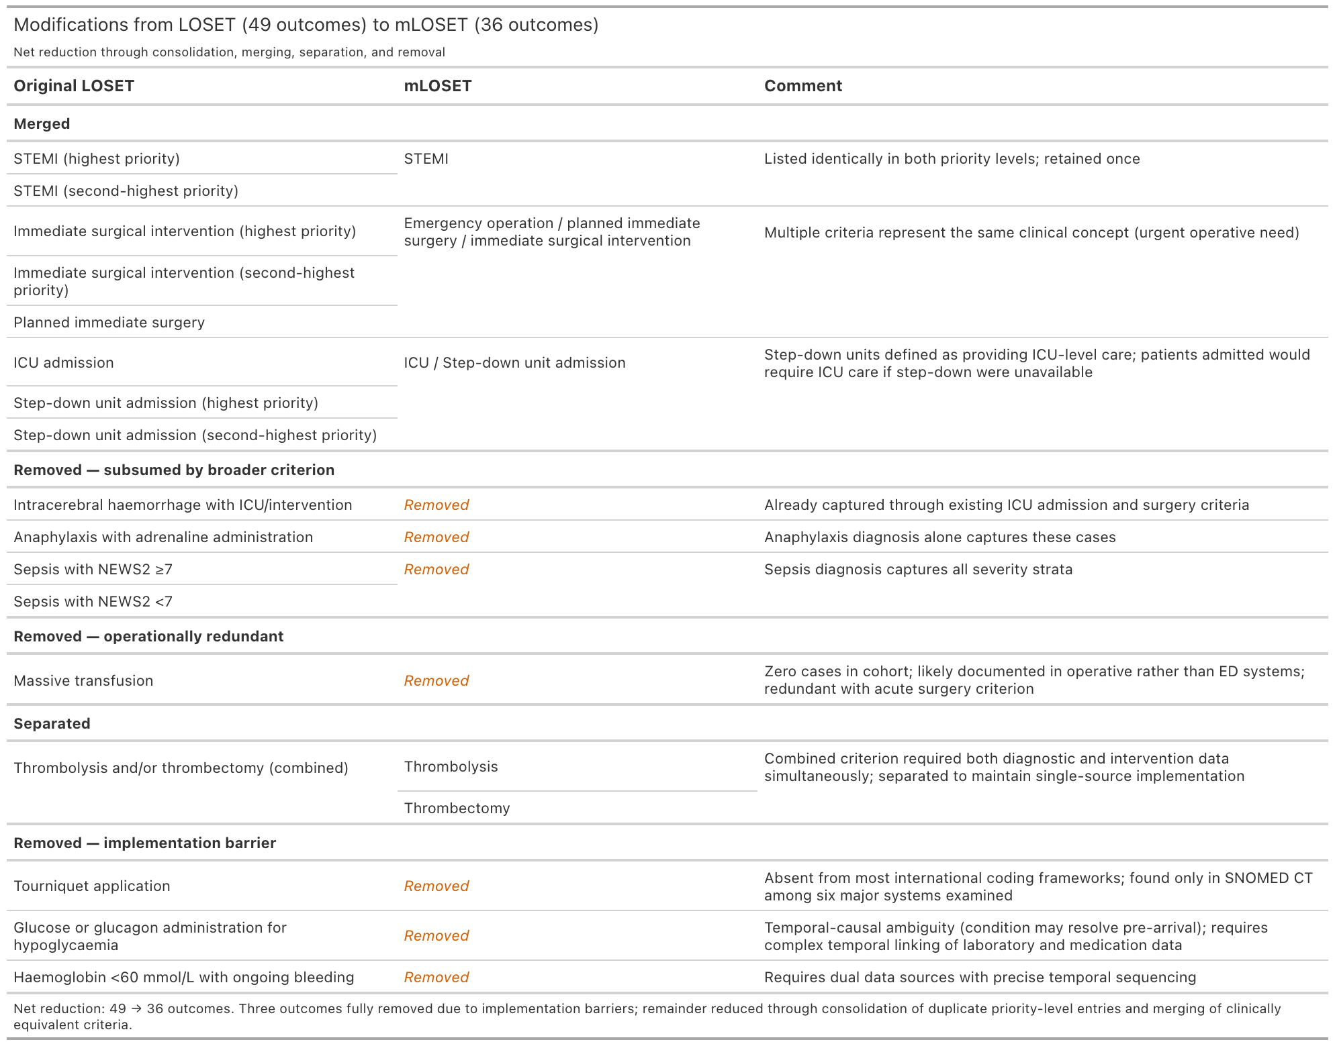
Supplementary Table 5: Systematic modifications applied to LOSET during development of mLOSET. Outcomes were modified through four processes: merging of clinically equivalent or duplicate criteria, removal of outcomes subsumed by broader criteria, removal of operationally redundant outcomes, and removal of outcomes with implementation barriers. The original LOSET comprised 49 outcomes; modifications yielded 36 implementable outcomes (mLOSET). LOSET = Lund Outcome Set for Evaluation of Triage; mLOSET = modified LOSET; NEWS2 = National Early Warning Score 2; ICU = Intensive Care Unit.

