Subthalamic Deep Brain Stimulation Restores Temporal Flexibility of Cortical Beta Bursts During Motor Inhibition
Tingting Zhu^{a,b}, Wim Vandenberghe^{c,d}, Dante Mantini^{e}, Alexander T. Sack^{a,b}, James P. Coxon^{f}, Bart Nuttin^{g,h}, Stephan P. Swinnen^{e}, Inge Leunissen^{a,b*}
ª Department of Cognitive Neuroscience, Faculty of Psychology and Neuroscience, Maastricht University, Maastricht 6229 EV, The Netherlands
^{b} Maastricht Brain Imaging Centre (MBIC), Maastricht University, Oxfordlaan 55, Maastricht 6229 EV, The Netherlands
^{c} Laboratory for Parkinson Research, Department of Neurosciences, KU Leuven, 3000 Leuven, Belgium
^{d} Department of Neurology, University Hospitals Leuven, 3000 Leuven, Belgium
^{e} Movement Control and Neuroplasticity Research Group, Department of Movement Sciences, KU Leuven, 3001 Leuven, Belgium
^{f} School of Psychological Sciences, Turner Institute for Brain and Mental Health, Monash University, 3800 Victoria, Australia
^{g} Research Group Experimental Neurosurgery and Neuroanatomy, Department of Neurosurgery, KU Leuven, 3000 Leuven, Belgium
^{h} Department of Neurosurgery, University Hospital of Leuven, 3000 Leuven, Belgium

*Corresponding author
Email address: inge.leunissen@maastrichtuniversity.nl

Supplementary material
Table S1. Deep brain stimulation parameters for patients with Parkinson’s disease
Participant ID | Session | STN-contacts (L/R) | Electrical potential (V) | Pulse width (µs) | Frequency (Hz) | Impedance (Ω) | Current amplitude (mA)
1* | pre | 2–c+/10–c+ | 2.6/2.45 | 60/60 | 130/130 | 1726/1275 | 1.48/1.97
1* | post | 2–c+/10–c+ | 2.85/2.7 | 60/60 | 130/130 | 1805/1218 | 1.61/2.26
2# | pre | 2+3–/10+11– | 3.5/3.45 | 90/90 | 110/110 | –/– | –/–
2# | post | 2+3–/10+11– | 3.45/3.45 | 90/90 | 110/110 | 1284/1397 | 2.71/2.51
3# | pre | 1+2–/10–9+ | 3.65/3.75 | 80/80 | 110/110 | –/– | –/–
3# | post | 1+2–/10–9+ | 3.65/3.75 | 80/80 | 110/110 | –/– | –/–
4# | pre | 1+2–/9–10+ | 2.5/2.5 | 60/70 | 130/130 | 2262/2181 | 0.83/1.35
4# | post | 1+2–/9–10+ | 2.5/2.5 | 60/70 | 130/130 | 1703/2496 | 1.49/1.02
5# | pre | 2–3+/10+11– | 2.6/4.9 | 70/130 | 130/130 | –/– | –/–
5# | post | 2–3+/10+11– | 2.6/5.1 | 70/140 | 110/110 | –/– | –/–
6* | pre | 2–c+/9–c+ | 1.7/1.2 | 60/60 | 130/130 | –/– | –/–
6* | post | 2–c+/9–c+ | 1.9/1.3 | 60/60 | 130/130 | 1040/1216 | 1.8/1.1
7* | pre | 1–c+/9–c+ | 2/2 | 60/60 | 130/130 | 856/1268 | 2.35/1.6
7* | post | 1–c+/9–c+ | 2.3/2.3 | 60/60 | 130/130 | –/– | –/–
8* | pre | 2–c+/10–c+ | 1.85/1.85 | 60/60 | 130/130 | 1260/1342 | 1.28/1.21
8* | post | 2–c+/10–c+ | 1.85/1.85 | 60/60 | 130/130 | –/– | –/–
9# | pre | 2–c+/10–c+ | 3/0.6 | 60/60 | 130/130 | 1243/2315 | 2.28/0.28
9# | post | 2–c+/10–c+ | 3.4/0.4 | 60/60 | 130/130 | 1342/2200 | 2.6/0.2
10* | pre | 1–c+/9–c+ | 3.5/1.95 | 90/60 | 130/– | –/– | –/–
10* | post | 1–c+/9–c+ | 3.7/1.9 | 90/60 | 130/130 | –/– | –/–
11* | pre | 2–c+/9+10– | 3.8/4.4 | 60/80 | 130/130 | 1531/1518 | 2.5/2.7
11* | post | 2–c+/9+10– | 3.8/4.4 | 60/80 | 130/130 | 1564/1500 | 2.5/2.9
12# | pre | contacts 2–4 (34/33/33%)/contacts 2–4 (20–13%) | 0.9/– | 60/90 | 130/130 | –/– | –/1.3
12# | post | contacts 10–15 (34/33/33%)/contacts 10–15 (20–13%) | 1.2/– | 60/90 | 130/130 | –/– | –/1.6
13* | pre | 1–2–c+/9–10–c+ | 3.3/3.3 | 60/60 | 130/130 | 2076/2072 | 1.6/1.6
13* | post | 2–c+/10–c+ | 3.45/3.45 | 90/90 | 110/110 | 1776/2003 | 2/1.8
14* | pre | 3–c+/9–c+ | 1.9/1.8 | 60/60 | 125/125 | –/– | –/–
14* | pre-R2 | –/10–c+ | –/2.2 | –/90 | –/125 | –/– | –/–
14* | post | 3–c+/9–c+ | 1.9/1.8 | 60/60 | 125/125 | 1303/1215 | 1.5/1.5
14* | post-R2 | –/10–c+ | –/2.2 | –/90 | –/125 | –/1304 | –/1.7
Mean |  | – | 2.69/2.62 | 67.50/75.33 | 125.36/125.17 | 1518.07/1657.50 | 1.90/1.58
STD |  | – | 0.84/1.22 | 12.06/20.63 | 8.27/8.07 | 381.21/462.85 | 0.56/0.73
Range |  | – | 0.90–3.80 / 0.40–5.10 | 60–90 / 60–140 | 110–130 / 110–130 | 856–2262 / 1215–2496 | 0.83–2.71 / 0.20–2.90
*Bipolar stimulation; #Monopolar stimulation. All parameters are presented in the order of left/right subthalamus nucleus (L/R STN) across columns. Participant 14 had two right STN electrodes, where the second right electrode was added in a single row.

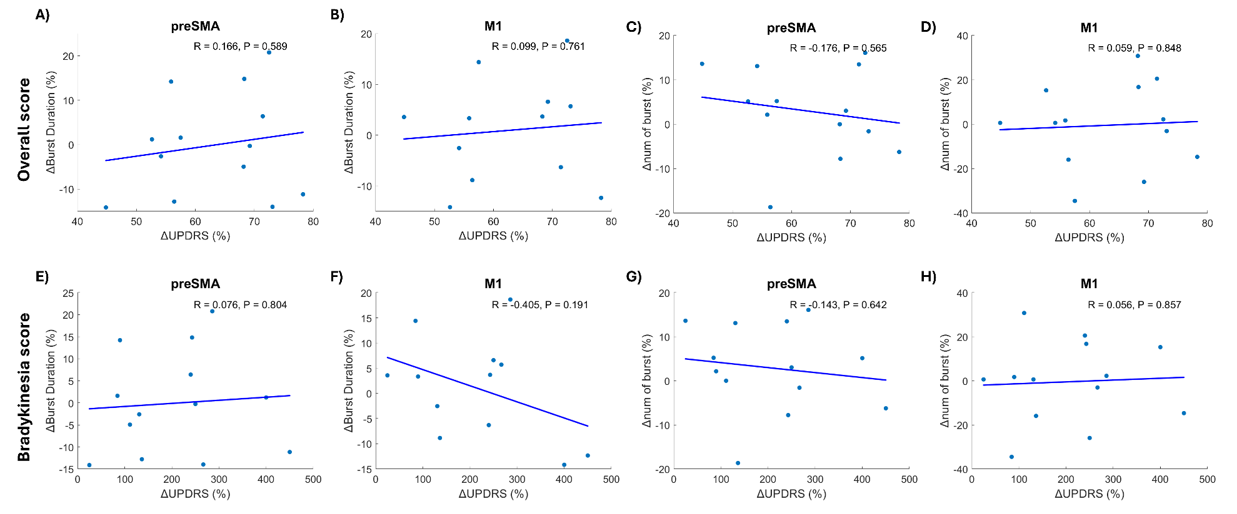
Figure S1. Correlation between beta burst properties and clinical symptom severity. The correlation was displayed for A-D) overall Unified Parkinson’s Disease Rating Scale III (UPDRS) and E-H) bradykinesia sub-score.

