SUPPLEMENTARY MATERIAL
Item | Variable | Factor 1 | Factor 2 | Factor 3 | Primary Factor
1 | lifting | 0.8118 | 0.0518 | -0.1401 | 1
2 | carrying in the hands | 0.9132 | -0.2967 | 0.145 | 1
3 | carrying in the arms | 0.6764 | 0.1177 | 0.2022 | 1
4 | carrying on shoulders, hip and back | 0.6737 | 0.2332 | -0.1362 | 1
5 | pushing | 0.8958 | 0.0494 | -0.1903 | 1
6 | reaching | 0.6737 | -0.057 | 0.0629 | 1
7 | driving human-powered transport | 0.3644 | 0.0197 | 0.2148 | 1
8 | washing body parts | 0.4289 | 0.3976 | 0.1091 | 1
9 | washing whole body | 0.3259 | 0.6037 | -0.0783 | 2
10 | caring for teeth | 0.0115 | -0.0289 | 0.9194 | 3
11 | putting on clothes | -0.0587 | 0.9357 | 0.0843 | 2
12 | taking off clothes | -0.0985 | 0.9308 | 0.0278 | 2
13 | eating | -0.0719 | 0.068 | 0.8932 | 3
14 | drinking | -0.0296 | 0.0492 | 0.956 | 3
15 | washing and drying clothes and garments | 0.6053 | 0.1306 | 0.1824 | 1
Table I: exploratory factor analysis of FDAP items after rotation

Item | Physically Demanding Activities | Grooming and Dressing Tasks | Essential Self-Care
lifting | 0.737 | 0.47 | 0.208
carrying in the hands | 0.747 | 0.305 | 0.381
carrying in the arms | 0.804 | 0.555 | 0.503
carrying on shoulders, hip and back | 0.676 | 0.547 | 0.255
pushing | 0.799 | 0.48 | 0.184
reaching | 0.591 | 0.384 | 0.308
driving human-powered transport | 0.427 | 0.313 | 0.323
washing body parts | 0.672 | 0.662 | 0.419
washing and drying clothes and garments | 0.728 | 0.577 | 0.463
washing whole body | 0.642 | 0.682 | 0.298
putting on clothes | 0.569 | 0.898 | 0.428
taking off clothes | 0.515 | 0.784 | 0.351
caring for teeth | 0.409 | 0.352 | 0.878
eating | 0.386 | 0.37 | 0.864
drinking | 0.438 | 0.413 | 0.944
Table II: internal convergent and divergent validity (Spearman rho-correlation coefficient); italic: higher correlation with a domain that the item is not distributed to

 | FDAP | FDAP physically demanding activities | FDAP grooming and dressing tasks | FDAP essential self-care | SPADI | SPADI pain | SPADI disability | TSK | TSK activity avoidance | TSK somatic focus | FABD | FABD physical activity | FABQ work | pain intensity
FDAP | 1.00
FDAP physically demanding activities | 0.95 ** | 1.00
FDAP grooming and dressing tasks | 0.84 ** | 0.68 ** | 1.00
FDAP essential self-care | 0.43 ** | 0.39 * | 0.29 * | 1.00
SPADI | 0.86 ** | 0.85 ** | 0.72 ** | 0.34 * | 1.00
SPADI pain | 0.75 ** | 0.71 ** | 0.6 ** | 0.29 * | 0.92 | 1.00
SPADI disability | 0.83 ** | 0.81 ** | 0.72 ** | 0.33 * | 0.91 ** | 0.70 ** | 1.00
TSK | 0.21 | 0.18 | 0.23 | 0.21 | 0.10 | 0.10 | 0.06 | 1.00
TSK activity avoidance | 0.16 | 0.13 | 0.20 | 0.12 | 0.09 | 0.12 | 0.03 | 0.95 ** | 1.00
TSK somatic focus | 0.26 | 0.22 | 0.30 * | 0.24 | 0.08 | 0.02 | 0.08 | 0.82 ** | 0.62 ** | 1.00
FABQ | 0.38 ** | 0.38 * | 0.24 | 0.21 | 0.35 * | 0.34 * | 0.32 * | 0.44 ** | 0.46 ** | 0.24 | 1.00
FABQ physical activity | 0.25 | 0.26 | 0.18 | 0.06 | 0.28 * | 0.29 * | 0.21 | 0.56 ** | 0.59 ** | 0.35 * | 0.75 ** | 1.00
FABQ work | 0.44 ** | 0.42 * | 0.29 ** | 0.32 * | 0.41 ** | 0.37 ** | 0.42 ** | 0.12 | 0.13 | 0.02 | 0.79 ** | 0.29 * | 1.00
pain intensity | 0.63 ** | 0.60 ** | 0.55 ** | 0.26 | 0.69 ** | 0.70 ** | 0.58 ** | 0.04 | 0.07 | -0.04 | 0.29 * | 0.23 | 0.35 * | 1.00
Table III: spearman rho correlation matrix. * p≤0.05 ** p≤0.01

Predictor: Duration
Coefficient (SE) | -0.11 (0.05)
R² | 0.09
Adj. R² | 0.07
F-statistic | -2.19
p-value (F-statistic) | 0.033
Table IV: linear regression for the association of symptom duration and FDAP total score

Figure I: Showing the respective FDAP scores by duration of symptoms (mean, standard deviation)
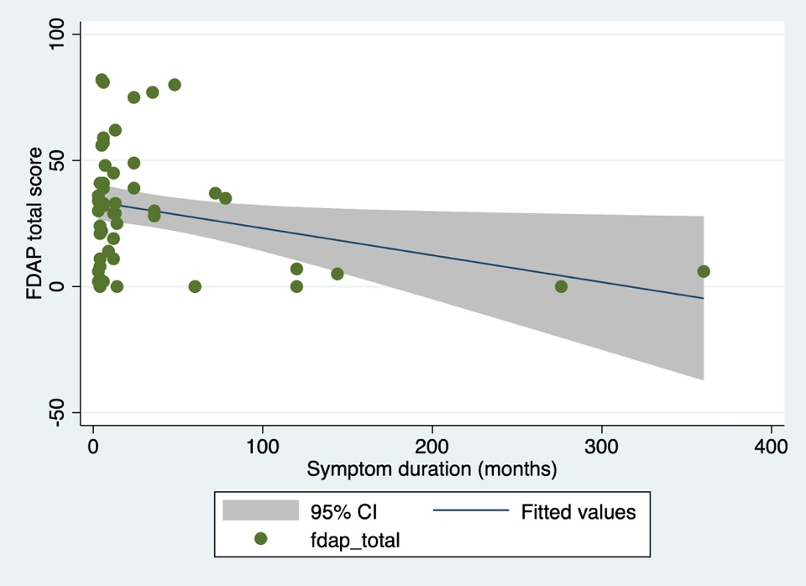
Figure II: Scatter plot of FDAP total scores and symptom duration

