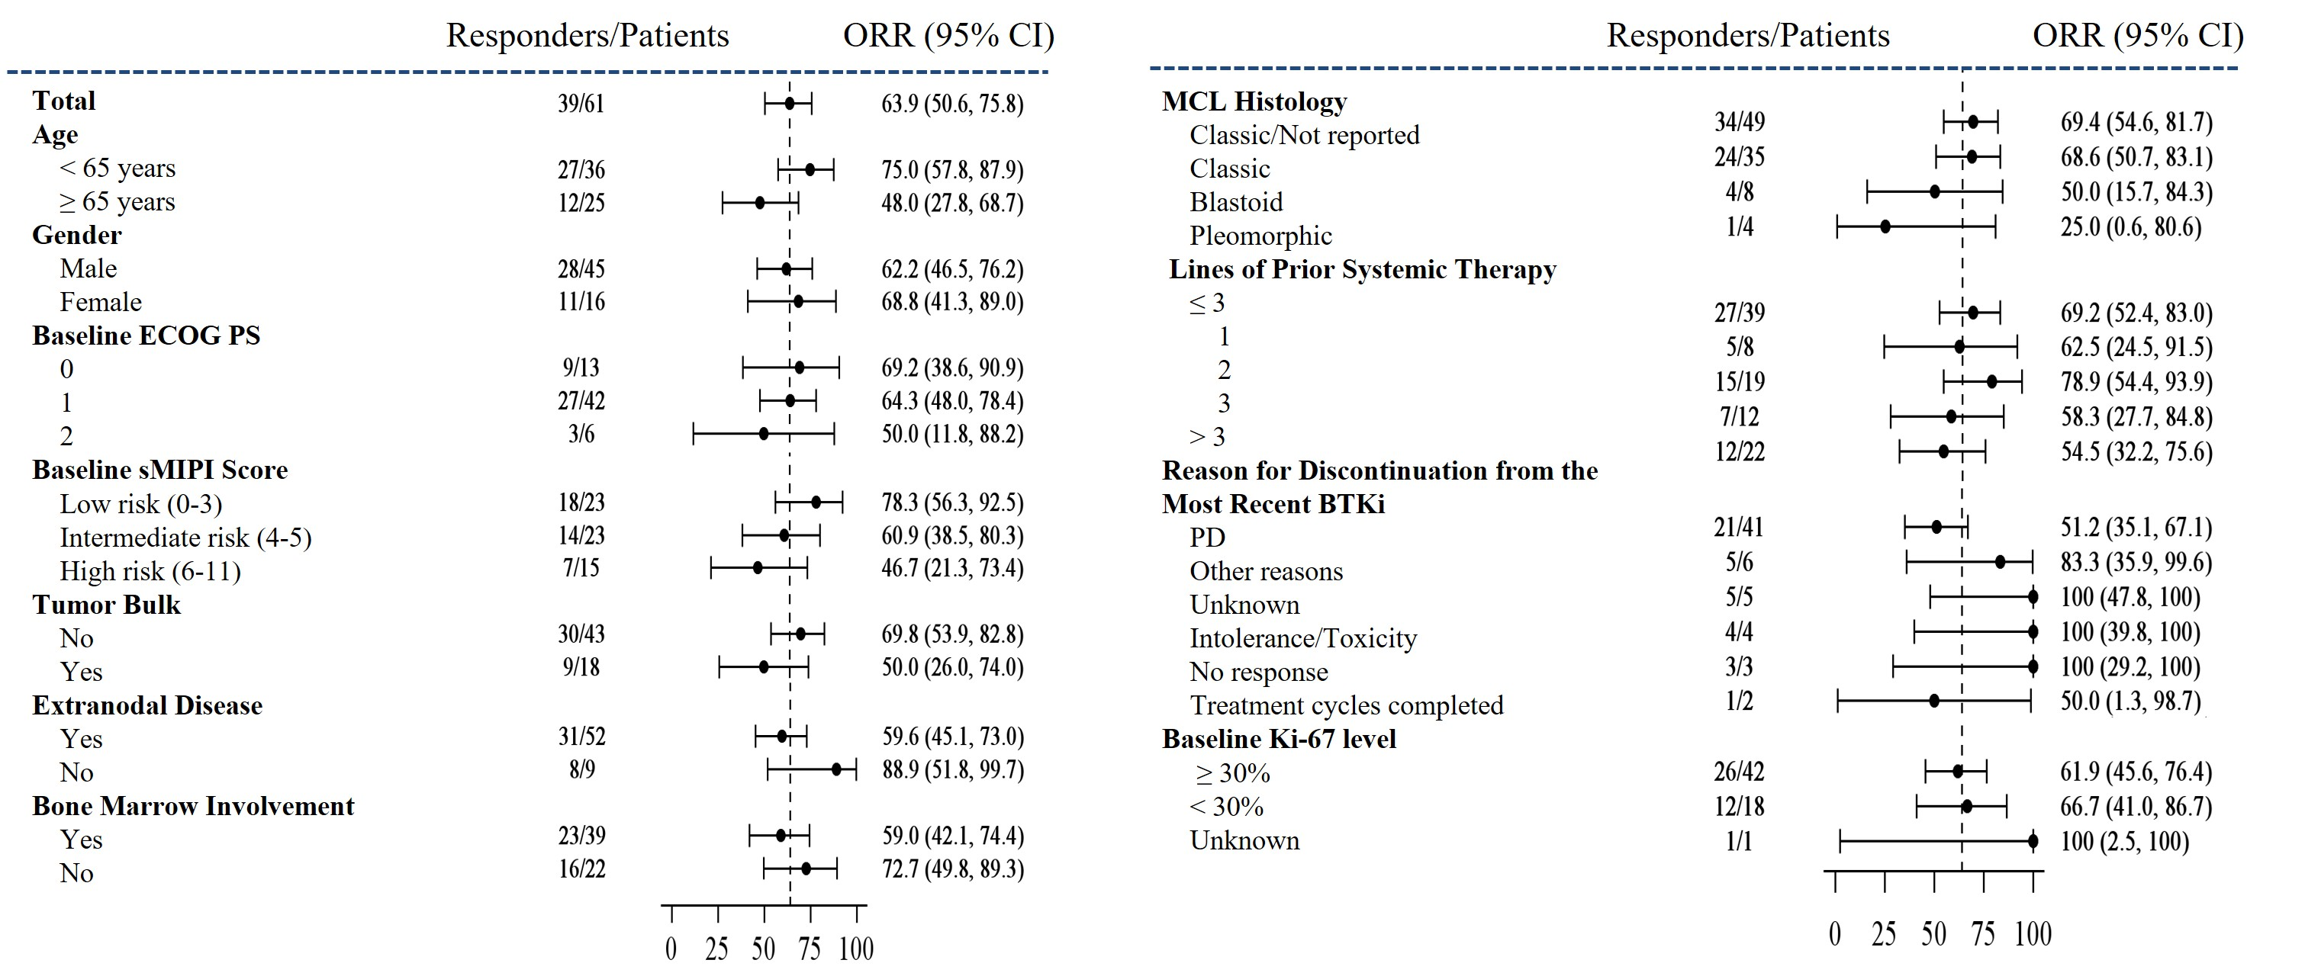
Figure S1. Subgroup analysis of IRC-assessed ORR
Forest plot containing overall response by prespecified subgroups according to baseline demographic and clinical characteristics. 95% CIs were based on exact binomial distribution.
Figure S2. Kaplan-Meier curve of (A) duration of response (DOR), (B) progression-free survival (PFS) in patients with cBTKi pre-treated MCL treated with rocbrutinib assessed by investigators

